Approach:-

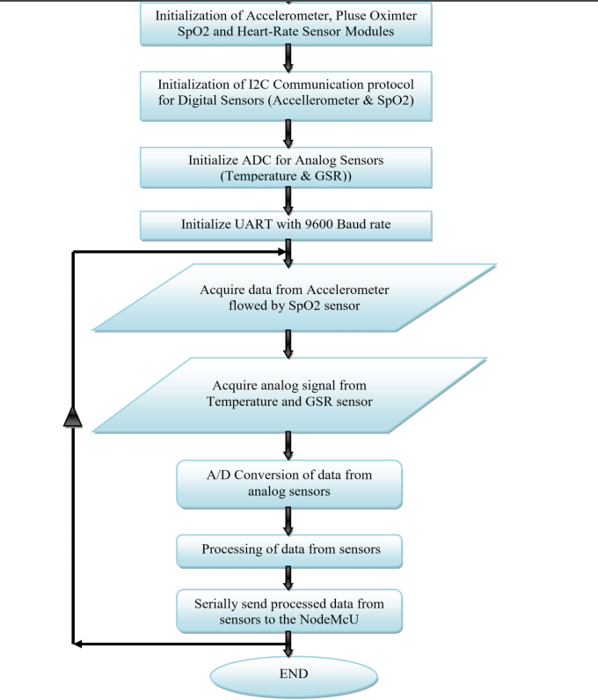

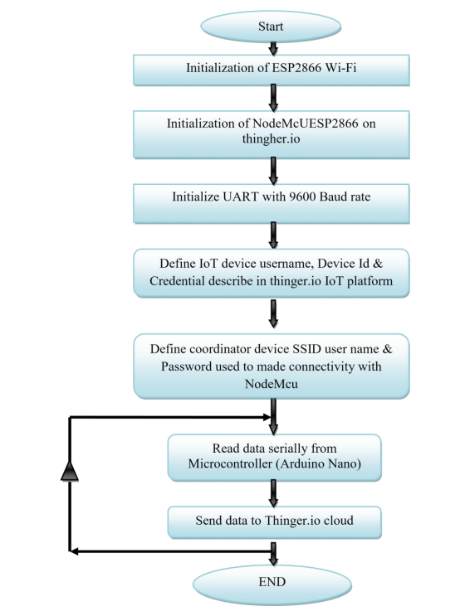

Program Flow chart for NodeMcU Wi-Fi Dev. board

What is Thinger.io?
Thinger.io is a cloud IoT Platform that provides every needed tool to prototype, scale and manage connected products in a very simple way. The goal is to democratize the use of IoT making it accessible to the whole world, and streamlining the development of big IoT projects.
- Free IoT platform: Thinger.io provides a lifetime freemium account with only few limitations to start learning and prototyping when our product becomes ready to scale, we can deploy a Premium Server with full capacities within minutes.
- Simple but Powerful: Just a couple code lines to connect a device and we can start retrieving data or controlling its functionalities with the web-based Console, able to connect and manage thousands of devices in a simple way.
- Hardware agnostic: Any device from any manufacturer can be easily integrated with Thinger.io's infrastructure.
- Extremely scalable & efficient infrastructure: due to the unique communication paradigm, in which the IoT server subscribes device resources to retrieve data only when it is necessary, a single Thinger.io instance is able to manage thousands of IoT devices with low computational load, bandwidth and latencies.
- Open-Source: most of the platform modules, libraries and APP source code are available in the Github repository to be downloaded and modified with MIT license.
Thinger.io is an Open-source cloud-based IoT Platform developed by INTERNET OF THINGER SL, a Spanish company whose objective is to provide an efficient, consistent and easy to use technology for IoT.

Thinger.io Platform project started life in early 2015, despite some of the first source code lines was made on 2014, as a side-project by Ph.D. Alvaro Luis Bustamante when he was working as researcher at the University Carlos III of Madrid (Spain), when he was studying different solutions to work online with cheap electronic devices, and he found that all the existent platforms were very difficult to use, inefficient or doesn't had enough capacities to create IoT projects in a simple way.

Thinger.io Main Features
Thinger.io platform is formed by two main products - a Backend (which is the actual IoT server) and a web-based Frontend that simplifies working with all the features using any computer or smartphone. The image below shows the main features provides by this platform to create IoT projects.
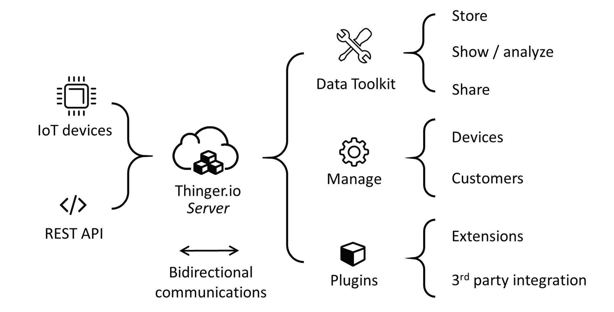

- Connect devices: Fully compatible with every kind of device, no matter the processor, the network or the manufacturer. Thinger.io allows to create bidirectional communications with Linux, Arduino, Raspberry Pi, or MQTT devices and even with edge technologies like Sigfox or LoRaWAN or other internet API data resources.
- Store Device Data: Just a couple clicks to create a Data Bucket a store IoT data in a scalable, efficient and affordable way, that also allows real-time data aggregation.
- Display Real-time or Stored Data in multiple widgets such as time series, donut charts, gauges, or even custom made representations to create awesome dashboards within minutes.
- Trigger events and data values using an embedded Node-RED rule engine
- Extend with custom features with multiple plugins to integrate IoT projects into your company's software or any other third party Internet service.
- Custom the appearance thanks to the fully rebrand able frontend, that allows introducing our branding colours, logotypes and web domain

The core of Thinger.io IoT Platform is designed to be lean and lightweight, to maximize flexibility and minimize learning and common configuration of IoT networks. Plugins offer custom functions that can be deployed on-demand, allowing each user to complement their IoT server as its specific needs.

Dashboards are a data visualization tool that allow all users to understand the analytics that matter to their business, department or project. Even for non-technical users, dashboards allow them to participate and understand the analytics process by compiling data and visualizing trends and occurrences. We plan to make a web based dashboard for effective and easy monitoring and understanding of the various health parameters of the patient, such as blood pressure and temperature.
Thinger.io dashboard system is a feature that allows creating nice data representation interfaces within minutes in a very simple way. No coding is required, just selecting different widgets from a list and using drag drop technology to configure the layout of the dashboard, then using the configuration forms it is possible to set the data sources, sampling interval, and other behaviours of each widget. The main types of these widgets are:
- Real-time data representation
- Historical data representation from buckets
- Control device functions or change values with On/Off buttons or sliders
Why this approach?
We could have used normal website coding (using HTML,CSS) to design a website for displaying the parameters. But we preferred using this since we found that it was open source,easy to use and most importantly, it was convenient to create simple,attractive dashboards using this platform. Moreover, the array of devices supported by thinger.io is humongous. So, a wide variety of devices can be easily integrated in the project, irrespective of the manufacturers or properties.

Working :-
- Create device – create a device on thinger.io by registering a new device. By logging into console dashboard, go to Devices ->Add Device.
Add the device credentials such as identifier, description and credentials, like Wi-Fi username, etc. as mentioned in the code.
If everything is successful a message appears and the device is displayed in the list of devices.

- Add a display widget -while editing on the dashboard, a new button Add Widget appears, where the type can be selected based on requirement.
Widget selection is done like this –

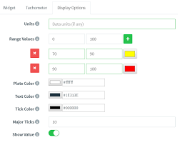
- To manage all our dashboards, it is necessary to access to the Dashboards section, by clicking in the following menu item:
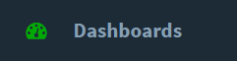
Then click on the Add Dashboard button that will open a new interface for entering the dashboard details.
It is necessary to configure different parameters:
- Dashboard Id: Unique identifier for your dashboard.
- Dashboard name: A representative name of your dashboard, in a more friendly way than its identifier.
- Dashboard description: Fill here any description or detailed information you need to keep about the dashboard.
- Creating a data bucket – it is a kind of virtual storage for time series info over time. This can be used to plot info in dashboards, or can be exported in different formats for offline processing.To create a data bucket, we need to access Data buckets feature and Add Bucket.
Here are some dashboard layouts created using the platform :-
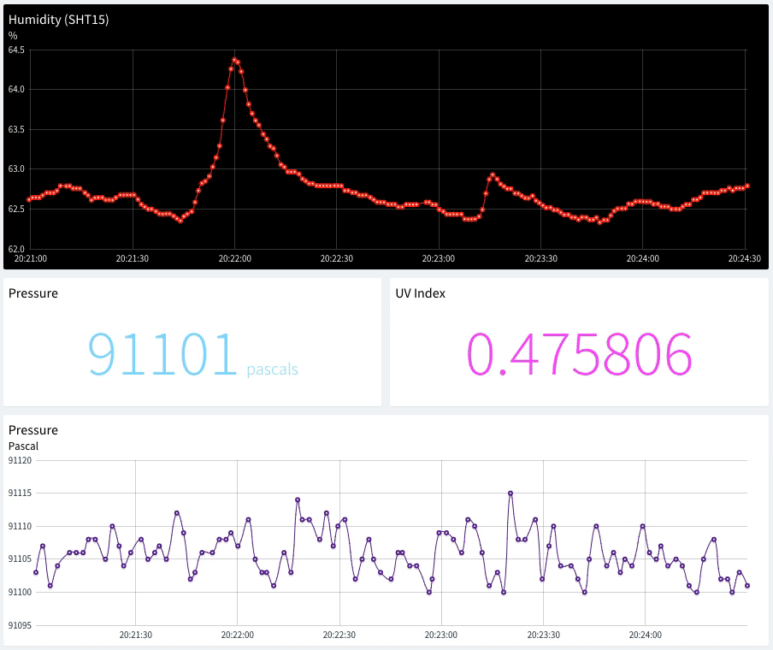
Here is an example dashboard with some widgets defined, like time series charts, donut charts, maps, or single values.
Once created, dashboards can be shared with third parties through a link or configured as templates to analyze data from different devices of the same type.
The following subsections describe the different parameters for each widget type.

Time Series Chart
A time-series chart is a graph that can display values over time. In this sense, this is quite useful when it is required to display time-series data, like temperature variable that changes over time. It is possible to plot a single variable or multiple values in the same chart.

Donut Chart
A donut chart is a graph that can display a value, normally in form of a rounded percentage. In this sense, this is quite useful when you have a know variable that oscillates between a maximum and minimum value. In this case, it is only possible to only represent a single variable, that can be both updated in real-time from a device, or from a data bucket.

Text/Value
The text/value widget is an useful widget to display any arbitrary data, specially text values that cannot be represented with other widgets. As any other widget, can display data both from connected devices or data buckets.

Clock
This widget is just a clock widget that can display the current time both in the local time zone or in UTC, which can be useful when monitoring processes in real-time. This widget takes the current time just from our computer.
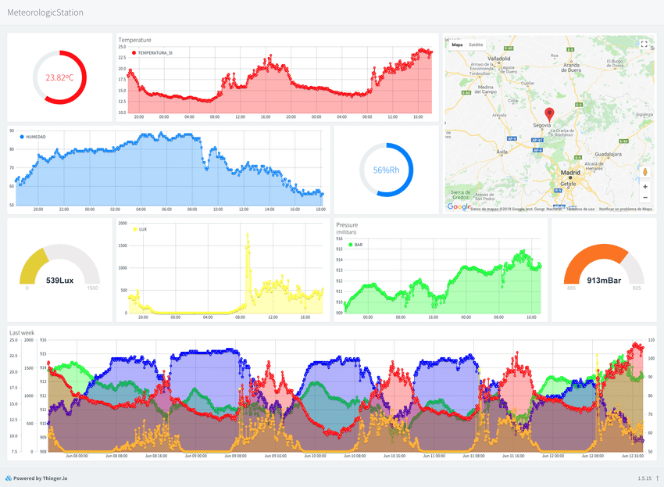
A Dashboard Tab is an additional work page that can be added to a dashboard to organize the visualization of data and simplify navigation between related pannels. The widgets and data sources of each tab can be completely independent of the others but all the tabs will share the same configuration settings (column number, background image, widgets border-radius, etc).
This feature also has the advantage of keeping all the tabs of a dashboard open even if they are not being visualized, so the data of the devices shown in real-time will not be lost when changing from one tab to another.
An example of how a patient monitoring dashboard looks like –
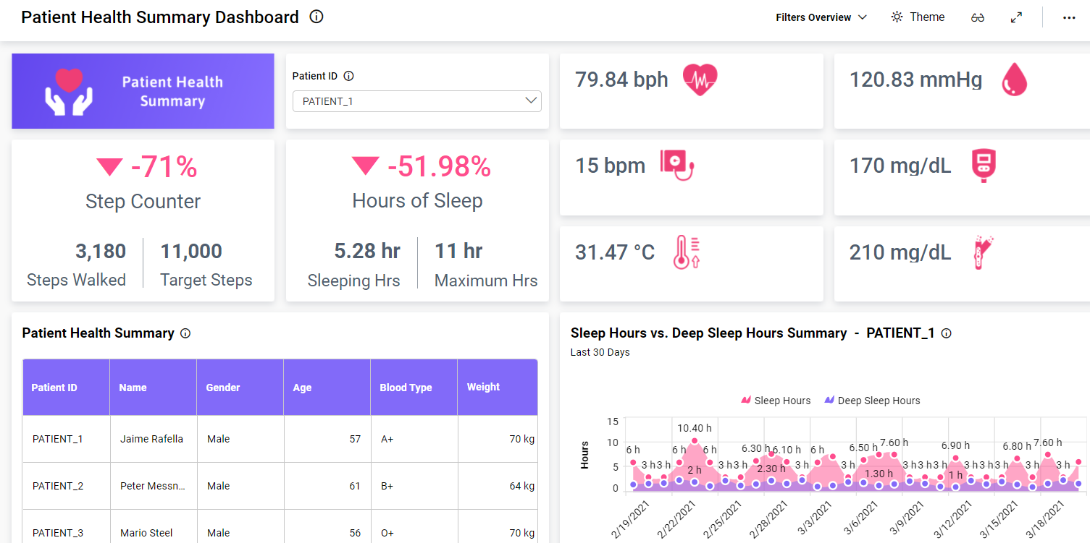
It has various parameters displayed in an easily comprehensible lucid manner, using different charts and graphs to indicate different variables,like temperature,pressure,etc.