|  |  |  |
| --- | --- | --- |
| KIIT(sponsor).png | | |
|  | | |
|  | | |
|  | | |
| A **MAJOR PROJECT** report on : | | |
|  | | |
| **ADVANCED HEALTHCARE MONITORING AND RECOMMENDATION SYSTEM** | | |
|  | | |
| submitted in partial fulfillment of the requirements for the degree of | | |
| B. Tech | | |
| In | | |
| **Electronics and Electrical Engineering** | | |
| By | | |
| |  |  | | --- | --- | | Souvik Karmakar | 1807228 | | Sudeshna Dutta | 1807232 | | Indrashis Mitra | 1807274 | | Kinjal Sarkar | 1807277 | | Pratyay Basu | 1807291 |   under the guidance of | | |
| **Prof. K.B. Ray** | | |
| |  | | --- | | School of Electronics Engineering | | **KIIT Deemed to be University**  **BHUBANESWAR**  **April 2022** | |  | | | |
| **CERTIFICATE**  This is to confirm that the project report "**A COMPARATIVE ANALYSIS OF MACHINE LEARNING ALGORITHMS**" provided by  Souvik Karmakar 1807228  Sudeshna Dutta 1807232  Indrashis Mitra 1807274  Kinjal Sarkar 1807277  Pratyay Basu 1807291  is true and correct.  A bonafide record of the work carried out under my(our) guidance and supervision at the School of Electronics Engineering, KIIT, in partial fulfilment of the requirements for the award of the Bachelor of Technology in Electronics and Electrical Engineering is submitted in partial fulfilment of the requirements for the award of the Bachelor of Technology in Electronics and Electrical Engineering from KIIT(Deemed to be University). | | |
|  | Signature of Supervisor 1  Prof.K.B.Ray  School of Electronics Engineering  KIIT (Deemed to be University) | |
|  | | |
|  | | |
| **The Project was evaluated by us on _____________** | | |
|  | | |
| EXAMINER 1 | | EXAMINER 2 |
| EXAMINER 3 | | EXAMINER 4 |
|  | |  |
|  | |  |
|  | |  |

**ACKNOWLEDGEMENT**

We are overjoyed and honoured to offer our deepest and most sincere appreciation to **Prof. K.B.Ray**, our project supervisor, for her superb supervision during our project work. Her commitment, hard labour, and meticulous attention to detail have been a source of tremendous inspiration for us. Thank you very much, mam, for your unwavering support and patience with us. We'd want to express our gratitude to her for patiently and meticulously revising all of our submissions.

We are also very thankful to **Prof.Suman Roy,** **Prof. Pravat Biswal**

**Prof. M. Ramana,** FIC project (EEE), Associate Dean **Dr. Amlan Datta,** and **Dr. Suprava Patnaik**, Dean (School Of Electronics) for their support and suggestions during our course of the project work in the final year of our undergraduate course.

**STUDENT SIGNATURE:-**

|  |  |  |
| --- | --- | --- |
| Roll Number | Name | Signature |
| **1807228** | **Souvik Karmakar** |  |
| **1807232** | **Sudeshna Dutta** |  |
| **1807274** | **Indrashis Mitra** |  |
| **1807277** | **Kinjal Sarkar** |  |
| **1807291** | **Pratyay Basu** |  |

Date:-

**ABSTRACT**

Patients can be monitored outside of typical healthcare facilities, improving access to treatments and cutting costs.IoT not only helps in preventing the spread of disease but also in getting a proper diagnosis, even if the doctor is present at a remote distance . IoT has enabled us to build numerous complicated systems such as smart home appliances, smart traffic control systems, and so on by permitting effortless interaction among diverse modules.The COVID-19 pandemic had a terrible impact on healthcare, owing to a lack of planning. In some susceptible populations, such as the elderly, frail, or those with many chronic conditions, COVID-19 has a higher chance of catastrophic outcomes. The scarcity of medications was also a major role in the significant number of deaths we saw.

Hence our project proposes a method to resolve this, by applying machine learning techniques to stock up medicines, which have been observed to be of significant demand, so that there is no dearth and we can give them to those in need. In order to discover solutions to healthcare concerns, new technologies such as Big Data and Cloud are needed. New technologies, such as Big Data and Cloud, are required to discover answers to healthcare issues. Healthcare data is exploding these days, necessitating a quick, efficient, and cost-effective solution to lower mortality rates. In the development of the concept of business intelligence and analysis, the importance of data collection, integration, processing, and reporting of underlying knowledge has been emphasised, as well as how this knowledge can assist in making more appropriate business decisions and gaining a better understanding of market behaviour and trends. We may be able to use Big Data analysis for successful decision-making in the healthcare business by using current machine learning algorithms with minor tweaks. Choosing the right algorithm to forecast disease based on the data set supplied by the researcher, on the other hand, is always difficult.

**PROPOSED SYSTEM:** We intend to leverage Machine learning to aid in medicine supply. Using the support metrics of the Apriori algorithm, we plan to make a recommendation system of the medicine a particular customer is most likely to buy so that there is a win-win situation for both the customer and the shop owner - the customer gets the most appropriate medicine they want, at all times and do not have to face the hassles of out of stock medicines; while the pharmacist also learns the particular combination of medicines, which is made available easily, will yield the maximum benefit in the upcoming future.

**TABLE OF CONTENTS**

Abstract

Table of Contents

List of Figures

List of Tables

List of symbols/ abbreviations

**CHAPTER I**: **INTRODUCTION**

|  |  |  |
| --- | --- | --- |
| 1.1 | Background | 1 |
| 1.2 | Literature Survey | 1 |

**CHAPTER 2: EMBEDDED SYSTEMS - Metrics Monitoring**

|  |  |  |
| --- | --- | --- |
| **2.1** | Objective (I) and Components required | **2** |
|  | (a) Detailed description of the components | **3** |
|  | (b) Module features | **3** |
| **2.2** | MLX90614 detailed pin configuration | **3** |
| **2.3** | MLX90614 -Features and benefits | **4** |
| **2.4** | Advantages of MLX90614 | **4** |
| **2.5** | Applications of MLX90614 | **5** |
| **2.6** | Arduino UNO interfacing of MLX90614 | **6-7** |
| **2.7** | Board schematic representation | **8** |
| **2.8** | MAX30102 Pulse Rate Sensor - Product description | **9** |
| **2.9** | Detailed pin description of MAX30102 | **10** |
| **2.10** | Advantages of MAX30102 | **10** |
| **2.11** | Principle of working and specifications | **11** |
| **2.12** | Arduino UNO Interfacing MAX30102 | **12** |
| **2.13** | Flowchart of the procedure. | **13** |

**CHAPTER 3(A)**: **IOT - WEBSITE MONITORING**

|  |  |  |
| --- | --- | --- |
| 3.1 | Introduction to Thinger.io | 16-17 |
| 3.2 | Main features of Thinger.io | 18-19 |

**CHAPTER 3(B)**:  **IOT- BLYNK**

|  |  |  |
| --- | --- | --- |
| 3.3 | Introduction to the Blynk Community | 19 |
| 3.4 | Blynk features | 20 |
| 3.5 | Blynk application in metrics monitoring | 21 |
| 3.6 | Blynk - My APPS | 22-24 |

**CHAPTER 4: MACHINE LEARNING**

|  |  |  |
| --- | --- | --- |
| 4.1 | Introduction | 24 |
| 4.2 | How does Machine learning work? | 25-27 |
| 4.3 | How do machines learn? | 27 |
| 4.4 | Types of ML algorithms | 28 |
| 4.5 | What is Association Rule Learning? | 28 |
| 4.6 | Working | 28-29 |
| 4.7 | Model specifications | 29-30 |
| 4.8 | Dataset | 30 |
| 4.9 | Screen snippets | 31 |

**CHAPTER 5**: **CONCLUSION**

|  |  |  |
| --- | --- | --- |
| 5.1 | Summary | 45 |
| 5.2 | Future scope | 46-48 |
| 5.3 | Cost Analysis | 49 |

**CHAPTER 6 : PLANNING & REFERENCES** 50-52

**LIST OF FIGURES**

|  |  |  |
| --- | --- | --- |
| **Fig no.** | **Description** | **Page No.** |
| 2.1 | MLX90614 temperature sensor module | 2 |
| 2.2 | MLX90614 Pin-out Configuration | 3 |
| 2.3 | Arduino UNO and Nodemcu interfacing with MLX90614 | 6 |
| 2.4 | Connection diagram of MLX90614 with nodemcu board | 7 |
| 2.5 | Board schematic representation | 8 |
| 2.6 | MAX 30102 pulse rate sensor | 8 |
| 2.7 | MAX 30102 Pinout configuration | 09 |
| 2.8 | Connection diagram of MAX30102 with Nodemcu | 10 |
| 2.13 | Flow diagram (For monitoring parameters) | 10 |
| 3.1 | Connectivity of thinger.io platform | 11 |
| 3.2 | Illustration of widget selection | 13 |
| 3.3 | Dashboard layout | 14 |
| 3.4 | An example of how a dashboard monitor looks like | 16 |
| 3.5 | Organization of Blynk cloud | 18 |
| 3.6 | Illustration of account creation | 19 |
| 3.7 | Creation of project | 20 |
| 3.8 | Selection of hardware | 21 |
| 3.9 | Widget selection | 21 |
| 3.10 | Running the project | 22 |
| 3.11  4.1 | Blynk MyApp layout  Development cycle | 24  24 |
| 4.2  6.2 | Learning components  Gantt chart | 27  40 |

LIST OF TABLES

|  |  |  |
| --- | --- | --- |
| **Table ID** | **Table Title** | **Page** |
| 3.1 | MLX 90614 Pinout configuration | 7 |
| 3.2 | Pin connection table of MLX90614 | 10 |
| 3.3 | Pin connection table of MAX 30102 | 12 |
| 3.4 | Pin Connection chart of MAX 30102 with Nodemcu board | 15-16 |
| 6.3 | Cost Analysis | 48 |
| 7.1 | Showing details about project planning and management | 49 |

LIST OF SYMBOLS / ABBREVIATIONS

**Symbol / Abbreviations Description**

MLXMelexis

MEMS Micro-electromechanical systems

GPRS General Packet Radio Service

Wifi **Wireless Fidelity**

MAX Maxim integrated

ESP Espressif Systems

IC Integrated Circuit

I2C Inter-Integrated Circuit

ML Machine learning

**CHAPTER 1**

**INTRODUCTION**

**1.1 BACKGROUND**

As the information and technology revolution continues, smartphone-based health monitoring solutions are becoming increasingly widespread. These gadgets may be used to collect real-time health data and give clinicians feedback. In the long run, the adoption of monitoring systems can help the government save money on medical costs. Due to broad availability to mobile internet services, combining mobile internet with a health-care system utilising an open-source architecture has become quite simple. Doctors and patients can use a smart gadget to continually monitor the heart rate, gather essential data, and take adequate precautions to avoid serious harm. Heart rate and body temperature are two of the most important characteristics of the human body, and they play a big role in determining a patient's health.

A healthy adult's pulse rate ranges from 60 to 100 beats per minute. Males have a pulse rate of 70 beats per minute, whereas girls have a pulse rate of 75 beats per minute. Females with a heart rate of 12 and higher have a quicker rate than males.

**1.2 LITERATURE SURVEY**

Healthcare big data is a collection of patient, hospital, doctor, and medical treatment records that is so huge, complicated, scattered, and expanding at such a rapid rate that it is impossible to keep track of and analyse using typical data analytics methods. To overcome these challenges, a big data analytics framework is used to apply machine learning algorithms to such a large quantity of data. [1] Technology has also progressed significantly in the discovery and development of novel pharmaceuticals that have the potential to benefit patients with complex illnesses.[11] Some large tech companies, such as IBM and Google, have developed machine learning tools to help patients find new therapy options.Precision medicine is an important concept in this discussion since it entails understanding mechanisms underlying complex disorders and developing new treatment options.

Although numerous semi-supervised strategies to give additional training data have been presented, automatically produced labels are typically too noisy to properly retrain models.[2] The impact of COVID-19 pandemic on healthcare was catastrophic,mainly due to lack of preparedness. Hence in this project we have tried to make things easier in whatever way we can. Mainly we propose a model to classify COVID-19 patients .The risk of severe complications from COVID-19 is higher for certain vulnerable populations, particularly people who are elderly, frail, or have multiple chronic conditions.[3] Using such a classification we can implement a variety of measures for their betterment,such as a vaccine scheduler. Or,as all of us know,shortage of medicines was a huge factor behind the large number of deaths we have witnessed. Hence our project also proposes a method to resolve this,by applying machine learning techniques to stock up medicines,which have been observed to be of significant demand,so that there is no dearth and we can give them to those in need. In addition to this,our IOT based healthcare monitoring system helps to monitor patient parameters and alert doctors when needed,so that people do not need to panic. By means of this technology,similar results can be obtained as reported in [4][5]. In addition to this,the fall detection mechanism of our system helps to alert caregivers on time,in case an elderly person suffers injury,as suggested in [6]. All these parameters,which have been collected using various sensors and processed using NodeMCU board,like in [7], and are then displayed on a web based dashboard,as well as mobile app through Blynk.[12]

Big Data and the Cloud are two examples of new technologies that are helping to solve healthcare issues. Healthcare data is expanding at an exponential rate these days, necessitating an efficient, effective, and timely solution to cut mortality rates.[8]

The importance of data collection, integration, processing, and reporting of underlying knowledge has been emphasised in the development of the concept of business intelligence and analysis, as well as how this knowledge can assist in making more appropriate business decisions and gaining a better understanding of market behaviours and trends.[13][14] We have been able to unearth hidden information from data thanks to the massive expansion of data. Using current machine learning algorithms with minimal modifications, we may employ Big Data analysis for effective decision making in the healthcare industry.[9]According to our findings, many academics are motivated to study machine learning algorithms in the health-care industry. However, selecting the appropriate algorithm to predict disease based on the data set generated by the researcher is always tough.[10]

**1.3 ORGANIZATION OF THE REPORT**

This report has been divided into 6 chapters: -

Chapter 1 – Introduction

Chapter 2 – Embedded systems – Metrics monitoring

Chapter 3 A – IOT – Website monitoring

Chapter 3 B – IOT – Blynk

Chapter 4 - Machine Learning

Chapter 5 – Conclusion & Future Scope

Chapter 6 – Planning and References

**CHAPTER 4**

**MACHINE LEARNING**

**Objective -** Toleverage machine learning to predict customer behavior patterns concerning buying medicines

**Introduction**

Machine learning is a section of computer science that evolved from the analysis of pattern recognition in data as well as a computational learning theory in artificial intelligence. It rose from an environment that was the integration of the interaction between available data, computing power, and statistical methodologies. The perfect blend in these three widely differing and rapidly developing areas gave birth to what is now known as machine learning. Growth in available data compelled a spurt in computing power, which in turn stimulated the development of statistical methods to analyze large datasets, thus facilitating the collection and analysis of even larger and more complex, interesting data.

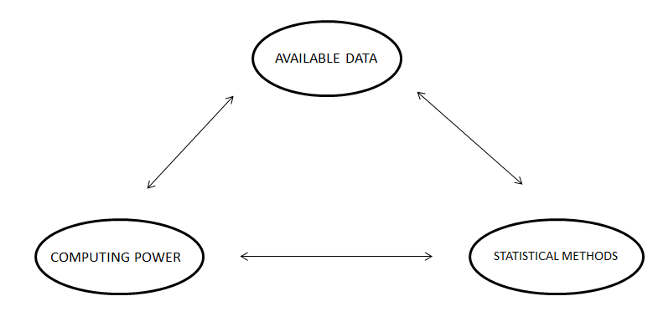

Fig 4.1 Development cycle

**DATA PREPROCESSING :**

The preprocessing of the dataset is very much required to support the regulations and syntax which the particular ML model asks for.

The different phases of the preprocessing include :

* Importing of libraries
* Importing the dataset
* Handling the missing data
* Encoding the categorical data
* Encoding the dependent variable
* Splitting the dataset ( Training and test set )
* Feature scaling

**IMPORTING THE LIBRARIES :**

For general use cases the following libraries are imported to support the model structure:

1. **NUMPY**: It will allow us to work with arrays.
2. **MATPLOTLIB**: It will allow us to plot very attractive charts and graphs for visual representation.
3. **PANDAS**: It will allow us to not only import the datasets but also create the matrix of features and dependent variable vectors.

**IMPORTING THE DATASET :**

A new variable is to be created which will contain the exact copy of the dataset we are aiming to deploy. The next target will be creating a data frame. We need to call a function from the panda’s library that is read_csv.

This data frame now created will be the same as the dataset variable.

This is not enough as we have to create two more entities that are:

Matrix of features and the dependent variable vector.

In most of the ML models, the dependent variable is at the end of the dataset and the beginning comprises the matrix of features.

**HANDLING THE MISSING DATA :**

We try to replace the missing values with the average of all the values in that particular column.

We take help from a reputed data science library that is SCIKIT LEARN.

Inside that, we take the help of a module named IMPUTE. We now create a tool/method in the object imputer to connect the object to the matrix of features.

Now the imputer transform replaces the missing values with the mean value and is stored or returned to the dataset portion which had the missing values.

**ENCODING THE CATEGORICAL DATA**

We try to encode the strings to certain numbers to let the ML model understand them and establish a correlation between them.

The encoding procedure used here is *ONE HOT ENCODING* ( which allows the representation of categorical data to be more expressive )

**ENCODING THE DEPENDENT VARIABLE**

LabelEncoder is a class in the preprocessing module of the scikit learn library that has no arguments if the dependent variable had only 2 categories. So we can just encode them into 1 and 0.

**SPLITTING THE DATASET**

The dataset is generally split into the Training set and Test set.

**Training set**: To train the ML model with the sets of data to identify attributes and features and patterns of the data.

**Test set**: To test the ML model with the new feature data to do performance monitoring.

We need to specify the test size to clarify how much % of the dataset we want in the test set and the remaining in the training set.

We set the random_state as 1 to choose the data from the dataset randomly so that we just do not feel lucky just for this particular dataset.

**FEATURE SCALING :**

In ML models, some of the features dominate over some of the features. To tackle this problem feature scaling is important.

Feature scaling is not required for all ML models; it is a model-specific procedure.

The method of feature scaling is Standardisation and Normalisation.

Normalization is usually preferred and recommended where we have a normal distribution in most of the features.

We don’t need feature scaling when the data is encoded or binary data.

**WORKING OF ML :**

Machine learning is made up of three components:

* a computer method that is at the heart of decision-making;
* Characteristics and factors that impact the decision
* The response is known for base knowledge, which aids(trains) the system in learning.

The model is given parameter data for which the solution is known at the start. The algorithm is then run, and changes are made until the output (learning) of the algorithm matches with the known solution. At this step, the system is given increasing volumes of data as input to help it learn and process higher computational judgments.

**How do machines learn?**

The fundamentals of learning are similar. It may be broken down into three sections:

• Data input: Observation, memory storage, and recall are used to give a factual foundation for subsequent reasoning.

• Abstraction: This is the process of transforming facts into more abstract representations.

• Generalization: It is a method of taking action based on abstracted facts.

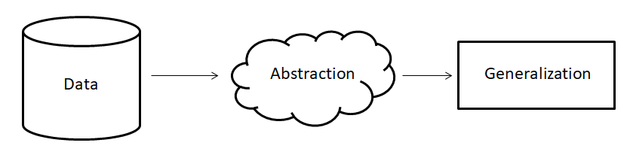

Fig 4.2 Learning process

**Types of ML Algorithms :**

Based on the type of input available during the training process or the desired outcome, there are 4 main types of machine learning algorithms:-

1. Supervised learning - used in those situations where the output is known, for a particular input; i.e. trained on labeled examples
2. Unsupervised learning - used in those situations where the output is not known, for a particular input;i.e. trained on unlabelled examples
3. Semi-supervised learning - works in those situations in which the combination of supervised and unsupervised learning is required to generate appropriate function or classifier
4. Reinforcement learning - is like a reward/punishment kind of a scenario. Desired manners are rewarded, while undesired ones are punished. Thus the agent behaves in such a way that a sequence of actions that lead to desirable outcomes are produced more times.

**ASSOCIATION RULE LEARNING:**

Association rule learning is a form of unsupervised learning approach that examines the reliance of one data item on another and maps appropriately to make it more lucrative. It tries to uncover some interesting relationships or links between the dataset's variables. It uses a set of rules to find interesting relationships between variables in a database.

**Working:-**

Association learning works on the if-else concept.

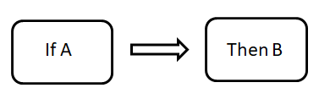

Fig 4.3

The If element of association is called the Antecedent.

The Then statement is called the Consequent.

This type of relationship is called Single Cardinality.

The metrics to find the association is:

1. **Support**
2. **Confidence**
3. **Lift**

**Support**

The frequency of X, or how frequently an item appears in the collection, is called support. It's the percentage of the transaction T that has the itemset X in it. If there are X datasets, the following may be written per transaction T:

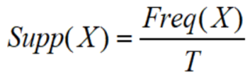

**Confidence**

The degree of confidence in a rule reflects how often it is correct. Or, since the incidence of X is already known, how frequently the elements X and Y appear together in the dataset. It's the proportion of a transaction including X and Y to the number of records containing X and Y. -



**Lift**

It is the strength of any rule, which can be defined as below formula:



It is the ratio of the observed support measure and expected support if X and Y are independent of each other. It has three possible values:

* Lift = 1: Antecedent and subsequent occurrence probabilities are independent of one another.
* Lift > 1: Determines the degree to which the two itemets are interdependent.
* Lift 1: It indicates that one object is a replacement for another, implying that one item causes harm to another.

**Model specifications:**

We utilised the Apriori model in this project to propose the pharmaceutical combination that the consumer is most likely to buy.

R.Agrawal and Srikant presented the Apriori method in 1994, which employs recurrent itemsets to construct association rules. It's primarily intended for use with transactional databases. It is possible to establish how strongly or weakly certain things are related using these principles.

The Apriori approach iteratively finds frequent items from a big dataset using a Hash tree and a breadth-first search to determine the relationships.

What is a Frequent Itemset?

Itemsets that have a higher level of support than the threshold value or the user-specified minimum level of support are called frequent itemsets. If X and Y are frequent itemsets together, then X and Y should be frequent itemsets alone as well.

Assume there are two sets of items: X1,2,3,4,5 and Y2,4,6,8. The itemsets 2,4 are the most common in these two transactions.

**WORKING OF APRIORI MODEL :**

The following are the steps of the Apriori algorithm:-

1. Ascertain the support of itemsets in the transactional database and select the minimum confidence and support
2. Gather all the support values from the dataset which are larger than the minimum/selected support value
3. Note all the rules of the subsets that have a higher confidence value than the threshold or minimum confidence
4. Sort the rules in decreasing order of lift.
5. The descending order of the lift will allow us to comprehend the association between the medicines in a more accurate manner.

**Dataset:**

The dataset used is a sample of medicine combinations that have been commonly bought by customers over the past 2 months. It is a random dataset that we have made to illustrate the idea of medicine prediction and contains 7500 example records.

The dataset has been randomly generated thus ensuring the accuracy of the model in the context of its probability of getting lucky for a particular dataset .

The practical use case of this dataset is that it will be given by the chemist shop based on their previous sales . The apriori algorithm will be executed on this for getting the preferred result .

**Screen snippets:**

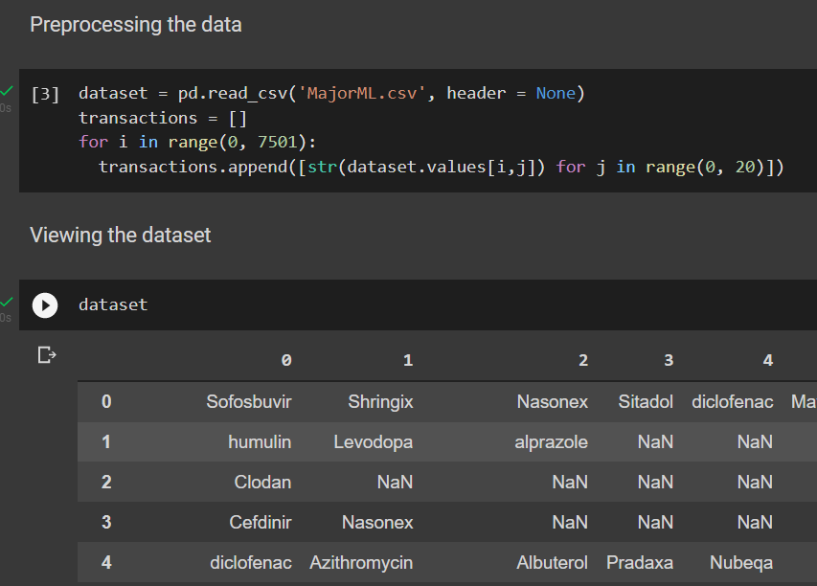

Word Cloud showing the most popular items

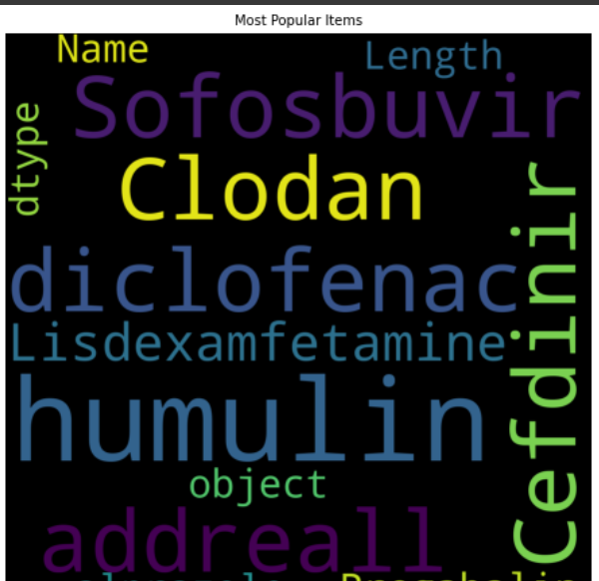

**Frequency of the most popular items :**

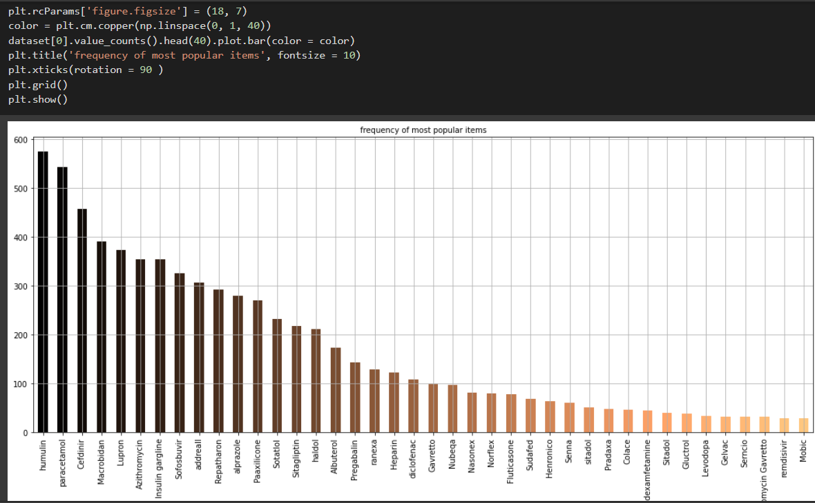

**Training the model :**

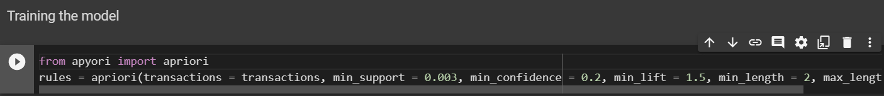

**Displaying the results**

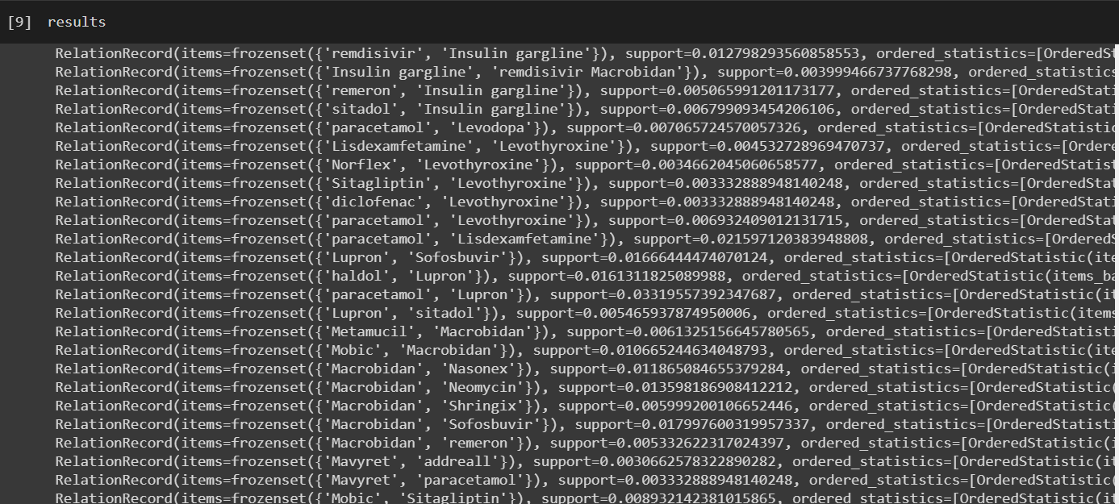

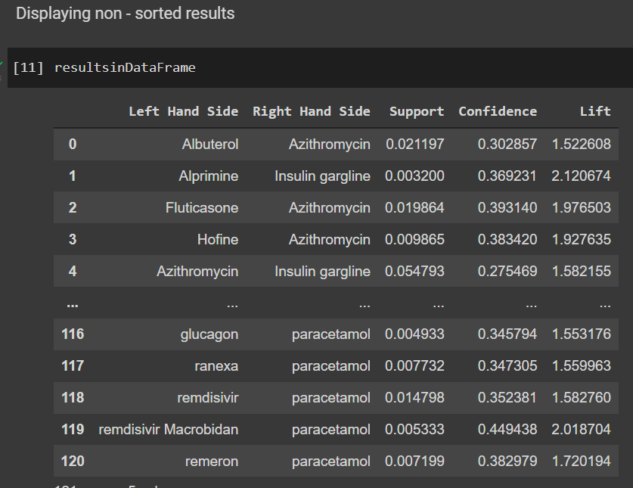

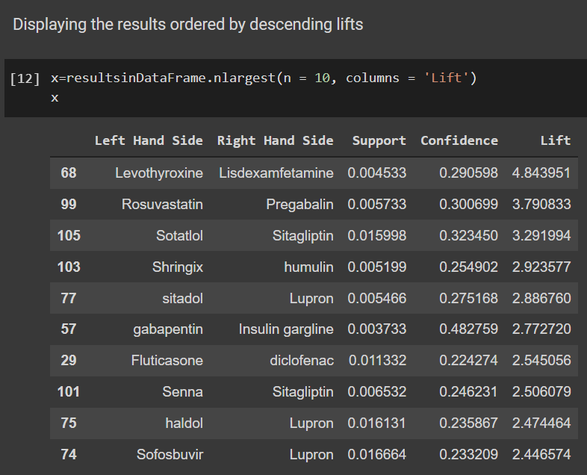

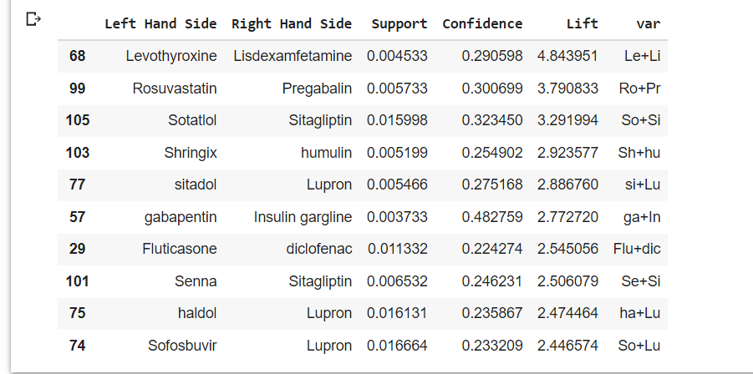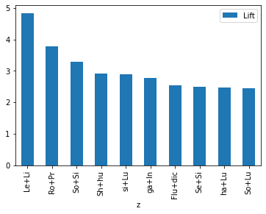

Visuals of results

**CHAPTER 5**

**CONCLUSION AND FUTURE SCOPE**

**5.1 Summary:-**

Health care is given extreme importance nowadays by each country with the advent of the novel coronavirus. Thus in this regard, an IoT-controlled healthcare monitoring system is most probably the best solution for such an epidemic. Internet of Things (IoT) is the new revolution of the internet which is a growing research field, especially in health-related services.

We have mainly focused on two objectives. The first one was a smart health monitoring system, to collect the health history of patients with a unique ID and store it in a database so that doctors need not spend much of their time in search of the report and give analysis right from the dashboard. Any health-care that is being done will be updated and reflected in the dashboard itself.

# Secondly, the medicine recommendation system will be helpful for the healthcare sector. People won’t have to face the problem of unavailable medicines, since the stores will be stocked well in advance since they can know which medicines are most likely to be bought. Moreover, the economy will be helped since the medical black market will be eliminated as medicines are readily available so there is no shortage, thus no scope of dishonest people to dupe others by profiteering from selling medicines at exorbitant rates to needy people.

However, there are a few shortcomings to this too. Basic knowledge of the operation is to be learned by the caregivers. Also, both the caregiver and the wearer should know how to protect the sensors from water damage or any physical damage. Moreover, there might not always be the medicines that have been predicted, people might need some other medicines.

**5.2 Future Scope:-**

Though the medical sector was unhurried in the first stage to adopt IoT technology compared to other sectors, the new uproar Internet of Medical Things (IoMT) proved revolutionary in today’s world. It is set to transform how to keep people healthy and safe while bearing costs in mind.

The that internet of Medical Things (IoMT) combines medical devices and applications that connect [healthcare IT systems](https://en.wikipedia.org/wiki/Health_information_technology)via different network technologies. The technology can lower needless visits to hospitals along with decreasing the load on the health care sector by interconnecting patients and physicians. Also, it makes secure transmission of medical data possible.

As per experts, the global IoT market was worth $22.5 billion in 2016 and is expected to reach $72.02 billion by 2021. Contributing greatly to the healthcare domain, the IoMT market is filled with smart devices like medical/vital monitors at home, community, clinic along with wearables while connecting real-time location, telehealth, and other services.

Some of the ways in IoT in medical services can help in upcoming time are :

* Reducing waiting time in emergency rooms
* Tracking of patients, inventory, and staff
* Augmenting drug management techniques
* Ensuring the provision of essential hardware
* Converting data into activities

The main motive behind this model is to ensure that the common people get the best possible variant of the medicines available in the market at all points of time.

This model will just recommend the best associated combination of medicines that go along with each other in a certain manner based on the previous sales of those medicines. Thus it thereby allows the optimal transaction to happen between the patient and the chemist shop.

On the flip side , it also allows the chemist to update his/her stocks to its full potential at any given point in time so that the patient can get the best possible variants of the medicines , whenever he/she has a necessity of it .

The future scope of this apriori based machine learning recommendation model is that it will allow low infrastructural casualties in a healthcare center as it will always ensure that the best possible medicine or other health equipment are available at all times of the year . This will boost the lack of technical and managerial policies that are lacking today in different healthcare centres across India .

This model can be further integrated with UI/UX apps which will allow a patient and his/her family to get a clear visual understanding of the current status of the different healthcare facilities that are available at a healthcare center in some developed areas without even travelling long distances in search of a preferable diagnostic centre for the patient .

This approach will save many lives and thereby contribute to a better policy making attitude for the common people .

**(IOMT) benefits include :**

**REDUCTION IN ERRORS:**

The data created by connected devices aids in the making of effective and precise decisions, as well as ensuring smooth operations with reduced costs and waste.

**FASTER DIAGNOSIS:** Due to continuous monitoring and real-time tracking of patient data, doctors can diagnose/detect disease at an early stage for effective treatment.

**COST-EFFICIENT:** Doctors may monitor patients in real time by using IoT devices. As a result, this procedure can assist patients in reducing needless doctor visits and hospital stays.

**REMOTE MEDICAL ASSISTANCE:** It is very hard for lone patients in a medical emergency to call a doctor who is far away. This is made simple by IoT applications in healthcare and other relevant equipment. Furthermore, medical staff can do on-the-spot checks on patients.

**ALERTS AND TRACKING:** Timely alerts are critical in life-threatening situations. In these instances, IoMT devices and programmes may capture important data and deliver it to medical staff for real-time tracking. These devices can also provide real-time information on a patient's condition, independent of their location or time.

**REMOTE REPORTING AND MONITORING:** Doctors and physicians can better monitor their patients' health via connected gadgets. In an emergency, such as diabetic episodes, asthma attacks, or heart failure, real-time monitoring can save lives. The collecting of medical and other relevant health data is not difficult with the use of a smart medical gadget connected to a smartphone app. An authorised individual, such as a doctor, insurance company, participating health firm, or external consultant, may readily access and use data collected from these devices, regardless of their location, time, or device.

As per the latest innovations and requirements in medical technologies, we must form an organized network of smart devices that would collect, sync, and manage huge amounts of data effectively and cost-efficiently.

In the IoT future, the scope of automation in health industries is regarded as one of the most revolutionary schemes ever deployed in healthcare. We look forward to this upcoming boost in the infrastructure of the healthcare structure to build a greater nation.

This project has the scope to be expanded in the upcoming semester. Further features and work can be done on this topic.

**5.3 Cost Analysis-**

|  |  |
| --- | --- |
| **Equipment** | **Cost** |
| MLX 90614 Temperature Sensor. | Rs. 1299 |
| MAX 30102 Pulse Rate Sensor. | Rs. 699 |
| Machine learning - software work | Rs. 333 |
| NodeMCU ESP8266 Wi-Fi development board | Rs. 450 |
| Jumper wires | Rs. 199 |
| Total | Rs. 2700 |

**CHAPTER 6**

**PLANNING & REFERENCES**

**6.1 Planning and project management**

|  |  |  |  |
| --- | --- | --- | --- |
| **S.No.** | **Activity** | **Starting Week** | **Number of Weeks** |
| 1. | Literature Review | 1st-2nd week of Dec | 2 |
| 2. | Required software setup, coding,calibration | 3rd week of  Dec | 1 |
| 3. | Code Integration & Debugging | 1st week of Jan | 1 |
| 4. | Inclusion of ECLAT model | 2nd week of Jan | 1 |
| 5. | Medicine overview along with a basic understanding of python and data manipulation and preprocessing | 3rd week of  Jan | 1 |
| 6. | Preparing the model(train) | 4th week of Jan | 2 |
| 7. | Fitting model | 2nd week of Feb | 1 |
| 8. | Checking model | 3rd week of Feb | 1 |
| 9. | Analysis after training the model | 4th week of Mar | 2 |
| 10. | Metrics evaluation | 2nd week of Mar | 1 |
| 11. | Preparation of project report | 3rd week of  Mar | 2 |
| 12. | Preparation of Project presentation | 1st week of Apr | 1 |

**The Gantt Chart is shown below:-**

Total weeks

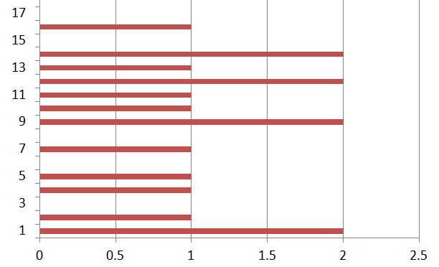 Fig 6.2 No.of indiv. weeks

**6.2 REFERENCES –**

[11]. P. S. Mung and S. Phyu. Effective analytics on healthcare big data using ensemble learning. In 2020 IEEE Conference on Computer Applications(ICCA), pages 1–4, 2020.

##### [12]. Samer Ellahham, Artificial intelligence in the diagnosis and management of COVID-19: a narrative review, *Journal of Medical Artificial Intelligence*,2021

[13]. Dave DeCaprio, Joseph Gartner, Carol J. McCall, Thadeus Burgess, Kristian Garcia, Sarthak Kothari, Shaayaan Sayed, Building a COVID-19 vulnerability index, *Journal of Medical Artificial Intelligence*,2020

[14]. Pahulpreet Singh Kohli and Shriya Arora. Application of machine learning in disease prediction. In 2018 4th International Conference on Computing Communication and Automation (ICCCA), pages 1–4. IEEE, 2018.

[15]. Munira Ferdous, Jui Debnath and Narayan Ranjan Chakraborty, Machine Learning Algorithms in Healthcare: A Literature Survey, In, that on 2020 11th International Conference on Computing, Communication, and Networking Technologies (ICCCNT)

[16]. Shweta Ganiger and KMM Rajashekharaiah. Chronic diseases diagnosis using machine learning. In 2018 International Conference on Circuits and Systems in Digital Enterprise Technology (ICCSDET), pages 1–6. IEEE, 2018.

[17]. Dharavath Ramesh, Pranshu Suraj, and Lokendra Saini. Big data analytics in healthcare: A survey approach. In 2016 International Conference on Microelectronics, Computing and Communications (MicroCom), pages 1–6. IEEE, 2016

[18]. Kumar SP, Samson VRR, Sai UB, Rao PLSDM, Eswar KK. Smart health monitoring system of patient through IoT. In: 2017 International conference on I-SMAC (IoT in social, mobile, analytics and cloud) (I-SMAC). IEEE; 2017. p. 551–6.

[19]. Trivedi S, Cheeran AN. Android based health parameter monitoring. In: *2017 International conference on intelligent computing and control systems (ICICCS).* IEEE; 2017. p. 1145–9

[20]. Acharya AD, Patil SN. IoT based health care monitoring kit. In: 2020 Fourth international conference on computing methodologies and communication (ICCMC). IEEE; 2020. p. 363–8.

[21]. Geron, “Hands-On Machine Learning with Scikit-Learn, Keras, and TensorFlow”, O’Reilly Media, Inc., Canada, 2019

**SELF DECLARATION FOR PLAGIARISM CHECK**

We, Souvik Karmakar(1807228), Sudeshna Datta(1807232),Indrashis Mitra(1807274), Kinjal Sarkar(1807277) and Pratyay Basu(1807291) are declaring that our Project report on “ADVANCED **HEALTHCARE MONITORING AND RECOMMENDATION SYSTEM**” has plagiarism well within the limits prescribed to us. We take full responsibility for it.