**IoMT based Smart Health Monitoring: The Future of HealthCare**

Indrashis Mitra, Yashi Srivastava, Kananbala Ray, Tejaswini Kar

1807274@kiit.ac.in,1828220@kiit.ac.in, [kbrayfet@kiit.ac.in](mailto:kbrayfet@kiit.ac.in), [tkarfet@kiit.ac.in](mailto:tkarfet@kiit.ac.in)

School of Electronics Engineering, KIIT Deemed to be University, Bhubaneswar

***Abstract -*** The healthcare sector has received an immense boost in terms of science, technology, and services in the recent past. The next big change that is to skyrocket this field in terms of quality, efficiency, and quantity is the introduction of "automation" in these sectors. With the assistance of IoT, the target is a large part of the population that will get the diagnosis readily available at cheaper rates even in the absence of a medical professional. In this work, the heartbeat and the temperature sensor collect the data from the patient and send it to the cloud via a Wi-Fi module, which then displays information remotely, which can ensure care of the patient within the crucial golden hour. In this process, patients themselves can also monitor their health parameters while sitting at home, thus increasing the efficiency of the healthcare sector. Moreover, if the patient falls, then the designed fall detection system sends an alert to the caregiver for further processing. By implementing this technology in the near future, people can effectively reduce the hassles they have to face and thus not only unlock, but also boost the true potential of the healthcare system.

***Keywords***: Temperature Sensor, IoT, Android, Microcontroller, ESP8266 Wi-Fi Module, IFTTT,Blynk

1. **Introduction**

The worldwide population of elderly people is expected to more than quadruple over the next three decades, reaching 1.5 billion in 2050. In this scenario, there is an epidemiological and demographic shift that is affecting the health state of the entire population. In this scenario, the Internet of Things (IoT) plays an important role, which ensures remote monitoring of the elderly patients during crucial times. The IoT is a notion that encompasses anybody, at any time, in any location, with any service, on any network. It is a megatrend in next-generation technologies that has the potential to influence the whole business continuum. It may be defined as the connectivity of uniquely identified smart items and devices inside today's internet infrastructure, with additional benefits. Readers can further refer to [1] [2] [3] [4] for a deeper, more vivid understanding of IoT. In the present era, IoT-based smart monitoring techniques for health conditions are gaining popularity. The IoT-based smart health monitoring framework is a new paradigm in the healthcare industry towards better medical care administration for individuals [5]. Currently, hospitals and medical care organisations are transforming from a customary way to a modernised patient-focused methodology. Conventionally, specialists are required during medical emergencies for physical examination of patients. Likewise, the real-time readings provide the professionals with necessary data that can be used to guide and monitor a patient's health on a regular basis [6]. The Internet of Things (IoT) has turned into one of the most influential communication paradigms of the 21st century. In the IoT environment, all items in our everyday life become portions of the online web because of their correspondence and processing capacities. Through prompt detection, continuous fitness monitoring can save up to 60% of human lives and aid in real-time monitoring of patients' health indicators[7]. Heart rate is one of the fundamental physiological cut-off points, essential for observing and providing the conclusion of each patient, thereby assisting in the maintenance of good health.[8]. To keep people motivated and healthy, a quick and open modern medical care framework is increasingly important, and it turns out to be more effective in saving money and decreasing sickness.In this work, an upgraded medical care observing framework is portrayed, which is an advanced mobile phone-based system and is intended to offer remote methodology and social help to members. IoT, by and large, has arisen as a popular answer for many day-to-day issues. In clinic units like ICUs, CCUs require broad consideration of patients having critical conditions and continuous administration of specialists along with attendants, which isn't generally conceivable because of the enormous number of patients[9]. With an improvement in innovation and the scaling down of sensors, there have been endeavours to implement innovation in different areas to enhance mankind. Developments have made it easier to distinguish between daily life actions and accidents, thus helping in delivering timely assistance to the needy[10]. One principal zone of exploration is the medical services area. Subsequently, this venture is an endeavour to tackle the medical services issue that is prevalent currently[11]. The fundamental goal of the undertaking was to plan a distant medical care framework. It is divided into three main sections. The first phase involved using sensors to locate the patient's vitals; the second involved sending information to a bluetooth-connected android app on a mobile phone and displaying data on a dashboard; and the third involved transmitting the recognised data to faraway individuals.

Table 1: Description of the Sensors.

| Sl. No. | Sensor | Features |
| --- | --- | --- |
| 1. | MLX 90614 | Touchless InfraRed Digital Temperature Sensor  Range : -70° C to 382 °C  Voltage ranges of 3-5V  Dimensions: 11mm × 17mm  SMbus compatible interface |
| 2. | MAX 30102 | Integrated heart rate monitor and pulse oximeter biosensor  Power : 1.8 V ; 5.0V supply for internal LEDs  Dimensions : 20.3 × 15.2 mm  Weight : 1.1g  I2C compatible communication interface  LED peak-to-peak wavelength: 660nm/880nm  LED power supply voltage: 3.3~5V  Detection signal type: light reflection signal (PPG)  Output signal interface: I2C communication interface  Voltage: 1.8~3.3V~5V (optional)  Board reserved assembly hole size: 0.5 x 8.5mm  Main power input terminal : 1.8 - 5 V 3-bit pad |
| 3. | MPU 6050 | [3-axis gyroscope](https://robu.in/product-tag/gyro/) and a 3-axis [accelerometer](https://robu.in/product-tag/accelerator/)  I2C Interfacing : 2 Aux pins  Resistor : 4.7K (pull-up), 4.7K (pull-down)  Data propagation : I2C bus  Voltage change detector : 16-bit ADC |

1. **Related work and Findings**

Many articles can be found in the literature in the field of smart health monitoring. Tamilselvi et al. [7] built a health monitoring system that can track fundamental symptoms of a patient such as heart rate, oxygen saturation percentage, body temperature, and eye movement. Heartbeat, SpO2, temperature and eye blink sensors were employed as capturing components, while an Arduino-UNO was used as a processing device. Although the designed system was deployed, no specific performance measurements for any patient were given. Trivedi et al. [8] proposed a mobile device-controlled Arduino-based health parameter monitoring system. The analogue sensor data was captured and delivered to the Arduino Uno board. The captured analogue values are transformed into digital data via the inbuilt analogue to digital converter. The physical properties were transferred to the designed gadget through Bluetooth. The Bluetooth gadget made use of a module that didn't cover a large region. In an IoT setting, Acharya et al. [9] presented a healthcare monitoring kit. Heartbeat, ECG, body temperature, and respiration were among the fundamental health metrics tracked by the designed system. The main hardware components employed here are the pulse sensor, temperature sensor, blood pressure sensor, ECG sensor, and Raspberry Pi. Sensor data was captured and forwarded to a Raspberry Pi for processing before being sent back to the IoT network. The system's main flaw is that no data visualisation interfaces have been created. Bourke [10] used two tri-axial accelerometers on the trunk and thigh to derive four thresholds, upper and lower thresholds for the trunk and thigh, respectively. A decline would happen if any of the four thresholds were exceeded. The difficulty with this strategy is that other ADLs, such as fast sitting down and leaping, also involve significant vertical acceleration. As a result, relying just on acceleration to identify falls leads to a high number of false positives.

It is observed from the literature review that most of the works include a set of sensors for monitoring health parameters and displaying them on a webpage. But that has its own set of challenges, like the webpage might not be calibrated for display on any screen size, like that of laptops and mobile phones. Or the sensors measuring the parameters might take up a lot of space and lead to a cumbersome, uncomfortable device that has to be worn by the patient. Therefore, in our proposal, we presented a less bulky display that is also easier to grasp than what is presented in [5]. Overall, the ideation is similar to what is presented in [6], but it vastly improves upon the presentation by enabling a seamless transition between laptop as well as mobile screens. The dashboard and mobile connectors are new features that allow sharing patient data with others who are far away in a simple and painless way.

1. **Proposed Model and Approach**

i. Objective of the work

The most important idea behind this project is to design, develop, and implement a smart patient healthcare monitoring system. The sensors used here are embedded in the body of the patient to sense parameters like heartbeat and temperature. These sensors are connected to a master unit that calculates all the values. These values are then transmitted by leveraging IoT cloud technology to the base. From the base station, these can be easily accessed by the doctor present at some other location. Thus, based on the temperature and heartbeat values that the doctor can easily refer to, using web as well as phone applications, the physician can determine the state of the patient and necessary measures can be taken. Furthermore, the methodology also includes a system to detect if an aged patient falls down and alert the caregivers so that they can receive immediate help.

ii. System approach

The complete system for monitoring the required parameters is shown in Fig. 1. The first step for the functioning of the system is to initialise the sensors for the collection of data for monitoring. The patient data,i.e. temperature and blood pressure are then read and compared with predetermined values. If the values are found to violate them, then the data is sent and respective people are alerted through the buzzer sound. The doctor receives this data and can take necessary action, thus not wasting the golden hour,which is vital for the patient’s immediate care.

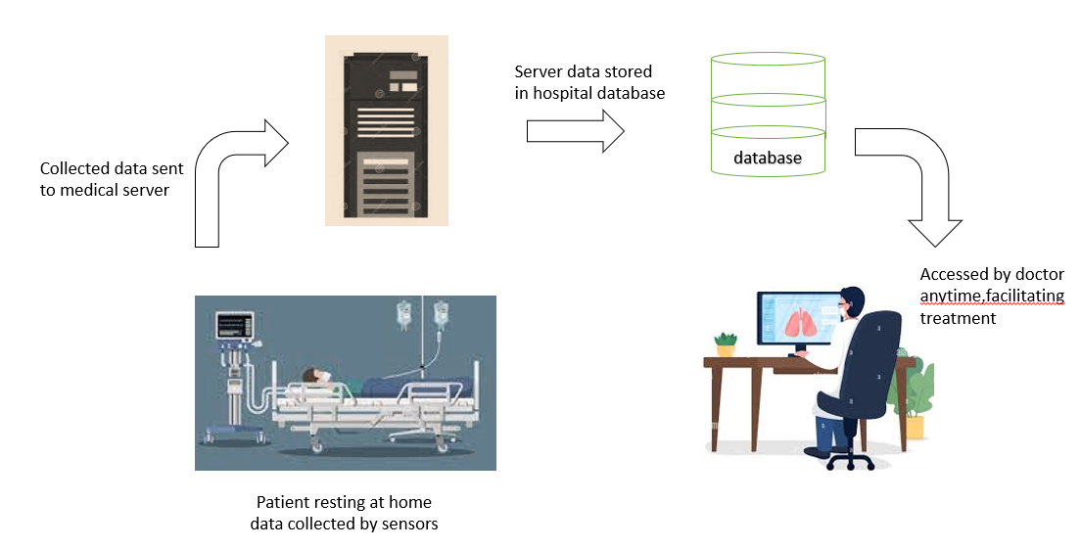

Fig 1 : Patient monitoring workflow

The second part of the project is the fall detection mechanism which is based on classical physics. The reasons behind choosing the Cartesian coordinate system are -

(i)Gravity is always perpendicular to the ground and

(ii)If a vest is worn on the body, then the orientation of the vest and trunk are always the same. The origin is assumed to be near the neck, aligned to the geodetic system.

At any given time t, acceleration along the 3 axes are denoted as Ax(t), Ay(t) and Az(t) separately, namely A(t) = {Ax(t), Ay(t), Az(t)}. The resulting acceleration α(t) can be found out using equation (i)

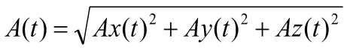 (i)

The gravitational components are essentially an approximation. The trunk angle θ(t) can be calculated using Equation (ii):

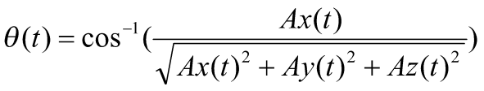 (ii)

iii. Data Acquisition

A sensor board, measuring 65 mm × 40 mm × 7 mm , is appropriate for use in a vest. It has a class 2 Bluetooth module and a low power microcontroller. The default transmission rate of the module is 1,15,200 bps with the maximum range being 10m. The tri-axial accelerometer can measure upto ±16 g with full-scale reading of the gyroscope being ±2000°/s. The sampled data from both of these are acquired and transmitted to a smartphone.

Human activities tend to occur at frequencies less than 20 Hz, hence the sampling frequency of human activities can be set at 100 Hz. The board can acquire tri-axial accelerations and angular velocity, which can be relayed directly to a smartphone.

As falls are distinguished by great angular velocity and rapid acceleration, hence 4 subcategories of activities of daily living(ADLs) and 2 types of falls are proposed so that the difference between ADLs and falls can be found out. ADLs include Sitting (Sd), Squatting down (Sq),Walking (Wk), and Bowing (Bw). Falls include Backward fall (Bw-Fall) and Sideward fall (Sw-Fall) .

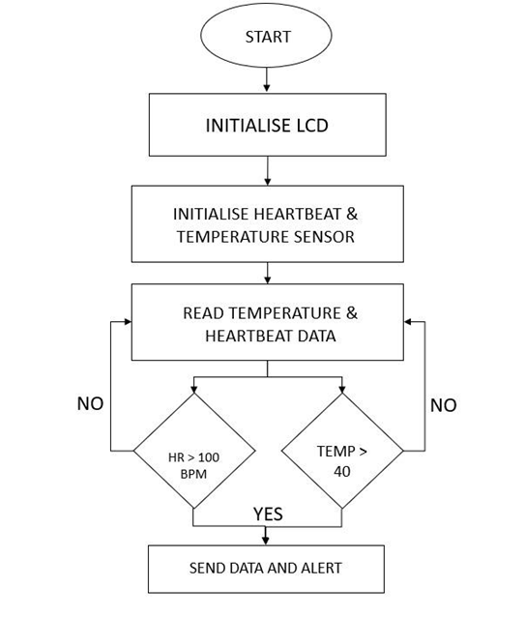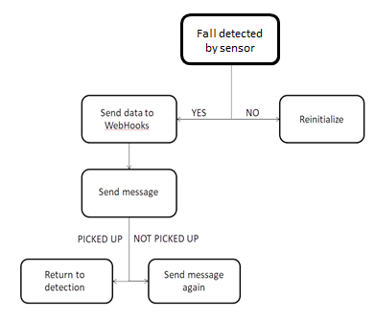

Figure 2 (a) : Flow diagram of metrics monitoring, (b) : Fall detection flow chart

Fig. 2 illustrates an overview of the complete algorithm. Fig. 2(a) indicates the first part of the work i.e. patient metric monitoring and the Fig. 2(b) indicates the fall detection workflow.

iv. IFTTT Integration

IFTTT (**If This Then That**) is an Internet service through which sequences of conditional statements, called applets, can be created. Using these applets, emails can be exchanged, music played, messages exchanged, notifications received and sent, etc. The information exchange is facilitated in real time through Webhooks. This is a godsend since it alerts the caregivers about the condition of the elderly and makes it easier for them to take prompt action. This is achieved by using IFTTT to send SMS notifications to the mobile phone when a fall is detected.

After setting up the desired connection and step-by-step execution of the instructions, the results can be displayed on the mobile interface. The complete experimental set up and the display of the output message in response to a sample fall detection on the mobile interface are depicted in Fig. 3.

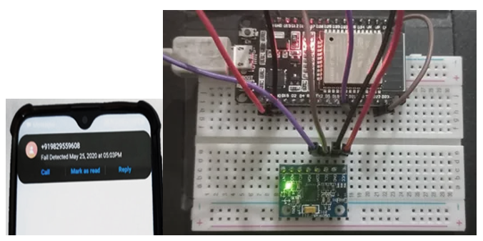

Figure 3 : Notifications from MPU6050 via IFTTT integration displayed on cellphone

The parameters that are being monitored by the sensors are checked via a website that will display the sensor data in a graphical way for better understanding and to keep check on the threshold limits of the parameters.

v. IoT - Dashboard

Dashboards are a means to visualise data, giving all users the ability to understand the analytics essential for their business or project. Generic users can use this to participate in and understand the analytics through data compilation and see trends. The plan is to make a web-based dashboard for effective and easy monitoring and understanding of the various health parameters of the patient, such as blood pressure and temperature, as shown in Fig. 1.

Thinger.io is a free, cloud IoT Platform that helps to prototype, scale and manage connected products in an easy way. The aim is to regularise IoT usage, thereby making it reachable to the whole world, and modernising the evolution of big IoT projects. It has a connected platform that expedites communication between devices,software architecture and various data toolkits, plugins and integrations to manage and work with generated information. The complete connectivity structure of the thinger.io platform is given in Fig.5.

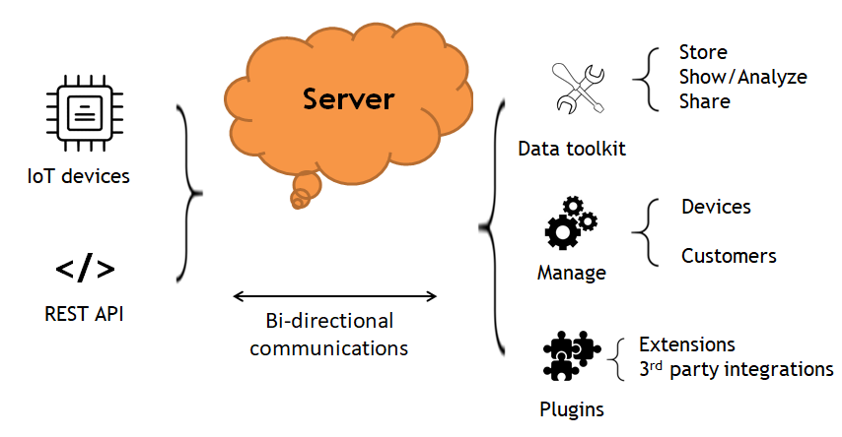

Figure 5 : Connectivity of thinger.io platform

The Thinger.io dashboard system is a property that lets us design data presentation interfaces easily. While eliminating the need for coding, it is made in such a way that various elements from an inventory can be selected. Moreover, using point-click methodology, the entire layout can be configured. Using the configuration forms, it is possible to set the sampling interval, data sources, and other characteristics for each widget.

Normal website coding (using HTML, CSS, and JS) could have been used to design a website for displaying the parameters. But since it was open source, easy to use, and most importantly, it was convenient to create simple, attractive dashboards using this platform, the choice was obvious. Moreover, the array of devices supported by thinger.io is humongous. So, a wide variety of devices can be easily integrated into the project, irrespective of the manufacturers or properties.

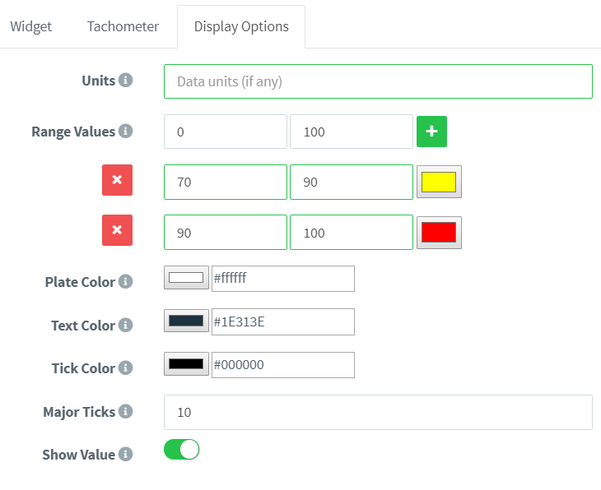

Figure 6 : Illustration of widget selection

Fig. 6 is an illustration of defined widgets and how they can be configured for displaying customised results, such as colour, text type, units, etc. It is possible to share dashboards with others through a hyperlink. To analyse data from different devices of the same type, dashboards can be configured using appropriate templates.

The following is a description of various widgets and their parameters:

*Time-series chart*: A time-series chart shows how values change over time.It is convenient to display time-series data. A single variable as well as multiple values can be depicted in the same chart.

*A Donut chart:* is a graph that can show a value, rounded to the nearest percent. It is highly useful for a variable fluctuating between the largest and the smallest value. In such a scenario, it is appropriate to represent a single variable whilst updating it in real-time from a data bucket or a gadget.

*Text/Value:* is a convenient widget to show random data, especially text that is unfit for representation with other widgets. It can display data from connected devices as well as data buckets.

*Clock*-can display the present time in the local time zone or in UTC. It is quite handy when processes are being monitored in real-time.

The Dashboard Tab is an extra page that helps to simplify navigation between interlinked consoles and helps to arrange the data visualisation. Each tab might have varying widgets and data sources, but all the tabs have the same configuration settings (widget border-radius, column index, etc).

There is also the benefit of keeping all unused tabs open so that no real-time data is lost when switching tabs.

vi. IoT - Blynk

The parameters that are being monitored by the different sensors are visualised remotely on smartphones via the Blynk app, which has a back-end server that provides data on request and is supported by a wide array of libraries integrating various features such as different connections, no laptop needed, etc. The entire organisation of the Blynk app is demonstrated in Fig. 7. Thus, a quality GUI experience can be provided to the customers, i.e., the relatives and family members of the patient. By using the Blynk app, anyone, who is shared with the QR code can download the app and it will contain the required project for metrics monitoring. This approach will reduce the amount of panic within family members and will provide a suitable environment and time duration for the best possible outcome.

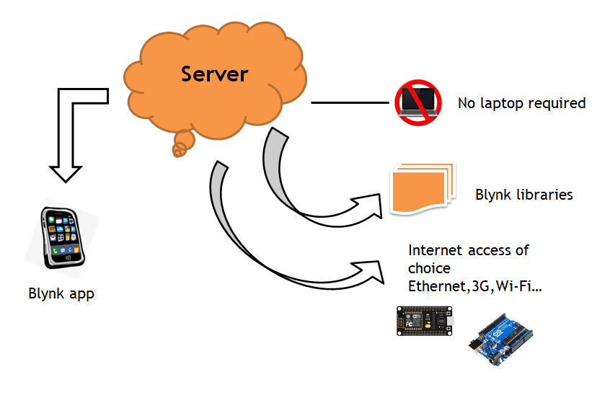

Figure 7 : Organization of Blynk cloud

Blynk helps to plot the graphical representation of data that will be given by the sensors that are being used. It uses a virtual **pin** concept through which data can be pushed from the nodemcu to the blynk **mobile app widgets** and also get the data from the widgets to the Node MCU via the ESP8266 Wi-Fi module present. **Blynk Inc.'s Virtual Pin** is a feature incorporated by Blynk Inc. that facilitates data exchange between hardware and the Blynk mobile app.

Sample layout illustrations of the Blynk app are shown in Fig. 8.

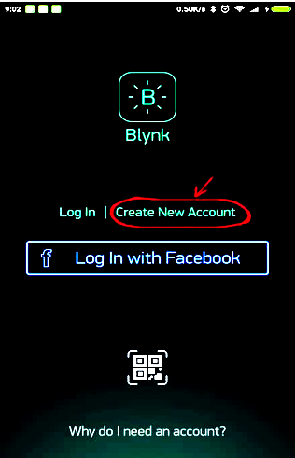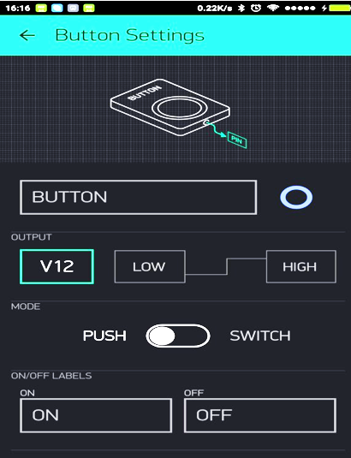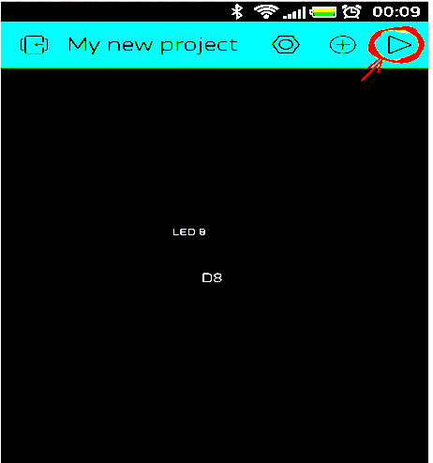

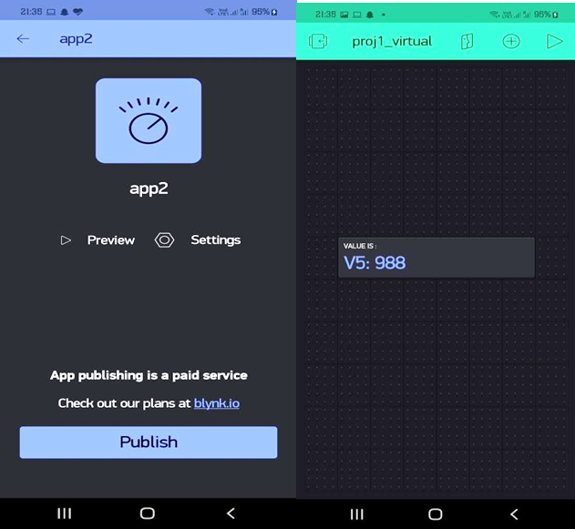

Figure 8 : Blynk MyApp layout

1. **Conclusions**

This chapter described a system to effectively use technology for the benefit of the healthcare domain. The entire focus was mainly on two objectives. The first one was a smart health monitoring system, to collect the health history of patients with a unique ID and store it in a database so that doctors did not need to spend much time in search of the report and give analysis right from the dashboard. Any health care that is being done will be updated and reflected in the dashboard itself. The latter is the Wearable-Sensor-Based Fall Detection System for aged people, to keep track of their movements and identify falls by analysing deviations in readings from daily activities, automatically sending a request or an alert for help to the caregivers so that they can pick up the patient. In today's mobile-connected world, it's more convenient to receive notifications on the phone itself rather than through a web-based site, which is exactly what this did. Furthermore, with the vivid, crystal-clear display, the combination of the Blynk app platform and the thinger.io dashboard feature makes it simple for a lay person to grasp the variations in patient data. The features of the dashboard allow presentation of the data using various charts that are instrumental in conveying and displaying the results over a period of time, thus helping the doctors to understand how the health parameters are fluctuating and make effective decisions for the patient’s treatment. Exploratory work based on WSN is the initial IoT-based healthcare research effort. [11]This is an expansion of the existing work that has already been carried out.

However, there are a few shortcomings to this too. A basic knowledge of the operation is to be learnt by the care givers. More sensors can be connected to collect more information. Also, both the caregiver and the wearer should know how to protect the sensors from water damage or other physical damage.

Though the medical sector was unhurried in the first stage of adopting IoT technology as compared to other sectors, the new uproar in the Internet of Medical Things (IoMT) proved to be revolutionary in today’s world. It is set to transform how we keep people healthy and safe, while bearing costs in mind. The Internet of Medical Things (IoMT) is an amalgamation of applications and medical devices that connect Medicare IT systems via different network technologies. The technology can reduce needless hospital visits along with decreasing the load on the health care sector by interconnecting patients and physicians. The suggested project is reasonable and is market-based. With easily available, secure data at their fingertips, it is possible for the healthcare sector to take huge strides towards progress and development for the betterment of humanity. Thus, it can be deduced that this will have a huge impact on the available healthcare scene.

1. **References**

[1]. J. Höller, V. Tsiatsis, C. Mulligan, S. Karnouskos, S. Avesand and D. Boyle, From Machine-to-Machine to the Internet of Things: Introduction to a New Age of Intelligence, Amsterdam, The Netherlands:Elsevier, 2014.

[2]. G. Kortuem, F. Kawsar, D. Fitton and V. Sundramoorthy, "Smart objects as building blocks for the Internet of Things", *IEEE Internet Comput.*, vol. 14, pp. 44-51, Jan./Feb. 2010.

[3]. K. Romer, B. Ostermaier, F. Mattern, M. Fahrmair and W. Kellerer, "Real-time search for real-world entities: A survey", *Proc. IEEE*, vol. 98, no. 11, pp. 1887-1902, Nov. 2010.

[4]. D. Guinard, V. Trifa and E. Wilde, "A resource oriented architecture for the Web of Things", *Proc. Internet Things (IOT)*, pp. 1-8, Nov./Dec. 2010.

[5].Md. Milon Islam, Ashikur Rahaman and Md. Rashedul Islam. 2020. Development of Smart Healthcare Monitoring System in IOT Environment *Springer Nature Singapore Pte Ltd*.

[6]. Deepak N, Rajendra Prasad C H and Sanjay Kumar Ch. 2018. Patient Health Monitoring using IOT *International Journal of Innovative Technology and Exploring Engineering* 8.

[7]. Tamilselvi V, Sribalaji S, Vigneshwaran P, Vinu P, GeethaRamani J. IoT based health monitoring system. In: 2020 6th International conference on advanced computing and communication systems (ICACCS). IEEE; 2020. p. 386–9

[8]. Trivedi S, Cheeran AN. Android based health parameter monitoring. In: *2017 International conference on intelligent computing and control systems (ICICCS).* IEEE; 2017. p. 1145–9

[9]. Acharya AD, Patil SN. IoT based health care monitoring kit. In: 2020 Fourth international conference on computing methodologies and communication (ICCMC). IEEE; 2020. p. 363–8.

[10]. A. K. Bourke, J. V. O’Brien, and G. M. Lyons. Evaluation of a threshold-based tri-axial accelerometer fall detection algorithm. Gait and Posture, 26:194–199, 2007.

[11]. Riazul Islam SM, Kwak Daehan, Humaun Kabir M, Hossain M, Kwak Kyung-Sup. The Internet of Things for health care: a comprehensive survey. *IEEE Access. 2015;3:678–708*.

[12].Li, Q.; Stankovic, J.A.; Hanson, M.A.; Barth, A.T.; Lach, J.; Zhou, G. Accurate, fast fall detection using gyroscopes and accelerometer derived posture information. In Body Sensor Networks; International Workshop on Wearable & Implantable Body Sensor Networks: Berkeley, CA, USA, 2009; pp. 138–143.

[13]. Islam M S, Islam M T, Ali F. Almutairi, GankokBeng, Amid N M N. 2019. Monitoring of the Human Body Signal through the Internet of Things (IoT) Based LoRa Wireless Network

*System Journal of Applied Sciences 9*

[14]. Prakash H Patil, Pratyush Singh, Swatee Biradar and Prasad Rane. 2013. Design and Implementation of Wireless Patient Health Monitoring System *International Journal of Engineering Research and Technology 2* (6).

[15]. He, J.; Hu, C.; Wang, X.Y. A Smart Device Enabled System for Autonomous Fall Detection and Alert. Int. J. Distrib. Sens. Netw. 2016, 12, 1–10

[16]. Desai MR, Toravi S. A smart sensor interface for smart homes and heart beat monitoring using WSN in IoT environment. *In: 2017 International conference on current trends in computer, electrical, electronics and communication (CTCEEC). IEEE; 2017. p. 74–7*

[17]. Kumar SP, Samson VRR, Sai UB, Rao PLSDM, Eswar KK. Smart health monitoring system of patient through IoT. In: 2017 International conference on I-SMAC (IoT in social, mobile, analytics and cloud) (I-SMAC). IEEE; 2017. p. 551–6.

[18]. Wang, J.; Zhang, Z.; Li, B.; Lee, S.; Sherratt, R.S. An Enhanced Fall Detection System for Elderly Person Monitoring using Consumer Home Networks. *IEEE Trans. Consum. Electron.*2014, *60*, 23–28.

[19]. Rahaman A, Islam M, Islam M, Sadi M, Nooruddin S. Developing IoT based smart health monitoring systems: a review. *Rev Intell Artif. 2019;33:435–440. doi: 10.18280/ria.330605.*

[20]. Vavoulas, G.; Pediaditis, M.; Spanakis, E.G.; Tsiknakis, M. The MobiFall dataset: An initial evaluation of fall detection algorithms using smartphones. In Proceedings of the IEEE 13th International Conference on Bioinformatics and Bioengineering, Chania, Greece, 10–13 November 2013; pp. 1–4.

[21]. F. Bianchi, S. J. Redmond, M. R. Narayanan, S. Cerutti, and N. H. Lovell, “Barometric pressure and triaxial accelerometry-based falls event detection,” IEEE Transactions on Neural Systems and Rehabilitation Engineering, vol. 18, no. 6, pp. 619–627, 2010

[22]. Becker, C.; Schwickert, L.; Mellone, S.; Bagalà, F.; Chiari, L.; Helbostad, J.L.; Zijlstra, W.; Aminian, K.; Bourke, A.; Todd, C.; et al. Proposal for a multiphase fall model based on real-world fall recordings with body-fixed sensors. In *Zeitschrift Für Gerontologie Und Geriatrie; Springer International Publishing: Berlin, Germany*, 2012; pp. 707–715.

[23]. R.Kumar,M.Rajakesan; An IoT based patient monitoring system using raspberry Pi,*In* : *2016International Conference on Computing Technologies and Intelligent Data Engineering(ICCTIDE’16)*

[24]. D.Mehta,S.Feng,R.Hillman,H.Cheyne and M.Zanartu,Mobile Voice Health Monitoring Using A Wearable Accelerometer Sensor and a Smartphone Platform ;  IEEE Transactions on Biomedical Engineering,2012

[25]. S. D. Bersch, C. M. J. Chislett, D. Azzi, R. Kusainov, and J. S. Briggs, “Activity detection using frequency analysis and off the-shelf devices: fall detection from accelerometer data,” in Proceedings of the 5th International Conference on Pervasive Computing Technologies for Healthcare and Workshops (PervasiveHealth ’11), pp. 362–365, Dublin, Ireland, May 2011.