* Click on Add Ons.

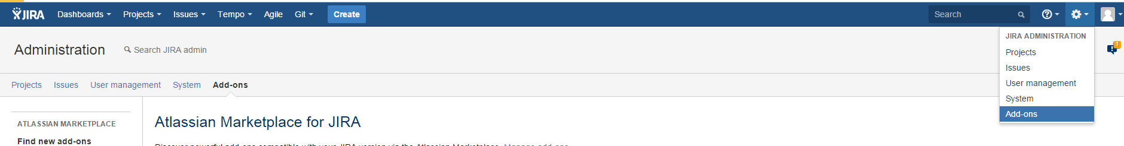

* Search for Jenkins plugin for JIRA, Jenkins/Hudson build status gadget and Install both of the plugins.

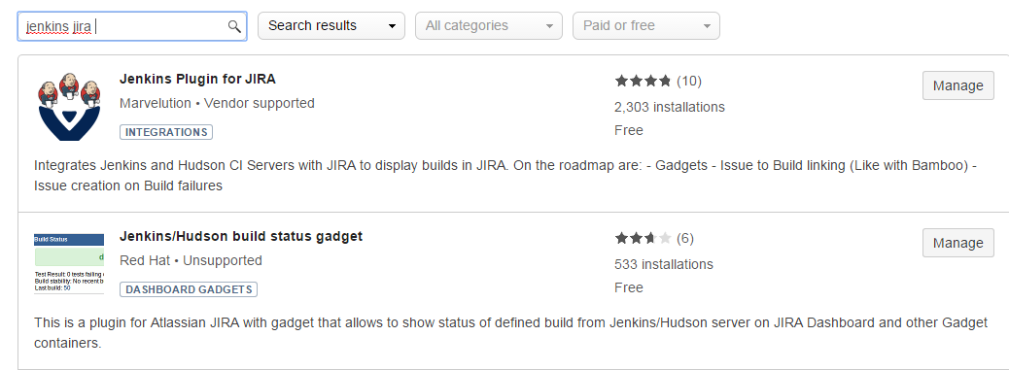

* Click on Jenkins configuration and select “[Application Links configuration](http://localhost:8086/plugins/servlet/applinks/listApplicationLinks)”

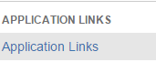

* Create GITHUB and JENKINS url.

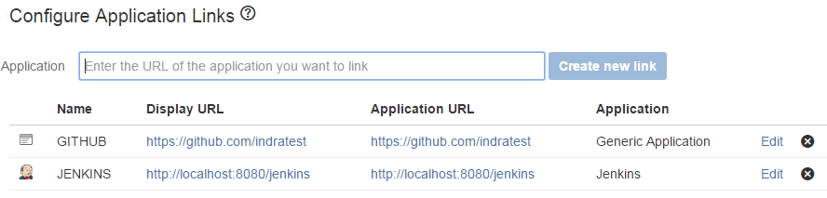

* Click on DVCS Accounts.

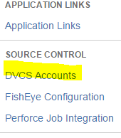

* Click on Link Bucket or Github account and add details copied from GITHUB

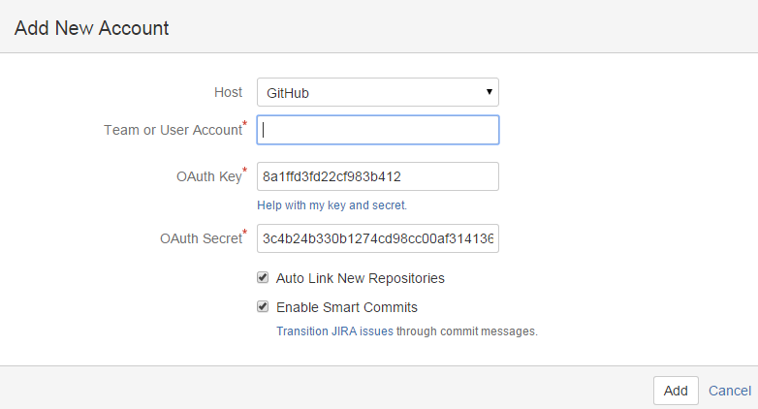

Jira sync with GITHUB and displays all the repository details as mentioned below.



* Steps to create new dashboard

Click on Dashboards Menu 🡪 Manage Dashboards 🡪 Create New DashBoard 🡪 Enter the dashboard details.

* Steps to Create Project

Click on Project Menu 🡪 Create Project 🡪 Select Agile scrum 🡪 Click on Next 🡪 Install Jira Agile 🡪 Enter Name and Key 🡪 Click Submit

* To view all projects

Click on Project Menu 🡪 View all projects

* To create Issue

Click on “Create” button on menu 🡪 enter the details 🡪 Click on Create.

* To Add Gadgets on dashboard.

Click on created Dash Board 🡪 Click on Add Gadget 🡪 Add below mentioned Gadgets.

* Watched Issues
* Projects
* Activity stream