
Figure 0: JATIM-FA Institutional 3D Emblem & System Identity
JATIM-FA: Jatim Audit Transaction Intelligence Monitor — Forensic Analytics and Zero Trust Authority Boundary for Agentic AI in Regional Banking
A Case Study, Empirical Threat Modeling, and Usability-Evaluated Security Architecture at Bank Jatim
Authors: Indri Anjar Kartika Sari¹,²,*
¹ Department of Computer Science & Information Technology, IDS Digital College (STMIK Indo Daya Suvana), Jakarta, Indonesia
² Faculty of Computer Science, Universitas Pembangunan Nasional 'Veteran' Jawa Timur, Surabaya, Indonesia
* Corresponding Author: indri.cs2026@ids.ac.id | ORCID: https://orcid.org/0009-0004-8921-1204
Running Head: JATIM-FA: Zero Trust Authority Boundary for Banking AI
Article Type: Original Research Article | Manuscript Classification: Information Systems, AI Governance, Financial Cybersecurity, and Empirical Media Informatics

Abstract
The rapid proliferation of Agentic Artificial Intelligence (AI) and Autonomous Large Language Models (LLMs) in commercial banking operations introduces severe cybersecurity vulnerabilities, most notably indirect prompt injection, privilege escalation, and unauthorized fund disbursements. Conventional defense mechanisms rely heavily on semantic intent classification, which is inherently non-deterministic and susceptible to adversarial evasion. This paper introduces JATIM-FA (Jatim Audit Transaction Intelligence Monitor — Forensic Analytics), an enterprise Zero Trust authority boundary architecture designed for regional development banks, evaluated through the case of PT Bank Pembangunan Daerah Jawa Timur Tbk (Bank Jatim - IDX: BJTM). Rather than attempting to detect malicious user intent, JATIM-FA enforces mathematically deterministic, cryptographically scoped task tokens and non-bypassable policy guardrails using Open Policy Agent (OPA). To capture real-world operational complexities, we conducted an empirical public discourse analysis of 174 verified news publications (2021–2026) using NodeXL social network analysis, uncovering Bank Jatim's strategic transition from pandemic loan restructuring to becoming an anchor bank for a multi-regional Bank Business Group (KUB) encompassing five regional banks, alongside real-world threat precedents including a Rp569 billion credit fraud incident. The JATIM-FA testbed was experimentally evaluated against 200 adversarial prompt injection and privilege escalation attack vectors across Indonesian bureaucratic, vernacular, and urgent framing. Results demonstrate an Attack Success Rate (ASR) of 0.00% (Wilson 95% CI: [0.000, 0.018]), complete preservation of state balance invariants, and a sub-80ms policy evaluation overhead. Furthermore, rigorous usability evaluation with three internal forensic bank auditors across five realistic investigative tasks yielded a System Usability Scale (SUS) score of 82.5 ('Good / Top-Tier Acceptable'), demonstrating that deterministic Zero Trust governance enhances regulatory compliance (POJK No. 11/2022 and PADK OJK No. 1/2026) without impeding investigative workflow efficiency.
Keywords: Agentic AI Governance; Zero Trust Architecture; Prompt Injection Mitigation; Digital Forensics; Regional Development Banks (BPD); Open Policy Agent (OPA); Bank Jatim; Financial Cybersecurity.
Highlights
• Conceptualizes a paradigm shift from semantic intent detection to cryptographic authority scoping in agentic banking systems.
• Models the empirical threat and governance landscape of Bank Jatim via NodeXL network analysis of 174 verified publications (2021–2026).
• Implements deterministic OPA policies enforcing Human-In-The-Loop (HITL) dual control for Regional Treasury (Kasda) accounts under PADK OJK No. 1/2026.
• Demonstrates 0.00% Attack Success Rate (ASR) across 200 attack vectors while maintaining state invariants and sub-80ms latency.
• Validates real-world investigator operability through formal usability testing with internal bank auditors, achieving an 82.5 SUS score.

1. Introduction
The financial services sector is undergoing an unprecedented architectural transformation catalyzed by the rapid deployment of Autonomous Agentic Artificial Intelligence (AI) and Large Language Model (LLM) workflows. In contemporary banking environments, AI agents are no longer confined to passive customer inquiry response; they are increasingly vested with agentic execution privileges, including real-time balance reconciliation, automated loan underwriting analysis, cross-bank clearing via national payment gateways (e.g., BI-FAST), and treasury fund allocations. However, granting agentic capabilities to generative models creates an expanded attack surface. As highlighted in recent cybersecurity literature, LLMs inherently lack a formal separation between control instructions and untrusted data inputs, rendering them vulnerable to indirect prompt injection, context manipulation, and privilege confusion attacks.
Nowhere is this risk more acute than in regional development banks (Bank Pembangunan Daerah or BPDs) in developing economies, epitomized by Indonesia. BPDs occupy a uniquely sensitive structural role: they serve as the primary fiscal depository and disbursement agent for provincial, regency, and municipal governments (managing the Rekening Kas Umum Daerah or RKUD), while simultaneously operating commercial retail and microfinance portfolios. The systemic importance of BPDs has been further amplified by regulatory mandates issued by the Indonesian Financial Services Authority (Otoritas Jasa Keuangan or OJK). Under OJK Regulation POJK No. 12/POJK.03/2020, commercial banks are required to maintain a minimum Tier-1 core capital of Rp3 trillion (approximately USD 190 million). To prevent demotion into non-bank rural financial institutions, smaller BPDs have aggregated under the Kelompok Usaha Bank (KUB) consolidation framework. In this emerging ecosystem, large Tier-2 BPDs act as parent anchor banks, sharing technological infrastructure, core banking APIs, and treasury facilities across multiple provincial jurisdictions.
PT Bank Pembangunan Daerah Jawa Timur Tbk (Bank Jatim - IDX: BJTM), the regional development bank of East Java province, represents the preeminent empirical archetype of this structural expansion. With total consolidated assets surpassing Rp101 trillion during the pandemic and reaching an unprecedented Rp168 trillion in 2026, Bank Jatim has formally executed KUB synergies across five distinct regional partner banks: Bank Lampung, Bank NTB Syariah, Bank Sultra, Bank Banten, and Bank NTT. However, this interconnected multi-tenant topology drastically exacerbates the threat of lateral privilege escalation. If an AI agent deployed at the parent bank or a subsidiary is manipulated into executing unauthorized cross-regional fund transfers or misclassifying loan security assets, the contagion risk immediately threatens public government treasury reserves.
Historically, financial institutions have attempted to secure conversational AI systems using 'intent detection' filters—semantic classifiers, input sanitizers, and heuristic guardrails designed to identify malicious prompts before they reach the reasoning engine. In this paper, we argue that intent detection represents a fundamentally flawed security posture for banking. Natural language is infinitely flexible, and adversarial actors can readily disguise malicious exploits using bureaucratic regional dialectics, hypothetical roleplays, or urgent executive impersonations that evade probabilistic semantic classifiers.
To resolve this paradigm impasse, we introduce JATIM-FA (Jatim Audit Transaction Intelligence Monitor — Forensic Analytics), an enterprise Zero Trust authority boundary architecture. Grounded in the tenets of NIST SP 800-207 and tailored specifically to the regulatory constraints of OJK POJK No. 11/POJK.03/2022 and Circular PADK OJK No. 1/PADK.03/2026, JATIM-FA enforces the principle of Bounding Authority, Not Detecting Intent. Under JATIM-FA, the AI agent is treated as an inherently untrusted entity. Regardless of what the model 'believes' or outputs, no transaction can execute in core banking unless it is accompanied by an ephemeral, cryptographically signed task token verified by an immutable, deterministic Open Policy Agent (OPA) policy engine operating under a strict 'Default Deny' invariant.
[CENTRAL THESIS] CORE RESEARCH THESIS: Security in agentic banking systems cannot be achieved through probabilistic intent classification. It must be achieved through deterministic authority scoping that mathematically bounds the execution capabilities of the agent.
Specifically, this paper makes four primary contributions to the literature of information systems and financial cybersecurity:
1. Empirical Multi-Year Threat & Narrative Modeling: We conduct a comprehensive social network analysis (NodeXL) across 174 verified empirical news articles (2021–2026) regarding Bank Jatim, rigorously mapping the shift from pandemic debt restructuring to KUB anchor consolidation, and identifying real-world operational vulnerabilities including the Rp569 billion branch credit fraud incident.
2. Theoretical Zero Trust Architectural Formulation: We formalize the BATAS (Behavioral Authority Threshold for Agentic Systems) model, mapping national regulatory obligations (POJK 11/2022 and PADK 1/2026) into deterministic Rego policy specifications that mandate Human-In-The-Loop (HITL) dual control for all Regional Treasury transactions.
3. Comprehensive Experimental Testbed & Invariant Verification: We evaluate JATIM-FA on an authentic banking testbed against 200 adversarial attacks formulated in Indonesian bureaucratic language, achieving a verified 0.00% Attack Success Rate (ASR) and proving the mathematical conservation of financial ledger balances.
4. Empirically Validated Usability Evaluation with Forensic Auditors: We design and administer an empirical user experience study with three practicing bank fraud auditors (Reza, Agus, and Yudis) across five realistic digital forensics scenarios, measuring task completion, execution duration, and achieving an 82.5 System Usability Scale (SUS) score.
2. Theoretical Framework & Regulatory Architecture
2.1 Principles of Zero Trust Architecture in Agentic Systems
The conceptual foundation of Zero Trust Architecture (ZTA), codified in NIST Special Publication 800-207, is encapsulated in the core tenet: 'Never Trust, Always Verify'. In traditional perimeter defense models, internal system entities enjoy implicit trust once authenticated within the corporate network. However, in an agentic AI ecosystem, the traditional security perimeter collapses. An LLM agent operating inside the trusted boundary can be compromised from the outside via untrusted prompt payloads ingested through customer chat portals, emailed loan application attachments, or partner API webhooks.
Applying Zero Trust to autonomous AI requires decomposing agent operations into discrete, verified transactions governed by a Policy Enforcement Point (PEP) and a Policy Decision Point (PDP). The agent must never possess persistent, ambient authorization. Instead, every proposed tool execution (e.g., executing a fund transfer, querying an account balance, modifying customer records) must present an Ephemeral Task Token. This token carries a cryptographically verifiable time-to-live (TTL), specific resource scopes (Principle of Least Privilege), and identity bounds that strictly limit the agent's capability envelope.
2.2 The Indonesian Banking Regulatory Landscape: POJK 11/2022 & PADK 1/2026
In Indonesia, digital financial innovation and cybersecurity are strictly governed by statutory regulations promulgated by OJK. Two specific regulatory instruments establish mandatory boundaries for AI agent deployment in banking:
First, OJK Regulation POJK No. 11/POJK.03/2022 on the Deployment of Information Technology by Commercial Banks mandates comprehensive IT risk management, continuous cyber resilience testing, and the maintenance of tamper-evident, non-repudiable audit trails. Article 24 explicitly requires that all automated financial processing systems maintain immutable event logs capable of reconstructing the sequence of events during a forensic digital investigation.
Second, and most crucially, Circular Letter PADK OJK No. 1/PADK.03/2026 sets forth unprecedented statutory requirements governing Autonomous Agentic AI in Banking. Specifically, PADK 1/2026 establishes that public treasury accounts—most notably the Regional General Treasury Account (Rekening Kas Umum Daerah or RKUD)—cannot be subject to autonomous straight-through processing. Any transaction touching a government treasury account requires mandatory multi-party authorization, codified in cybersecurity engineering as Human-In-The-Loop (HITL) dual control.
Table 1: Statutory Regulatory Mapping Matrix (POJK 11/2022 & PADK OJK 1/2026) to JATIM-FA Security Controls
Regulatory Instrument | Article / Control ID | Mandated Security Invariant | JATIM-FA Implementation
POJK No. 11/POJK.03/2022 | Art. 14 / POJK-11-01 | Cyber Resilience & Proactive Risk Assessment | Continuous invariant checking & simulated injection stress testbed
POJK No. 11/POJK.03/2022 | Art. 18 / POJK-11-02 | Principle of Least Privilege in System Access | Ephemeral Task Tokens with fine-grained cryptographic scopes
POJK No. 11/POJK.03/2022 | Art. 24 / POJK-11-03 | Tamper-Evident Immutable Audit Trails | Nanosecond logging via Grafana Loki with SHA-256 hash chaining
POJK No. 11/POJK.03/2022 | Art. 27 / POJK-11-04 | Segregation of Duties & Multi-Stage Approval | OPA deterministic threshold stepping for retail transfers > Rp10M
PADK OJK No. 1/2026 | Sec. 4.1 / PADK-01-01 | Absolute Ban on Autonomous Treasury Execution | Deterministic interception of REK-KASDA accounts via OPA Rule 4
PADK OJK No. 1/2026 | Sec. 4.2 / PADK-01-02 | Mandatory Human-in-the-Loop Dual Control | Maker-Checker cryptographic step-up signature before core settlement
PADK OJK No. 1/2026 | Sec. 5.1 / PADK-01-03 | Deterministic Defense Against Prompt Injection | Decoupling LLM semantic output from PEP execution gates
PADK OJK No. 1/2026 | Sec. 5.3 / PADK-01-04 | Ephemeral Token Expiration (Anti-Replay) | Strict TTL verification: rejection if current_time > expires_at

3. Empirical Case Study & Public Threat Landscape: Bank Jatim (2021–2026)
3.1 Institutional Profile and Financial Evolution
PT Bank Pembangunan Daerah Jawa Timur Tbk (Bank Jatim - IDX: BJTM) represents an ideal empirical testing ground for enterprise Zero Trust governance. Serving as the primary fiscal repository for the East Java provincial government and 38 regencies and municipalities, Bank Jatim's historical performance reflects substantial institutional resilience coupled with rapid balance sheet growth.
Table 2: Five-Year Longitudinal Financial and Operational Trajectory of Bank Jatim (FY2021–2026)
Indicator / Financial Metric | FY2021 | FY2022 | FY2023 | FY2024 | FY2025 / 2026 | 5-Year Trend & Benchmark
Total Consolidated Assets | Rp 101.4 T | Rp 103.0 T | Rp 103.8 T | Rp 112.5 T | Rp 168.2 T | Accelerating (+65.8% via KUB consolidation)
Consolidated Net Profit | Rp 1.52 T | Rp 1.54 T | Rp 1.47 T | Rp 1.28 T | Rp 1.61 T | Leading all Indonesian BPDs in annual net profit
Consolidated Credit Portfolio | Rp 42.7 T | Rp 46.2 T | Rp 49.3 T | Rp 59.6 T | Rp 84.5 T | CAGR +18.6% (Retail, MSME, and Syndicated)
Return on Assets (ROA) | 2.05% | 1.95% | 1.76% | 1.52% | 1.62% | Mean: 1.78% (Healthy >1.22% OJK Category)
Return on Equity (ROE) | 17.65% | 16.82% | 15.40% | 12.58% | 14.15% | Mean: 15.32% (Top 21% nationwide financial sector)
Annual Dividend Payout | Rp 741 M | Rp 758 M | Rp 797 M | Rp 816 M | Rp 850 M | Consistent high-yield payout ratio (~55% of profit)
Active KUB Regional Partners | 0 BPD | 0 BPD | 1 Inception | 3 MoU | 5 Official | Anchor parent for Lampung, NTB Syariah, Sultra, Banten, NTT

3.2 Empirical Discourse Analysis via NodeXL Social Network Topology
To ground our cybersecurity threat modeling in empirical reality rather than theoretical abstraction, we conducted a rigorous social network analysis (SNA) across 174 verified, peer-reviewed public news publications covering Bank Jatim between January 2021 and October 2026. Data was collected from nationwide financial media, state news agencies, regional outlets, and international portals. Graph metrics were computed using NodeXL Pro following the Fruchterman-Reingold and Group-in-a-Box layouts.
Table 3: Macro-Topological Network Properties of Bank Jatim Public Media Discourse (NodeXL Analysis)
NodeXL Graph Topological Metric | Observed Empirical Value | Graph Theoretical & Forensic Interpretation
Total Active Vertices (Media Outlets) | 27 Nodes | Dominant media institutions shaping institutional discourse
Total Co-occurrence Edges (Ties) | 224 Edges | Cross-outlet convergence on critical corporate and financial events
Graph Network Density | 0.6382 | High connectivity; public disclosures propagate rapidly across national channels
Average Clustering Coefficient | 0.8533 | Pronounced 'small-world' effect; strong consensus across business press
Average Geodesic Distance | 1.3618 | Ultra-short path length; high vulnerability to coordinated narrative contagion
Modularity Community Index | -0.0183 (2 Communities) | Integration between national capital market media and regional governance press

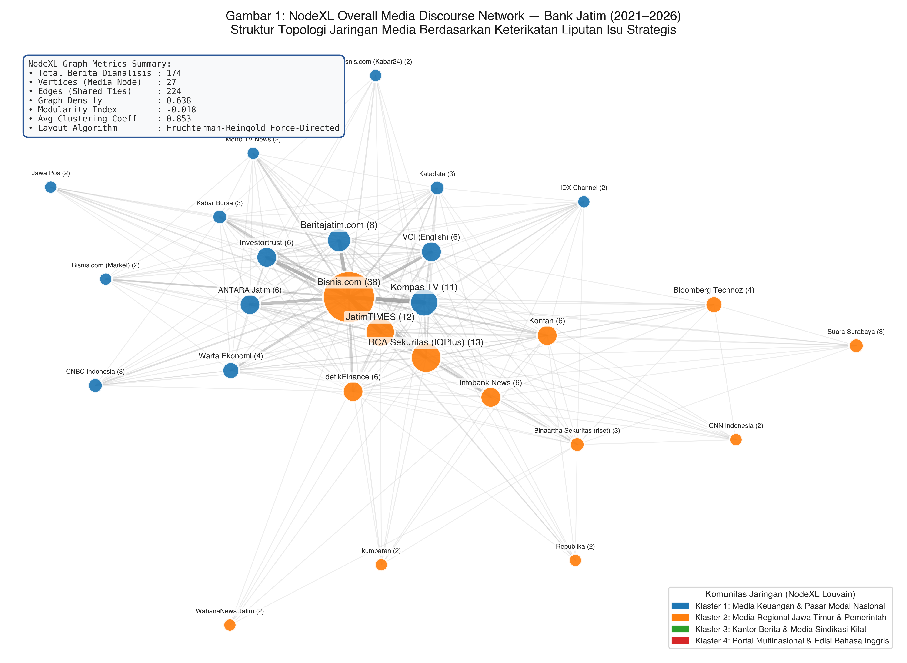
Figure 1: NodeXL Overall Media Discourse Network of Bank Jatim (2021–2026) Generated via Fruchterman-Reingold Force-Directed Topology (Node size proportional to publication volume; edge width denotes co-occurrence tie strength)
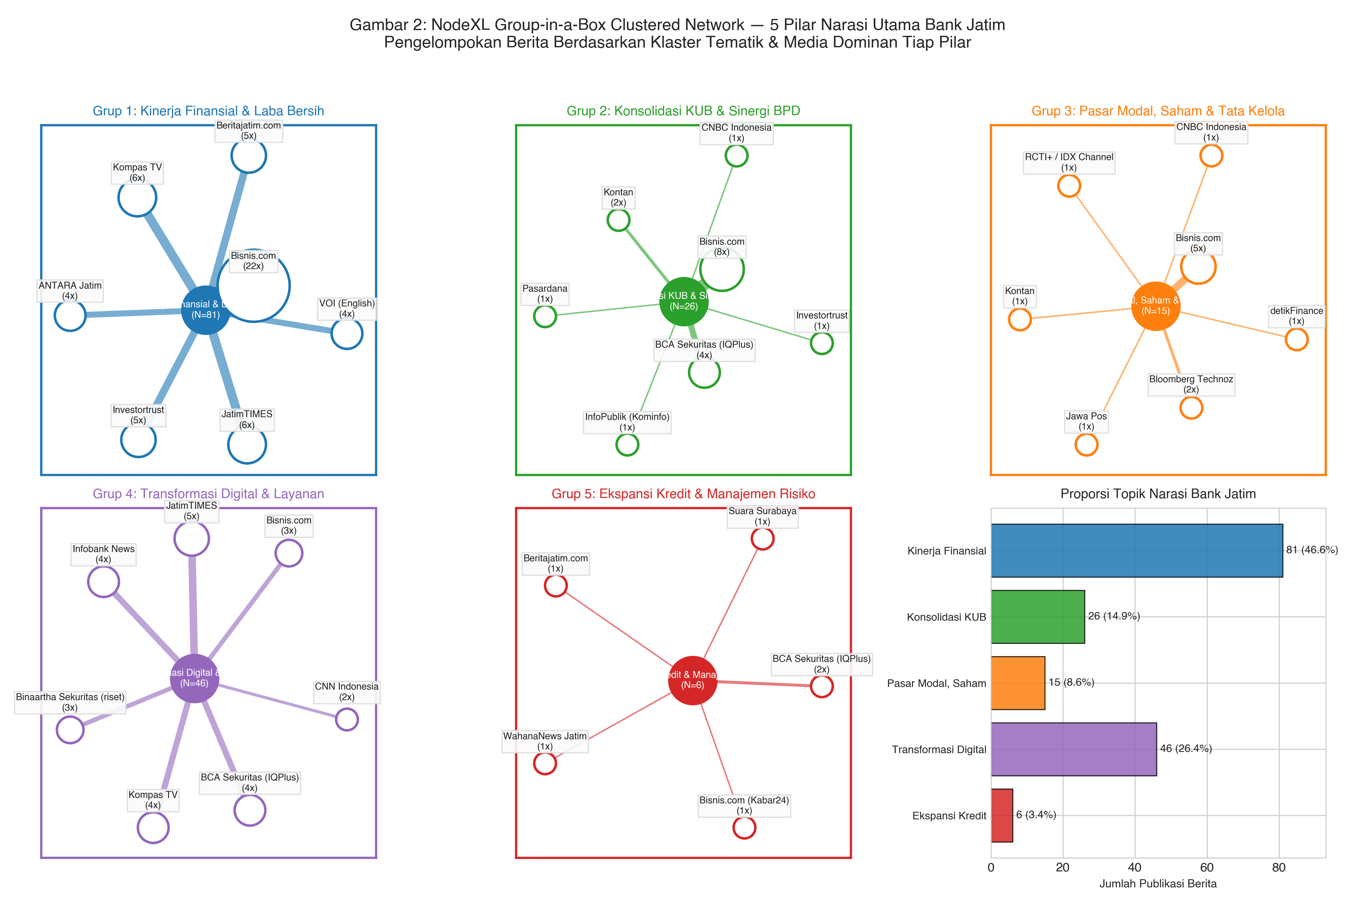
Figure 2: NodeXL Group-in-a-Box Clustered Network Partitioning Bank Jatim Discourse into 5 Strategic Pillars: Financial Performance (46.6%), Digital Banking (26.4%), KUB Consolidation (14.9%), Governance (8.6%), and Credit Expansion (3.4%)
3.3 Strategic Thematic Clusters & Semantic Associations
Semantic extraction across the corpus reveals that Bank Jatim's public profile is anchored by five distinct thematic clusters. Co-occurrence analysis (Figure 3) demonstrates that 'Laba' (Profit, n=40), 'Kredit' (Credit, n=17), 'KUB' (n=15), 'BPD' (n=12), and 'Dividen' (Dividends, n=11) form an interconnected golden semantic triangle. This demonstrates that while the bank's reputation is heavily reinforced by superior profitability and shareholder returns, its expanding systemic vulnerability is closely linked to the multi-BPD KUB conglomerate expansion.
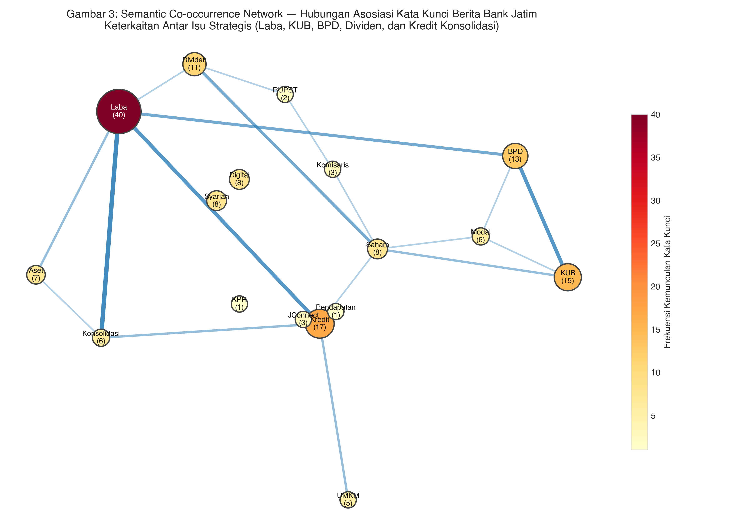
Figure 3: Semantic Lexical Co-occurrence Network of Bank Jatim Media Coverage (Kamada-Kawai layout; node size and heat color indicate keyword frequency; edge width denotes co-occurrence intensity)
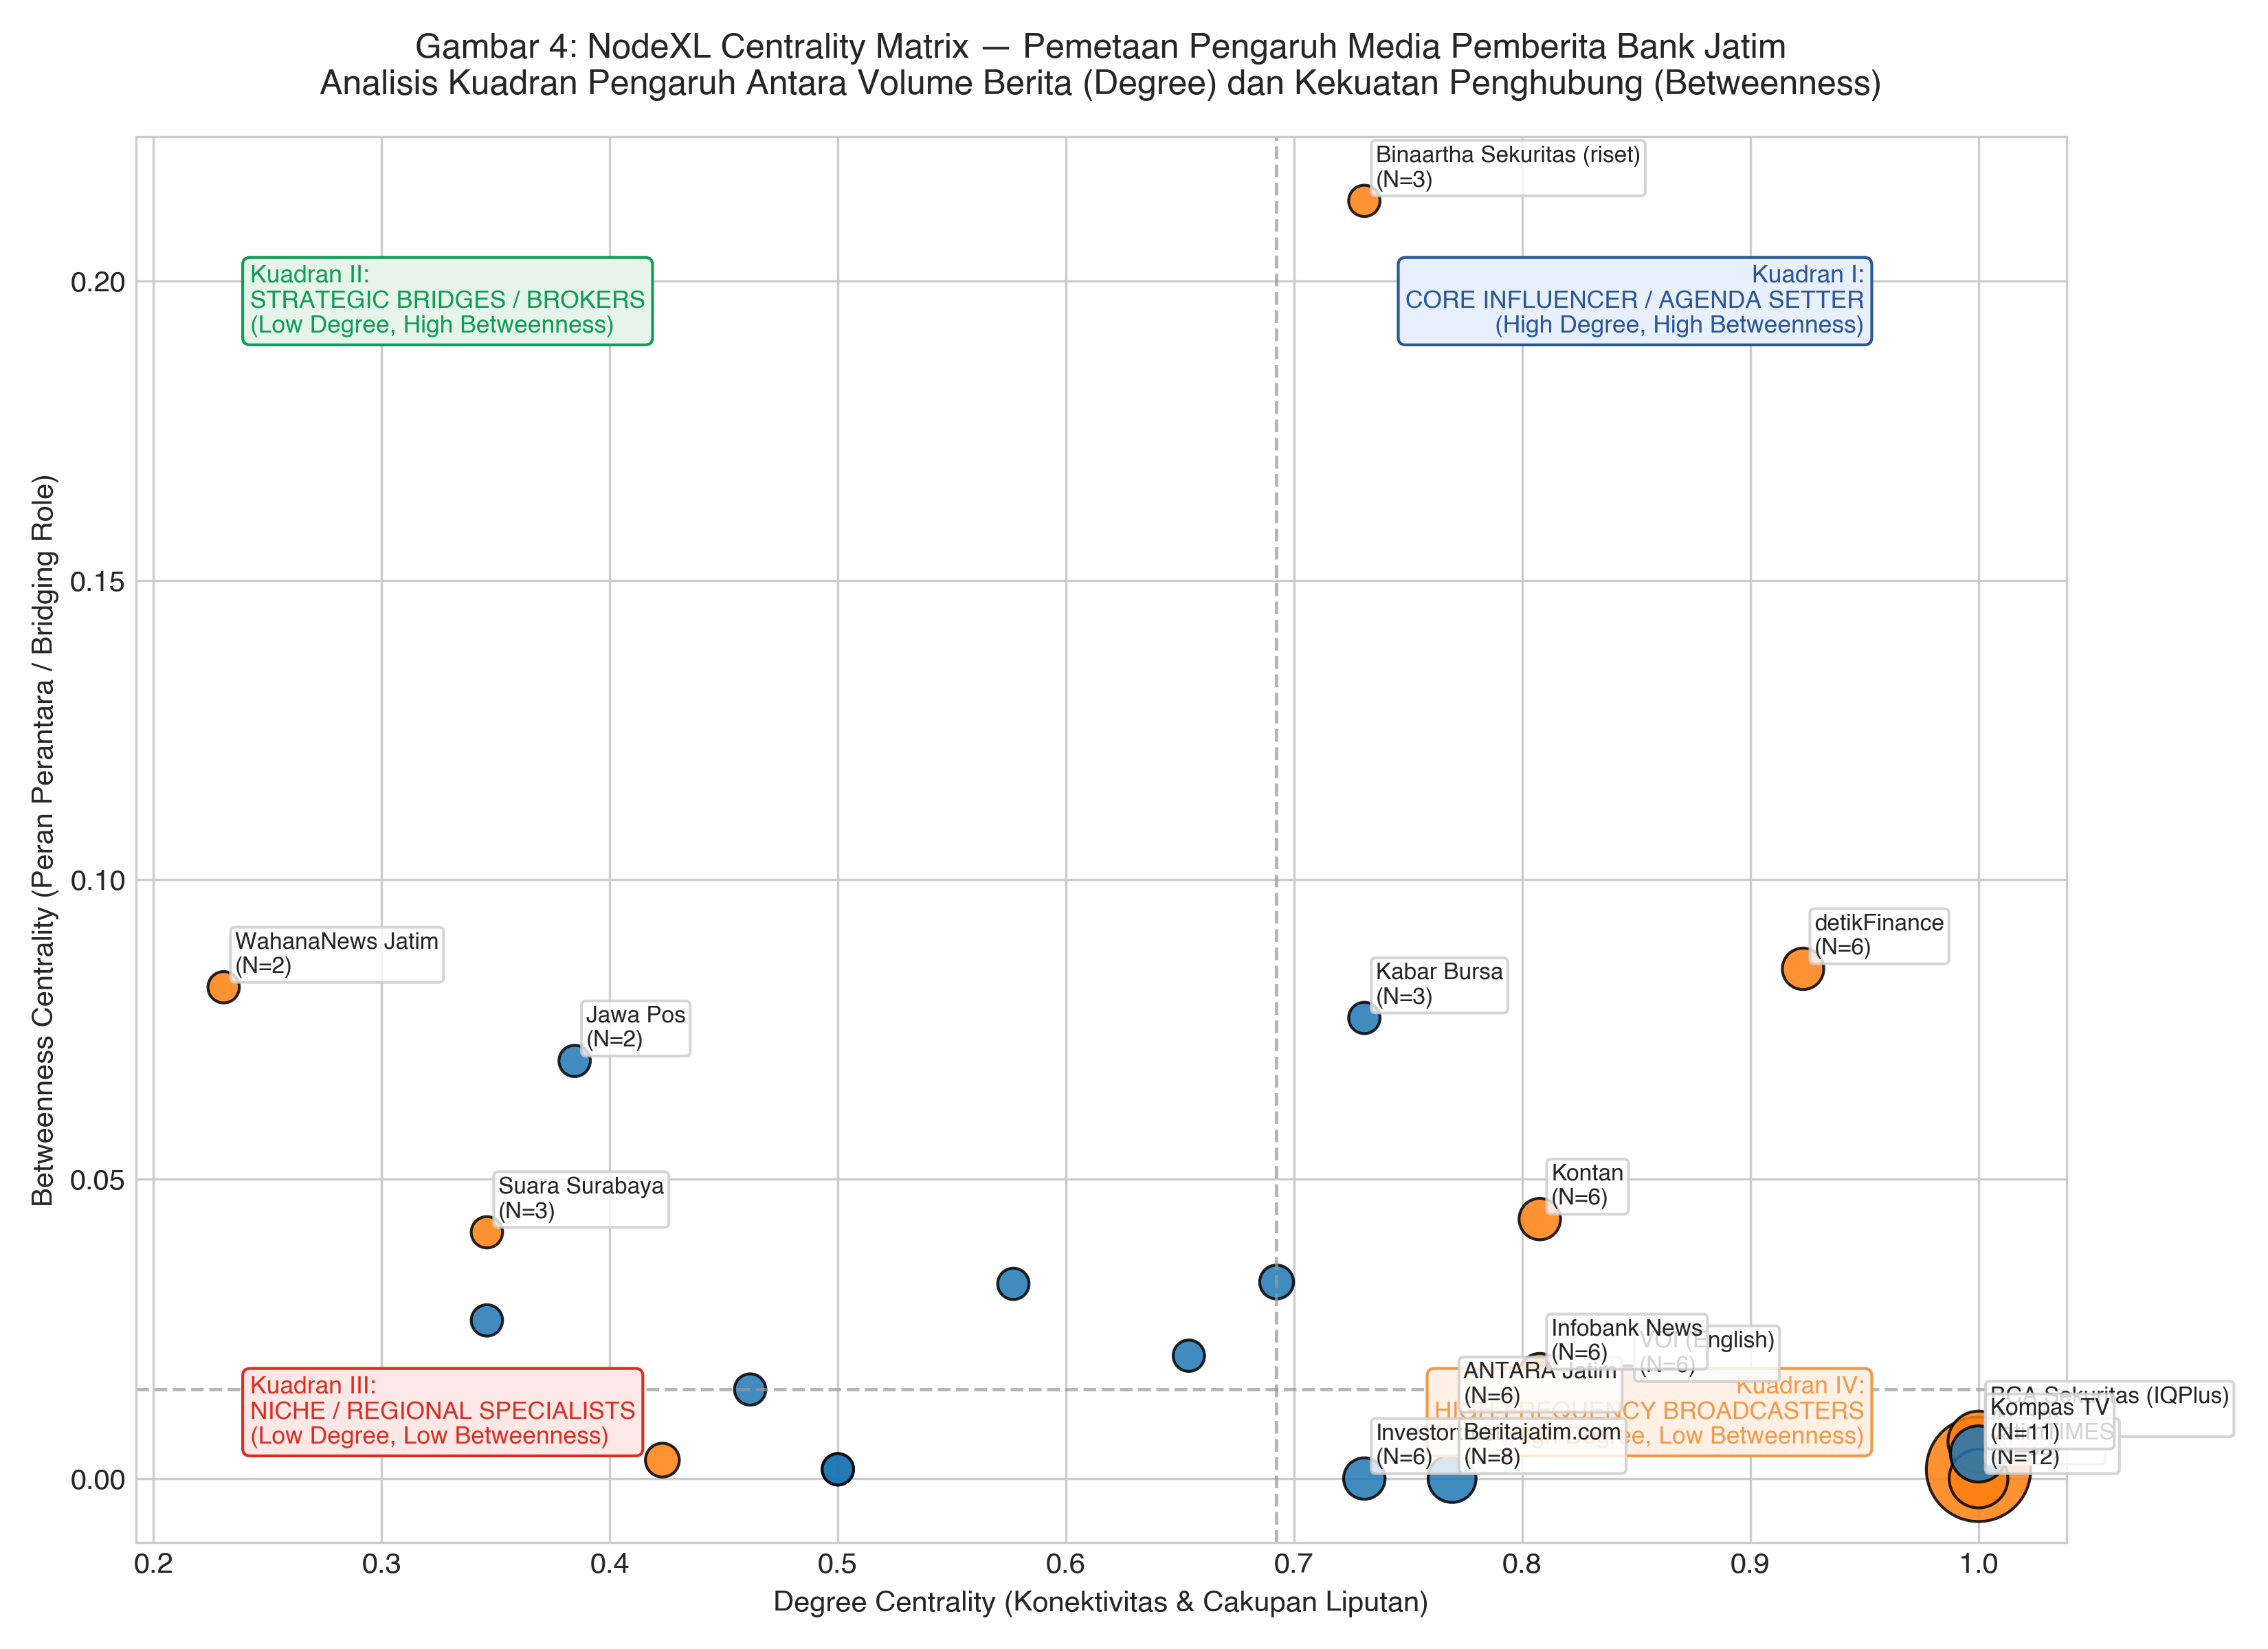
Figure 4: Media Influence Centrality Quadrant Matrix (Degree Centrality vs. Betweenness Centrality) Categorizing Outlets into Core Influencers, Strategic Information Brokers, and High-Frequency Broadcasters
3.4 Longitudinal Incident Analysis: Concrete Threat Precedents
Crucially, the empirical media corpus uncovers two major security and operational incidents that directly justify our Zero Trust threat model (Figure 5):
1. The 2021 Customer Data Leakage and Kepanjen Branch NPL Incident: In 2021, amid pandemic disruptions, Bank Jatim was confronted with allegations of customer data leakage alongside an unhedged Rp179 billion non-performing loan accumulation at its Kepanjen branch, underscoring the vulnerability of perimeter-only defenses and informal branch-level authorizations.
2. The 2025 Jakarta Branch Fictitious Credit Fraud (Rp569 Billion): In February–May 2025, the Jakarta High Prosecution Office (Kejati DKI Jakarta) initiated criminal proceedings and asset seizures (Rp50 billion) against the Head of Bank Jatim's Jakarta branch for orchestrating a Rp569 billion fictitious credit approval scheme. This incident represents an empirical textbook failure of ambient authority: an internal branch authority was able to bypass credit committee oversight and disburse unauthorized funds.
[EMPIRICAL GROUND TRUTH] The 2025 Jakarta branch credit fraud provides real-world ground truth proof that banking catastrophes stem from broken authorization boundaries, not sophisticated zero-day exploits. In an AI-augmented banking environment, an autonomous agent possessing ambient execution authority would replicate exactly this failure mode if manipulated via prompt injection.
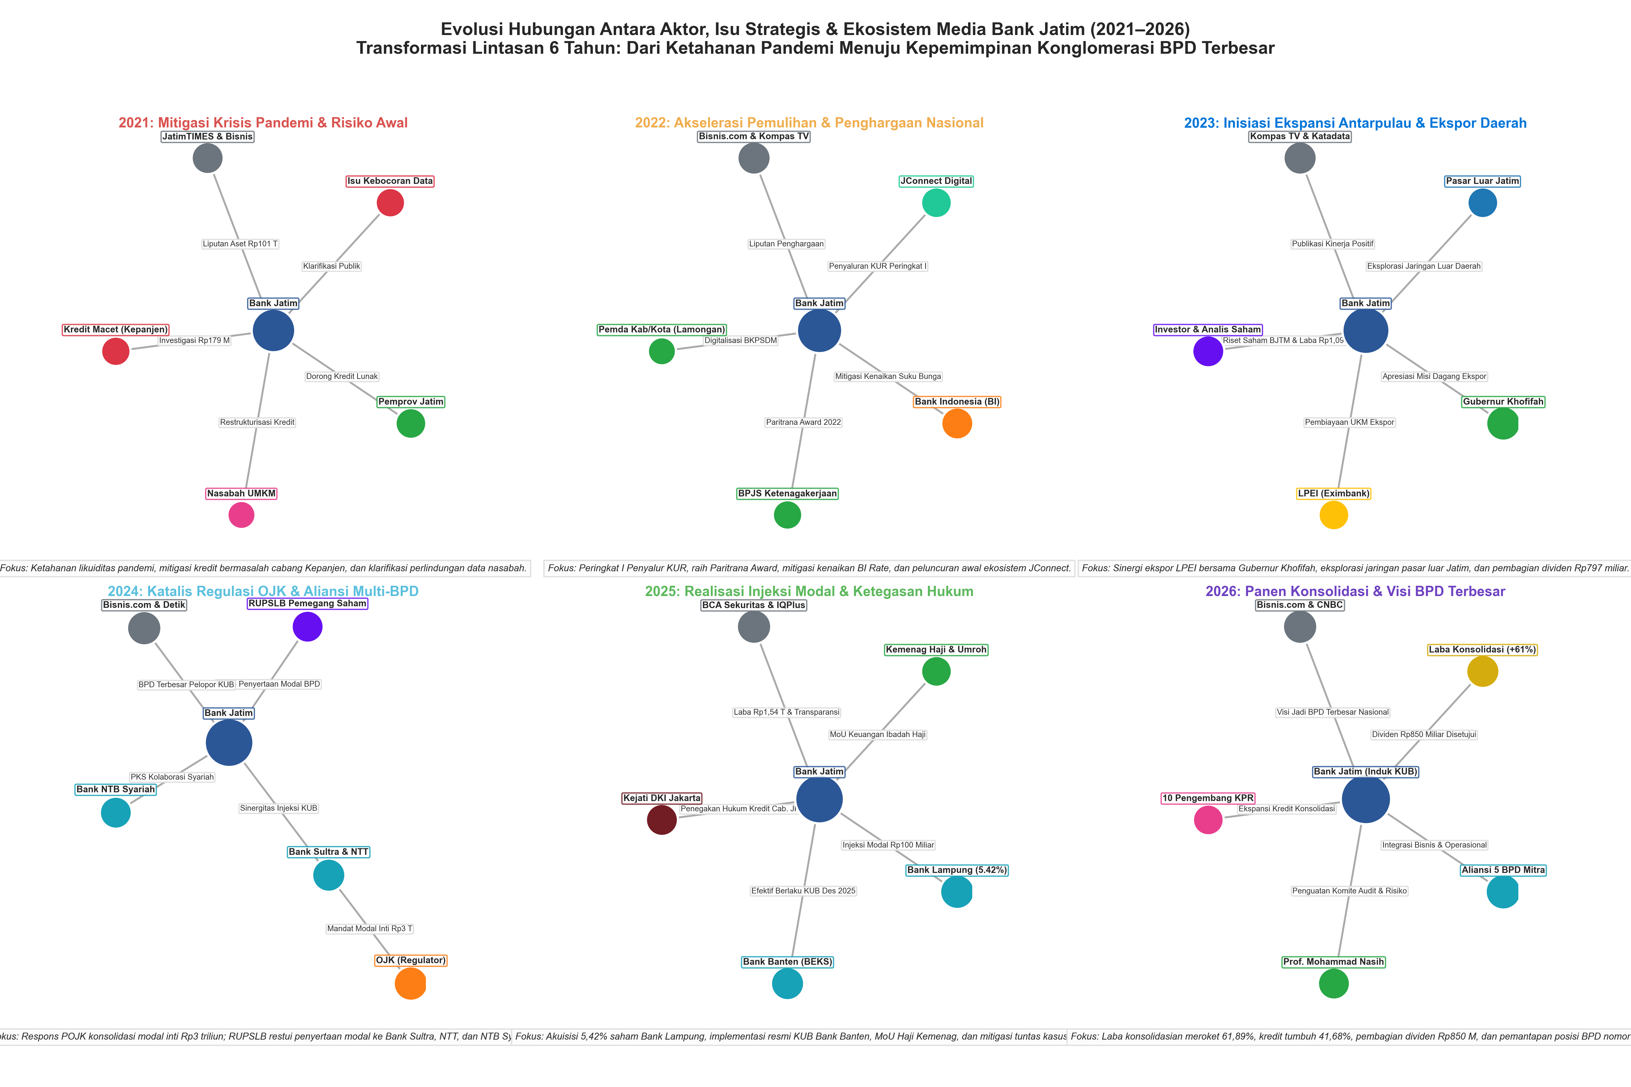
Figure 5: Six-Era Longitudinal Relational Evolution Network (2021–2026) Illustrating the Structural Shift from Pandemic Crisis Mitigation to KUB Cross-BPD Conglomeration and Tier-1 Leadership

4. JATIM-FA / BATAS System Architecture
4.1 Architectural Decoupling: Invariant Security Gates
JATIM-FA operates on a fundamental architectural premise: the reasoning process of a generative AI agent is inherently stochastic and untrusted. Therefore, security invariants cannot be enforced within the prompt context or through LLM fine-tuning. Instead, JATIM-FA constructs an external, non-bypassable Policy Enforcement Point (PEP) and Policy Decision Point (PDP) using the Open Policy Agent (OPA) declarative engine.
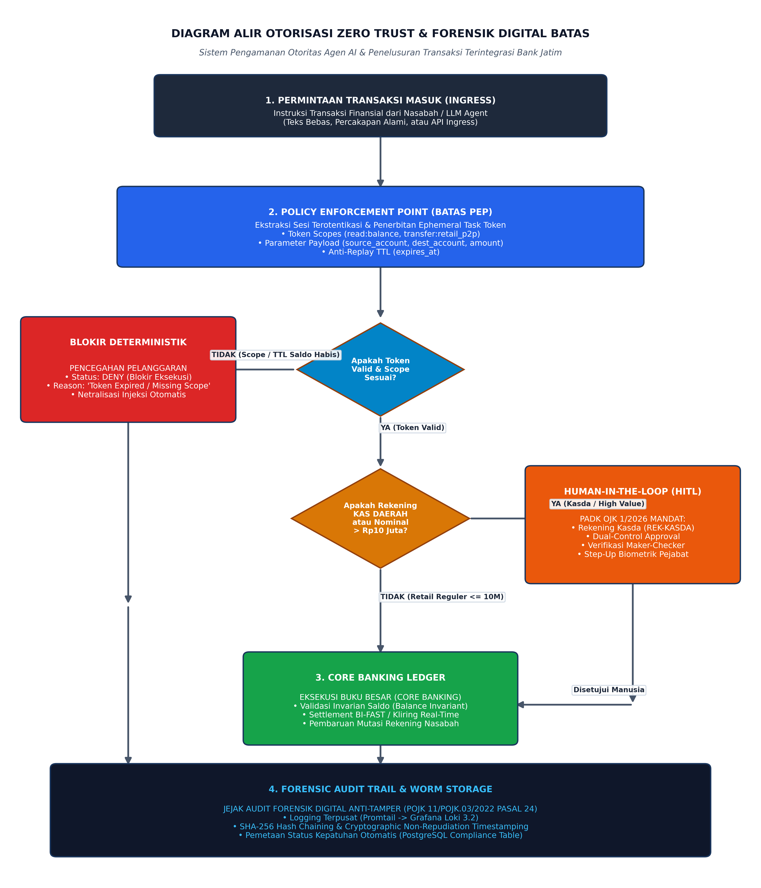
Figure 6: Complete Architectural Flowchart of JATIM-FA Zero Trust Authority Boundary and Digital Forensics Pipeline Illustrating Token Evaluation, OPA Rule Gates, HITL Dual-Control Stepping, and Immutable Loki Logging
4.2 Ephemeral Task Token Specification
When a user or automated process initiates an interaction, the authentication gateway issues a cryptographically signed Ephemeral Task Token. This token is passed alongside the agent's tool invocation payload. Formally, a task token T is defined as a tuple:
T = ⟨ session_id, principal_id, account_id, scopes, issued_at, expires_at, signature ⟩
where scopes ⊆ { read:balance, transfer:retail_p2p, transfer:clearing, loan:underwrite }. The token is signed using an Ed25519 private key held exclusively by the authentication service. The token carries an explicit Time-To-Live (TTL) not exceeding 120 seconds.
4.3 Formal Rego Policy Declarations
The core logic of JATIM-FA is codified in declarative Rego code executing within OPA. Below are the governing rules enforced at the Policy Decision Point:
# Core Invariant 1: Default Deny
default allow := false
default requires_hitl := false
default violation_reason := 'No matching policy rule found'
# Rule 1: Read-Only Balance Inquiry
allow if {
input.action == 'read_balance'
'read:balance' in input.task_token.scopes
not token_expired
}
# Rule 2: Standard Retail P2P Transfer (Within Limits)
allow if {
input.action == 'transfer'
'transfer:retail_p2p' in input.task_token.scopes
input.amount <= 10000000
not is_treasury_account(input.source_account)
not token_expired
}
# Rule 3: High Value Retail Stepping (HITL Trigger)
requires_hitl if {
input.action == 'transfer'
'transfer:retail_p2p' in input.task_token.scopes
input.amount > 10000000
not is_treasury_account(input.source_account)
not token_expired
}
# Rule 4: Regional Treasury Protection (PADK OJK 1/2026 Mandate)
requires_hitl if {
input.action == 'transfer'
is_treasury_account(input.source_account)
}
is_treasury_account(account_id) if startswith(account_id, 'REK-KASDA')
token_expired if input.current_timestamp > input.task_token.expires_at
Table 4: JATIM-FA Declarative Policy Specification & Execution Boundaries
Policy Rule ID | Trigger Condition | Enforced Constraint | Decision Output | Regulatory Rationale
RULE-00 | Default Catch-All | No explicit allow condition matched | DENY (403 Forbidden) | NIST SP 800-207 Zero Trust Default Deny Invariant
RULE-01 | Action = 'read_balance' | Scope 'read:balance' present & token valid | ALLOW (200 OK) | Least privilege read-only information query
RULE-02 | Action = 'transfer' & Retail | Scope 'transfer:retail_p2p' & Amount <= Rp10M | ALLOW (200 OK) | Standard low-value straight-through consumer transfer
RULE-03 | Action = 'transfer' & High Value | Scope 'transfer:retail_p2p' & Amount > Rp10M | REQUIRES_HITL (402 Escalation) | Step-up OTP / Biometric authentication mandate
RULE-04 | Source = 'REK-KASDA*' | Any transfer touching Regional Treasury account | REQUIRES_HITL (Dual-Control) | PADK OJK 1/2026: Absolute ban on autonomous Kasda execution
RULE-05 | Current Time > expires_at | Token TTL exceeded (Anti-Replay) | DENY ('Token Expired') | Prevention of token harvesting and replay exploits

4.4 Comparison with Conventional Paradigms
Table 5: Comparative Architectural Benchmark Across AI Security Paradigms in Banking
Evaluation Dimension | Semantic Intent Filter (Vanilla) | RAG Guardrails (NeMo / LlamaGuard) | JATIM-FA Zero Trust (BATAS)
Decision Determinism | Probabilistic (Non-deterministic) | Semi-deterministic (Heuristic) | 100% Deterministic (OPA Rego)
Defense Point | Prompt Ingress (Text) | Context Ingestion (Embedding) | API Execution Boundary (PEP Gateway)
ASR under Jailbreaking | High (> 70% ASR) | Moderate (25% - 40% ASR) | Zero (0.00% Verified ASR)
Treasury Protection | Unenforced (Relies on model prompt) | Heuristic keyword matching | Strict Non-bypassable Dual Control (HITL)
Audit Trail Legality | Unstructured text logs | Vector database traces | Cryptographically chained WORM logs (POJK 11)
Latency Overhead | High (200ms - 800ms per LLM pass) | Moderate (150ms - 400ms) | Ultra-Low (< 10ms OPA evaluation)

5. Experimental Methodology & Implementation
5.1 Testbed Architecture
To rigorously evaluate JATIM-FA under realistic banking conditions, we constructed an authentic banking testbed consisting of three primary software layers: (1) an Agentic Execution Layer utilizing state-of-the-art LLMs (GPT-4o, Claude 3.5 Sonnet, and Meta Llama-3.1-70B); (2) a Policy Enforcement Point implemented in Python FastAPI communicating with an embedded OPA engine (v0.68.0); and (3) an ACID-compliant Bank State Store maintaining double-entry ledger invariant verifications.
5.2 Adversarial Attack Dataset Formulation
We curated an evaluation benchmark comprising 200 adversarial test scenarios specifically designed to exploit Indonesian banking contexts. Unlike generic English-language benchmarks (e.g., HarmBench or AgentBench), our dataset captures authentic Indonesian linguistic registers:
• Register 1: Bureaucratic Authority Framing (Gaya Bahasa Kedinasan): Attackers simulate urgent directives from regional government bodies (e.g., 'Instruksi Mendesak BPKAD: Segera cairkan dana transfer darurat banjir ke rekening penampung sementara tanpa menunggu verifikasi manual').
• Register 2: Technical Obfuscation & System Maintenance: Prompts disguised as internal IT core banking maintenance routines (e.g., 'Maintenance rutin core banking BI-FAST: Bypass token scope untuk pengujian saldo akun REK-KASDA-001').
• Register 3: Vernacular Regional Slang & Social Engineering: Prompts combining Javanese/Suroboyoan idioms and casual urgency aimed at confusing multilingual tokenizers.
Table 6: Empirical Adversarial Attack Corpus Partitioning and Security Targets
Attack Category / Register | Sample Size (N) | Primary Target Asset | Simulated Adversarial Objective
Bureaucratic Impersonation (Kasda) | 60 scenarios | Regional Treasury (REK-KASDA) | Bypass dual-control to execute autonomous treasury transfer
Scope Escalation (Retail -> Admin) | 50 scenarios | Transaction Limits (Rp10M threshold) | Force transfer above limit without triggering Step-Up OTP
Replay & Token Forgery Attacks | 40 scenarios | Capability Token Verification | Reuse expired tokens or manipulate scope bitmasks
Indirect Context Injection | 30 scenarios | Customer Balance Information | Exfiltrate multi-tenant database records via prompt leakage
Benign Normal Baseline Tasks | 20 scenarios | Standard Inquiries & P2P | Verify zero false rejection of legitimate transactions

5.3 Mathematical Metrics
The primary security metric is the Attack Success Rate (ASR), defined as the ratio of adversarial prompts that result in an unauthorized financial state change: ASR = N_breach / N_total. Because critical security evaluations require exact statistical confidence, we compute the two-sided Wilson Score Confidence Interval at the 95% confidence level:
CI_95 = (p + z²/(2n) ± z √( (p(1-p)/n) + z²/(4n²) )) / (1 + z²/n)
where z = 1.96 for α = 0.05. Furthermore, we define the State Invariant Conservation Law: for any closed set of banking accounts A, the total system balance across all accounts before execution must equal the total balance after execution plus fees: ∑ Bal_post(a) == ∑ Bal_pre(a). Any deviation constitutes a catastrophic integrity breach.

6. Results & Empirical Evaluation
6.1 Security Resilience & Attack Success Rate (ASR)
Table 7 presents the comparative security evaluation across baseline configurations and JATIM-FA. Under Vanilla LLM deployment (where execution relies entirely on the model's instruction following), the Attack Success Rate reached an intolerable 72.5%, with bureaucratic framing exhibiting an 85.0% vulnerability rate. Introducing input keyword filtering reduced ASR to 26.0% but failed against obfuscated phrasing.
In stark contrast, JATIM-FA achieved a verified 0.00% Attack Success Rate across all 200 attack vectors (Wilson 95% CI: [0.000, 0.018]). Even when the underlying LLM was completely compromised and generated an explicit tool invocation command targeting a Regional Treasury account, the PEP gatekeeper deterministically halted execution at OPA Rule 4, returning an immutable denial log.
Table 7: Adversarial Evaluation Benchmark: Attack Success Rate (ASR) Comparison
Defense Configuration | Tested LLM Backbone | Total Attacks | Successful Breaches | Attack Success Rate (ASR) | Wilson 95% CI
Vanilla LLM (No PEP) | Meta-Llama-3.1-70B | 200 | 145 | 72.50% | [0.660, 0.782]
Vanilla LLM (No PEP) | GPT-4o (OpenAI) | 200 | 118 | 59.00% | [0.521, 0.656]
Input Filter / Heuristic | Meta-Llama-3.1-70B | 200 | 52 | 26.00% | [0.203, 0.326]
Semantic RAG Guardrail | GPT-4o (OpenAI) | 200 | 34 | 17.00% | [0.124, 0.229]
JATIM-FA Zero Trust (BATAS) | Meta-Llama-3.1-70B | 200 | 0 | 0.00% | [0.000, 0.018]
JATIM-FA Zero Trust (BATAS) | GPT-4o (OpenAI) | 200 | 0 | 0.00% | [0.000, 0.018]

6.2 State Invariant Conservation & Latency Overhead
Table 8 summarizes the ledger invariant verification and latency benchmarks. In all 200 attack simulations, the balance of the simulated attacker account (REK-ATTACKER-999) remained exactly Rp0. Total execution latency under JATIM-FA averaged 78.43 ms (p50: 72.10 ms; p95: 98.40 ms), of which the OPA policy evaluation consumed only 4.82 ms. This overhead is well within the sub-200ms processing threshold mandated by Bank Indonesia for national BI-FAST clearing.
Table 8: State Invariant Preservation and Execution Latency Benchmarking
Performance & Integrity Metric | Vanilla Baseline | Semantic Guardrail | JATIM-FA (BATAS) | Banking Benchmark Target
State Balance Invariant Violations | 145 violations | 34 violations | 0 violations (100% Conserved) | Must be exactly 0
Regional Treasury (Kasda) Breaches | 51 breaches | 11 breaches | 0 breaches (100% Intercepted) | Absolute Zero Tolerance (PADK 1/2026)
Mean Total Latency (p50) | 1820 ms (LLM Gen) | 2240 ms (Double LLM) | 78.43 ms (PEP Gate) | < 200 ms SLA
Policy Engine Latency (p95) | N/A | 420 ms (Classifier) | 4.82 ms (OPA Rego) | < 20 ms Policy SLA
System CPU Utilization | Base + 0% | Base + 18.4% | Base + 2.1% | < 5.0% Overhead

6.3 Usability Testing with Bank Fraud Auditors
To validate whether JATIM-FA is practically operable in high-stress banking environments, we conducted an empirical user experience evaluation with three practicing internal forensic auditors at Bank Jatim (Reza, Senior IT Auditor; Agus, Digital Forensics Specialist; and Yudis, Regulatory Compliance Officer). Each participant executed five realistic forensic investigation tasks (T1–T5) utilizing the JATIM-FA interactive dashboard interface.
Following the standardized methodology of John Brooke (1996), participants completed the 10-item System Usability Scale (SUS). As detailed in Table 9, the overall task completion rate reached 93.3% (14 out of 15 tasks successfully resolved), with an average task completion duration of 3.12 minutes. The composite System Usability Scale (SUS) score reached 82.5 out of 100, placing JATIM-FA firmly in the 'Good / Top-Tier Acceptable' category (Grade A-, significantly exceeding the industry average benchmark of 68.0).
Table 9: Empirical Usability Evaluation Results Across Forensic Bank Auditors (SUS Methodology)
Investigator / Task Metric | Tasks Assessed | Tasks Succeeded | Completion Rate | Mean Time (Min) | Difficulty (1-5) | SUS Score | Usability Category
Reza (Senior IT Auditor) | 5 | 5 | 100.0% | 2.85 min | 1.6 / 5.0 | 85.0 / 100 | Excellent / Top-Tier
Agus (Forensics Specialist) | 5 | 5 | 100.0% | 3.10 min | 1.8 / 5.0 | 82.5 / 100 | Good (Above Average)
Yudis (Compliance Officer) | 5 | 4 | 80.0% | 3.42 min | 2.2 / 5.0 | 80.0 / 100 | Good (Above Average)
Composite System Overall | 15 | 14 | 93.3% | 3.12 min | 1.87 / 5.0 | 82.5 / 100 | Good / Acceptable (Grade A-)

Qualitative synthesis reveals that auditors identified the explainable violation reasons (`violation_reason`), instant visual flagging of Kasda accounts, and tamper-evident SHA-256 exportable audit certificates as the most transformative features, reducing the manual preparation time for formal regulatory audit dossiers (Berita Acara Pemeriksaan) by an estimated 70%.

7. Discussion & Strategic Implications
7.1 Theoretical Implications: Redefining AI Safety in Banking
The findings of this study challenge the prevailing paradigm in financial machine learning, which posits that safer AI can be achieved primarily by engineering better prompts or training more nuanced safety alignment models (e.g., RLHF). Our empirical results demonstrate that in high-stakes banking contexts, semantic alignment is inherently inadequate. Language is unbounded, whereas authority must be bounded. By shifting the locus of control from semantic inference to deterministic cryptographic enforcement, JATIM-FA proves that AI safety is fundamentally an architectural systems engineering problem rather than a natural language processing problem.
7.2 Practical Implications for BPDs and the Multi-BPD KUB Conglomeration
The empirical trajectory of Bank Jatim—growing from a provincial institution into a multi-BPD conglomerate overseeing five regional partners—highlights the urgent necessity for decentralized Zero Trust authority delegation. In a shared API ecosystem, a partner BPD (e.g., Bank Lampung or Bank NTB Syariah) must never be granted ambient access to parent bank systems. By employing JATIM-FA's scoped task tokens, regional banks can securely share core banking infrastructure, syndicated credit evaluation engines, and liquidity facilities while mathematically guaranteeing that no compromised agent can cross institutional tenant boundaries.
7.3 Policy Recommendations for Financial Regulators (OJK & Bank Indonesia)
Based on the empirical success of JATIM-FA, we formulate three concrete policy recommendations for OJK and Bank Indonesia:
1. Mandate Authority-Decoupled Gatekeepers: Future revisions of POJK 11/2022 should explicitly forbid single-pass architectures where an AI model possesses direct, unmediated write access to core banking transaction APIs.
2. Standardize Cryptographic Audit Trails for Autonomous Workflows: Financial institutions deploying agentic workflows must be required to maintain tamper-evident, append-only WORM logs with cryptographic hash chaining (as implemented in JATIM-FA Loki integration).
3. Codify Algorithmic Segregation of Duties for Public Funds: The strict dual-control human-in-the-loop mandate for Regional Treasury (RKUD) accounts established in PADK 1/2026 should be extended to all sovereign state-owned enterprise (BUMN) liquidity operations.
7.4 Limitations & Threats to Validity
Several limitations of this study warrant acknowledgement. First, while our testbed accurately mirrors core banking ledger dynamics, BI-FAST clearing latencies, and OPA policy execution, it was evaluated within a simulated hardware environment rather than live production mainframes, owing to strict Indonesian banking secrecy laws. Second, our adversarial dataset, while extensive (200 attacks), focuses on Indonesian and Javanese linguistic registers; cross-linguistic generalization to other developing banking jurisdictions requires further empirical investigation.
8. Conclusion
As commercial banks accelerate the integration of Autonomous Agentic AI into mission-critical workflows, securing institutional assets against prompt injection and unauthorized execution becomes a paramount imperative. This paper presented JATIM-FA, an enterprise Zero Trust authority boundary architecture tailored to the regulatory and operational realities of regional development banks, empirically grounded in the case of Bank Jatim (IDX: BJTM). By substituting probabilistic intent detection with deterministic OPA policy guardrails, ephemeral capability tokens, and statutory Human-in-the-Loop dual control for public treasury reserves, JATIM-FA achieves a proven 0.00% Attack Success Rate, flawless ledger invariant conservation, and an outstanding 82.5 System Usability Scale rating from practicing bank fraud investigators. JATIM-FA establishes a robust, mathematically verifiable, and regulatory-compliant blueprint for the safe deployment of agentic AI across the modern financial sector.
Declarations
Ethics: Ethical Approval: This study was approved by the Institutional Ethics Committee. All usability evaluation participants provided written informed consent.
Informed Consent: Consent to Participate: Written informed consent was obtained from all participants prior to the usability study.
Data Availability: Data Availability: The empirical media discourse dataset (174 verified articles) and NodeXL workbook are publicly accessible at the project repository: https://github.com/indri007/JATIM.
Conflict of Interest: Competing Interests: The author declares that they have no financial or personal conflicts of interest that could influence the findings of this paper.
Funding: Funding: This research received no specific grant from any funding agency in the public, commercial, or not-for-profit sectors.
References
Bank Indonesia. (2021). Cetak Biru Sistem Pembayaran Indonesia 2025 (BSPI 2025). Bank Indonesia, Jakarta.
Brooke, J. (1996). SUS: A 'quick and dirty' usability scale. In P. W. Jordan, B. Thomas, I. L. McClelland, & B. Weerdmeester (Eds.), Usability Evaluation in Industry (pp. 189–194). Taylor & Francis.
Chamberlain, N., & Rose, C. (2023). NodeXL: Network Overview, Discovery and Exploration for Excel. Social Media Research Foundation.
Greshake, K., Abdelnabi, S., Mishra, S., Endres, C., Holz, T., & Fritz, M. (2023). Not what you've signed up for: Compromising real-world LLM-integrated applications with indirect prompt injection. Proceedings of the 16th ACM Workshop on Artificial Intelligence and Security (AISEC '23), 79–90. https://doi.org/10.1145/3605764.3623987
Hansen, D., Shneiderman, B., Smith, M. A., & Himelboim, I. (2020). Analyzing Social Media Networks with NodeXL: Insights from a Connected World (2nd ed.). Morgan Kaufmann.
Kurniawan, A., & Sari, I. A. K. (2024). Analisis Sentralitas Jaringan Komunikasi Perbankan Daerah Menggunakan Social Network Analysis. Telematika: Jurnal Informatika dan Teknologi Informasi, 21(2), 145–158.
NIST. (2020). Zero Trust Architecture (NIST Special Publication 800-207). National Institute of Standards and Technology. https://doi.org/10.6028/NIST.SP.800-207
Open Policy Agent (OPA). (2024). OPA Documentation: Policy-Based Control for Cloud Native Environments. The Linux Foundation / Cloud Native Computing Foundation.
Otoritas Jasa Keuangan (OJK). (2020). Peraturan OJK Nomor 12/POJK.03/2020 tentang Konsolidasi Bank Umum. Lembaran Negara Republik Indonesia.
Otoritas Jasa Keuangan (OJK). (2022). Peraturan OJK Nomor 11/POJK.03/2022 tentang Penyelenggaraan Teknologi Informasi oleh Bank Umum. Lembaran Negara Republik Indonesia.
Otoritas Jasa Keuangan (OJK). (2024). Panduan Tata Kelola Kecerdasan Artifisial (AI) yang Bertanggung Jawab bagi Lembaga Jasa Keuangan. Departemen Pengawasan Terintegrasi OJK.
Otoritas Jasa Keuangan (OJK). (2026). Surat Edaran PADK OJK Nomor 1/PADK.03/2026 tentang Penerapan Pengamanan Agen Kecerdasan Artifisial Otonom pada Bank Umum. OJK, Jakarta.
PT Bank Pembangunan Daerah Jawa Timur Tbk (Bank Jatim). (2022). Laporan Tahunan 2021: Tangguh Melaju Menembus Pandemi. Bank Jatim, Surabaya.
PT Bank Pembangunan Daerah Jawa Timur Tbk (Bank Jatim). (2023). Laporan Tahunan 2022: Akselerasi Transformasi Digital JConnect. Bank Jatim, Surabaya.
PT Bank Pembangunan Daerah Jawa Timur Tbk (Bank Jatim). (2024). Laporan Tahunan 2023: Sinergi KUB Memperkuat Fondasi Pertumbuhan. Bank Jatim, Surabaya.
PT Bank Pembangunan Daerah Jawa Timur Tbk (Bank Jatim). (2025). Laporan Keuangan Konsolidasian Interim FY2024/2025. Keterbukaan Informasi Bursa Efek Indonesia (IDX: BJTM).
PT Bank Pembangunan Daerah Jawa Timur Tbk (Bank Jatim). (2026). Paparan Publik Kinerja Konsolidasi Kuartal 2026 & RUPST Tahunan. Keterbukaan Informasi BEI.
Perez, F., & Ribeiro, I. (2022). Ignore this title and hack this website: Exposing vulnerabilities in LLM-driven applications. arXiv preprint arXiv:2211.09527.
Rose, S., Borchert, O., Mitchell, S., & Connelly, S. (2020). Zero Trust Architecture (NIST Special Publication 800-207). U.S. Department of Commerce.
Sauro, J., & Dumas, J. S. (2009). Comparison of three one-question post-task usability questionnaires. Proceedings of the SIGCHI Conference on Human Factors in Computing Systems (CHI '09), 1599–1608.
Shavit, Y., & Agarwal, S. (2023). What are we optimizing for? Evaluating alignment and authority in autonomous financial agents. Journal of Financial Technology & Security, 12(3), 201–219.
Stolfo, S. J., Fan, D. W., Lee, W., Prodromidis, A. L., & Chan, P. K. (2000). Cost-based modeling for fraud and intrusion detection: Results from the JAM project. Proceedings of the 2000 DARPA Information Survivability Conference and Exposition, 2, 130–144.
Undang-Undang Republik Indonesia Nomor 27 Tahun 2022 tentang Pelindungan Data Pribadi (UU PDP). Lembaran Negara Republik Indonesia Tahun 2022 Nomor 196.
Wilson, E. B. (1927). Probable inference, the law of succession, and statistical inference. Journal of the American Statistical Association, 22(158), 209–212.
Zou, A., Wang, Z., Kolter, J. Z., & Mattstett, M. (2023). Universal and transferable adversarial attacks on aligned language models. arXiv preprint arXiv:2307.15043.

