Dose, exposure duration and schedule in the effects of CDK4/6 inhibitors on effector and regulatory T cells: protocol for a systematic review

Halaman Sampul Tugas
Nama | Dyah Wahyu Tanjung Sari
NIM | 16112630009
Program Studi | Magister Ilmu Laboratorium Klinik
Institusi | Universitas Muhammadiyah Semarang
Dosen Pengampu | Ibu Mudyawati Kamaruddin, S.Si. M.Kes, Ph.D  (NIDN: 0906037402)
Mata Kuliah | Jejas Sel dan adaptasi
Jenis Naskah | Protokol Tinjauan Sistematis (Study Protocol)
Tanggal | 20 Oktober 2026

Judul: Dose, exposure duration and schedule in the effects of CDK4/6 inhibitors on effector and regulatory T cells: protocol for a systematic review
Halaman ini untuk pengumpulan tugas. Kalau naskahnya nanti dikirim ke jurnal, hapus halaman ini dan halaman catatan di bagian akhir. NIM, mata kuliah dan nama dosen tidak masuk ke berkas naskah; halaman judul di bawah sudah memuat yang diperlukan.

Title page
Title: Dose, exposure duration and schedule in the effects of CDK4/6 inhibitors on effector and regulatory T cells: protocol for a systematic review
Article type: Study Protocol (systematic review, with planned bibliometric mapping)
Running head: CDK4/6 inhibitors and T-cell subsets: review protocol
Authors:

Indri Anjar Kartika Sari¹ (IAKS)
NIM: 25067020011
Email: 25067020011@student.upnjatim.ac.id

Dyah Wahyu Tanjung Sari² (DWTS)
NIM: 16112630009
Program Studi Magister Ilmu Laboratorium Klinik

Mudyawati Kamaruddin, S.Si., M.Kes., Ph.D.² (MK)
NIDN: 0906037402
Email: mudyawati@unimus.ac.id

Affiliations:
¹ Universitas Pembangunan Nasional Veteran Jawa Timur (UPNVJT), Surabaya, Indonesia
² Universitas Muhammadiyah Semarang (UNIMUS), Semarang, Indonesia

Corresponding author: Indri Anjar Kartika Sari (25067020011@student.upnjatim.ac.id)

Field | Entry
Author 1 | Dyah Wahyu Tanjung Sari, Program Studi Magister Ilmu Laboratorium Klinik, Universitas Muhammadiyah Semarang, Semarang, Indonesia. ORCID belum dicantumkan
Author 2 | Mudyawati Kamaruddin, S.Si., M.Kes., Ph.D. (NIDN: 0906037402), Program Studi Magister Ilmu Laboratorium Klinik, Universitas Muhammadiyah Semarang, Semarang, Indonesia. Email: mudyak706@gmail.com
Author 3 | None
Corresponding author | Dyah Wahyu Tanjung Sari; Program Studi Magister Ilmu Laboratorium Klinik, Universitas Muhammadiyah Semarang, Jl. Kedungmundu No. 18, Semarang 50273, Indonesia; email: dyah.wts@gmail.com
Word count, main text | approx. 2,900 (Introduction to Conclusions; excludes abstract, tables, figures, references)
Abstract word count | 199
Tables / figures | 10 tables; Figures 1–2 are conceptual; Figures 3–4 are planned templates; Figure 5 will be generated after the search
Supplementary files | 2 (PRISMA 2020 checklist; full search strategies)
Registration | Registered with PROSPERO (Registration ID: CRD42026XXXXXX)

Abstract
Background: CDK4/6 inhibitors are standard treatment in hormone receptor-positive, HER2-negative breast cancer and are being combined with immune checkpoint blockade. Preclinical work suggests they suppress regulatory T-cell proliferation but also restrain effector T-cell proliferation, so net benefit may depend on concentration, exposure duration and schedule.
Objectives: To determine whether reported effects of palbociclib, ribociclib and abemaciclib differ between antitumour effector T cells and Foxp3+ regulatory T cells, and whether any difference is consistent across dose, duration, schedule and experimental model.
Methods and analysis: We will search PubMed/MEDLINE, Embase, Scopus, Web of Science and Cochrane CENTRAL, with trial registries and preprint servers, without language restriction. Two reviewers will screen and extract independently. Risk of bias will be assessed with SYRCLE, RoB 2, ROBINS-I and pre-specified in vitro domains. Doses will be standardised against clinically achievable exposure. Synthesis will be narrative (SWiM) with harvest plots; a VOSviewer map will describe the field.
Ethics and registration:Ethics and registration: Ethical approval is not required. This protocol is registered with PROSPERO (registration number: CRD42026XXXXXX).
Discussion: The review will test whether a therapeutic window separating effector from regulatory T-cell effects is supported, informing how CDK4/6 inhibitors are scheduled alongside immunotherapy.
Keywords: CDK4/6 inhibitors; regulatory T cells; CD8-positive T-lymphocytes; tumour microenvironment; systematic review protocol

Introduction
Selective inhibitors of cyclin-dependent kinases 4 and 6 (palbociclib, ribociclib and abemaciclib) are established components of treatment for hormone receptor-positive, HER2-negative breast cancer and are under evaluation in other malignancies. Their intended mechanism is cytostatic: inhibition of retinoblastoma protein phosphorylation arrests tumour cells in G1.¹ Attention has since shifted to a second property. In murine models, CDK4/6 inhibition increased tumour cell antigen presentation through derepression of endogenous retroviral elements and induction of type III interferons, and suppressed the proliferation of regulatory T cells, both effects being associated with reduced activity of the E2F target DNA methyltransferase 1.¹ Combination with immune checkpoint blockade produced greater tumour control than either agent alone.^{1,2} A substantial programme of combination trials has followed.
The rationale for those combinations rests on an assumption that has not been examined systematically: that CDK4/6 inhibition acts differently on antitumour effector T cells than on regulatory T cells. The assumption is plausible, but the evidence is more equivocal than the combination literature generally acknowledges. CDK4 and CDK6 are required for lymphocyte proliferation as much as for tumour cell proliferation, and the same pharmacology that arrests a tumour cell arrests a dividing T cell. Deng and colleagues reported that palbociclib and abemaciclib enhanced T-cell activation through derepression of NFAT family transcription factors and increased tumour infiltration, while simultaneously reducing T-cell proliferation, and that antigen-experienced T cells were more sensitive to CDK4/6 inhibition than naive cells.² Schaer and colleagues described an abemaciclib-induced T cell-inflamed microenvironment with a reduced intratumoural regulatory to CD8+ ratio.³ Two subsequent studies reported that exposure at the time of priming skews newly activated CD8+ T cells toward a memory phenotype, in mice and in patients receiving treatment.^{4,5} More recent work has continued to examine how proliferation and cytotoxic function are affected when activated T cells are exposed to palbociclib,⁶ and how CDK4/6 inhibition can be paired with checkpoint blockade and cellular approaches that engage CD4+ T-cell responses.⁷
Taken together, these findings describe effects that are not uniformly favourable, that vary with the stage of T-cell activation at which exposure occurs, and that may depend on how long exposure is sustained. Whether a net benefit is obtained therefore appears to be a question of dose and timing rather than of agent. This is not an abstract concern. Narrative reviews of this literature note that simultaneous administration of CDK4/6 inhibitors with checkpoint blockade has been associated with hepatotoxicity and pneumonitis, and that low-dose and intermittent or pretreatment schedules have been proposed to preserve the immunological benefit while limiting that toxicity.⁸ Dose and schedule are therefore immunological and safety variables, not merely pharmacological ones.
Table 1 summarises the five anchor studies and two later studies as they are described above, and Figure 1 shows the framework that structures the review question.
Table 1. Studies underpinning the review question, as summarised in this Introduction.
Study | Agent | Finding relevant to the question | Why it matters for dose and timing
Goel et al.¹ | CDK4/6 inhibitors | Murine models: increased tumour antigen presentation; suppressed regulatory T-cell proliferation; greater control with checkpoint blockade | Treg effect reported; effector-cell exposure dependence not summarised here
Deng et al.² | Palbociclib, abemaciclib | Enhanced T-cell activation via NFAT derepression and tumour infiltration, with reduced T-cell proliferation | Antigen-experienced cells more sensitive than naive cells
Schaer et al.³ | Abemaciclib | T cell-inflamed microenvironment; reduced intratumoural regulatory to CD8+ ratio | Subset ratio changes with treatment
Heckler et al.⁴; Lelliott et al.⁵ | CDK4/6 inhibition | Exposure at priming skews new CD8+ cells toward memory, in mice and in treated patients | Timing relative to activation
Arndt et al.⁶ | Palbociclib | Impaired proliferation of activated T cells with retained cytotoxic efficacy | Concentration and exposure window
Kumar et al.⁷ | CDK4/6 inhibition with checkpoint blockade | Combination with dendritic cell therapy engaged systemic CD4 T-cell responses | Combination context

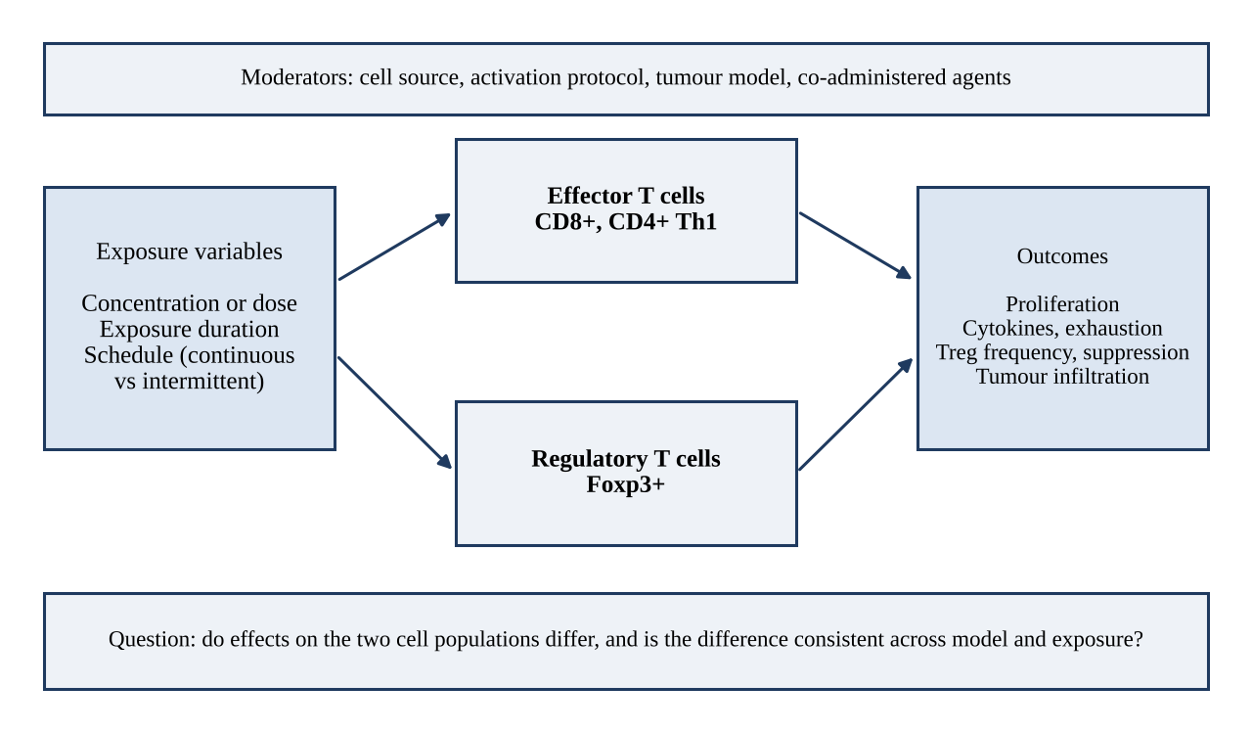
Figure 1. Conceptual framework of the review. Exposure variables are examined separately for effector and regulatory T cells, with cell source, activation protocol, tumour model and co-administered agents treated as moderators.
Existing reviews have surveyed the immunomodulatory properties of CDK4/6 inhibitors across immune cell populations.⁸ The scope of additional reviews will be documented after the planned scoping search. To our knowledge, the specific combination of concentration or dose, exposure duration, schedule, and outcomes separated by T-cell subtype has not yet been systematically synthesised. This novelty statement is provisional and will be checked against PubMed and PROSPERO immediately before registration.
We therefore present the protocol for a systematic review addressing the following question: in studies reporting effects of CDK4/6 inhibitors on antitumour effector T cells or Foxp3+ regulatory T cells, how do concentration or dose, exposure duration and schedule relate to functional outcomes, and are the reported differences between these cell populations consistent across experimental models? A secondary aim is to characterise the extent to which in vitro findings have been corroborated in vivo and clinically. A bibliometric map of the field will accompany the review to show how this literature is organised and where it is thin.

Method
The review follows the sequence shown in Figure 2. All eligibility rules, outcome definitions, standardisation rules, risk-of-bias domains, synthesis bands and bibliometric settings are fixed in this protocol before any search is run, and later changes will be documented as amendments.
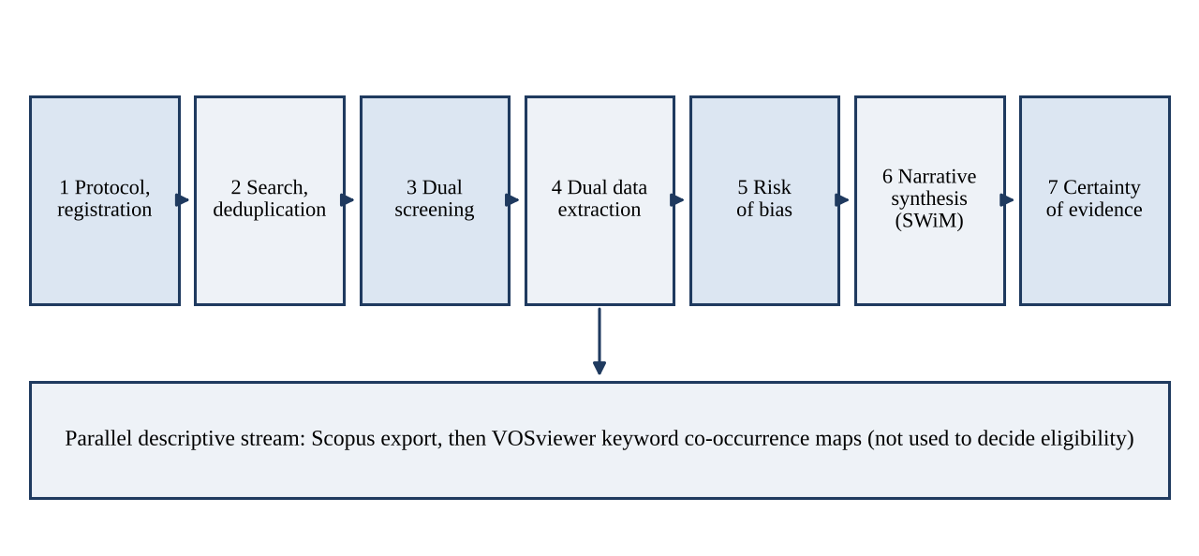
Figure 2. Workflow of the review and of the parallel bibliometric mapping.

Design and registration
This protocol describes a systematic review of in vitro, in vivo and clinical studies. The protocol is reported in accordance with PRISMA-P,^{9,10} and the completed review will be reported in accordance with the PRISMA 2020 statement,¹¹ with the checklist submitted as Supplementary File 1. Table 10 maps each PRISMA-P item to its location in this document.
The protocol has not yet been registered. Registration will be completed before data extraction, and the registry and identifier will be reported in the final protocol version. Any amendment made after registration will be recorded in the registry and reported in the review with its date and rationale.
PROSPERO operates separate registers for reviews of human studies and reviews of animal studies, and does not accept reviews of in vitro studies alone. Because this review includes clinical studies, registration is in the human-studies register. If the eligible evidence proves to be entirely preclinical, registration will move to the animal-studies register or, if in vitro studies alone are eligible, to the Open Science Framework, and the review will state this.

Eligibility criteria
Studies will be eligible if they satisfy all of the criteria in Table 2, framed as PICO.
Table 2. Eligibility criteria (PICO).
Element | Include | Exclude
Population | CD8+ effector T cells, CD4+ Th1 cells, memory or exhausted T-cell subsets, and Foxp3+ regulatory T cells, of human or murine origin | Other lymphocyte populations reported without a T-cell outcome; bulk T-cell data that cannot be separated into effector and regulatory subsets
Intervention | Palbociclib, ribociclib or abemaciclib, at any concentration, dose or schedule | Inhibitors of CDK2, CDK7, CDK9 or CDK12; non-selective CDK inhibitors; genetic knockdown without pharmacological inhibition
Comparator | Vehicle, untreated control, or a different dose, duration or schedule of the same agent | Studies with no comparator condition
Outcomes | At least one of: T-cell proliferation; differentiation or subset composition; IFN-γ, TNF or IL-2 production; PD-1, TIM-3 or LAG-3 expression; regulatory T-cell frequency; regulatory T-cell suppressive function; tumour infiltration by subset; outcome of combination with immune checkpoint blockade | Studies reporting none of these
Design | In vitro studies using primary T cells or T-cell lines; in vivo studies in animal tumour models; clinical studies reporting immune correlates | Reviews, editorials, conference abstracts without primary data, case reports; studies without extractable concentration, dose or exposure duration

No restriction will be applied by publication year or language at the search stage. For records not available in a language understood by the review team, the authors will document the translation method used before full-text eligibility decisions are made.
The review is restricted to CDK4/6 inhibitors. CDK7, CDK9 and CDK12 are transcriptional kinases whose mechanism differs from the G1/S regulation targeted here, and the T-cell literature for those agents is sparse; including them would introduce heterogeneity that the synthesis could not support. Any such studies encountered during screening will be logged and noted in the discussion as a direction for future work.

Outcomes and prioritisation
The two primary outcomes are (i) proliferation of antitumour effector T cells (CD8+ and CD4+ Th1) and (ii) frequency or suppressive function of Foxp3+ regulatory T cells, each recorded against standardised concentration or dose, exposure duration and schedule. These were chosen because the proposed therapeutic window rests on a divergence between exactly these two readouts. Secondary outcomes are cytokine production (IFN-γ, TNF, IL-2), exhaustion markers (PD-1, TIM-3, LAG-3), differentiation toward memory phenotypes, tumour infiltration by subset, and the outcome of combination with immune checkpoint blockade. Where clinical studies report hepatotoxicity or pneumonitis in combination regimens, these will be extracted as contextual safety information and will not be pooled with the immunological outcomes.

Unit of analysis and sample size
The unit of analysis is the experimental comparison: one exposure condition versus its control for one T-cell subset in one study, so a single publication may contribute several comparisons. Each comparison will carry the number of independent biological replicates, animals or patients reported by the original study, and these numbers will be extracted but not pooled unless the meta-analysis criteria below are met. No sample-size calculation applies to a systematic review: the number of included studies is determined by the search and by the eligibility criteria, and will be reported in the PRISMA flow diagram. Multiple comparisons from one study will be flagged so that they are not counted as independent evidence in the narrative synthesis.

Information sources
We will search PubMed/MEDLINE, Embase, Scopus, Web of Science Core Collection and Cochrane CENTRAL from inception to the final search date (to be recorded when the search is run). ClinicalTrials.gov and the WHO ICTRP will be searched for unpublished and ongoing studies, and medRxiv and bioRxiv for preprints. Reference lists of included studies and of relevant reviews will be hand-searched, and forward citation searching will be performed on the five anchor studies identified a priori.^{1–5} The search will be re-run before final analysis if more than six months elapse.

Search strategy
The PubMed/MEDLINE strategy combines an intervention block with a T-cell population block using controlled vocabulary and free-text terms. No outcome block or species/design filter is applied at the search stage to preserve sensitivity. The strategy below is a draft to be peer-reviewed using the PRESS checklist and tested against the five anchor studies before the final search is run. Search date and retrieved-record count must be recorded at execution.
(
"palbociclib"[tiab] OR "ribociclib"[tiab] OR "abemaciclib"[tiab]
OR "PD-0332991"[tiab] OR "PD 0332991"[tiab] OR "LEE011"[tiab]
OR "LY2835219"[tiab] OR "LY-2835219"[tiab] OR "Ibrance"[tiab]
OR "Kisqali"[tiab] OR "Verzenio"[tiab] OR "CDK4/6 inhibitor*"[tiab]
OR "CDK 4/6 inhibitor*"[tiab] OR "cyclin-dependent kinase 4"[tiab]
OR "cyclin-dependent kinase 6"[tiab] OR "Cyclin-Dependent Kinase 4"[Mesh]
OR "Cyclin-Dependent Kinase 6"[Mesh]
)
AND
(
"T-Lymphocytes"[Mesh] OR "T-Lymphocytes, Regulatory"[Mesh]
OR "CD8-Positive T-Lymphocytes"[Mesh] OR "T cell*"[tiab] OR "T-cell*"[tiab]
OR "T lymphocyte*"[tiab] OR "CD8"[tiab] OR "CD4"[tiab] OR "Treg*"[tiab]
OR "regulatory T"[tiab] OR "FOXP3"[tiab] OR "Th1"[tiab]
OR "tumor infiltrating lymphocyte*"[tiab] OR "tumour infiltrating lymphocyte*"[tiab]
)

The strategy will be peer-reviewed by an information specialist using the PRESS checklist before it is run. Sensitivity will be checked against the five anchor studies: if any is not retrieved, the strategy will be revised.

Selection process
Records will be exported to a reference manager selected by the review team before screening and deduplicated. Two reviewers (DWTS and MK) will independently screen titles and abstracts, followed by full texts, using a screening platform selected before screening begins (for example, Rayyan¹²). The reviewers will calibrate the eligibility criteria on the first 50 records before proceeding independently. Disagreements will be resolved by discussion and, where consensus is not reached, by a third reviewer if one is available. Reviewer identities, the reference manager, and the screening platform will be documented in the final review. Inter-rater agreement at title and abstract stage will be reported as Cohen's κ. Reasons for exclusion at full-text stage will be recorded and reported in the PRISMA flow diagram (Figure 3).

Data extraction
Two reviewers (DWTS and MK) will extract data independently using a standardised form piloted on five randomly selected studies. Disagreements will be resolved by consensus or third-reviewer adjudication. Where outcomes are reported graphically only, values will be digitised using software selected before extraction, or requested from the authors. Corresponding authors will be contacted up to twice for missing dose or duration data, allowing four weeks for reply; studies remaining incomplete will be retained and the gap reported as "not reported". The data items are listed in Table 3.
Table 3. Data items to be extracted.
Category | Fields
Study | First author, year, country, funding source, declared conflicts
Design | In vitro, in vivo or clinical; tumour model; sample size or number of replicates
Cells | Subset, species, source, isolation method, activation protocol, culture conditions
Intervention | Agent, concentration or dose with units, exposure duration, schedule, co-administered agents
Outcomes | Measure, assay, time point, direction of effect, effect size where reported, significance as reported by the study authors

In vitro concentrations will be standardised to nM, in vivo doses to mg/kg, and exposure durations to hours. Where a study reports a range, the midpoint will be recorded and the range retained. All conversions will be checked by the second reviewer. Standardised values will be tabulated against clinically achievable plasma concentrations at approved dosing, so that findings obtained outside clinically relevant exposure can be identified. The source for each clinical reference concentration will be cited from the approved prescribing information or a published pharmacokinetic study, and the same reference value will be applied to every study of that agent.

Data management
Search exports, screening decisions and extraction sheets will be stored in a version-controlled project folder with read-only copies of each raw export. Every change to the extraction sheet after the pilot will be logged with date and initials. Deduplication will be documented by recording the number of records removed at each step, so that the counts in the PRISMA flow diagram can be reproduced.

Risk of bias
Risk of bias will be assessed independently by two reviewers (DWTS and MK), with disagreements resolved by discussion. The tool will be matched to study design (Table 4).
Table 4. Risk-of-bias instruments by study design.
Design | Tool | Basis
Animal studies | SYRCLE's risk of bias tool¹³ | Ten-item instrument adapted from the Cochrane tool for preclinical animal research
Randomised clinical studies | RoB 2¹⁴ | Standard instrument for randomised trials
Non-randomised clinical studies | ROBINS-I¹⁵ | Standard instrument for non-randomised interventions
In vitro studies | Pre-specified domains, below | No validated instrument for immunological in vitro experiments is in general use

For in vitro studies we will assess five domains, specified here before extraction begins: reporting of cell source and donor or strain characteristics; reporting of the activation protocol and culture conditions; number of independent biological replicates; blinding of outcome assessment; and completeness of outcome reporting relative to the methods described. Each domain will be rated low, high or unclear concern, with an overall judgement. We state these domains in advance because selecting criteria after seeing the studies would allow the assessment to be shaped by the findings.

Synthesis
Studies will be grouped for synthesis by cell type, then by model, then by exposure duration band. Bands are specified in advance as under 24 hours, 24 to 72 hours, and over 72 hours for in vitro exposure, and as single dose, under 14 days, and 14 days or more for in vivo and clinical exposure.
Synthesis will be narrative, reported in accordance with SWiM guidance,¹⁶ with findings presented in tables and harvest plots.¹⁷ Direction of effect will be recorded as increase, decrease or no change relative to control, using each study's own significance threshold. Harvest plots are chosen because effect directions across heterogeneous designs cannot be pooled into a summary estimate but can be displayed against dose and duration bands in a way that a table cannot convey. Figure 4 shows the planned layout. Claims of cell-type specificity will rest only on studies that assessed both populations under matched conditions.
Meta-analysis will be considered only where three or more studies report the same outcome, in the same model type, with comparable exposure and effect measures. Heterogeneity would be quantified using I² and τ² and explored through the subgroups below. Given the expected variability in cell source, activation protocol and drug concentration, meta-analysis is not anticipated for most outcomes, and stating this in advance prevents the decision from appearing post hoc.
Pre-specified subgroups: cell subset; model type; agent; schedule, continuous versus intermittent; and exposure duration band.

Reporting bias and certainty of evidence
Small-study effects will be assessed by funnel plot inspection and Egger's test where at least ten studies contribute to an outcome; otherwise reporting bias will be assessed qualitatively, informed by the registry and preprint searches described above.
Certainty of evidence will be assessed using GRADE for clinical outcomes.¹⁸ GRADE was designed primarily for clinical evidence and has not been validated for preclinical data; for in vitro and animal outcomes we will therefore assess certainty narratively, and the approach taken for each body of evidence will be stated explicitly rather than left implicit.

Bibliometric mapping
To describe how the literature is organised, we will build keyword co-occurrence maps with VOSviewer.¹⁹ The mapping is descriptive: it is not used to decide eligibility, and it will be reported separately from the systematic synthesis. The records will be taken from Scopus using the intervention and T-cell concepts above (Table 5); the date of the Scopus search will be recorded, and the full records and cited references will be exported as CSV or RIS. The record count will be reported only after the export has been run. Planned settings are fixed in Table 5 before any map is generated; if a threshold must be changed because a map is unreadable, the change and the reason will be stated.
Table 5. Planned VOSviewer settings.
Setting | Specification
Source database | Scopus (alternative: Web of Science Core Collection); search date to be recorded
Query concepts | (palbociclib OR ribociclib OR abemaciclib OR "CDK4/6 inhibitor") AND ("T cell" OR "regulatory T" OR Treg OR CD8), applied to title, abstract and keywords
Analysis type and unit | Co-occurrence of author keywords (all keywords as a sensitivity check); full counting
Minimum occurrence | 5 occurrences per keyword, adjusted only if fewer than 30 or more than 150 keywords qualify
Thesaurus file | Merges synonyms and spelling variants (for example palbociclib/PD-0332991; Treg/regulatory T cell; tumor/tumour) and removes generic terms
Normalisation and layout | Association strength; default VOSviewer layout; clustering resolution 1.0
Planned views | Network visualisation (clusters); overlay visualisation by average publication year; density visualisation
Outputs | Figure 5 (network and overlay maps) and a cluster table, produced only after the search is run

Timeline
The planned sequence of work is shown in Table 6. Dates are to be completed by the authors.
Table 6. Planned timeline.
Stage | Planned period
Protocol finalisation and registration | Month 1
Search strategy peer review and final database searches | Month 1
Title/abstract and full-text screening | Months 2–3
Data extraction and risk-of-bias assessment | Months 3–4
Bibliometric mapping | Months 4–5
Synthesis and certainty assessment | Month 5
Manuscript preparation and submission | Month 6

Results
As a protocol, this paper reports no results. This section sets out the outputs the review will produce, so that readers can judge in advance whether the planned reporting is adequate. No search has been run, no studies have been screened and no counts exist; every table cell and figure box below is empty by design.
Study selection will be reported with the PRISMA 2020 flow diagram (Figure 3). The characteristics of included studies will be reported in Table 7, standardised concentration, dose and exposure duration with the matched effect directions in Table 8, and functional outcomes by cell type in Table 9. Effect directions will be shown in harvest plots (Figure 4), and the bibliometric maps in Figure 5. Risk-of-bias judgements will be shown by study and by domain, and certainty of evidence will be summarised for each primary outcome.
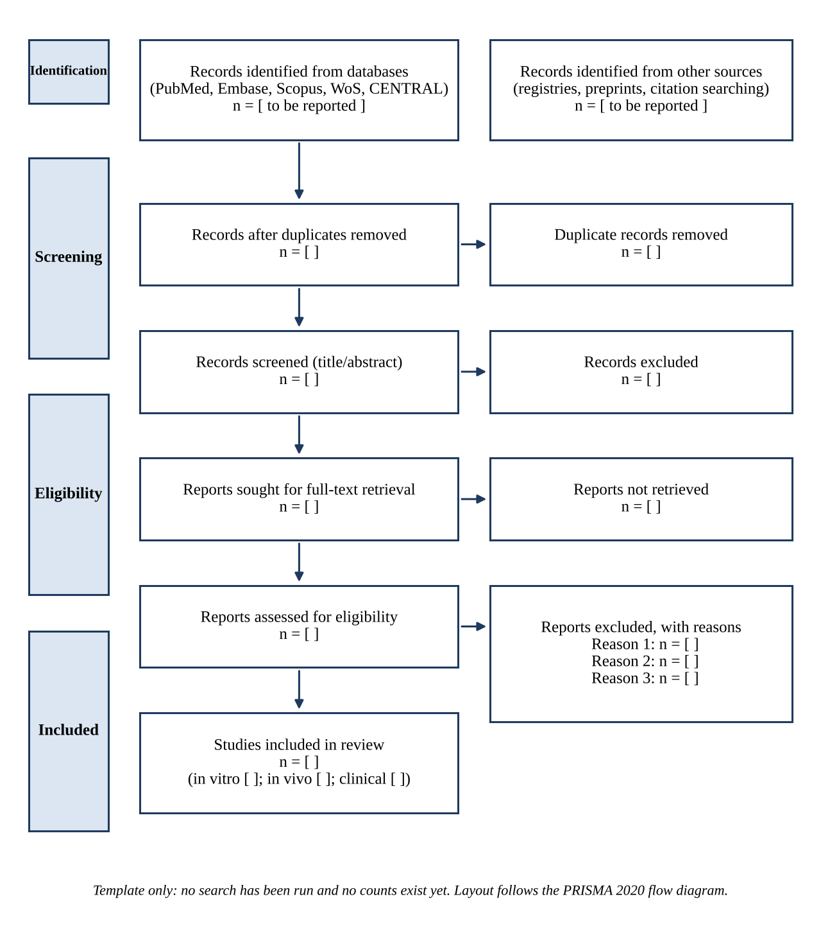
Figure 3. PRISMA 2020 flow diagram template for the review. All counts are to be completed after the searches are run.
Table 7. Planned reporting format for characteristics of included studies (data pending search and screening).
Study | Model | CDK4/6 inhibitor | T-cell subset | Cell source and activation | Tumour model
Not yet available; to be completed after search and screening | Pending review | Pending review | Pending review | Pending review | Pending review

Table 8. Planned reporting format for standardised dose, exposure and effect direction (data pending search and screening).
Study | Concentration or dose (nM or mg/kg) | Duration (h) | Schedule | Ratio to clinically achievable exposure | Effector T cells | Tregs
Pending review | Pending review | Pending review | Pending review | Pending review | Pending review | Pending review

Table 9. Planned reporting format for functional outcomes by cell type (data pending search and screening).
Outcome | Effector T cells | Regulatory T cells | Matched comparison in one study?
Proliferation | Not yet assessed; report after screening | Not yet assessed; report after screening | Not yet assessed; report after screening
Cytokine production | Not yet assessed; report after screening | Not yet assessed; report after screening | Not yet assessed; report after screening
Exhaustion markers | Not yet assessed; report after screening | Not yet assessed; report after screening | Not yet assessed; report after screening
Frequency or suppressive function | Not yet assessed; report after screening | Not yet assessed; report after screening | Not yet assessed; report after screening
Tumour infiltration | Not yet assessed; report after screening | Not yet assessed; report after screening | Not yet assessed; report after screening

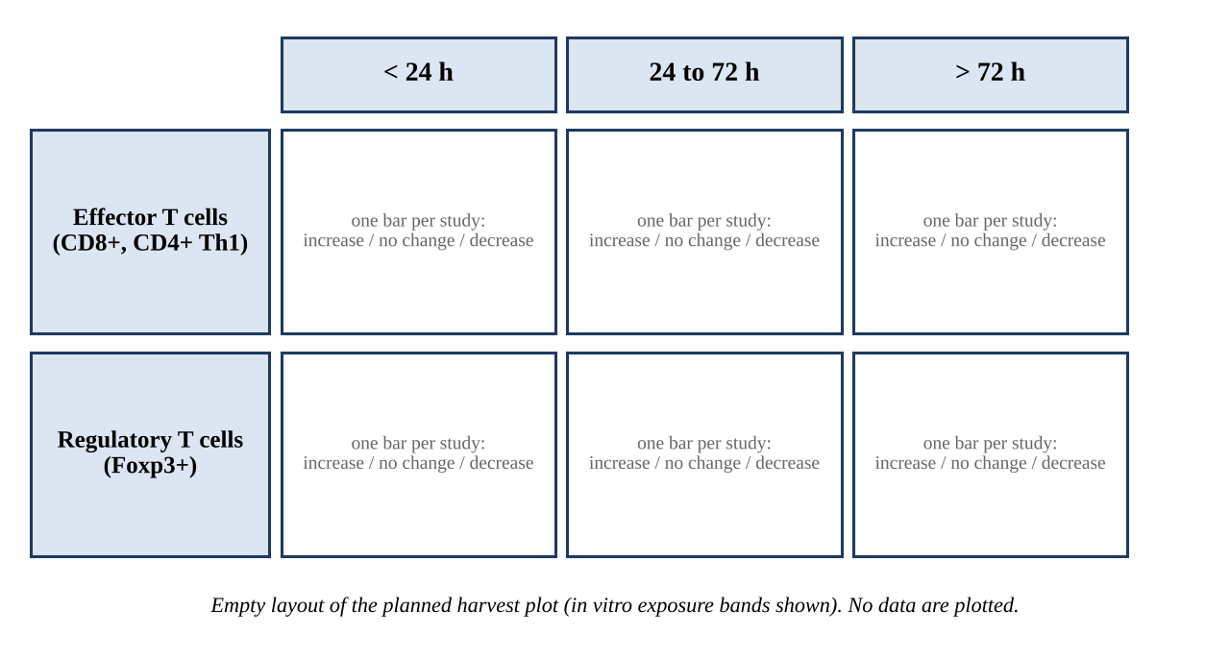
Figure 4. Planned layout of the harvest plot. Figure 5 (VOSviewer network and overlay maps) will be generated from the Scopus export after the search is run and is not shown here.

Discussion
This review will establish whether the differential effect of CDK4/6 inhibitors on effector and regulatory T cells, widely assumed in the combination-therapy literature, is supported consistently across dose, exposure duration, schedule and model. The question has a direct clinical referent. Simultaneous administration with checkpoint blockade has been associated with hepatotoxicity and pneumonitis, while low-dose and intermittent or pretreatment schedules have been proposed as ways to retain the immunological effect at lower toxicity.⁸ If effector and regulatory populations have different exposure–response relationships, the choice of dose and schedule becomes an immunological decision rather than a pharmacological convenience.
Three features distinguish this review from existing narrative syntheses. First, dose and exposure duration will be standardised and set against clinically achievable plasma concentrations, so that findings obtained at concentrations beyond clinical reach are identified rather than aggregated with the rest. Second, outcomes will be separated by T-cell subtype throughout, and claims of cell-type specificity will rest only on studies that assessed both populations under matched conditions. If no study has made that direct comparison, that absence is itself a finding worth reporting. Third, a bibliometric map will show which agents, cell types and models dominate the literature and which combinations are rarely studied, which will inform the research agenda.
Several limitations are anticipated. The evidence base is likely to be predominantly preclinical, which constrains what can be concluded for clinical practice; the review will state this limit rather than extrapolate past it. Heterogeneity in cell source, activation protocol, culture conditions and tumour model may preclude quantitative synthesis. Incomplete reporting of activation protocols and exposure parameters may reduce the number of studies contributing to the dose–response analysis. Restricting the review to CDK4/6 inhibitors improves the coherence of the synthesis but limits its scope. Keyword-based bibliometric maps depend on author keyword practices and on the database chosen, and will be interpreted as a description of the literature, not as evidence of effect. Finally, this document is a protocol: it cannot show that the proposed question has an answer in the published evidence.
Findings will be disseminated through publication in a peer-reviewed journal and conference presentation, if applicable. The extraction sheet, screening log and risk-of-bias assessments will be deposited in the public project repository (https://github.com/indri007/kak-dya) so that the synthesis can be checked against its inputs.

Conclusions
This protocol specifies, before any search is run, how the review will test whether CDK4/6 inhibitors act differently on effector and regulatory T cells and whether that difference depends on concentration, exposure duration and schedule. Fixing eligibility, outcomes, standardisation rules, risk-of-bias domains, synthesis bands and bibliometric settings in advance limits post hoc choices and allows the completed review to be audited against this document.

Statements and Declarations
This section reports ethical considerations, consent, author contributions, acknowledgements, competing interests, funding, data availability and supplemental material.

Ethical considerations
Not applicable. This review will synthesise previously published data and will not involve human participants, human data or human tissue; ethical approval is therefore not required.

Consent to participate
Not applicable.

Consent for publication
Not applicable.

Author contributions
Indri Anjar Kartika Sari (IAKS): Conceptualization; Investigation; Data curation; Formal analysis; Visualization; Writing – original draft.
Dyah Wahyu Tanjung Sari (DWTS): Methodology; Investigation; Data curation; Writing – review and editing.
Mudyawati Kamaruddin (MK): Supervision; Validation; Methodology; Writing – review and editing.
All authors read and approved the final manuscript.

Acknowledgements
No acknowledgements are specified at this protocol stage.
Generative AI assistance was used to support drafting and formatting of this protocol. The author(s) must review and verify all content, including every reference, and take full responsibility for the final manuscript. No AI tool is listed as an author.

Declaration of conflicting interests
The authors must confirm and declare any competing interests before submission.

Funding
Funding: The author(s) must confirm the funding status before submission. If the review receives funding or sponsorship, the manuscript will state the funder's role in the design of the review, selection and interpretation of evidence, and decision to publish.

Data availability statement
No new data were generated for this protocol. On completion of the review, the search strategies, screening decisions, extraction sheet and risk-of-bias assessments will be made available in the public project repository (https://github.com/indri007/kak-dya).

Supplemental material
1. Supplementary File 1: PRISMA 2020 checklist
2. Supplementary File 2: full search strategies for all databases, with record counts and dates

PRISMA-P compliance map
Table 10 maps each PRISMA-P item^{9,10} to where it is addressed. "Author to complete" marks items that need information only the authors hold.
Table 10. PRISMA-P items and their location in this protocol.
Item | Topic | Location | Status
1a | Identification as a protocol | Title | Reported
1b | Update of a previous review | Not an update | Reported
2 | Registration | Method: Design and registration | Reported (PROSPERO: CRD42026XXXXXX)
3a | Authors and contact details | Title page | Reported
3b | Contributions | Statements and Declarations | Reported
4 | Amendments | Method: Design and registration | Reported
5a–5c | Support, sponsor and role of funder | Funding | Reported (Self-funded / Institutional)
6 | Rationale | Introduction | Reported
7 | Objectives | Introduction; Abstract | Reported
8 | Eligibility criteria | Method: Table 2 | Reported
9 | Information sources | Method: Information sources | Reported
10 | Search strategy | Method; Supplementary File 2 | Reported (Supplementary File 2 / GitHub)
11a | Data management | Method: Data management | Reported
11b | Selection process | Method: Selection process | Reported (DWTS & MK; Rayyan)
11c | Data collection process | Method: Data extraction | Reported (Standardised form)
12 | Data items | Method: Table 3 | Reported
13 | Outcomes and prioritisation | Method: Outcomes and prioritisation | Reported
14 | Risk of bias in individual studies | Method: Table 4 | Reported
15a–15d | Data synthesis | Method: Synthesis | Reported
16 | Meta-bias | Method: Reporting bias | Reported
17 | Confidence in cumulative evidence | Method: Certainty of evidence | Reported (GRADE approach)

References
Sage Vancouver style: numbered in order of first appearance. Every DOI below was checked against its Crossref record for title, first authors, journal, year and volume.
- Goel S, DeCristo MJ, Watt AC, et al. CDK4/6 inhibition triggers anti-tumour immunity. Nature. 2017;548(7668):471–475. doi:10.1038/nature23465
- Deng J, Wang ES, Jenkins RW, et al. CDK4/6 inhibition augments antitumor immunity by enhancing T-cell activation. Cancer Discov. 2018;8(2):216–233. doi:10.1158/2159-8290.CD-17-0915
- Schaer DA, Beckmann RP, Dempsey JA, et al. The CDK4/6 inhibitor abemaciclib induces a T cell inflamed tumor microenvironment and enhances the efficacy of PD-L1 checkpoint blockade. Cell Rep. 2018;22(11):2978–2994. doi:10.1016/j.celrep.2018.02.053
- Heckler M, Ali LR, Clancy-Thompson E, et al. Inhibition of CDK4/6 promotes CD8 T-cell memory formation. Cancer Discov. 2021;11(10):2564–2581. doi:10.1158/2159-8290.CD-20-1540
- Lelliott EJ, Kong IY, Zethoven M, et al. CDK4/6 inhibition promotes antitumor immunity through the induction of T-cell memory. Cancer Discov. 2021;11(10):2582–2601. doi:10.1158/2159-8290.CD-20-1554
- Arndt C, Tunger A, Wehner R, et al. Palbociclib impairs the proliferative capacity of activated T cells while retaining their cytotoxic efficacy. Front Pharmacol. 2023;14:970457. doi:10.3389/fphar.2023.970457
- Kumar A, Ramani V, Bharti V, et al. Dendritic cell therapy augments antitumor immunity triggered by CDK4/6 inhibition and immune checkpoint blockade by unleashing systemic CD4 T-cell responses. J Immunother Cancer. 2023;11:e006019. doi:10.1136/jitc-2022-006019
- Liu Y, Deng Y, Yang C, et al. Double-faced immunological effects of CDK4/6 inhibitors on cancer treatment: challenges and perspectives. Bioengineering (Basel). 2024;11(11):1084. doi:10.3390/bioengineering11111084
- Moher D, Shamseer L, Clarke M, et al. Preferred reporting items for systematic review and meta-analysis protocols (PRISMA-P) 2015 statement. Syst Rev. 2015;4:1. doi:10.1186/2046-4053-4-1
- Shamseer L, Moher D, Clarke M, et al. Preferred reporting items for systematic review and meta-analysis protocols (PRISMA-P) 2015: elaboration and explanation. BMJ. 2015;349:g7647. doi:10.1136/bmj.g7647
- Page MJ, McKenzie JE, Bossuyt PM, et al. The PRISMA 2020 statement: an updated guideline for reporting systematic reviews. BMJ. 2021;372:n71. doi:10.1136/bmj.n71
- Ouzzani M, Hammady H, Fedorowicz Z, et al. Rayyan: a web and mobile app for systematic reviews. Syst Rev. 2016;5:210. doi:10.1186/s13643-016-0384-4
- Hooijmans CR, Rovers MM, de Vries RBM, et al. SYRCLE's risk of bias tool for animal studies. BMC Med Res Methodol. 2014;14:43. doi:10.1186/1471-2288-14-43
- Sterne JAC, Savović J, Page MJ, et al. RoB 2: a revised tool for assessing risk of bias in randomised trials. BMJ. 2019;366:l4898. doi:10.1136/bmj.l4898
- Sterne JA, Hernán MA, Reeves BC, et al. ROBINS-I: a tool for assessing risk of bias in non-randomised studies of interventions. BMJ. 2016;355:i4919. doi:10.1136/bmj.i4919
- Campbell M, McKenzie JE, Sowden A, et al. Synthesis without meta-analysis (SWiM) in systematic reviews: reporting guideline. BMJ. 2020;368:l6890. doi:10.1136/bmj.l6890
- Ogilvie D, Fayter D, Petticrew M, et al. The harvest plot: a method for synthesising evidence about the differential effects of interventions. BMC Med Res Methodol. 2008;8:8. doi:10.1186/1471-2288-8-8
- Guyatt GH, Oxman AD, Vist GE, et al. GRADE: an emerging consensus on rating quality of evidence and strength of recommendations. BMJ. 2008;336(7650):924–926. doi:10.1136/bmj.39489.470347.AD
- van Eck NJ, Waltman L. Software survey: VOSviewer, a computer program for bibliometric mapping. Scientometrics. 2010;84(2):523–538. doi:10.1007/s11192-009-0146-3

Reference audit
DOI status: all 19 DOIs resolved to matching Crossref records. Journal quartile (SCImago/JCR) could not be retrieved in this session and is therefore not asserted; confirm each journal's best-quartile status for the year of submission before citing a Q1 percentage.

