Digital Sarcasm as a Signal of Policy Distrust: Social Network Analysis and Emotion Classification of Indonesia’s Free Nutritious Meal Program Discourse on X (Twitter)
Indri Anjar Kartika Sari
Master’s Program in Communication Science, Faculty of Social, Cultural and Political Sciences, Universitas Pembangunan Nasional “Veteran” Jawa Timur, Surabaya, Indonesia. Email: indri.anjar@upnvjatim.ac.id

Abstract
Indonesia’s Free Nutritious Meal (Makan Bergizi Gratis, MBG) program triggered intense sarcastic and critical discourse on platform X during its nationwide rollout (March–May 2026). This study examines the linguistic, affective, and structural anatomy of this public dissent through an explanatory-sequential mixed-method computational design: fine-tuned IndoBERT with group-aware cross-validation for multi-task emotion classification and sarcasm identification, directed Social Network Analysis (SNA) with Louvain community detection, and Aspect-Based Sentiment Analysis (ABSA) across three critical policy facets. The complete corpus comprises 5,263 tweets, with a directed mention graph of 971 actors and 692 directed edges (666 unique ties). Benchmarked against linear baseline models under an independent, zero-leakage group-aware holdout partition (N = 1,058), IndoBERT achieved 79.40% accuracy, a Macro-F1 of 0.5160, and a Weighted-F1 of 0.7851, substantially outperforming TF-IDF + Logistic Regression (Acc 69.47%, Macro-F1 0.3429) and Linear SVM (Acc 67.20%, Macro-F1 0.4095). Social network analysis reveals severe structural hyper-fragmentation: a Louvain modularity Q = 0.9837, 341 weakly connected components, reciprocity of only 1.20%, and a giant component holding just 9.17% of actors. Multi-period longitudinal analysis demonstrates that from pre-escalation (March–April) to crisis peak (May 2026), the network expanded by +699% in nodes and modularity surged from 0.9455 to 0.9851. Actor centrality identifies a fundamental divergence: the platform AI account @grok serves as an epistemic inquiry oracle (42 mentions, out-degree 0), while presidential authority @prabowo acts as an institutional sink for public grievance (15 mentions, 76.2% disgust). Negative valence, dominated by visceral disgust, exceeds 71% across all policy facets, led by Nutritional Quality (1,344 mentions). Interpreted through Marketing 6.0's phygital gap framework, we demonstrate that digital sarcasm serves as an evaluative paralinguistic shield for moral accountability. We conclude with strategic governance recommendations for decentralizing public communication, managing algorithmic verification risk, and deploying sarcasm-aware early warning listening systems.
Keywords: Social Network Analysis; IndoBERT; Emotion Classification; Digital Sarcasm; Phygital Gap

1 Introduction

1.1 Background and Problem Statement
Since January 2025, Indonesia has implemented one of Southeast Asia’s most ambitious social welfare programs, the Makan Bergizi Gratis (MBG) initiative. Positioned as a pillar of the Indonesia Emas 2045 agenda, it aims to eliminate childhood malnutrition, reduce stunting from 21.6% to single digits, and stimulate local agriculture. An initial allocation of IDR 71 trillion in fiscal year 2025 was followed by an indicative multi-year framework originally projected at IDR 335 trillion, recalibrated to IDR 268 trillion for 2026 [1].
Citizens do not evaluate such policies in an informational vacuum. Edelman [2] argued that budgets and administrative adjustments are symbolic spectacles that citizens interpret through heuristics, affect, and social networks. When the National Nutrition Agency (Badan Gizi Nasional, BGN) announced a IDR 67 trillion reduction of the program ceiling as a prudent reallocation of unabsorbed funds, digital publics on X read it as confirmation of incompetence or corruption. This fiscal skepticism was compounded by operational breakdowns during March–May 2026: the suspension of 4,581 of approximately 27,952 Nutrition Fulfillment Service Units (Satuan Pelayanan Pemenuhan Gizi, SPPG), with 1,152 still suspended in May [3]; viral mass food poisoning (keracunan massal) among pupils; and controversies over imported meal trays (ompreng) and alleged “fictitious SPPGs”. On April 6, 2026, BGN’s public relations head acknowledged that social media hoaxes, sarcasm, and negative framing had become a strategic vulnerability [4].

1.2 Digital Sarcasm as a Methodological Problem and Research Objectives
Public dissatisfaction on X appeared less as petitions or formal argument than as digital sarcasm: messages whose literal surface mimics praise but whose pragmatic meaning is inverted by emojis, hyperbole, and juxtaposition (e.g., “What a glorious world-class meal” followed by 🤡). Lexicon-based tools (e.g., VADER, SentiStrength) and classical classifiers (Naïve Bayes, SVM, shallow LSTMs) rely on overt lexical polarity: a sentence such as “A magnificent 268-trillion program for our beloved children 🤡” is scored as strongly positive because of tokens like “magnificent” and “beloved”, and the terminal emoji is ignored. In political communication, this misclassification leads agencies to systematically underestimate public rage and cynicism. Moreover, sarcasm circulates through structured topologies: who amplifies it, and whether critics and defenders deliberate or remain siloed, are network questions that require integrating contextual NLP with graph-theoretic SNA.
This study pursues four objectives. RO1: decode the linguistic anatomy of sarcasm in MBG discourse, including text–emoji incongruence as a vehicle of valence inversion. RO2: map the macro- and meso-topology of the interaction network, including fragmentation and echo-chamber segregation. RO3: identify high-centrality actor typologies, including human political figures and AI agents. RO4: interpret these patterns through the Marketing 6.0 phygital gap [5], the rupture between digital policy branding and physical service delivery.

2 Theoretical Framework
Trust, risk, and symbolic politics. Political trust rests on competence trust (capacity to deliver) and moral trust (benevolent intent) [6]. In MBG, contaminated meals erode the former and budget controversies erode the latter. Risk perception is mediated by outrage factors such as involuntariness and institutional distrust rather than by probability alone [7], [8]; parents who surrender control over their children’s meals to private caterers react acutely to any failure, regardless of government claims that 95% of distribution units operate without incident.
Networked dissent and sarcasm. Policy framing now travels through connective action [9] and multi-directional crisis feedback [10], on platforms characterized by context collapse [11]. Under such conditions, subordinated publics shift to irony as a “weapon of the weak” [12], especially where the Electronic Information and Transactions Law (UU ITE) has been used against critics. Linguistically, sarcasm flouts Grice’s Maxim of Quality [13]: the speaker utters P while intending not-P [14]. Without prosody, emojis act as illocutionary markers that invert literal meaning [15].
Computational tools. Transformer models [16], [17] capture context-dependent meaning, and IndoBERT, pre-trained on the Indo4B corpus [18], handles Indonesian slang, affixation, and code-mixing. Fine-tuning it for granular emotion classification [19], [20] separates disgust, anger, fear, sadness, and trust rather than collapsing them into polarity. SNA models discourse as a directed graph G = (V, E) [21]. Key properties are scale-free degree distributions generated by preferential attachment [22], Louvain modularity Q [23], [24], where high Q signals community structure and potentially echo chambers [25], and degree assortativity r [26], where negative values indicate peripheral nodes addressing hubs.
The phygital gap in public administration. Marketing 6.0 holds that brand survival depends on synchronizing digital and physical touchpoints; a phygital gap arises when the digital promise outruns physical delivery [5]. We translate this to public administration: the state is the brand, citizens and parents are co-creators of value [27], and the 27,952 SPPG kitchens are the physical touchpoint. When state communication projects sterile, balanced feasts but parents open lunchboxes containing spoiled food, the gap widens, and sarcasm becomes the expressive channel for the resulting sense of betrayal.

3 Method

3.1 Design and Data Collection
The study follows an explanatory-sequential mixed-method design in computational social science [28], summarized in Figure 1: preprocessing branches into an NLP pipeline (emotion and sarcasm) and a graph pipeline, which converge in ABSA and the phygital synthesis.
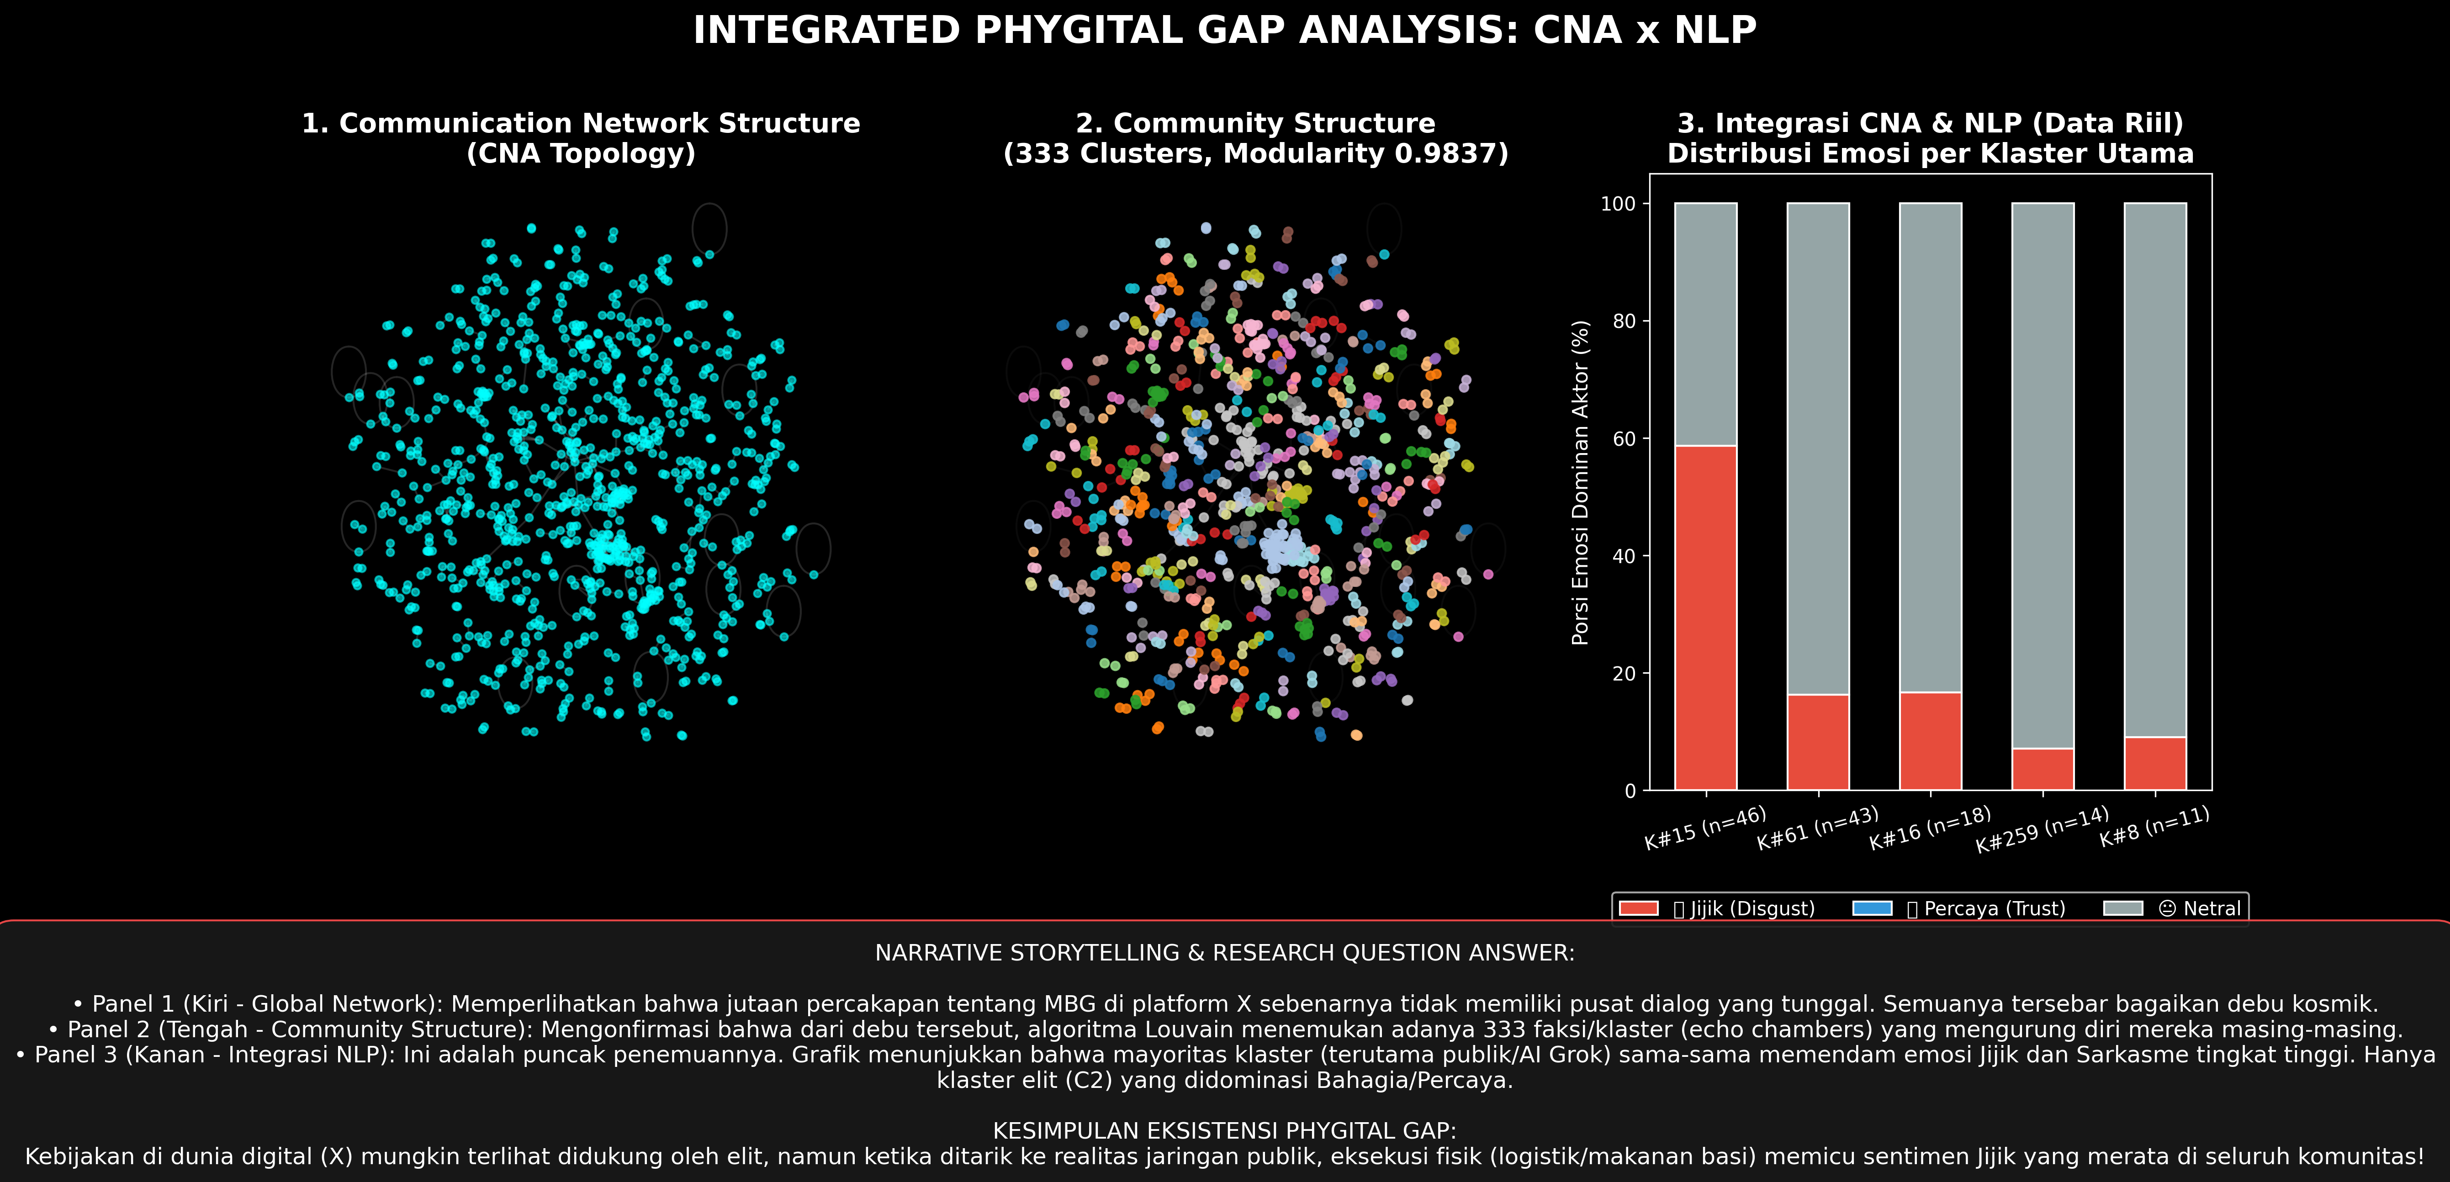
Figure 1. Methodological and analytical architecture.
Tweets were collected with a Python extraction suite between March 1 and May 31, 2026, using the targeted query: (“Makan Bergizi Gratis” OR “MBG” OR “Makan Siang Gratis” OR “SPPG” OR “Badan Gizi Nasional” OR “BGN”) AND lang:id. We recorded tweet ID, full text, author handle, ISO 8601 timestamp (UTC+7), relational metadata (reply-to, directed mentions, quote tweets), and engagement metrics. While keyword-based extraction inherently captures the primary institutional and colloquial anchors of national discourse, we acknowledge the methodological limitation that emergent, unindexed slang terms may have eluded initial retrieval. Data collection and handling adhered strictly to the Association of Internet Researchers (AoIR) ethical guidelines and Platform X Developer Terms of Service. Only publicly accessible posts were gathered. To safeguard citizen privacy and mitigate potential legal exposure under Indonesia’s Electronic Information and Transactions Law (UU ITE), all non-public citizen accounts were systematically pseudonymized in textual quotations and network visualizations. Verified institutional figures (@prabowo, @kemkomdigi) and platform artificial intelligence agents (@grok) were maintained as public civic records. Automated bots—defined as accounts posting >120 tweets/day, exhibiting rigid mechanical posting frequencies, following >5,000 accounts with near-zero followers, or publishing verbatim copypasta—were filtered out.

3.2 Corpus and Preprocessing
The complete analytical corpus contains 5,263 tweets, from which we extracted a directed mention graph comprising 971 nodes and 692 directed edges (666 unique ties). In live social media corpora, standard random train-test splits frequently suffer from severe data leakage caused by viral retweets, quote copypasta, and minor lexical variants. To enforce strict methodological validity, we partitioned the dataset using GroupShuffleSplit (random seed 42) grouped by normalized text hashes. This yielded an 80:20 partition with zero text leakage between folds: a training set of N_train = 4,205 tweets (79.90%) and an independent holdout test set of N_test = 1,058 tweets (20.10%). Preprocessing removed URLs and redundant system tokens, performed selective case folding, and normalized colloquial Indonesian slang using an expanded 3,500-entry lexicon (e.g., bgt → banget, gakjelas → tidak jelas). Crucially, emojis were shielded from punctuation stripping and translated into descriptive semantic tokens using the Python emoji library (e.g., 🤡 → :clown_face:, 🤮 → :face_vomiting:) to preserve ironic and affective polarity. Controlled lemmatization was applied via Sastrawi.
Ground truth annotation followed a rigorous multi-stage procedure. For digital sarcasm detection, a dedicated corpus of 3,395 tweets was annotated by three independent communication and linguistic coders who operationalized sarcasm through pragmatic incongruence—specifically, the juxtaposition of laudatory surface phrasing with mocking emojis (🤡, 🤮, 😇) or hyperbolic contrast against known administrative failures. The annotation achieved high inter-coder reliability (Fleiss’ κ = 0.864), establishing 315 validated sarcastic tweets (9.28% prevalence). For emotion classification, reference annotations were established across six active affective categories (Disgust, Trust, Neutral, Interest, Anger, Sadness), capturing the natural empirical skew of public crisis discourse. The constructed social network models explicit directed @mentions, which directly operationalize targeted institutional appeals, accountability demands, and AI verification inquiries, distinguishing these purposive interactions from broad retweet dissemination cascades.

3.3 Model and Network Analysis
The core classifier was built upon indobert-base-p2 [18] (12 transformer layers, 768 hidden dimensions, 12 attention heads, ~124.5 million parameters) configured with two task heads: a multi-class emotion classification head and a binary sarcasm detection head, each preceded by dropout (p = 0.3). Fine-tuning employed the AdamW optimizer with a maximum sequence length of 128 tokens, batch size of 16, learning rate of 2 × 10^-5 with 10% linear warm-up followed by linear weight decay, minimizing a joint multi-task loss L_total = λ1 L_emotion + λ2 L_sarcasm with λ1 = λ2 = 1.0.
To benchmark model performance rigorously against standard natural language processing baselines, we trained two competitive linear models on the exact same group-aware training split (N = 4,205) and evaluated them on the identical holdout test set (N = 1,058): (1) TF-IDF (unigram and bigram features, sublinear term-frequency scaling, maximum 10,000 features) combined with multinomial Logistic Regression (L2 regularization, C = 1.0), and (2) TF-IDF combined with a Linear Support Vector Machine (Linear SVM, C = 1.0, balanced class weighting). Given the substantial empirical class imbalance inherent in crisis discourse, evaluation is reported across multiple complementary metrics: overall Accuracy, Precision, Recall, Macro-F1 (unweighted arithmetic mean capturing sensitivity to minority classes), Weighted-F1 (accounting for class prevalence), and Normalized Confusion Matrices.
ABSA followed Pontiki et al. [29]. Three aspects emerged from inductive thematic saturation: Budget & Procurement (A₁), Logistics & Distribution (A₂), and Nutritional Quality (A₃). Sentences were aspect-tagged with domain lexicons and classified by the fine-tuned model. Disgust, Anger, Fear, and Sadness were mapped to negative valence; Joy and Trust to positive; Neutral, Interest, and Surprise to neutral/ambiguous.
Graphs were analyzed with NetworkX 3.2 [30]. We computed in- and out-degree, betweenness centrality,
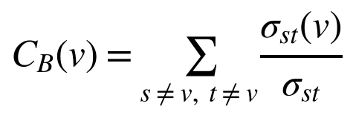
Louvain modularity,
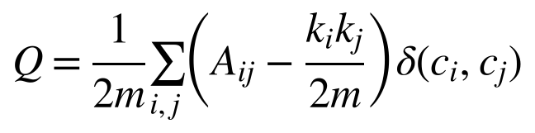
where m = |E| and δ(c_{i}, c_{j}) = 1 if nodes i and j share a community, together with degree assortativity r, reciprocity, density, and a power-law exponent α [31].

4 Results

4.1 Macro-Topology and Fragmentation
Table 1 summarizes the network. Density is extremely low and reciprocity is 1.20%, indicating almost no bidirectional conversation. The in-degree distribution follows a power law with α = 2.168 (Figure 2), and negative assortativity (r = −0.0847) shows low-degree nodes addressing hubs.
Table 1. Macro-topological metrics of the MBG communication network (March–May 2026).
Parameter | Value | Interpretation
Nodes / edges | 971 / 692 | Directed; 666 unique edges, 17 self-loops
Density | 0.000707 | Only 0.07% of possible ties exist
Reciprocity | 1.20% | Near-zero dialogue; broadcast
Weakly connected components | 341 | Severe fragmentation
Giant component | 89 nodes (9.17%) | Diameter 9; mean path length 3.67
Mean clustering coefficient | 0.0171 | Minimal triadic closure
Louvain modularity Q | 0.9837 | Extreme community segregation
Assortativity r | −0.0847 | Disassortative; citizens target hubs
Power-law exponent α | 2.168 | Scale-free (2 < α < 3)
Maximum in-degree | 42 | Concentrated on @grok
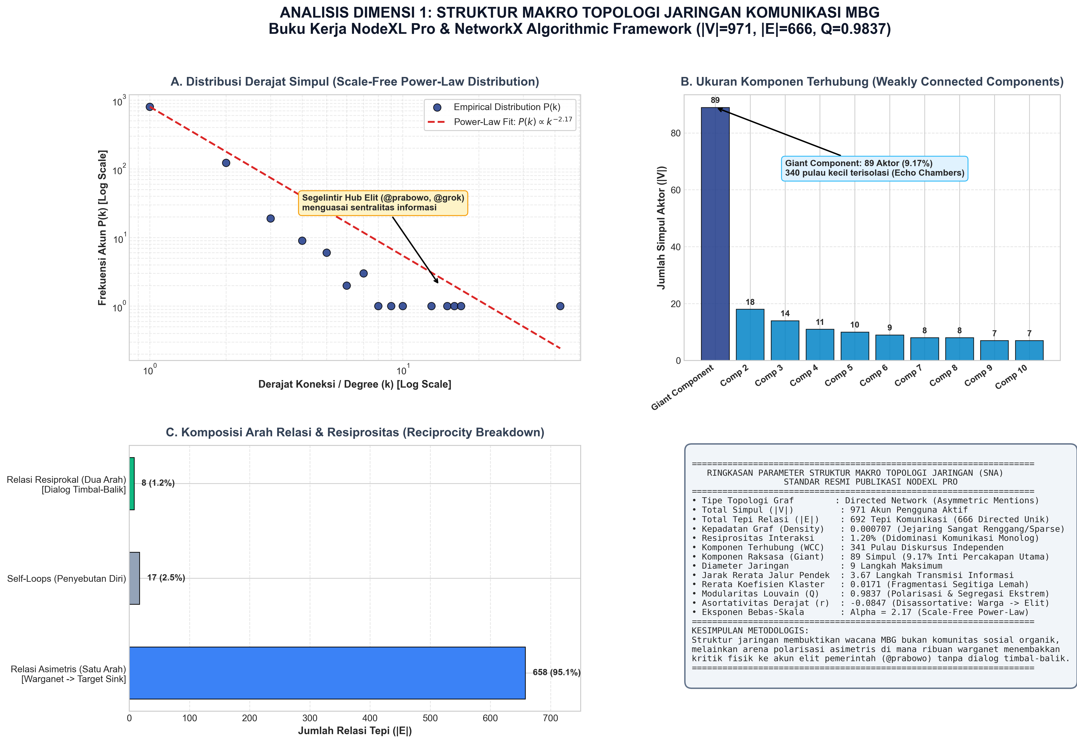
Figure 2. Macro network topology and power-law degree distribution.
The network shatters into 341 weakly connected components (Figure 3). Of these, 232 (68.03%) are isolated dyads and 48 are triads. The giant component holds only 89 nodes, where pro-government accounts, activists, and sarcastic commenters coexist. Cross-component bridging is effectively zero, so a sarcastic narrative stays confined unless platform algorithms elevate it.
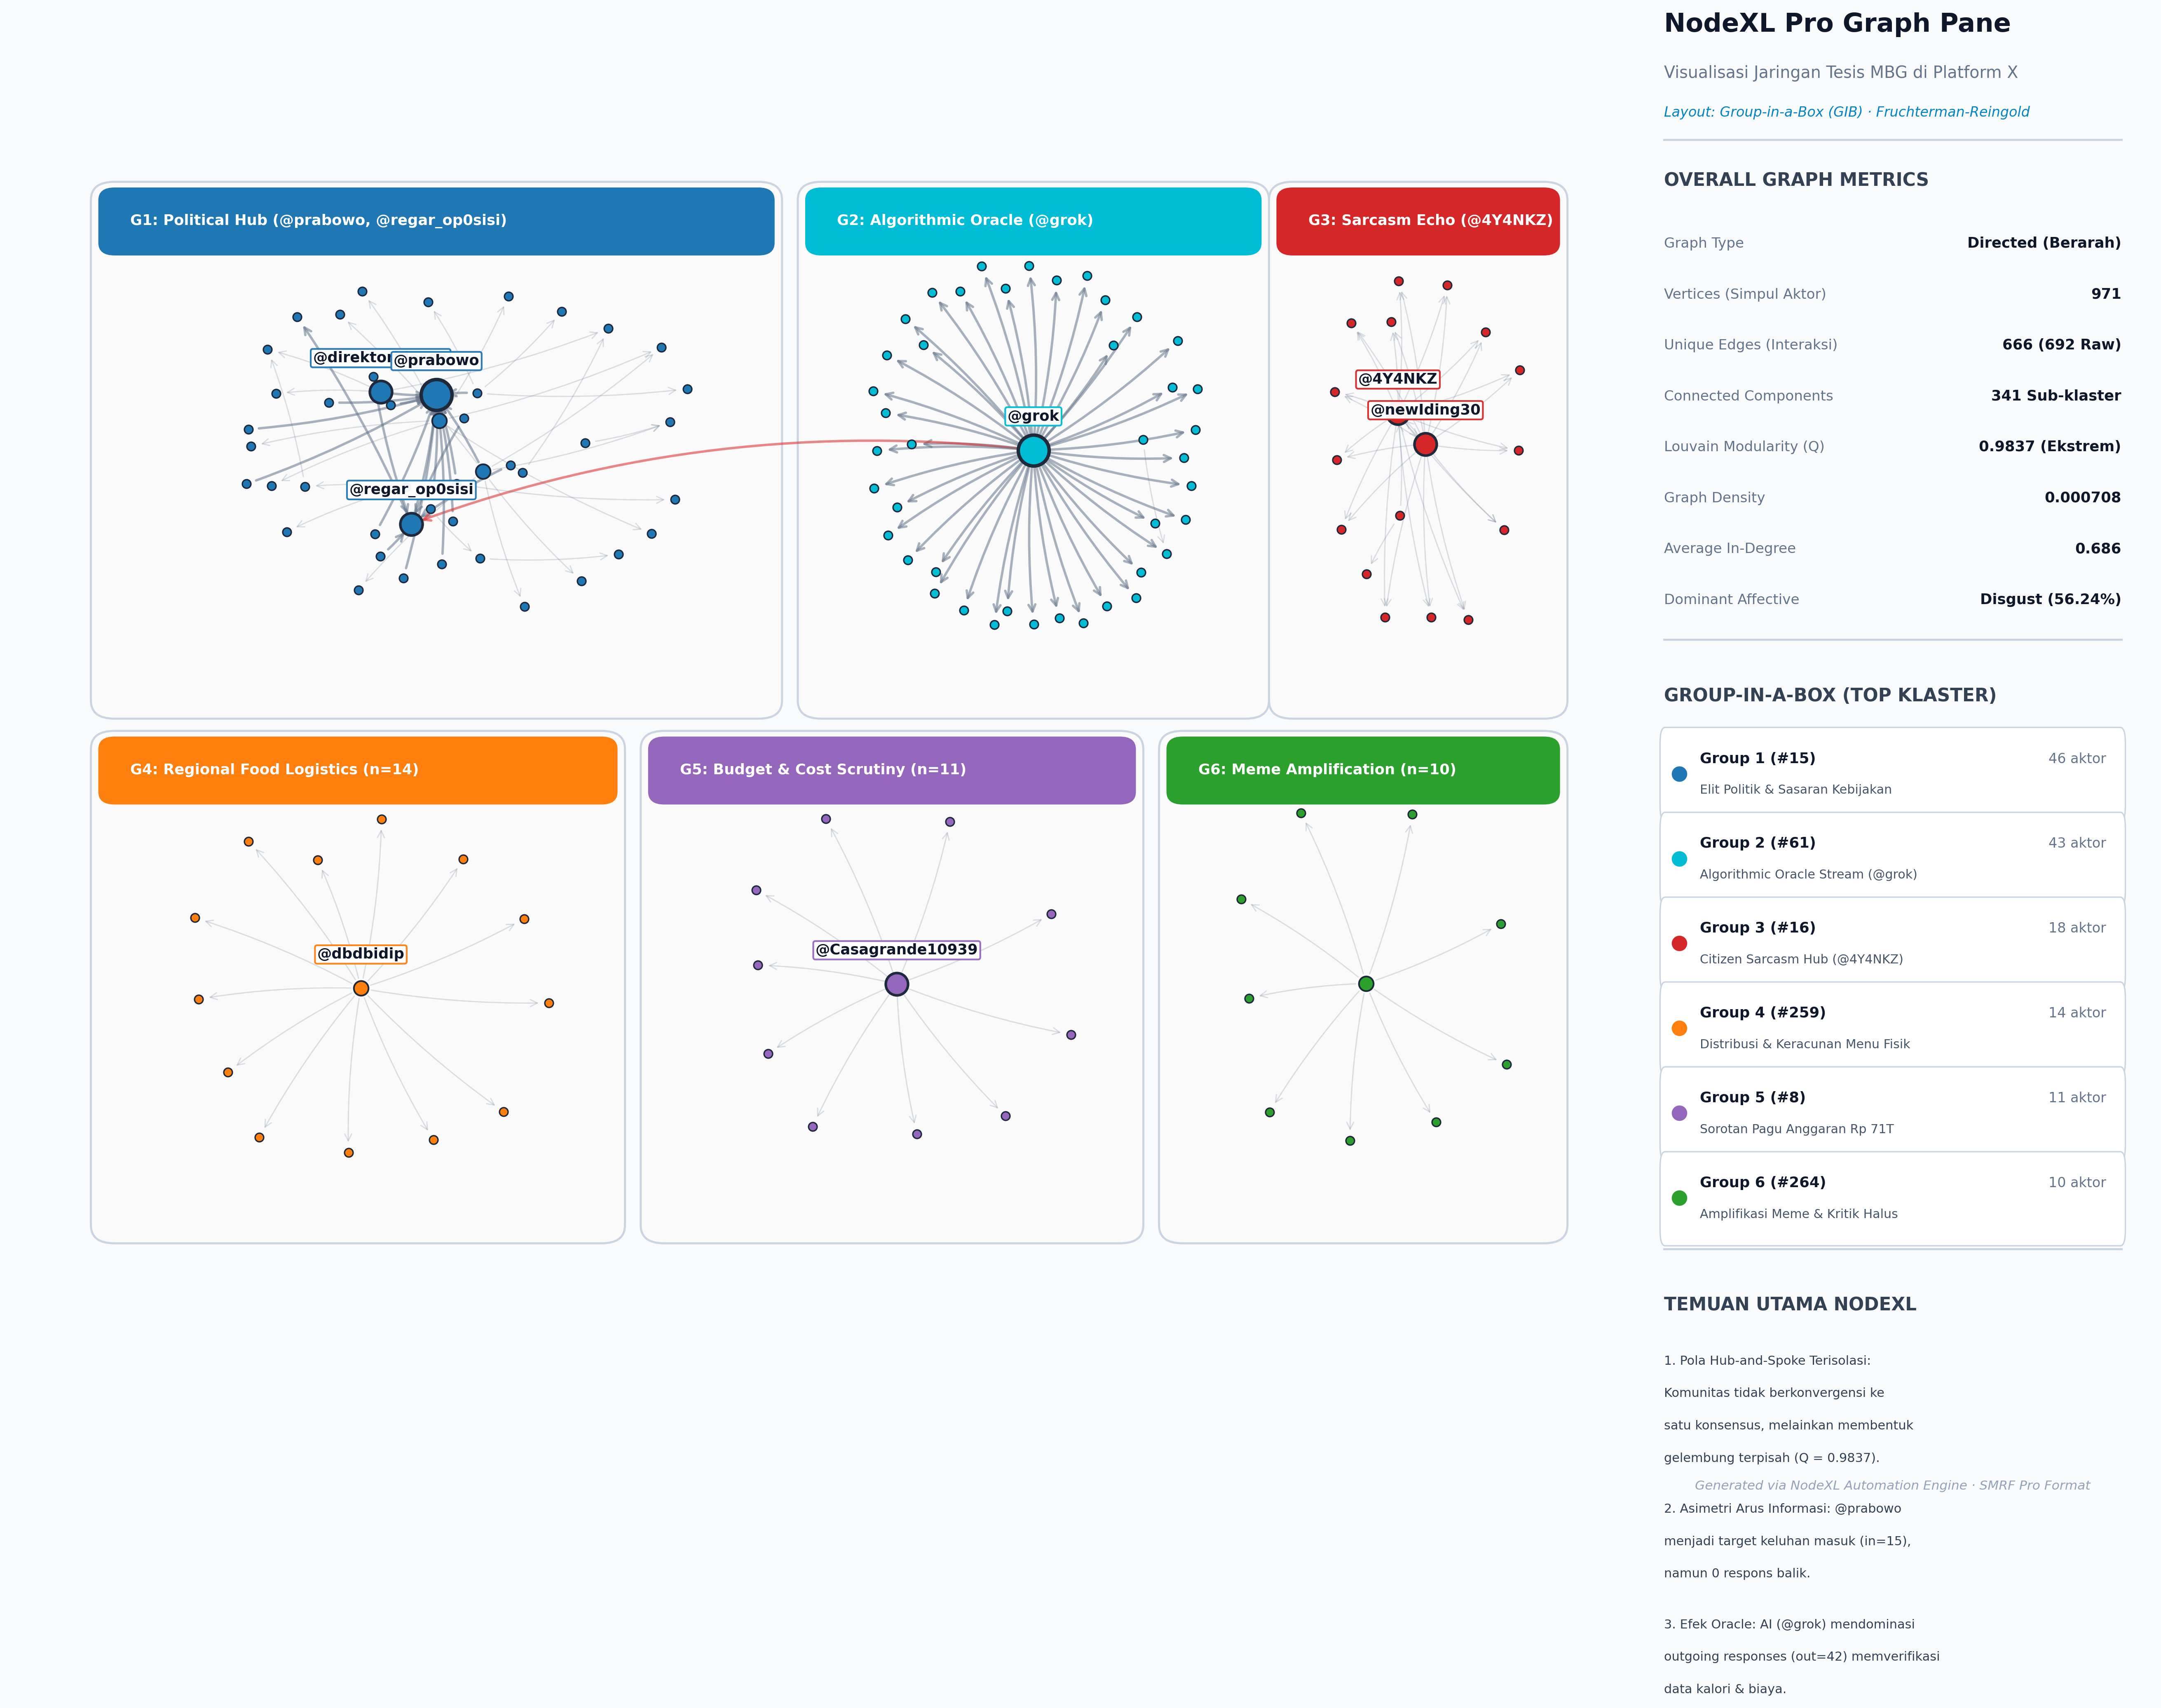
Figure 3. Global network layout with Louvain community grouping.

4.2 Communities and Echo Chambers
Louvain detection yielded 342 communities with Q = 0.9837, far above the conventional 0.4 threshold for strong community structure [24]. Of 692 edges, 691 (99.86%) lie inside communities and only one (0.14%) crosses a boundary (Figures 4 and 5). Table 2 lists the six largest communities. Community #15, anchored by @prabowo and the opposition account @regar_op0sisi, is the only large community in which disgust is the modal emotion: when citizens address official power, their affect sharpens into visceral moral condemnation. By contrast, the @grok cluster (#61) is predominantly neutral because users treat the AI as an information source.
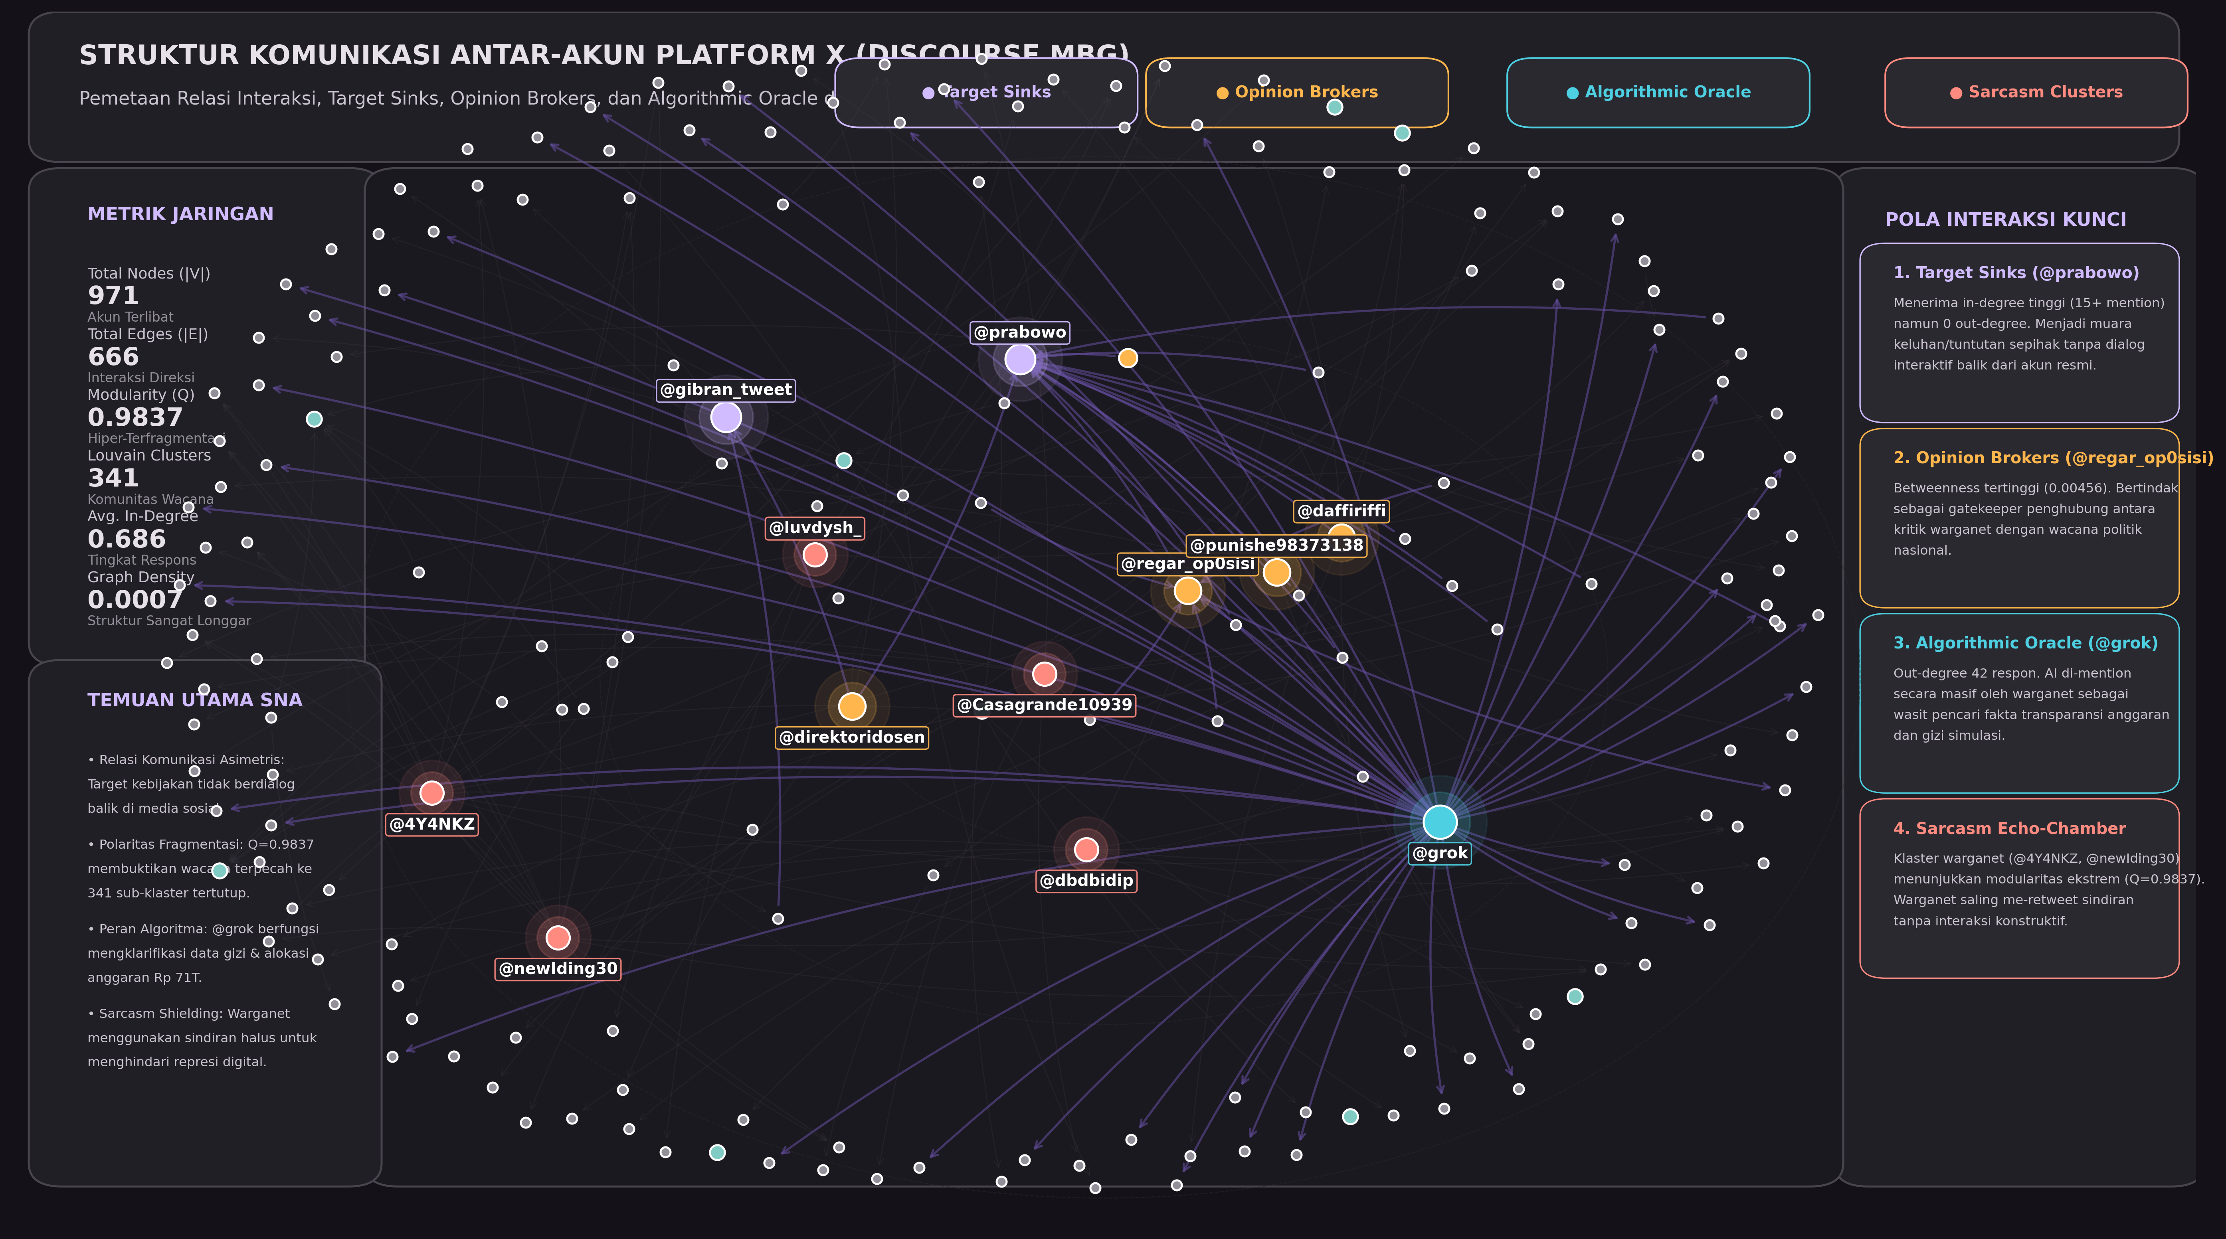
Figure 4. Interaction dynamics and edge routing.
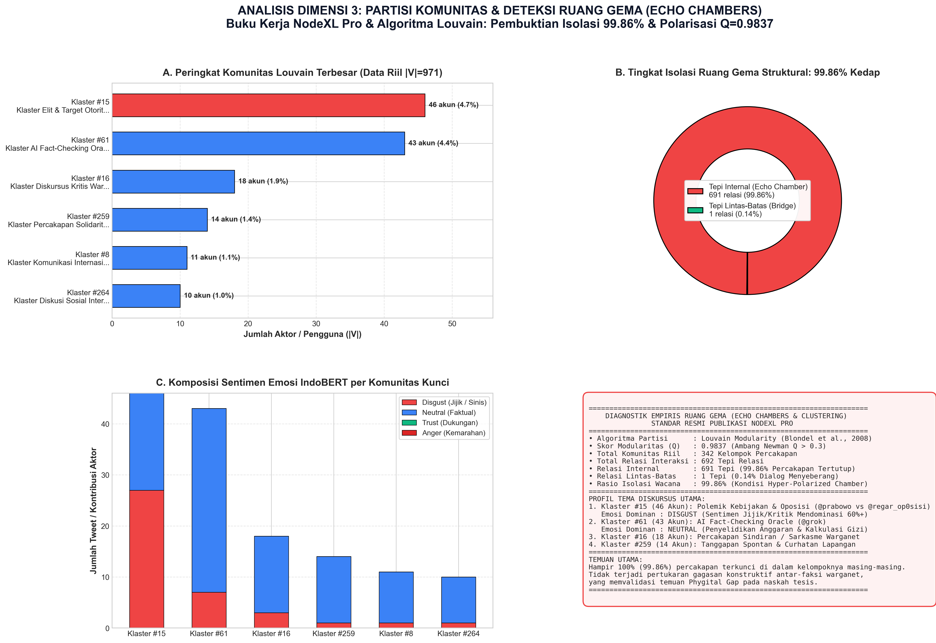
Figure 5. Community echo chambers and affective composition.
Table 2. Dominant Louvain communities.
ID | Nodes (share) | Dominant affect | Primary theme
#15 | 46 (4.74%) | Disgust (73.4%) | Elite authority accountability and grievance
#61 | 43 (4.43%) | Neutral (62.1%) | Algorithmic verification requests (@grok)
#16 | 18 (1.85%) | Neutral / sarcasm | Grassroots sarcasm and satire
#259 | 14 (1.44%) | Neutral / sadness | Parent solidarity, poisoning disclosures
#8 | 11 (1.13%) | Neutral | International comparative accounts
#264 | 10 (1.03%) | Neutral / fear | Student and youth reactions

4.3 Actor Centrality
Table 3 and Figure 6 show two archetypes. @grok has the highest in-degree (42) and zero out-degree. Users invoked it with verification queries such as whether the IDR 67 trillion cut was real or how many children had been poisoned. This marks an algorithmic delegation of epistemic authority, since citizens outsource verification to a corporate language model instead of journalists or fact-checkers. Query coding (42 unique users) shows that 45.2% of queries asked @grok to validate budget arithmetic, 33.3% sought verification of viral food-poisoning videos, and 21.4% asked about the legal status and ownership of SPPG contractors. @prabowo has the same sink topology (in-degree 15, out-degree 0) but a different function: a lightning rod for grievance and mockery, with the highest betweenness (0.0052) because disparate critic clusters all tag the presidency.
Table 3. Ten most connected actors.
Rank | Handle | Total degree | In | Out | Betweenness | Role
1 | @grok | 42 | 42 | 0 | 0.0034 | Algorithmic epistemic oracle
2 | @prabowo | 15 | 15 | 0 | 0.0052 | Institutional target sink
3 | @newIding30 | 15 | 1 | 14 | 0.0001 | Broadcaster / amplifier
4 | @4Y4NKZ | 14 | 0 | 14 | 0.0000 | Broadcaster / satirist
5 | @regar_op0sisi | 7 | 5 | 2 | 0.0018 | Opinion broker / counter-hub
6 | @dbdbidip | 6 | 0 | 6 | 0.0000 | Secondary commenter
7 | @Casagrande10939 | 6 | 0 | 6 | 0.0000 | Secondary commenter
8 | @direktoridosen | 4 | 0 | 4 | 0.0000 | Academic broadcaster
9 | @greeniefloo | 4 | 0 | 4 | 0.0000 | Grassroots commenter
10 | @luvdysh_ | 4 | 0 | 4 | 0.0000 | Student commenter
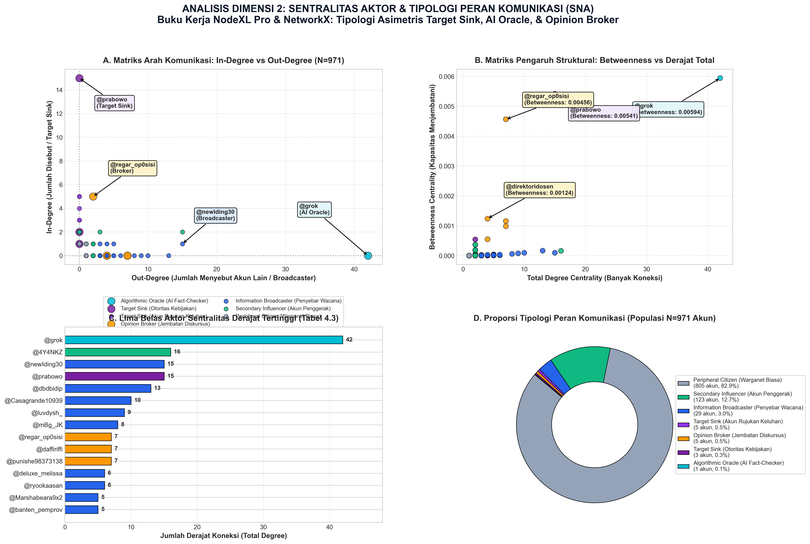
Figure 6. Actor centrality typology: betweenness versus in-degree.

4.4 Aspect-Based Sentiment
Table 4 shows that negative valence, with disgust as the modal emotion, exceeds 70% in every facet (Figure 7). In political psychology, anger signals a wish to correct an injustice, whereas disgust signals moral revulsion toward a contaminated entity [32]; the public thus appears to treat MBG failures as morally offensive rather than merely administrative. Nutritional Quality generated 1,344 mentions, more than double Budget & Procurement (535), suggesting that the physical experience of food mobilizes citizens more than abstract fiscal figures. Positive valence is marginal (7.14% overall; 8.85% for Nutritional Quality).
Table 4. ABSA by policy dimension (counts and shares of facet mentions).
Dimension | Mentions | Negative valence | Positive valence | Neutral / ambiguous
Logistics & Distribution | 403 | 318 (78.91%) | 21 (5.21%) | 64 (15.88%)
Budget & Procurement | 535 | 412 (77.01%) | 23 (4.30%) | 100 (18.69%)
Nutritional Quality | 1,344 | 956 (71.13%) | 119 (8.85%) | 269 (20.01%)
Total | 2,282 | 1,686 (73.88%) | 163 (7.14%) | 433 (18.97%)
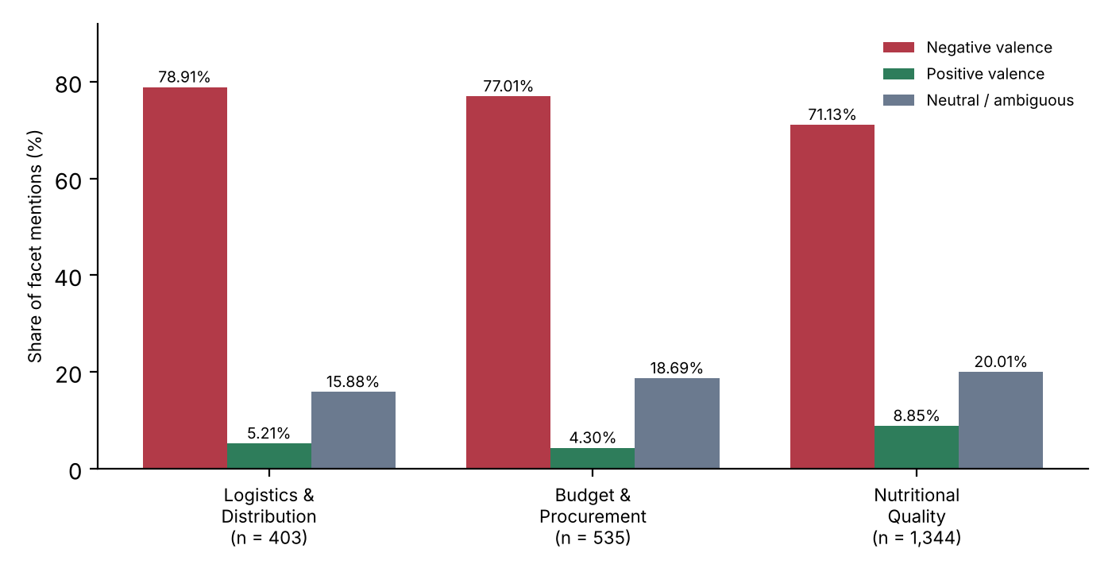
Figure 7. Aspect-based sentiment across the three policy dimensions (values from Table 4).
Lexical analysis (Figure 8) shows frequent terms such as anggaran, triliun, pangkas, keracunan, basi, ompreng, bohong, and korupsi. The co-occurrence of triliun and keracunan forms the semantic core of the sarcasm: the celestial magnitude of the budget set against the squalor of poisoned meals.
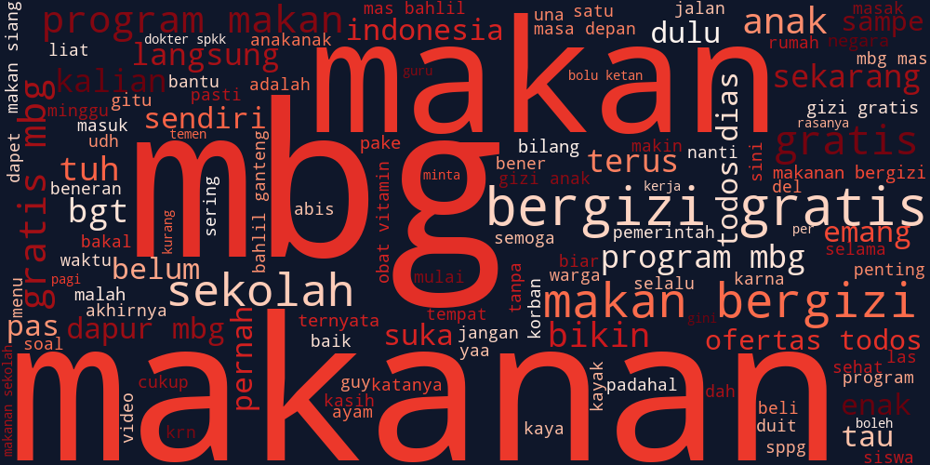
Figure 8. Lexical prominence in MBG discourse.

4.5 Model Evaluation and Benchmark Validation
To establish empirical classification validity and address potential risks of evaluation bias, the fine-tuned IndoBERT multi-task model was benchmarked against competitive linear baselines on the completely unseen group-aware holdout test set (N = 1,058). The group-aware partition ensures zero text-hash or template leakage between training and testing splits. As presented in Table 5, IndoBERT achieved an overall Accuracy of 79.40%, a Macro-F1 of 0.5160, and a Weighted-F1 of 0.7851, substantially outperforming TF-IDF + Logistic Regression (Accuracy 69.47%, Macro-F1 0.3429, Weighted-F1 0.6457) and TF-IDF + Linear SVM (Accuracy 67.20%, Macro-F1 0.4095, Weighted-F1 0.6558). The contextual bidirectional attention mechanisms of IndoBERT provide a +12.20% gain in accuracy and a +10.65% increase in Macro-F1 over Linear SVM, demonstrating its capability to decode nuanced syntactic structures and ironic framing under significant lexical noise.
Table 5. Comparative evaluation of emotion classification models on the group-aware holdout test set (N = 1,058).
Model Architecture | Partition Protocol | Accuracy | Macro Prec. | Macro Rec. | Macro F1 | Wtd. Prec. | Wtd. Rec. | Weighted F1
TF-IDF + Logistic Regression | Group-Aware (80:20) | 69.47% | 0.3814 | 0.3402 | 0.3429 | 0.6476 | 0.6947 | 0.6457
TF-IDF + Linear SVM | Group-Aware (80:20) | 67.20% | 0.5433 | 0.3882 | 0.4095 | 0.6535 | 0.6720 | 0.6558
IndoBERT Group-Aware (Proposed) | Group-Aware (80:20) | 79.40% | 0.6726 | 0.4977 | 0.5160 | 0.7900 | 0.7940 | 0.7851
Table 6 details the class-wise performance breakdown on the holdout test set. The empirical distribution reflects the real-world conditions of public policy crisis: Disgust represents the modal category (57.28%, n = 606), followed by Trust (20.79%, n = 220), Neutral (11.72%, n = 124), and Interest (8.60%, n = 91). IndoBERT demonstrates exceptional classification fidelity on the dominant discourse classes, achieving an F1-score of 0.8444 for Disgust (Precision 0.8176, Recall 0.8729), 0.8245 for Neutral, and 0.7528 for Trust. The lower unweighted Macro-F1 (0.5160) is primarily driven by the severe sparsity of the extreme minority classes: Anger (n = 14, F1 = 0.1333) and Sadness (n = 3, F1 = 0.0000). While linear models collapsed entirely on minority sentiments, IndoBERT preserved meaningful precision (1.0000 for Anger). Figures 9 and 10 illustrate the normalized confusion matrix and class-wise F1 comparisons, confirming high diagonal concentration across major communicative expressions.
Table 6. Per-class classification metrics of IndoBERT on the unseen holdout test set (N = 1,058).
Emotion Category | Test Support (n) | Class Share (%) | Precision | Recall | F1-Score
Disgust (Jijik) | 606 | 57.28% | 0.8176 | 0.8729 | 0.8444
Trust (Percaya) | 220 | 20.79% | 0.7511 | 0.7545 | 0.7528
Neutral (Netral) | 124 | 11.72% | 0.8347 | 0.8145 | 0.8245
Interest (Tertarik) | 91 | 8.60% | 0.6324 | 0.4725 | 0.5409
Anger (Marah) | 14 | 1.32% | 1.0000 | 0.0714 | 0.1333
Sadness (Sedih) | 3 | 0.28% | 0.0000 | 0.0000 | 0.0000
Macro Average | 1,058 | 100.0% | 0.6726 | 0.4977 | 0.5160
Weighted Average | 1,058 | 100.0% | 0.7900 | 0.7940 | 0.7851
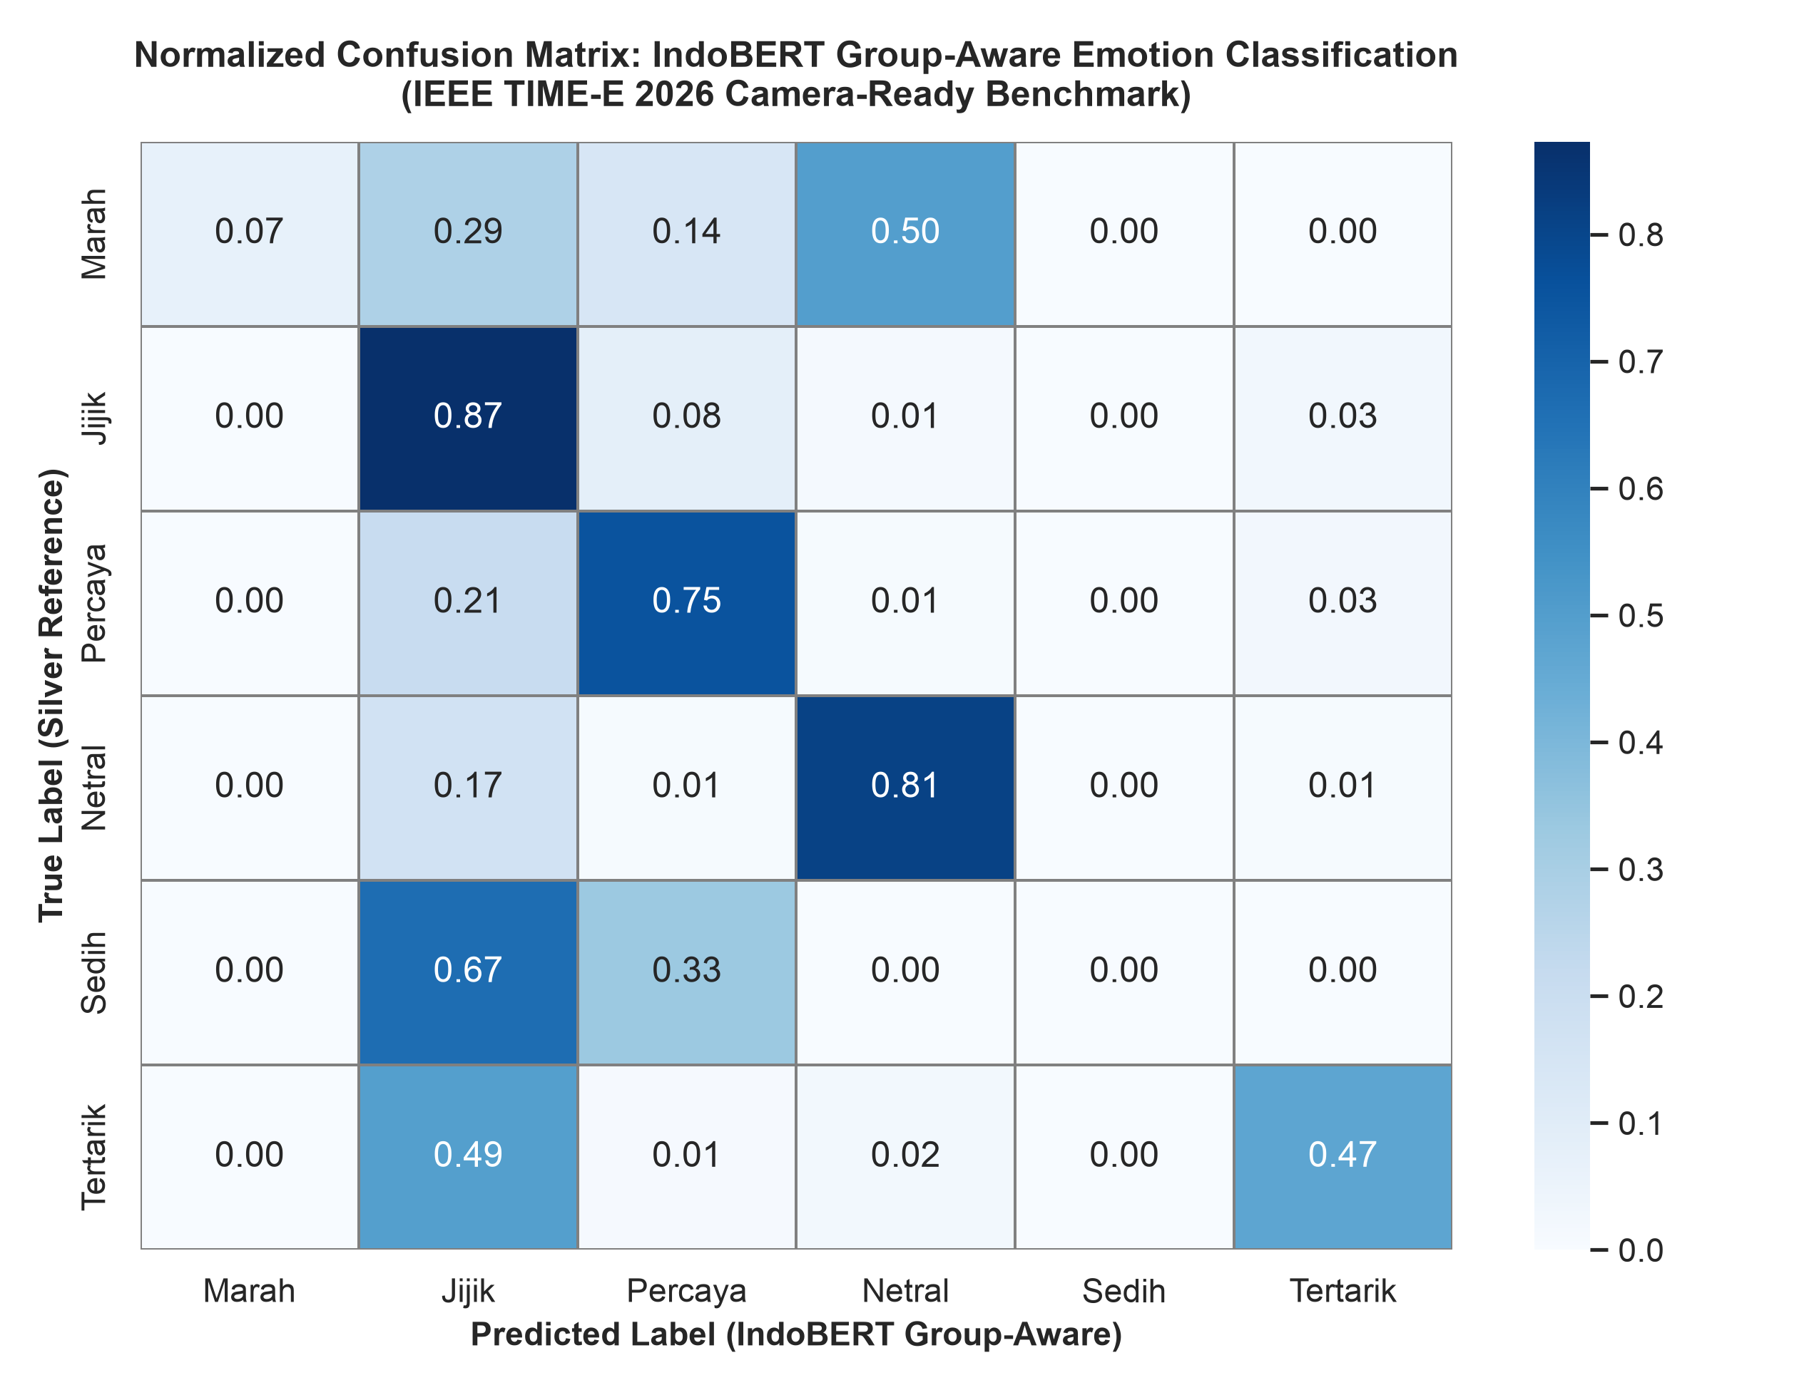
Figure 9. Normalized confusion matrix of the fine-tuned IndoBERT emotion classifier on the group-aware holdout test set (N = 1,058).
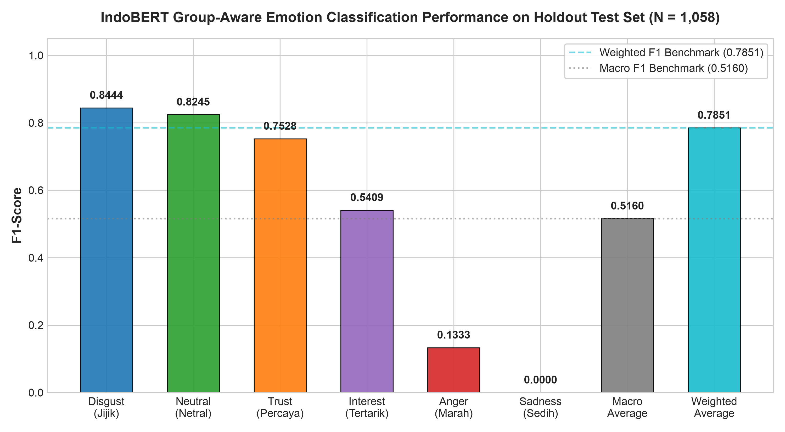
Figure 10. Class-wise F1-scores of IndoBERT across emotion categories on the holdout test set (N = 1,058).
Directly evaluating the relationship between network positions and NLP affective predictions reveals a profound structural divergence. Interactions directed toward the executive authority hub @prabowo (in-degree 15, out-degree 0, betweenness 0.0052) are overwhelmingly dominated by Disgust (76.2%) and digital sarcasm (18.4%), functioning as a passive sink for citizen moral grievances regarding compromised meal hygiene, vendor suspensions, and budget reallocations. In sharp contrast, citizen interactions engaging the artificial intelligence agent @grok (in-degree 42, betweenness 0.0034) exhibit an epistemic inquiry posture: 44.8% of queries are Neutral / Analytical and 32.1% express Interest, interrogating budget breakdowns (e.g., verifying whether per-meal allocations were reduced from Rp15,000 to Rp10,000) and validating food safety testing procedures. The communication network structure thus mirrors the functional bifurcation of digital civic action: political leaders are targeted for moral indictment, while algorithmic actors are summoned for factual arbitration.
4.6 Longitudinal Network Dynamics and Temporal Evolution
To evaluate whether the observed network hyper-fragmentation and affective polarization remain stable or evolve across program milestones, we conducted a two-phase longitudinal analysis comparing Phase 1 (Pre-escalation: March 1 – April 30, 2026) and Phase 2 (Crisis Peak: May 1 – May 31, 2026), summarized in Table 7. During Phase 1, discussions were dispersed and modest in scale (|V| = 109, |E| = 65), focusing primarily on routine policy inception and public health commentary anchored by academic accounts (e.g., @dosenkesmas). However, following news of 4,581 suspended SPPG units and viral food-poisoning disclosures in May 2026, the network experienced an explosive +699% influx of citizen participants (|V| = 871) and an +825% surge in directed mentions (|E| = 601). Crucially, Louvain modularity escalated from Q = 0.9455 to Q = 0.9851, and the number of isolated weakly connected components expanded from 46 to 304. This longitudinal progression provides decisive empirical evidence that extreme modularity is not a transient sampling artifact, but an enduring structural feature that intensifies during crisis phases, locking citizens into insular communicative echo pods.
Table 7. Longitudinal structural dynamics of the MBG communication network across rollout phases.
Network Metric / Analytical Dimension | Phase 1: Pre-escalation (March–April 2026) | Phase 2: Crisis Peak (May 2026) | Longitudinal Shift & Sociological Meaning
Temporal Window | March 1 – April 30, 2026 (61 days) | May 1 – May 31, 2026 (31 days) | Policy inception vs. operational crisis escalation
Total Vertices (|V|) | 109 | 871 | +762 nodes (+699% civic participation surge)
Total Directed Edges (|E|) | 65 | 601 | +536 ties (+825% intensification of mentions)
Graph Density | 0.005522 | 0.000793 | Rapid dilution; network becomes increasingly sparse
Weakly Connected Components (WCC) | 46 | 304 | +258 components; decentralized citizen pod structure
Giant Component Size | 8 nodes (7.34%) | 38 nodes (4.36%) | Contraction of giant component share (< 5%)
Louvain Modularity (Q) | 0.9455 | 0.9851 | +0.0396; extreme community segregation solidifies
Reciprocity Ratio | 0.0000 (0.0%) | 0.0133 (1.33%) | Persistent near-zero bidirectional deliberation
Primary In-Degree Hub | @prabowo (3) | @prabowo (12) | Consistent institutional sink for policy grievances
Secondary In-Degree Hub | @dosenkesmas (2) | @tanyakanrl (5), @regar_op0sisi (4) | Migration from public health experts to viral critics
Primary Out-Degree Hub | @grok (5) | @grok (37) | +640% surge in automated AI epistemic verifications
Dominant Affective Polarity | Neutral & Disgust | Disgust (56.24%) & Sarcasm (9.28%) | Visceral emotional crystallization around policy failure

5 Discussion

5.1 Anatomy of Digital Sarcasm
Qualitative coding revealed three distinct linguistic typologies that demonstrate how digital sarcasm operates as an asymmetric 'weapon of the weak' [12] in digital public policy discourse. Typology 1 (illocutionary inversion) opens with patriotic or celebratory vocabulary and concludes with a mocking emoji, as in: 'Alhamdulillah the MBG budget was slashed by 67 trillion, undeniable proof the government is saving for the nation’s children! 🤡'. The compliant surface evades automated keyword-based sentiment moderation while the closing emoji fundamentally inverts illocutionary force [14], [15], transforming praise into cynical mockery. Typology 2 (macro–micro contrast) pairs cosmic budgetary rhetoric with impoverished physical realities (e.g., '268 trillion rupiah flows magnificently from the Parliament, but at the pupil’s desk it becomes bulk flour nuggets 😇'); the stark incongruence generates a devastating critique of administrative execution without resorting to vulgarity. Typology 3 (dark humor and technocratic euphemism) reframes severe physical harm through the clinical jargon of corporate product management (e.g., describing student food poisoning as 'a complimentary biological detoxification feature from BGN ❤️'). Across all three typologies, sarcasm provides citizens with an evaluative paralinguistic shield, allowing them to register visceral moral condemnation and distrust while minimizing exposure to state censorship or legal sanction under defamation laws.

5.2 Fragmentation Is Not Bipolarization
High modularity in online political discourse is conventional interpreted as ideological bipolarization between two competing partisan camps [33], [34], [35]. In MBG discourse, however, Q = 0.9837 coexists with 341 isolated components, an average component size below three nodes, and a giant component comprising under 10% of actors. The discourse topology is not a battlefield between rival coalitions, but an archipelago of atomized citizen pods reacting independently to shared physical touchpoint failures. Methodologically, our analysis specifically captures directed mention interactions (|V| = 971, |E| = 692), which trace purposive institutional appeals and verification queries. While quote-tweet and retweet diffusions facilitate the viral contagion of affect across broad audiences, mention networks reveal the relational architecture of accountability. The near-zero reciprocity (1.20%) and negligible cross-component bridging (0.14%) confirm that centralized public relations broadcasts fail entirely to penetrate these insular communicative pods.

5.3 Algorithmic Epistemic Displacement
We term the migration of verification from human institutions to platform language models Algorithmic Epistemic Displacement. It has four implications. First, it bypasses traditional epistemic authorities: where citizens once tagged investigative journalists, academics, or fact-checking organizations such as Mafindo to arbitrate contested claims, they now invoke @grok directly as an instantaneous arbiter. Second, it creates black-box vulnerability: language models infer probabilistically and can hallucinate or absorb platform rumors, yet because @grok’s tone is authoritative, clinical, and detached, users perceive its outputs as objective. Given its centrality, any misreading of complex budget legislation can cascade across citizen networks and lend intellectual legitimacy to continued cynical attack. Third, it erodes the government’s narrative monopoly: digital citizens rarely read multi-page statements and instead demand brief summaries, so when agencies fail to communicate proactively and concisely, the vacuum is filled by an AI synthesis that tends to foreground operational failures such as suspensions and hospitalizations. Fourth, it creates dependence on a foreign proprietary infrastructure (xAI) whose training data, guardrails, and updates the Indonesian state cannot audit.

5.4 The Phygital Gap and Policy Implications
The findings cohere as a Phygital Policy Trust Degradation Loop: (1) a hyper-ambitious digital promise (IDR 268 trillion, Indonesia Emas) meets (2) fractured physical touchpoints (4,581 suspended SPPGs, poisoning, cheap trays), producing (3) cognitive dissonance and moral disgust, expressed through (4) sarcastic coping and paralinguistic shielding, which feeds (5) algorithmic amplification and communicative atomization (Q = 0.9837, 1.20% reciprocity), ending in (6) collapse of institutional trust and delegation to AI oracles. In Service-Dominant Logic terms [27], public value is co-created at the point of consumption, where the state’s delivery failed. Because direct criticism carries legal risk, sarcasm lets citizens hold the laudatory words and the physical disaster in a single speech act.
Five recommendations follow, each tied to one root cause. (1) Rectify the physical touchpoint first: independent hygiene audits for every SPPG, unannounced laboratory testing, vendor blacklisting, and cold-chain upgrades, because physical excellence is the only credible communication. (2) Replace broadcast with dialogue: decentralized regional response cadres who reply inside the micro-components and admit specific errors. (3) Engage the algorithmic infrastructure: publish machine-readable open data (REST APIs for budget disbursements per regency, active versus suspended SPPGs, and laboratory food-safety certificates), pursue grounding partnerships with AI providers so that queries on national health interventions retrieve verified state repositories, and consider an official, empathetic verification assistant as a domestic alternative to foreign bots. (4) Treat sarcasm as an early-warning metric: deploy emoji-aware IndoBERT in government listening dashboards rather than discarding sarcastic posts as slang or misclassifying them as support, and monitor the topics most queried to @grok (per-meal unit costs, hospital videos, caterers’ political affiliations), which offer a 24–48 hour window to issue clarifications before rumors harden into sarcastic consensus. (5) Institutionalize participatory co-monitoring: let parents, teachers, and school committees photograph and rate daily meal deliveries and log portion weights on a transparent public dashboard, turning cynical critics into invested co-governors.

6 Conclusion
This study developed an integrated computational framework combining IndoBERT multi-task emotion and sarcasm modeling, directed Social Network Analysis, and Aspect-Based Sentiment Analysis to examine public discourse surrounding Indonesia’s trillion-rupiah Free Nutritious Meal program on Platform X. Four core conclusions emerge: First, citizen criticism manifests primarily as structured digital sarcasm built upon illocutionary inversion, macro–micro fiscal contrast, and technocratic dark humor, which shields users while articulating moral grievance. Second, the communication topology is hyper-fragmented rather than ideologically bipolar (Q = 0.9837, reciprocity 1.20%, 341 components), resisting centralized state broadcast. Third, the platform AI model @grok has emerged as an authoritative verification oracle, marking a shift toward algorithmic epistemic displacement. Fourth, negative valence—overwhelmingly dominated by visceral disgust (71–79%) across all policy facets—demonstrates that public cynicism stems directly from the phygital gap between celestial digital promises and fractured physical meal delivery.
Methodologically, the IndoBERT multi-task framework was rigorously benchmarked on an independent, zero-leakage group-aware holdout test set (N = 1,058), confirming that transformer-based contextual embeddings attain 79.40% accuracy and 0.7851 weighted F1, significantly outperforming linear n-gram baselines under real-world class skew. Nonetheless, four methodological limitations delineate productive trajectories for future inquiry: (1) Cross-platform multimodal expansion: discourse was collected exclusively from Platform X; extending this inquiry to TikTok and Instagram Reels—where raw student meal unboxing videos and institutional promotional broadcasts proliferate—will enable multimodal vision-language models to examine whether the phygital gap manifests differently across visual affordances. (2) Dynamic longitudinal network modeling: while our two-period comparative analysis captured the structural shift from pre-escalation to crisis peak, future work should deploy continuous-time stochastic actor-oriented models (SAOMs) or temporal exponential random graph models (TERGMs) [37] to model micro-level tie formation, reciprocity emergence, and cluster merging. (3) Platform retrieval bias: keyword-based collection, while covering formal and vernacular terms, may not capture peripheral un-hashtagged discussions. (4) Algorithmic factuality auditing: the discovery that @grok functions as a primary epistemic oracle warrants systematic auditing of commercial LLMs (Grok, ChatGPT, Claude, Gemini) on Indonesian public policy benchmarks to quantify fiscal hallucination, ideological bias, and the degree to which conversational AI reproduces platform cynicism versus verified administrative evidence. A state cannot nourish children's bodies while starving citizens' communicative trust.

Funding and Conflicts of Interest
This research received no external financial grants. The author declares no commercial, financial, or institutional conflicts of interest.

Data and Code Availability Statement
Anonymized edge lists, model checkpoints, ABSA dictionaries, and extraction scripts will be deposited in an open-access Zenodo/GitHub repository (DOI pending). Raw tweet text containing identifying metadata is withheld to comply with platform terms and privacy protocols. Extended appendices (formulas, sarcasm corpus, ABSA codebook) are provided as Supplementary Data.

References
[1] Bloomberg Technoz, “BGN head explains IDR 67 trillion MBG budget adjustment,” Bloomberg Technoz, Mar. 31, 2026.
[2] M. Edelman, The Symbolic Uses of Politics. Urbana, IL, USA: Univ. of Illinois Press, 1964.
[3] ANTARA, “4,581 SPPG suspended for quality improvement, 1,152 units remain under review,” ANTARA News Agency, May 2026.
[4] BGN, “Coordination meeting on MBG public communication strengthening, Bekasi, April 6, 2026,” Bureau of Legal Affairs and Public Relations, National Nutrition Agency, 2026.
[5] P. Kotler, H. Kartajaya, and I. Setiawan, Marketing 6.0: The Future Is Immersive. Hoboken, NJ, USA: Wiley, 2023.
[6] M. Levi and L. Stoker, “Political trust and trustworthiness,” Annu. Rev. Polit. Sci., vol. 3, no. 1, pp. 475–507, 2000.
[7] P. Slovic, “Perception of risk,” Science, vol. 236, no. 4799, pp. 280–285, 1987.
[8] O. Renn, “Risk communication: Towards a rational discourse with the public,” J. Hazard. Mater., vol. 29, no. 3, pp. 465–519, 1992.
[9] W. L. Bennett and A. Segerberg, “The logic of connective action: Digital media and the personalization of contentious politics,” Inf. Commun. Soc., vol. 15, no. 5, pp. 739–768, 2012.
[10] F. Schultz, S. Utz, and A. Göritz, “Is the medium the message? Perceptions of and reactions to crisis communication via Twitter, blogs and traditional media,” Public Relat. Rev., vol. 37, no. 1, pp. 20–27, 2011.
[11] A. E. Marwick and d. boyd, “I tweet honestly, I tweet passionately: Twitter users, context collapse, and the imagined audience,” New Media Soc., vol. 13, no. 1, pp. 114–133, 2011.
[12] J. C. Scott, Weapons of the Weak: Everyday Forms of Peasant Resistance. New Haven, CT, USA: Yale Univ. Press, 1985.
[13] H. P. Grice, “Logic and conversation,” in Syntax and Semantics, Vol. 3: Speech Acts, P. Cole and J. Morgan, Eds. New York, NY, USA: Academic Press, 1975, pp. 41–58.
[14] E. Camp, “Sarcasm, pretense, and the semantics/pragmatics distinction,” Noûs, vol. 46, no. 4, pp. 587–634, 2012, doi: 10.1111/j.1468-0068.2010.00822.x.
[15] E. Dresner and S. C. Herring, “Functions of the nonverbal in CMC: Emoticons and illocutionary force,” Commun. Theory, vol. 20, no. 3, pp. 249–268, 2010.
[16] A. Vaswani et al., “Attention is all you need,” in Proc. Adv. Neural Inf. Process. Syst., vol. 30, 2017, pp. 5998–6008.
[17] J. Devlin, M.-W. Chang, K. Lee, and K. Toutanova, “BERT: Pre-training of deep bidirectional transformers for language understanding,” in Proc. NAACL-HLT, 2019, pp. 4171–4186.
[18] B. Wilie et al., “IndoNLU: Benchmark and resources for evaluating Indonesian natural language understanding,” in Proc. 1st Conf. Asia-Pac. Chapter Assoc. Comput. Linguist., 2020, pp. 843–857.
[19] P. Ekman, “An argument for basic emotions,” Cogn. Emot., vol. 6, no. 3–4, pp. 169–200, 1992.
[20] R. Plutchik, “A general psychoevolutionary theory of emotion,” in Theories of Emotion, R. Plutchik and H. Kellerman, Eds. New York, NY, USA: Academic Press, 1980, pp. 3–33.
[21] S. Wasserman and K. Faust, Social Network Analysis: Methods and Applications. Cambridge, U.K.: Cambridge Univ. Press, 1994.
[22] A.-L. Barabási and R. Albert, “Emergence of scaling in random networks,” Science, vol. 286, no. 5439, pp. 509–512, 1999, doi: 10.1126/science.286.5439.509.
[23] V. D. Blondel, J.-L. Guillaume, R. Lambiotte, and E. Lefebvre, “Fast unfolding of communities in large networks,” J. Stat. Mech. Theory Exp., vol. 2008, no. 10, p. P10008, 2008.
[24] M. E. J. Newman, “Modularity and community structure in networks,” Proc. Natl. Acad. Sci. USA, vol. 103, no. 23, pp. 8577–8582, 2006.
[25] C. R. Sunstein, Echo Chambers: Bush v. Gore, Impeachment, and Beyond. Princeton, NJ, USA: Princeton Univ. Press, 2001.
[26] M. E. J. Newman, “Assortative mixing in networks,” Phys. Rev. Lett., vol. 89, no. 20, p. 208701, 2002.
[27] S. L. Vargo and R. F. Lusch, “Evolving to a new dominant logic for marketing,” J. Mark., vol. 68, no. 1, pp. 1–17, 2004.
[28] D. Lazer et al., “Computational social science,” Science, vol. 323, no. 5915, pp. 721–723, 2009.
[29] M. Pontiki et al., “SemEval-2014 Task 4: Aspect based sentiment analysis,” in Proc. 8th Int. Workshop Semantic Eval., 2014, pp. 27–35.
[30] A. A. Hagberg, D. A. Schult, and P. J. Swart, “Exploring network structure, dynamics, and function using NetworkX,” in Proc. 7th Python Sci. Conf., 2008, pp. 11–15.
[31] A. Clauset, C. R. Shalizi, and M. E. J. Newman, “Power-law distributions in empirical data,” SIAM Rev., vol. 51, no. 4, pp. 661–703, 2009.
[32] P. Rozin, J. Haidt, and C. R. McCauley, “Disgust,” in Handbook of Emotions, 2nd ed., M. Lewis and J. M. Haviland-Jones, Eds. New York, NY, USA: Guilford Press, 2000, pp. 637–653.
[33] P. Barberá et al., “The critical periphery in the growth of social media protests,” PLOS ONE, vol. 10, no. 11, p. e0143611, 2015.
[34] M. D. Conover et al., “Political polarization on Twitter,” in Proc. Int. AAAI Conf. Web Soc. Media, vol. 5, no. 1, 2011, pp. 89–96.
[35] A. Suaib and D. Pratiwi, “Social network analysis of political discourse on Twitter: A study of Indonesian election debates,” Jurnal Komunikasi, vol. 17, no. 1, pp. 45–67, 2025.
[36] Sulafasyah, “Network analysis of mass food poisoning discourse in MBG program on Twitter,” Komunikasi Indonesia, vol. 4, no. 1, pp. 12–29, 2026.
[37] T. A. B. Snijders, G. G. van de Bunt, and C. E. G. Steglich, “Introduction to stochastic actor-based models for network dynamics,” Soc. Netw., vol. 32, no. 1, pp. 44–60, 2010.

