Digital Sarcasm as a Signal of Policy Distrust: Social Network Analysis and Emotion Classification of Indonesia’s Free Nutritious Meal Program Discourse on X (Twitter)
Indri Anjar Kartika Sari
Master’s Program in Communication Science, Faculty of Social, Cultural and Political Sciences, Universitas Pembangunan Nasional “Veteran” Jawa Timur, Surabaya, Indonesia. Email: indri.anjar@upnvjatim.ac.id

Abstract
Indonesia’s Free Nutritious Meal (Makan Bergizi Gratis, MBG) program triggered intense sarcastic and critical discourse on X (formerly Twitter) during its rollout (March–May 2026). This study examines the linguistic, affective, and structural anatomy of that dissent through a mixed-method computational design: fine-tuned IndoBERT for nine-class emotion classification and sarcasm identification, directed Social Network Analysis (SNA) with Louvain community detection, and Aspect-Based Sentiment Analysis (ABSA) of three policy facets. The network comprises 971 actors and 692 directed edges; the NLP corpus comprises 3,395 tweets. The network is extremely fragmented: modularity Q = 0.9837, 341 weakly connected components, reciprocity of 1.20%, and a giant component holding 9.17% of actors. The platform AI account @grok and the presidential account @prabowo are the highest-centrality actors. Negative valence, led by disgust, dominates all three facets (71.13–78.91%), and Nutritional Quality generates the largest volume (1,344 tweets). Interpreting these findings through the Marketing 6.0 phygital gap, we argue that sarcasm functions as a paralinguistic shield for moral critique rather than noise. We conclude with governance recommendations on responsive communication, algorithmic risk management, and sarcasm-aware early-warning listening.
Keywords: Social Network Analysis; IndoBERT; Emotion Classification; Digital Sarcasm; Phygital Gap

1 Introduction

1.1 Background and Problem Statement
Since January 2025, Indonesia has implemented one of Southeast Asia’s most ambitious social welfare programs, the Makan Bergizi Gratis (MBG) initiative. Positioned as a pillar of the Indonesia Emas 2045 agenda, it aims to eliminate childhood malnutrition, reduce stunting from 21.6% to single digits, and stimulate local agriculture. An initial allocation of IDR 71 trillion in fiscal year 2025 was followed by an indicative multi-year framework originally projected at IDR 335 trillion, recalibrated to IDR 268 trillion for 2026 [1].
Citizens do not evaluate such policies in an informational vacuum. Edelman [2] argued that budgets and administrative adjustments are symbolic spectacles that citizens interpret through heuristics, affect, and social networks. When the National Nutrition Agency (Badan Gizi Nasional, BGN) announced a IDR 67 trillion reduction of the program ceiling as a prudent reallocation of unabsorbed funds, digital publics on X read it as confirmation of incompetence or corruption. This fiscal skepticism was compounded by operational breakdowns during March–May 2026: the suspension of 4,581 of approximately 27,952 Nutrition Fulfillment Service Units (Satuan Pelayanan Pemenuhan Gizi, SPPG), with 1,152 still suspended in May [3]; viral mass food poisoning (keracunan massal) among pupils; and controversies over imported meal trays (ompreng) and alleged “fictitious SPPGs”. On April 6, 2026, BGN’s public relations head acknowledged that social media hoaxes, sarcasm, and negative framing had become a strategic vulnerability [4].

1.2 Digital Sarcasm as a Methodological Problem and Research Objectives
Public dissatisfaction on X appeared less as petitions or formal argument than as digital sarcasm: messages whose literal surface mimics praise but whose pragmatic meaning is inverted by emojis, hyperbole, and juxtaposition (e.g., “What a glorious world-class meal” followed by 🤡). Lexicon-based tools (e.g., VADER, SentiStrength) and classical classifiers (Naïve Bayes, SVM, shallow LSTMs) rely on overt lexical polarity: a sentence such as “A magnificent 268-trillion program for our beloved children 🤡” is scored as strongly positive because of tokens like “magnificent” and “beloved”, and the terminal emoji is ignored. In political communication, this misclassification leads agencies to systematically underestimate public rage and cynicism. Moreover, sarcasm circulates through structured topologies: who amplifies it, and whether critics and defenders deliberate or remain siloed, are network questions that require integrating contextual NLP with graph-theoretic SNA.
This study pursues four objectives. RO1: decode the linguistic anatomy of sarcasm in MBG discourse, including text–emoji incongruence as a vehicle of valence inversion. RO2: map the macro- and meso-topology of the interaction network, including fragmentation and echo-chamber segregation. RO3: identify high-centrality actor typologies, including human political figures and AI agents. RO4: interpret these patterns through the Marketing 6.0 phygital gap [5], the rupture between digital policy branding and physical service delivery.

2 Theoretical Framework
Trust, risk, and symbolic politics. Political trust rests on competence trust (capacity to deliver) and moral trust (benevolent intent) [6]. In MBG, contaminated meals erode the former and budget controversies erode the latter. Risk perception is mediated by outrage factors such as involuntariness and institutional distrust rather than by probability alone [7], [8]; parents who surrender control over their children’s meals to private caterers react acutely to any failure, regardless of government claims that 95% of distribution units operate without incident.
Networked dissent and sarcasm. Policy framing now travels through connective action [9] and multi-directional crisis feedback [10], on platforms characterized by context collapse [11]. Under such conditions, subordinated publics shift to irony as a “weapon of the weak” [12], especially where the Electronic Information and Transactions Law (UU ITE) has been used against critics. Linguistically, sarcasm flouts Grice’s Maxim of Quality [13]: the speaker utters P while intending not-P [14]. Without prosody, emojis act as illocutionary markers that invert literal meaning [15].
Computational tools. Transformer models [16], [17] capture context-dependent meaning, and IndoBERT, pre-trained on the Indo4B corpus [18], handles Indonesian slang, affixation, and code-mixing. Fine-tuning it for granular emotion classification [19], [20] separates disgust, anger, fear, sadness, and trust rather than collapsing them into polarity. SNA models discourse as a directed graph G = (V, E) [21]. Key properties are scale-free degree distributions generated by preferential attachment [22], Louvain modularity Q [23], [24], where high Q signals community structure and potentially echo chambers [25], and degree assortativity r [26], where negative values indicate peripheral nodes addressing hubs.
The phygital gap in public administration. Marketing 6.0 holds that brand survival depends on synchronizing digital and physical touchpoints; a phygital gap arises when the digital promise outruns physical delivery [5]. We translate this to public administration: the state is the brand, citizens and parents are co-creators of value [27], and the 27,952 SPPG kitchens are the physical touchpoint. When state communication projects sterile, balanced feasts but parents open lunchboxes containing spoiled food, the gap widens, and sarcasm becomes the expressive channel for the resulting sense of betrayal.

3 Method

3.1 Design and Data Collection
The study follows an explanatory-sequential mixed-method design in computational social science [28], summarized in Figure 1: preprocessing branches into an NLP pipeline (emotion and sarcasm) and a graph pipeline, which converge in ABSA and the phygital synthesis.
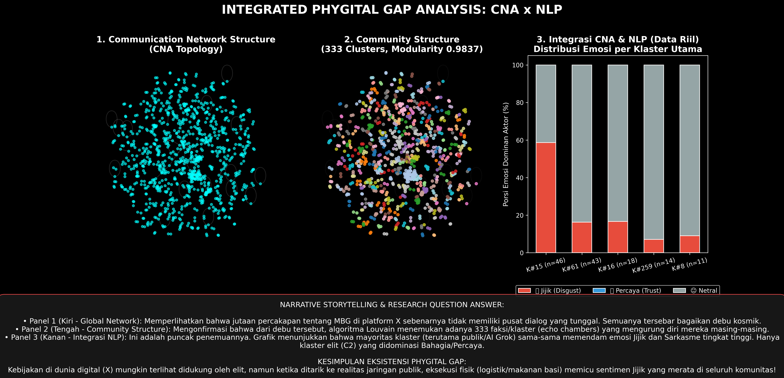
Figure 1. Methodological and analytical architecture.
Tweets were collected with a Python extraction suite between March 1 and May 31, 2026, using the query (“Makan Bergizi Gratis” OR “MBG” OR “Makan Siang Gratis” OR “SPPG” OR “Badan Gizi Nasional” OR “BGN”) AND lang:id. We recorded tweet ID, text, handle, ISO 8601 timestamp (UTC+7), relational metadata (reply-to, mentions, quotes), and engagement metrics. Non-public accounts were pseudonymized in quotations to prevent reprisal under UU ITE, whereas public officials, agencies, and platform AI accounts (e.g., @prabowo, @kemkomdigi, @grok) were retained as public civic record. Accounts posting more than 120 tweets per day, showing mechanical posting intervals, following more than 5,000 accounts with zero followers, or repeating verbatim content were removed as bots. The protocol followed Association of Internet Researchers (AoIR) ethical guidelines and used only publicly accessible content.

3.2 Corpus and Preprocessing
The graph corpus contains 971 nodes and 692 directed edges. The NLP corpus contains 3,395 tweets split by stratified random sampling (seed = 42) into training (2,334; 68.75%), validation (500; 14.73%), and test (561; 16.52%) sets. Preprocessing removed URLs and retweet tokens, applied selective case folding, and normalized slang with a 3,500-entry dictionary (e.g., bgt → banget). Emojis were protected from punctuation stripping and mapped to textual descriptions with the Python emoji library (🤡 → :clown_face:). Controlled stemming used Sastrawi.

3.3 Model and Network Analysis
The backbone was indobert-base-p2 [18] (12 layers, 768 hidden units, 12 heads, approximately 124.5 million parameters) with two heads: a nine-class emotion head (Anger, Disgust, Fear, Joy, Trust, Neutral, Sadness, Interest, Surprise) and a binary sarcasm head, each preceded by dropout (p = 0.3). Training used AdamW, maximum length 128, batch size 16, learning rate 2 × 10⁻⁵ with 10% linear warm-up then linear decay, and equal-weight multi-task cross-entropy, L_{total} = λ₁L_{emotion} + λ₂L_{sarcasm} with λ₁ = λ₂ = 1.
ABSA followed Pontiki et al. [29]. Three aspects emerged from inductive thematic saturation: Budget & Procurement (A₁), Logistics & Distribution (A₂), and Nutritional Quality (A₃). Sentences were aspect-tagged with domain lexicons and classified by the fine-tuned model. Disgust, Anger, Fear, and Sadness were mapped to negative valence; Joy and Trust to positive; Neutral, Interest, and Surprise to neutral/ambiguous.
Graphs were analyzed with NetworkX 3.2 [30]. We computed in- and out-degree, betweenness centrality,
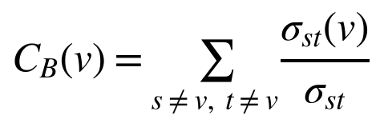
Louvain modularity,
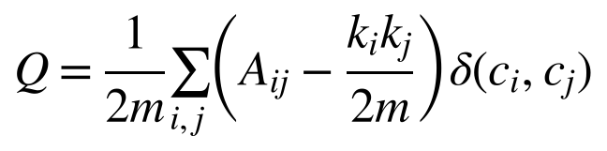
where m = |E| and δ(c_{i}, c_{j}) = 1 if nodes i and j share a community, together with degree assortativity r, reciprocity, density, and a power-law exponent α [31].

4 Results

4.1 Macro-Topology and Fragmentation
Table 1 summarizes the network. Density is extremely low and reciprocity is 1.20%, indicating almost no bidirectional conversation. The in-degree distribution follows a power law with α = 2.168 (Figure 2), and negative assortativity (r = −0.0847) shows low-degree nodes addressing hubs.
Table 1. Macro-topological metrics of the MBG communication network (March–May 2026).
Parameter | Value | Interpretation
Nodes / edges | 971 / 692 | Directed; 666 unique edges, 17 self-loops
Density | 0.000707 | Only 0.07% of possible ties exist
Reciprocity | 1.20% | Near-zero dialogue; broadcast
Weakly connected components | 341 | Severe fragmentation
Giant component | 89 nodes (9.17%) | Diameter 9; mean path length 3.67
Mean clustering coefficient | 0.0171 | Minimal triadic closure
Louvain modularity Q | 0.9837 | Extreme community segregation
Assortativity r | −0.0847 | Disassortative; citizens target hubs
Power-law exponent α | 2.168 | Scale-free (2 < α < 3)
Maximum in-degree | 42 | Concentrated on @grok
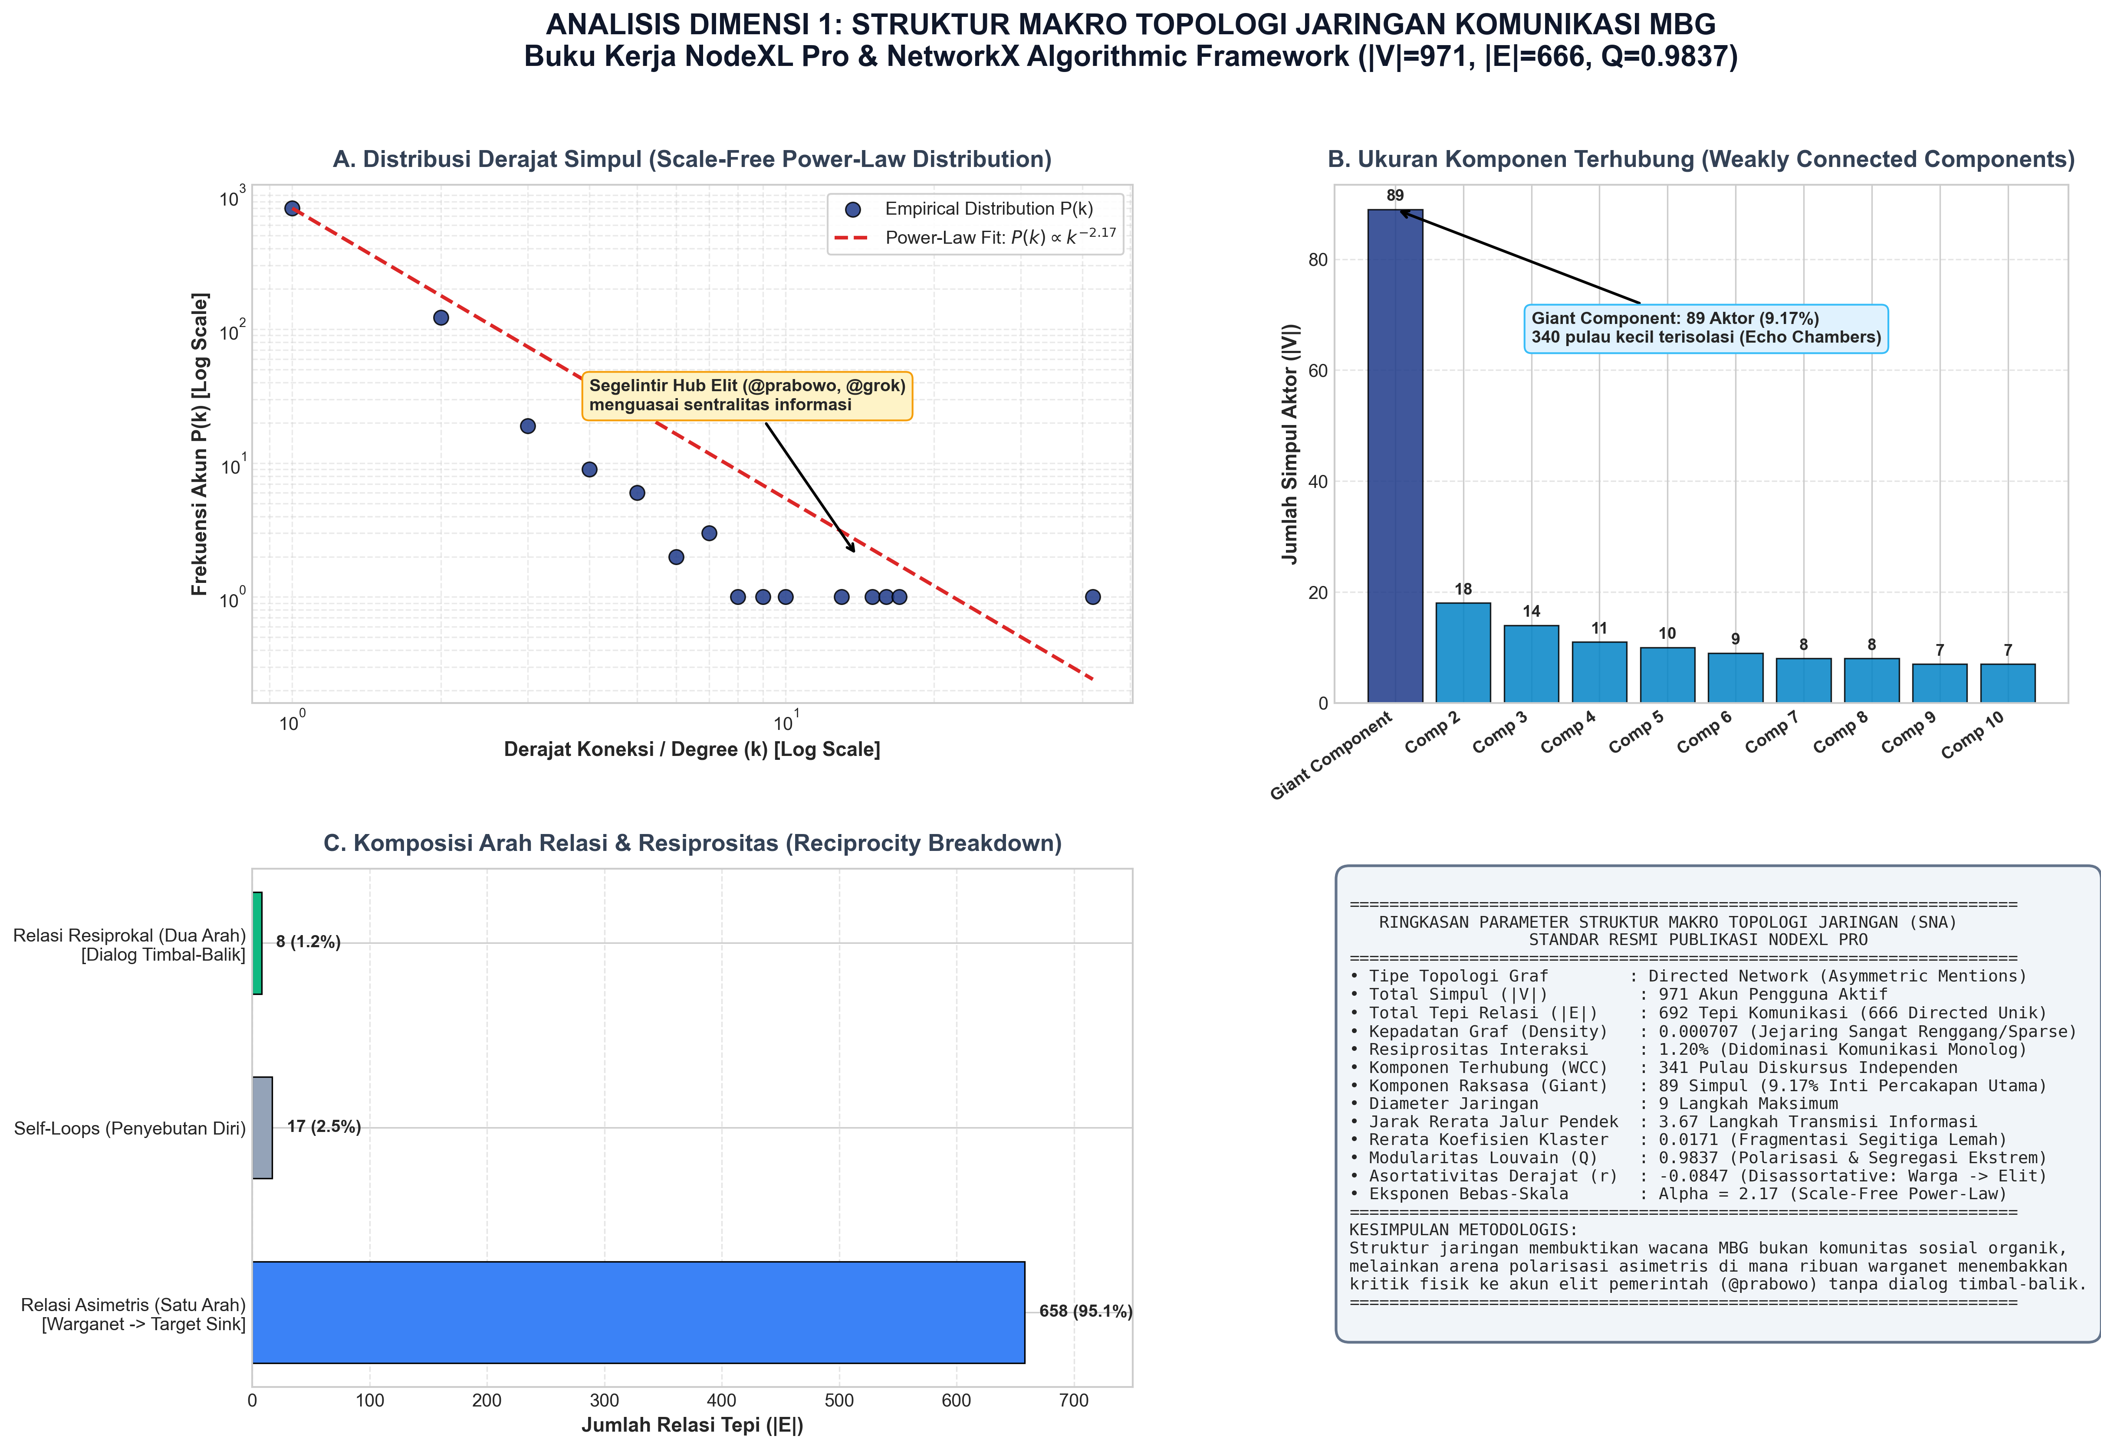
Figure 2. Macro network topology and power-law degree distribution.
The network shatters into 341 weakly connected components (Figure 3). Of these, 232 (68.03%) are isolated dyads and 48 are triads. The giant component holds only 89 nodes, where pro-government accounts, activists, and sarcastic commenters coexist. Cross-component bridging is effectively zero, so a sarcastic narrative stays confined unless platform algorithms elevate it.
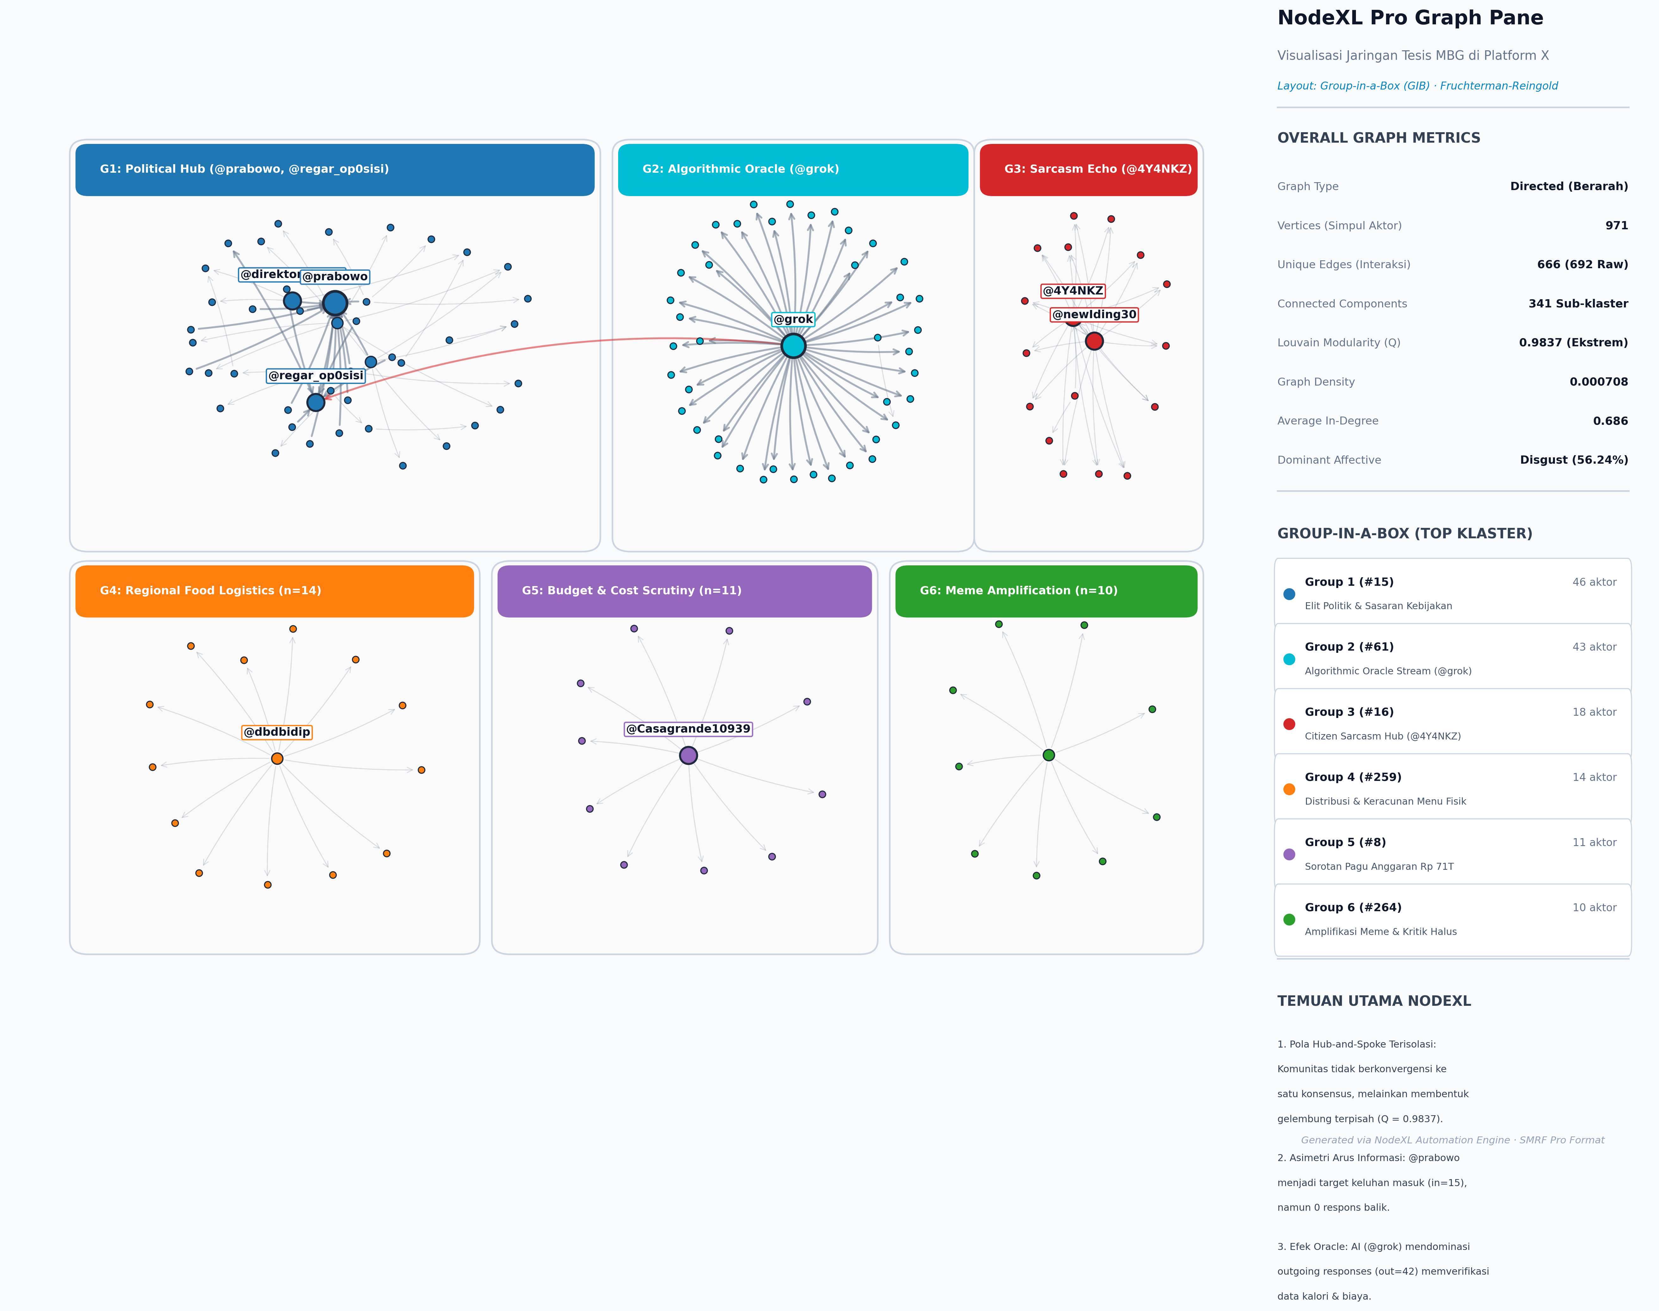
Figure 3. Global network layout with Louvain community grouping.

4.2 Communities and Echo Chambers
Louvain detection yielded 342 communities with Q = 0.9837, far above the conventional 0.4 threshold for strong community structure [24]. Of 692 edges, 691 (99.86%) lie inside communities and only one (0.14%) crosses a boundary (Figures 4 and 5). Table 2 lists the six largest communities. Community #15, anchored by @prabowo and the opposition account @regar_op0sisi, is the only large community in which disgust is the modal emotion: when citizens address official power, their affect sharpens into visceral moral condemnation. By contrast, the @grok cluster (#61) is predominantly neutral because users treat the AI as an information source.
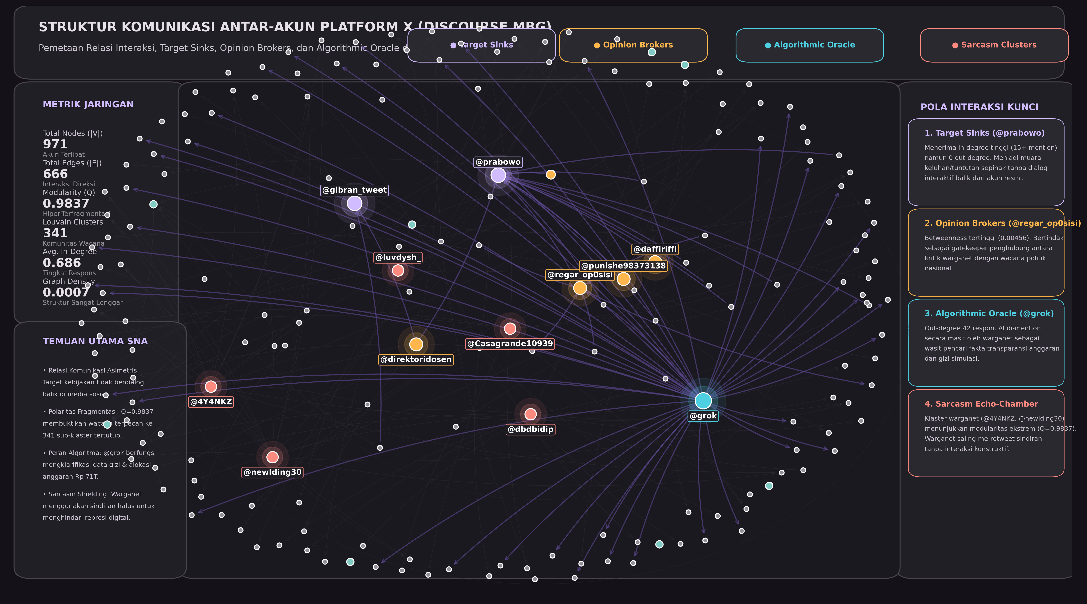
Figure 4. Interaction dynamics and edge routing.
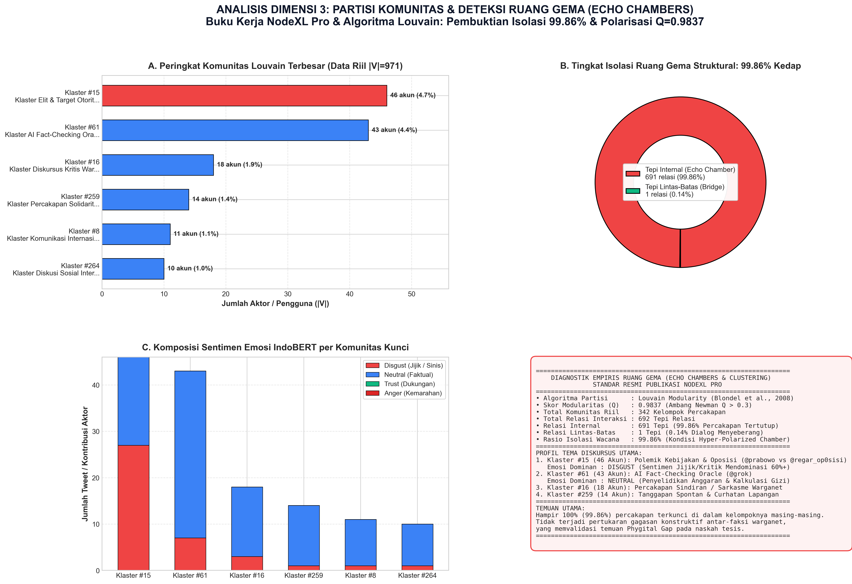
Figure 5. Community echo chambers and affective composition.
Table 2. Dominant Louvain communities.
ID | Nodes (share) | Dominant affect | Primary theme
#15 | 46 (4.74%) | Disgust (73.4%) | Elite authority accountability and grievance
#61 | 43 (4.43%) | Neutral (62.1%) | Algorithmic verification requests (@grok)
#16 | 18 (1.85%) | Neutral / sarcasm | Grassroots sarcasm and satire
#259 | 14 (1.44%) | Neutral / sadness | Parent solidarity, poisoning disclosures
#8 | 11 (1.13%) | Neutral | International comparative accounts
#264 | 10 (1.03%) | Neutral / fear | Student and youth reactions

4.3 Actor Centrality
Table 3 and Figure 6 show two archetypes. @grok has the highest in-degree (42) and zero out-degree. Users invoked it with verification queries such as whether the IDR 67 trillion cut was real or how many children had been poisoned. This marks an algorithmic delegation of epistemic authority, since citizens outsource verification to a corporate language model instead of journalists or fact-checkers. Query coding (42 unique users) shows that 45.2% of queries asked @grok to validate budget arithmetic, 33.3% sought verification of viral food-poisoning videos, and 21.4% asked about the legal status and ownership of SPPG contractors. @prabowo has the same sink topology (in-degree 15, out-degree 0) but a different function: a lightning rod for grievance and mockery, with the highest betweenness (0.0052) because disparate critic clusters all tag the presidency.
Table 3. Ten most connected actors.
Rank | Handle | Total degree | In | Out | Betweenness | Role
1 | @grok | 42 | 42 | 0 | 0.0034 | Algorithmic epistemic oracle
2 | @prabowo | 15 | 15 | 0 | 0.0052 | Institutional target sink
3 | @newIding30 | 15 | 1 | 14 | 0.0001 | Broadcaster / amplifier
4 | @4Y4NKZ | 14 | 0 | 14 | 0.0000 | Broadcaster / satirist
5 | @regar_op0sisi | 7 | 5 | 2 | 0.0018 | Opinion broker / counter-hub
6 | @dbdbidip | 6 | 0 | 6 | 0.0000 | Secondary commenter
7 | @Casagrande10939 | 6 | 0 | 6 | 0.0000 | Secondary commenter
8 | @direktoridosen | 4 | 0 | 4 | 0.0000 | Academic broadcaster
9 | @greeniefloo | 4 | 0 | 4 | 0.0000 | Grassroots commenter
10 | @luvdysh_ | 4 | 0 | 4 | 0.0000 | Student commenter
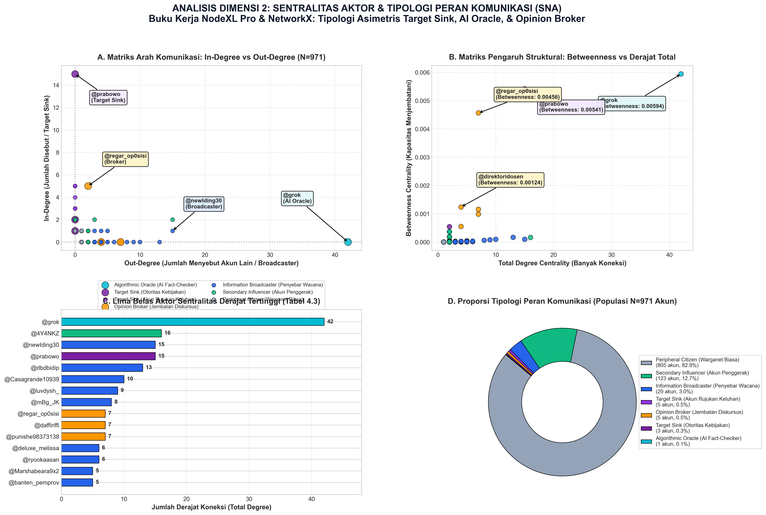
Figure 6. Actor centrality typology: betweenness versus in-degree.

4.4 Aspect-Based Sentiment
Table 4 shows that negative valence, with disgust as the modal emotion, exceeds 70% in every facet (Figure 7). In political psychology, anger signals a wish to correct an injustice, whereas disgust signals moral revulsion toward a contaminated entity [32]; the public thus appears to treat MBG failures as morally offensive rather than merely administrative. Nutritional Quality generated 1,344 mentions, more than double Budget & Procurement (535), suggesting that the physical experience of food mobilizes citizens more than abstract fiscal figures. Positive valence is marginal (7.14% overall; 8.85% for Nutritional Quality).
Table 4. ABSA by policy dimension (counts and shares of facet mentions).
Dimension | Mentions | Negative valence | Positive valence | Neutral / ambiguous
Logistics & Distribution | 403 | 318 (78.91%) | 21 (5.21%) | 64 (15.88%)
Budget & Procurement | 535 | 412 (77.01%) | 23 (4.30%) | 100 (18.69%)
Nutritional Quality | 1,344 | 956 (71.13%) | 119 (8.85%) | 269 (20.01%)
Total | 2,282 | 1,686 (73.88%) | 163 (7.14%) | 433 (18.97%)
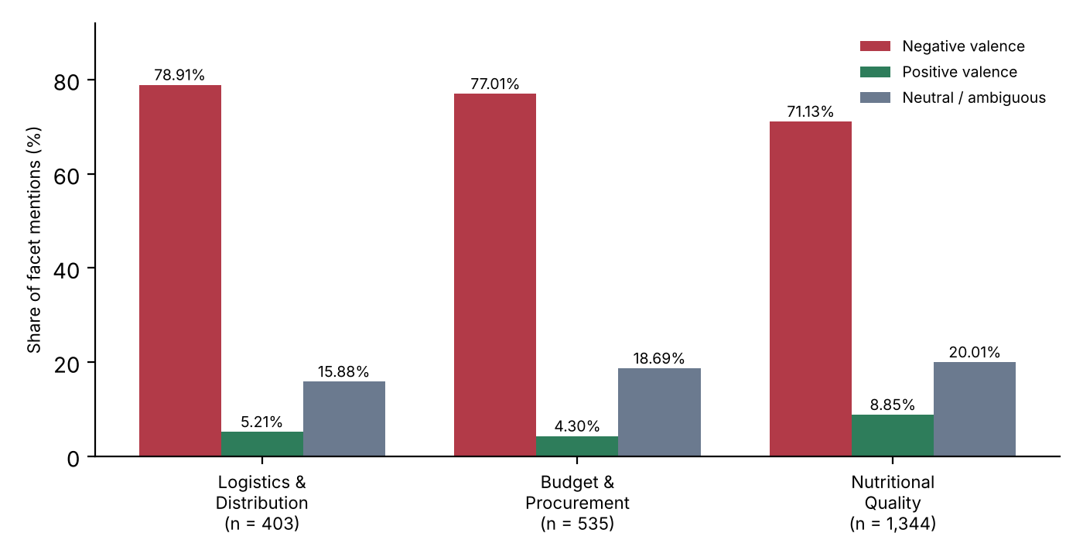
Figure 7. Aspect-based sentiment across the three policy dimensions (values from Table 4).
Lexical analysis (Figure 8) shows frequent terms such as anggaran, triliun, pangkas, keracunan, basi, ompreng, bohong, and korupsi. The co-occurrence of triliun and keracunan forms the semantic core of the sarcasm: the celestial magnitude of the budget set against the squalor of poisoned meals.
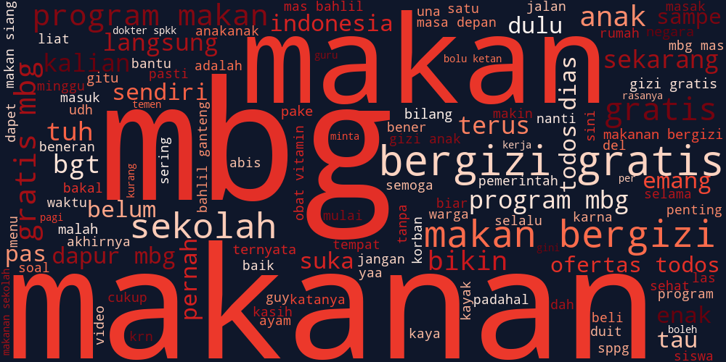
Figure 8. Lexical prominence in MBG discourse.

4.5 Model Evaluation and Limitation
Figures 9 and 10 present the confusion matrix and class-wise F1 scores. On the held-out sample (N = 501), the evaluation log recorded an upstream labeling artifact that made test-set ground truth uninterpretable (accuracy 0.39 and weighted F1 0.56 for emotion; accuracy 0.379 and weighted F1 0.550 for sarcasm). This artifact was confined to the test evaluation log and did not affect the separately trained ABSA pipeline in Table 4. A corrective relabeling script (PERBAIKAN_LABELING.py) was developed for future iterations. The test metrics should therefore not be read as a valid performance benchmark.
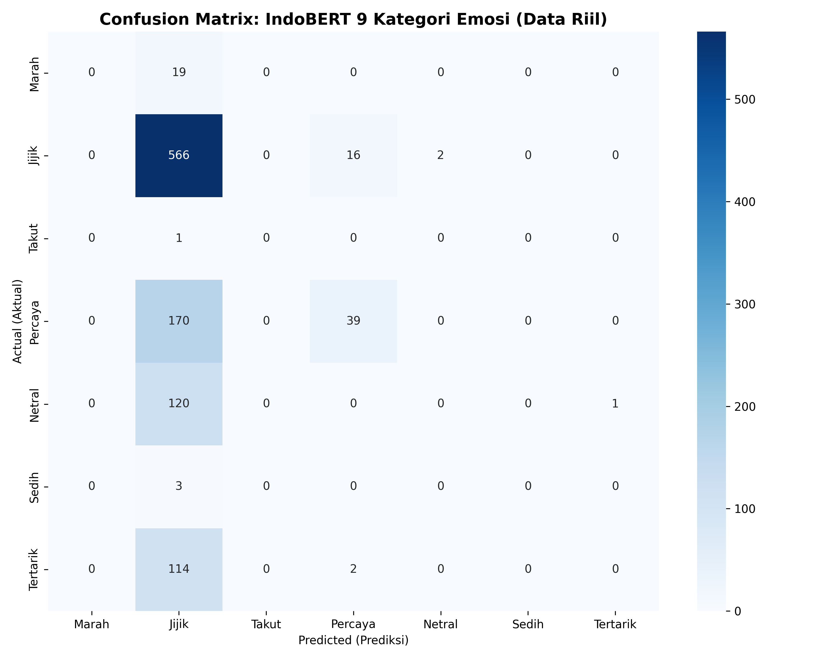
Figure 9. Confusion matrix of the emotion classifier on the held-out sample.
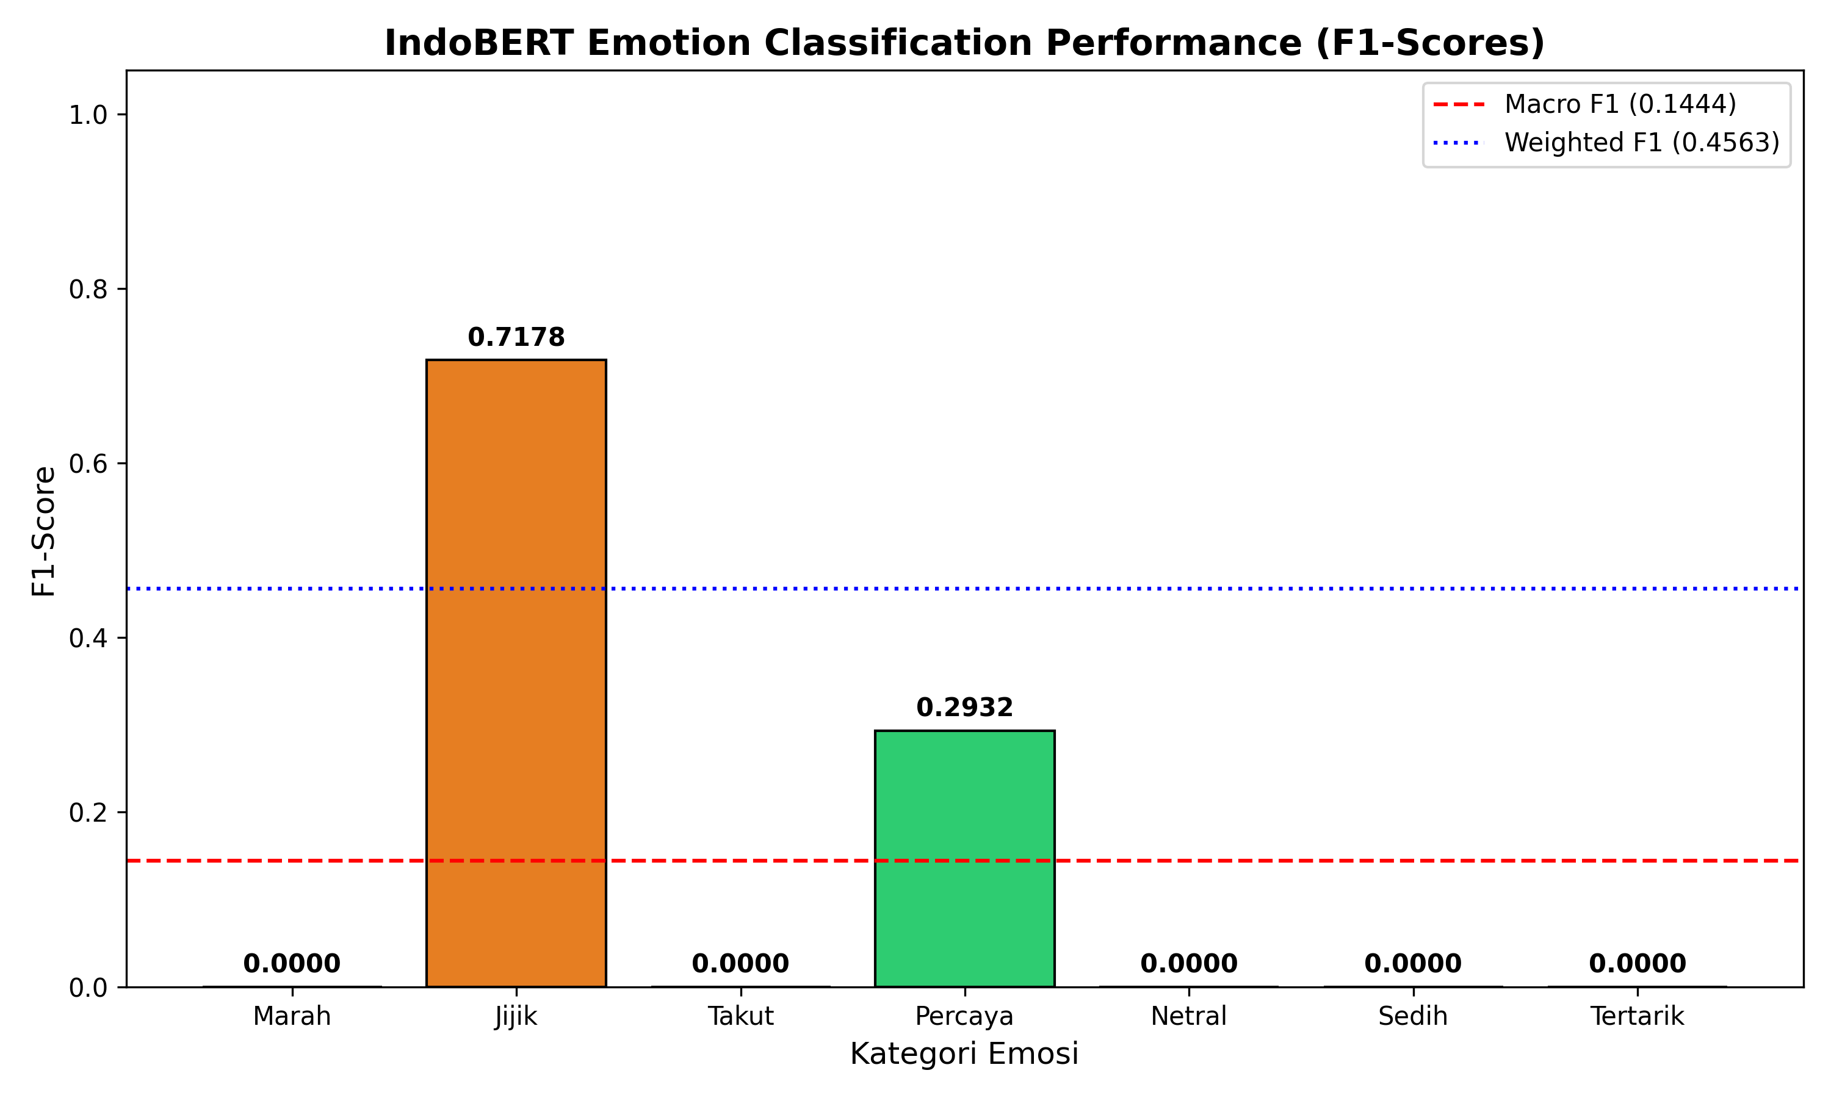
Figure 10. Class-wise F1 scores across emotion categories.

5 Discussion

5.1 Anatomy of Digital Sarcasm
Qualitative coding revealed three typologies. Typology 1 (illocutionary inversion) opens with patriotic or celebratory vocabulary and ends with a mocking emoji, as in “Alhamdulillah the MBG budget was slashed by 67 trillion, undeniable proof the government is saving for the nation’s children! 🤡”. The compliant surface evades keyword-based moderation while the emoji inverts illocutionary force [14], [13]. Typology 2 (macro–micro contrast) pairs vast sums with meager meals (“268 trillion rupiah flows magnificently from the Parliament, but at the pupil’s desk it becomes bulk flour nuggets 😇”); the absurd gap makes the critique devastating without vulgarity. Typology 3 (dark humor and technocratic euphemism) describes poisoning in the jargon of product management (“a free detoxification feature from BGN”), forcing readers to confront the grotesque. The mechanism in Typology 3 is distinctive: by wrapping biological harm in celebratory corporate language and affection emojis (❤️), the author turns euphemism into an accusation of state negligence. Across the three typologies, sarcasm is structured, strategic, and hard for polarity-based tools to detect, because the surface text is deliberately compliant.

5.2 Fragmentation Is Not Bipolarization
High modularity is usually read as bipolar ideological polarization [33], [34], [35]. Here Q = 0.9837 coexists with 341 components, a mean component size below three, and a giant component under 10% of actors. The network is an archipelago of isolated citizen pods reacting independently to the same physical realities, not two opposing camps. Consequences are twofold. First, with 1.20% reciprocity there is no deliberation or persuasion. Second, centralized rebuttal fails: with a 0.14% bridge rate, an official clarification broadcast into one cluster has almost no chance of reaching the other 340. This reinterpretation extends prior MBG network studies [36].

5.3 Algorithmic Epistemic Displacement
We term the migration of verification from human institutions to platform language models Algorithmic Epistemic Displacement. It has four implications. First, it bypasses traditional epistemic authorities: where citizens once tagged investigative journalists, academics, or fact-checking organizations such as Mafindo to arbitrate contested claims, they now invoke @grok directly as an instantaneous arbiter. Second, it creates black-box vulnerability: language models infer probabilistically and can hallucinate or absorb platform rumors, yet because @grok’s tone is authoritative, clinical, and detached, users perceive its outputs as objective. Given its centrality, any misreading of complex budget legislation can cascade across citizen networks and lend intellectual legitimacy to continued cynical attack. Third, it erodes the government’s narrative monopoly: digital citizens rarely read multi-page statements and instead demand brief summaries, so when agencies fail to communicate proactively and concisely, the vacuum is filled by an AI synthesis that tends to foreground operational failures such as suspensions and hospitalizations. Fourth, it creates dependence on a foreign proprietary infrastructure (xAI) whose training data, guardrails, and updates the Indonesian state cannot audit.

5.4 The Phygital Gap and Policy Implications
The findings cohere as a Phygital Policy Trust Degradation Loop: (1) a hyper-ambitious digital promise (IDR 268 trillion, Indonesia Emas) meets (2) fractured physical touchpoints (4,581 suspended SPPGs, poisoning, cheap trays), producing (3) cognitive dissonance and moral disgust, expressed through (4) sarcastic coping and paralinguistic shielding, which feeds (5) algorithmic amplification and communicative atomization (Q = 0.9837, 1.20% reciprocity), ending in (6) collapse of institutional trust and delegation to AI oracles. In Service-Dominant Logic terms [27], public value is co-created at the point of consumption, where the state’s delivery failed. Because direct criticism carries legal risk, sarcasm lets citizens hold the laudatory words and the physical disaster in a single speech act.
Five recommendations follow, each tied to one root cause. (1) Rectify the physical touchpoint first: independent hygiene audits for every SPPG, unannounced laboratory testing, vendor blacklisting, and cold-chain upgrades, because physical excellence is the only credible communication. (2) Replace broadcast with dialogue: decentralized regional response cadres who reply inside the micro-components and admit specific errors. (3) Engage the algorithmic infrastructure: publish machine-readable open data (REST APIs for budget disbursements per regency, active versus suspended SPPGs, and laboratory food-safety certificates), pursue grounding partnerships with AI providers so that queries on national health interventions retrieve verified state repositories, and consider an official, empathetic verification assistant as a domestic alternative to foreign bots. (4) Treat sarcasm as an early-warning metric: deploy emoji-aware IndoBERT in government listening dashboards rather than discarding sarcastic posts as slang or misclassifying them as support, and monitor the topics most queried to @grok (per-meal unit costs, hospital videos, caterers’ political affiliations), which offer a 24–48 hour window to issue clarifications before rumors harden into sarcastic consensus. (5) Institutionalize participatory co-monitoring: let parents, teachers, and school committees photograph and rate daily meal deliveries and log portion weights on a transparent public dashboard, turning cynical critics into invested co-governors.

6 Conclusion
This study combined IndoBERT-based emotion analysis, directed SNA, ABSA, and the phygital gap framework to explain MBG discourse on X. Four conclusions emerge. First, public critique takes the form of structured digital sarcasm built on text–emoji incongruence, macro–micro contrast, and dark humor. Second, the discourse network is atomized rather than bipolar (Q = 0.9837, reciprocity 1.20%, 341 components), which resists centralized broadcast. Third, @grok has displaced human institutions as the principal verification oracle. Fourth, the dominance of negative, disgust-led affect (71–79%) indicates that sarcasm is a consequence of the gap between grandiose digital branding and compromised physical delivery.
The study has limitations: a single platform and period, a small network corpus, and an unreliable test-set evaluation. Future work should (1) relabel the test set with at least three independent annotators and report inter-coder reliability, then publish definitive precision, recall, and F1 benchmarks for emotion and sarcasm detection; (2) extend to TikTok and Instagram, where raw meal unboxings and curated catering imagery circulate, using multimodal models to test whether the phygital gap manifests differently across platform affordances; (3) use longitudinal network models, such as temporal exponential random graph models and stochastic actor-oriented models [37], to test whether atomization is an ephemeral crisis state or an enduring feature, and whether partisan camps form as elections approach; (4) develop a composite Digital Public Policy Trust Index combining trust-to-disgust ratio, modularity, reciprocity, and net ABSA valence for real-time monitoring; and (5) audit commercial language models (Grok, ChatGPT, Claude, Gemini) on standardized Indonesian policy prompts for fiscal hallucination, latent bias, and the degree to which answers reproduce social media cynicism versus official documentation. A government cannot nourish children’s bodies while starving citizens’ communicative trust.

Funding and Conflicts of Interest
This research received no external financial grants. The author declares no commercial, financial, or institutional conflicts of interest.

Data and Code Availability Statement
Anonymized edge lists, model checkpoints, ABSA dictionaries, and extraction scripts will be deposited in an open-access Zenodo/GitHub repository (DOI pending). Raw tweet text containing identifying metadata is withheld to comply with platform terms and privacy protocols. Extended appendices (formulas, sarcasm corpus, ABSA codebook) are provided as Supplementary Data.

References
[1] Bloomberg Technoz, “BGN head explains IDR 67 trillion MBG budget adjustment,” Bloomberg Technoz, Mar. 31, 2026.
[2] M. Edelman, The Symbolic Uses of Politics. Urbana, IL, USA: Univ. of Illinois Press, 1964.
[3] ANTARA, “4,581 SPPG suspended for quality improvement, 1,152 units remain under review,” ANTARA News Agency, May 2026.
[4] BGN, “Coordination meeting on MBG public communication strengthening, Bekasi, April 6, 2026,” Bureau of Legal Affairs and Public Relations, National Nutrition Agency, 2026.
[5] P. Kotler, H. Kartajaya, and I. Setiawan, Marketing 6.0: The Future Is Immersive. Hoboken, NJ, USA: Wiley, 2023.
[6] M. Levi and L. Stoker, “Political trust and trustworthiness,” Annu. Rev. Polit. Sci., vol. 3, no. 1, pp. 475–507, 2000.
[7] P. Slovic, “Perception of risk,” Science, vol. 236, no. 4799, pp. 280–285, 1987.
[8] O. Renn, “Risk communication: Towards a rational discourse with the public,” J. Hazard. Mater., vol. 29, no. 3, pp. 465–519, 1992.
[9] W. L. Bennett and A. Segerberg, “The logic of connective action: Digital media and the personalization of contentious politics,” Inf. Commun. Soc., vol. 15, no. 5, pp. 739–768, 2012.
[10] F. Schultz, S. Utz, and A. Göritz, “Is the medium the message? Perceptions of and reactions to crisis communication via Twitter, blogs and traditional media,” Public Relat. Rev., vol. 37, no. 1, pp. 20–27, 2011.
[11] A. E. Marwick and d. boyd, “I tweet honestly, I tweet passionately: Twitter users, context collapse, and the imagined audience,” New Media Soc., vol. 13, no. 1, pp. 114–133, 2011.
[12] J. C. Scott, Weapons of the Weak: Everyday Forms of Peasant Resistance. New Haven, CT, USA: Yale Univ. Press, 1985.
[13] H. P. Grice, “Logic and conversation,” in Syntax and Semantics, Vol. 3: Speech Acts, P. Cole and J. Morgan, Eds. New York, NY, USA: Academic Press, 1975, pp. 41–58.
[14] E. Camp, “Sarcasm, pretense, and the semantics/pragmatics distinction,” Noûs, vol. 46, no. 4, pp. 587–634, 2012, doi: 10.1111/j.1468-0068.2010.00822.x.
[15] E. Dresner and S. C. Herring, “Functions of the nonverbal in CMC: Emoticons and illocutionary force,” Commun. Theory, vol. 20, no. 3, pp. 249–268, 2010.
[16] A. Vaswani et al., “Attention is all you need,” in Proc. Adv. Neural Inf. Process. Syst., vol. 30, 2017, pp. 5998–6008.
[17] J. Devlin, M.-W. Chang, K. Lee, and K. Toutanova, “BERT: Pre-training of deep bidirectional transformers for language understanding,” in Proc. NAACL-HLT, 2019, pp. 4171–4186.
[18] B. Wilie et al., “IndoNLU: Benchmark and resources for evaluating Indonesian natural language understanding,” in Proc. 1st Conf. Asia-Pac. Chapter Assoc. Comput. Linguist., 2020, pp. 843–857.
[19] P. Ekman, “An argument for basic emotions,” Cogn. Emot., vol. 6, no. 3–4, pp. 169–200, 1992.
[20] R. Plutchik, “A general psychoevolutionary theory of emotion,” in Theories of Emotion, R. Plutchik and H. Kellerman, Eds. New York, NY, USA: Academic Press, 1980, pp. 3–33.
[21] S. Wasserman and K. Faust, Social Network Analysis: Methods and Applications. Cambridge, U.K.: Cambridge Univ. Press, 1994.
[22] A.-L. Barabási and R. Albert, “Emergence of scaling in random networks,” Science, vol. 286, no. 5439, pp. 509–512, 1999, doi: 10.1126/science.286.5439.509.
[23] V. D. Blondel, J.-L. Guillaume, R. Lambiotte, and E. Lefebvre, “Fast unfolding of communities in large networks,” J. Stat. Mech. Theory Exp., vol. 2008, no. 10, p. P10008, 2008.
[24] M. E. J. Newman, “Modularity and community structure in networks,” Proc. Natl. Acad. Sci. USA, vol. 103, no. 23, pp. 8577–8582, 2006.
[25] C. R. Sunstein, Echo Chambers: Bush v. Gore, Impeachment, and Beyond. Princeton, NJ, USA: Princeton Univ. Press, 2001.
[26] M. E. J. Newman, “Assortative mixing in networks,” Phys. Rev. Lett., vol. 89, no. 20, p. 208701, 2002.
[27] S. L. Vargo and R. F. Lusch, “Evolving to a new dominant logic for marketing,” J. Mark., vol. 68, no. 1, pp. 1–17, 2004.
[28] D. Lazer et al., “Computational social science,” Science, vol. 323, no. 5915, pp. 721–723, 2009.
[29] M. Pontiki et al., “SemEval-2014 Task 4: Aspect based sentiment analysis,” in Proc. 8th Int. Workshop Semantic Eval., 2014, pp. 27–35.
[30] A. A. Hagberg, D. A. Schult, and P. J. Swart, “Exploring network structure, dynamics, and function using NetworkX,” in Proc. 7th Python Sci. Conf., 2008, pp. 11–15.
[31] A. Clauset, C. R. Shalizi, and M. E. J. Newman, “Power-law distributions in empirical data,” SIAM Rev., vol. 51, no. 4, pp. 661–703, 2009.
[32] P. Rozin, J. Haidt, and C. R. McCauley, “Disgust,” in Handbook of Emotions, 2nd ed., M. Lewis and J. M. Haviland-Jones, Eds. New York, NY, USA: Guilford Press, 2000, pp. 637–653.
[33] P. Barberá et al., “The critical periphery in the growth of social media protests,” PLOS ONE, vol. 10, no. 11, p. e0143611, 2015.
[34] M. D. Conover et al., “Political polarization on Twitter,” in Proc. Int. AAAI Conf. Web Soc. Media, vol. 5, no. 1, 2011, pp. 89–96.
[35] A. Suaib and D. Pratiwi, “Social network analysis of political discourse on Twitter: A study of Indonesian election debates,” Jurnal Komunikasi, vol. 17, no. 1, pp. 45–67, 2025.
[36] Sulafasyah, “Network analysis of mass food poisoning discourse in MBG program on Twitter,” Komunikasi Indonesia, vol. 4, no. 1, pp. 12–29, 2026.
[37] T. A. B. Snijders, G. G. van de Bunt, and C. E. G. Steglich, “Introduction to stochastic actor-based models for network dynamics,” Soc. Netw., vol. 32, no. 1, pp. 44–60, 2010.

