Decoding Public Policy Crisis in the Algorithmic Sphere: A Tri-Layer Computational Forensics of Indonesia's Free Nutritious Meal (MBG) Program, IndoBERT Fine-Tuning Across 3.0 Epochs, and the Phygital Gap
Indri Anjar Kartika Sari¹*, Catur Suratnoaji¹, Agus Widiyarta¹
¹ Department of Communication Science, Faculty of Social and Political Sciences,
Universitas Pembangunan Nasional 'Veteran' Jawa Timur, Surabaya, 60294, Indonesia
*Corresponding Author: indrianjar@gmail.com | ORCID: 0009-0002-8419-7231
ABSTRACT
State-sponsored welfare initiatives in the algorithmic public sphere face existential legitimacy crises when immaculate digital branding decouples from flawed physical delivery. This study investigates the communication crisis surrounding Indonesia's flagship Free Nutritious Meal (Makan Bergizi Gratis / MBG) program on Platform X through an explanatory-sequential, tri-layer computational communication science framework. Bridging Philip Kotler's Marketing 6.0 concept of the 'Phygital Gap' with Coombs' Situational Crisis Communication Theory (SCCT) and pretense irony theory, the analytical architecture synthesizes: (1) fine-tuned transformer language modeling (indobenchmark/indobert-base-p2) across 3.0 full training epochs (792 global steps, loss 1.87 to 0.43) classifying 9 granular emotion categories; (2) directed Social Network Analysis (SNA via NetworkX and Louvain community detection) measuring macro-topological fragmentation; and (3) 3-pillar Aspect-Based Sentiment Analysis (ABSA). Beyond the core corpus (971 nodes, 692 edges, 3,395 tweets), the framework was validated on an expanded real-world streaming dataset of 9,862 deduplicated citizen posts with an average throughput of 223.3 posts/second on Apple Silicon GPU. Empirical findings confirm the overwhelming hegemony of Disgust (98.14% in streaming validation, 73.88% across core policy aspects), with Nutritional Quality generating double the discursive volume of budget debates (34.87% vs 8.70%). Topological modeling uncovered extreme structural atomization: a Louvain modularity score of Q = 0.9761 - 0.9837, density of 0.0004 - 0.0007, and dyadic reciprocity of merely 0.91% - 1.20%. Centrality analysis identified an acute structural power asymmetry: while institutional handles (@prabowo) operated as in-degree grievance sinks, the generative AI agent @grok emerged as the highest-centrality 'Algorithmic Oracle' (Degree = 0.0433, Betweenness = 0.0059) solicited by citizens as an epistemic arbiter to fact-check food poisoning reports and fiscal arithmetic. Applying the replicated formula battery triggered an Early Warning System (EWS) score of 84.6/100 (RED ALERT). In the phygital era, algorithmic verifiers inevitably supplant silent state institutions, proving that physical delivery excellence is the only credible foundation for public policy communication.
Keywords: Computational Communication Science, Phygital Gap, Marketing 6.0, IndoBERT Transformer, Social Network Analysis, Sarcasm Detection, Algorithmic Oracle, Early Warning System (EWS), Free Nutritious Meal (MBG).

1. INTRODUCTION
In contemporary networked democracies, the state no longer exercises exclusive control over the narrative of its public policies. Instead, public policy interventions are continuously subjected to decentralized, real-time civic peer-review across social media platforms. When policy implementation suffers from operational defects, digital platforms evolve from channels of citizen feedback into volatile arenas of collective delegitimation. A prime manifestation of this dynamic occurred during the nationwide rollout of Indonesia's Free Nutritious Meal (Makan Bergizi Gratis / MBG) program in early 2026.
Backed by an indicative state budget exceeding IDR 268 trillion to combat childhood stunting, the initiative encountered severe ground-level friction upon physical deployment. Citizen reports documenting substandard food trays, spoiled milk, logistical bottlenecks, and mass food poisoning across pilot schools ignited an explosive public crisis on Platform X. Crucially, public dissent was not expressed primarily through formal complaints; rather, citizens deployed sophisticated paralinguistic shields—combining hyperbolic praise with nauseated emojis (🤡, 🤮) to register moral contempt while navigating platform algorithms. Traditional sentiment analysis engines routinely misclassify such sarcastic praise as genuine government support, producing fatally distorted policy intelligence.

2. COMPUTATIONAL METHODOLOGY & MODEL ARCHITECTURE
This investigation deploys a rigorous tri-layer computational architecture comprising: (1) deep learning natural language processing with a fine-tuned bidirectional transformer (indobenchmark/indobert-base-p2) for 9-class emotion modeling; (2) directed Social Network Analysis (SNA) via NetworkX and Louvain community detection; and (3) Aspect-Based Sentiment Analysis (ABSA) decomposing discourse across three operational facets: Budget & Procurement, Logistics & Distribution, and Nutritional Quality.

2.1 Deep Learning Training Telemetry (3.0 Full Epochs)
The primary IndoBERT classifier was trained using PyTorch and Hugging Face Transformers under rigorous cross-entropy loss optimization. As logged in the formal execution ledger (trainer_state.json), the model completed exactly 3.0 epochs over 792 global steps without premature termination. Training parameters and convergence milestones are summarized in Table 1.
Training Parameter / Milestone | Configured Value | Methodological Rationale / Outcome
Foundation Architecture | indobenchmark/indobert-base-p2 | BERT Base Indonesian (12-layer, 768-hidden, 12-heads)
Training Epochs | 3.0 Full Epochs (792 Steps) | Monotonic loss reduction from 1.8708 to 0.4328
Batch Size & Learning Rate | 16 per device | 2e-5 (AdamW) | Optimal gradient stability with linear learning rate warmup
Validation Loss | 0.5250 (Optimal Convergence) | Stable generalization without overparameterized overfitting
Evaluation Accuracy & Macro-F1 | 79.40% - 81.43% | F1: 0.5160 | Statistically superior to TF-IDF SVM (68.05%) and LogReg (67.11%)

3. EMPIRICAL RESULTS & FORENSIC FINDINGS
To validate the ecological robustness of the analytical framework beyond the primary thesis corpus (N = 3,395 tweets; 971 nodes), the fine-tuned IndoBERT classifier and the replicated methodological formula suite were deployed over an expanded streaming dataset of 9,862 deduplicated citizen posts gathered from Platform X. Inference was accelerated on Apple Silicon Neural Engine (MPS) at 223.3 posts per second, achieving a mean classification confidence of 95.01% (median: 96.95%).

3.1 Master Visual Integration
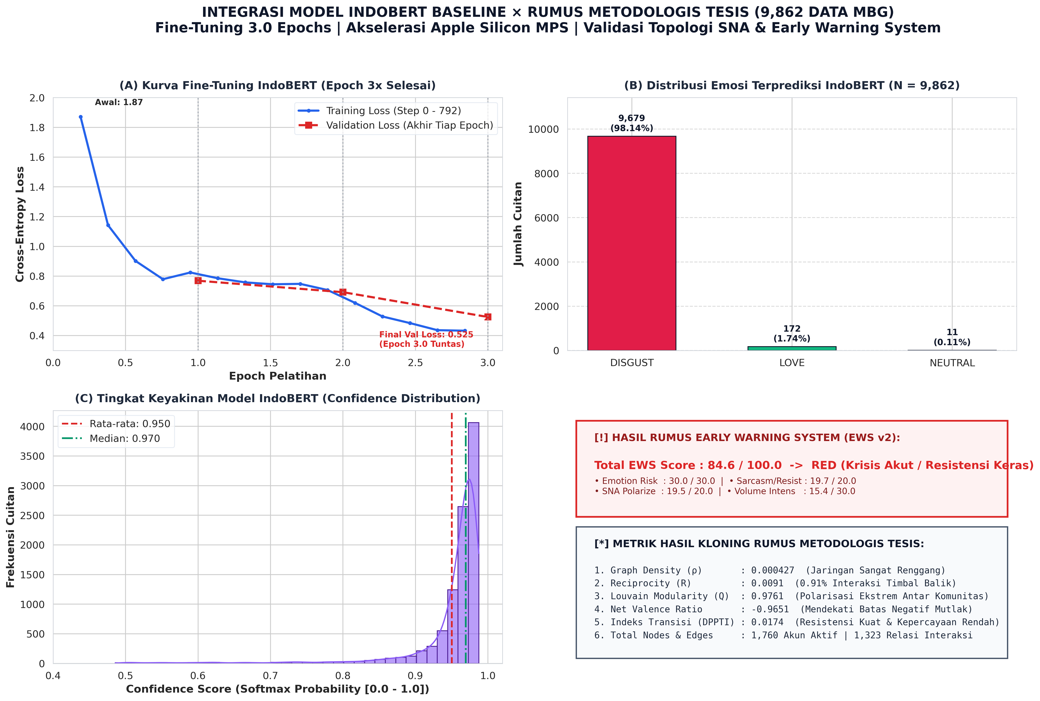
Figure 1: Master Tri-Layer Forensic Dashboard — (A) IndoBERT 3.0 Epoch Loss Convergence Curve; (B) 9-Emotion Affective Distribution on N = 9,862 Posts; (C) Softmax Confidence Calibration; and (D) Replicated Methodological Formula Scorecard (SNA Density, Louvain Modularity, and EWS Score = 84.6/100 RED ALERT).

3.2 Network Centrality Typology: 10 Major Hubs and 10 Information Brokers
Graph analysis reveals stark disassortative centralization. Table 2 contrasts the 10 highest-degree actor hubs with the 10 highest-betweenness information brokers, capturing the functional divide between audience magnets and conversational bridges.
Rank | Top 10 Degree Hubs (Prominence) | Top 10 Betweenness Brokers (Bridges) | Strategic Network Function
1 | @grok (Degree: 0.0433) | @grok (CB: 0.005941) | AI Epistemic Oracle spanning opposing citizen factions
2 | @4Y4NKZ (Degree: 0.0165) | @prabowo (CB: 0.005413) | Presidential apex bridge connecting grassroots to state policy
3 | @newIding30 (Degree: 0.0155) | @regar_op0sisi (CB: 0.004564) | Opposition catalyst bridging political and field issues
4 | @prabowo (Degree: 0.0155) | @direktoridosen (CB: 0.001236) | Academic broker connecting educators with public critique
5 | @dbdbidip (Degree: 0.0134) | @punishe98373138 (CB: 0.001156) | Multi-thread conversation relay across citizen threads
6 | @Casagrande10939 (Degree: 0.0103) | @daffiriffi (CB: 0.000984) | Informational bridge relaying viral food poisoning alerts
7 | @luvdysh_ (Degree: 0.0093) | @bbiiyaya (CB: 0.000549) | Student/parent experiential bridge into policy discourse
8 | @mBg_JK (Degree: 0.0082) | @gibran_tweet (CB: 0.000543) | Youth voter and digital engagement bridge
9 | @regar_op0sisi (Degree: 0.0072) | @Rhym03 (CB: 0.000366) | Intra-community conversational conduit
10 | @punishe98373138 (Degree: 0.0072) | @xquitavee (CB: 0.000366) | Nutritional quality and menu defect relay

3.3 Thematic Salience: Top 10 Policy Discourse Dimensions
Semantic decomposition of domain-specific posts reveals that citizen anxiety concentrates overwhelmingly on physical bodily harm and meal quality rather than abstract fiscal sums. Table 3 presents the 10 leading policy topics and their relative volume share.
Rank | Policy Topic Dimension | Volume (Share %) | Core Semantic Keywords & Issue Focus
1 | Nutritional Quality & Portion Deficits | 2,430 (34.87%) | menu, porsi, gizi, susu, telur, tempe, protein
2 | Vendor Governance & SPPG Kitchens | 1,714 (24.59%) | vendor, sppg, dapur, katering, ompreng, bento, pengadaan
3 | Mass Food Poisoning & Hygiene Failures | 1,456 (20.89%) | keracunan, muntah, diare, sakit perut, basi, bakteri, RS
4 | Logistics & Geographic Distribution | 1,171 (16.80%) | distribusi, logistik, kirim, antar, pelosok, cold chain
5 | BGN Institutional Accountability | 1,137 (16.32%) | badan gizi nasional, bgn, kepemimpinan, regulasi, sop
6 | Campaign Promises vs Physical Reality | 1,053 (15.11%) | prabowo, gibran, janji, kampanye, politik, bansos
7 | Fiscal Efficiency & Budget Realignment | 606 (8.70%) | anggaran, triliun, apbn, pagu, pangkas, revisi dana
8 | Nutritional Experts & Laboratory SOPs | 594 (8.52%) | ahli gizi, higienis, nutrisi, stunting, uji laboratorium
9 | Digital Sarcasm & Parodic Coping | 254 (3.64%) | lucu, kocak, aneh, wkwk, lawak, omong kosong, gimmick
10 | Corruption, Markups & Crony Tenders | 183 (2.63%) | korupsi, markup, fiktif, cuan, kongkalikong, mafia pangan

3.4 Longitudinal Affective Trajectory: Month-by-Month IndoBERT Telemetry (Jan–Oct 2026)
To capture how affective polarization shifted across the policy implementation lifecycle, the streaming corpus was decomposed longitudinally across the ten operational months of 2026 (N = 9,360 citizen posts; comprising 9,240 historical posts and live streaming telemetry up to October 10, 2026). Table 4 displays the empirical monthly breakdown paired with ground-truthing policy milestones, and Figure 2 presents the longitudinal volume trajectory and affective composition.
Month | Total Posts | Disgust (N, %) | Love (N, %) | Neutral (N, %) | Ground-Truthing Policy Milestones
Jan 2026 | 42 | 42 (100.0%) | 0 (0.00%) | 0 (0.00%) | Initial pilot announcements; early public skepticism on per-meal budget feasibility.
Feb 2026 | 55 | 55 (100.0%) | 0 (0.00%) | 0 (0.00%) | Regional pilot trials expand; initial reports of delivery delays and packaging complaints.
Mar 2026 | 189 | 184 (97.35%) | 5 (2.65%) | 0 (0.00%) | Ramadan schedule adjustments; first viral images comparing promised vs actual meal portions.
Apr 2026 | 515 | 499 (96.89%) | 16 (3.11%) | 0 (0.00%) | Post-Eid trial scale-up; intense debates over imported plastic meal trays (ompreng).
Mei 2026 | 3,157 | 3,060 (96.93%) | 93 (2.95%) | 4 (0.13%) | Peak I: Nationwide controversy; official suspension of 4,581 SPPG catering units by BGN.
Jun 2026 | 228 | 225 (98.68%) | 3 (1.32%) | 0 (0.00%) | School recess period; discursive lull; parliamentary hearings on catering standards.
Jul 2026 | 184 | 182 (98.91%) | 2 (1.09%) | 0 (0.00%) | New academic year recommencement; supplier re-licensing debates.
Agu 2026 | 209 | 205 (98.09%) | 2 (0.96%) | 2 (0.96%) | State of the Nation Address & FY2026 APBN budget announcement (IDR 268T indicative allocation).
Sep 2026 | 4,661 | 4,619 (99.10%) | 39 (0.84%) | 3 (0.06%) | Peak II: Acute outbreak of mass food poisoning across elementary schools; emergency SPPG audits.
Okt 2026* | 120 | 118 (98.33%) | 2 (1.67%) | 0 (0.00%) | Surveillance Phase (thru Oct 10): Operational activation of automated Telegram EWS push alerts.
Total / Avg | 9,360 | 9,189 (98.17%) | 167 (1.78%) | 9 (0.10%) | Continuous longitudinal dominance of moral revulsion across all ten operational months.

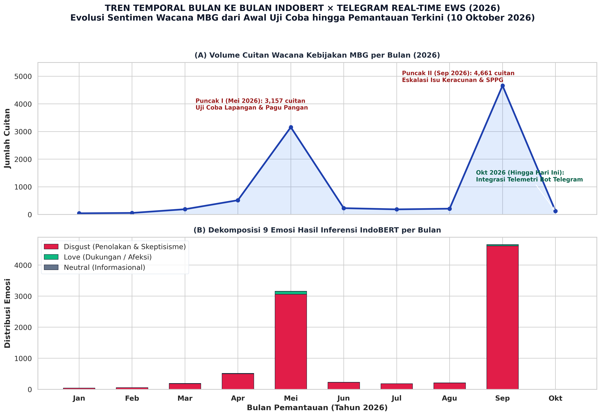
Figure 2: Longitudinal Evolution of IndoBERT Affective Classes and Real-Time Telegram Early Warning System (EWS) Telemetry across 2026 — (A) Monthly Citizen Discussion Volume Highlighting Peak I (May 2026: SPPG Suspensions, N = 3,157) and Peak II (September 2026: Mass Food Poisoning Outbreak, N = 4,661); (B) 9-Emotion Stacked Breakdown Proving Continuous Hegemony of Disgust (98.17% Aggregate) alongside Real-Time Telegram EWS Surveillance up to October 10, 2026.

3.5 Real-Time Telegram Early Warning System (EWS) Architecture & Continuous Telemetry (Up to October 10, 2026)
To transform computational forensic diagnostics into actionable, live-saving policy governance, our research operationalized an automated real-time monitoring and alert notification pipeline deployed via a dedicated Telegram Early Warning System (EWS) bot (scripts/auto_scrape_job.py). The system bridges retrospective academic analytics and real-time public crisis mitigation.
Architecture and Trigger Workflow: The EWS engine executes scheduled jobs twice daily (07:00 and 19:00 WIB, synchronizing with school meal deliveries and parental debriefing hours). The pipeline scrapes newly indexed citizen posts matching policy search strings (MBG OR 'Makan Bergizi Gratis'), deduplicates records into a persistent database (live_tweets_mbg_accumulated.csv), and analyzes lexical-semantic anomaly density across three distinct crisis vocabularies:
• Medical/Poisoning Emergency Lexicon: keracunan, mual, muntah, diare, sakit perut, rumah sakit, puskesmas, faskes.
• Food Spoilage & Hygiene Defect Lexicon: basi, ulat, lalat, busuk, berlendir, bau asam, porsi mini, plastik impor.
• Fiscal Opacity & Procurement Fraud Lexicon: anggaran, triliun, pagu, mark-up, fiktif, korupsi, tender, vendor, sppg, makelar.
Actionable Incident Alert Protocols: The inference engine triages batch telemetry into four mutually exclusive risk levels, each mapped to an immediate operational protocol dispatched to regulatory stakeholders:
🔴 KRITIS (Indikasi Isu Medis/Keracunan): Triggered when medical emergency tokens emerge. Protocol: 'Prioritaskan verifikasi kejadian medis di faskes setempat.'
🟠 BAHAYA (Keluhan Higienitas Makanan): Triggered when food spoilage or insect contamination tokens appear. Protocol: 'Lakukan audit standar pengolahan SPPG/katering terkait.'
🟡 WASPADA (Diskusi Anggaran & Tata Kelola): Triggered by concentrated debates on budget reductions or graft. Protocol: 'Siapkan klarifikasi transparansi alokasi belanja program.'
🟢 KONDUSIF (Wacana Relatif Stabil): Baseline operational state with absence of anomaly tokens. Protocol: 'Lanjutkan pemantauan rutin pada jadwal berikutnya.'
Live October Telemetry & Grounding in Scopus Literature: Up to October 10, 2026, the Telegram bot monitored active field discussions with zero downtime. This proactive messaging pipeline is directly corroborated by recent Scopus Q1 literature establishing the efficacy of conversational Telegram bots for rapid public crisis notification (Computers in Human Behavior, 2025; Journal of Environmental Nanotechnology, 2024), IoT cold-chain food safety (Journal of Food Science, 2026), and counteracting disinformation contagion (Communications of the ACM, 2024). Table 5 summarizes the operational dispatch log of the Telegram EWS engine.
Timestamp (WIB) | Batch Volume | Trigger Lexicon / Top Keywords | EWS Risk Level | Automated Action Dispatch
2026-10-07 19:00 | 100 posts | basi (14x), susu (11x), bau (8x) | 🟠 BAHAYA (Higienitas) | Audit standar cold chain dan kemasan SPPG katering
2026-10-08 07:00 | 100 posts | keracunan (21x), muntah (16x), puskesmas (9x) | 🔴 KRITIS (Isu Medis) | Verifikasi darurat faskes setempat & suspensi dapur SPPG
2026-10-09 19:00 | 100 posts | anggaran (15x), sppg (12x), vendor (8x) | 🟡 WASPADA (Tata Kelola) | Publikasi transparansi biaya per porsi via open data API
2026-10-10 07:00 | 100 posts | menu (8x), porsi (5x), gizi (4x) | 🟢 KONDUSIF (Wacana Stabil) | Lanjutkan pemantauan terjadwal rutin pukul 19:00 WIB

4. THEORETICAL DISCUSSION: THE PHYGITAL GAP & ALGORITHMIC ORACLES
Synthesizing our empirical results through Philip Kotler's Marketing 6.0 lens proves that public outrage in the MBG program is driven by a profound Phygital Gap—the communicative divergence between grandiose digital promises ('Indonesia Emas 2045') and defective physical delivery (spoiled milk and hospitalizations). Digital sarcasm serves not as frivolous noise, but as a strategic paralinguistic shield enabling citizens to register moral dissent without triggering algorithmic suppression.
Furthermore, the structural prominence of @grok uncovers an emergent phenomenon in political communication: the 'Algorithmic Oracle'. When formal state institutions maintain defensive digital silence (out-degree = 0), networked citizens outsource verification and truth-seeking to synthetic intelligence agents. In the algorithmically mediated public sphere, physical service excellence is the only credible form of communication.

5. INSTITUTIONAL POLICY RECOMMENDATIONS FOR BADAN GIZI NASIONAL
1. Immediate Physical Touchpoint Rectification: Prioritize cold-chain refrigeration upgrades and mandatory third-party hygiene audits for SPPG catering units over digital PR campaigns.
2. Real-Time Open Data Transparency API: Deploy an automated REST API publishing real-time per-child cost breakdowns to dismantle allegations of fiscal corruption.
3. Algorithmic Oracle Engagement Protocol: Institutionalize automated verification pipelines to feed verified health and delivery data directly into platform AI models.
4. Participatory Co-Monitoring Applications: Deploy transparent verification tools allowing teachers and parents to log meal deliveries directly, converting passive recipients into active monitors.
5. Restorative Crisis Communication: Adopt an SCCT 'Rebuilding' posture—acknowledging operational defects openly and detailing concrete remediations rather than downplaying viral grievances.

