From the Unfinished Plate to the Resource Cascade
A measurement-first framework and pre-specified study protocol for quantifying and valorising school-meal plate waste in Indonesia's Free Nutritious Meal (Makan Bergizi Gratis, MBG) programme
Indri Anjar Kartika Sari^{1,2*}, Enny Zulaika^{3,} Purwa Hartono⁴
¹ Master's Programme in Communication Science, Universitas Pembangunan Nasional "Veteran" Jawa Timur, Surabaya, Indonesia
² Cyber Security Study Programme, IDS Digital College (STMIK Indo Daya Suvana), Indonesia
³ Institut Teknologi Sepuluh Nopember (ITS), Surabaya, Indonesia [department to be confirmed by the author]
⁴ Purwadhika Digital Technology School, Indonesia
* Corresponding author: indri.cs2026@ids.ac.id
Article type: Framework and study protocol (original research, no results reported) | Draft v3.0 — 29 September 2026

Highlights
- School-meal plate waste is framed as a measurable signal, not a disposal endpoint.
- A four-layer architecture links sensing, inference, material analysis and decisions.
- Validation is pre-specified: leave-schools-out testing and Bland–Altman agreement.
- A five-stream cascade is treated as a gated decision matrix, not a fixed recipe.
- An evidence ledger tags every number as measured, modelled, scenario or assumed.

Abstract
Background. Indonesia's Free Nutritious Meal programme (Makan Bergizi Gratis, MBG) reached roughly 59.9 million beneficiaries through more than 21,000 service kitchens by January 2026, with an official target of 82.9 million for the year. The programme is designed and monitored around what is cooked and delivered; what pupils actually eat, and what they leave on the tray, is far less visible. Early estimates suggest that MBG-related food waste may already amount to around one million tonnes per year, yet no standardised, auditable instrument exists for measuring it at the plate.
Aim. This paper presents a measurement-first framework and a pre-specified study protocol that connect plate-level waste quantification to the material recovery of what is left behind.
Framework. The architecture has four layers: (1) standardised image sensing with fiducial markers, colour reference and capture-quality gates; (2) inference of food-class mass from segmentation, monocular depth and a density–porosity model, validated against gravimetric reference; (3) laboratory characterisation of waste fractions; and (4) decision support through a mass-balance ledger, life-cycle assessment (LCA) and techno-economic assessment (TEA). Recovery options — used cooking oil to biodiesel, eggshell to calcium phosphate, protein–carbohydrate residues to black soldier fly larvae, wet organics to biomethane, and residuals to compost or biochar — are organised as a gated decision matrix rather than a fixed recipe.
Protocol. A staged programme (protocol freeze, pilot, multi-site validation across five geographic zones in East Java, laboratory replication, system assessment and prospective monitoring) is specified in advance, including hypotheses, primary and secondary outcomes, leave-schools-out validation, Bland–Altman agreement analysis, a capture-protocol ablation, uncertainty propagation and an explicit evidence ledger.
Contribution. No results are reported. The contribution is an integrated, falsifiable research design that makes the boundary between measurement and projection visible before data are collected, and that is transferable to other large-scale school-feeding programmes.
Keywords: plate waste; school feeding; Makan Bergizi Gratis; computer vision; measurement validity; circular bioeconomy; black soldier fly; life-cycle assessment; study protocol

1. Introduction

1.1 A tray at half past twelve
Picture a primary-school classroom in East Java shortly after lunch. The trays go back to the service kitchen. On one there is a mound of rice; on another, the vegetables have been pushed to the rim; on a third, only the fried chicken is gone. Each tray looks trivial. None of them is recorded. The kitchen knows exactly how many portions it cooked and dispatched; nobody knows how much of each portion was eaten. (This scene is illustrative and describes no observed school.)
This paper starts from that moment of invisibility. It argues that the unfinished plate is not the end of a food system but one of its most informative signals — about portion size, menu acceptance, nutrient delivery, public expenditure and the material that will soon become waste. The problem is that the signal is almost never measured in a way that can be compared across schools, audited, or connected to what happens to the waste afterwards.

1.2 Why the scale of MBG makes the plate matter
MBG is among the largest public feeding programmes in the world. According to Indonesia's National Nutrition Agency (Badan Gizi Nasional, BGN), the programme served about 59.86 million beneficiaries through 21,102 service units (Satuan Pelayanan Pemenuhan Gizi, SPPG) as of 20 January 2026, targeted 82.9 million beneficiaries for 2026, and projected around 21 billion meal portions per year; roughly 70% of the operational budget is allocated to raw food materials [1]. At this scale, a leftover that is negligible on one tray becomes a national material flow.
Independent attempts to estimate that flow are only beginning. A 2026 analysis estimated that food waste associated with MBG may reach 1.1–1.4 million tonnes per year and argued for composting, anaerobic digestion and insect-based recovery as alternatives to unmanaged disposal [2]. Such estimates are valuable but rest on assumed per-portion waste rates rather than on standardised plate-level measurements. They sit within a national picture that was already challenging before MBG: Indonesia's national planning ministry estimated food loss and waste at 23–48 million tonnes per year over 2000–2019 [3], and the global Food Waste Index places household, food-service and retail waste at roughly a billion tonnes annually [4].

1.3 Four losses hidden in one leftover
A single leftover carries four distinct losses, and each demands a different kind of evidence.
- Nutrition. Food that is served but not eaten does not deliver its intended nutrients. Mass alone cannot tell us how much protein, iron or energy was lost; that requires linking waste to food class and menu composition.
- Money. Procurement, preparation, labour and logistics are spent before food reaches the tray. Plate waste does not mean the whole cost is lost in accounting terms, but it marks the share of delivered food that failed to produce its intended benefit.
- Materials and climate. Poorly managed organic residues emit methane; the same residues also contain recoverable lipids, minerals, nitrogen and carbon.
- Information. Without comparable measurements, repeated leftovers remain anecdotes. With them, they become a longitudinal signal that kitchens, nutritionists and programme managers can act on.

1.4 Three literatures that rarely close the loop
The first literature concerns measuring plate waste. Weighed individual plate waste has long been the reference method in school settings, while visual estimation trades accuracy for practicality [5]. A systematic review of the United States National School Lunch Program shows both the persistence of plate waste over decades and the heterogeneity of measurement approaches, which complicates comparison between studies [6]. Survey-based characterisation of food-service waste has likewise shown how strongly consumption context shapes what is left on the plate [7]. Computer vision promises scalable measurement: convolutional networks have been used to recognise foods and estimate waste from before-and-after images [8], and recent object detectors have been applied directly to canteen plates [9]. Most such work, however, reports model accuracy rather than agreement with physical weight under heterogeneous field conditions.
The second literature concerns what to do with the waste. Black soldier fly larvae can convert organic residues into protein and frass, with performance strongly dependent on feeding rate and substrate [10, 11]. Anaerobic digestion of food waste is well characterised but sensitive to substrate composition and process conditions [12]. Used cooking oil with high free fatty acids requires pretreatment before transesterification to biodiesel [13], and eggshells can serve as a calcium source for hydroxyapatite synthesis [14]. These studies usually optimise a single pathway for a given feedstock; they rarely ask where the feedstock comes from, how much of it there will be, or how variable it is.
The third literature concerns system-level decisions. The food waste hierarchy prioritises prevention and higher-value recovery over disposal [15], and comparative LCAs of food waste management show that conclusions depend heavily on system boundaries, substitution assumptions and data quality [16]. LCA and TEA become far more decision-relevant when their inventory is anchored in measured flows rather than generic factors.
The gap addressed here is therefore integration. The claim is not that image-based estimation, larval bioconversion, biogas, biodiesel or LCA are individually new. The claim is that they have not been connected into a single auditable chain in which a standardised plate-level measurement supplies the quantity signal, laboratory characterisation supplies the quality signal, a gated cascade supplies the recovery options, and LCA/TEA translate those options into decisions — with the evidential status of every number made explicit.

1.5 Aim, research questions and hypotheses
The aim is to specify, before data collection, an auditable framework for measuring MBG plate waste and connecting the measured stream to evidence-based recovery pathways.
- RQ1 (measurement). Can a smartphone-based capture protocol with physical references estimate food-class plate waste with agreement to gravimetric reference that is adequate for operational monitoring?
- RQ2 (robustness). Does standardising capture geometry and colour reduce the loss of performance across lighting conditions and unseen schools?
- RQ3 (materials). Which measured fractions meet the quality criteria for each recovery pathway, and in what quantities?
- RQ4 (decisions). Under which assumptions do the recovery pathways remain environmentally and economically favourable compared with current disposal?
Pre-specified hypotheses:
- H1. Food-class mass estimates agree with gravimetric reference within pre-defined limits of agreement for the majority of food classes (criteria in Section 3.6).
- H2. The full capture kit (fiducials + colour reference) yields a smaller performance drop from controlled to low-light and outdoor conditions than raw capture.
- H3. Performance on schools held out of training is not materially worse than on training schools (tested via leave-schools-out validation).
- H4. At least one cascade configuration yields a lower global-warming impact than the prevailing disposal baseline across the central range of the sensitivity analysis.

1.6 Contributions
- A four-layer architecture that treats measurement, material analysis and decision support as one chain.
- A pre-specified validation design that tests agreement with physical weight, generalisation to unseen schools and the effect of capture standardisation.
- A gated cascade decision matrix with explicit quality, logistics and mass-balance criteria.
- An evidence ledger that tags every reported quantity by its evidential status, preventing modelled numbers from acquiring the authority of measurements.
- A communication layer that translates technical metrics into indicators suited to kitchens, nutritionists, recovery operators and policy makers.

2. Conceptual framework: from plate to resource cascade
The framework follows the life of a leftover (Fig. 1). Layer 1 — Sensing turns an ordinary tray into a measurement surface: fiducial markers fix scale and perspective, a colour reference normalises camera response, and simple quality gates reject images that are tilted, too dark or incomplete. Layer 2 — Inference converts pixels into grams by segmenting each food class, reconstructing its volume and applying a class-specific density and porosity correction. Layer 3 — Materials asks what the waste is, not only how much: moisture, volatile solids, ash, elemental composition, lipids and minerals determine which recovery routes are feasible. Layer 4 — Decision closes the loop through a mass-balance ledger, LCA and TEA, and returns information to kitchens and programme managers.
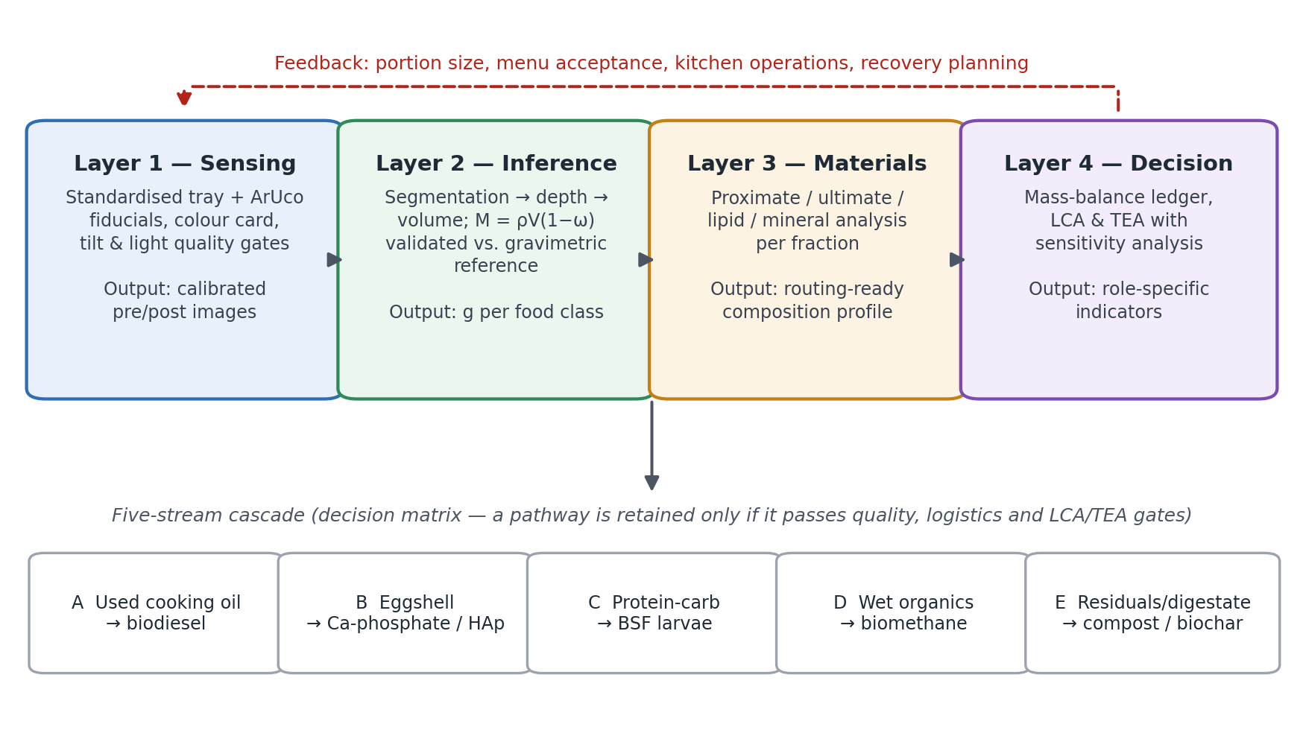
Figure 1. The four-layer measurement-first architecture. Measured plate waste flows from sensing to decision support; the five recovery streams form a gated decision matrix; results feed back to portioning, menu design and recovery planning.
Two design principles run through the architecture. The first is that standardisation happens before modelling: a model cannot fully correct variation that was introduced by uncontrolled geometry, light and colour, so the physical capture protocol is part of the measurement instrument. The second is that waste is not one bucket: used cooking oil, eggshell, cooked rice and leafy vegetables behave differently, and a cascade should preserve those differences before any residual streams are combined.
A third principle is communicative. Each audience needs a different view of the same data: engineers need error distributions, nutritionists need food-class mass, kitchens need simple per-meal indicators, recovery operators need feedstock forecasts, and decision makers need scenario ranges with uncertainty. The framework fails if any audience receives numbers it cannot interpret in its own operational context.

3. Study protocol

3.1 Staged design
The programme is staged so that each stage produces evidence the next stage depends on (Fig. 2). Stage 0 freezes the protocol, data dictionary and analysis plan and obtains ethical approval. Stage 1 is a pilot in a small number of schools that tunes capture quality gates and calibrates density and porosity parameters in the laboratory. Stage 2 is a multi-site validation across five geographic and operational zones of East Java — metropolitan, coastal, agricultural, mountainous and industrial — chosen to expose the pipeline to heterogeneous conditions, not to claim provincial or national representativeness. Stage 3 replicates characterisation and runs bench-scale recovery experiments. Stage 4 assembles the mass-balance ledger and the LCA/TEA. Stage 5 pilots a monitoring dashboard with periodic gravimetric re-checks to detect drift.
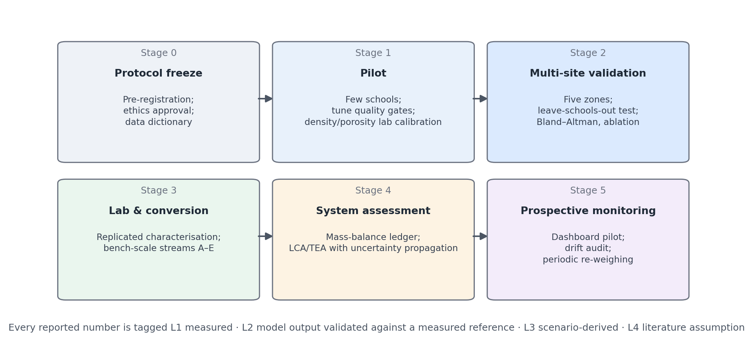
Figure 2. Staged research programme and the evidence ledger used to label every reported quantity.

3.2 Setting, units and sampling
The unit of analysis is a post-meal tray observation: a paired pre- and post-meal image set linked to gravimetric reference weights for each food component, plus metadata (anonymised school and SPPG identifier, zone, date, menu, device, capture conditions). Schools will be selected within each zone in cooperation with the SPPG responsible for them; selection rules and refusals will be documented. Trays, not pupils, are the sampling units, and no pupil-level identifiers will be collected.
Sample size is driven by the precision of the Bland–Altman limits of agreement rather than by hypothesis tests. For n paired observations, the standard error of a limit of agreement is approximately √(3s²/n), where s is the standard deviation of the differences [17]. With about 200 trays per food class, the 95% confidence half-width of each limit is therefore about 0.24 s; the final target will be inflated by a design effect for clustering within schools, estimated from pilot data.

3.3 Capture protocol and quality gates
Each tray is photographed before and after the meal from above, using a mid-range smartphone on a simple fixed-height stand. The tray carries four ArUco fiducial markers, whose detection is robust to partial occlusion [18], and a printed colour reference card. Candidate quality gates, to be tuned during the pilot, are: all four markers detected; camera tilt below 15° from inertial sensors; ambient illumination at or above about 150 lux; and a colour-reference error below a threshold in CIELAB space. Images failing a gate are re-taken on the spot; the rejection rate itself is reported as an operational outcome.

3.4 Gravimetric reference
Reference weights are obtained by selective weighing of each food component before serving and of each residual after the meal, using calibrated digital scales with at least 0.1 g resolution, following established weighed plate-waste practice [5, 6]. Scales are checked with certified masses at the start of each session. Weighing staff are blinded to model outputs.

3.5 Inference pipeline
Segmentation of food classes will use a promptable segmentation foundation model fine-tuned on annotated MBG trays [19]; relative depth will be obtained from a monocular depth model [20] and converted to metric scale using the fiducial geometry. Mass for food class i is estimated as
Mᵢ = ρᵢ · Vᵢ · (1 − ωᵢ) (1)
where Vᵢ is the reconstructed volume, ρᵢ a class-specific bulk density and ωᵢ a porosity correction for foods such as rice or leafy vegetables. ρᵢ and ωᵢ are measured in the laboratory for each recurring menu item during Stage 1 rather than taken from generic tables. Every model, checkpoint, preprocessing step and software version is recorded, and the code is released with a tagged version.

3.6 Validation and statistical analysis
- Data partitioning. Train, validation and test sets are split by school (leave-schools-out), so that no school contributes trays to both training and testing. A second external test uses menus not seen in training.
- Primary outcome. Agreement between estimated and weighed waste mass per food class, assessed with Bland–Altman bias and 95% limits of agreement [17].
- Secondary outcomes. Mean absolute error (g), mean absolute percentage error, coefficient of determination, and segmentation mAP; all reported per food class with school-clustered bootstrap confidence intervals.
- Pre-specified acceptance criterion. For operational monitoring, a food class is considered adequately measured if the limits of agreement fall within a clinically and operationally meaningful band agreed in advance with the nutrition partner (proposed: ±20% of the mean served portion of that class). Classes that fail are flagged for hybrid monitoring with periodic weighing.
- Ablation (H2). Three capture protocols — raw smartphone photo, homography correction only, and the full kit — are compared under indoor, low-light and outdoor conditions using the same trays.
- Decision sensitivity. Beyond accuracy, the analysis reports how often the system would flag a school or menu as high-waste when weighing would not, and vice versa.
- Reporting. Results follow a transparent reporting structure: number of trays per class, exclusions, rejection rates, inference time and hardware.

3.7 Material characterisation
Composite samples of each fraction (mixed residues, used cooking oil, eggshell and other recurring components) are collected per zone and analysed in replicate. Candidate methods, to be confirmed with the partner laboratory, include AOAC methods for moisture and ash, ASTM D3172 for proximate analysis, ASTM D5373 or CHNS analysis for elemental composition, free-fatty-acid and water content for oils, and elemental analysis for mineral fractions. Measured concentrations and derived indices (for example the C/N ratio) are reported separately so that uncertainty can be propagated.

3.8 The five-stream cascade as a gated decision matrix
Each stream is retained only if the measured feedstock passes quality gates and is available in sufficient, predictable quantity (Table 1). The matrix is deliberately not a claim that every school should run every process; regional facilities may be more appropriate for some streams.
Table 1. Recovery streams, entry criteria and the quality evidence required before a stream is retained.
Stream | Feedstock | Pathway | Entry / quality gate | Key references
A | Used cooking oil (kitchen) | Pretreatment + transesterification to biodiesel | FFA and water content; product tested against ASTM D6751 | [13]
B | Eggshell | Calcination + wet precipitation to calcium phosphate / hydroxyapatite | Phase identity (XRD, FTIR); phosphorus reagent and energy inventoried | [14]
C | Protein–carbohydrate residues | Black soldier fly larval bioconversion | Moisture, particle size, contaminants; feeding rate and WRI/FCR defined | [10, 11]
D | Wet organics | Anaerobic digestion to biomethane | Volatile solids; biochemical methane potential tested | [12]
E | Residuals, digestate, frass | Composting / biochar co-composting | Stability and contaminant limits under the applicable national standard | [15, 16]

Stream A deserves particular care with boundaries: used cooking oil arises mainly in kitchens rather than on plates, so it is accounted for as a separate kitchen-process flow. Stream B requires a phosphorus source and substantial heat; its environmental benefit must therefore be demonstrated against the incumbent route rather than assumed from its waste origin.

3.9 Mass-balance ledger
Let M_total be the measured plate-waste mass entering the system. It is partitioned into fractions f₁ … f₅ with Σ fₖ = 1 on a stated moisture basis, after accounting for contamination and measurement uncertainty. Every kilogram is assigned to exactly one of four destinations: a measured product, a modelled intermediate, an unavoidable loss, or an explicitly excluded fraction. This prevents double counting — for example, the same residue being credited both to larval conversion and to methane production.

3.10 Life-cycle and techno-economic assessment
The LCA follows ISO 14040/14044 [21, 22]. The functional unit is one tonne of MBG plate waste collected at the school or SPPG gate. Baseline scenarios include the prevailing disposal route observed during Stage 2 (e.g. open dumping or landfill without gas capture) and centralised composting. The inventory uses measured mass and composition from Stages 2–3; transport distances come from the actual SPPG network; avoided-product credits, biogenic carbon and methane assumptions are declared explicitly. The TEA evaluates a regional facility at capacities derived from measured feedstock, reporting net present value, internal rate of return and break-even thresholds. Both assessments propagate uncertainty (Monte Carlo) from image error, laboratory variability and process yields, and report one-at-a-time and global sensitivity for collection radius, utilisation, yields, product prices and electricity intensity. Results will be communicated as ranges and thresholds, not single optimistic numbers.

3.11 Ethics, privacy and data governance
Images are framed to capture trays only; the stand geometry excludes faces, and any frame in which a person appears is automatically blurred or discarded. The study will seek approval from the relevant institutional ethics committee and permission from schools, SPPG operators and the regional education office before Stage 1. No pupil-level personal data are collected. An anonymised dataset (images, reference weights, metadata and data dictionary), analysis code and model checkpoints will be deposited in a public repository with a persistent identifier upon publication, subject to school consent.

3.12 The evidence ledger
Every number reported from this programme will carry one of four tags: L1 directly measured; L2 model output validated against a measured reference; L3 scenario-derived; L4 literature-based assumption. Tables and figures will show these tags. Earlier internal drafts of this project contained illustrative parameter values (for example conversion yields and financial indicators) that were not derived from experiments; none of them is reported here, and none will be reported as a result unless it is produced and documented under this protocol.

4. Anticipated outputs and pre-specified interpretation
Because this is a protocol, the most useful thing to state now is how results will be read, so that interpretation cannot drift after data are seen.
Table 2. Pre-specified interpretation rules.
Possible finding | Interpretation | Operational consequence
Limits of agreement within the acceptance band for a food class | The class can be monitored by images alone | Routine image-based monitoring; periodic re-weighing for drift
Limits exceed the band for fragmented or mixed foods (e.g. leafy vegetables) | Measurement is morphology-limited, not a general failure | Hybrid monitoring: images for trends, weighing for that class
Full-kit advantage concentrated in low-light and outdoor conditions (H2 supported) | Physical standardisation is part of the instrument | Kit becomes mandatory where lighting is uncontrolled
Held-out school performance substantially lower (H3 rejected) | Model is site-specific | Site-level calibration step before deployment
Cascade benefit reverses under plausible transport or yield ranges (H4 rejected) | Recovery is logistics-limited | Prioritise prevention and simpler recovery (compost/AD) over complex streams

5. Discussion

5.1 Why measure first
Most proposals for MBG waste begin at the end of the chain — with a digester, a larval farm or a compost site. This framework begins at the plate for a simple reason: every downstream decision inherits the quality of the upstream number. A digester sized on an assumed waste rate may be over- or under-built; a larval facility fed on unpredictable supply underperforms; an LCA built on generic factors cannot distinguish a good menu from a poor one. Measuring first converts waste management from supply-agnostic engineering into feedstock-aware planning — and, more importantly, makes prevention possible, because the same measurement that forecasts feedstock also shows which menu items pupils are not eating.

5.2 From technical metrics to decisions people can act on
Measurement only has value when it reaches the person who must act. A kitchen manager does not need a segmentation score; a policy analyst does need to know whether a trend is robust. The communication layer therefore translates outputs into role-specific indicators: grams of waste per portion, share of edible food remaining, a menu acceptance index with an uncertainty band, expected feedstock per week for recovery operators, and cost and emission ranges for decision makers. Recommendations should follow validated thresholds rather than opaque model outputs, and human review remains necessary where nutrition, food safety or procurement decisions are involved. Publishing uncertainty alongside every indicator is itself a design choice: it allows the programme to communicate urgency without overstating certainty, which matters for public trust in a programme of this visibility.

5.3 Transferability
School-feeding programmes operate in many countries, and several face the same asymmetry between well-documented supply and undocumented consumption. The components here — tray-level references, leave-sites-out validation, fraction-specific routing and an evidence ledger — do not depend on Indonesian specifics and can be adapted to other menus, devices and waste systems.

5.4 Limitations
The main limitation is that no results are yet available; the framework's value will be judged by whether the pre-specified tests are passed or failed. The East Java sampling frame supports heterogeneity, not national representativeness. Image-based estimation will remain weaker for fragmented, mixed and sauce-covered foods. Bench-scale conversion results may not transfer to regional scale. Finally, LCA and TEA outcomes will depend on local disposal practices and logistics that may change as the programme evolves; the staged design and drift audits are intended to keep the evidence current.

6. Conclusion
The unfinished plate is where a school-feeding programme's intentions meet its outcomes. This paper proposes to measure it consistently, understand what it is made of, route each fraction to the highest-value feasible use, and return the information to the people who plan menus and manage waste. Its central commitment is methodological honesty: hypotheses and acceptance criteria are fixed in advance, results will be tagged by evidential status, and projections will be reported as ranges. If the framework succeeds, MBG plate waste becomes a measurable circular-economy intervention rather than a disposal afterthought; if parts of it fail, the pre-specified design will show exactly where and why.

Declarations
CRediT author statement (proposed; to be confirmed by all authors). Indri Anjar Kartika Sari: conceptualisation, methodology (sensing, AI and data), communication framework, writing — original draft, project administration. Enny Zulaika: methodology (biochemical and microbiological characterisation, biological valorisation), writing — review and editing. Purwa Hartono: methodology (digital technology and software architecture), writing — review and editing.
Funding. None at the time of writing.
Competing interests. The authors declare no competing interests.
Data and code availability. Data and code will be deposited as described in Section 3.11. A prototype repository is available at github.com/indri007/sisa-mbg; it contains software scaffolding only and no study data.
Ethics. Approval will be sought before Stage 1 (Section 3.11).
Declaration of generative AI use. Generative AI tools were used to help structure and edit the text. The authors reviewed and edited all content and take full responsibility for it. (Adjust to the target journal's required wording.)

References
[1] Badan Gizi Nasional. (2026, January 20). Awal 2026, Program MBG jangkau hampir 60 juta penerima manfaat [Press release]. https://www.bgn.go.id/news/siaran-pers/awal-2026-program-mbg-jangkau-hampir-60-juta-penerima-manfaat
[2] Pambudi, P. A., & Fardiani, S. N. (2026). Food waste in the implementation of the Free Nutritious Meals (MBG) program: From nutrition to emissions and management strategies. Environmental Pollution Journal, 6(2), 170–182. https://doi.org/10.58954/epj.v6i2.454
[3] Ministry of National Development Planning/Bappenas. (2021). Food loss and waste in Indonesia [Study report, Low Carbon Development Initiative]. Jakarta: Bappenas. https://lcdi-indonesia.id/wp-content/uploads/2021/07/Report-Kajian-FLW-ENG.pdf
[4] United Nations Environment Programme. (2024). Food Waste Index Report 2024. Nairobi: UNEP.
[5] Comstock, E. M., St. Pierre, R. G., & Mackiernan, Y. D. (1981). Measuring individual plate waste in school lunches. Journal of the American Dietetic Association, 79(3), 290–296. https://doi.org/10.1016/S0002-8223(21)39368-3
[6] Byker Shanks, C., Banna, J., & Serrano, E. L. (2017). Food waste in the National School Lunch Program 1978–2015: A systematic review. Journal of the Academy of Nutrition and Dietetics, 117(11), 1792–1807. https://doi.org/10.1016/j.jand.2017.06.008
[7] Wang, L., Liu, G., Liu, X., Liu, Y., Gao, J., Zhou, B., Gao, S., & Cheng, S. (2017). The weight of unfinished plate: A survey based characterization of restaurant food waste in Chinese cities. Waste Management, 66, 3–12. https://doi.org/10.1016/j.wasman.2017.04.007
[8] Lubura, J., Pezo, L., Sandu, M. A., Voronova, V., Donsì, F., et al. (2022). Food recognition and food waste estimation using convolutional neural network. Electronics, 11(22), 3746. https://doi.org/10.3390/electronics11223746
[9] Ferreira, J., et al. (2025). Food waste detection in canteen plates using YOLOv11. Applied Sciences, 15(13), 7137. https://doi.org/10.3390/app15137137
[10] Diener, S., Zurbrügg, C., & Tockner, K. (2009). Conversion of organic material by black soldier fly larvae: Establishing optimal feeding rates. Waste Management & Research, 27(6), 603–610. https://doi.org/10.1177/0734242X09103838
[11] Surendra, K. C., Tomberlin, J. K., van Huis, A., Cammack, J. A., Heckmann, L. H. L., & Khanal, S. K. (2020). Rethinking organic wastes bioconversion: Evaluating the potential of the black soldier fly (Hermetia illucens (L.)) (Diptera: Stratiomyidae) (BSF). Waste Management, 117, 58–80. https://doi.org/10.1016/j.wasman.2020.07.050
[12] Zhang, C., Su, H., Baeyens, J., & Tan, T. (2014). Reviewing the anaerobic digestion of food waste for biogas production. Renewable and Sustainable Energy Reviews, 38, 383–392. https://doi.org/10.1016/j.rser.2014.05.038
[13] Lam, M. K., Lee, K. T., & Mohamed, A. R. (2010). Homogeneous, heterogeneous and enzymatic catalysis for transesterification of high free fatty acid oil (waste cooking oil) to biodiesel: A review. Biotechnology Advances, 28(4), 500–518. https://doi.org/10.1016/j.biotechadv.2010.03.002
[14] Kareem, Z., & Eyiler, E. (2024). Synthesis of hydroxyapatite from eggshells via wet chemical precipitation: A review. RSC Advances, 14(30), 21439–21452. https://doi.org/10.1039/d4ra02198c
[15] Papargyropoulou, E., Lozano, R., Steinberger, J. K., Wright, N., & Ujang, Z. (2014). The food waste hierarchy as a framework for the management of food surplus and food waste. Journal of Cleaner Production, 76, 106–115. https://doi.org/10.1016/j.jclepro.2014.04.020
[16] Bernstad, A., & la Cour Jansen, J. (2012). Review of comparative LCAs of food waste management systems – Current status and potential improvements. Waste Management, 32(12), 2439–2455. https://doi.org/10.1016/j.wasman.2012.07.023
[17] Bland, J. M., & Altman, D. G. (1986). Statistical methods for assessing agreement between two methods of clinical measurement. The Lancet, 327(8476), 307–310. https://doi.org/10.1016/S0140-6736(86)90837-8
[18] Garrido-Jurado, S., Muñoz-Salinas, R., Madrid-Cuevas, F. J., & Marín-Jiménez, M. J. (2014). Automatic generation and detection of highly reliable fiducial markers under occlusion. Pattern Recognition, 47(6), 2280–2292. https://doi.org/10.1016/j.patcog.2014.01.005
[19] Ravi, N., et al. (2024). SAM 2: Segment anything in images and videos. arXiv:2408.00714. https://arxiv.org/abs/2408.00714
[20] Yang, L., et al. (2024). Depth Anything V2. arXiv:2406.09414. https://arxiv.org/abs/2406.09414
[21] ISO. (2006). ISO 14040:2006 Environmental management — Life cycle assessment — Principles and framework. Geneva: International Organization for Standardization.
[22] ISO. (2006). ISO 14044:2006 Environmental management — Life cycle assessment — Requirements and guidelines. Geneva: International Organization for Standardization.

