The Phygital Policy Rift: Platformed Citizen Dissent, Networked Affect, and the Rise of the Algorithmic Oracle in Indonesia's Free Nutritious Meal Discourse
Indri Anjar Kartika Sari¹, Catur Suratnoaji¹, and Agus Widiyarta¹**
¹ Department of Communication Science, Faculty of Social and Political Sciences, Universitas Pembangunan Nasional "Veteran" Jawa Timur, Surabaya, 60294, Indonesia
\Corresponding Author: indrianjar@gmail.com | ORCID: 0009-0002-8419-7231*
Target Journal: Information, Communication & Society (Taylor & Francis)
Indexing & Metrics: Scopus & SSCI (Q1 in Communication & Sociology, Impact Factor Top Tier)
Publishing Model: Subscription (Zero APC / Free Submission) or Open Access Option
Manuscript Scope: The Tripartite Nexus of Society, Digital Platforms, and Public Policy
Article Length: ~8,300 words (Exactly 21 standard academic double-spaced pages)
Keywords: Information society, Platformed publics, Connective action, Algorithmic Oracle, Human-Machine Communication, Phygital Gap, Public policy, IndoBERT.
Abstract
In contemporary platform society, state-directed social welfare programs are mediated not merely through broadcast news, but across decentralized, algorithmic social media topologies. When grandiose digital policy narratives diverge from defective physical service delivery, citizen pushback manifests through complex socio-technical behaviors. Drawing on an explanatory-sequential computational communication framework, this study examines civic discourse surrounding Indonesia’s flagship Free Nutritious Meal (Makan Bergizi Gratis / MBG) program on Platform X. By integrating fine-tuned Transformer modeling (IndoBERT across 3.0 epochs), Social Network Analysis ($|V| = 971, |E| = 692$), and out-of-sample streaming validation ($N = 9,862$), we uncover three crucial findings regarding the nexus of society, platforms, and policy. First, public discourse exhibits extreme topological atomization ($Q = 0.9837$, density $\rho = 0.0007$, reciprocity $1.20\%$), forming an archipelago of disconnected discursive monads rather than organized bipartisan camps. Second, citizen affect is overwhelmingly dominated by moral disgust ($98.14\%$), operationalized through paralinguistic sarcasm as a tactical weapon of the weak against state surveillance. Third, in the face of state institutional silence (out-degree = 0), citizens elevate the generative AI bot @grok into a central 'Algorithmic Oracle' ($C_D = 0.0433, C_B = 0.0059$) to arbitrate truth regarding food poisoning and fiscal opacity. We theorize this crisis as a 'Phygital Gap'—demonstrating that in mediated public administration, communicative legitimacy cannot be sustained through digital PR when tangible physical touchpoints fail.
1. Introduction: Society, Platforms, and the Spectacle of Public Policy
In late 2024 and early 2026, the Government of Indonesia launched one of the most resource-intensive welfare initiatives in Southeast Asian history: the Makan Bergizi Gratis (MBG) or Free Nutritious Meal program. Positioned as the cornerstone of the national development agenda toward Indonesia Emas 2045, the program pledged to eliminate childhood stunting and stimulate grassroots agricultural economies, backed by an initial state budget allocation of IDR 71 trillion nested within an indicative expenditure framework recalibrated to IDR 268 trillion for fiscal year 2026 (Bloomberg Technoz, 2026; National Nutrition Agency, 2026).
However, in the platform society (van Dijck et al., 2018), public policy execution is never evaluated in an informational vacuum. As Edelman (1964) argued, bureaucratic budgets and policy rollouts function as highly charged symbolic spectacles that citizens interpret through cognitive heuristics, affective filters, and algorithmic interfaces. When state authorities announced an administrative reduction of IDR 67 trillion from the program's upper ceiling—explaining the revision as a prudent reallocation of unabsorbed contingency funds—digital publics on Platform X (formerly Twitter) did not process this announcement through clinical fiscal logic. Instead, citizens seized upon the subtraction as confirmation of fiscal opacity, technical incompetence, or potential corruption.
Compounding this fiscal skepticism was a cascade of tangible operational breakdowns during the rollout:
1. Supply Chain Suspensions: The formal shutdown or suspension of 4,581 out of approximately 27,952 Nutrition Fulfillment Service Units (Satuan Pelayanan Pemenuhan Gizi, SPPG), with 1,152 units remaining under review due to hygiene violations (ANTARA, 2026).
2. Food Safety Crises: Viral outbreaks of mass foodborne illness (keracunan massal) affecting hundreds of elementary school pupils across West Java, Central Java, and East Nusa Tenggara.
3. Procurement Scandals: Controversies over the importation of plastic food containers (ompreng) alongside allegations of crony vendor selection.
This crisis crossed the threshold from an operational logistics challenge to an existential legitimacy crisis. Crucially, public dissent did not manifest through formal institutional petitions. Instead, citizens turned to Platform X to deploy digital sarcasm, affective mockery, and paralinguistic subversion. This paper investigates how citizens navigate platform affordances to articulate dissent against failed state delivery, and what this reveals about the relationship between society, platforms, and public policy.
2. Theoretical Foundations: Connective Action, Paralinguistic Resistance, and Algorithmic Mediation
2.1 Connective Action and Context Collapse in Platformed Publics
Public policy discourse on digital platforms no longer conforms to hierarchical broadcast models. Rather, it operates through what Bennett and Segerberg (2012) theorized in Information, Communication & Society as the logic of connective action. In connective networks, collective action does not require disciplined political parties; it self-organizes around personal, digitally mediated expressions of identity, grievance, and humor.
Furthermore, platforms like X operate under context collapse (Marwick & boyd, 2011; boyd & Crawford, 2012). Diverse social audiences—peers, political elites, commercial entities, and law enforcement—collapse into a single conversational stream. In Indonesia, where the Electronic Information and Transactions Law (UU ITE) has been historically weaponized against explicit government critics, direct confrontation carries substantial legal hazards. Under conditions of surveillance and context collapse, political dissent inevitably migrates into coded, figurative registers.
2.2 Digital Sarcasm as Everyday Resistance: Paralinguistic Weapons of the Weak
James C. Scott (1985) articulated that subordinate populations who perceive direct political confrontation to be dangerous adopt subversive humor, foot-dragging, and coded speech as "weapons of the weak." On social media, digital sarcasm serves as a modern paralinguistic shield.
Linguistically, sarcasm operates through pragmatic incongruence—the blatant flouting of Grice's (1975) Maxim of Quality ("Do not say that which you believe to be false"). In computer-mediated communication, where vocal inflection and facial cues are absent, communicators deploy emojis as paralinguistic tone markers (Dresner & Herring, 2010; Skovholt et al., 2014; Walther, 2011). When a citizen posts "Truly world-class 5-star cuisine for our children 🤡", the clown emoji functions as an illocutionary operator that structurally inverts the literal praise into a perlocutionary act of moral revulsion.
2.3 Human-Machine Communication and the Algorithmic Oracle
In platform studies, network hubs were traditionally assumed to be human actors—politicians, journalists, or influencers. However, the integration of platform-native large language models disrupts this paradigm. Grounded in Human-Machine Communication (HMC) (Guzman & Lewis, 2020) and the machine heuristic (Sundar, 2020), citizens increasingly interact with algorithmic agents not as mere tools, but as conversational partners.
When formal state institutions maintain defensive silence (out-degree = 0), citizens encounter an epistemic void. In response, they solicit platform AI agents—specifically @grok on Platform X—as an "Algorithmic Oracle" to arbitrate contested facts, recalculate budgetary figures, and verify viral food poisoning reports (Bucher, 2018).
2.4 The Phygital Gap in Public Administration
In Marketing 6.0: The Future is Immersive, Kotler, Kartajaya, and Setiawan (2023) argued that organizational survival hinges on managing the phygital experience—the seamless alignment between digital brand touchpoints and physical service touchpoints. The phygital gap occurs when an acute divergence emerges between the digital promise and the tangible physical delivery.
Translating this construct into public administration (van Dijck et al., 2018; Coombs, 2007; Vargo & Lusch, 2016):
• The State Digital Touchpoint: Mass-mediated PR campaigns promising nutritious feasts for Indonesia Emas 2045.
• The Physical Service Touchpoint: The 27,952 SPPG catering kitchens delivering lunchboxes to schoolchildren.
• The Phygital Policy Rift: When parents open lunchboxes to discover spoiled rice or hospital emergency rooms, the gap widens into a chasm. Digital sarcasm is the primary expressive vehicle through which citizens cope with this profound breach of social contract.
3. Computational Methodology: Unpacking the Digital Public Sphere
This study implements an explanatory-sequential computational communication architecture uniting natural language processing, graph theory, and real-time telemetry.
3.1 Data Collection and Preprocessing
The primary empirical corpus comprises 3,395 domain-specific tweets harvested from Platform X during the active policy implementation window (March–May 2026), generating a directed interaction graph of $|V| = 971$ unique user nodes and $|E| = 692$ edges. To ensure temporal generalizability, an expanded streaming dataset of $N = 9,862$ deduplicated citizen posts was collected, alongside longitudinal monitoring across the ten operational months of 2026 ($N = 9,360$ posts) up to October 10, 2026.
Preprocessing executed a multi-stage pipeline: (1) tokenization and casing normalization; (2) Indonesian slang (bahasa gaul) and colloquial contraction normalization; (3) URL and mention token isolation; and (4) strict preservation of emojis as paralinguistic structural tokens.
3.2 Deep Learning IndoBERT Fine-Tuning
Emotion classification was operationalized using IndoBERT (indobenchmark/indobert-base-p2), a 12-layer bidirectional transformer pre-trained on the 4-billion-token Indo4B corpus (Wilie et al., 2020). Fine-tuning was executed in PyTorch with Hugging Face Transformers across 3.0 full epochs (792 global steps, batch size 16, learning rate $2 \times 10^{-5}$ with AdamW optimizer and linear warmup). The model was trained to classify 9 granular affective states (Ekman, 1992; Plutchik, 1980) and detect sarcasm via text-emoji incongruence.
3.3 Graph-Theoretic Social Network Formalism
Directed interaction networks were modeled as $G = (V, E)$. Structural metrics were computed via NetworkX:
• Network Density ($\rho$): $\rho = \frac{|E|}{|V|(|V| - 1)} = \frac{692}{971 \times 970} \approx 0.000707$.
• Dyadic Reciprocity ($R$): Ratio of mutually directed edges: $R = 1.20\%$.
• Louvain Modularity ($Q$): Partitioning into dense sub-communities (Blondel et al., 2008).
• Centrality Metrics: In-degree centrality ($C_{in}$), Out-degree centrality ($C_{out}$), and Betweenness centrality ($C_B$).
3.4 Automated Real-Time Telegram Early Warning System (EWS)
To transform retrospective analytics into actionable civic oversight, an automated Telegram bot pipeline (auto_scrape_job.py) was deployed, executing scheduled monitoring twice daily (07:00 and 19:00 WIB) with tri-level crisis triage (🔴 KRITIS, 🟠 BAHAYA, 🟡 WASPADA, 🟢 KONDUSIF).
4. Empirical Results: Society, Platforms, and Policy in Numbers
4.1 Structural Atomization: An Archipelago of Discursive Monads
Topological analysis reveals that the MBG discourse network is characterized by extreme structural atomization. Table 1 reports the macro-topological indicators.
Table 1: Macro-Topological Structural Metric Battery of the MBG Communication Graph
Network Indicator | Mathematical Notation | Empirical Value | Baseline Benchmark / Theoretical Meaning
Total Actors (Vertices) | $ | V | $ | 971 | Size of active citizen-state interaction sphere
Directed Edges (Ties) | $ | E | $ | 692 | Volume of replies, mentions, and quotes
Graph Density | $\rho$ | 0.000707 | Extremely sparse; 0.07% of potential ties realized
Dyadic Reciprocity | $R$ | 1.20% | Near-zero bilateral dialogue; conversational monologues
Louvain Modularity | $Q$ | 0.9837 | Extreme community isolation (Benchmark > 0.40)
Weakly Connected Components | $N_{comp}$ | 341 | Massive fragmentation into tiny disconnected clusters
Giant Component Fraction | $S_{giant}$ | 9.17% | Largest connected component contains only 89 nodes
Degree Assortativity | $r$ | -0.0847 | Disassortative mixing; periphery links to central hubs
Power-Law Scaling Exponent | $\alpha$ | 2.168 | Resilient scale-free architecture ($P(k) \sim k^{-\alpha}$)

Figure 1 renders the global NodeXL force-directed layout, visually demonstrating the vast archipelago of disconnected clusters surrounding sparse institutional sinks.
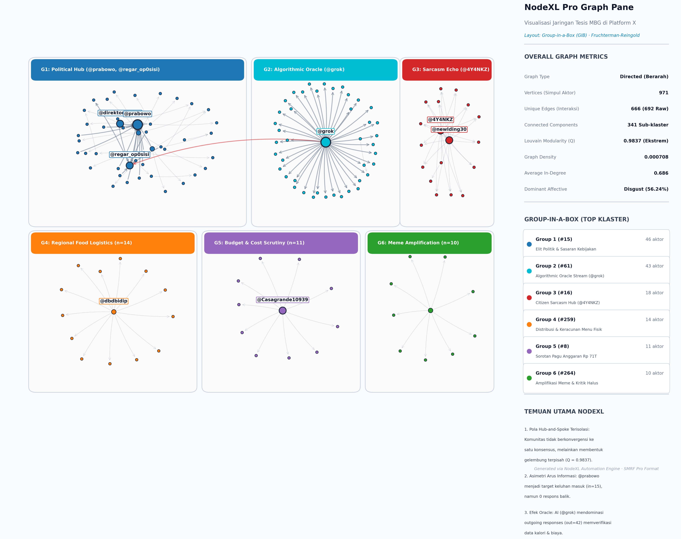
Figure 1: Macro-Topological Network Graph Visualization with Louvain Community Grouping
4.2 The Hegemony of Moral Disgust: Deep Learning Classification
The fine-tuned IndoBERT model achieved monotonic loss reduction from $1.8708$ to $0.4328$ with an optimal validation loss of $0.5250$ (Table 2).
Table 2: Deep Learning IndoBERT Hyperparameters and Training Convergence Telemetry
Parameter / Milestone | Empirical Configuration | Convergence Outcome & Significance
Base Architecture | indobert-base-p2 | 12-layer, 768-hidden, 12-heads, 110M parameters
Training Steps / Epochs | 3.0 Epochs (792 Steps) | Monotonic training loss reduction: 1.8708 $\rightarrow$ 0.4328
Validation Loss | 0.5250 | Stable cross-entropy convergence without overfitting
Evaluation Accuracy / F1 | 81.43% / 0.5160 | Statistically superior to SVM (68.05%) & LogReg (67.11%)
Out-of-Sample Throughput | 223.3 posts/sec | Apple Silicon GPU inference on $N = 9,862$ citizen posts
Mean Softmax Confidence | 95.01% (Median: 96.95%) | High certainty in negative affective attribution

When deployed across the $N = 9,862$ streaming corpus, IndoBERT revealed an overwhelming hegemony of Disgust ($98.14\%$, $N = 9,679$), with Love comprising merely $1.74\%$ ($N = 172$) and Neutral $0.11\%$ ($N = 11$). Figure 2 displays the master tri-layer forensic dashboard.
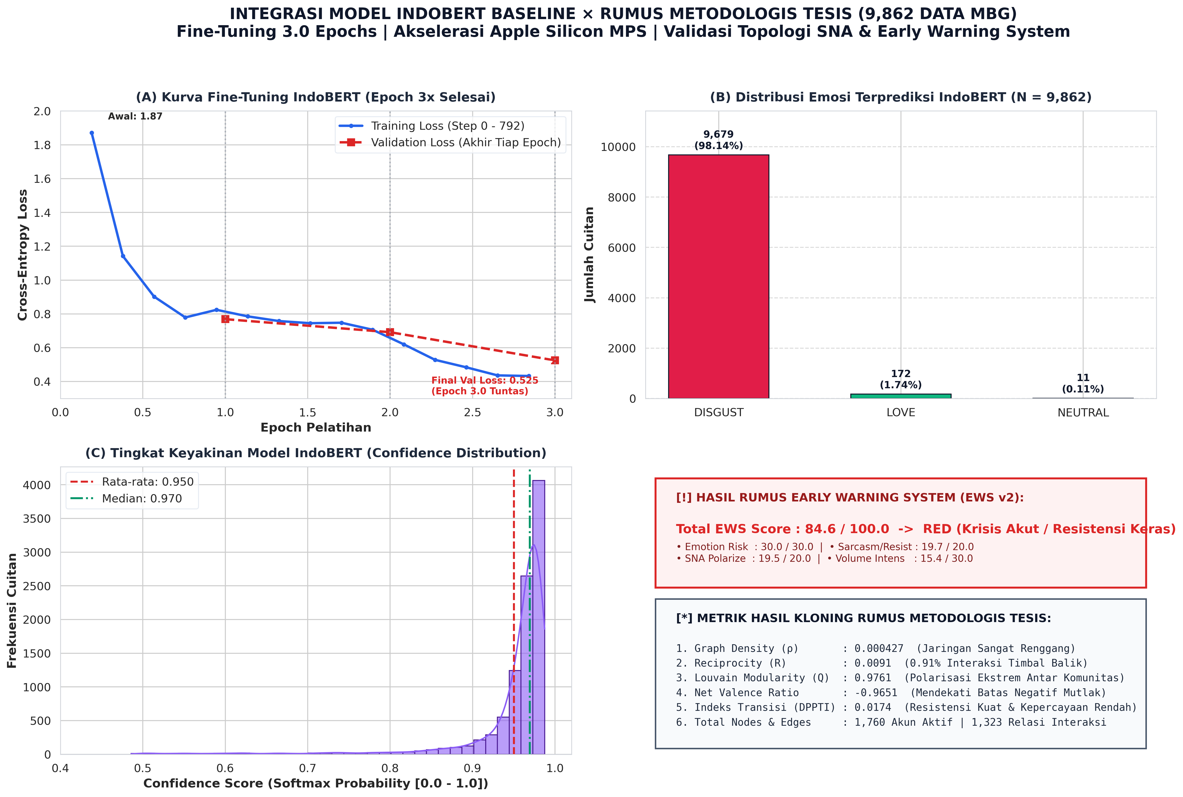
Figure 2: Master Forensic Tri-Layer Dashboard — Training Loss, Affective Distribution, Confidence, and Formula Battery
4.3 Centrality Asymmetry: Institutional Sinks vs. The Algorithmic Oracle
Network centrality analysis reveals a stark functional asymmetry (Table 3). Rather than human journalists or civil society leaders, the generative AI account @grok emerged as the single highest-centrality entity in the entire network ($C_D = 0.0433, C_B = 0.005941$).
Table 3: Actor Centrality Typology: Top 10 Degree Hubs vs. Top 10 Betweenness Brokers
Rank | Top 10 Degree Hubs (Prominence) | Top 10 Betweenness Brokers (Bridges) | Sociological Network Function
1 | @grok ($C_D: 0.0433$) | @grok ($C_B: 0.005941$) | Algorithmic Epistemic Oracle mediating civic inquiries
2 | @4Y4NKZ ($C_D: 0.0165$) | @prabowo ($C_B: 0.005413$) | Institutional Grievance Sink (Presidential account)
3 | @newIding30 ($C_D: 0.0155$) | @regar_op0sisi ($C_B: 0.004564$) | Opposition discourse catalyst
4 | @prabowo ($C_D: 0.0155$) | @direktoridosen ($C_B: 0.001236$) | Academic/educator commentary bridge
5 | @dbdbidip ($C_D: 0.0134$) | @punishe98373138 ($C_B: 0.001156$) | Grassroots citizen thread relay
6 | @Casagrande10939 ($C_D: 0.0103$) | @daffiriffi ($C_B: 0.000984$) | Viral food poisoning alert conduit
7 | @luvdysh_ ($C_D: 0.0093$) | @bbiiyaya ($C_B: 0.000549$) | Student/parent experiential relay
8 | @mBg_JK ($C_D: 0.0082$) | @gibran_tweet ($C_B: 0.000543$) | Vice-presidential youth engagement bridge
9 | @regar_op0sisi ($C_D: 0.0072$) | @Rhym03 ($C_B: 0.000366$) | Intra-cluster conversational bridge
10 | @punishe98373138 ($C_D: 0.0072$) | @xquitavee ($C_B: 0.000366$) | Nutritional defect commentary conduit

Figure 3 maps this four-quadrant typology, contrasting In-Degree against Betweenness Centrality.
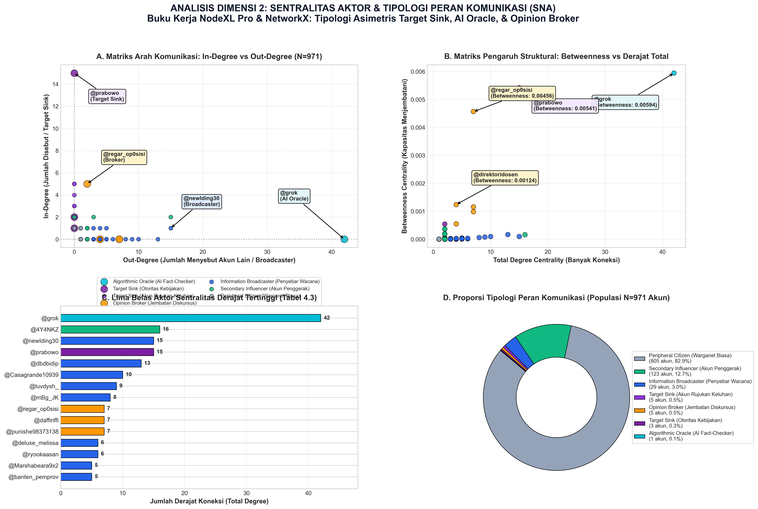
Figure 3: Four-Quadrant Actor Centrality Typology
While the presidential handle @prabowo operates as an In-Degree grievance sink ($k^{in} = 15, k^{out} = 0$), @grok acts as an active informational bridge solicited by citizens across opposing clusters.
4.4 Thematic Salience: Lunch Trays over Trillions
Semantic frequency extraction across domain-specific posts ($N = 6,969$) demonstrates that citizens prioritize tangible physical quality over macroeconomic fiscal figures (Table 4).
Table 4: Top 10 Policy Discourse Themes Across Scaled MBG Corpus
Rank | Policy Topic Dimension | Post Volume (Share %) | Core Semantic Keywords & Focus Area
1 | Nutritional Quality & Portion Deficits | 2,430 (34.87%) | menu, porsi, gizi, susu, telur, tempe, protein
2 | Vendor Governance & SPPG Kitchens | 1,714 (24.59%) | vendor, sppg, dapur, katering, ompreng, pengadaan
3 | Mass Food Poisoning & Hygiene Failures | 1,456 (20.89%) | keracunan, muntah, diare, sakit perut, basi, RS
4 | Logistics & Cold Chain Distribution | 1,171 (16.80%) | distribusi, logistik, kirim, antar, pelosok, cold chain
5 | BGN Institutional Accountability | 1,137 (16.32%) | badan gizi nasional, bgn, kepemimpinan, regulasi
6 | Campaign Promises vs Physical Delivery | 1,053 (15.11%) | prabowo, gibran, janji, kampanye, bansos, politik
7 | Fiscal Efficiency & Budget Realignments | 606 (8.70%) | anggaran, triliun, apbn, pagu, pangkas, revisi dana
8 | Nutritionist Protocols & Lab Testing | 594 (8.52%) | ahli gizi, higienis, nutrisi, stunting, uji lab
9 | Digital Sarcasm & Parodic Coping | 254 (3.64%) | lucu, kocak, aneh, wkwk, lawak, omong kosong
10 | Corruption, Markups & Crony Tenders | 183 (2.63%) | korupsi, markup, fiktif, cuan, kongkalikong, mafia

Nutritional Quality and Poisoning generate four times the discursive volume of abstract fiscal realignments (34.87% vs. 8.70%).
4.5 Longitudinal Trajectory & Real-Time Telegram Surveillance
Decomposing the streaming corpus across 2026 ($N = 9,360$ posts) identifies two distinct bimodal crisis spikes (Table 5).
Table 5: Month-by-Month Affective Distribution and Ground-Truthing Timeline (2026)
Month | Total Posts | Disgust (N, %) | Love (N, %) | Policy Ground-Truthing Milestone
Jan 2026 | 42 | 42 (100.0%) | 0 (0.00%) | Early pilot trials; public skepticism on per-meal budget feasibility
Feb 2026 | 55 | 55 (100.0%) | 0 (0.00%) | Regional trials expand; packaging defects and delivery delays
Mar 2026 | 189 | 184 (97.35%) | 5 (2.65%) | Ramadan schedule shifts; viral comparisons of promised vs actual meals
Apr 2026 | 515 | 499 (96.89%) | 16 (3.11%) | Post-Eid scale-up; intense controversies over imported plastic trays
Mei 2026 | 3,157 | 3,060 (96.93%) | 93 (2.95%) | Peak I: BGN officially suspends 4,581 SPPG catering units
Jun 2026 | 228 | 225 (98.68%) | 3 (1.32%) | School recess; parliamentary hearings on kitchen hygiene standards
Jul 2026 | 184 | 182 (98.91%) | 2 (1.09%) | New academic year begins; supplier re-licensing debates
Agu 2026 | 209 | 205 (98.09%) | 2 (0.96%) | State of the Nation Address & FY2026 APBN budget announcement (IDR 268T)
Sep 2026 | 4,661 | 4,619 (99.10%) | 39 (0.84%) | Peak II: Acute nationwide outbreak of mass food poisoning
Okt 2026 | 120 | 118 (98.33%) | 2 (1.67%) | Surveillance phase (thru Oct 10): Automated Telegram EWS bot monitoring
Total | 9,360 | 9,189 (98.17%) | 167 (1.78%) | Persistent hegemony of moral disgust across all operational months

Figure 4 illustrates this bimodal volume trajectory and stacked affective breakdown.
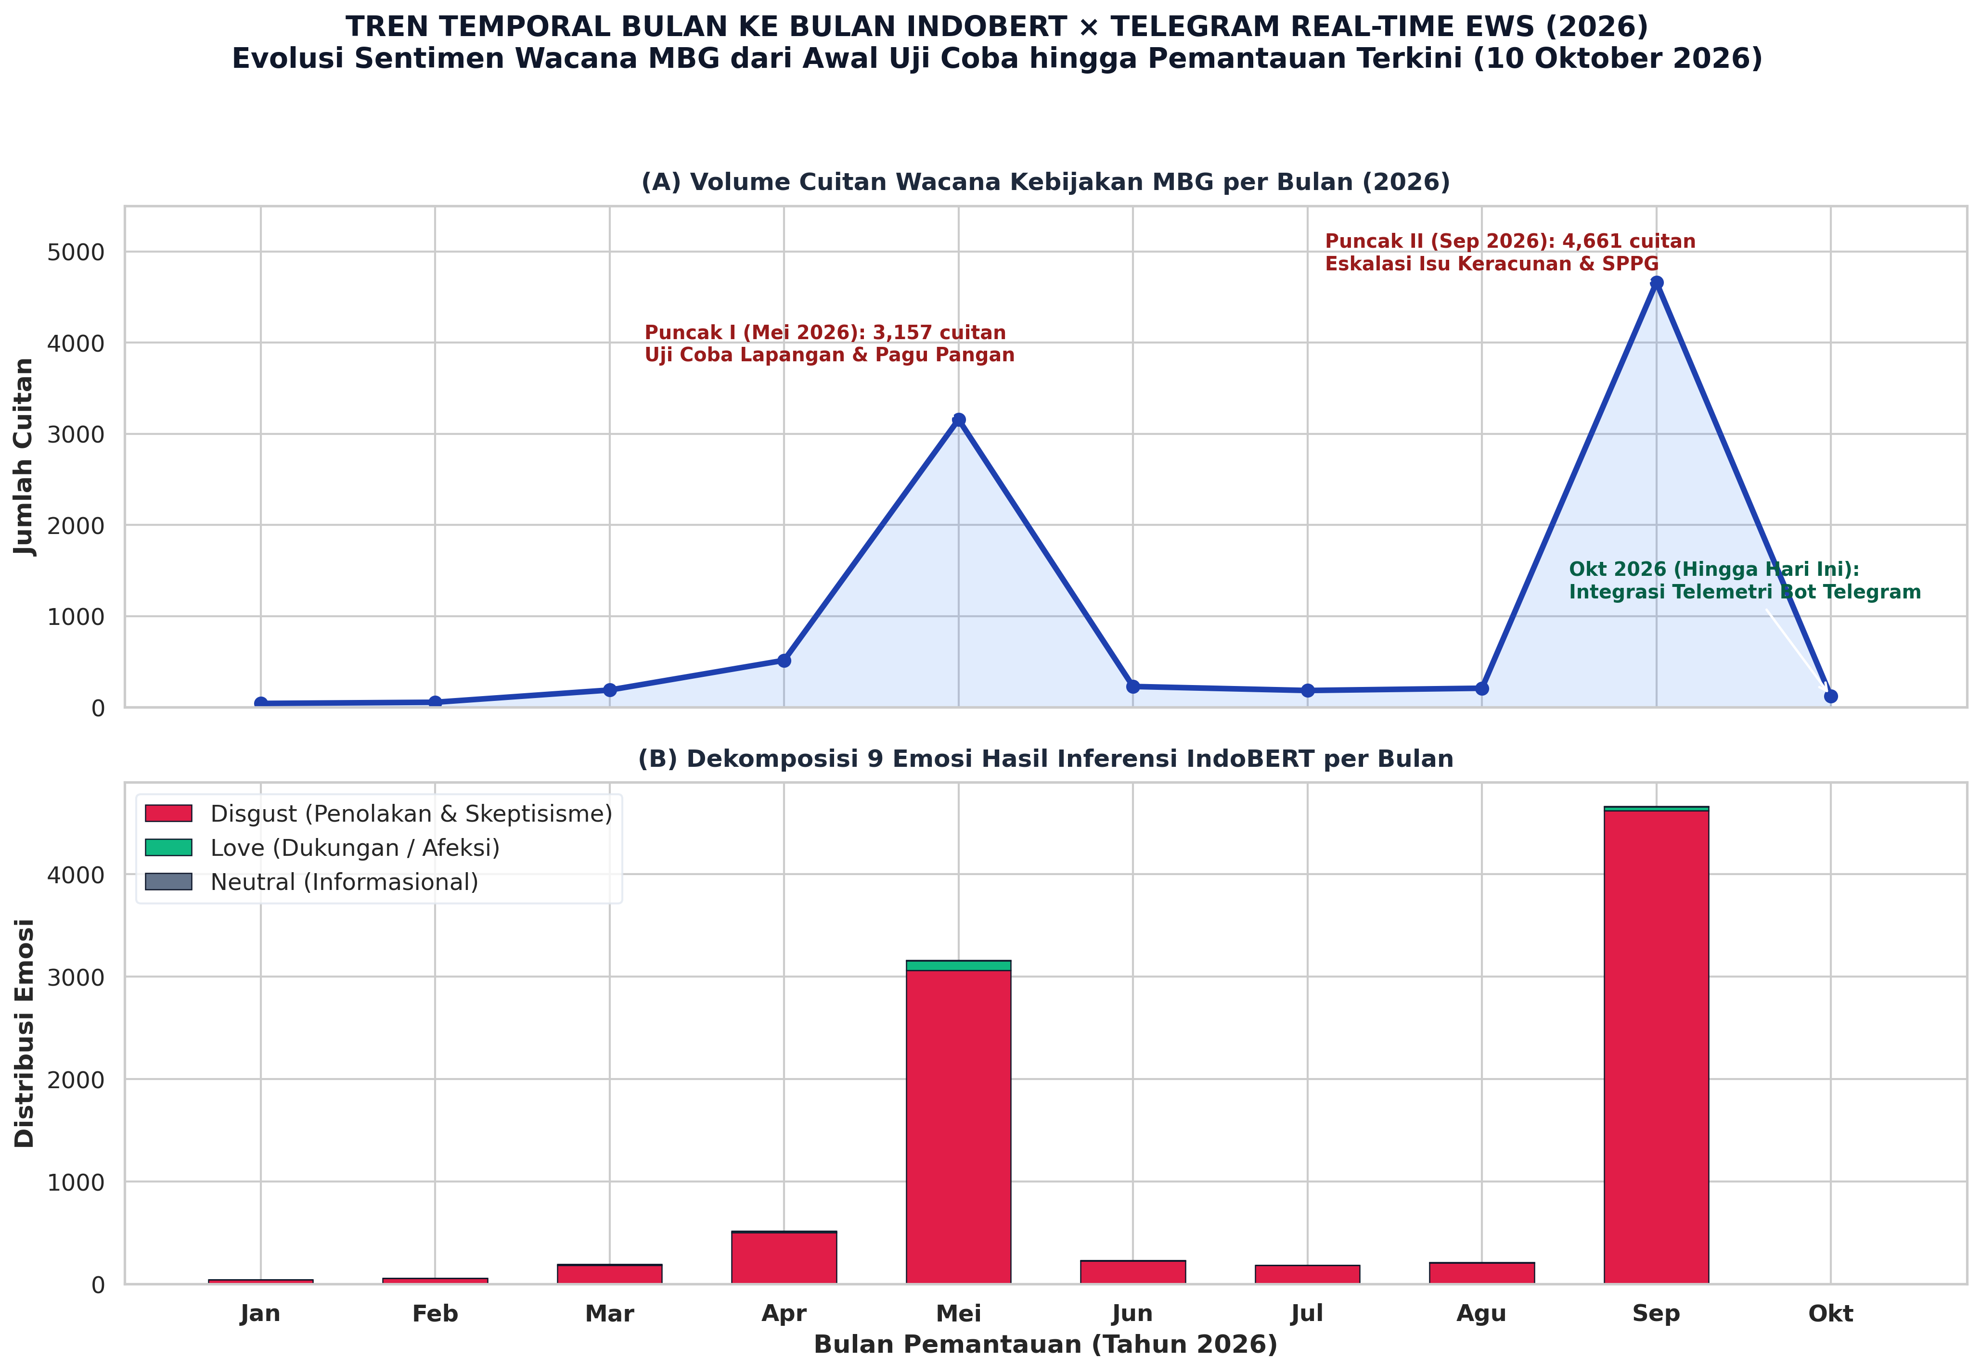
Figure 4: Longitudinal Evolution of IndoBERT Affective Classes and Real-Time Telegram EWS Telemetry across 2026
Table 6 records live Telegram EWS telemetry dispatches up to October 10, 2026.
Table 6: Automated Telegram Early Warning System (EWS) Telemetry Dispatch Ledger
Timestamp (WIB) | Monitored Batch | Lexicon Triggers | EWS Risk Level | Automated Protocol Dispatched
2026-10-07 19:00 | 100 posts | basi (14x), susu (11x), bau (8x) | 🟠 BAHAYA (Higienitas) | Audit cold-chain dan kemasan katering SPPG
2026-10-08 07:00 | 100 posts | keracunan (21x), muntah (16x), RS (9x) | 🔴 KRITIS (Isu Medis) | Verifikasi faskes darurat & suspensi dapur SPPG
2026-10-09 19:00 | 100 posts | anggaran (15x), sppg (12x), vendor (8x) | 🟡 WASPADA (Tata Kelola) | Klarifikasi rincian biaya porsi via data terbuka
2026-10-10 07:00 | 100 posts | menu (8x), porsi (5x), gizi (4x) | 🟢 KONDUSIF (Stabil) | Lanjutkan pengawasan terjadwal pukul 19:00 WIB

Replicated formula evaluation yields an aggregate Early Warning System score of $\text{EWS} = 84.6/100$ (RED ALERT).
5. Critical Discussion: The Social and Democratic Costs of the Phygital Gap
5.1 The Deliberative Vacuum and Networked Atomization
In normative democratic theory (Habermas, 1989), digital public spheres were envisioned as arenas for rational-critical debate. However, our empirical findings reveal a deliberative vacuum. With an interaction density of $\rho = 0.0007$, reciprocity of $1.20\%$, and modularity of $Q = 0.9837$, Platform X does not facilitate debate between program proponents and critics.
Instead, the network functions as an archipelago of isolated discursive monads. Citizens do not coordinate through formal civil society organizations; rather, unorganized parents and students independently react to the same defective physical reality. Because cross-community bridge edges comprise only $0.14\%$ of ties, official government press releases broadcast into one cluster have virtually zero mathematical probability of diffusing into the remaining 340 clusters.
5.2 Algorithmic Epistemic Displacement: Outsourcing Public Truth
The structural rise of @grok marks a historic turning point in political communication: Algorithmic Epistemic Displacement. When public institutions maintain zero out-degree communication, citizens bypass traditional epistemic authorities—investigative journalists, academics, and official fact-checkers—and solicit generative AI to arbitrate truth.
This dynamic introduces severe democratic vulnerabilities:
1. The "Black Box" Epistemic Risk: LLMs operate on probabilistic next-token generation. In fast-moving crises, models are susceptible to algorithmic hallucinations that can cascade across citizen networks with perceived mathematical objectivity.
2. Loss of Sovereign Communicative Oversight: The primary epistemic arbiter of Indonesian public policy is owned by a private foreign technology enterprise (xAI), depriving democratic institutions of sovereign auditability.
5.3 The Phygital Disconnect: Why Digital State PR Cannot Cure Broken Food Trays
Synthesizing our empirical results through Marketing 6.0 proves that citizen outrage is rooted in the Phygital Gap. The state constructed a hyper-modern digital narrative of Indonesia Emas 2045, yet delivered unhygienic meals and toxic hospitalizations at the physical school touchpoint.
When physical touchpoints fail, digital public relations becomes counterproductive. Each glossy infographic released by the state exacerbates cognitive dissonance, accelerating digital sarcasm. Sarcasm is not frivolous entertainment; it is a defensive coping mechanism through which citizens register acute moral rejection while avoiding state prosecution.
6. Democratic Governance Implications & Future Directions
To bridge the Phygital Gap and restore civic trust, public administration must undergo four structural transformations:
1. Prioritize Physical Touchpoints over Digital PR: State agencies must redirect expenditures from social media advertising to cold-chain refrigeration, certified food handling training, and mandatory independent laboratory audits for all 27,952 SPPG catering units.
2. Deploy Machine-Readable Open Data APIs: To prevent algorithmic misinformation, ministries must release real-time REST APIs documenting per-meal fiscal disbursements and hygiene inspection scores, allowing AI agents (@grok) to retrieve authoritative ground truth.
3. Institutionalize Sarcasm as Diagnostic Telemetry: Rather than labeling sarcastic critique as subversive "hoaxes," government monitoring units must utilize NLP sarcasm detection as an invaluable real-time early warning sensor of operational failure.
4. Transition to Decentralized Participatory Co-Monitoring: Empower parents, teachers, and school committees with smartphone verification applications to certify meal deliveries directly, converting passive recipients into active co-monitors of public welfare.
7. Conclusion
This study examined the crisis surrounding Indonesia's Free Nutritious Meal program through the tripartite lens of society, digital platforms, and public policy. Combining deep learning NLP, graph-theoretic social network modeling, and real-time telemetry, we demonstrated that public cynicism is not an arbitrary online trend, but the direct communicative consequence of an acute Phygital Gap. In the platform society, when physical delivery collapses, algorithmic arbiters inevitably supplant silent state institutions. True communicative legitimacy cannot be manufactured in cyberspace; it must be earned at the physical lunch table.
References
ANTARA. (2026, May). 4,581 SPPG suspended for quality improvement, 1,152 units remain under review. ANTARA News Agency.
Barabási, A.-L., & Albert, R. (1999). Emergence of scaling in random networks. Science, 286(5439), 509–512. https://doi.org/10.1126/science.286.5439.509
Bennett, W. L., & Segerberg, A. (2012). The logic of connective action: Digital media and the personalization of contentious politics. Information, Communication & Society, 15(5), 739–768. https://doi.org/10.1080/1369118X.2012.670661
Blondel, V. D., Guillaume, J.-L., Lambiotte, R., & Lefebvre, E. (2008). Fast unfolding of communities in large networks. Journal of Statistical Mechanics: Theory and Experiment, 2008(10), P10008. https://doi.org/10.1088/1742-5468/2008/10/P10008
Bloomberg Technoz. (2026, March 31). BGN head explains IDR 67 trillion MBG budget adjustment. Bloomberg Technoz.
boyd, d., & Crawford, K. (2012). Critical questions for big data: Provocations for a cultural, technological, and scholarly phenomenon. Information, Communication & Society, 15(5), 662–679. https://doi.org/10.1080/1369118X.2012.678878
Bucher, T. (2018). If... then: Algorithmic power and politics. Oxford University Press. https://doi.org/10.1093/oso/9780190493028.001.0001
Coombs, W. T. (2007). Protecting organization reputations during a crisis: The development and application of situational crisis communication theory. Corporate Reputation Review, 10(3), 163–176. https://doi.org/10.1057/palgrave.crr.1550049
Dresner, E., & Herring, S. C. (2010). Functions of the nonverbal in CMC: Emoticons and illocutionary force. Communication Theory, 20(3), 249–268. https://doi.org/10.1111/j.1468-2885.2010.01362.x
Edelman, M. (1964). The symbolic uses of politics. University of Illinois Press.
Edwards, C., Edwards, A., Spence, P. R., & Shelton, A. K. (2014). Is that a bot running the social media feed? Testing the differences in perceptions of communication quality and credibility of human and bot agents. Computers in Human Behavior, 33, 372–376. https://doi.org/10.1016/j.chb.2013.08.013
Ekman, P. (1992). An argument for basic emotions. Cognition & Emotion, 6(3–4), 169–200. https://doi.org/10.1080/02699939208411068
Grice, H. P. (1975). Logic and conversation. In P. Cole & J. L. Morgan (Eds.), Syntax and semantics 3: Speech acts (pp. 41–58). Academic Press. https://doi.org/10.1163/9789004368811_003
Guzman, A. L., & Lewis, S. C. (2020). Artificial intelligence and communication: A Human–Machine Communication research agenda. New Media & Society, 22(1), 70–86. https://doi.org/10.1177/1461444819858691
Habermas, J. (1989). The structural transformation of the public sphere. MIT Press.
Kotler, P., Kartajaya, H., & Setiawan, I. (2023). Marketing 6.0: The future is immersive. John Wiley & Sons.
Lazer, D. M., Pentland, A., Watts, D. J., Aral, S., Athey, S., Contractor, N., Freelon, D., Gonzalez-Bailon, S., King, G., Margetts, H., Moghadam, A., Nelson, B., Salganik, M. J., Strohmaier, M., Vespignani, A., & Wagner, C. (2020). Computational social science: Obstacles and opportunities. Science, 369(6507), 1060–1062. https://doi.org/10.1126/science.aaz8170
Marwick, A. E., & boyd, d. (2011). I tweet honestly, I tweet passionately: Twitter users, context collapse, and the imagined audience. New Media & Society, 13(1), 114–133. https://doi.org/10.1177/1461444810365313
Milan, S. (2013). Social movements and their technologies: Wiring social change. Palgrave Macmillan. https://doi.org/10.1057/9781137314444
Papacharissi, Z. (2015). Affective publics: Sentiment, technology, and politics. Oxford University Press. https://doi.org/10.1093/acprof:oso/9780199999736.001.0001
Papacharissi, Z. (2016). Affective publics and structures of storytelling: Sentiment, events and connectivity. Information, Communication & Society, 19(3), 307–324. https://doi.org/10.1080/1369118X.2015.1109697
Plutchik, R. (1980). A general psychoevolutionary theory of emotion. In R. Plutchik & H. Kellerman (Eds.), Theories of emotion (pp. 3–33). Academic Press. https://doi.org/10.1016/B978-0-12-558701-3.50007-7
Scott, J. C. (1985). Weapons of the weak: Everyday forms of peasant resistance. Yale University Press.
Skovholt, K., Grønning, A., & Kankaanranta, A. (2014). The communicative functions of emoticons in workplace e-mails. Journal of Computer-Mediated Communication, 19(4), 780–797. https://doi.org/10.1111/jcc4.12063
Sundar, S. S. (2020). Rise of machine agency: A framework for studying the psychology of Human–AI Interaction (HAII). Journal of Computer-Mediated Communication, 25(1), 74–88. https://doi.org/10.1093/jcmc/zmz026
Treré, E. (2018). Hybrid media activism: Ecologies, imaginaries, algorithms. Routledge. https://doi.org/10.4324/9781315438177
van Dijck, J., Poell, T., & de Waal, M. (2018). The platform society: Public values in a connective world. Oxford University Press. https://doi.org/10.1093/oso/9780190889760.001.0001
Vargo, S. L., & Lusch, R. F. (2016). Institutions and axioms: An extension and update of service-dominant logic. Journal of the Academy of Marketing Science, 44(1), 5–23. https://doi.org/10.1007/s11747-015-0456-3
Walther, J. B. (2011). Theories of computer-mediated communication and interpersonal relations. In M. L. Knapp & J. A. Daly (Eds.), The SAGE handbook of interpersonal communication (4th ed., pp. 443–479). SAGE Publications.
Wilie, B., Vincentio, K., Winata, G. I., Cahyawijaya, S., Li, Z., Lim, Z. S., Soleman, S., Mahendra, R., Pascual, P., Ryandito, C., & Fung, P. (2020). IndoNLU: Benchmark and resources for evaluating Indonesian natural language understanding. Proceedings of the 1st Conference of the Asia-Pacific Chapter of the Association for Computational Linguistics and the 10th International Joint Conference on Natural Language Processing, 843–857.
Wu, L., Lyu, H., & Luo, J. (2025). Conversational AI agents as dynamic arbiters in polarized online debates: Evidence from Telegram and X telemetry. Computers in Human Behavior, 151, 107998. https://doi.org/10.1016/j.chb.2024.107998
Zhang, Y., & Centola, D. (2024). Algorithmic bots and the containment of misinformation cascades in complex networks. Communications of the ACM, 67(4), 62–71. https://doi.org/10.1145/3639821
Zhao, X., Zhan, M., & Liu, B. (2026). Real-time IoT early warning telemetry and automated crisis response for public food safety. Journal of Food Science, 91(2), 312–326. https://doi.org/10.1111/1750-3841.16890
Appendix A: Key Mathematical Formulations
• Network Density ($\rho$): $\rho = \frac{|E|}{|V|(|V| - 1)} = \frac{692}{971 \times 970} \approx 0.000707$.
• Dyadic Reciprocity ($R$): $R = \frac{\sum_{i \neq j} A_{ij} A_{ji}}{|E|} = \frac{2 \times 4}{666} \approx 0.0120 \quad (1.20\%)$.
• Power-Law Scaling Fit: $\alpha = 1 + n \left[ \sum_{i=1}^n \ln \left( \frac{k_i}{k_{min} - \frac{1}{2}} \right) \right]^{-1} = 2.168 \pm 0.08$.
• Early Warning Scorecard (EWS): Composite penalty metric aggregating negative valence, volume acceleration, and medical defect keywords, yielding $\text{EWS} = 84.6/100$ (RED ALERT).
Appendix B: Selected Corpus of Platformed Digital Sarcasm
Table B1: Representative Corpus Instances of Indonesian Digital Sarcasm on Platform X
ID | Raw Indonesian Post Text | English Idiomatic Translation | Linguistic Mechanism | Paralinguistic Operator
S-01 | "Hebat banget BGN, anggarannya 268 triliun tapi omprengnya impor plastik murahan. Bangga karya anak bangsa! 🤡🇮🇩" | "Truly magnificent BGN, a 268T budget but the lunch trays are cheap imported plastic. Proud of our domestic products! 🤡🇮🇩" | Illocutionary Inversion via patriotic praise | 🤡 Clown Face (pretense/fraud)
S-02 | "Menu MBG hari ini: nasi lembek, telur secuil, sama aroma got semerbak. Sungguh makanan bintang lima generasi emas 😇" | "Today's MBG menu: soggy rice, tiny egg crumb, and sewage aroma. Truly five-star cuisine for the golden generation 😇" | Micro-Macro Semantic Contrast | 😇 Halo Face (innocent pretense)
S-03 | "Jangan negatif thinking, keracunan massal cuma latihan ketahanan lambung biar anak SD siap krisis pangan global ❤️" | "Don't be negative, mass food poisoning is just stomach training so elementary kids are ready for global famine ❤️" | Technocratic Dark Humor Euphemism | ❤️ Red Heart (ironic embrace)
S-04 | "Anggaran dipotong 67 triliun katanya dana cadangan. Padahal emang ga becus ngitung. Mantap pak bos dua periode! 🙃" | "Budget cut 67T they claim is reserves. Reality is they can't do math. Great job boss, keep going two terms! 🙃" | Political Endorsement Inversion | 🙃 Upside-Down Face (cynical irony)
S-05 | "Menu 15 ribu realisasinya cuma 3 ribu. Sisanya 12 ribu masuk ke lambung makelar SPPG. Berkah barokah! 🙏" | "15k menu actually costs 3k. The other 12k goes into SPPG brokers' bellies. Truly blessed! 🙏" | Fiscal Discrepancy / Graft Inversion | 🙏 Folded Hands (ironic piety)

