# Linux Command for CS Troubleshooting

**ps aux | grep java**

*Can be used to identify:*

* *Is the application up and running on this node?*
* *When was the last time the application was bounced?*
* *Is background job execution enabled on this node?*

To Use:

1. Open a terminal session for the applicable node (Tunneler, SSH, etc)
2. Type: ps aux | grep java

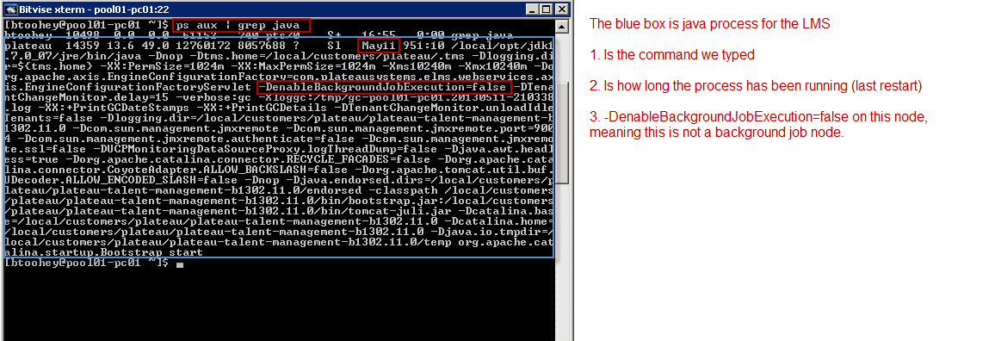

**df -hl**

This command will show the current disk usage for volumes local to the server in human-readable output.

*Can be used to identify:*

* *Possible disk space issues on the application node*

To Use:

1. Open a terminal session for the application node (Tunneler, SSH, etc)
2. Type: df –hl

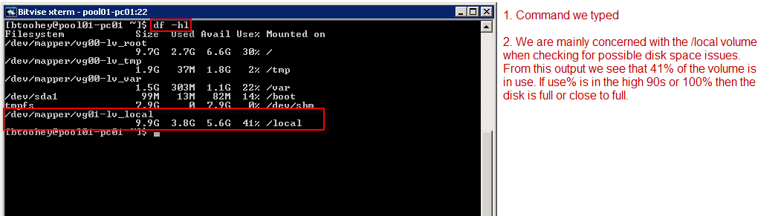

**find /path/to/search -iname ‘filename*’**

*Can be used for:*

* *You can use the find command to search for files on the server.*

Example:

find /local/customers -iname ‘jobexecutionservice.properties’

This command will look for all files named ‘jobexecutionservice.properties’ in the the /local/customers directory and all sub-directories.

Using *-iname* performs a non-case sensitive search.

Using *-name* will perform a case sensitive search.

**pwd**

Present working directory – shows what directory you are currently in.

**cd <directory_name>**

Change directory – change directory to <directory_name>

**ls -al**

Lists directory contents.

The ‘a’ option is to include all files (includes hidden).

The ‘l’ option is to display the long listing (more info).

**sftp <user_name>@<host>**

This command will allow you to establish an SFTP connection for <user_name> account on <host> SFTP site.

*Can be used for:*

* *Verify a connector node is able to access the SFTP site the connector is configured to use (no firewall issues)*
* *Log into an SFTP site to check to see where files are located (connector input files)*

Note for the commands listed below:

Remote host – is the SFTP site you are connected to

Local machine – is the machine you were on to connect to the SFTP site.

Ex. If you SSH into pool01-pcc1 and then connect to a customer account on sftp.plateau.com, sftp.plateau.com will be the remote host and pool01-pcc1 will be the local machine.

Common sftp commands for CS troubleshooting:

|  |  |
| --- | --- |
| **Command** | **Description** |
| cd remote-path | Change directory on remote host |
| lcd local-path | Change directory on local machine |
| pwd | Display the path of the current working directory on remote host |
| lpwd | Display the path of the current working directory on local machine |
| ls | List current directory files on remote host |
| lls | List current directory files on local machine |
| get remote-path [local-path] | Download file from remote host. If the local-path is not specified, the file will be downloaded to the current working directory on local machine. |
| bye | Exit SFTP |