**Project: Fire Detection**

**Project description:**

Build an efficient model to detect Fire from the images provided.

You can use any strategy for processing the data and modelling.

**Images**

<https://drive.google.com/drive/folders/1Yt7MkJhdB_ykSSUmto6bnnGLSIhX7-ux?usp=sharing>

**Expected Output:**

When an image with fire or smoke is uploaded to the model, then on the image “Fire” key word should be written, if it detects as a fire.

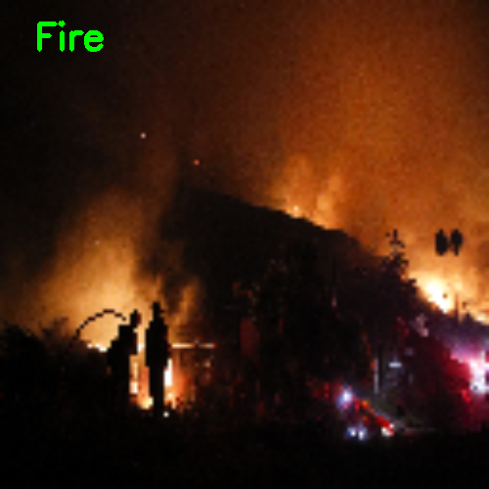

**Evaluation Scheme:**

**Total marks:** **100**

**Deliverables [Total marks - 95]:**

1. Loading the data into python 🡪 10 marks
2. Defining the convolutional neural network architecture 🡪 50 marks
3. Training the data by with the above CNN model 🡪 30 marks
4. Making the predictions for a single test image 🡪 5 marks

**Project Submission [Total marks - 5]:**

1. Once the project has been created, upload all the files on GitHub & commit (save) all the changes, make sure you add a readme file containing detailed description of your thoughts during the project creation. **[3 marks]**
2. Once done, kindly copy the GitHub link of your project & submit the same using your dashboard. **[2 mark]**