

BLOOD BANK
MANAGEMENT SYSTEM
Project Document and Presentation Guide

Frontend: HTML, CSS, JavaScript
Backend: Python (FastAPI)
Database: SQLite

Team member | Roll number | Module
Member 1 |  | Authentication and security
Member 2 |  | Donor module
Member 3 |  | Inventory and admin dashboard
Member 4 |  | Hospital and blood requests
Member 5 |  | Camps, database and testing

College / Department: ____________________ Guide: ____________________

Contents
1. Introduction and problem statement
2. Objectives
3. Users and roles
4. Functionalities (implemented and recommended)
5. Technology stack and why we chose it
6. System architecture
7. Database design
8. Business rules
9. Backend API reference
10. Frontend design and screens
11. Project structure and how to run
12. Security
13. Testing
14. Team work division
15. Presentation day plan and demo script
16. Possible viva questions with answers
17. Limitations and future scope
18. Conclusion

1. Introduction and problem statement
Blood is needed every day for surgeries, accidents, childbirth and treatment of diseases such as thalassemia and cancer. It cannot be manufactured, so hospitals depend completely on voluntary donors. In many places, blood banks still keep records on paper or in separate spreadsheets. This causes four common problems:
- Stock is not visible. Hospitals phone several blood banks to find out whether a blood group is available.
- Blood expires unnoticed. Red blood cells can be stored for only 42 days, and without tracking, units are wasted.
- Donors are hard to reach and manage. Nobody tracks who is eligible to donate again, so donors are called too early or forgotten.
- Requests are slow. Emergency requests are handled by phone calls and paper forms, with no priority and no record.
Problem statement: build a web based system that keeps live blood stock, manages donors and donation camps, and lets hospitals request blood online, so that blood is found quickly, issued fairly and not wasted.

2. Objectives
1. Maintain accurate, real time blood stock for all eight blood groups.
2. Register donors and automatically check whether they are eligible to donate.
3. Let hospitals raise blood requests with an urgency level and track their status.
4. Issue blood using the oldest units first (FIFO) to reduce wastage, and warn about low stock and near expiry.
5. Organise donation camps and let donors book slots online.
6. Give the administrator a dashboard with charts and alerts for quick decisions.
7. Keep the system secure with role based access and hashed passwords.

3. Users and roles
Role | Who | What they can do
Admin | Blood bank staff | View dashboard and alerts, manage inventory, approve or reject requests, manage donors list, create camps, record donations
Donor | Public volunteers | Register, see eligibility and next donation date, book camps, view donation history, edit profile
Hospital | Hospital blood desk | Register, see live availability, raise blood requests, track or cancel requests, search donors by group and city

4. Functionalities
The table below lists every functionality we built (Core) and the ones we recommend as extra features for future work. We kept the built version simple on purpose, so that every feature can be explained and demonstrated without errors.

4.1 Implemented in this project
No. | Module | Functionality | Why it matters
1 | Accounts | Registration and login for donors and hospitals; admin account is pre created | Each user sees only their own screens
2 | Accounts | Role based access: every API checks the role of the logged in user | Prevents a donor from opening admin pages
3 | Donor | Eligibility check: age 18 to 65, weight at least 50 kg, haemoglobin at least 12.5 g/dL, gap of 3 months (men) or 4 months (women) since last donation | Protects donor and patient health
4 | Donor | Profile, donation history, total donations and lives helped | Motivates repeat donation
5 | Donor | Book and cancel a slot in a donation camp (capacity limit, no double booking) | Planned collection of blood
6 | Inventory | Stock by blood group with unit level records (collected date, expiry date, status) | Live and accurate stock
7 | Inventory | Automatic expiry after 42 days, low stock alert (below 5 units), expiring in 7 days alert | Reduces wastage
8 | Inventory | Admin can add or remove units manually | Handles walk in donors and corrections
9 | Requests | Hospital raises request with patient, group, units and urgency (normal, urgent, critical) | Replaces phone calls and paper
10 | Requests | Admin sees requests sorted by status and urgency, then issues blood or rejects with a reason | Critical cases handled first
11 | Requests | FIFO issue: units closest to expiry are used first | Fewer expired units
12 | Requests | Optional use of compatible groups when exact group is short (for example O negative for any patient) | Saves lives in shortage
13 | Camps | Admin creates camps; recording a donation adds one unit to stock and restarts the donor's waiting period | Connects donors, camps and stock
14 | Search | Hospitals and admin search donors by blood group and city | Quick emergency contact
15 | Knowledge | Blood compatibility checker (who can donate to and receive from whom) | Useful tool and good demo point
16 | Dashboard | Statistics cards, stock chart, six month donation chart and alerts | Management view at a glance
17 | Public home | Home page without login: live availability for 8 groups, upcoming camps, counters, FAQ, compatibility checker | Same idea as eRaktKosh: help before login
18 | Public home | Rolling ticker fed from the database: urgent requests, low stock, camps, health facts (no patient names) | Real time awareness, impressive demo
19 | Demo mode | Floating guide with 8 demo steps, one click role switch, reset sample data, large size mode, arrow keys | Smooth and error free presentation
20 | Branding | LifeDrop logo (SVG), animated heart, floating drops and ECG line (CSS only) | Professional look, works offline

4.2 Recommended extra features (future scope)
These are good ideas to mention when the examiner asks "what else can be added". They were not built to keep the project reliable.
Feature | Description | Effort
Email / SMS alerts | Notify matching donors when a critical request is raised or stock is low (Twilio, SMTP) | Medium
Donor certificate | Download a PDF certificate after each donation | Low
Emergency broadcast | One click message to all eligible donors of a group in a city | Medium
Nearby blood banks map | Show blood banks and camps on a map (Leaflet / OpenStreetMap) | Medium
Reports export | Download stock, donation and request reports as PDF or Excel | Low
Multiple branches | Several blood banks with stock transfer between them | High
Barcode / QR tracking | Scan a unit label to issue or verify it | High
Demand forecasting | Predict future demand from past requests using simple machine learning | High
Stronger security | JWT tokens with expiry, HTTPS, login attempt limits, audit log | Medium
Cloud deployment | Docker container with PostgreSQL on a cloud server | Medium

4.3 Public home page and demo mode
The first page is a public home page, not just a login box. This was inspired by eRaktKosh (the national blood bank portal), which offers blood availability search and camp schedules before any login, and by Max Healthcare's donor guidance pages, which explain who can donate. The home page contains:
- Rolling ticker: urgent requests, low stock groups, upcoming camps and health facts, read live from the database. Patient names are never shown.
- Hero section: animated heart, floating drops and an ECG line made with CSS, and buttons to become a donor or request blood.
- Live counters and availability: donors, units in stock, fulfilled requests and 8 blood group tiles that refresh every 30 seconds.
- Camps, eligibility rules, how it works and FAQ: with photographs stored locally in frontend/assets (credits in ATTRIBUTION.md).
Demo mode is a floating guide available on every page. It lists the 8 steps of the demo, switches between Admin, Donor and Hospital with one click, resets the sample data (works only on the computer running the server) and can enlarge the page for the back row.

4.4 Study of existing systems
Feature | eRaktKosh (national portal) | Max Healthcare (information pages) | LifeDrop (this project)
Blood availability without login | Yes, search by state, district and group | Not found on the pages we studied | Yes, live tiles on the home page
Donation camps list | Yes, camp schedule and camp registration | Information about donating | Yes, home page and donor booking
Donor registration and login | Yes | Not found | Yes, with eligibility check
Eligibility guidance | About blood donation page | Age 18-65, Hb 12.5, gap 3 / 4 months, weight 50 kg | Applied automatically by the system
Hospital request workflow | Thalassemia request, blood bank services | Not applicable | Yes, urgency, approval and issue
Expiry tracking and oldest first issue | Not verified | Not applicable | Yes, unit level tracking

Note: this comparison is based on the public pages and search results we reviewed; the real systems have more features than we list. It is used to show which good ideas we adopted, not to claim that those systems lack anything.

5. Technology stack and why we chose it
Layer | Technology | Reason
Frontend | HTML, CSS, JavaScript (no framework) | Required by the project, easy to explain line by line, works in any browser without a build step
Backend | Python 3 with FastAPI | Short readable code, automatic request validation (Pydantic), automatic API documentation at /docs, very fast, widely used in industry
Web server | Uvicorn | The server that runs FastAPI; starts with one command
Database | SQLite | Zero setup (single file), part of Python, supports full SQL with foreign keys, ideal for a college demo
Security | PBKDF2 (hashlib), random session tokens | Built into Python, no extra libraries
Charts | HTML Canvas drawn with JavaScript | No internet or library needed during the presentation
Design assets | SVG logo, CSS animation, photos from Wikimedia Commons stored locally | Works without internet; image credits are listed in the project

5.1 Why FastAPI instead of Flask or Django
 | FastAPI (chosen) | Flask | Django
Learning curve | Easy | Easy | Steeper
Input validation | Automatic | Manual | Forms / serializers
API documentation | Automatic (Swagger) | Needs extra library | Needs extra library
Speed | Very high | Medium | Medium
Best for | REST APIs with a JS frontend | Small apps | Large full stack apps with admin panel

5.2 Why SQLite instead of MySQL or PostgreSQL
SQLite stores the whole database in one file, needs no installation and is still a real relational database with tables, primary keys, foreign keys, constraints and indexes. For a single blood bank with a few hundred users it is enough. Because all queries are standard SQL, moving to MySQL or PostgreSQL later only requires changing the connection code.

6. System architecture
The system uses a three layer design. The browser shows pages and calls the backend using fetch(). The backend (FastAPI) applies the rules and talks to SQLite. The browser never touches the database directly.
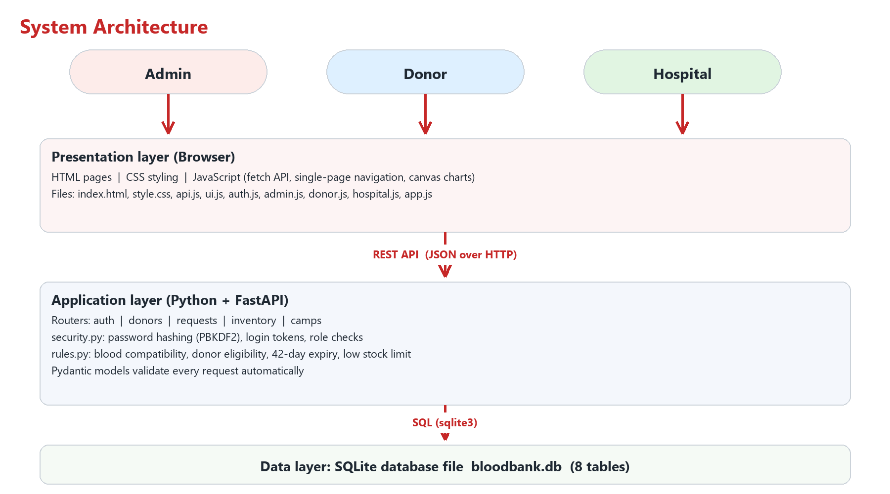
Figure 1: System architecture

6.1 Request flow example: hospital requests blood
1. Hospital user fills the form in hospital.js, which calls POST /api/requests with the login token.
2. FastAPI checks the token, confirms the role is hospital, and validates the data (blood group, units 1 to 20).
3. The request is saved in the requests table with status pending.
4. Admin opens Blood Requests; GET /api/requests returns pending requests with critical ones first.
5. Admin clicks Issue blood; POST /api/requests/{id}/fulfill selects the units that expire first, marks them issued and marks the request fulfilled.
6. The hospital sees the status change to Fulfilled on its My Requests page.
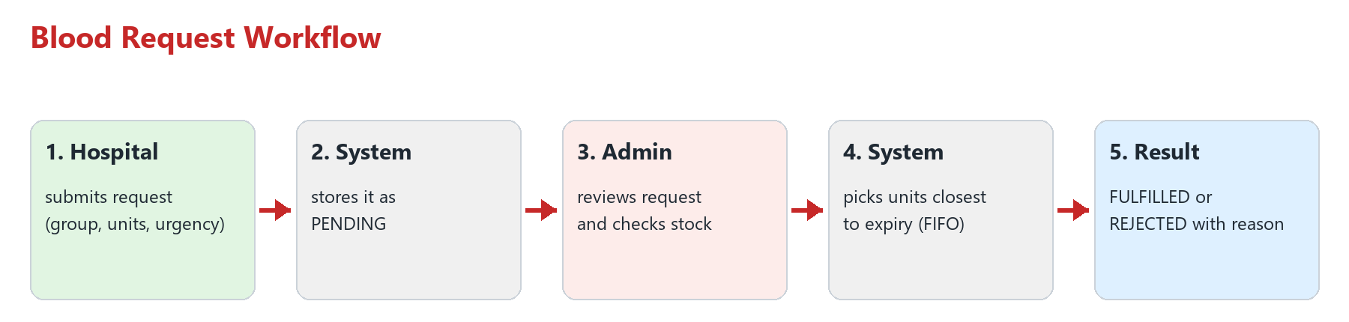
Figure 2: Blood request workflow

7. Database design
The database has eight tables. Foreign keys are enabled, and CHECK constraints keep values valid (for example, request status can only be pending, fulfilled, rejected or cancelled).
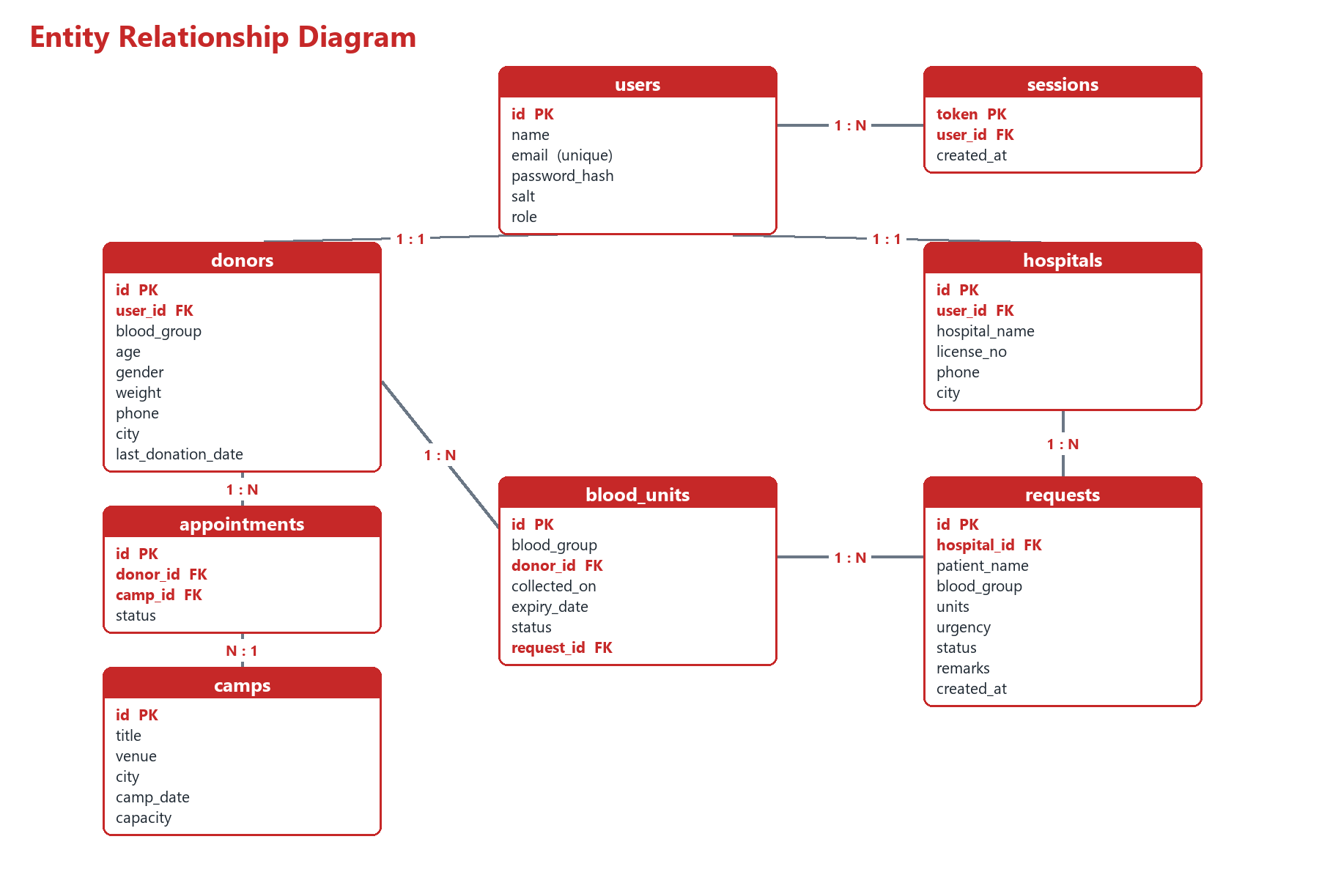
Figure 3: Entity relationship diagram

7.1 Table descriptions
Table | Purpose | Important columns
users | Login accounts for all roles | email (unique), password_hash, salt, role (admin / donor / hospital)
sessions | Active logins | token, user_id
donors | Donor details | user_id, blood_group, age, weight, city, last_donation_date
hospitals | Hospital details | user_id, hospital_name, license_no, city
blood_units | One row per bag of blood | blood_group, donor_id, collected_on, expiry_date, status (available / issued / expired), request_id
requests | Hospital blood requests | hospital_id, patient_name, blood_group, units, urgency, status, remarks
camps | Donation camps | title, venue, city, camp_date, capacity
appointments | Donor bookings for camps | donor_id, camp_id, status (booked / completed / cancelled), unique per donor and camp

7.2 Sample SQL from the project
-- Units to issue: oldest first (FIFO)
SELECT id FROM blood_units
WHERE blood_group = ? AND status = 'available' AND expiry_date >= ?
ORDER BY expiry_date
LIMIT ?;

-- Stock count for one blood group
SELECT COUNT(*) FROM blood_units
WHERE blood_group = 'O+' AND status = 'available';

8. Business rules
Rule | Value | Where it is coded
Donor age | 18 to 65 years | rules.py check_eligibility()
Donor weight | At least 50 kg | rules.py check_eligibility()
Gap between donations | 90 days (men), 120 days (women and others) | rules.py gap_days()
Haemoglobin | At least 12.5 g/dL (when provided) | rules.py check_eligibility()
Shelf life of a unit | 42 days from collection | rules.py expiry_for()
Low stock alert | Fewer than 5 units of a group | rules.py LOW_STOCK_LIMIT
Expiry warning | Units expiring within 7 days | rules.py EXPIRY_WARNING_DAYS
Issue order | Earliest expiry first (FIFO) | routers/requests.py fulfill_request()
Compatibility | ABO and Rh matching table | rules.py CAN_DONATE_TO

8.1 Blood compatibility table
Blood group | Can donate to | Can receive from
O- | All groups (universal donor) | O-
O+ | O+, A+, B+, AB+ | O-, O+
A- | A-, A+, AB-, AB+ | O-, A-
A+ | A+, AB+ | O-, O+, A-, A+
B- | B-, B+, AB-, AB+ | O-, B-
B+ | B+, AB+ | O-, O+, B-, B+
AB- | AB-, AB+ | O-, A-, B-, AB-
AB+ | AB+ (universal receiver) | All groups

9. Backend API reference
All endpoints start with /api. Except register and login, every call needs the header Authorization: Bearer <token>. FastAPI also publishes an interactive version at http://127.0.0.1:8000/docs, which is very useful to show during the presentation.
Method | Endpoint | Role | Purpose
POST | /auth/register | Public | Create donor or hospital account
POST | /auth/login | Public | Login and get token
POST | /auth/logout | Any | End session
GET | /donor/profile | Donor | Profile with eligibility
PUT | /donor/profile | Donor | Update profile
GET | /donor/history | Donor | Own donations
GET | /donors/search | Admin, Hospital | Search by group and city
GET | /admin/donors | Admin | All donors
GET | /inventory/summary | Any | Stock per blood group with alerts
GET | /public/summary | Public | Live stock per group and counters (home page)
GET | /public/camps | Public | Upcoming camps (home page)
GET | /public/ticker | Public | Rolling ticker messages
GET | /public/compatibility/{group} | Public | Compatibility checker
POST | /demo/reset | Local only | Reset sample data (demo mode)
GET / POST | /inventory/units | Admin | List or add blood units
DELETE | /inventory/units/{id} | Admin | Remove a unit
GET | /compatibility/{group} | Any | Who can donate to and receive from a group
GET | /stats | Admin | Dashboard numbers and monthly donations
POST | /requests | Hospital | Raise a request
GET | /requests/mine | Hospital | Own requests
POST | /requests/{id}/cancel | Hospital | Cancel a pending request
GET | /requests | Admin | All requests
POST | /requests/{id}/fulfill | Admin | Issue blood
POST | /requests/{id}/reject | Admin | Reject with remarks
GET | /camps | Any | List camps
POST / DELETE | /camps | Admin | Create or delete camp
POST | /camps/{id}/book | Donor | Book a slot
GET | /appointments/mine | Donor | Own bookings
POST | /appointments/{id}/cancel | Donor | Cancel booking
GET | /camps/{id}/appointments | Admin | Donors booked in a camp
POST | /appointments/{id}/complete | Admin | Record donation and add stock

9.1 Code sample: donor eligibility (rules.py)
def check_eligibility(age, weight, last_donation_date, gender=None, haemoglobin=None):
reasons = []
if age < MIN_AGE or age > MAX_AGE:
reasons.append("Age must be between 18 and 65")
if weight < MIN_WEIGHT:
reasons.append("Weight must be at least 50 kg")
if haemoglobin is not None and haemoglobin < MIN_HAEMOGLOBIN:
reasons.append("Haemoglobin must be at least 12.5 g/dL")
next_date = None
if last_donation_date:
next_date = date.fromisoformat(last_donation_date) + timedelta(days=gap_days(gender))
if next_date > date.today():
reasons.append(f"Next possible date is {next_date.isoformat()}")
return {"eligible": not reasons, "reasons": reasons}

9.2 Code sample: issuing blood (routers/requests.py)
groups = [req["blood_group"]]
if data.allow_compatible:
groups += [g for g in can_receive_from(req["blood_group"]) if g != req["blood_group"]]

picked = []
for group in groups:
need = req["units"] - len(picked)
if need <= 0:
break
rows = db.execute(
"SELECT id FROM blood_units WHERE blood_group = ? AND status = 'available' "
"AND expiry_date >= ? ORDER BY expiry_date LIMIT ?", (group, today, need)).fetchall()
picked += [r["id"] for r in rows]

if len(picked) < req["units"]:
raise HTTPException(400, "Not enough suitable units in stock")

9.3 Code sample: protecting an endpoint by role (security.py)
def require_role(*roles):
def checker(user=Depends(current_user)):
if user["role"] not in roles:
raise HTTPException(403, "You are not allowed to do this")
return user
return checker

@router.get("/stats")
def dashboard_stats(user=Depends(require_role("admin")), db=Depends(get_db)):
...

10. Frontend design and screens
The frontend is a single page application written in plain JavaScript. index.html loads one stylesheet and seven small script files. app.js reads the URL hash (for example #/inventory), shows the correct menu for the logged in role and calls the matching view function. api.js wraps fetch() and attaches the login token. Charts are drawn on an HTML canvas, so no internet is required.
File | Responsibility
index.html | Page skeleton: home page, login area, sidebar, content area, modal and toast containers
css/landing.css | Styles and animations of the public home page and demo guide
js/landing.js | Home page: ticker, live availability, camps, counters, FAQ
js/demo.js | Demo mode: step guide, role switch, reset, large size
assets/ | Logo (SVG and PNG), photos and animated heart with image credits
css/style.css | Complete design: colours, cards, tables, badges, responsive layout
js/api.js | Single place for all server calls and error handling
js/ui.js | Shared helpers: popup dialogs, toast messages, badges, bar chart, compatibility checker
js/auth.js | Login, registration and logout screens
js/admin.js | Dashboard, inventory, requests, donors, camps
js/donor.js | Donor dashboard, camps, history, profile
js/hospital.js | Availability, new request, my requests, find donors
js/app.js | Menu per role and page navigation

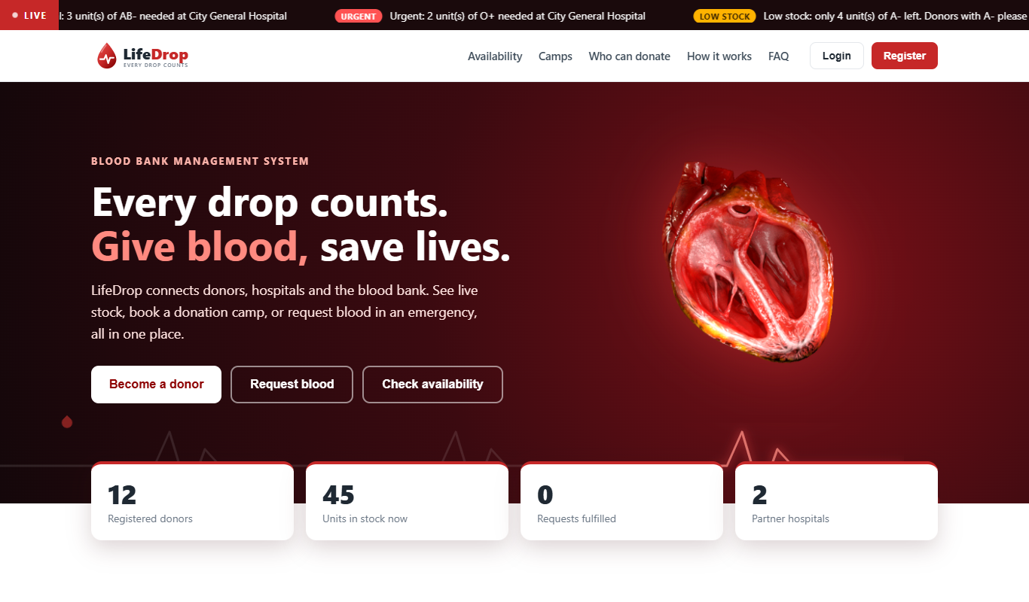
Figure 4: Public home page: ticker, hero and live counters
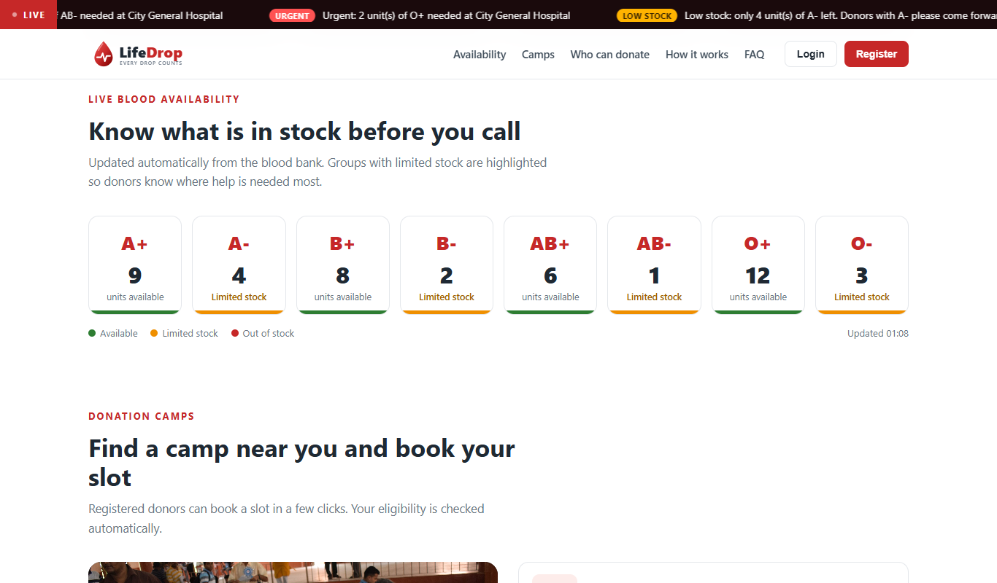
Figure 5: Live availability and upcoming camps
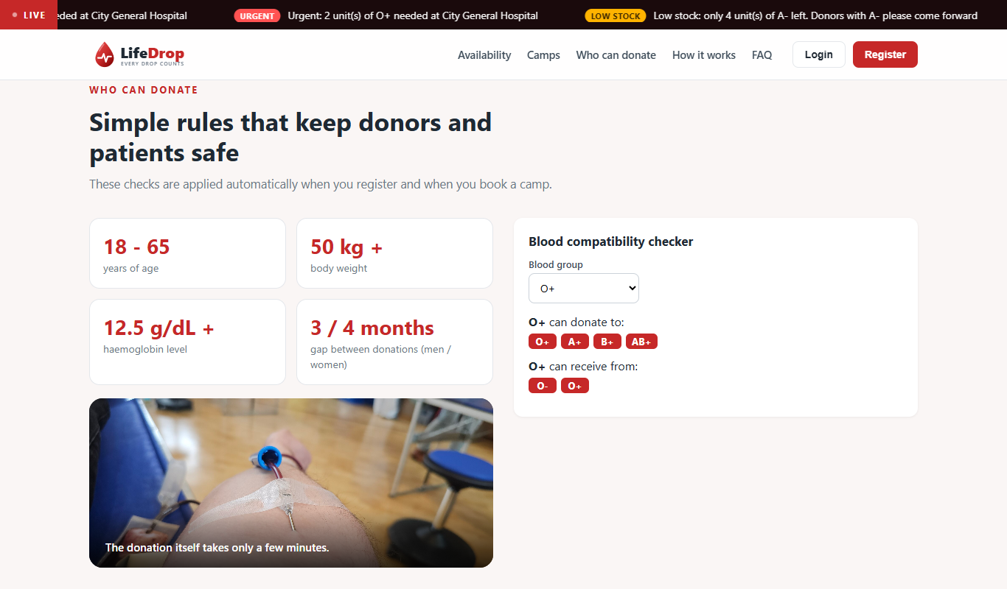
Figure 6: Who can donate and compatibility checker
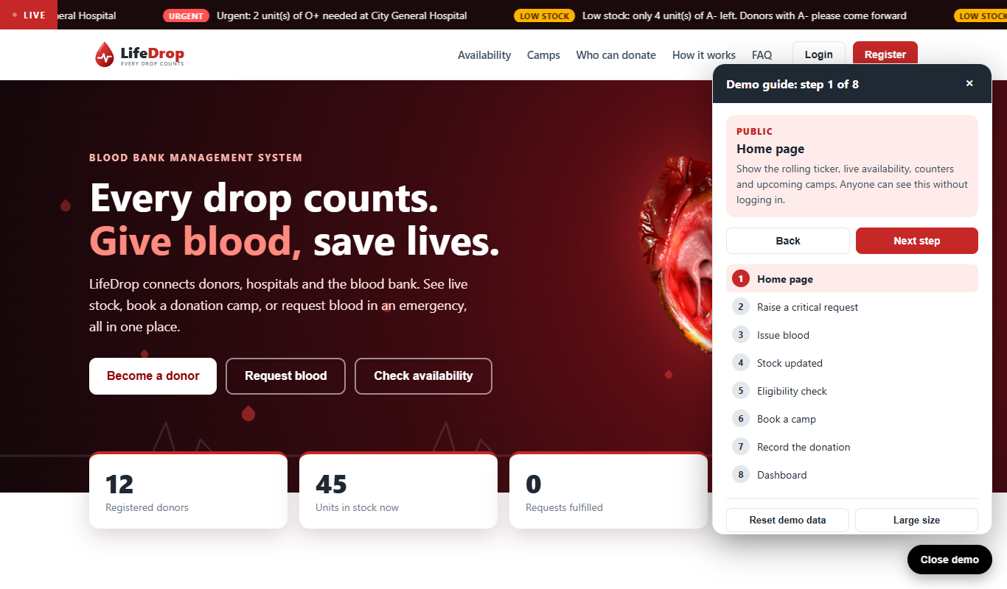
Figure 7: Demo mode guide
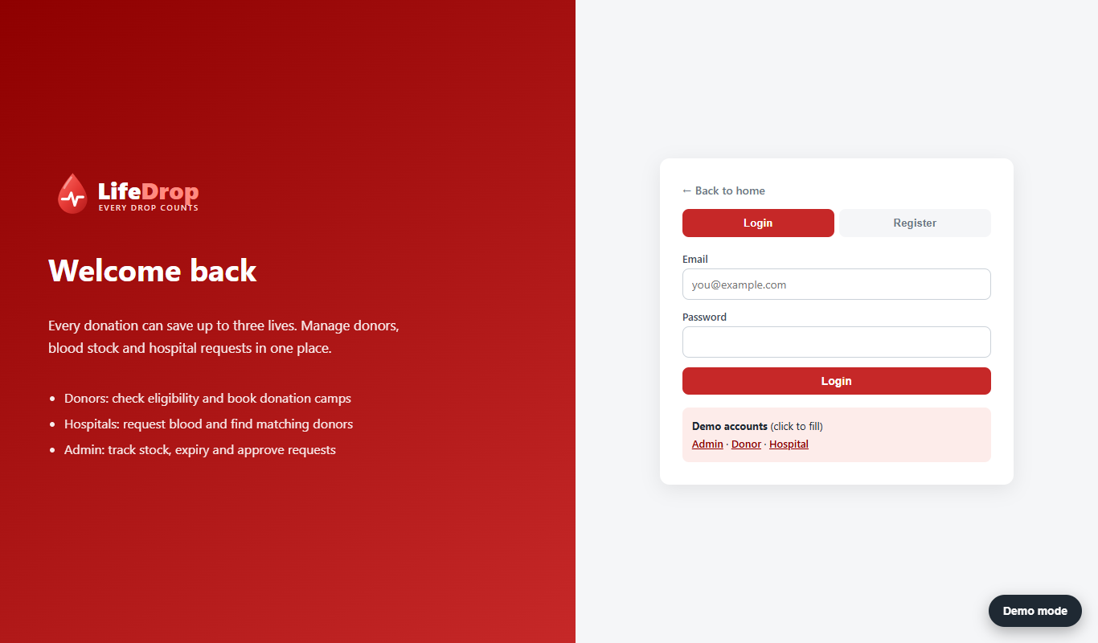
Figure 8: Login page with demo accounts
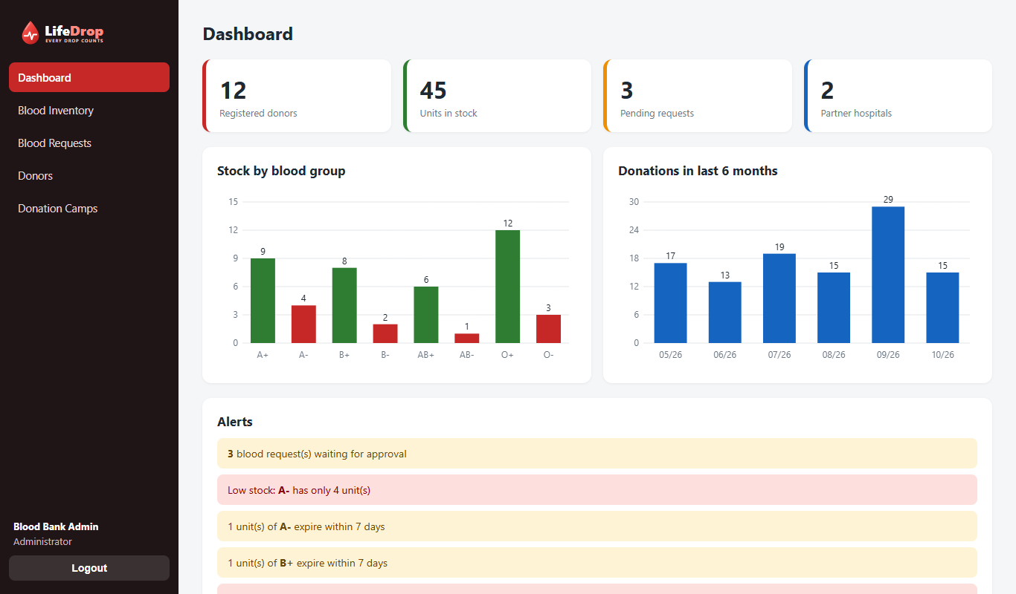
Figure 9: Admin dashboard with statistics, charts and alerts
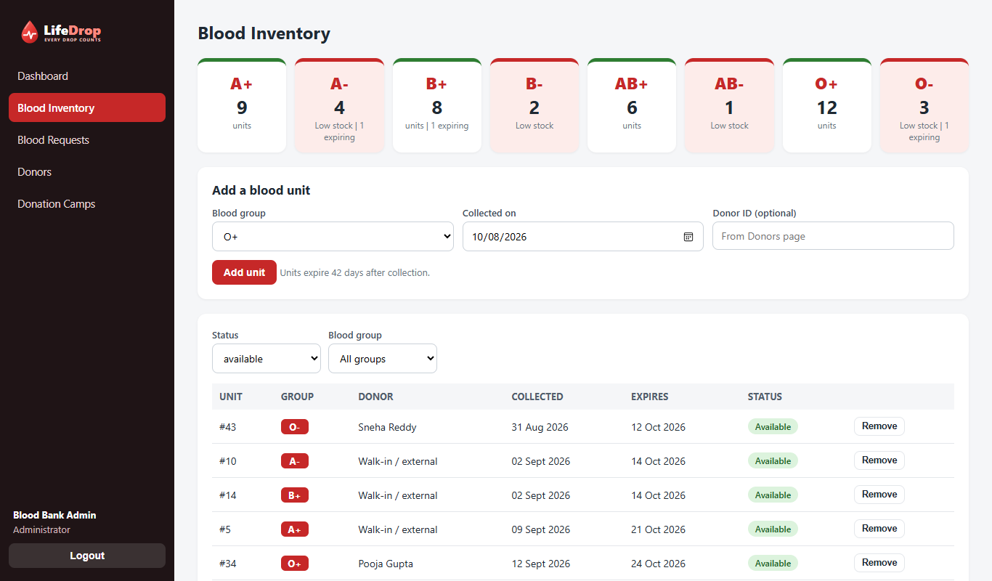
Figure 10: Blood inventory with stock tiles and unit list
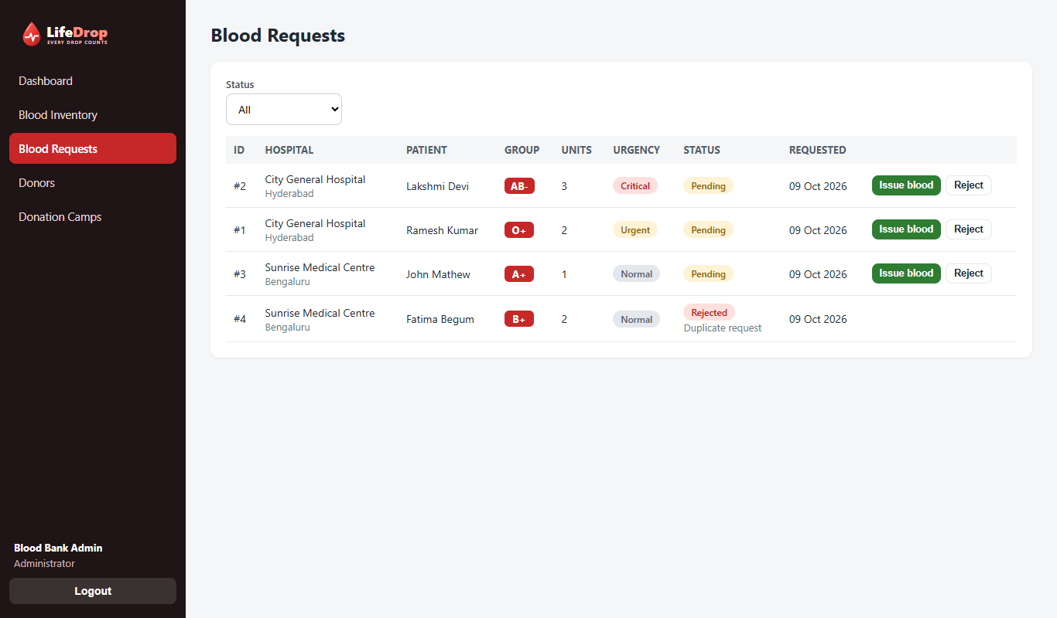
Figure 11: Blood requests waiting for approval
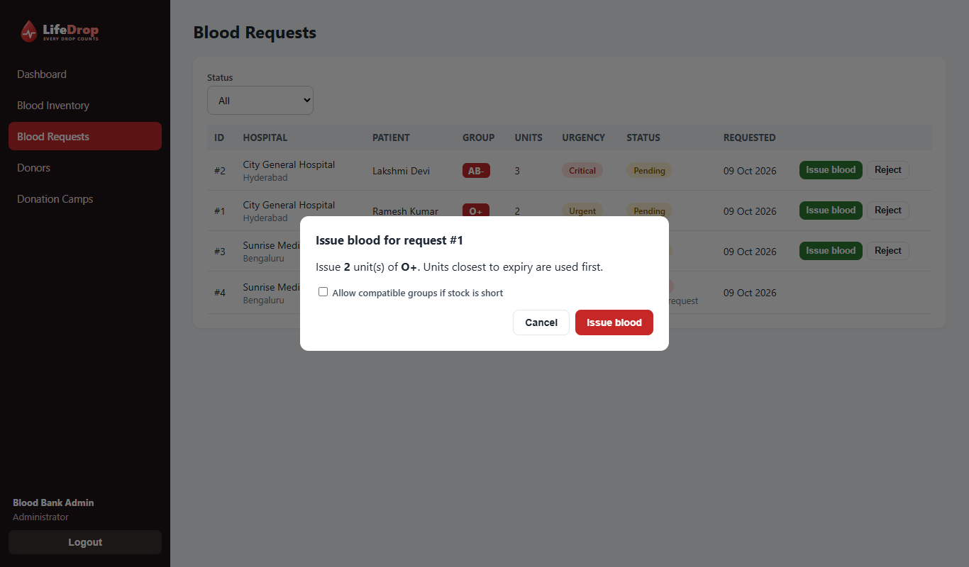
Figure 12: Issuing blood with the compatible group option
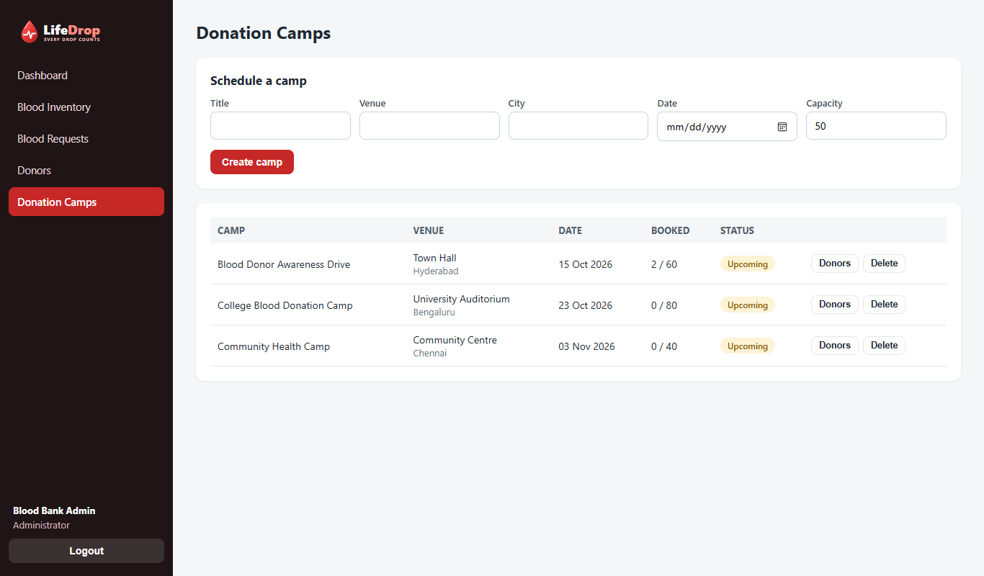
Figure 13: Donation camp management
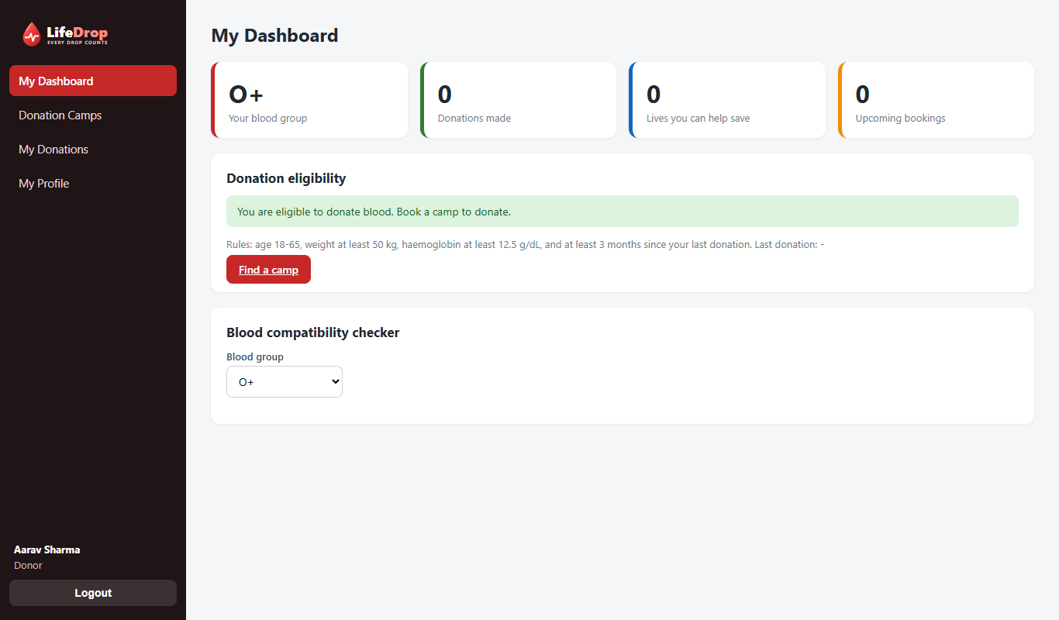
Figure 14: Donor dashboard with eligibility check
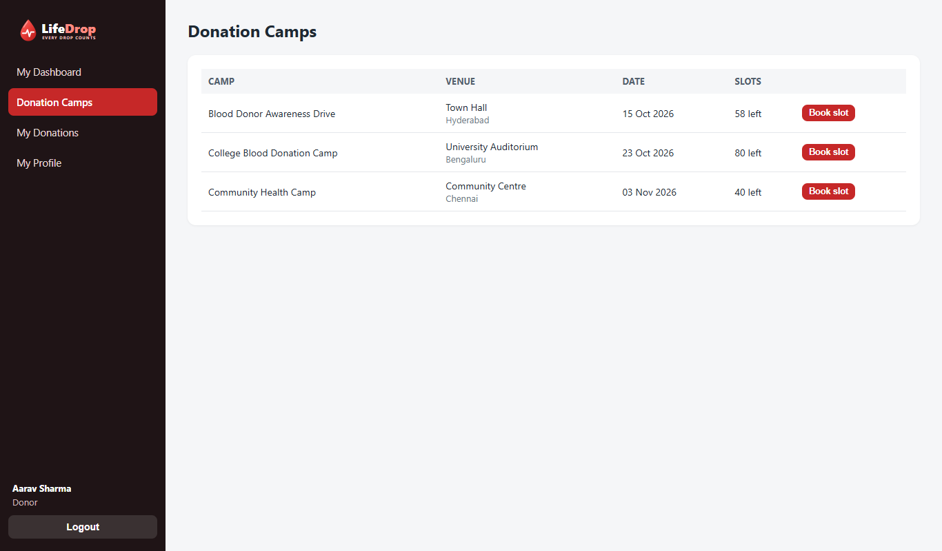
Figure 15: Donor booking a camp
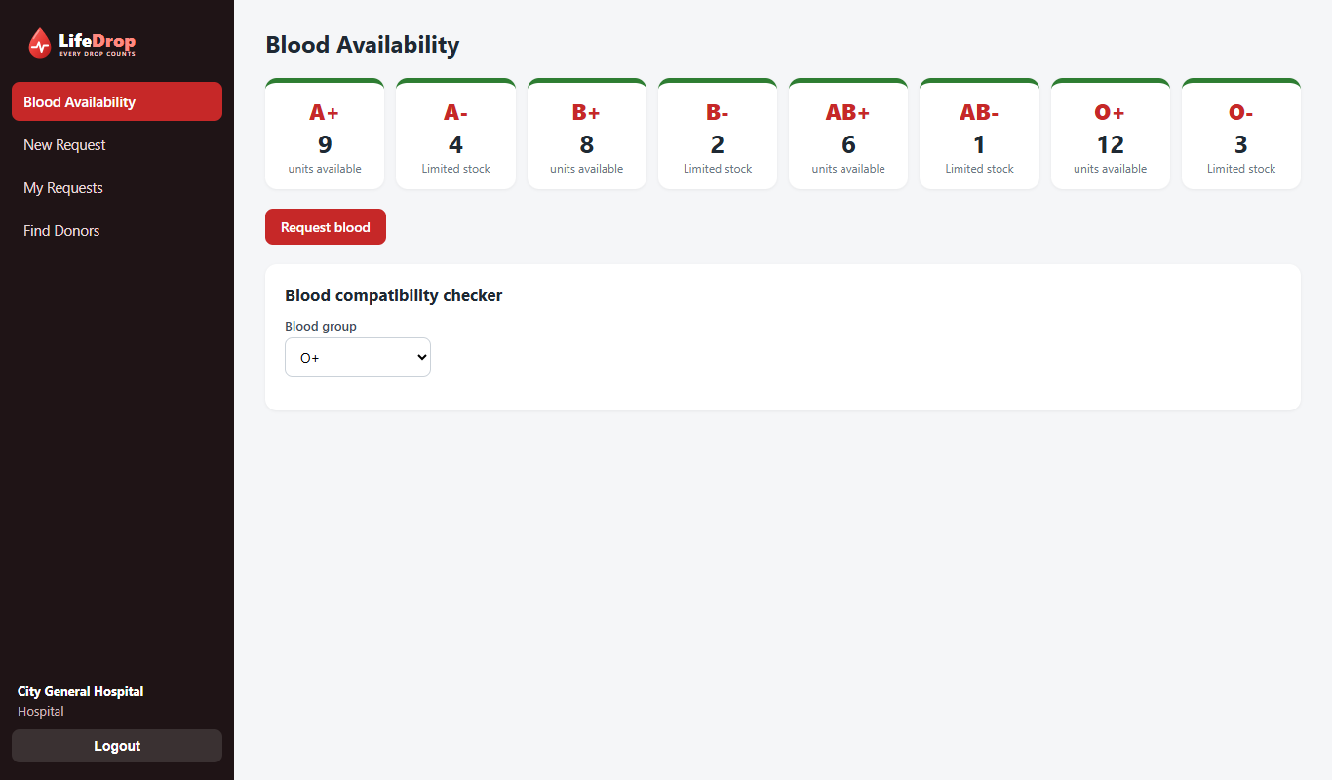
Figure 16: Hospital view of live blood availability
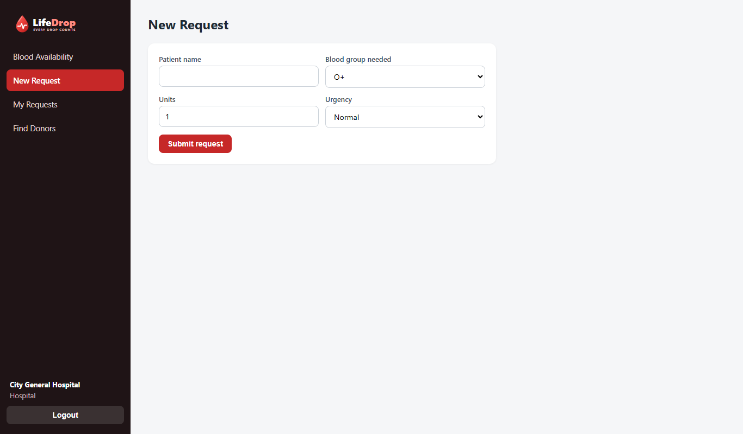
Figure 17: Hospital raising a blood request

11. Project structure and how to run
BloodBankMS/
backend/
main.py start point, connects routers, serves frontend
database.py tables and connection
security.py password hashing, tokens, role checks
rules.py blood rules
seed.py sample data
routers/ auth.py donors.py requests.py inventory.py camps.py
frontend/
index.html css/style.css css/landing.css js/*.js
assets/ logo, photos, image credits
docs/ this document, presentation, diagrams, screenshots
requirements.txt run.bat README.md

11.1 Steps to run
1. Install Python 3.10 or newer from python.org (tick "Add Python to PATH").
2. Open a terminal in the BloodBankMS folder and run: pip install -r requirements.txt
3. Start the server: double click run.bat, or run cd backend then python -m uvicorn main:app --reload --port 8000
4. Open http://127.0.0.1:8000 in Chrome or Edge.
5. To reset all data to the original sample data, use Demo mode and Reset demo data, or stop the server, delete backend/bloodbank.db and start again.

11.2 Demo accounts
Role | Email | Password
Admin | admin@bloodbank.com | admin123
Donor (eligible) | donor1@example.com | donor123
Donor (recently donated) | donor4@example.com | donor123
Donor (low haemoglobin) | donor6@example.com | donor123
Hospital | city@hospital.com | hospital123

12. Security
- Password hashing: passwords are never stored as text; PBKDF2 with SHA-256, 100,000 rounds and a random salt per user.
- Token based login: a random token is generated at login and must be sent with every request.
- Role checks on the server: hiding a menu is not security, so every endpoint verifies the role (returns 403 if not allowed).
- SQL injection protection: all queries use ? placeholders, never string joining.
- Input validation: Pydantic models plus extra checks (valid blood group, age and weight range, date format).
- XSS protection: user text is escaped before it is shown on a page.
Limitations (to be honest in viva): tokens do not expire automatically, HTTPS is not configured for the local demo, and there is no limit on wrong password attempts. These are listed under future scope.

13. Testing
We tested the backend by calling the API directly and the screens by opening every page for every role in a browser (Microsoft Edge). The cases below were executed on the final version.
No. | Test case | Expected result | Result
1 | Login with correct admin credentials | Token returned, dashboard opens | Pass
2 | Login with wrong password | Error 401, message shown | Pass
3 | Call API without token | Error 401 | Pass
4 | Hospital opens admin statistics | Error 403 forbidden | Pass
5 | Register a new donor | Account created and logged in | Pass
6 | Hospital requests invalid blood group | Error 400 with message | Pass
7 | Hospital raises valid request | Status pending | Pass
8 | Issue 3 units of AB- when only 1 exists (no compatible option) | Error: only 1 unit in stock | Pass
9 | Same request with compatible groups allowed | 3 units issued, request fulfilled | Pass
10 | Issue an already fulfilled request again | Error 400 | Pass
11 | Donor books a camp | Booking saved | Pass
12 | Same donor books same camp again | Error: already booked | Pass
13 | Admin marks donation completed | One unit added to stock, donation count becomes 1 | Pass
14 | Donor tries to book another camp right after donating | Rejected: not eligible, next date shown | Pass
15 | Open the home page, all 13 role screens and walk through the 8 demo steps | No JavaScript or loading errors | Pass
16 | Open availability, camps and ticker without logging in | Data shown, no patient names | Pass
17 | Register a donor with haemoglobin 12.0 and an invalid value 2 | Not eligible with reason; invalid value rejected | Pass
18 | Reset demo data | Sample data restored, new accounts removed | Pass

14. Team work division
With five members, each person owns one module end to end (database, backend and screen). This way everyone can explain a complete feature and answer questions about it.
Member | Module | Backend files | Frontend files | Presents
1 | Authentication, security and home page design | routers/auth.py, security.py | js/auth.js, css/style.css, css/landing.css | Login, register, hashing, roles, home page look
2 | Donor module | routers/donors.py, rules.py (eligibility) | js/donor.js | Eligibility rules, profile, donor search
3 | Inventory and dashboard | routers/inventory.py | js/admin.js (dashboard, inventory), ui.js charts | Stock, expiry, alerts, charts
4 | Hospital and requests | routers/requests.py | js/hospital.js, admin.js (requests) | Request workflow, FIFO issue, compatibility
5 | Camps, database, public API, demo mode and testing | routers/camps.py, public.py, database.py, seed.py, main.py | admin.js (camps), landing.js, demo.js, api.js, app.js | ER diagram, SQL, camps, home page data, demo mode, test cases

15. Presentation day plan and demo script

15.1 Checklist before you walk in
- Run the project once on the presentation laptop and confirm the login page opens. Do not depend on a different laptop.
- Reset the data: open Demo mode and click Reset demo data (or stop the server, delete backend/bloodbank.db and start again), so the demo data is fresh.
- Keep the server running and the browser open on the login page. Zoom the browser to 110 percent so the back row can read it.
- Keep the PowerPoint file and a copy of the screenshots folder open as a backup in case the laptop or server fails.
- Copy the whole project to a pen drive and to your email or cloud drive.
- Open http://127.0.0.1:8000/docs in a second tab; examiners like seeing the automatic API documentation.
- Charge the laptop and carry the charger. No internet is needed for the demo.

15.2 Suggested order of the presentation
Step | Who | Content
1 | Member 1 | Problem statement, objectives, why this project matters, introduce the team
2 | Member 1 | Technology stack, architecture diagram, security (hashing, roles)
3 | Member 5 | Database design: ER diagram, tables, one SQL example
4 | Member 2 | Donor module with live demo: register, eligibility result, book a camp
5 | Member 4 | Hospital module with live demo: raise request, admin issues blood, status changes
6 | Member 3 | Admin dashboard, inventory, expiry and low stock alerts, charts
7 | Member 5 | Camps, testing summary, future scope
8 | All | Conclusion and questions

15.3 Live demo script (follow this order)
1. Open the home page. Point at the rolling ticker, the live availability tiles, the counters and the camps. Then open Demo mode and show the 8 step guide you will follow.
2. Login as Admin (admin@bloodbank.com). Show the dashboard: the stock chart has red bars for low stock, and the alerts list shows pending requests, low stock and units expiring soon.
3. Open Blood Inventory. Show the tiles per blood group, the unit list with expiry dates, and add one unit of O+ to show stock increases.
4. Logout. Login as Hospital (city@hospital.com). Show live availability, then New Request: patient Anil, blood group AB-, 3 units, Critical. Submit.
5. Open My Requests: status is Pending. Show Find Donors by group and city.
6. Logout. Login as Admin again. Open Blood Requests: the critical request is at the top. Click Issue blood. First without the compatible option to show the error (not enough AB- units), then tick Allow compatible groups and issue.
7. Go back to Inventory to show the stock reduced. Login as Hospital to show the request is Fulfilled.
8. Logout. Register a new donor live (blood group B+, age 22, weight 60). Show the eligibility message and the compatibility checker.
9. Open Donation Camps and book a slot. Logout, login as Admin, open Donation Camps, click Donors for that camp and click Mark donated. Stock for B+ goes up by one.
10. Login as the same new donor: eligibility now says not eligible, the next possible date is months away. This shows the rules working together.
11. Open /docs in the second tab and show the interactive API documentation.

15.4 What to say when something goes wrong
- If the page does not open: the server is not running. Start run.bat again; the data is kept.
- If a number looks different from earlier: sample data is random in dates, and the demo changes stock. That is expected after issuing blood.
- If everything fails: switch to the PowerPoint screenshots and explain the flow from them.

16. Possible viva questions with answers
Q1. Why did you choose FastAPI?
It needs little code, validates input automatically, produces API documentation by itself and is faster than most Python frameworks. The frontend and backend are separate and talk using JSON.
Q2. What is REST API?
A style of building a backend where each URL represents a resource and HTTP methods describe the action: GET reads, POST creates, PUT updates, DELETE removes.
Q3. Why SQLite and not MySQL?
SQLite needs no installation and stores everything in one file, which is perfect for a demo. It is still a full relational database, so moving to MySQL later only means changing the connection code.
Q4. How are passwords stored?
Never as plain text. We use PBKDF2 with SHA-256, 100,000 iterations and a random salt for each user, so even the same password gives different hashes.
Q5. How do you stop a donor from opening admin pages?
Every admin API uses require_role('admin'). The server checks the role stored in the database for that login token and returns 403 if it does not match. Hiding menu items alone would not be secure.
Q6. What is SQL injection and how did you avoid it?
It is when user input changes the meaning of a query. We always pass values as ? parameters so input is treated only as data.
Q7. Explain FIFO in your project.
When issuing blood we sort available units by expiry date and take the earliest first, so older units are used before they expire.
Q8. Why do blood units expire after 42 days?
Stored red blood cells are safe for about 42 days. After that the unit cannot be used, so the system marks it expired automatically.
Q9. What is the rule for donor eligibility?
Age 18 to 65, weight at least 50 kg, haemoglobin at least 12.5 g/dL, and a gap of 3 months for men or 4 months for women since the last donation. These are checked on the server.
Q10. What are universal donor and universal receiver?
O negative can be given to any patient (universal donor). AB positive can receive from any group (universal receiver).
Q11. What happens if two admins issue the same request together?
The first one changes the request to fulfilled; the second gets an error because only pending requests can be issued. For heavy use we would add database transactions with locking.
Q12. How does the frontend talk to the backend?
JavaScript fetch() sends JSON to URLs starting with /api and shows the JSON reply on the page. api.js adds the login token to every call.
Q13. What are foreign keys and where did you use them?
A column that points to the primary key of another table. For example blood_units.donor_id points to donors.id, and requests.hospital_id points to hospitals.id. They keep data consistent.
Q14. Can this system handle many users?
SQLite and a single server are fine for one blood bank. For many branches we would move to PostgreSQL, run several server workers and deploy on a cloud server.
Q15. What is the future scope?
SMS and email alerts to matching donors, maps of nearby blood banks, PDF reports and certificates, JWT with expiry and HTTPS, and a mobile app.
Q16. What did you personally build?
Each member should answer from their module in section 14 and be ready to open their own files.

17. Limitations and future scope
- Login tokens do not expire and there is no HTTPS or login attempt limit on the local demo.
- The system serves a single blood bank; there is no stock transfer between branches.
- Hospitals and donors are not notified automatically; admin must check the screens.
- Blood component types (plasma, platelets) and test results (HIV, hepatitis screening) are not tracked.
- Everything runs on one machine with SQLite; large scale use needs PostgreSQL and cloud hosting.
See section 4.2 for the list of recommended extra features.

18. Conclusion
The Blood Bank Management System replaces paper records with one connected web application. Donors can check eligibility and book camps, hospitals can see live stock and request blood, and the blood bank can issue the oldest units first, avoid wastage and react to low stock early. The project uses simple, widely used technologies (HTML, CSS, JavaScript, Python, FastAPI and SQLite), is easy to run on any laptop and can grow into a larger system with the extensions listed above.

