## NFT

Ans: D choose the non functional testing solutions delivered as part of nftaas from the following

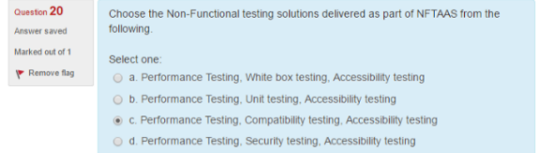

Ans: True endurance tests helps to find any memory leak issues

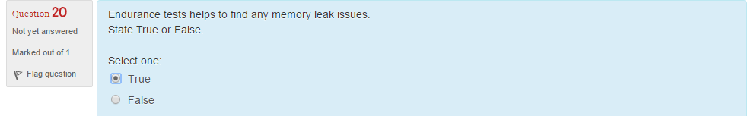

Ans: True arrival rate represents the number of requests arriving at the system boundary per unit of time

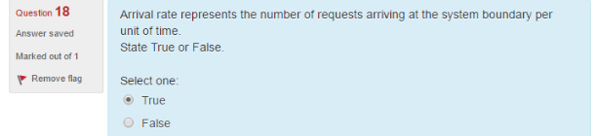

Ans: D 100% cpu utilization for ordinary tasks at a moderate load is considered as which of the folowing

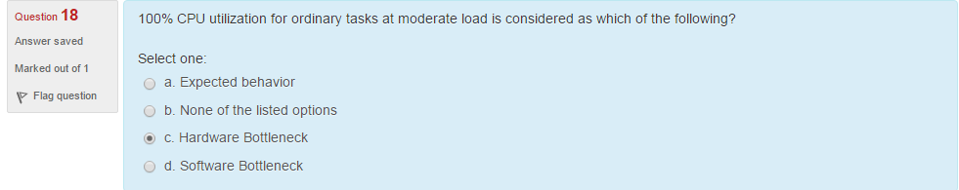

Ans: True

the users who are authorisedto use the system are known as registered users

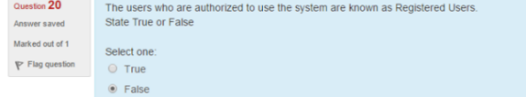

Ans: False

response time is not the most important criteria for load test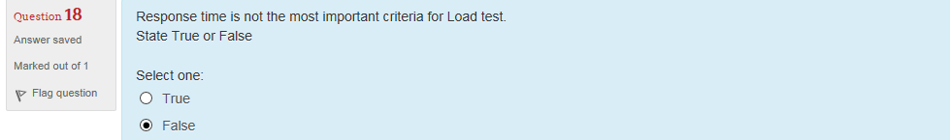

Ans: B

load/demand is expressed as which of the following

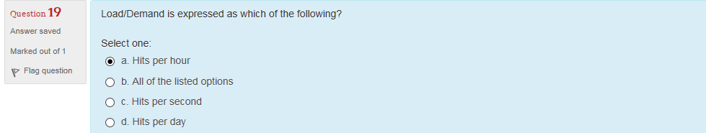

Ans: A

load/demand is refers which of the following

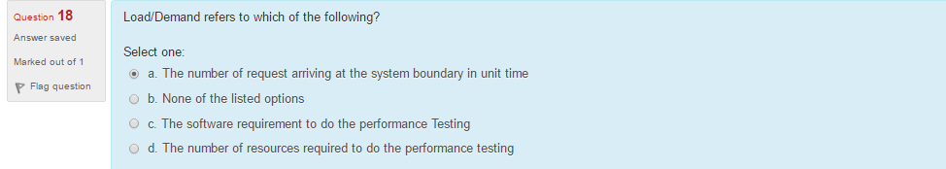

Ans: False. It is hardware bottleneck

improper configuration of hardware resources is a software bottleneck

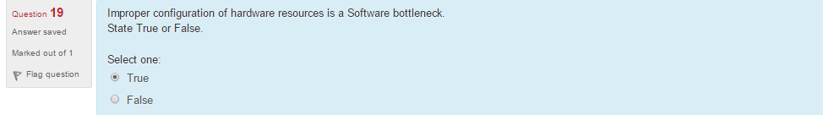

Ans: B

what are the security concepts that cover security testing

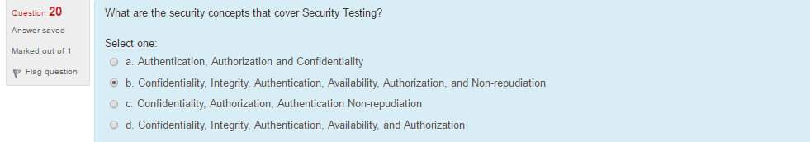

Ans: B

which of the following is a security related test scenario

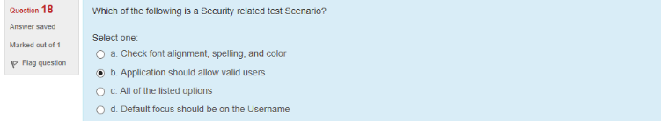

Ans: A

which of the following is not a valid user category in performance engineering

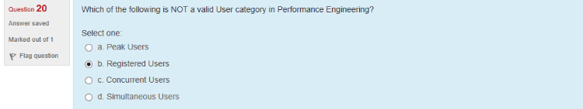

Ans: B

identify the assistive tools used by visually challenged users from the following

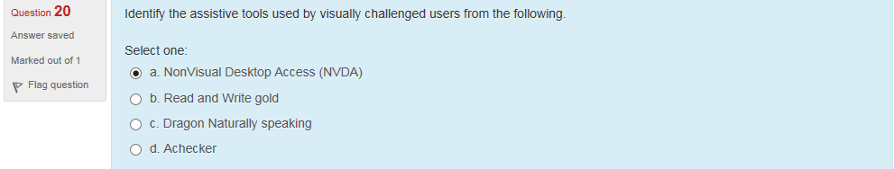

## Mobile Testing

Ans: False. Robotium is Android only.

Robotium supports ios as well as android app automation

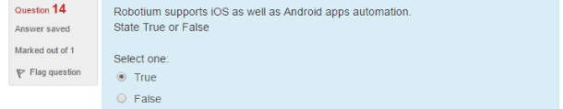

Ans: B

Which of the following are like native apps which run on the device and is written with web technologies ?

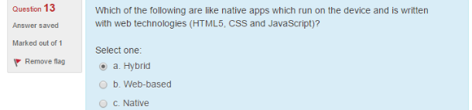

Ans: D

What are the main challenges of mobile applications testing?

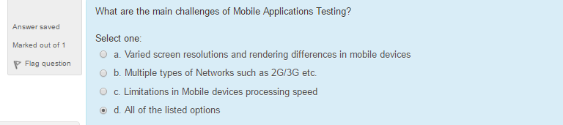

Ans: True

Iphone simulator does not emulate an iphone processor disk drive or memory constraints

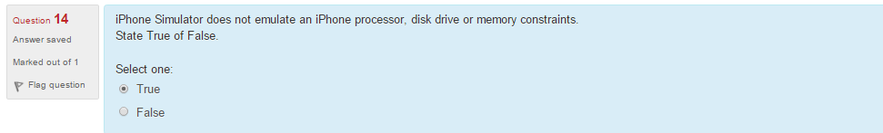

Ans: A

Which of the following is the integrated development environment that manages your application projects and lets to edit complie run and debug code?

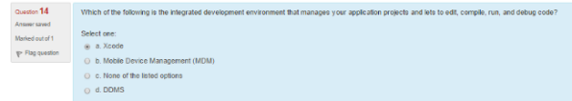

Ans: A

What are the prerequisties of windows 7 emulator?

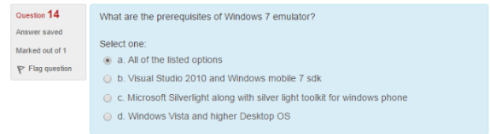

## HP ALM

Ans: False

THE project generated in hp-alm can’t be customized as per the template required for the report.

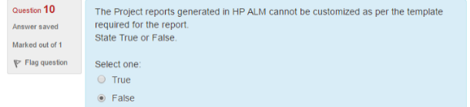

Ans: A

.Each time when you time add the new defects –ALM store list of keywords

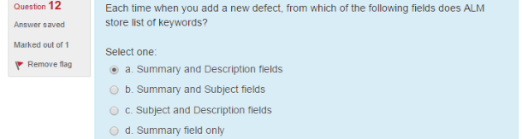

Ans: D

In defect module while viewing and deciding which new defects to be fixed the QA manager assigns them to appropriate.

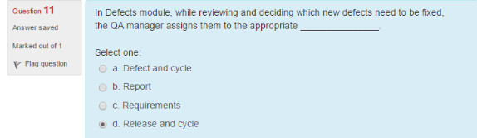

Ans: A, C, D

From the given options identify the valid sequence that a defect can traverse through

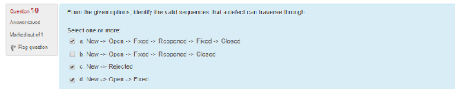

Ans: A

From the given options identify the options that list out architectural components of HP ALM.

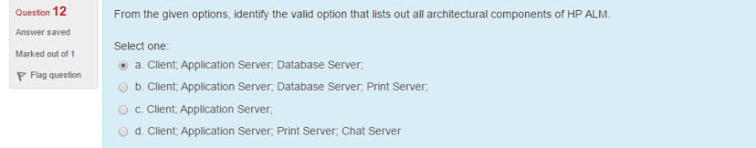

Ans: C

A defect can be linked to an entity like run step or test or run step

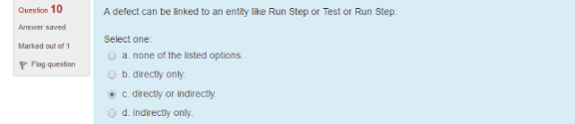

Ans: A if a user wants to display data from various modules which type of graph should the user choose from the options liasted below?

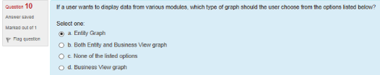

Ans: D

Which of the following statements with respect to defect module is correct

1 user can only remove direct links from the linked defects grid

2 indirect linkns are removed automatixally when the direct links are removed

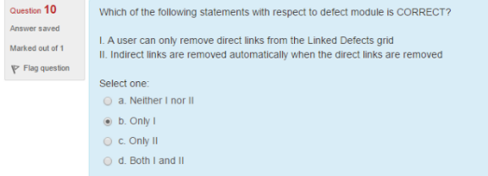

Ans: C

Benny has created a release with start date as 9th may 2016. He then creates a cycle with start date as 2nd may 2016 .determine the valid scenario

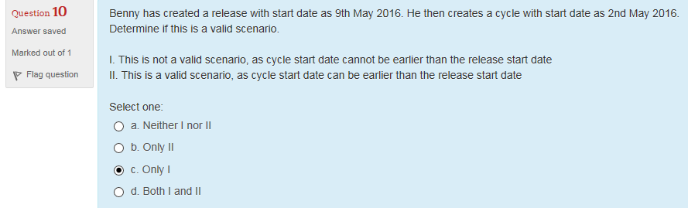

Ans: B

In the requirements module of h palm, requirement related topics are recorded by creating which of the following?

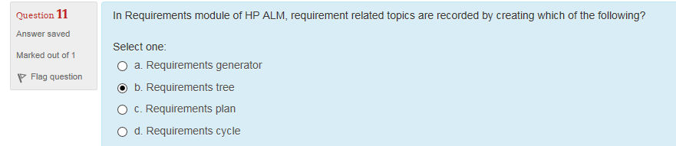

Ans: True

A user can add a new defect to an hp alm project from any stage of the testing process

