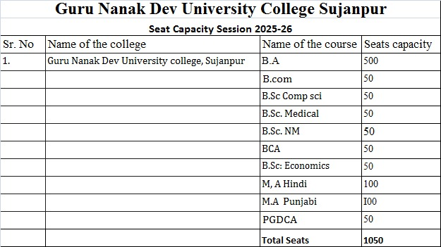

**UG COURSES**

|  |  |  |  |  |
| --- | --- | --- | --- | --- |
| **Sr. no.** | **Course name** | **Department** | **Seats** | **Syllabus** |
|  | Bachelor of Arts (BA) | Department of Arts | 500 | <https://online.gndu.ac.in/syllabi.asp> |
|  | Bachelor of Science (B.Sc Medical) | Department of Science | 50 | <https://online.gndu.ac.in/syllabi.asp> |
|  | Bachelor of Science (B.Sc Non-Medical ) | Department of Science | 50 | <https://online.gndu.ac.in/syllabi.asp> |
|  | Bachelor of Science (B.Sc Computer Science) | Department of Science | 50 | <https://online.gndu.ac.in/syllabi.asp> |
|  | Bachelor of Science (B.Sc Economics) | Department of Science | 50 | <https://online.gndu.ac.in/syllabi.asp> |
|  | Bachelor of Computer Applications (BCA) | Department of Computer Science and Applications | 50 | <https://online.gndu.ac.in/syllabi.asp> |
|  | Bachelor of Commerce (B.Com Hons.) | Department of Commerce | 50 | <https://online.gndu.ac.in/syllabi.asp> |

**PG COURSES**

|  |  |  |  |  |
| --- | --- | --- | --- | --- |
| **Sr. no.** | **Course name** | **Department** | **Seats** | **Syllabus** |
|  | M.A. (Hindi) | Department of Arts | 100 | <https://online.gndu.ac.in/syllabi.asp> |
|  | M.A. (Punjabi) | Department of Arts | 100 | <https://online.gndu.ac.in/syllabi.asp> |
|  | PGDCA | Department of Computer Science and Applications | 50 | <https://online.gndu.ac.in/syllabi.asp> |