A Faculty Development Program Website

1. Introduction

* The project involves publicity of a faculty development program showing details of the upcoming sessions,speakers and agenda.

2. Design and Implementation.

In particular, this section should contain:

* Have used bootstrap classes to ensure the responsiveness and a separate style sheet to maintain the look of the website
* Made modifications in the table template and used media queries for its responsiveness.
* Used bootstrap and nodejs to test the website before deployment on actual domain puchases

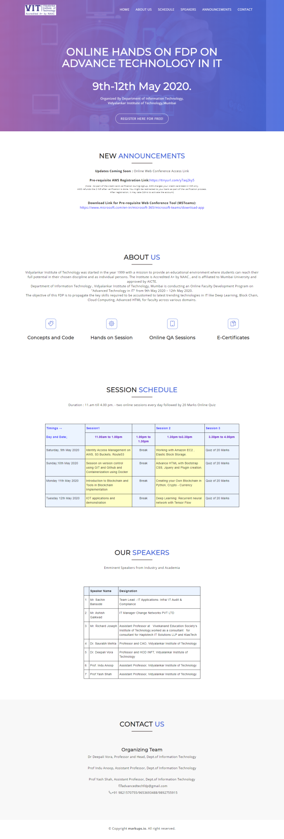

Fig: webpage

3. Conclusions

* Developed a responsive and styled website which was later deployed.
* Have not included separate pages for each menu item, instead have used #target to move to a new section of the same index.html page

4. References

<https://websitesetup.org/bootstrap-tutorial-for-beginners/>

<https://www.w3schools.com/howto/howto_website_bootstrap4.asp>