|  |  |  |
| --- | --- | --- |
| **Tech Saksham**  Final Project Report  **Web Development** |  |  |

**“Campus Placement Cell”**

**“Rajiv Gandhi University of Knowledge Technologies, Kadapa”**

|  |  |
| --- | --- |
| **ROLL NO** | **NAME** |
| R170470 | Indu Chennupati |
|  |  |
|  |  |
|  |  |
|  |  |

|  |  |
| --- | --- |
|  | Poovaragavan Velumani |
|  | Trainer Name |
|  | Master Trainer |

**ABSTRACT**

* Campus Placement Cell (CPC) is web-based tool to reduce communication gap between Job providers and Job seekers or students. The Main objective of this project is to make easy the recruitment process of any organization.
* This CPC is designed by keeping in mind both parties Job providers and Job seekers. CPC allows students to register their details like skills and experience with the system, and then on the other hand even it allows job providers to post their requirements with the system.
* This portal's main aim is to provide the vacancies available for the students in IT technologies. CPC will automatically send mails to all students whose skills are matched with the requirement

**INDEX**

|  |  |  |
| --- | --- | --- |
| **Sr. No.** | **Table of Contents** | **Page No.** |
| 1 | Chapter 1: Introduction | 1 |
| 2 | Chapter 2: Services and Tools Required | 2 |
| 3 | Chapter 3: Project Architecture | 3 |
| 4 | Chapter 4: Architecture Blocks Detail Working | 4 |
| 5 | Chapter 5: Project Budget | 5 |
| 6 | Conclusion | 6 |
| 7 | References | 7 |
| 8 | Code | 8 |

**CHAPTER 1**

**INTRODUCTION**

* 1. **Overview**

This portal's main aim is to provide the vacancies available for the students in IT technologies. CPC will automatically send mails to all students whose skills are matched with the requirement.

* 1. **Feature**

The main aim of this website is to make job searching process easier. Students or Job seekers can log in to the website and apply for jobs which can match their skill

* 1. **Future Work**

This system is helpful for the college campus recruitment process for training and placement department to shortlist students in advance and prepares students for placements.

**CHAPTER 2**

**SERVICES AND TOOLS REQUIRED**

**2.1 Tools and Softwares used**

Front-End : HTML5,CSS3 AND JAVASCRIPT

Back-End : NODEJS

Database : MySQL

Tool : VS Code Editor

**2.2.1 NodeJS**

Node.js is an open-source, cross-platform, back-end JavaScript runtime environment that runs on a JavaScript Engine and executes JavaScript code outside a web browser, which was designed to build scalable network application.

**2.2.2 HTML**

HTML stands for the Hyper Text Markup Language. HTML is the standard markup language for Web pages. HTML elements are the blocks of the HTML Markup. HTML elements consist of start tag,end tag and content in between them

**2.2.3 Cloud Foundry**

MySQL is a relational database management system based on the Structured Query Language, which is the popular language for accessing and managing the records in the database. MySQL is open-source and free software under the GNU license. It is supported by Oracle Company.

**CHAPTER 3**

**PROJECT ARCHITECTURE**

**3.1 Architecture**

**USER FRONTEND BACKEND**

|  |  |  |
| --- | --- | --- |
|  | **HTML 5** | **NODEJS 14.0**  **Database** |

**CHAPTER 4**

**ARCHITECTURE BLOCKS DETAIL WORKING**

**4.1 Blocks**

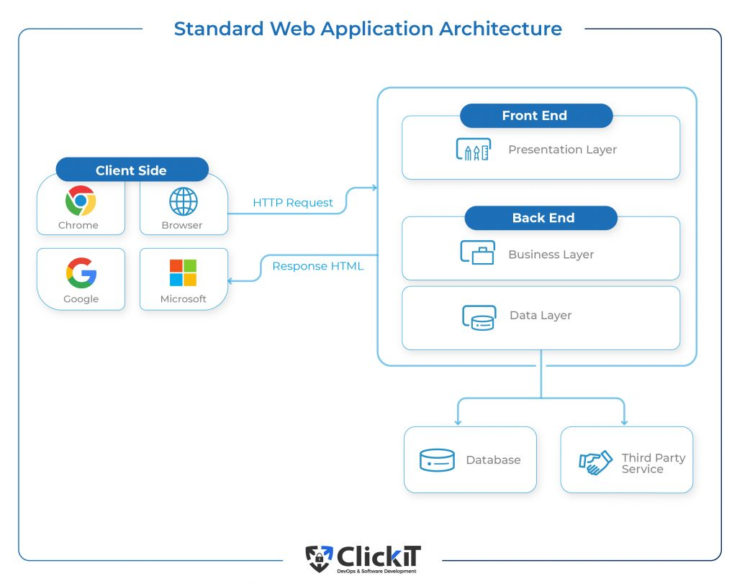

**CHAPTER 5**

**PROJECT BUDGET**

* **This project is build by taking reference from different websites and with the help of trainer. No external resourced were bought to complete the project**

**CONCLUSION**

From a proper analysis of positive points and constraints on the CPC, it can be safely concluded that the project CPC is a highly e client GUI based component. Nowadays manual process of searching a job

of one's choice as well as searching the appropriate candidate for a specific job has become a huge task and so realizing the need for easy management of this process, the site has been developed. It is very easy to update and maintain information through this site. The main features of this site include exibility, ease of manipulation of information, easy access searching, storage,reduction of manual work in an e client manner, a quick, convenient, reliable,timely and active way to reach recruiting, search and employment professionals worldwide and it is also very economical.

**REFERENCES**

* <https://developer.mozilla.org/>
* https://www.w3schools.com/

**CODE**

**Github Link : https://github.com/induchennupati/Tecksaksam.git**