EDGE INTELLIGENCE LAB TASK -2
(MACSE604)
INDUJA K
25MML0055
EXP 1:
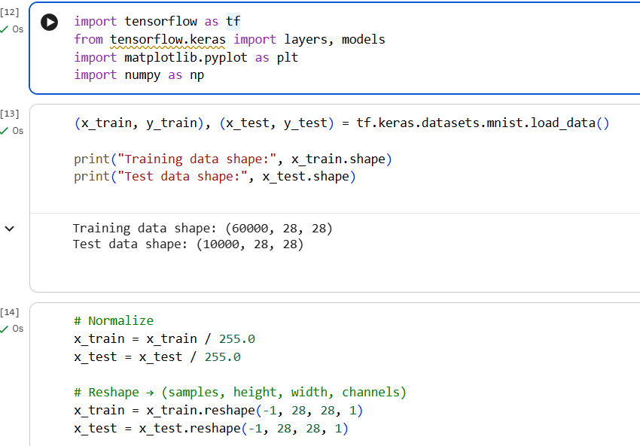
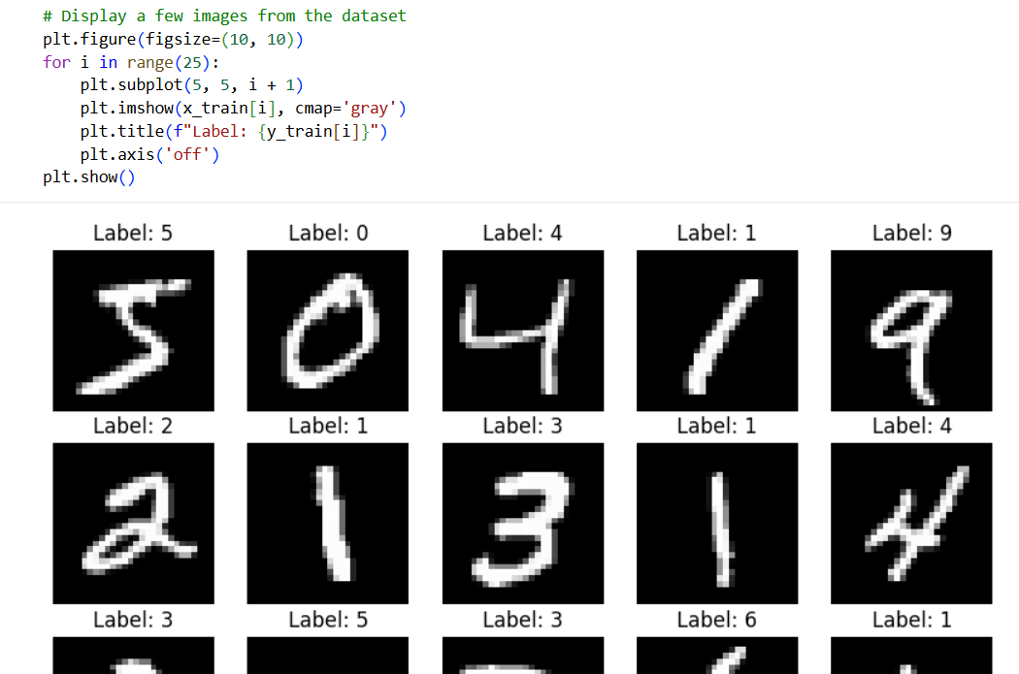
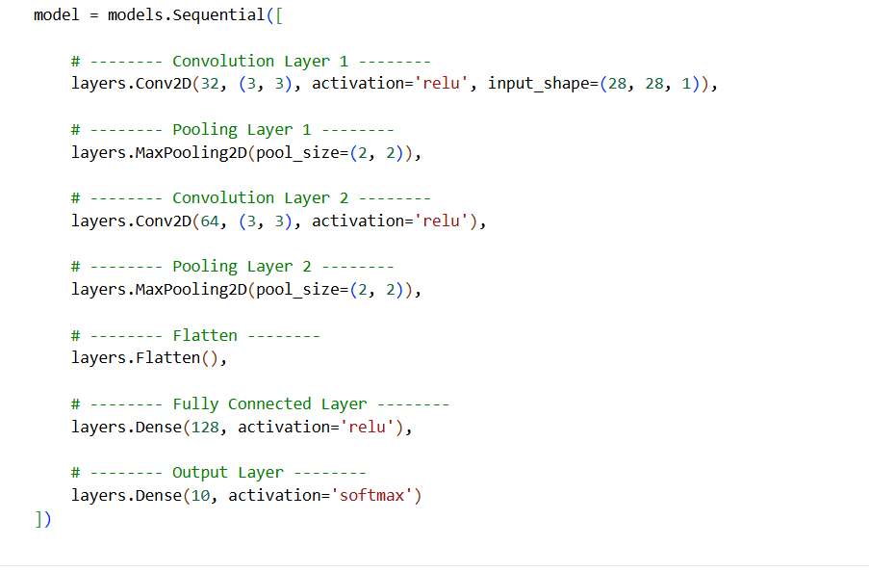
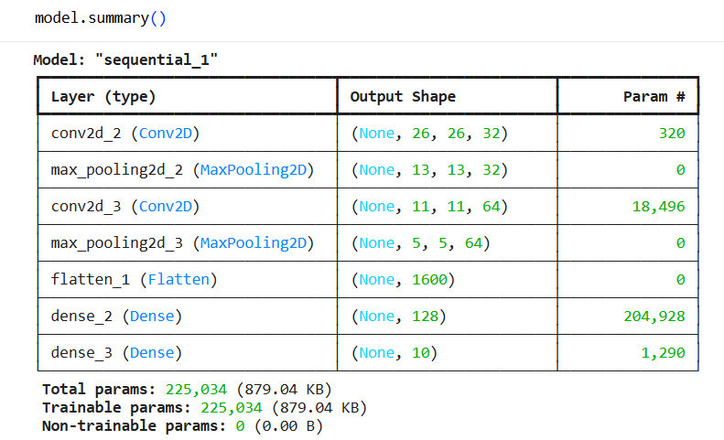
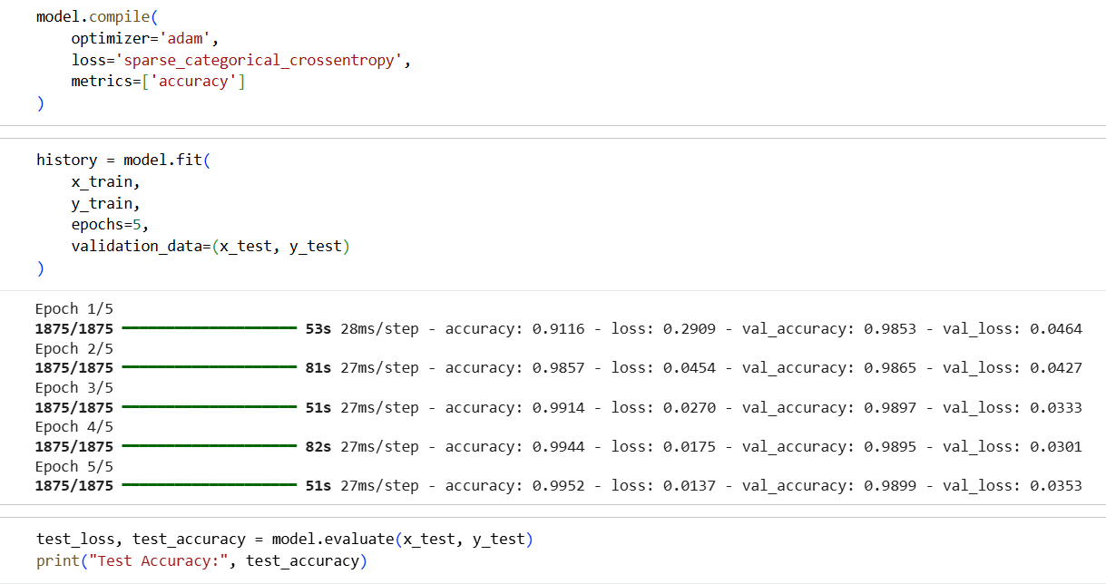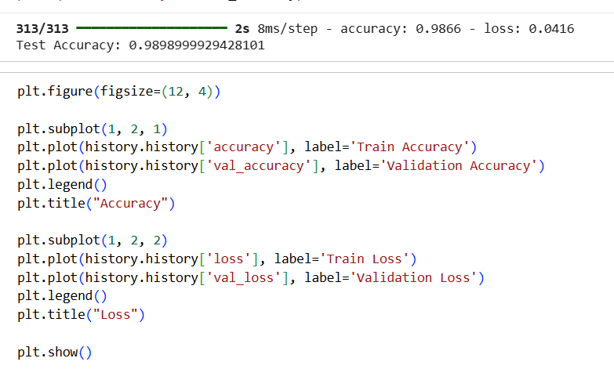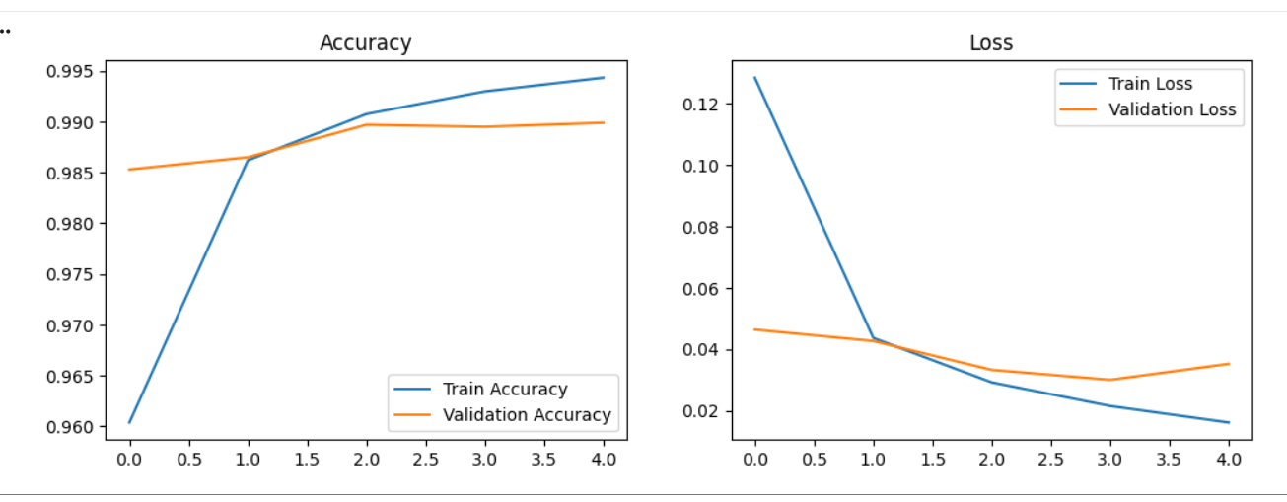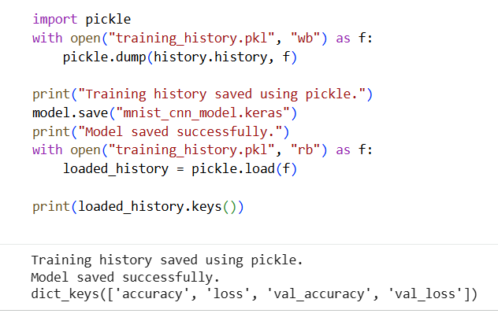
- The MNIST image dataset was analyzed to understand its structure and characteristics. The dataset consists of grayscale images of handwritten digits, which were subjected to basic preprocessing operations, including normalization of pixel values and reshaping to make the data suitable for neural network models.
- A Convolutional Neural Network (CNN) was implemented to perform image classification. The model was trained on the preprocessed MNIST images, and its performance was evaluated using accuracy and loss metrics. Training and validation curves were plotted to analyze the learning behavior of the model.
- After training, the trained CNN model was saved using the native Keras .keras format, while the training history (accuracy and loss values) was saved using the Python pickle module for future analysis and reuse.

EXP 2: 1. Create account in edge impulse
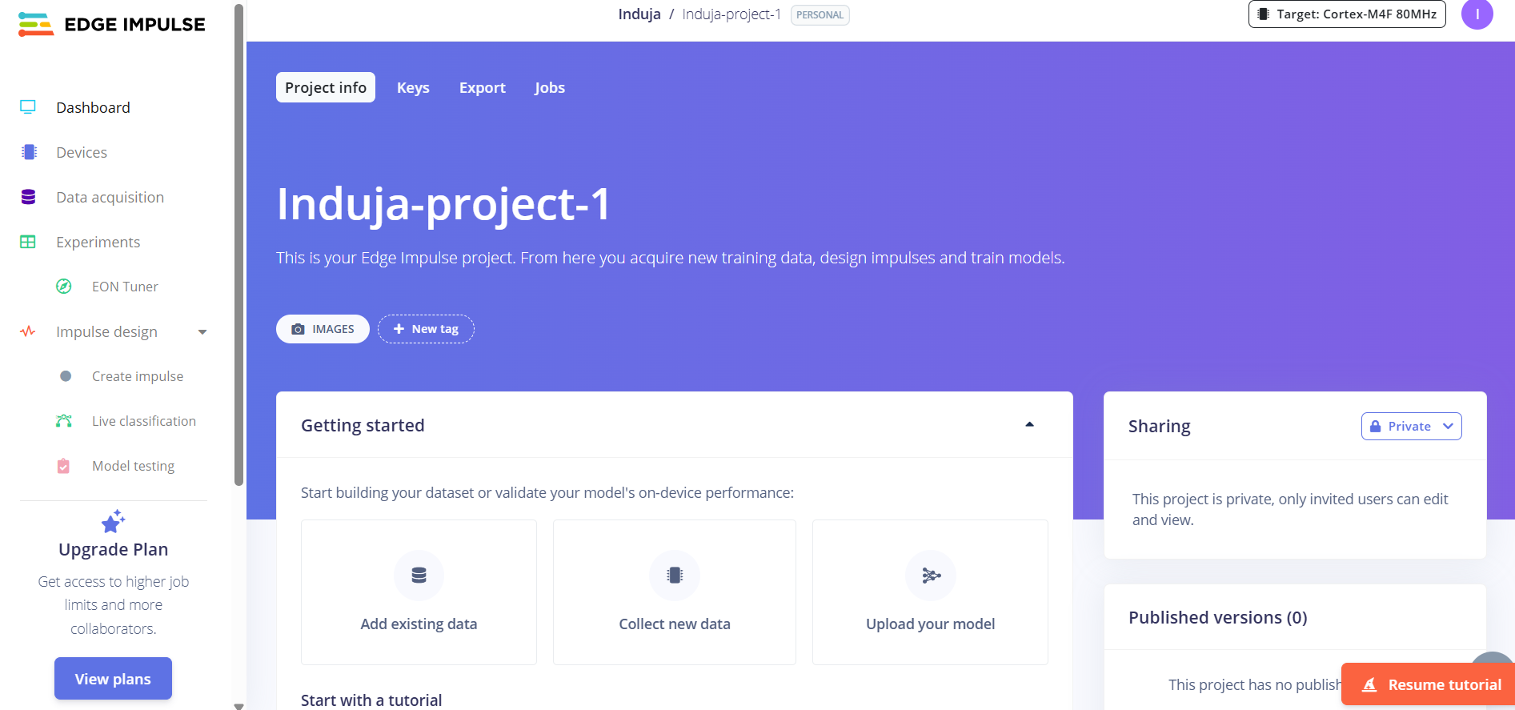
2.go to data acquisition
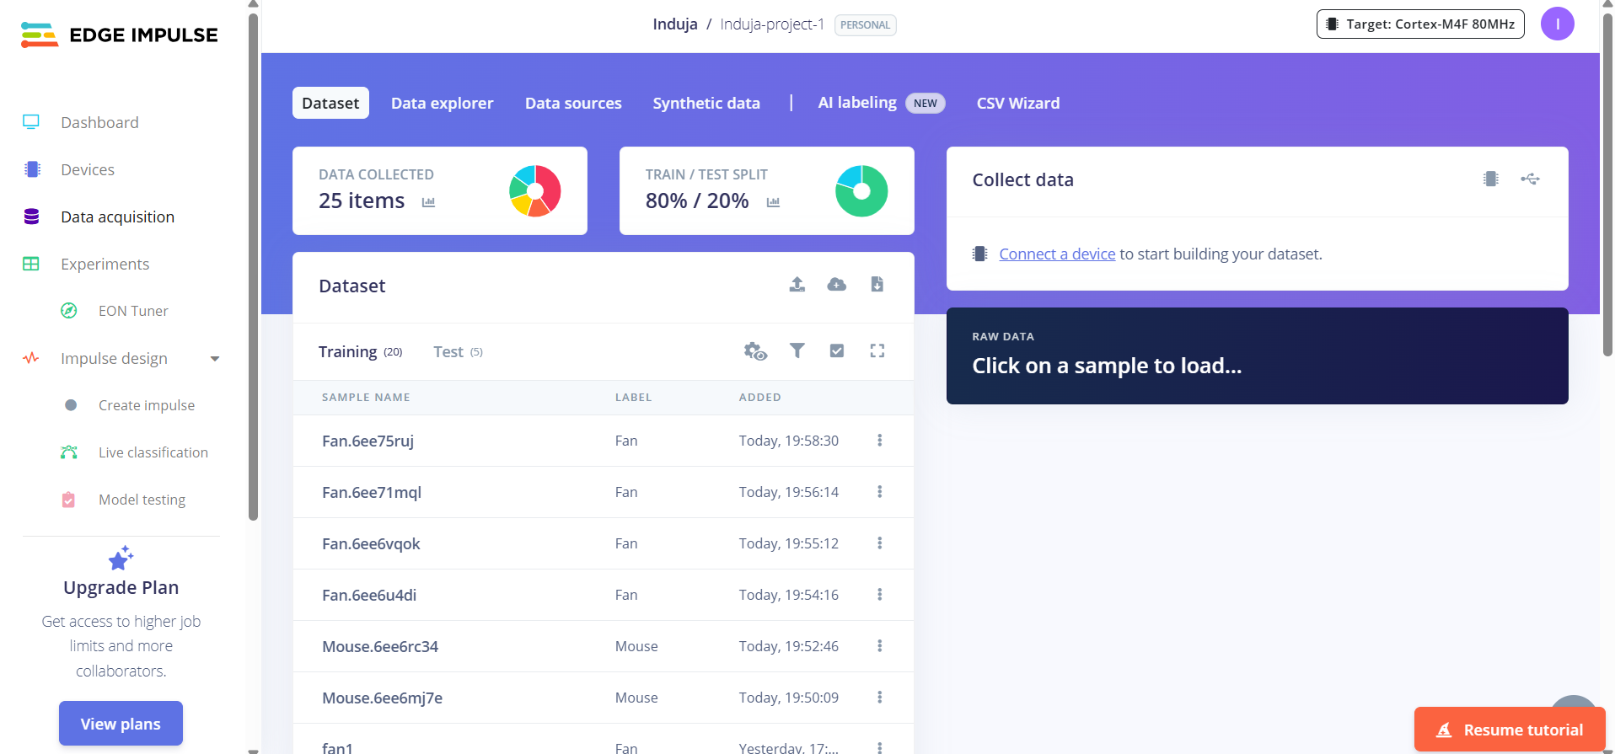

3.Choose connect data option
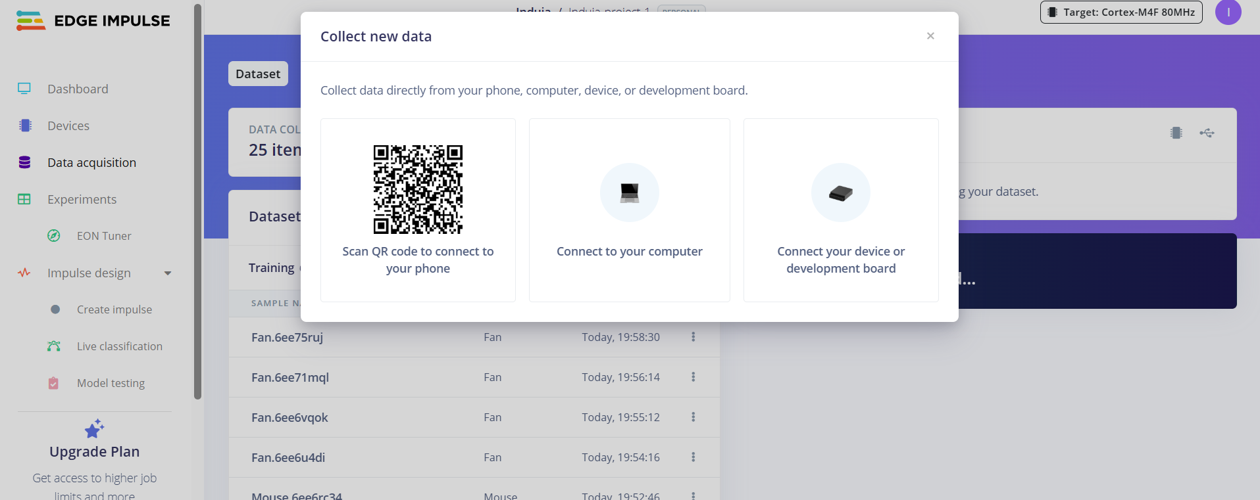
4.scan QR using phone, Split the clicked photos into train and test data
