TIER 1 SUPPORT AGENT WITH RAG
Real-Time Customer Support using Company Documentation and a Vector Database

Project Documentation
Technology workflow: n8n + Gmail + AI Agent + RAG + Pinecone + LLM

1. Project Overview
The Tier 1 Support Agent with RAG is an AI-powered customer support automation system. Its purpose is to resolve common customer inquiries in real time through web chat or email. Instead of relying only on the language model's general knowledge, the agent retrieves relevant information from company documentation stored in a vector database and uses that information to generate a grounded response.
The workflow shown in the current n8n implementation receives an incoming Gmail message, retrieves the message content, sends it to an AI Agent, retrieves supporting information through a vector-store tool, and sends the generated answer back through Gmail.

2. Objective
The main objective is to build a Tier 1 customer-support agent that can understand customer questions, retrieve the most relevant company knowledge, generate a clear response, and deliver the response automatically with minimal human intervention.
- Resolve frequently asked customer questions quickly and consistently.
- Use company-approved documentation as the primary knowledge source.
- Retrieve relevant information from a vector database using semantic search.
- Generate natural-language responses using an AI/LLM agent.
- Support email-based conversations and provide a workflow that can be extended to web chat.
- Reduce repetitive work for human Tier 1 support staff.

3. Problem Statement
Customer support teams receive repeated questions about products, services, account processes, policies, troubleshooting, and frequently requested information. Manual handling of these repetitive questions can increase response time and workload. A support agent that combines retrieval-augmented generation (RAG) with workflow automation can search the organization's documentation and provide consistent answers in real time.

4. Scope of the System
Area | Scope
Input | Customer questions received through email; the same RAG core can be connected to web chat.
Knowledge | Company FAQs, manuals, policies, product information, troubleshooting guides, and other approved documents.
Retrieval | Semantic retrieval from a vector database using embeddings.
Reasoning | AI Agent combines the customer question with retrieved context to formulate a response.
Output | A customer-friendly reply sent through email or returned to a chat interface.
Escalation | Unresolved or sensitive cases can be routed to a human support agent in a future/extended workflow.

5. System Architecture
The solution follows a Retrieval-Augmented Generation architecture. The knowledge documents are loaded, split into smaller chunks, converted into embeddings, and stored in a vector database. When a customer asks a question, the system retrieves the most relevant chunks and supplies them to the AI Agent as context.
- Customer → Email/Web Chat
- Input Trigger → Receive the customer message
- Message Retrieval → Read the complete message and relevant metadata
- AI Agent → Understand the request and decide how to answer
- RAG Tool → Search the vector store for relevant company information
- Vector Database → Pinecone stores document embeddings and searchable chunks
- LLM → Generates a grounded, natural-language response
- Output → Send the response back to the customer
High-level flow:
Customer Question → AI Agent → Vector Search → Relevant Company Context → LLM Response → Customer

6. RAG (Retrieval-Augmented Generation) Process
Document Collection: Collect trusted company documents such as FAQs, product guides, policies, and troubleshooting information.
Document Loading: Use a document/data loader to bring the source content into the workflow.
Text Splitting: Use a Recursive Character Text Splitter to divide long documents into smaller searchable chunks.
Embedding Generation: Convert each chunk into a numerical vector representation using an embedding model.
Vector Storage: Store the vectors and their associated text in Pinecone Vector Store.
Question Embedding: Convert the customer's question into an embedding for semantic similarity search.
Context Retrieval: Retrieve the most relevant document chunks from Pinecone.
Answer Generation: The AI Agent uses the retrieved context and an LLM to generate the response.

7. Components Used in the Current n8n Workflow
Component | Purpose
Gmail Trigger | Starts the workflow when a new email is received.
Get a Message | Retrieves the incoming Gmail message so the agent can process its content.
AI Agent | Core support agent that interprets the customer request and uses available tools/model connections.
OpenAI Chat Model | LLM connection available to the AI Agent for response generation.
Answer Questions with Vector Store | RAG tool connected to the AI Agent for retrieving company knowledge.
Pinecone Vector Store | Stores and retrieves document embeddings and relevant knowledge chunks.
OpenAI Embeddings | Creates embeddings for the knowledge-base documents and search queries.
Default Data Loader | Loads source documentation into the RAG pipeline.
Recursive Character Text Splitter | Breaks source documents into manageable chunks before embedding.
Google Gemini Chat Model | An additional model connection shown in the workflow and available for the RAG tool/agent configuration.
Send a Message | Sends the AI-generated response back through Gmail.

8. Current Workflow in n8n
The provided n8n workflow screenshot shows the main automation path as:
Gmail Trigger → Get a Message → AI Agent → Send a Message
The AI Agent is connected to an OpenAI Chat Model and to a vector-store question-answering tool. The vector-store side uses Pinecone, OpenAI Embeddings, a data loader, and a Recursive Character Text Splitter. A Google Gemini Chat Model is also visible as a model connection in the workflow.
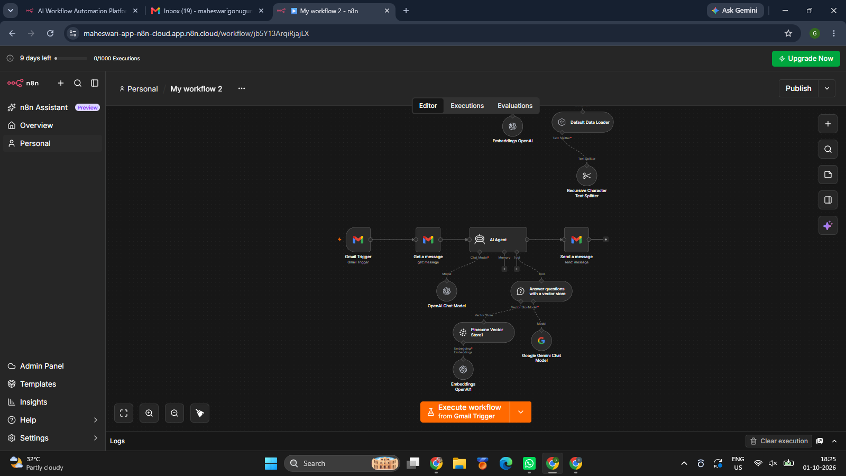
Figure 1. n8n workflow for the Tier 1 Support Agent with RAG.

9. System Requirements

Software / Services
- n8n for workflow automation.
- Gmail or another supported email service for message input/output.
- Pinecone account and vector index for semantic retrieval.
- An embedding model, such as OpenAI Embeddings.
- An LLM, such as an OpenAI or Google Gemini chat model.
- Company documentation in supported document/data formats.

Functional Requirements
- The system shall receive a customer inquiry.
- The system shall extract the question from the incoming message.
- The system shall search the company knowledge base for relevant information.
- The system shall generate an answer using retrieved context.
- The system shall send the response to the customer.
- The system should avoid inventing company-specific information when the knowledge base does not provide an answer.

Non-Functional Requirements
- Fast response time for common inquiries.
- Reliable and consistent responses.
- Secure handling of customer and company information.
- Scalable knowledge base.
- Easy maintenance and updating of company documentation.

10. Example Use Case
Customer question: “What is the process for resetting my account password?”
Processing: The email trigger receives the message. The AI Agent identifies the intent as a password-reset question. The RAG tool searches Pinecone and retrieves the relevant company procedure. The LLM uses that retrieved information to produce a concise response.
Expected response: A clear step-by-step explanation based on the company's approved documentation, including the correct support link or escalation path if one is documented.

11. Work Completed / Current Status
- Created the n8n workflow structure.
- Configured Gmail as the incoming trigger.
- Added a message retrieval step.
- Added an AI Agent for customer-support response generation.
- Connected an LLM chat model to the AI Agent.
- Added a vector-store question-answering tool.
- Configured Pinecone as the vector database.
- Added OpenAI Embeddings for semantic retrieval.
- Added a document loader and Recursive Character Text Splitter for knowledge-base preparation.
- Configured a Gmail send-message step for returning the response.

12. Future Enhancements
- Add a web-chat interface alongside email support.
- Add confidence checking and source references to responses.
- Add human escalation when the agent cannot find sufficient information.
- Add conversation history for multi-turn support.
- Add analytics for response time, resolved queries, and escalation rate.
- Add authentication and role-based access for support staff.
- Create an automated process for updating the vector database when company documents change.

13. Conclusion
The Tier 1 Support Agent with RAG combines workflow automation, artificial intelligence, and a vector database to provide fast and documentation-grounded customer support. The current n8n workflow demonstrates the main pipeline from Gmail input to AI processing, semantic knowledge retrieval through Pinecone, and automated email response. The design can be extended to web chat, human escalation, analytics, and additional company knowledge sources.

Appendix A – Key Terms
Term | Meaning
RAG | Retrieval-Augmented Generation: retrieves relevant external knowledge before generating an answer.
Embedding | A numerical representation of text used to compare semantic meaning.
Vector Database | A database optimized for similarity search over vector representations.
Pinecone | The vector database used in the shown workflow.
AI Agent | An AI component that interprets the request and can use tools to retrieve information.
Tier 1 Support | The first level of customer support that handles common and routine inquiries.

