**Test Automation Details**

**BDD Framework used**: SpecFlow

**Nuget packages**:

* Gherkin
* ExtentReports
* Specflow
* SpecFlow.MsTest

**Test Feature:**

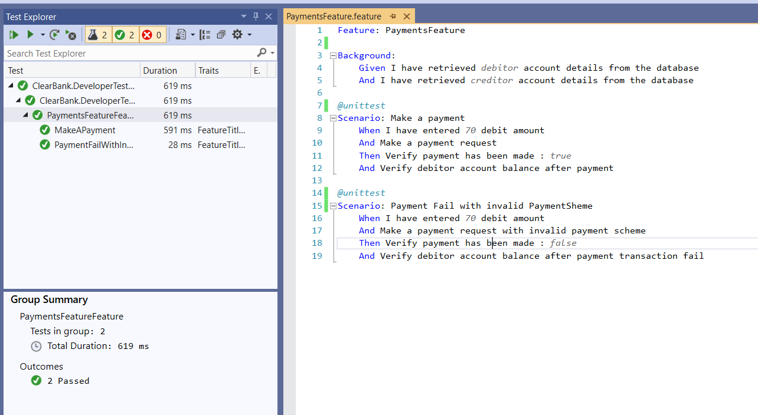

**Generated Extent test report**:

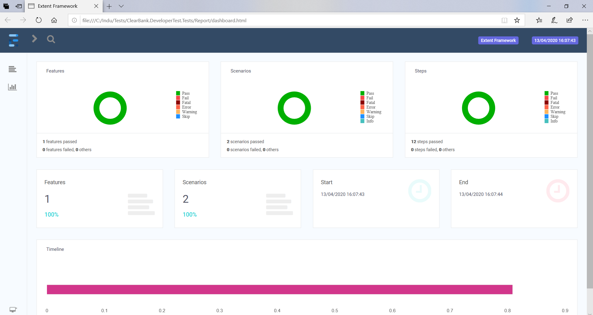

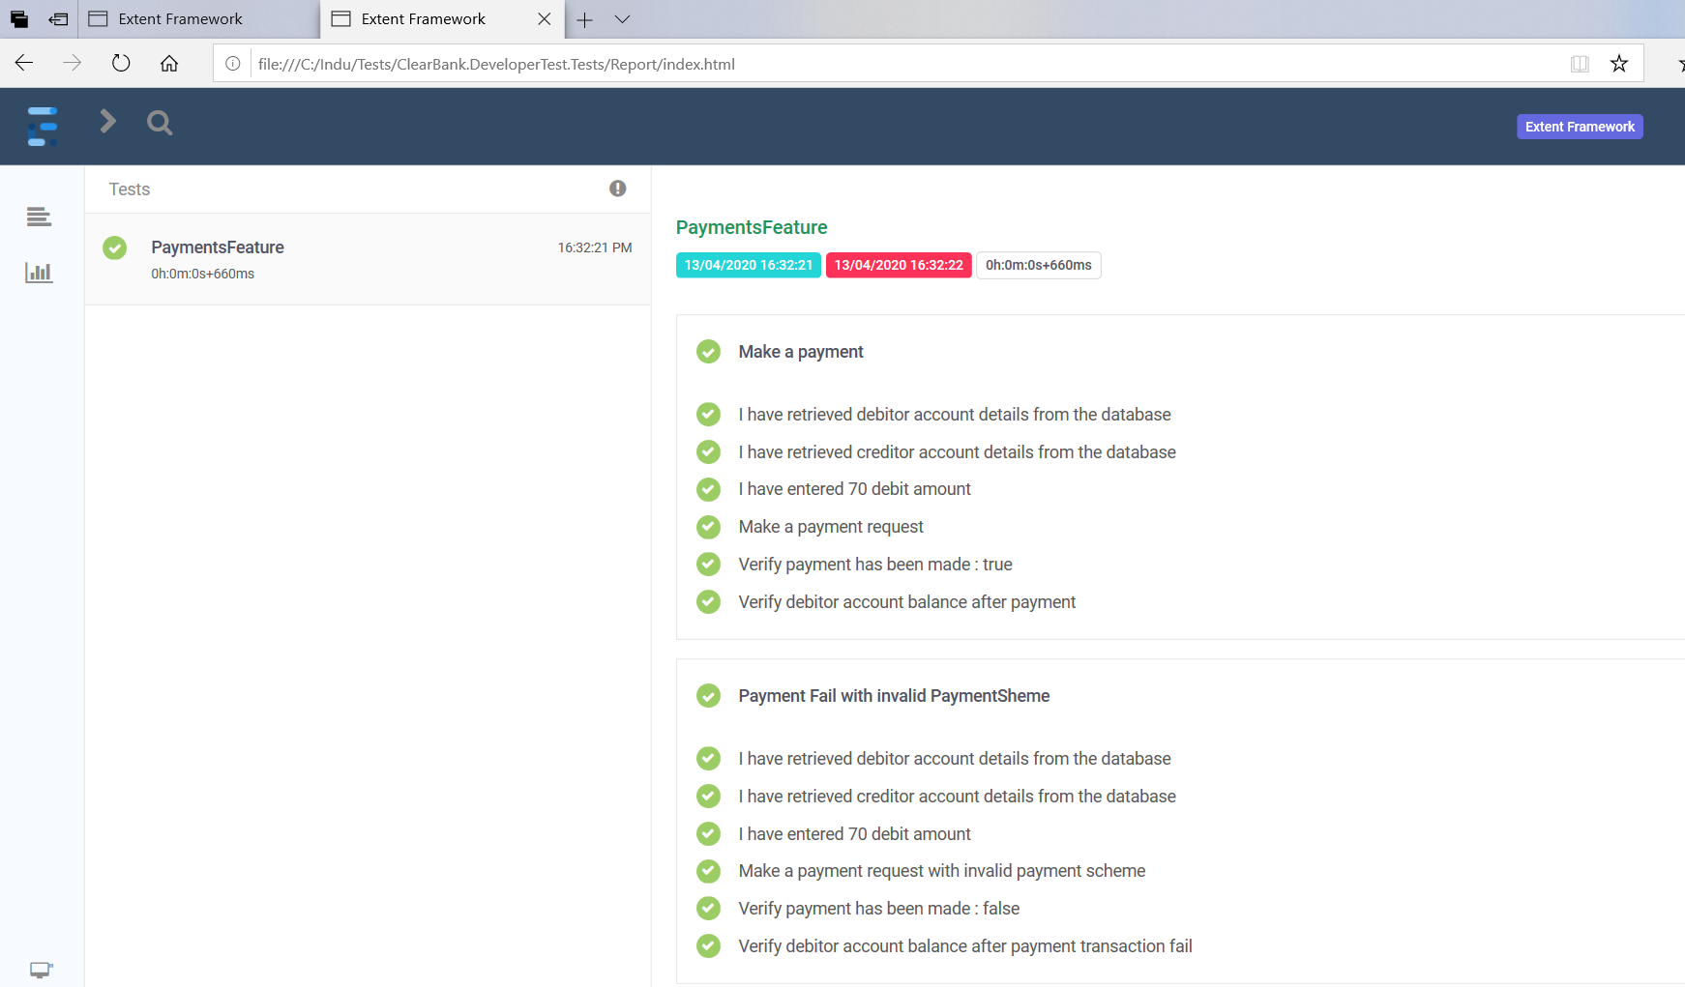

**Data sources for SQL server support:**

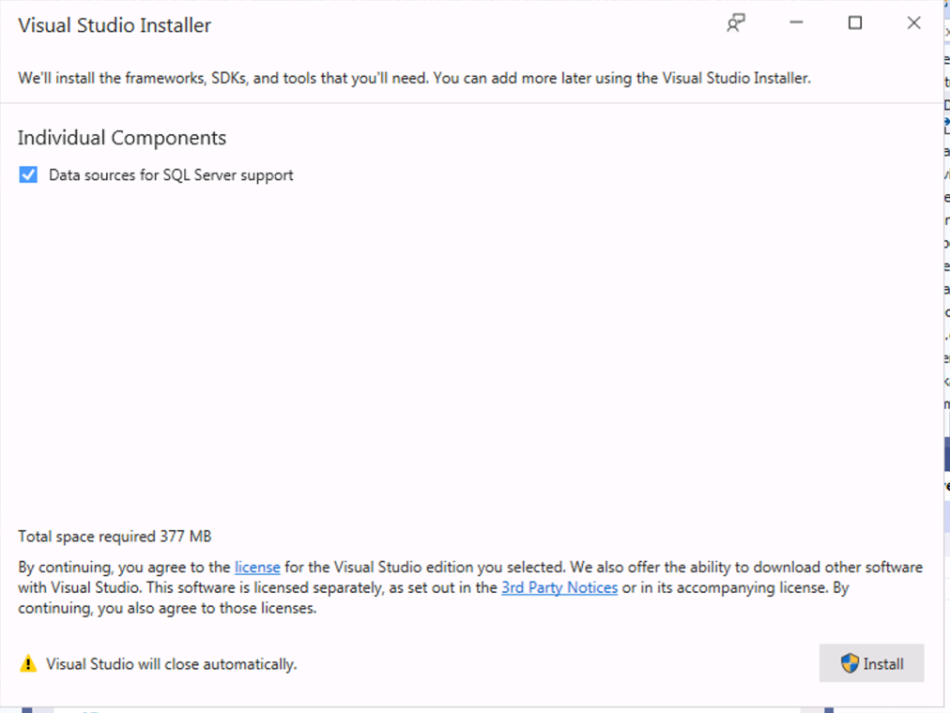

Database Schema:

