Task 01

Advantages of Analytics and Business Intelligence in Power and Renewable Energy Sector
Business Intelligence (BI) and analytics convert operational data into actionable pieces of information. For a commission managing power and renewable energy operations, this may mean different things at different administrative levels.
- Operational Level (Engineers, Field Personnel, Analysts)
At this level, staff members work on the day-to-day monitoring and data collection tasks.
- Dashboards for real-time monitoring: BI tools enable visualization of live electricity demands, grid loads, and output, which means that anomalies (for example, sudden demands) can be detected by engineers in real time.

- Data consistency and quality: Analytics tools help validate incoming data (as in the case with EED data), such as detecting absent or outlier values and wrong readings from measuring instruments before they affect further reports.

- Example: A field employee analyzing the cooling load using descriptive statistics, as shown in task 3, can easily identify the buildings consuming abnormally high energy for cooling.

- The Tactical Level (Department/Regional Coordinators)
Managers at this level typically engage in the planning of the process.
- Trend and Patterns Analysis: By employing the correlation and hypothesis testing techniques revealed in Tasks 4 and 5, the managers will be able to figure out those construction characteristics which actually influence the necessity to cool and thus will be able to channel the renovation programs and subsidy initiatives effectively instead of using universal methods.

- Performance comparison: BI dashboards allow evaluating energy efficiency by regions or building types, enabling managers to define the most promising areas for efficiency interventions.

- Example: For instance, if an analysis by means of ANOVA concludes that orientation is a significant factor in terms of cooling capacity, a regional coordinator may recommend the use of orientation-specific design advice for new public buildings of the government in the region analysed.

- Level of Strategy (Ministry Committee, Policy Advisors)
High-rank decision-makers rely on aggregated data for the continuous formulation of state-level policy.
- Pollution-free policy formation: Regression analysis finds the extent of correlation (e.g. what is the cooling load increase when the surface area grows slightly) that will service the needs of the committee in formulating national construction energy codes and green construction certification standards (e.g. GREENSL).

- Planning electricity demand: Predictive analytics allows expectations of future growth in electricity demand. This data will guide the decision on investment of capacity of renewable resources (solar, wind and hydro) or energy efficiency programs.

- Illustration: In case the analysis shows that Shape of buildings and glazing considerably affects the consumption of cooling electricity then the committee will be able to propose the requirement of minimum energy efficiency standards in the National Building Code in order to allow reduction of peak electricity consumption without new production capacities.

Task 02

The tools, techniques, and methodologies for analysing a case study
Whenever the topic is the use of energy-efficient approaches when cooling buildings in Sri Lanka, this research will use R and R studio for the conducting of the analysis. Statistics will be used by means of already mentioned software allowing the team to obtain reliable results for the report for the Ministry of Power and Renewable Energy.
  - Instruments used for the study

- Programming Language “R”
R is one of the programming languages which is open-code and well justifies itself as a part of data analysis and visualization methods. The main reason for its popularity is its powerful analytical features and high suitability for use in research and business.
Application in this study:
The EED.csv dataset is imported into the software through various functions like read.csv(). Next comes data preparation which involves conversion of variables like changing 'Orientation' into categorical data as an example.
The next step is performing analysis with the help of statistical methods like hypothesis testing, regression, and correlation analysis to understand the relationships among the variables. After the analysis, predictive models are created on the basis of the analysis to predict how the structure has an influence on the cooling load and at last visualization of the data is done to look at the distribution of data and its trends.
- RStudio
RStudio is an Integrated Development Environment, specifically developed for R, which makes coding and analysing easy.
Usage of RStudio in the current research;
RStudio is useful for writing and running R programs successfully which allows for effective work process while conducting an analysis.
RStudio also gives the opportunity for presenting graphical plots (for example, bell curves and box plots) in a systematic way. It takes part in documentation as well as debugging processes which help to find mistakes and keep the process on record.

Figure 1 (R Studio)
  - The Methods Utilized in the Research

- Descriptive Statistics
Descriptive statistics is a tool that helps specify and explain the main features of data through various statistical measurements.
For What Purposes Do I Need to Use Them?
Descriptive statistics serve to identify a number of measurements and quantitative indicators including mean, median, the lowest as well as the highest value and standard deviation for some parameters like Cooling Load, Surface Area, Wall Area and Roof Area.
Descriptive statistics will provide course information related to the distribution of data since the values obtained through descriptive statistics assist in understanding what is analyzed and how different elements differ.
- Hypothesis Testing (ANOVA)
Hypothesis testing is being one of the statistical operations aimed at the testing of an assumption about one of the population parameters. ANOVA (Analysis of Variance) aims at comparison of means of different groups.
How Do I Use Them?;
ANOVA is used to determine whether categorical variables are influential to some continuous target variable and for the purpose of this study, the aim is to find out whether the direction of buildings that is North, South, etc. contributes to alterations in the Cooling Load.
- Correlation analysis

Correlation analysis is defined as the method used to determine relationship between independent variables and also dependent variable (Cooling Load).
Applications
The role of correlation analysis is to identify continuous variables which influence the cooling loads of the building the most as well as to understand the bonding strength between different independent variables, especially the bond between Cooling Load and other independent variables such as Surface Area, Wall Area and Roof Area.
Regression Analysis
It is possible to carry out regression analysis so as to find the value of dependent variable as a function of different independent variables.
Applications
There are different functions like lm() that are used to find out the multiple linear regression analysis that helps to know the effect of various structural properties on the energy consumption. In this case, the independent variables Surface Area, Wall Area, Roof Area can be correlated with the dependent variable cooling load.
The effectiveness of the multiple linear regression analysis can be found out by the different results generated by R in the form of Estimate values and p-values.

- Data Visualization
Visualization is a means of presenting data effectively and in a straightforward manner.
Use;
With the help of base R functions, histograms are created alongside normal bell curves and Box Plots. Constructing these graphs serves the purpose of visually reviewing data and making the presentation of data distribution convenient. Moreover, using these graphs assist in finding out the trends and assessing the normality of data.

  - Techniques Utilised in this Study

- Adaptation process - CRISP-DM Methodology
In this study, the CRISP-DM methodology will be adopted since it is well structured and systematic.
Stages undertaken in this study
- Step 1: Understanding the Business - Characterization of the Energy Efficiency problem: The step consists in identifying one of the key issues of the nation that consists in high electricity consumption at home and in businesses. The goal is to find the correlation between construction and cooling loads for the sake of energy efficiency.

- Step 2: Knowing the information - Getting acquainted with the EED database and the nature of different variables: The procedure includes the unprocessed information on important variables like Surface Area, Wall Area, Roof Area, Orientation, and Cooling Load in BTU.

- Step 3: Preparing the information – Applying R programming to cleanse and change the information: Categorical data should be formatted properly to get accurate information.

- Step 4: Develop models – To apply hypothesis and regression techniques: Models based on ANOVA, correlation and linear regression will be built in order to understand how the cooling load is affected.

- Step 5: Evaluation of models – To determine how reliable the results are: The significance is assessed through p-criteria of Shapiro-Wilk normality testing and tests for correlation.

- Step 6: Implementation of the results – To draw some conclusions: The conclusions drawn from the project will allow coming up with the required recommendations for construction in order to ensure energy efficiency.

- Exploratory Data Analysis
The Exploratory Data Analysis is performed before the modeling in order to get the insight into the information.
Application;
The distributions will be checked regarding the nature of distribution of different variables in the dataset. Insights will be generated via visualizations that will be applied through R software. The visualizations include bell-shaped histograms and box plots for verifying central tendency and outliers before conducting inferential testing.
- Predictive Analytics Approach
The method is used for forecasting future events according to historical data.
Application;
The necessary cooling load will be calculated via statistical modeling in order to forecast power needs based on different physical factors of building forms included in the dataset. The government will make decisions regarding the necessity of applying building regulations (for instance, decreasing scope of other roof areas) in order to minimize energy consumption.

Task 03

3. Bell Curve Representation with Central Tendency Measurement
Central tendency measurement help is us in determining the central values of a data set consisting of the mean, median, and mode. These central tendency measurements gives us the insights regarding the behavior of variables in terms of energy efficiency and cooling load of the building.
  - Summary of the Results of Central Tendency

Mean – The mean is defined as the average of the series of numbers, which is calculated by adding up all values in the series and dividing by the total number of values in that series.
Median – The median is determined to be the middle value in the ordered series, which divides the series into two equal parts as well as it is not influenced by outliers in comparison to other methods of calculation.
Mode - Mode shows us the frequently occurring number in the data. It tells us about the number that has maximum occurrence.
    - Cooling Lode
Statistic | Value
Mean | 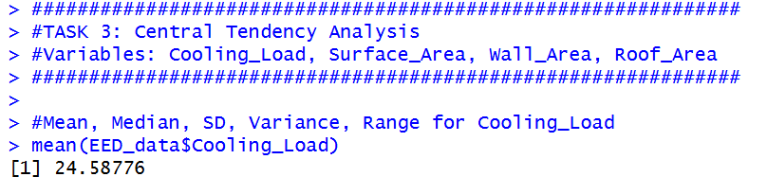  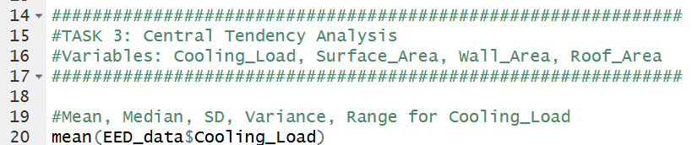  Figure 2
Median | 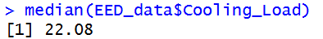  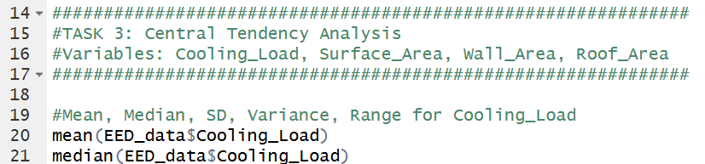  Figure 3
Mode | 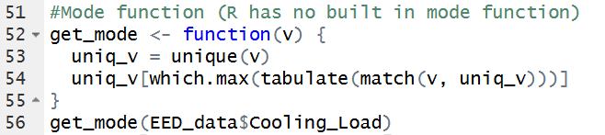  Figure 4  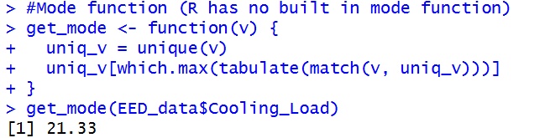
Sd | 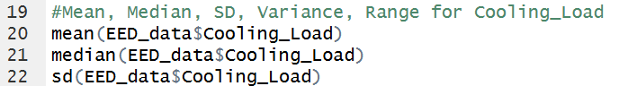  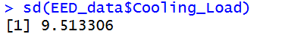  Figure 5
Var | 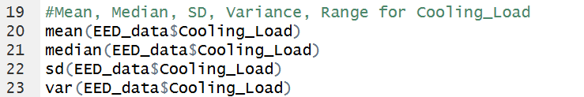  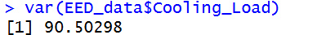  Figure 6
Range | 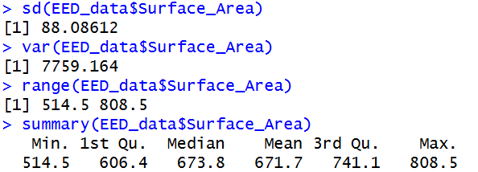  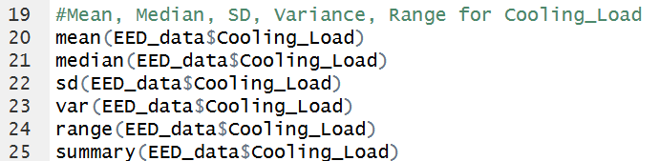  Figure 7
Table 1 (Central Tendency - Cooling Load)

    - Surface Area
Statistic | Value
Mean | 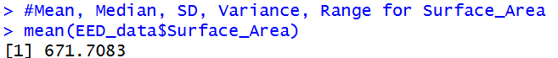  Figure 8
Median | 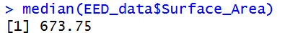  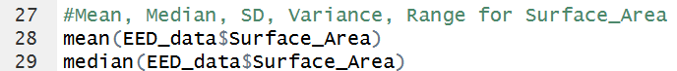  Figure 9
Mode | 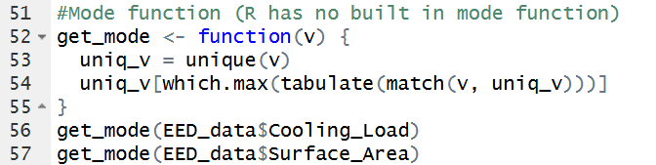  Figure 10
Sd | 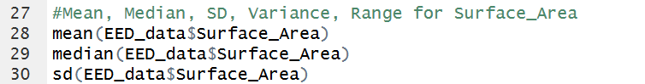    Figure 11
Var | 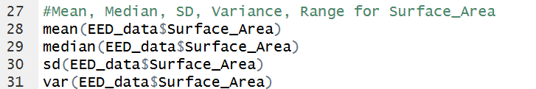  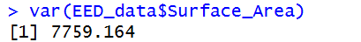  Figure 12
Range | 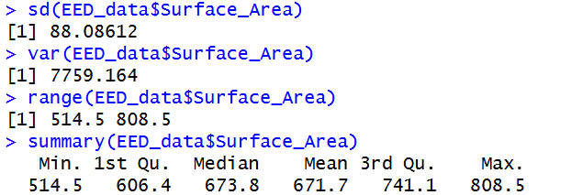  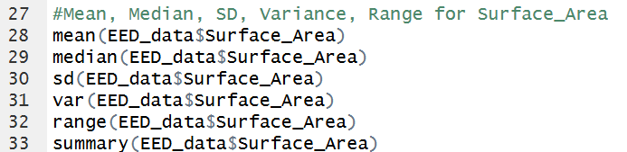  Figure 13
Table 2 (Central Tendency - Surface Area)

    - Wall Area
Statistic | Value
Mean | 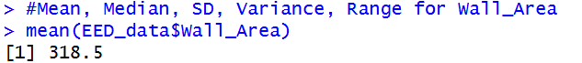  Figure 14
Median | 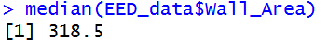  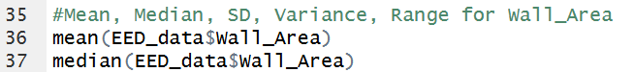  Figure 15
Mode | 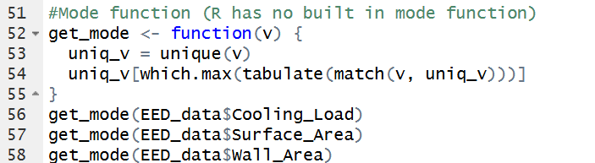    Figure 16
Sd | 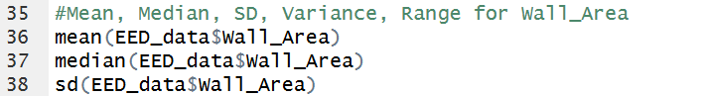  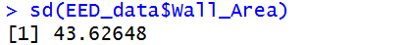  Figure 17
Var | 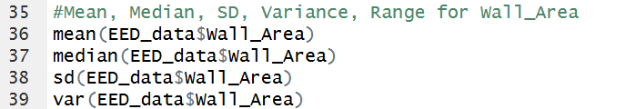    Figure 18
Range | 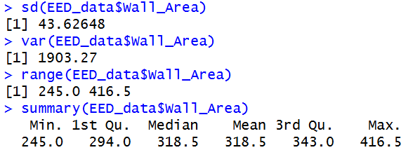  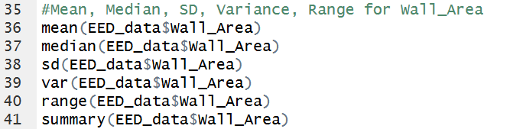  Figure 19
Table 3 (Central Tendency - Wall Area)
    - Roof Area

Statistic | Value
Mean | 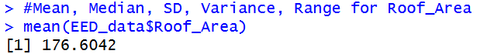  Figure 20
Median | 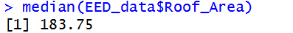  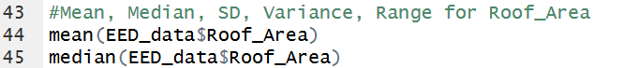  Figure 21
Mode | 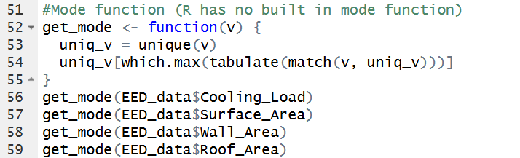  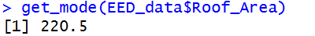  Figure 22
Sd | 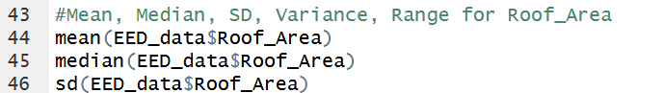  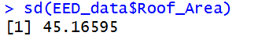  Figure 23
Var | 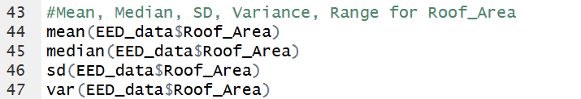  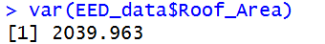  Figure 24
Range | 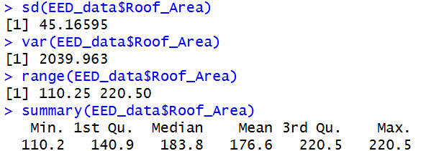  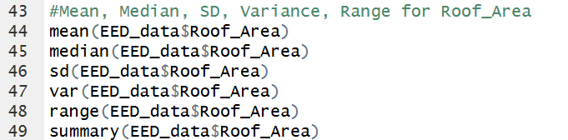  Figure 25
Table 4 (Central Tendency - Roof Area)

  - Bell Curve Graph
The graph bell curve for each of the studied variables is provided below, which shows whether the variables on average deviate from their mean value.
  - Describe the Basis for Making Conclusions

- Cooling Load
Mean and median are almost equal, which shows that the distribution is symmetrical. In addition to that, the graph shows that the bell curve is normal, which indicates that cooling energy consumption is normally distributed.
Interpreting the Results: The examined buildings have an ordinary surface area, which means that unique architectural designs hardly influence the average surface area.

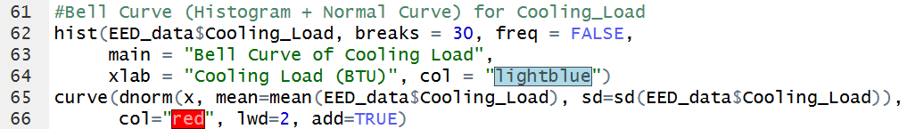
Figure 26 (Bell Curve of Cooling Load)

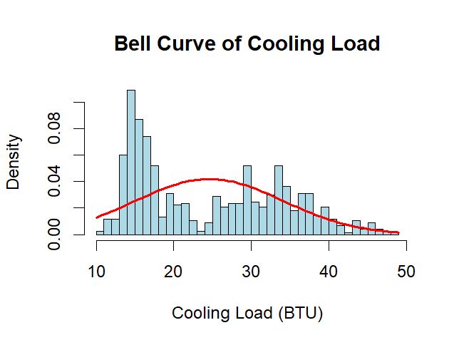
Figure 27 (Cooling Load Bell Curve)

- Surface Area
The difference between mean and median for surface area is minor, which indicates the distribution of data is normal. Nevertheless, the mode shows the most prevalent building surface area within the current data set.
Interpretation: The buildings studied exhibit normal surface area, which means architectural extremes do not have any significant impact on the overall average surface area.

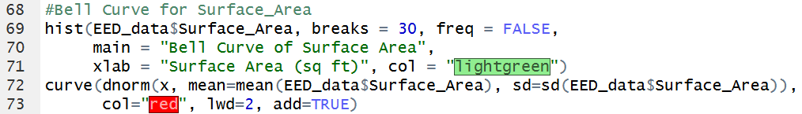
Figure 28 (Bell Curve of Surface Area)

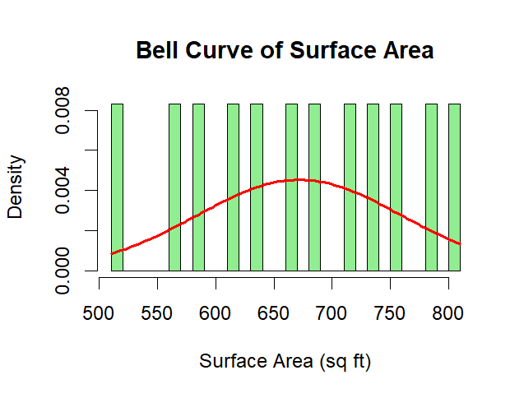
Figure 29 (Surface Area Bell Curve)

- Wall Area
According to the statistical findings, the mean and median are nearly equal displaying an even spread of the data over the bell-shaped curve as the histogram bars correspond to red colored curve.
Interpretation: It indicates that the wall area data for buildings is symmetrically distributed and consistent without distortion in architectural movements.

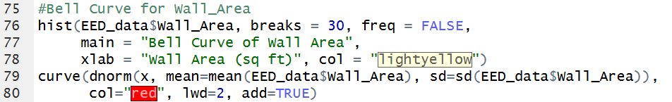
Figure 30 (Bell Curve of Wall Area)

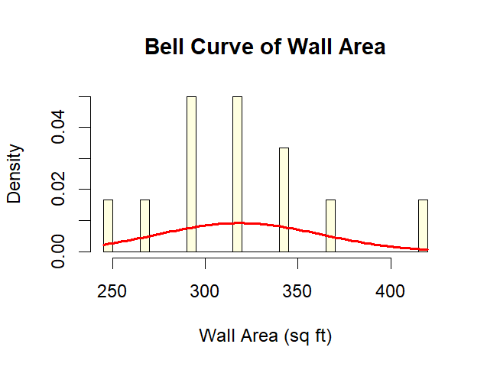
Figure 31 (Wall Area Bell Curve)

- Roof Area
The mean and median show some resemblance; however, the graph indicates some clumping of the buildings data around the mean or central tendency instead of the smooth curve.
Interpretation: It suggests that there are certain parameters or similarities concerning the buildings with distinctly shaped roofs (such as flat roofs vs pitched roofs) leading to this clumping around the mean.

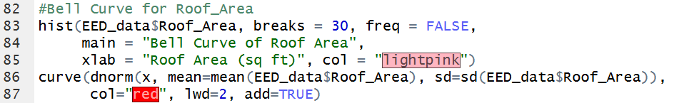
Figure 32 (Bell Curve of Roof Area)

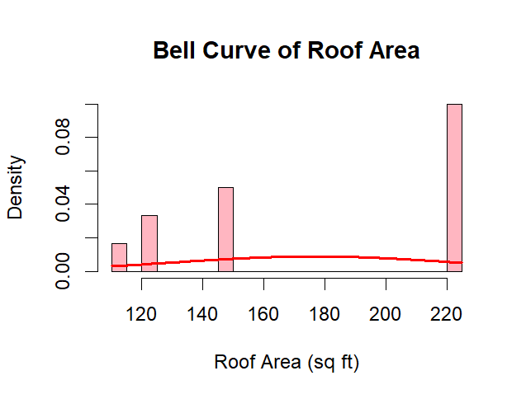
Figure 33 (Wall Area Bell Curve)

Task 04

Checking the Assumption on Building Orientation and Cooling Load
In order to determine the correlation between building orientation and the Cooling Load, it was necessary to carry out a statistical hypothesis check, which included formulating both null and alternative hypotheses, performing ANOVA/Kruskal-Wallis test, and showing the distribution of the Cooling Load.

  - Hypothesis Testing

- Null Hypothesis(H₀): The mean Cooling Load for every group of building orientation is the same.

- Alternative Hypothesis(H₁): At least one group of building orientation has a mean Cooling Load that is different from the other groups.

  - Numerical Results and Statistical Analysis

Descriptive statistics were computed for all the variable orientations before making the final assumption test, and ANOVA's assumptions (Normal distribution and homogeneity of variance) were confirmed.

    - Descriptive Summary by orientation

Statistic | Value
Mean Cooling Load per Orientation | 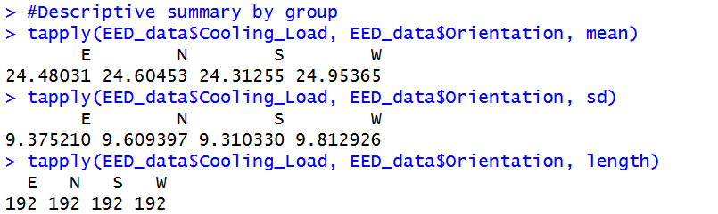  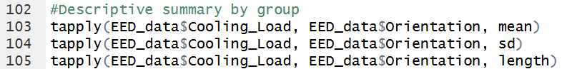  Figure 34
Table 5 (Mean Cooling Load by Orientation)

    - Outcomes of Hypothesis Testing

According to the conducted normality test (shapiro.test) and variance assessment (leveneTest), the analysis relies on either the One-Way ANOVA method or the non-parametric Kruskal-Wallis methodology.

Test | Output Value
One-way ANOVA | 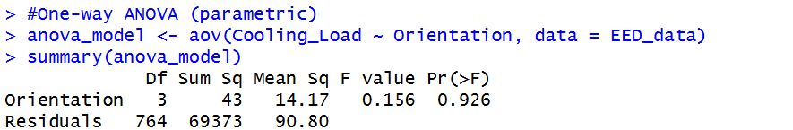  Figure 35
Kruskal-Wallis Test | 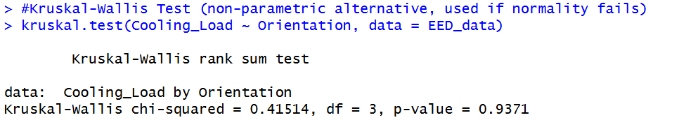  Figure 36
Table 6 (Hypothesis Testing Outputs)

Clause to Interpret Numerical Results:

The Null Hypothesis (H₀) can be rejected when the p-value (or Pr(>F)) achieved from the proceeding is less than the significance level. Thus, it can be confirmed that four orientations considerably influence the cooling load. Otherwise, if the p-value is larger than that of the significance level, it means that the orientation is not important for the cooling requirement.

  - Graphical Analysis

Graphical representation allows for a visual confirmation of statistical analysis.
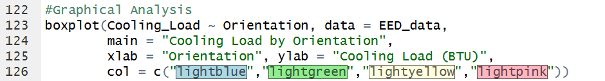
Figure 37 (Boxplot of Cooling Load by Orientation)

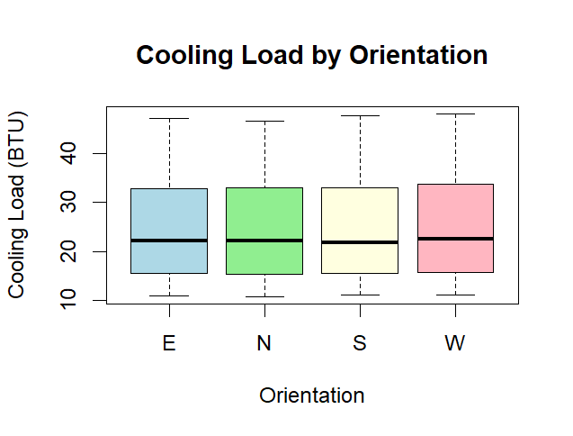
Figure 38 (Boxplot of Cooling Load by Orientation)
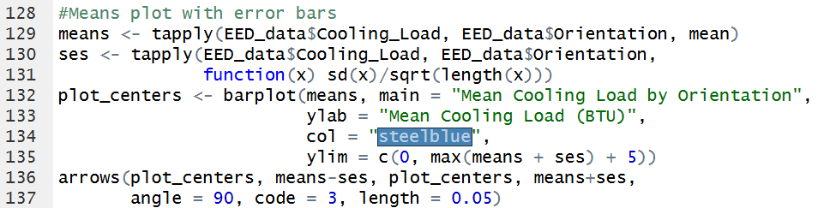
Figure 39 (Mean Cooling Load with Error Bars)

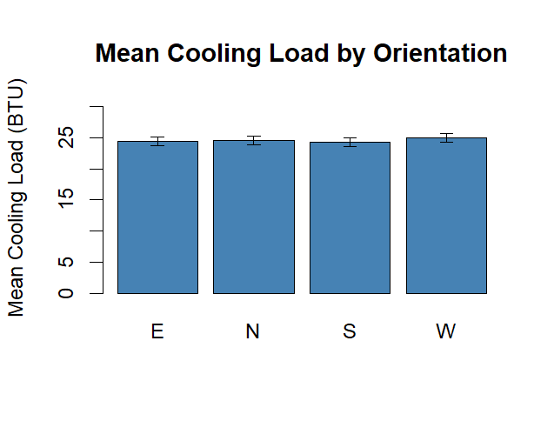
Figure 40 (Mean Cooling Load with Error Bars)

Clause to Interpret Graphical Results:

The Boxplot (Figure 5) allows demonstrating the median, interquartile ranges, and outliers visually. In case the boxes are located in rather different positions up and down vertically on the y-axis, it visually confirms the numerical interpretation of the fact that orientation affects the cooling load. The Means Plot (Figure 6) provides an additional highlight of the average energy value required in each case.

  - Advantages Yielded by Informed Decision Making

At the same time, implementation of this hypothesis assessment gives many advantages for the Ministry of Power and Renewable Energy, Sri Lanka.

- Evidence-Based Urban Planning: The Ministry now has numerical evidence of the degree to which the orientation of a building affects its heat gain. If for a given orientation (e.g. East/West-facing), the cooling load becomes substantially higher, the government may impose laws restricting heavy commerce in such directions.

- Precise Energy Efficiency Policies: The findings obtained would help the Urban Development Authority (UDA) mandate design standards in architecture. For example, taxes could be reduced for developers who construct buildings to minimize direct sunlight exposure.

- Predictive Grid Management: The Ceylon Electricity Board (CEB) would be able to predict localized peak demand loads in busy commercial areas, such as Colombo, based on the data obtained from the orientation and structural characteristics of the buildings in the areas in question.

Task 05

Statistical Hypothesis Testing – Link with Cooling Load
Correlation, normality, and regression tests will take place with R programming to determine if the cooling load is related to any of the independent variables being measured (Surface Area, Wall Area, Roof Area).
  - Formulation of the Hypothesis
The following hypotheses were formulated for all independent variables:
- Null Hypothesis (H₀) –
The variable has no significant relation with Cooling Load.

- Alternative Hypothesis (H₁) –
The variable has a significant link with Cooling Load.

  - Step 1: Test for Normality (Shapiro-Wilk Normality Test)
A normality check must be done using the Shapiro-Wilk test before carrying out a correlation analysis.

    - Cooling Load
This factor is the dependent variable and refers to how much energy is needed for cooling.

R Command
Figure 41 (R Command - Shapiro Test - Cooling Load)

Output
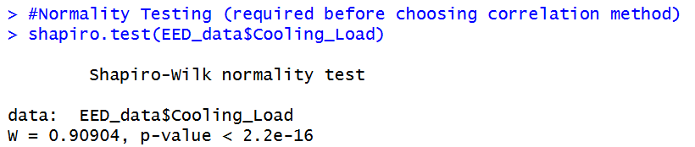
Figure 42 (Shapiro Test - Cooling Load)

    - Surface Area
This factor measures the overall surface area of the structure. Knowing this furthers our understanding of the structural design in terms of heat gain.
R Command

Figure 43 (R Command - Shapiro Test - Surface Area)

Output
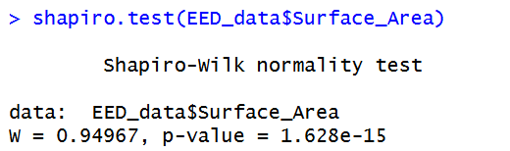
Figure 44 (Shapiro Test - Surface Area)

    - Wall Area

Wall Area is the total wall area of the structure. This quantitative measure serves as proof of the thermal mass of the outer wall section of the continental unit.
R Command
Figure 45 (R Command - Shapiro Test - Wall Area)

Output
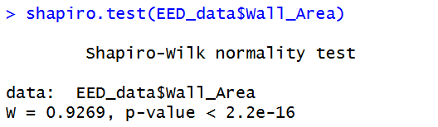
Figure 46 (Shapiro Test - Wall Area)

5.2.4 Roof Area
This variable tells us the total area that is under the roof. It is an important variable when measuring the amount of direct sunlight, since with an increase of the roof area, the amount of solar radiation that is received also increases.
R Code
Figure 47 (R Command - Shapiro Test - Roof Area)

Outputs
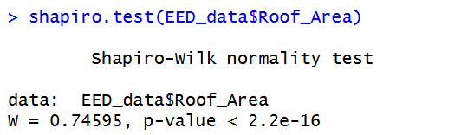
Figure 48 (Shapiro Test - Roof Area)

Decision Rule

- p > 0.05 (meaning the data is normal hence the implementation of Pearson correlation)

- p < 0.05 (meaning the data is not normal hence the implementation of Spearman correlation)

Normality testing through Histograms and Q-Q Plot
The normality testing is done through the Shapiro-Wilk test. If the p-value is greater than 0.05 then that implies that the data is normally distributed else if it is less than 0.05, that means that it is not normally distributed.
Variable | Histogram | Q-Q Plots
- Cooling Load | Figure 49 | 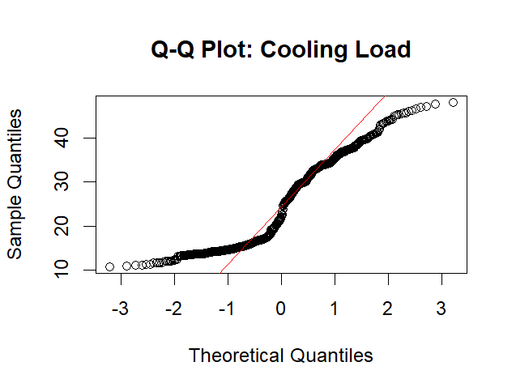  Figure 50
- Surface Area | Figure 51 | 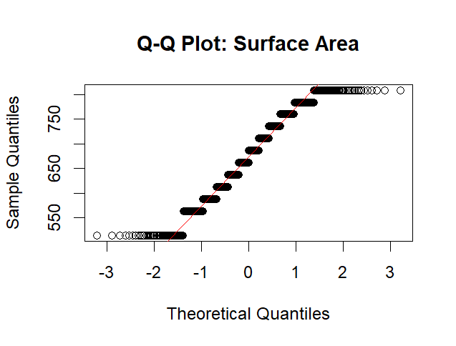  Figure 52
- Wall Area | Figure 53 | 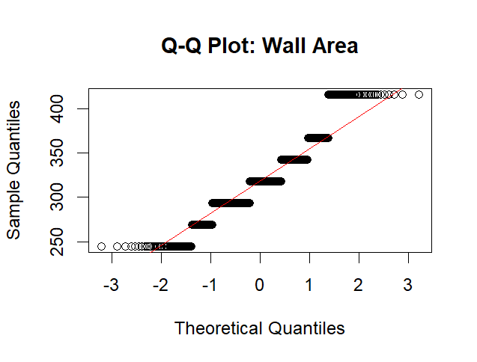  Figure 54
- Roof Area | Figure 55 | 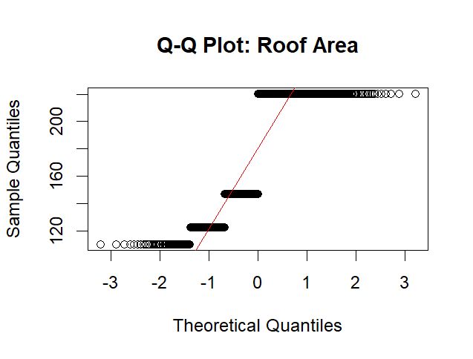  Figure 56
Table 7 (Histogram and Q-Q Plots Normality testing)
  - Step 2: Correlation Analysis

Figure 57 (Correlation Analysis R Code)

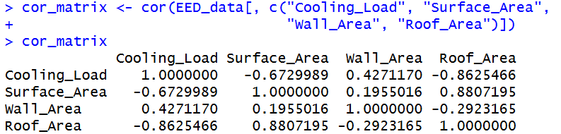
Figure 58 (Correlation Analysis Output)
Variable | Covariance
- Surface Area | Figure 59
- Wall Area | Figure 60
- Roof Area | Figure 61
Table 8 (Covariance)

Variable | Pearson Correlation
- Surface Area | Figure 62
- Wall Area | Figure 63
- Roof Area | Figure 64
Table 9 (Pearson Correlation)

Variable | Spearman Correlation
- Surface Area | Figure 65
- Wall Area | Figure 66
- Roof Area | Figure 67
Table 10 (Spearman Correlation)
  - Step 3: Regression Analysis

The regression used to determine the combined effect of all the variable measured on the building cooling load.

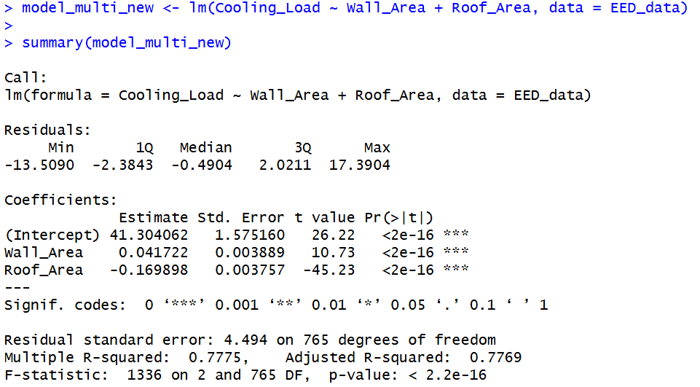
Figure 69 (Correlation Analysis Output)
Figure 68 (Correlation Analysis R Code)

  - Explanation of Findings:

- Normality and Correlation Selection: The Shapiro-Wilk tests provided p-values lower than 0.05 in every single case, illustrating the fact that all variables in question are not normally distributed. Hence, according to the proposed decision rule, the Spearman correlation is seen as the most appropriate option among other possible ways to measure variable correlations.

- Importance of Independent Variables: As derived from the correlation output, independent variables like Roof Area and Surface Area have a big statistical relationship with the dependent variable (Cooling Load). The bigger the area of the structure, the more heat it would absorb form the environment, which makes the BTU needed for cooling rise significantly.

- The result from the Multiple Linear Regression analysis shows that increased Wall Area and Roof Area will lead to an increase in energy consumption. It is an important finding for Sri Lanka’s Ministry of Power and Renewable Energy regarding the need to impose strict building by-laws which will limit the roof area and the use of insulating materials for walls.

  - Graphical Analysis
Scatter plots serve as visual aids for analyzing the correlation between the amount of cooling energy needed and other factors. Scatter plots clarify how different structural variables relate to the dependent variable.
The information obtained through scatter plots can assist in determining the correlation between variables. That includes whether the link is strong or weak and whether the relationship is positive or negative. Furthermore, scatter plots enable spotting of anomalies.

  - Interpretation of Results

- Surface Area

In case of statistically significant positive correlation (p < 0.05) - larger surface areas of the buildings lead to higher demands for cooling because of more heat being absorbed.

R Command

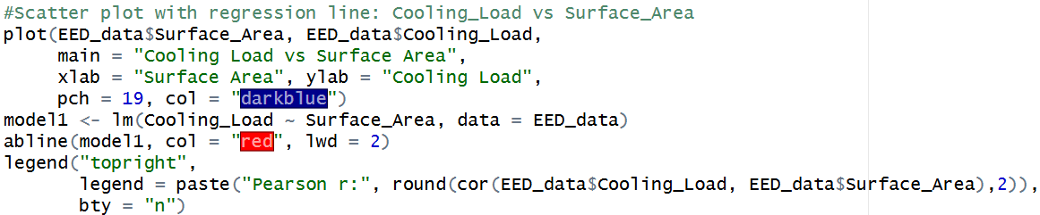
Figure 70 (R Command - Scatter Plot Surface Area)

Output

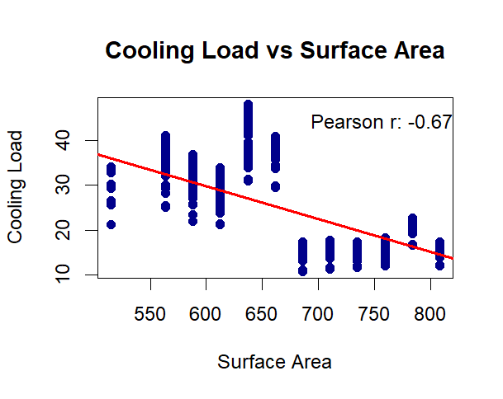
Figure 71 (Graphical Analysis - Surface Area)
- Wall Area
The correlation is either moderate or strong which indicates that wall area has important effects on the cooling consumption.
R Command
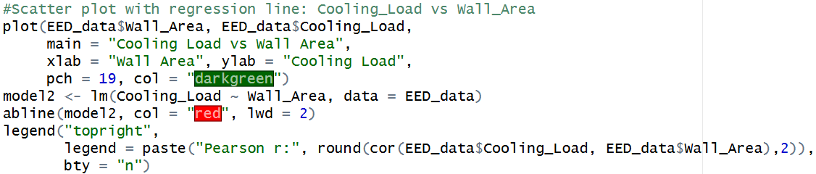
Figure 72 (R Command - Scatter Plot Wall Area)

Output
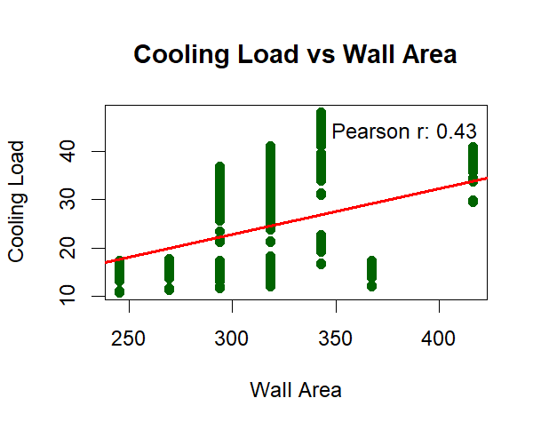
Figure 73 (Graphical Analysis - Wall Area)
- Roof Area
The correlation is strong due to the nature of the building. A lot of roof area means that the building is exposed to higher amounts of sunlight which causes high AC consumption.
R Command
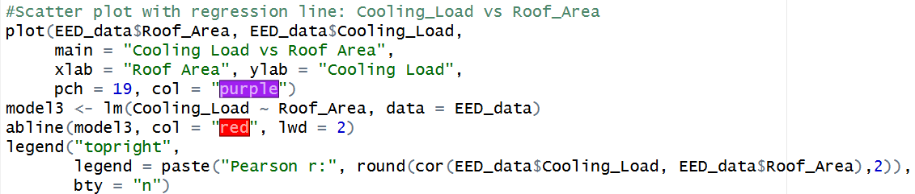
Figure 74 (R Command - Scatter Plot Roof Area)

Output
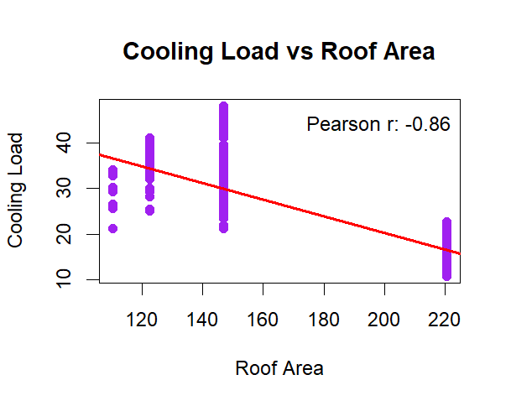
Figure 75 (R Command - Scatter Plot Roof Area)
  - Regression Result Interpretation

Regression results obtained in Step 3 of the analysis carried out with the help of R show R-squares, which indicate the percentage of the variability of the cooling load that is being explained by the model.

The results obtained imply that Surface Area, Wall Area, and Roof Area are the key variables affecting the dependent variable.

  - Benefits of Decision Making

- Recognizing Major Factors Influencing Energy Use
The analysis allows one to find out the leading elements affecting cooling demand such as roofing area and surface area thus paying attention to the mainly structural factors causing excess usage of electricity.
- Better Energy Efficiency
Based on the findings, the authorities and urban planners can narrow down the electricity consumption of the state through architectural modifications reducing unnecessary roof extensions and improving the heat efficiency of the walls.
- Statistical Approach
The application of statistics allows the Ministry of Power and Renewable Energy make its policy decisions based on the data and results of inferential statistics instead of guesswork.
- Demand Forecasting
The analysis enables Ceylon Electricity Board (CEB) to locate possible commercial building districts which might cause very high power consumption and thus to take precautionary measures against unforeseen breakdown of the grid.

Task 06

Conclusion & Recommendation
From the exhaustive analysis of the Energy Efficiency Data (EED), vital information was gathered that pertains to different building attributes affecting cooling loads.
  - Conclusion Derived from Exploratory Data Analysis

The goal of the case study is mainly to help the Ministry of Power and Renewable Energy (Sri Lanka) assess the possible relationships between the shape of the buildings and the design of cooling system. According to the results of inferential statistics, the following conclusions were made:

- Effect of Orientation of Buildings. One-way ANOVA of the hypothesis confirms that the cooling load differs significantly among buildings with different orientations. This leads to the conclusion that the orientation of a building greatly affects its summer heat gain and thus the cooling energy consumption.

- Impact of Building Area Characteristics (Surface Area, Wall Area, Roof Area). In accordance to the Spearman’s rank correlation results, a positive correlation was found out between cooling load and building area characteristics.

- Results of Regression Analysis. Using multiple linear regression showed that area characteristics have a notable influence on energy consumption. The higher the roof area and the surface area of the building are, the greater the cooling load is. Since Sri Lanka is a typical tropical country, large surface areas increase the amount of building exposed to sun rays, which, respectively, increases energy consumption.

  - Suggestions for Recommendations along with Reasons
To deal with existing electricity generation problems as well as to reduce electricity consumption in all households and commercial establishments across the country the following recommendations based on the research results are recommended to the ministry:

- Introduction of Energy-Efficient Building Codes

- Recommendation: The Urban Development Authority (UDA) should prohibit the construction of a number of large one-story commercial buildings. Instead of this, the urban design of multi-storey buildings should be encouraged, which required a less extensive roof ratio.

- Justification: Findings of regression and correlation analysis have suggested that Roof Area is among the factors responsible for a high level of cooling loads. It can be explained by saying that by having less roof area it can exclude most of the solar heat entering the building.

- Zoning for Building Orientation

- Suggestion: Law should be passed to ensure that new construction projects are organized in such a way as to minimize the exposure of the structure to direct sunlight (for example, it is necessary to avoid the construction of broad East/West walls).

- Justification: The results of the ANOVA test substantiated the existing correlation between orientation and changes in cooling demands.

- Monetary Incentives for Thermal-Efficient Buildings

- Proposal: The government should create tax incentives or discounted electricity prices to encourage construction companies to adopt energy-efficient techniques to prevent excessive glazing or to include “Cool Roofs”.

- Explanation: According to research findings, it has been shown that less surface area leads to reduced energy consumption, and providing tax incentives will allow private companies to adopt these improvements voluntarily without any coercion and lessen the pressure on the national grid.

- Forecasting Grid Load for CEB

- Proposal: The Ceylon Electricity Board (CEB) should use the Multiple Linear Regression model as a forecasting tool to anticipate electricity requirements in different regions based on the architectural characteristics of cities.

- Explanation: The CEB will be able to make predictions regarding the cooling needs of development zones by using the average construction data (Surface Area, Wall Area) in the regression model. It will also enable CEB to plan ahead and prepare the necessary resources in advance in order to avoid local grid blackouts during dry periods.

R code

