Git Branching Guide
Team workflow & branch rules — for all 5 members

Branch Structure at a Glance
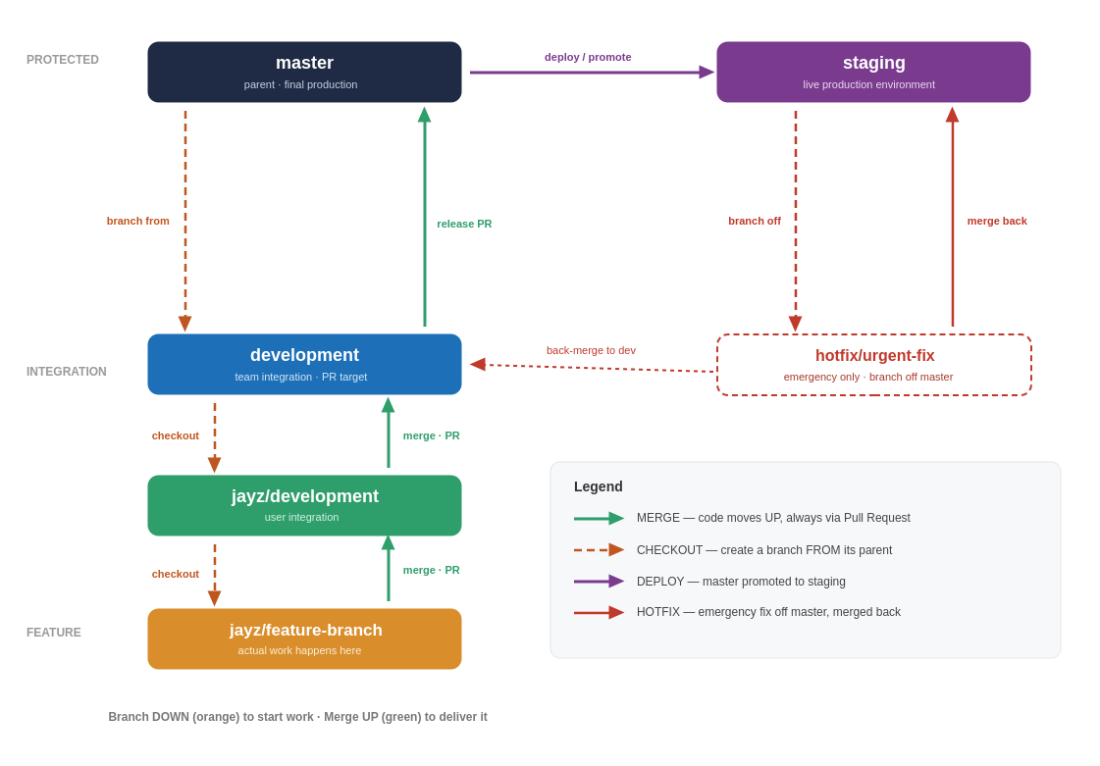
Green = merge up (PR). Orange dashed = checkout / branch from parent. Purple = deploy. Red = hotfix.

The Branches
Branch | Role | Rules
master | Parent / final production | Single source of truth. Never commit directly. Only updated through reviewed merges.
staging | Live production env | The deployed environment that acts as production. Receives releases promoted from master.
development | Integration | All child development branches merge here via Pull Request. Shared team integration branch.
jayz/development | User integration | Jayz's personal integration branch. All of Jayz's feature branches merge here before going up to development.
jayz/feature-branch | Feature | Where actual work happens. One per task/feature. Named jayz/<feature-name>.

How Code Flows

Upward — work being merged in (via PR)
- Create a feature branch off your user branch: jayz/feature-branch.
- Do the work, commit, push.
- Open a PR: jayz/feature-branch → jayz/development.
- When your user branch is ready, open a PR: jayz/development → development.
- development is the team integration point — everyone's work meets here.

Downward — releasing to production
- Tested code in development is merged up to master (the final production parent).
- master is then promoted / deployed to staging, the live production environment.

Checkout Direction (Creating Branches)
Always create a new branch FROM its parent so you start with the latest stable code. You branch downward.
New branch | Create FROM | Command
jayz/development | development | git checkout development
jayz/feature-x | jayz/development | git checkout jayz/development
Typical commands to start a feature:
git checkout jayz/development
git pull # get the latest
git checkout -b jayz/feature-x # branch off it

Merge Direction (Delivering Work)
Code only ever moves UPWARD, and always through a Pull Request into the listed target. Never merge a parent's branch "sideways" into another member's branch.
From (source) | Into (target) | Via
jayz/feature-x | jayz/development | Pull Request
jayz/development | development | Pull Request + review
development | master | Release PR + review
master | staging | Deploy / promote
hotfix/* | master | Emergency PR (then back-merge to development)
Keeping your branch up to date:
Before opening a PR, pull the latest parent into your branch so your PR is clean and conflicts surface early on your side, not in the shared branch:
git checkout jayz/feature-x
git merge jayz/development # or: git rebase jayz/development

Resolving Merge Conflicts
A conflict happens when two branches change the same lines. Git pauses and marks the file. Resolve it on YOUR branch before you push — never resolve conflicts directly on a protected branch.

Step by step
- Update your branch: git pull (or git merge jayz/development).
- Git lists the conflicted files. Open each one.
- Find the markers <<<<<<<, =======, >>>>>>> — the part above ======= is your code (HEAD), below is the incoming code.
- Edit the file to the correct final result and delete all three marker lines.
- Stage the resolved files: git add <file>.
- Complete it: git commit (for a merge) or git rebase --continue (for a rebase).
- Push, then verify your PR shows no remaining conflicts.

What a conflict looks like
<<<<<<< HEAD
const timeout = 30; // your change
=======
const timeout = 60; // incoming change
>>>>>>> jayz/development

Conflict etiquette for the team
- If unsure which side is right, ask the author of the other change — don't just pick one.
- Pull / merge often so conflicts stay small.
- After resolving, re-run the app/tests before pushing.
- Abort and start over safely with git merge --abort or git rebase --abort if it gets messy.
- Never force-push (git push --force) to a shared branch; only to your own feature branch, and prefer --force-with-lease.

Hotfixes (Emergencies Only)
When something is broken in production and can't wait for the normal flow, branch directly off master, fix, and merge straight back — then back-merge so the fix isn't lost.
- Branch off master: git checkout master, git pull, git checkout -b hotfix/urgent-fix.
- Make the smallest possible fix and open a PR straight into master.
- After review, merge to master and deploy/promote to staging.
- Back-merge the fix into development so it also reaches everyone's branches and isn't overwritten by the next release.
Use hotfixes sparingly — they bypass the normal review path, so keep them tiny and well-described.

Pull Request Rules & Gates
Every merge into a shared branch goes through a PR. Before a PR can be merged:
- At least one teammate has reviewed and approved it.
- CI / automated checks (build + tests) are green.
- There are no unresolved conflicts with the target branch.
- The PR title and description explain what changed and why.
- The branch is up to date with its target (merge or rebase the parent in first).
Tip: keep PRs small. A 200-line PR gets reviewed well; a 2,000-line PR gets rubber-stamped.

Switching Branches With Unfinished Work
If you need to switch branches but aren't ready to commit, stash your changes instead of committing half-done work:
git stash # set work aside
git checkout development
git stash pop # bring it back later

Command Cheat Sheet
Goal | Command
See current branch & status | git status
Start a feature off your user branch | git checkout jayz/development && git pull && git checkout -b jayz/feature-x
Save work in progress | git add . && git commit -m "message"
Push a new branch | git push -u origin jayz/feature-x
Update branch with latest parent | git merge jayz/development
Abort a messy merge / rebase | git merge --abort / git rebase --abort
Discard local changes in a file | git checkout -- <file>
Delete a merged local branch | git branch -d jayz/feature-x

Naming Convention
Each member follows the same pattern, replacing jayz with their own username:
- <user>/development — personal integration branch
- <user>/<feature-name> — one branch per feature, e.g. jayz/login-api

Team Rules
- Never push directly to master, staging, or development — always use a PR.
- Keep feature branches small and short-lived; merge often to avoid conflicts.
- Pull the latest development before starting a new feature branch.
- Every PR needs at least one reviewer before merge.
- Write clear commit messages and PR descriptions.
- Delete feature branches after they're merged.
- Don't merge a parent branch sideways into a teammate's branch — code only flows up via PR.
- Commit small and often; one logical change per commit.

Quick reference: feature → user/development → development → master → staging

