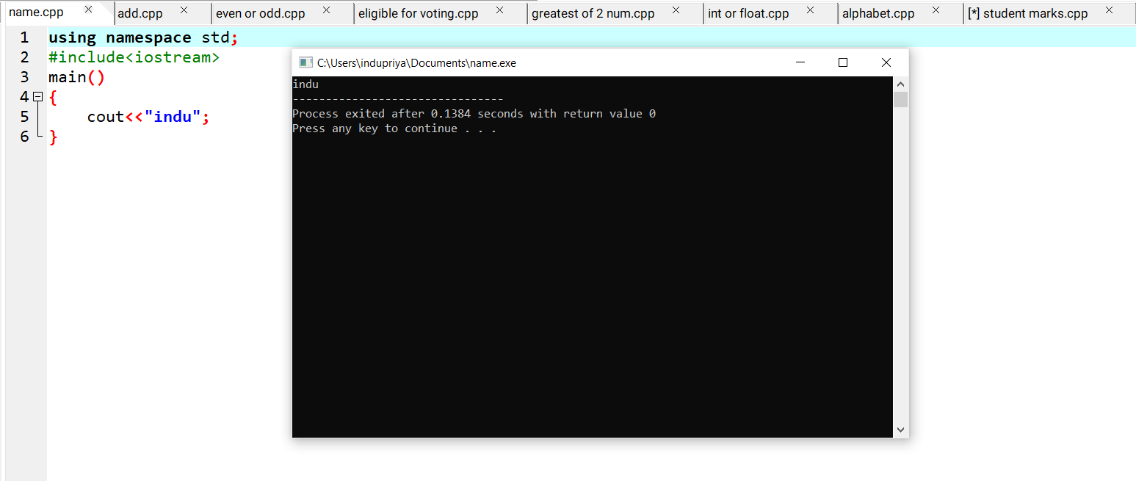1.Write a C++ program to display name.

2.Write a C++ program to find the sum of two numbers

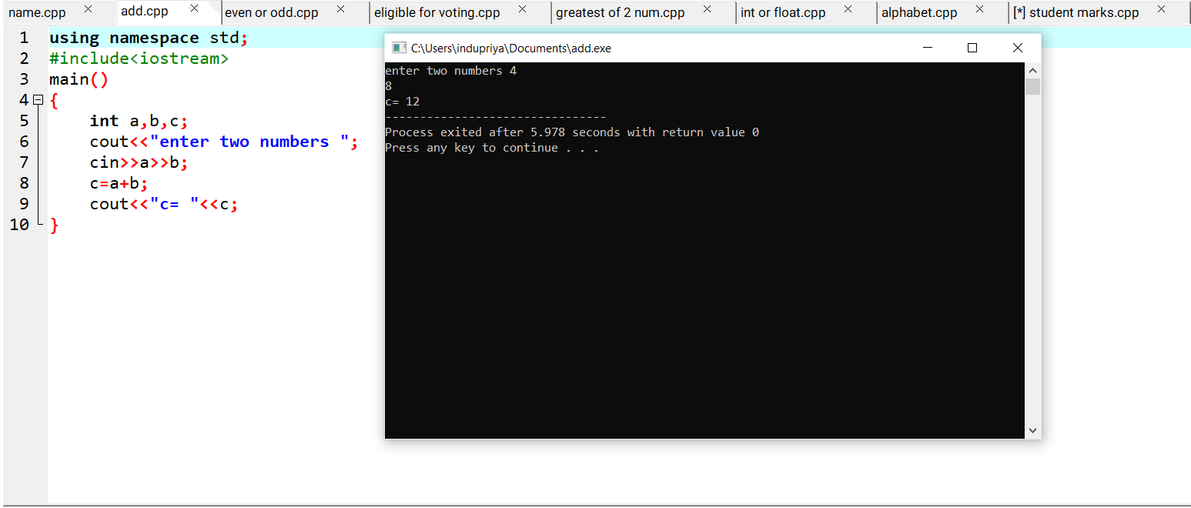

3.Write a C++ program for to find the biggest of two numbers.

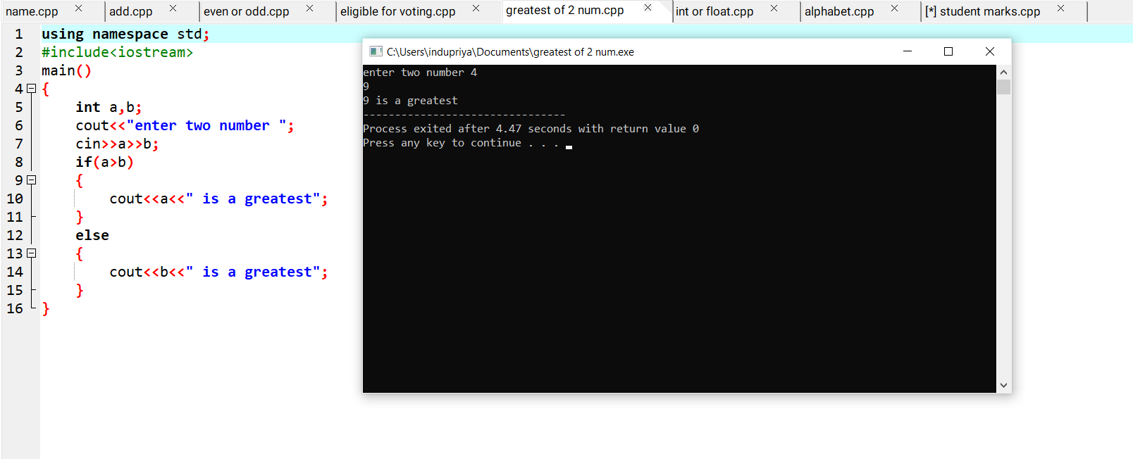

4.Write a C++ program to find the given number is even or odd.

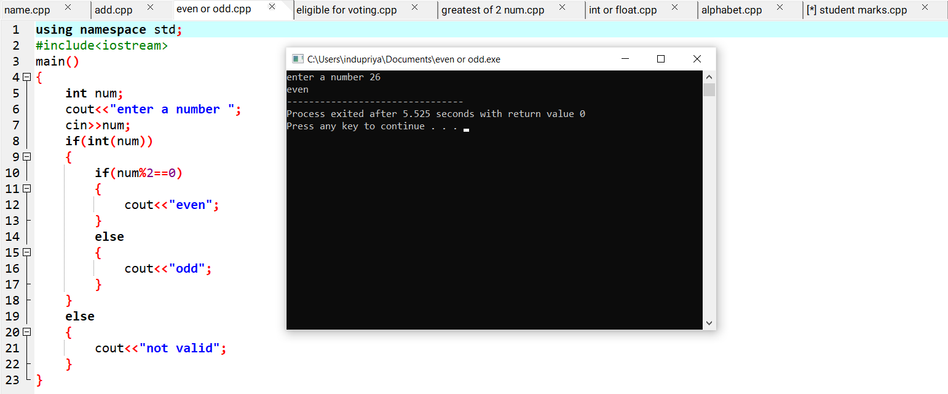

5.Write a C++ program to find the given person is eligible or not.

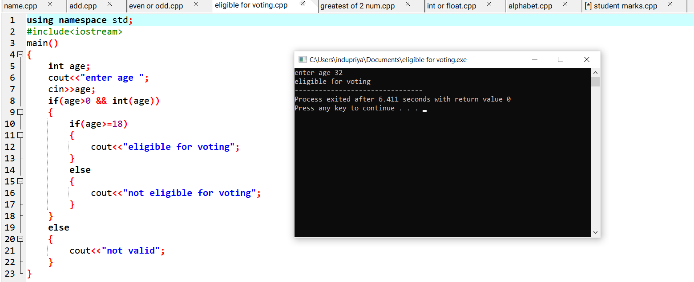

6.Write a C++ program to find the given value is alphabet or not.

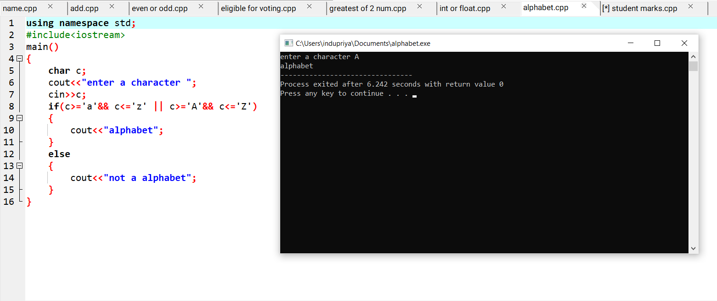

7.Write a C++ program to find the number is integer or not.

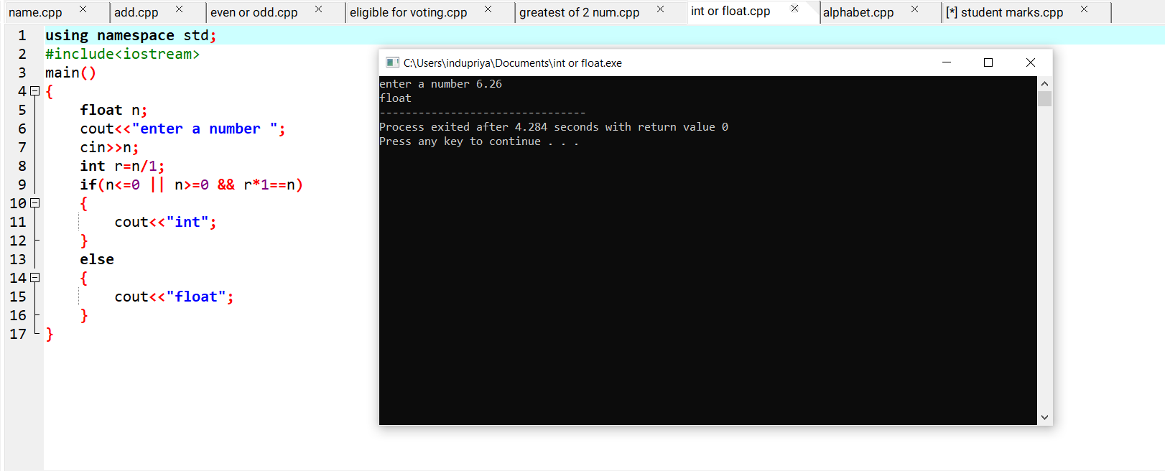

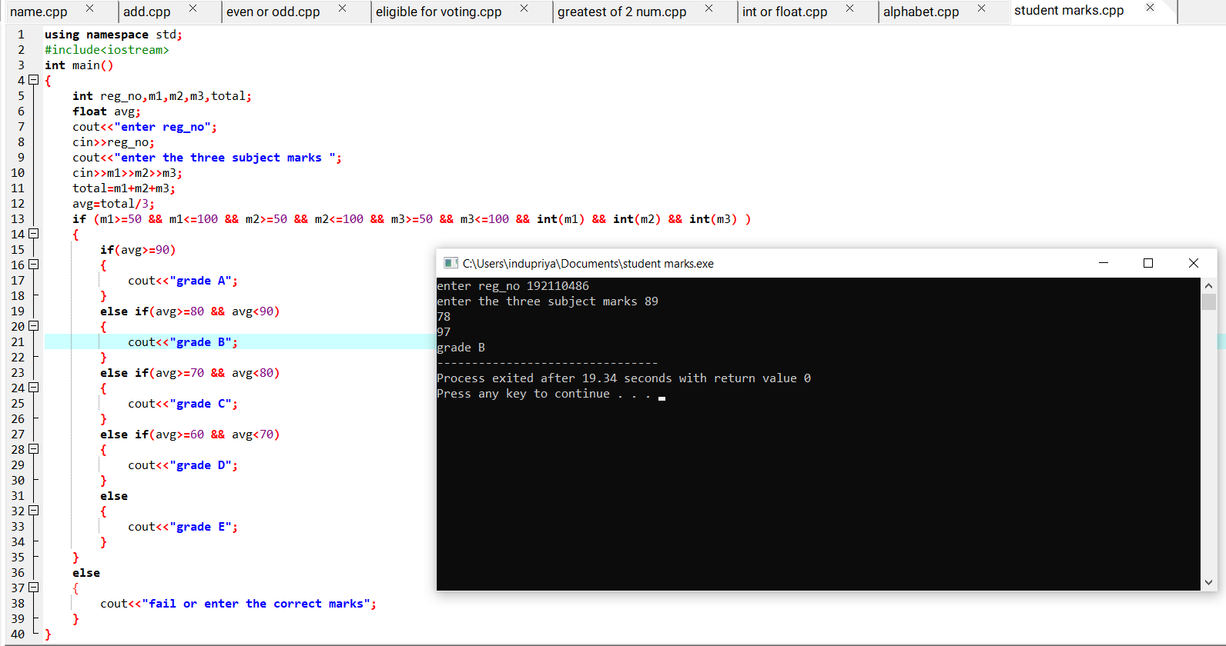8.Write a C++ program for to print the student reports the following fields reg_no,name,m1,m2,m3.