1.write a C++ program to add two numbers.

Condition: Number should be only integers.

Program:

using namespace std;

#include<iostream>

main()

{

int a,b;

cout<<"enter a and b values";

cin>>a>>b;

if(int(a) && int(b))

{

cout<<a+b;

}

else

{

cout<<"not valid";

}

}

Output:

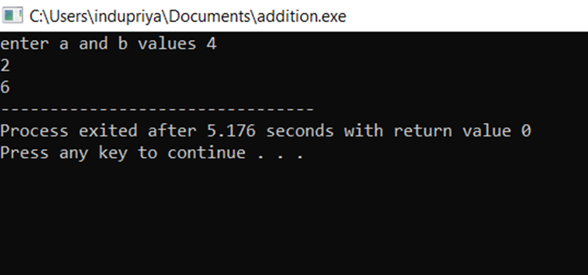

2. write a C++ program to subtract two numbers.

Condition: Number should be only integers.

Program:

using namespace std;

#include<iostream>

main()

{

int a,b;

cout<<"enter a and b values";

cin>>a>>b;

if(int(a) && int(b))

{

cout<<a-b;

}

else

{

cout<<"not valid";

}

}

Output:

