1.write a C++ program to find that given person is eligible for voting or not.

Conditions:

The value should be integer.

The number should be positive number.

Program:

using namespace std;

#include<iostream>

main()

{

int age;

cout<<"enter age ";

cin>>age;

if(age>0 && int(age))

{

if(age>=18)

{

cout<<"eligible for voting";

}

else

{

cout<<"not eligible for voting";

}

}

else

{

cout<<"not valid";

}

}

Output:

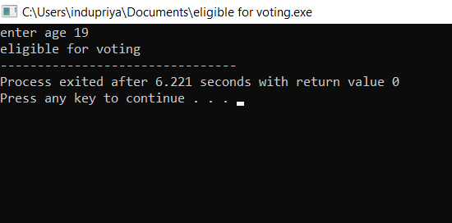

2.write a c++ program to show that the given number is even or odd.

Condition : Number should be integer.

Program :

using namespace std;

#include<iostream>

main()

{

int num;

cout<<"enter a number";

cin>>num;

if(int(num))

{

if(num%2==0)

{

cout<<"even";

}

else

{

cout<<"odd";

}

}

else

{

cout<<"not valid";

}

}

Output:

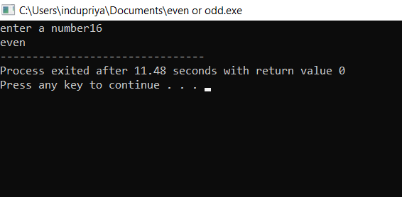

3.write a C++ program to find the area of circle and circumference of a circle.

Program:

using namespace std;

#include<iostream>

main()

{

float r;

cout<<"enter radius";

cin>>r;

int exp;

cout<<"enter the choice";

cin>>exp;

switch(exp)

{

case 1:

cout<<"area of the circle"<<3.14\*r\*r;

break;

case 2:

cout<<"circumference"<<2\*3.14\*r;

break;

default:

cout<<"enter the correct choice";

}

}

Output:

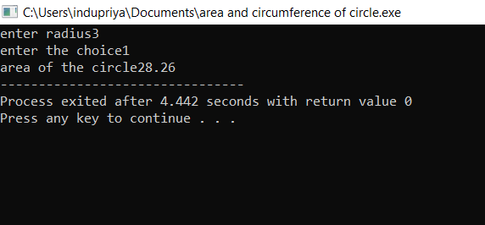

4.Write a C++ program to find the greatest among three values.

Conditions:

1.a= 5 , b=7,c= -9

2.a=0.0 1 , b=0.09,c=0.03

3.a=-9, b=-7, c= -10

4.a=x, b=y, c=z

Program:

using namespace std;

#include<iostream>

main()

{

float a,b,c;

cout<<"enter a,b and c values ";

cin>>a>>b>>c;

if(float(a) && float(b) && float(c))

{

if(a>b && a>c)

{

cout<<"a is greatest";

}

else if(b>c && b>a)

{

cout<<"b is greatest";

}

else

{

cout<<"c is greatest";

}

}

else

{

cout<<"not valid";

}

}

}

Output:

1.

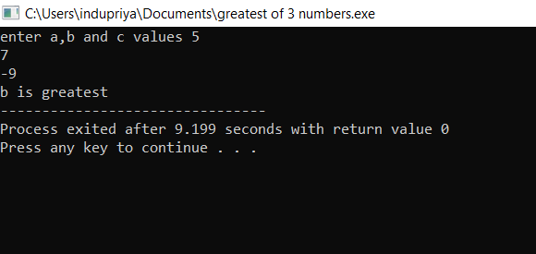

2.

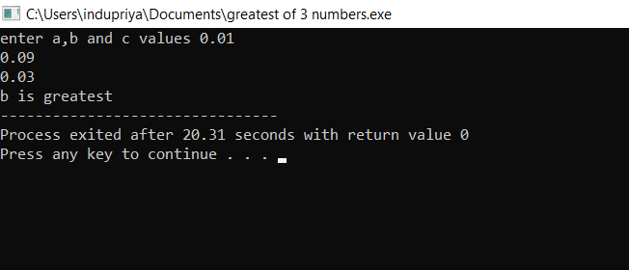

3.

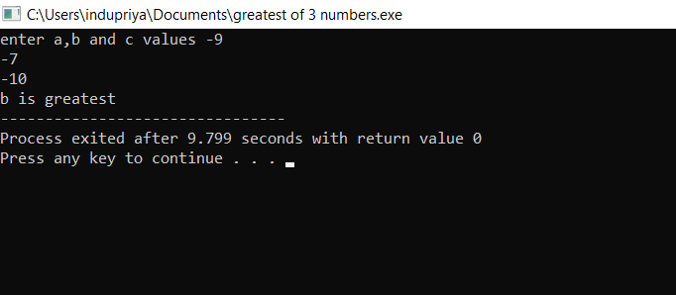

4.

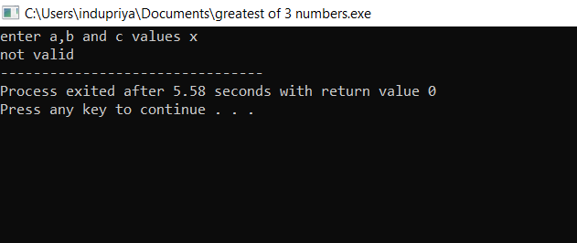

5. Write the C ++ program for student report read three marks and calculate the grade?

Conditions:

1. m1=80, m2=60, m3=90

2. m1=-10, m2=20, m3=100

3. m1=150, m2=10, m3=100

4. m1=80, m2=30, m3=60

5. m1=x, m2=y, m3=z

Program:

using namespace std;

#include<iostream>

int main()

{

int m1,m2,m3;

float total,avg;

cout<<"enter the three subject marks";

cin>>m1>>m2>>m3;

total=m1+m2+m3;

avg=total/3;

if (m1>=50 && m1<100 && m2>=50 && m2<100 && m3>=50 && m3<100 && int(m1) && int(m2) && int(m3) )

{

if(avg>=90)

{

cout<<"grade A";

}

else if(avg>=80 && avg<90)

{

cout<<"grase B";

}

else if(avg>=70 && avg<80)

{

cout<<"grade C";

}

else if(avg>=60 && avg<70)

{

cout<<"grade D";

}

else

{

cout<<"grade E";

}

}

else

{

cout<<"fail or enter the correct marks";

}

}

Output:

1.

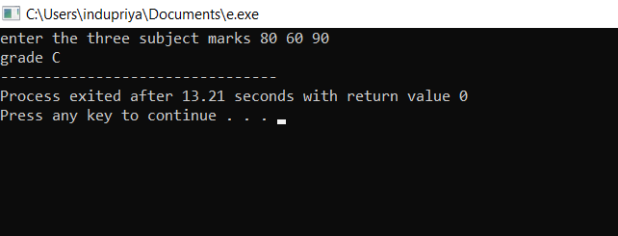

2.

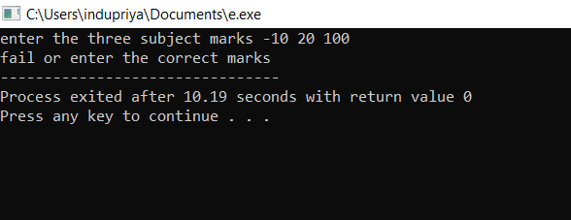

3.

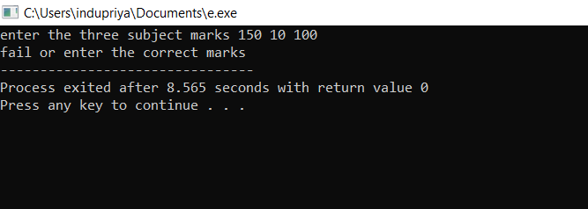

4.

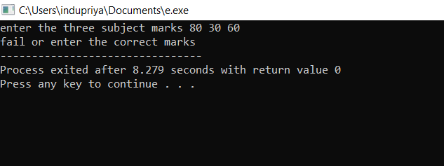

5.

