1.write a C++ program to sum of two numbers using class and object.

Program:

using namespace std;

#include<iostream>

class add

{

int x,y,z;

public:

void getdata();

void display();

};

void add::getdata()

{

cout<<"enter x and y values";

cin>>x>>y;

}

void add::display()

{

cout<<"sum of a and b numbers ";

z=x+y;

cout<<z;

}

int main()

{

add a;

a.getdata();

a.display();

}

Output:

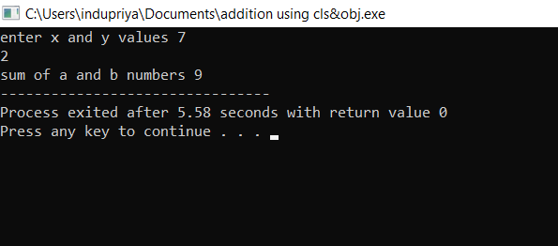

2.write a C++ program to calculate the volume of cone

using class and object.

Program:

using namespace std;

#include<iostream>

class vol

{

float R , H , Z;

public:

void getdata();

void display();

};

void vol::getdata()

{

cout<<"enter R and H values ";

cin>>R>>H;

}

void vol::display()

{

cout<<"volume of cone ";

Z=0.33\*3.14\*R\*R\*H;

cout<<Z;

}

int main()

{

vol a;

a.getdata();

a.display();

}

Output:

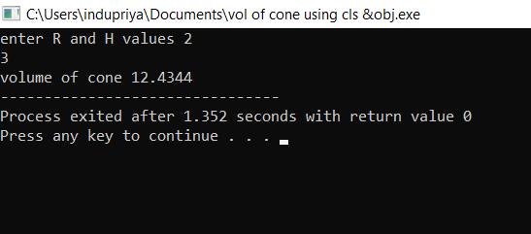

3.write a C++ program to calculate simple interest and compound interest using class and objects.

Program:

using namespace std;

#include<iostream>

#include<math.h>

class interest

{

double p,r,t,si,ci;

public:

void getdata();

void display();

};

void interest::getdata()

{

cout<<"enter the p,r and t values ";

cin>>p>>r>>t;

}

void interest :: display()

{

cout<<"simple interest ";

si=(p\*r\*t)/100;

cout<<si;

cout<<"compound interest ";

ci=p\*(pow((1+r/100),t));

cout<<ci;

}

main()

{

interest a;

a.getdata();

a.display();

}

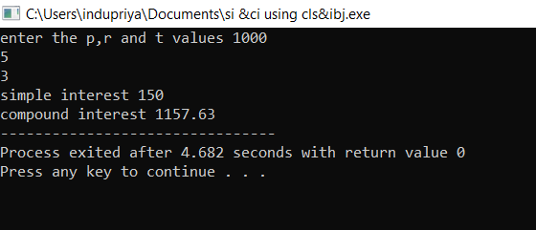Output:

4.write a C++ program to find the greatest among three numbers.

Program:

using namespace std;

#include<iostream>

class greatest

{

int a,b,c;

public:

void getdata();

void display();

};

void greatest::getdata()

{

cout<<"enter the a,b and c values: ";

cin>>a>>b>>c;

}

void greatest::display()

{

if(a>b && a>c)

{

cout<<"a is greatest number";

}

else if(b>a && b>c)

{

cout<<"b is greatest number";

}

else if(c>a && c>b)

{

cout<<"c is greatest number";

}

else

{

cout<<"enter the correct values";

}

}

int main()

{

greatest h;

h.getdata();

h.display();

}

Output:

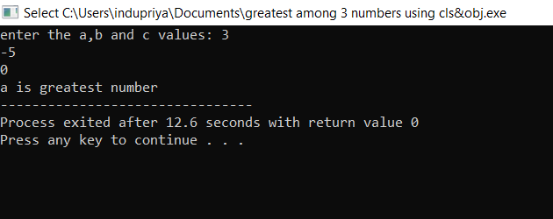

5.write a C++ program to find the area of rectangle using constructor.

Program:

using namespace std;

#include<iostream>

class rectangle

{

int l,b,a;

public:

rectangle();

rectangle(int,int);

};

rectangle::rectangle()

{

}

rectangle::rectangle(int l,int b)

{

cout<<"area of rectangle ";

a=l\*b;

cout<<a;

}

main()

{

rectangle myarea(10,20);

return 0;

}

Output:

