DAY-2

**9. Illustrate the concept of inter-process communication using shared memory with a C program.**

**PROGRAM:**

**OUTPUT:**

**10. Illustrate the concept of inter-process communication using message queue with a C program.**

**PROGRAM:**

**OUTPUT:**

**11. Illustrate the concept of multithreading using a C program.**

**PROGRAM:**

#include<stdio.h>

#include<stdlib.h>

#include<unistd.h>

#include<pthread.h>

void *myThreadFun(void *vargp)

{

sleep(1);

printf("Printing GeeksQuiz from Thread \n");

return NULL;

}

int main()

{

pthread_t thread_id;

printf("Before Thread\n");

pthread_create(&thread_id, NULL, myThreadFun, NULL);

pthread_join(thread_id, NULL);

printf("After Thread\n");

exit(0);

}

**OUTPUT:**

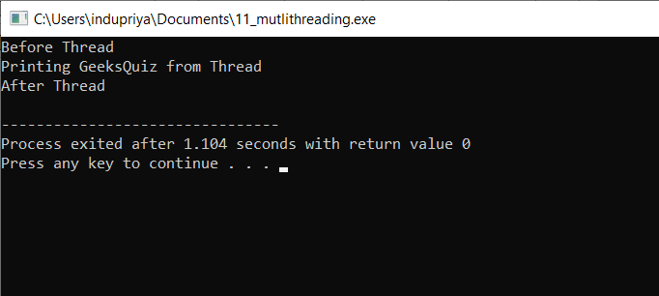

**12. Design a C program to simulate the concept of Dining-Philosophers problem.**

**PROGRAM:**

#include<stdio.h>

#include<stdlib.h>

#include<pthread.h>

#include<semaphore.h>

#include<unistd.h>

sem_t room;

sem_t chopstick[5];

void * philosopher(void *);

void eat(int);

int main()

{

int i,a[5];

pthread_t tid[5];

sem_init(&room,0,4);

for(i=0;i<5;i++)

sem_init(&chopstick[i],0,1);

for(i=0;i<5;i++){

a[i]=i;

pthread_create(&tid[i],NULL,philosopher,(void *)&a[i]);

}

for(i=0;i<5;i++)

pthread_join(tid[i],NULL);

}

void * philosopher(void * num)

{

int phil=*(int *)num;

sem_wait(&room);

printf("\nPhilosopher %d has entered room",phil);

sem_wait(&chopstick[phil]);

sem_wait(&chopstick[(phil+1)%5]);

eat(phil);

sleep(2);

printf("\nPhilosopher %d has finished eating",phil);

sem_post(&chopstick[(phil+1)%5]);

sem_post(&chopstick[phil]);

sem_post(&room);

}

void eat(int phil)

{

printf("\nPhilosopher %d is eating",phil);

}

**OUTPUT:**

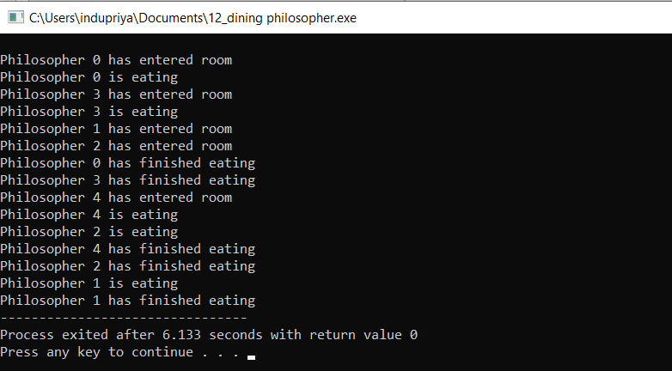

**13. Construct a C program for implementation the various memory allocation strategies.**

**PROGRAM:**

#include<stdio.h>

int main()

{

int bsize[10], psize[10], bno, pno, flags[10], allocation[10], i, j;

for(i = 0; i < 10; i++)

{

flags[i] = 0;

allocation[i] = -1;

}

printf("Enter no. of blocks: ");

scanf("%d", &bno);

printf("\nEnter size of each block: ");

for(i = 0; i < bno; i++)

scanf("%d", &bsize[i]);

printf("\nEnter no. of processes: ");

scanf("%d", &pno);

printf("\nEnter size of each process: ");

for(i = 0; i < pno; i++)

scanf("%d", &psize[i]);

for(i = 0; i < pno; i++)

for(j = 0; j < bno; j++)

if(flags[j] == 0 && bsize[j] >= psize[i])

{

allocation[j] = i;

flags[j] = 1;

break;

}

printf("\nBlock no.\tsize\t\tprocess no.\t\tsize");

for(i = 0; i < bno; i++)

{

printf("\n%d\t\t%d\t\t", i+1, bsize[i]);

if(flags[i] == 1)

printf("%d\t\t\t%d",allocation[i]+1,psize[allocation[i]]);

else

printf("Not allocated");

}

}

**OUTPUT:**

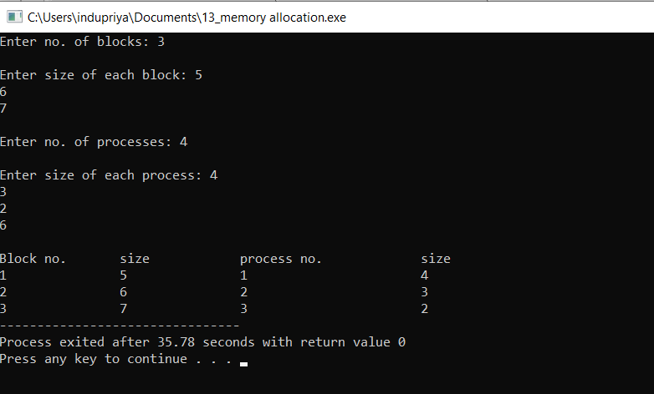

**14. Construct a C program to organize the file using single level directory.**

**PROGRAM:**

#include<stdio.h>

#include<conio.h>

#include<string.h>

int main()

{

int nf=0,i=0,j=0,ch;

char mdname[10],fname[10][10],name[10];

printf("Enter the directory name:");

scanf("%s",mdname);

printf("Enter the number of files:");

scanf("%d",&nf);

do

{

printf("Enter file name to be created:");

scanf("%s",name);

for(i=0;i<nf;i++)

{

if(!strcmp(name,fname[i]))

break;

}

if(i==nf)

{

strcpy(fname[j++],name);

nf++;

}

else

printf("There is already %s\n",name);

printf("Do you want to enter another file(yes - 1 or no - 0):");

scanf("%d",&ch);

}

while(ch==1);

printf("Directory name is:%s\n",mdname);

printf("Files names are:");

for(i=0;i<j;i++)

printf("\n%s",fname[i]);

getch();

}

**OUTPUT:**

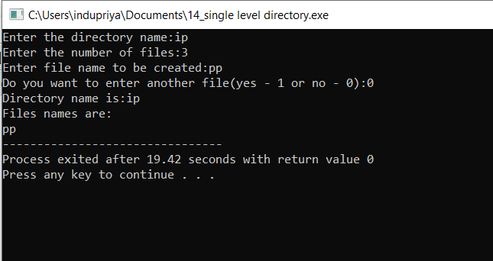

**15. Design a C program to organize the file using two level directory structure.**

**PROGRAM:**

#include<stdio.h>

#include<conio.h>

struct st

{

char dname[10];

char sdname[10][10];

char fname[10][10][10];

int ds,sds[10];

}dir[10];

int main()

{

int i,j,k,n;

printf("enter number of directories:");

scanf("%d",&n);

for(i=0;i<n;i++)

{

printf("enter directory %d names:",i+1);

scanf("%s",&dir[i].dname);

printf("enter size of directories:");

scanf("%d",&dir[i].ds);

for(j=0;j<dir[i].ds;j++)

{

printf("enter subdirectory name and size:");

scanf("%s",&dir[i].sdname[j]);

scanf("%d",&dir[i].sds[j]);

for(k=0;k<dir[i].sds[j];k++)

{

printf("enter file name:");

scanf("%s",&dir[i].fname[j][k]);

}

}

}

printf("\ndirname\t\tsize\tsubdirname\tsize\tfiles");

printf("\n******************************************************\n");

for(i=0;i<n;i++)

{

printf("%s\t\t%d",dir[i].dname,dir[i].ds);

for(j=0;j<dir[i].ds;j++)

{

printf("\t%s\t\t%d\t",dir[i].sdname[j],dir[i].sds[j]);

for(k=0;k<dir[i].sds[j];k++)

printf("%s\t",dir[i].fname[j][k]);

printf("\n\t\t");

}

printf("\n");

}

getch();

}

**OUTPUT:**

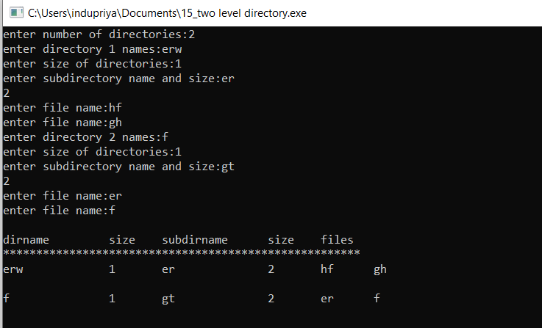

**16. Develop a C program for implementing random access file for processing the employee details.**

**PROGRAM:**

**OUTPUT:**