

DNA SEQUENCING using PARALLEL PROGRAMMING

Submitted for Parallel programming course work



submitted by

Induraj Pudhupattu Ramamurthy

# Exercise 1- Sequential Program

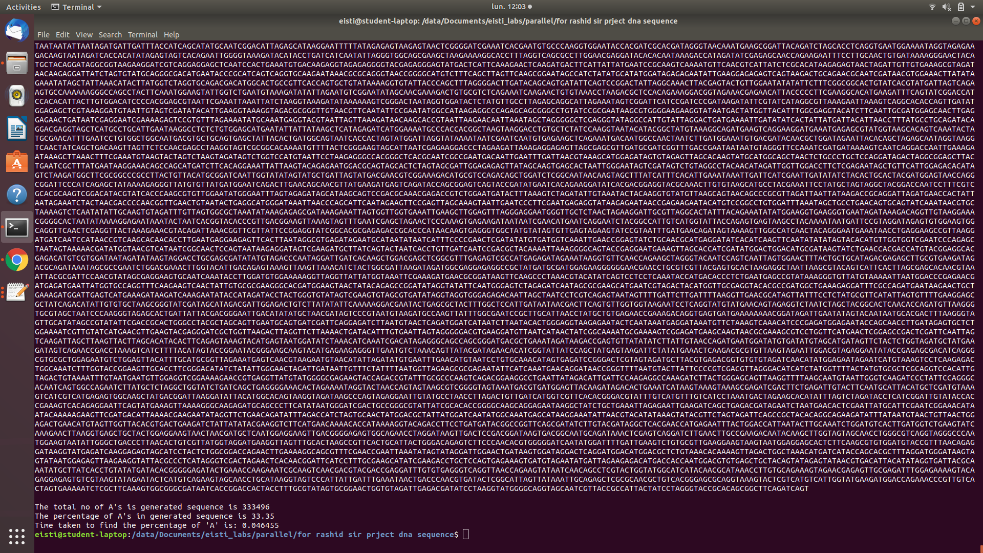

After generating a sequence of 10e^6 characters containing “A,G,T,C,R,W”, we replace the R and W with equal probability with its replacement mentioned in the question paper document.

It is found that the Total number of A’s generated in the sequence is 333496, i.e, in percentage, it can be said that there are 33.35% of Adenine in the sequence we had generated

The total time taken to generate the sequence and find the percentage of A’s in the sequence is 0.046455seconds

# Exercise 2- Parallel processing with open Mp (Multi threading)

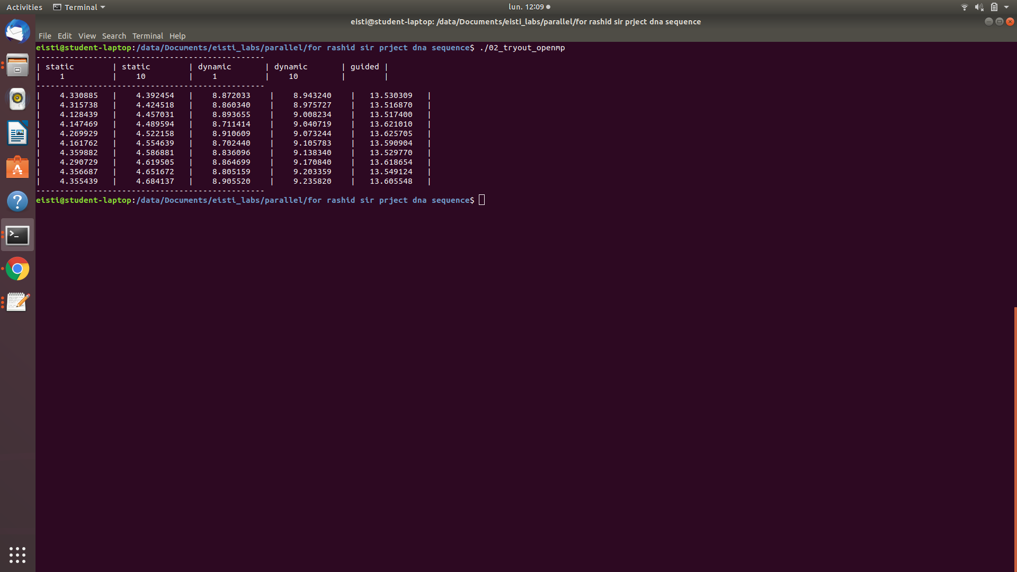

It is very clear that the static assignment with fixed chunk size of one has better result compared to dynamic and guided. Guided has the worst run time.

The performance is compared by running the same program for 10 number of loops for each method, the time taken by each method is summarized as follows,

Static 1 < Static 10 < Dynamic 1 < Dynamic 10 < Guided

The static method of parallel programming finds the percentage of A’s in the given sequence very fast compared to dynamic and guided methods

# Exercise 3- MPI (distributed- multiprocessing)

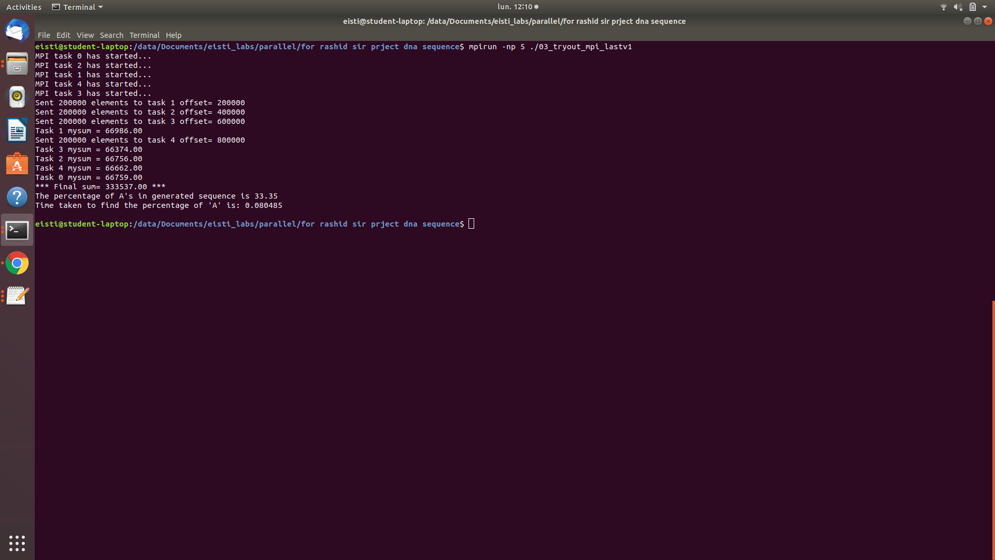

By Messaging passing interface, we send the chunks of arrays to different process and each process works with replacement and counting the number of A’s in its own chunk, then counts are sent to master process which calculates the global sum of the number of A’s present in the sequence.

It is found that the number of A’s present is 33.35% and the time taken by distributed processing to compute the percentage of A’s is 0.080485