**Problem Statement**

The objective of the assignment is the engineer to get the real time experience on Jenkins. The engineer need to learn and perform the below topics:

Understanding Jenkins and its Overview – Going through e-learning contents:

Jenkins.io.doc is the website for learning more about Jenkins that I will complete.

Jenkins Installation

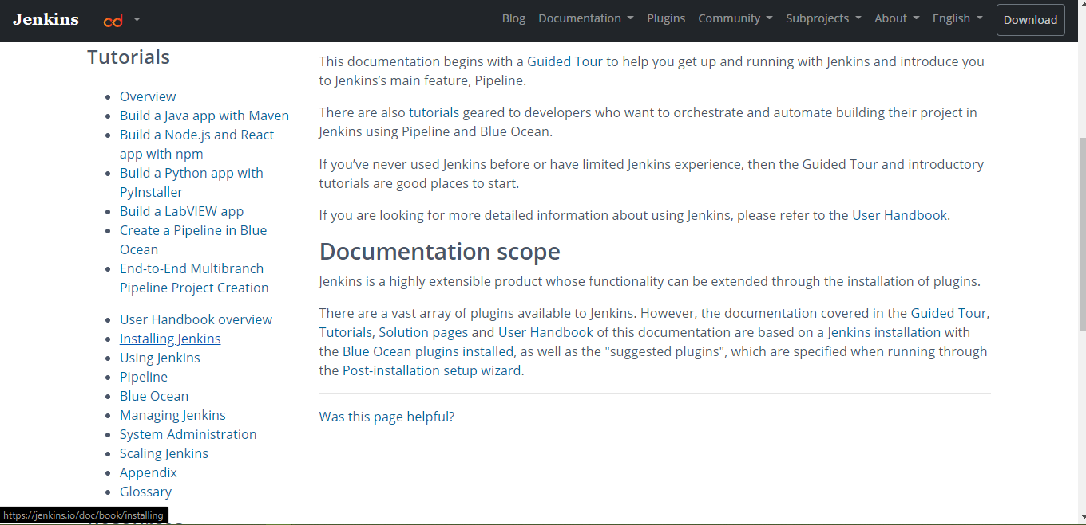

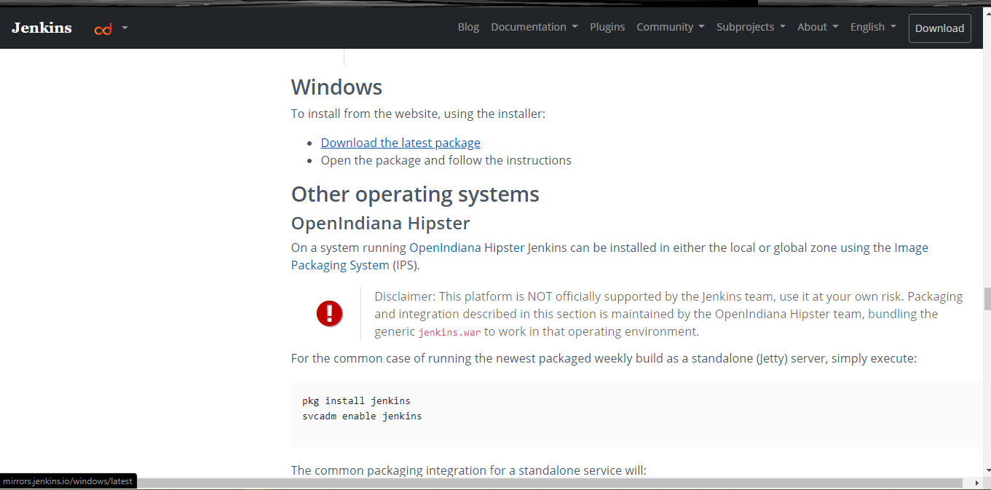

Job Creation in Jenkins

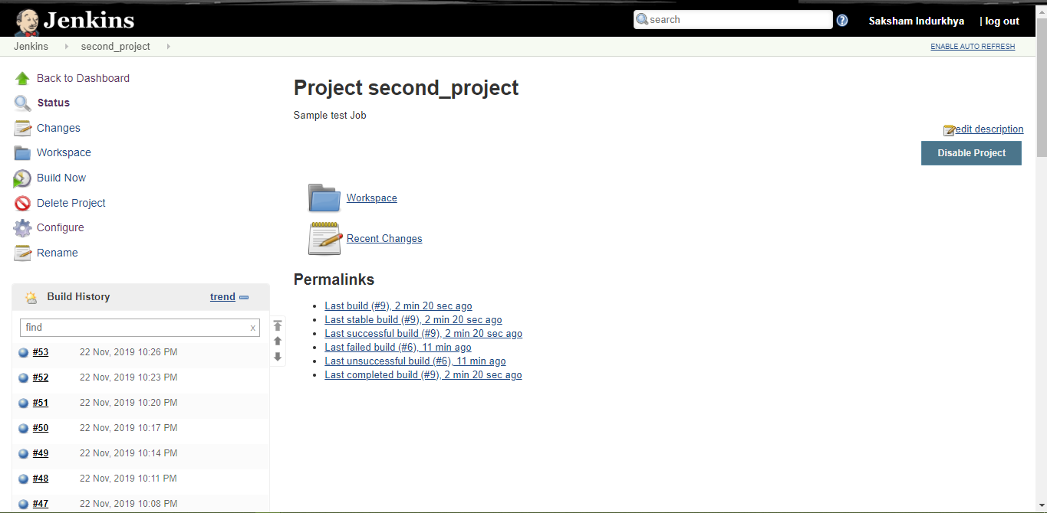

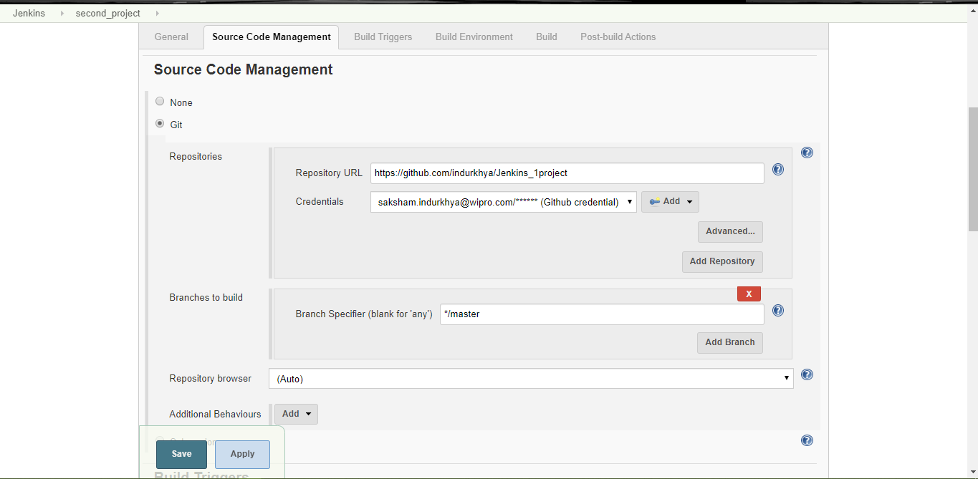

Job Scheduling and Scheduling cron jobs In Jenkins

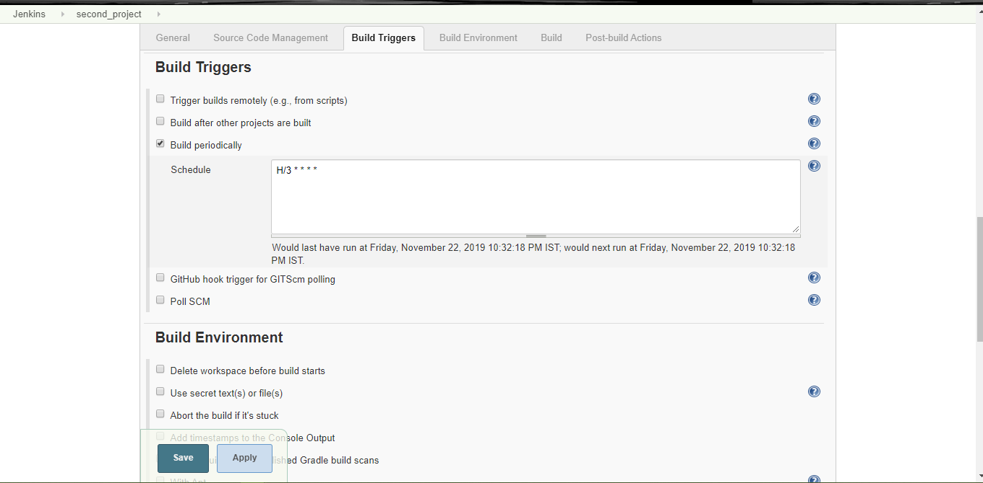

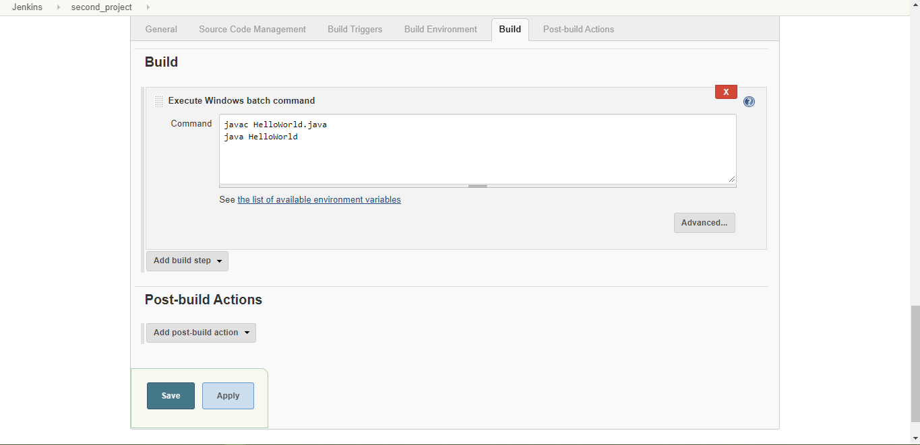

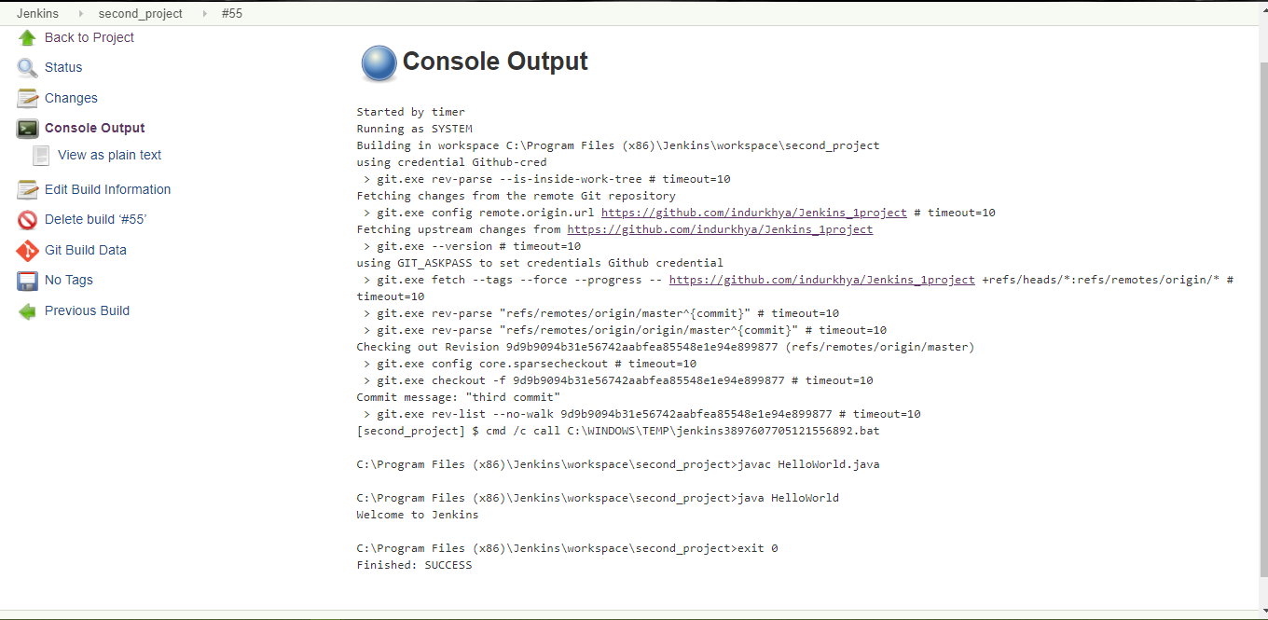

Installing Plugins

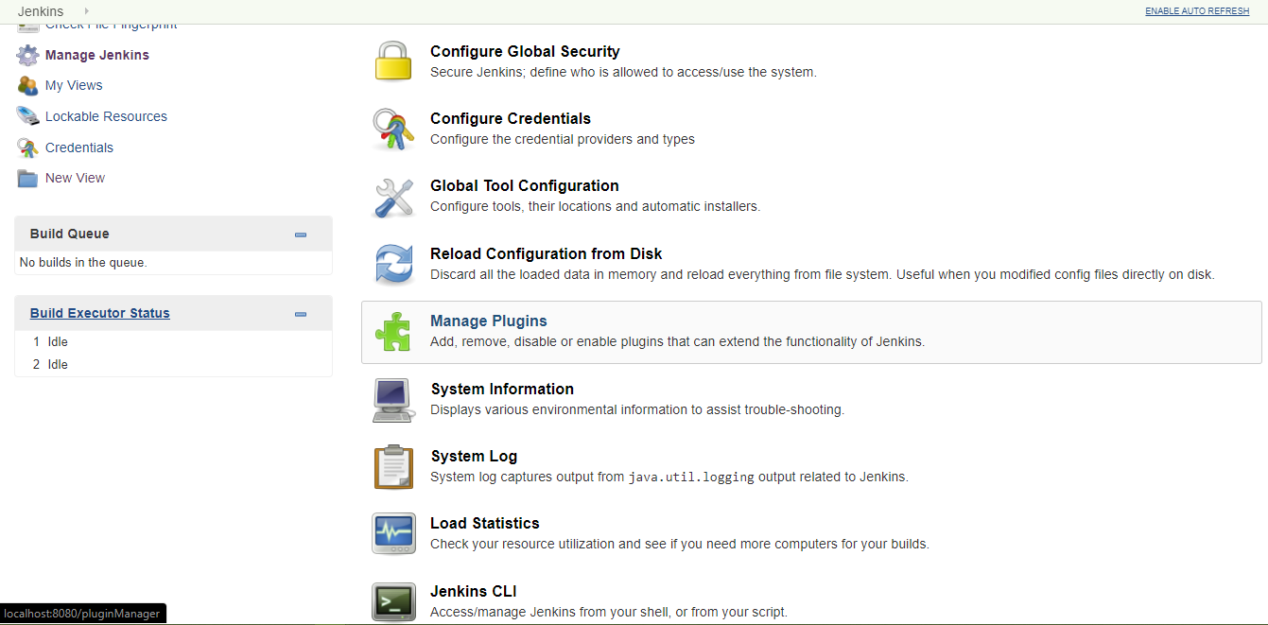

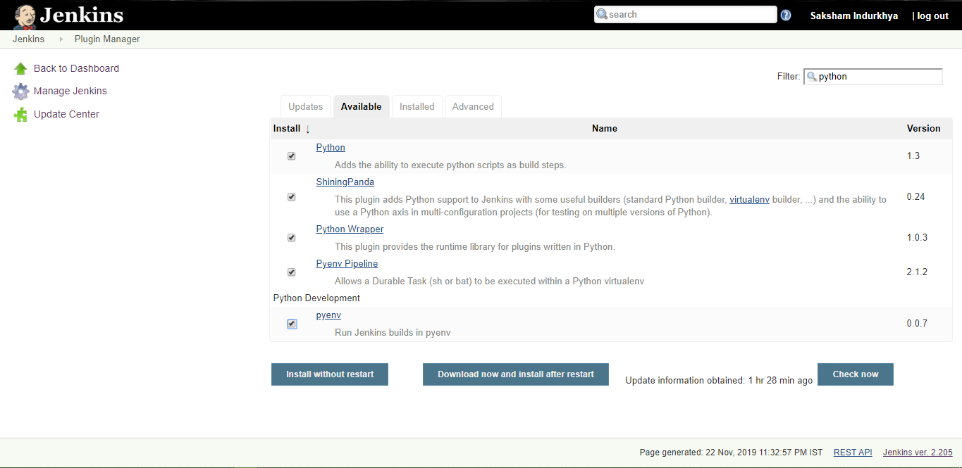

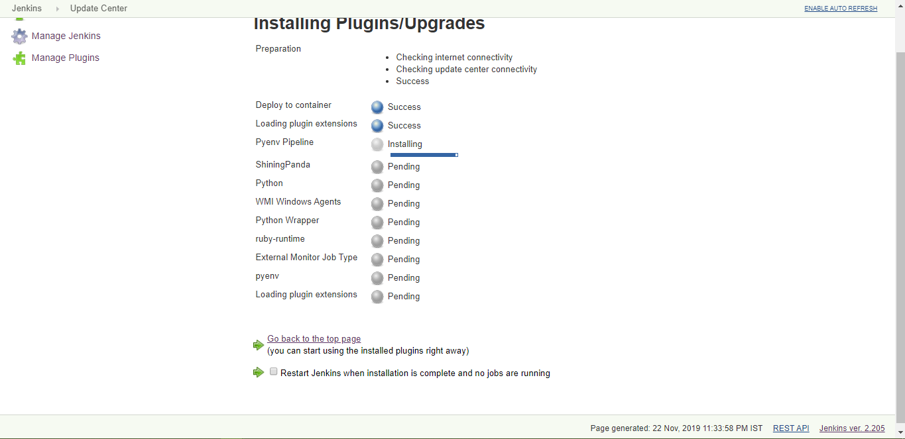

Creating Slaves

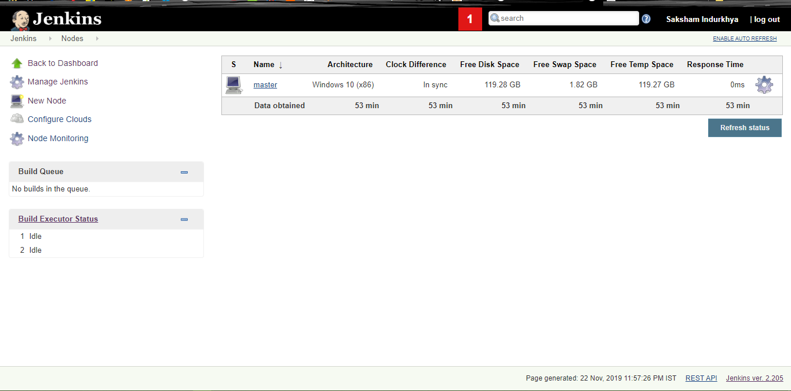

Authentication section for Jenkins:

