**TASK-4**

**FIRST TABLE:**

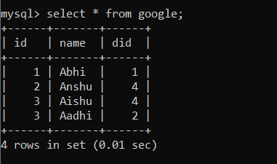

**SECOND TABLE:**

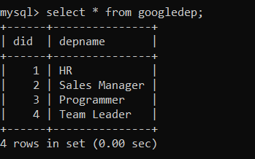

**CROSS JOIN:**

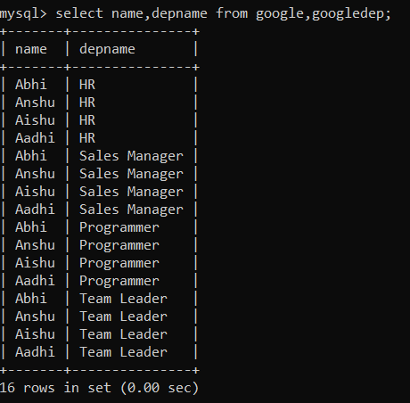

**INNER JOIN:**

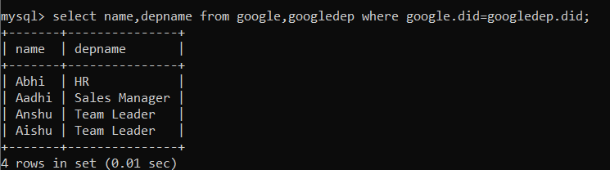

**LEFT OUTER JOIN (or)LEFT JOIN:**

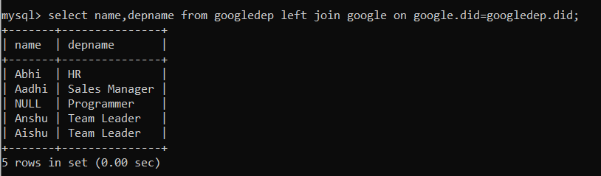

**RIGHT OUTER JOIN (or) RIGHT JOIN:**

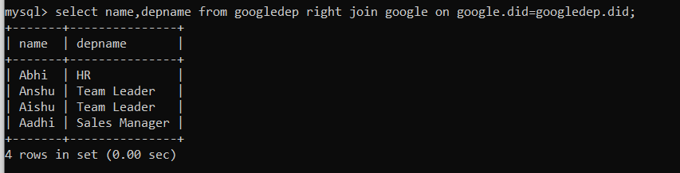

**FULL OUTER JOIN:**

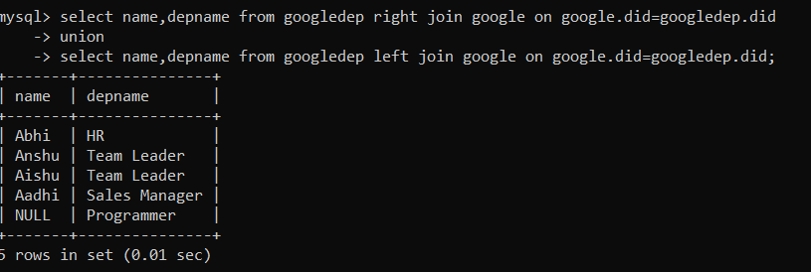

**SUB-QUERIES:**

**IN**

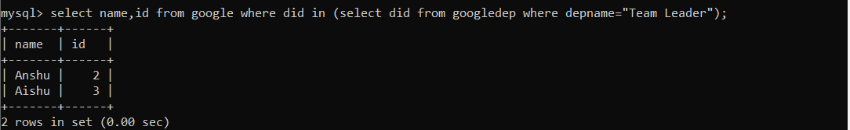

**ALL**

