1. Introduction
Media production organisations work with partner studios, productions and individual media assets such as trailers, episodes and promotional videos. Tracking these details in separate spreadsheets can make it difficult to keep records organised, avoid duplication and maintain correct relationships.
This project develops a Media Production and Asset Management Dashboard using Python, SQLite and a graphical user interface. It provides a single place to add, view and delete studio, production and media-asset records.

2. Problem Statement
The organisation needs a reliable way to manage partner studios, the productions commissioned under each studio, and the media assets delivered for each production. A spreadsheet-based process may lead to duplicate studio details, inconsistent records and accidental loss of related information. This project addresses the problem through a relational database application with foreign-key relationships, cascading deletion rules, input validation and a user-friendly dashboard.

3. Objectives
- Create a relational SQLite database containing Studios, Productions and Media Assets tables.
- Connect the tables using primary keys and foreign keys.
- Apply cascading deletes to remove dependent records when a parent record is deleted.
- Provide an interface to add a studio, production and media asset.
- Provide controls to delete a studio, production or individual media asset.
- Display a combined JOIN view and separate views of all three tables.
- Validate user input and refresh the displayed data after changes.

4. Tools and Technologies
Technology | Purpose
Python | Application logic and database operations.
SQLite | Relational database for storing records.
Tkinter / ttk | Graphical interface, tabs, dropdowns and tables.
Jupyter Notebook | Development and execution environment.

5. Database Design
The database contains three related tables. Each table has a primary key. Child tables contain foreign keys that refer to parent records.
Table | Main fields | Relationship
studios | studio_id (PK), studio_name (unique), email | Parent of productions
productions | production_id (PK), studio_id (FK), production_title, release_date | Belongs to a studio; parent of media_assets
media_assets | asset_id (PK), production_id (FK), asset_type, asset_duration | Belongs to a production
Foreign keys maintain referential integrity. ON DELETE CASCADE on the child relationships means deleting a studio also deletes its productions and their media assets; deleting a production deletes its media assets. Deleting one media asset removes only that asset.

6. Application Features

6.1 Insert Panel
The Insert Panel accepts studio name, studio email, production title, release date, asset type and asset duration. If the studio already exists, its existing ID should be reused; otherwise, a new studio record is created. The application then creates a production and a media asset linked to it.

6.2 Delete Panel
The Delete Panel provides dropdown selectors for choosing a studio, production or media asset. The corresponding delete action removes the selected record. Dropdown options and displayed tables should refresh after deletion.

6.3 Tabbed Display
The four tabs provide a combined JOIN view and individual raw views of Studios, Productions and Media Assets. The JOIN view displays production ID, studio name, production title, release date, asset type and asset duration.

7. Input Validation and Data Integrity
- Text fields should not accept blank submissions.
- Asset duration must be numeric and non-negative.
- Release date should follow the YYYY-MM-DD format.
- Studio names are unique.
- Foreign keys connect child records to valid parent records.
- Cascading deletes remove dependent records automatically.
- Tables and dropdowns refresh after insertions and deletions.

8. code ,Screenshots of the Application

import sqlite3
import tkinter as tk
from tkinter import ttk, messagebox
from datetime import datetime

DB_NAME = "media_management.db"

print("Libraries imported successfully.")

# 1. DATABASE CONNECTION AND TABLE CREATION

def get_connection():
"""Open a SQLite connection with foreign-key enforcement enabled."""
connection = sqlite3.connect(DB_NAME)
connection.execute("PRAGMA foreign_keys = ON")
return connection

def create_tables():
with get_connection() as conn:
conn.execute("""
CREATE TABLE IF NOT EXISTS studios (
studio_id INTEGER PRIMARY KEY AUTOINCREMENT,
studio_name TEXT NOT NULL UNIQUE,
email TEXT NOT NULL
)
""")

conn.execute("""
CREATE TABLE IF NOT EXISTS productions (
production_id INTEGER PRIMARY KEY AUTOINCREMENT,
studio_id INTEGER NOT NULL,
production_title TEXT NOT NULL,
release_date TEXT NOT NULL,
FOREIGN KEY (studio_id)
REFERENCES studios(studio_id)
ON DELETE CASCADE
)
""")

conn.execute("""
CREATE TABLE IF NOT EXISTS media_assets (
asset_id INTEGER PRIMARY KEY AUTOINCREMENT,
production_id INTEGER NOT NULL,
asset_type TEXT NOT NULL,
asset_duration REAL NOT NULL CHECK (asset_duration >= 0),
FOREIGN KEY (production_id)
REFERENCES productions(production_id)
ON DELETE CASCADE
)
""")

print("Database and all three tables are ready.")

create_tables()

# 2. INSERT SAMPLE RECORDS

def seed_database():
with get_connection() as conn:
studio_count = conn.execute(
"SELECT COUNT(*) FROM studios"
).fetchone()[0]

production_count = conn.execute(
"SELECT COUNT(*) FROM productions"
).fetchone()[0]

asset_count = conn.execute(
"SELECT COUNT(*) FROM media_assets"
).fetchone()[0]

if studio_count == 0 and production_count == 0 and asset_count == 0:

conn.executemany(
"INSERT INTO studios (studio_name, email) VALUES (?, ?)",
[
("Dream Studios", "dream@example.com"),
("Star Productions", "star@example.com"),
("Vision Media", "vision@example.com")
]
)

conn.executemany(
"""INSERT INTO productions
(studio_id, production_title, release_date)
VALUES (?, ?, ?)""",
[
(1, "The Lost World", "2026-01-15"),
(2, "Future Dreams", "2026-03-20"),
(3, "Ocean Life", "2026-05-10")
]
)

conn.executemany(
"""INSERT INTO media_assets
(production_id, asset_type, asset_duration)
VALUES (?, ?, ?)""",
[
(1, "Trailer", 2.5),
(1, "Episode", 45),
(2, "Promo", 1.5),
(3, "Trailer", 3)
]
)

print("Sample records inserted successfully.")

else:
print("The database is not completely empty. Sample data was not inserted.")

seed_database()

# 3. DATABASE OPERATIONS

def add_record(studio_name, email, production_title,
release_date, asset_type, duration):

"""Add or reuse a studio, then create one production and one asset."""

with get_connection() as conn:

row = conn.execute(
"SELECT studio_id FROM studios WHERE studio_name = ?",
(studio_name,)
).fetchone()

if row:
studio_id = row[0]

else:
cursor = conn.execute(
"INSERT INTO studios (studio_name, email) VALUES (?, ?)",
(studio_name, email)
)

studio_id = cursor.lastrowid

cursor = conn.execute(
"""INSERT INTO productions
(studio_id, production_title, release_date)
VALUES (?, ?, ?)""",
(studio_id, production_title, release_date)
)

production_id = cursor.lastrowid

conn.execute(
"""INSERT INTO media_assets
(production_id, asset_type, asset_duration)
VALUES (?, ?, ?)""",
(production_id, asset_type, duration)
)

return production_id

def delete_studio(studio_id):
with get_connection() as conn:
conn.execute(
"DELETE FROM studios WHERE studio_id = ?",
(studio_id,)
)

def delete_production(production_id):
with get_connection() as conn:
conn.execute(
"DELETE FROM productions WHERE production_id = ?",
(production_id,)
)

def delete_asset(asset_id):
with get_connection() as conn:
conn.execute(
"DELETE FROM media_assets WHERE asset_id = ?",
(asset_id,)
)

def fetch_all(query, params=()):
with get_connection() as conn:
return conn.execute(query, params).fetchall()

print("Database operation functions are ready.")

# 4. COMBINED JOIN QUERY

JOIN_QUERY = """
SELECT
p.production_id,
s.studio_name,
p.production_title,
p.release_date,
a.asset_type,
a.asset_duration
FROM productions AS p
JOIN studios AS s ON p.studio_id = s.studio_id
JOIN media_assets AS a ON p.production_id = a.production_id
ORDER BY p.production_id, a.asset_id
"""

print("Combined JOIN query is ready.")
print("Current combined records:", len(fetch_all(JOIN_QUERY)))

# 5. CREATE MAIN TKINTER WINDOW

root = tk.Tk()
root.title("Media Production & Asset Management Dashboard")
root.geometry("1250x800")
root.minsize(950, 650)

main_frame = ttk.Frame(root, padding=12)
main_frame.pack(fill="both", expand=True)

title_label = ttk.Label(
main_frame,
text="Media Production & Asset Management Dashboard",
font=("Arial", 18, "bold")
)

title_label.pack(pady=(0, 12))

# 6. INSERT PANEL

insert_frame = ttk.LabelFrame(
main_frame,
text="Insert Panel",
padding=10
)

insert_frame.pack(fill="x", pady=6)

field_frame = ttk.Frame(insert_frame)
field_frame.pack(fill="x")

studio_name_var = tk.StringVar()
email_var = tk.StringVar()
production_title_var = tk.StringVar()
release_date_var = tk.StringVar()
asset_type_var = tk.StringVar()
duration_var = tk.StringVar()

fields = [
("Studio Name", studio_name_var),
("Studio Email", email_var),
("Production Title", production_title_var),
("Release Date (YYYY-MM-DD)", release_date_var),
("Asset Type", asset_type_var),
("Asset Duration (minutes)", duration_var)
]

for index, (label_text, variable) in enumerate(fields):

row = index // 3
col = (index % 3) * 2

ttk.Label(
field_frame,
text=label_text
).grid(
row=row,
column=col,
padx=5,
pady=5,
sticky="w"
)

ttk.Entry(
field_frame,
textvariable=variable,
width=27
).grid(
row=row,
column=col + 1,
padx=5,
pady=5,
sticky="ew"
)

for col in range(6):
field_frame.columnconfigure(col, weight=1)

def clear_insert_fields():

for variable in (
studio_name_var,
email_var,
production_title_var,
release_date_var,
asset_type_var,
duration_var
):
variable.set("")

def handle_add_record():

studio_name = studio_name_var.get().strip()
email = email_var.get().strip()
production_title = production_title_var.get().strip()
release_date = release_date_var.get().strip()
asset_type = asset_type_var.get().strip()
duration_text = duration_var.get().strip()

# Reject blank fields

if not all([
studio_name,
email,
production_title,
release_date,
asset_type,
duration_text
]):

messagebox.showwarning(
"Missing Information",
"Please fill in all fields."
)

return

# Basic email validation

if "@" not in email or "." not in email.split("@")[-1]:

messagebox.showwarning(
"Invalid Email",
"Please enter a valid email address."
)

return

# Validate date format

try:
datetime.strptime(release_date, "%Y-%m-%d")

except ValueError:

messagebox.showwarning(
"Invalid Date",
"Enter the release date in YYYY-MM-DD format."
)

return

# Validate numeric, non-negative duration

try:

duration = float(duration_text)

if duration < 0:
raise ValueError

except ValueError:

messagebox.showwarning(
"Invalid Duration",
"Duration must be a numeric value greater than or equal to zero."
)

return

try:

production_id = add_record(
studio_name,
email,
production_title,
release_date,
asset_type,
duration
)

clear_insert_fields()
refresh_all()

messagebox.showinfo(
"Success",
f"Record added successfully.\nNew Production ID: {production_id}"
)

except sqlite3.Error as error:

messagebox.showerror(
"Database Error",
str(error)
)

add_button = ttk.Button(
insert_frame,
text="Add Record",
command=handle_add_record
)

add_button.pack(pady=(8, 2))

# 7. DELETE PANEL

delete_frame = ttk.LabelFrame(
main_frame,
text="Delete Panel",
padding=10
)

delete_frame.pack(fill="x", pady=6)

studio_choice = tk.StringVar()
production_choice = tk.StringVar()
asset_choice = tk.StringVar()

studio_combo = ttk.Combobox(
delete_frame,
textvariable=studio_choice,
state="readonly",
width=35
)

production_combo = ttk.Combobox(
delete_frame,
textvariable=production_choice,
state="readonly",
width=35
)

asset_combo = ttk.Combobox(
delete_frame,
textvariable=asset_choice,
state="readonly",
width=35
)

delete_items = [
("Studio", studio_combo, studio_choice),
("Production", production_combo, production_choice),
("Media Asset", asset_combo, asset_choice)
]

for col, (label_text, combo, variable) in enumerate(delete_items):

ttk.Label(
delete_frame,
text=f"Select {label_text}"
).grid(
row=0,
column=col,
padx=8,
pady=4,
sticky="w"
)

combo.grid(
row=1,
column=col,
padx=8,
pady=4,
sticky="ew"
)

delete_frame.columnconfigure(col, weight=1)

def selected_id(choice):

"""Extract the integer ID from a dropdown label such as '1 - Name'."""

value = choice.get().strip()

if not value:
return None

try:
return int(value.split(" - ", 1)[0])

except (ValueError, IndexError):
return None

def handle_delete_studio():

studio_id = selected_id(studio_choice)

if studio_id is None:

messagebox.showwarning(
"Selection Required",
"Select a studio to delete."
)

return

if messagebox.askyesno(
"Confirm Delete",
"Delete this studio and ALL its productions and media assets?"
):

try:

delete_studio(studio_id)
refresh_all()

messagebox.showinfo(
"Success",
"Studio and its related records deleted."
)

except sqlite3.Error as error:

messagebox.showerror(
"Database Error",
str(error)
)

def handle_delete_production():

production_id = selected_id(production_choice)

if production_id is None:

messagebox.showwarning(
"Selection Required",
"Select a production to delete."
)

return

if messagebox.askyesno(
"Confirm Delete",
"Delete this production and all its media assets?"
):

try:

delete_production(production_id)
refresh_all()

messagebox.showinfo(
"Success",
"Production and its assets deleted."
)

except sqlite3.Error as error:

messagebox.showerror(
"Database Error",
str(error)
)

def handle_delete_asset():

asset_id = selected_id(asset_choice)

if asset_id is None:

messagebox.showwarning(
"Selection Required",
"Select a media asset to delete."
)

return

if messagebox.askyesno(
"Confirm Delete",
"Delete only this media asset?"
):

try:

delete_asset(asset_id)
refresh_all()

messagebox.showinfo(
"Success",
"Media asset deleted. Its production and studio remain."
)

except sqlite3.Error as error:

messagebox.showerror(
"Database Error",
str(error)
)

ttk.Button(
delete_frame,
text="Delete Studio",
command=handle_delete_studio
).grid(
row=2,
column=0,
padx=8,
pady=8,
sticky="ew"
)

ttk.Button(
delete_frame,
text="Delete Production",
command=handle_delete_production
).grid(
row=2,
column=1,
padx=8,
pady=8,
sticky="ew"
)

ttk.Button(
delete_frame,
text="Delete Media Asset",
command=handle_delete_asset
).grid(
row=2,
column=2,
padx=8,
pady=8,
sticky="ew"
)

# 8. TABBED DATABASE DISPLAY PANEL

display_frame = ttk.LabelFrame(
main_frame,
text="Tabbed Database Display",
padding=8
)

display_frame.pack(
fill="both",
expand=True,
pady=6
)

notebook = ttk.Notebook(display_frame)
notebook.pack(fill="both", expand=True)

tab_definitions = [

(
"Combined JOIN View",
(
"Production ID",
"Studio Name",
"Production Title",
"Release Date",
"Asset Type",
"Asset Duration"
)
),

(
"Studios",
(
"Studio ID",
"Studio Name",
"Email"
)
),

(
"Productions",
(
"Production ID",
"Studio ID",
"Production Title",
"Release Date"
)
),

(
"Media Assets",
(
"Asset ID",
"Production ID",
"Asset Type",
"Asset Duration"
)
)
]

treeviews = {}

for tab_name, columns in tab_definitions:

tab = ttk.Frame(notebook, padding=5)
notebook.add(tab, text=tab_name)

tree = ttk.Treeview(
tab,
columns=columns,
show="headings"
)

for column in columns:

tree.heading(
column,
text=column
)

tree.column(
column,
width=150,
minwidth=90,
anchor="center"
)

vertical_scroll = ttk.Scrollbar(
tab,
orient="vertical",
command=tree.yview
)

horizontal_scroll = ttk.Scrollbar(
tab,
orient="horizontal",
command=tree.xview
)

tree.configure(
yscrollcommand=vertical_scroll.set,
xscrollcommand=horizontal_scroll.set
)

tree.grid(
row=0,
column=0,
sticky="nsew"
)

vertical_scroll.grid(
row=0,
column=1,
sticky="ns"
)

horizontal_scroll.grid(
row=1,
column=0,
sticky="ew"
)

tab.rowconfigure(0, weight=1)
tab.columnconfigure(0, weight=1)

treeviews[tab_name] = tree

# 9. POPULATE AND REFRESH TABLES

def populate_tree(tree, rows):

# Remove old rows before inserting the latest database state
for item in tree.get_children():
tree.delete(item)
for row in rows:
tree.insert("", "end", values=row)

def refresh_all():
"""Refresh all four views and all delete dropdowns."""

combined_rows = fetch_all(JOIN_QUERY)
studios = fetch_all(
"SELECT studio_id, studio_name, email FROM studios ORDER BY studio_id"
)
productions = fetch_all(
"""SELECT production_id, studio_id, production_title, release_date
FROM productions ORDER BY production_id"""
)
assets = fetch_all(
"""SELECT asset_id, production_id, asset_type, asset_duration
FROM media_assets ORDER BY asset_id"""
)
populate_tree(
treeviews["Combined JOIN View"],
combined_rows
)
populate_tree(
treeviews["Studios"],
studios
)
populate_tree(
treeviews["Productions"],
productions
)
populate_tree(
treeviews["Media Assets"],
assets
)
# Rebuild dropdown values from current database IDs
studio_values = [
f"{row[0]} - {row[1]}" for row in studios
]
production_values = [
f"{row[0]} - {row[2]}" for row in productions
]
asset_values = [
f"{row[0]} - {row[2]} (Production {row[1]})"
for row in assets
]
studio_combo["values"] = studio_values
production_combo["values"] = production_values
asset_combo["values"] = asset_values

# Clear selections so no deleted ID remains selected
studio_choice.set("")
production_choice.set("")
asset_choice.set("")

# 10. INITIAL DISPLAY AND APPLICATION EXECUTION
refresh_all()
print("Dashboard is ready. The Tkinter window will open now.")
# Start the GUI event loop
root.mainloop()

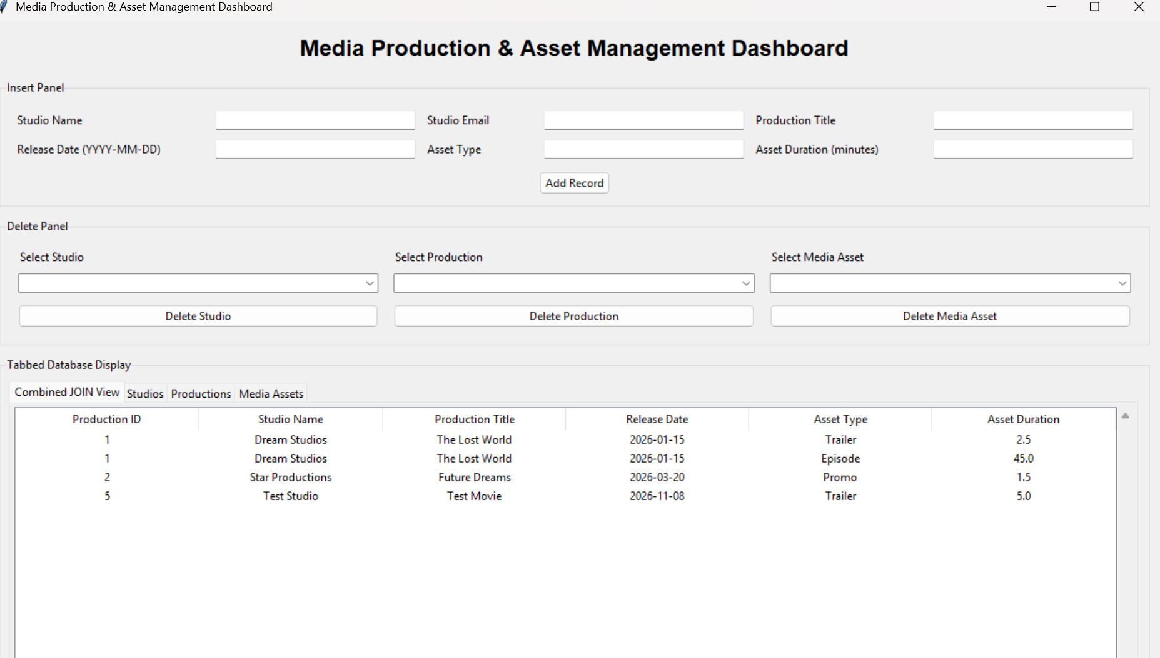

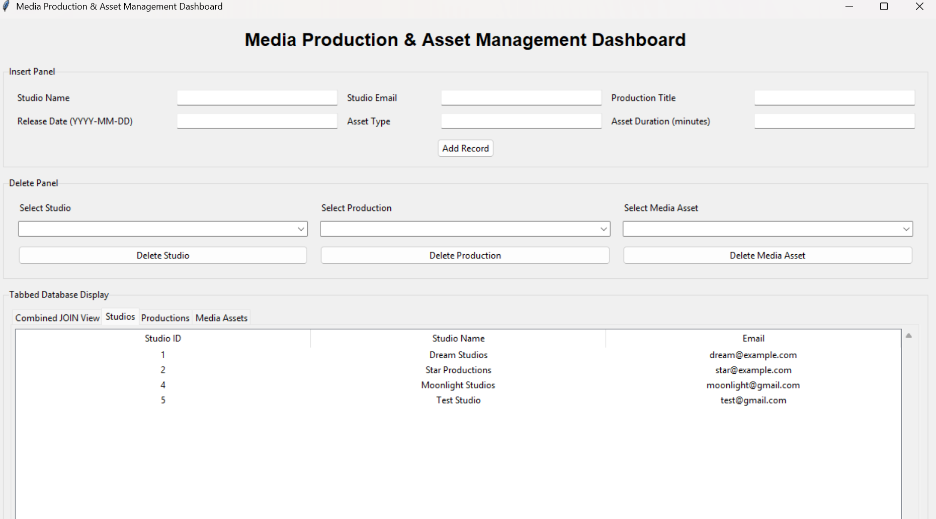

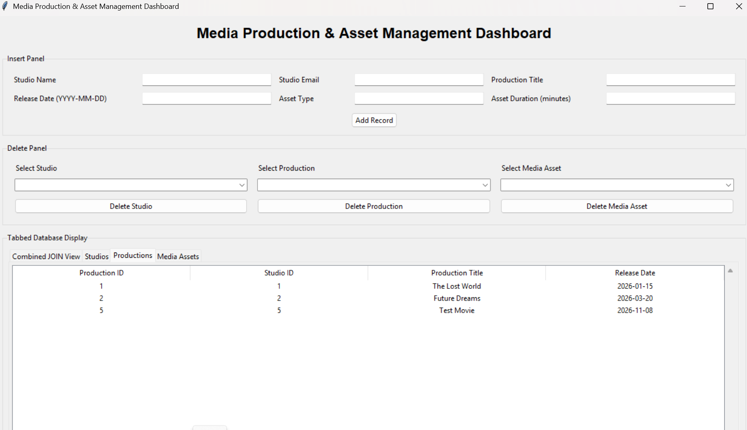

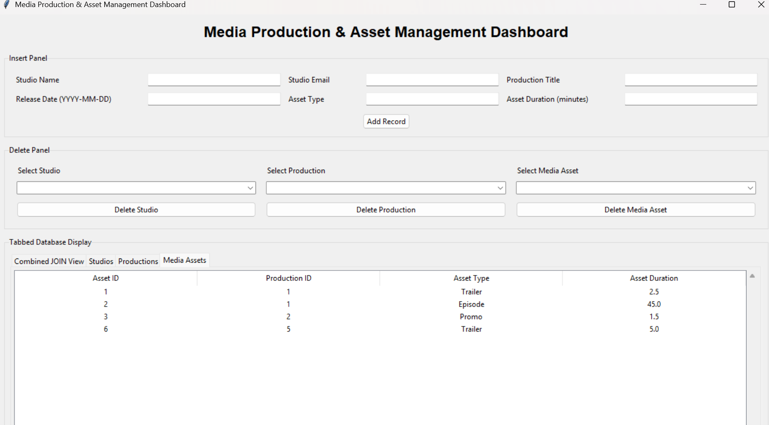

\9. Testing and Results
] Testing and Validation Results
Test | Expected Result | Actual Result
Add a new studio | Creates studio, one production and one asset. | Successfully added a new studio along with its production and media asset.
Add production for existing studio | Reuses existing studio ID; creates new production and asset. | Successfully reused the existing studio ID and added a new production and associated media asset.
Blank text submission | Rejected with a validation message. | Successfully rejected blank fields and displayed a validation warning.
Negative / non-numeric duration | Rejected with a validation message. | Successfully rejected negative and non-numeric duration values with a validation warning.
Delete one media asset | Only selected asset is deleted. | Successfully deleted the selected media asset while retaining its production and studio records.
Delete a production | Production and its child assets are deleted. | Successfully deleted the selected production along with its associated media assets.
Delete a studio | Studio, its productions and their assets are deleted. | Successfully deleted the selected studio along with all its associated productions and media assets.

10. Conclusion
The Media Production and Asset Management Dashboard provides a structured way to manage studio, production and media-asset information. SQLite stores the records and maintains relationships between tables. The interface supports inserting, deleting and viewing records. Foreign keys and cascading deletes help maintain data consistency, while validation helps prevent invalid entries.

11. Future Improvements
Future versions could include user login, role-based permissions, cloud synchronisation, automated backups, advanced search, reports and audit logs.

12. Project Files and Reproducibility
The runnable project should be shared through GitHub. Include the Jupyter Notebook and any required supporting files. The notebook should create and seed the SQLite database when it does not exist and should enable foreign-key enforcement on each database connection. Test the notebook from top to bottom in a fresh environment before submission.
GitHub repository URL: Upload files · induseetha2007/Media-Production-Asset-Management
Notebook filename: Media_Production_Asset_Management.ipynb
Database filename: media_management.db

