A3 Report — Defect reduction in a steel rolling line  Continuous improvement · DMAIC cycle · Steel Plates Faults dataset (UCI #198, n=1,941) | Esteban López  Industrial Eng.  2026

1. Background & problem (DEFINE)
In steel rolling, surface defects drive rework, scrap and customer claims. Without a data-based priority, improvement resources scatter across many failure modes with very different impact. This A3 analyses real inspection data from 1,941 plates (27 vision/process variables, 7 defect types) to decide where to act first and with which countermeasures.
Goal: identify the vital few that hold most of the defects and propose actions that reduce scrap and improve first-pass yield (FPY).
2. Current state (MEASURE)
1,941  plates inspected | 75.5%  defects in only 3 of 7 types | 12.2x  imbalance ratio | 0  missing values

The defect distribution is strongly imbalanced. The Pareto chart separates the "vital few" from the "trivial many":
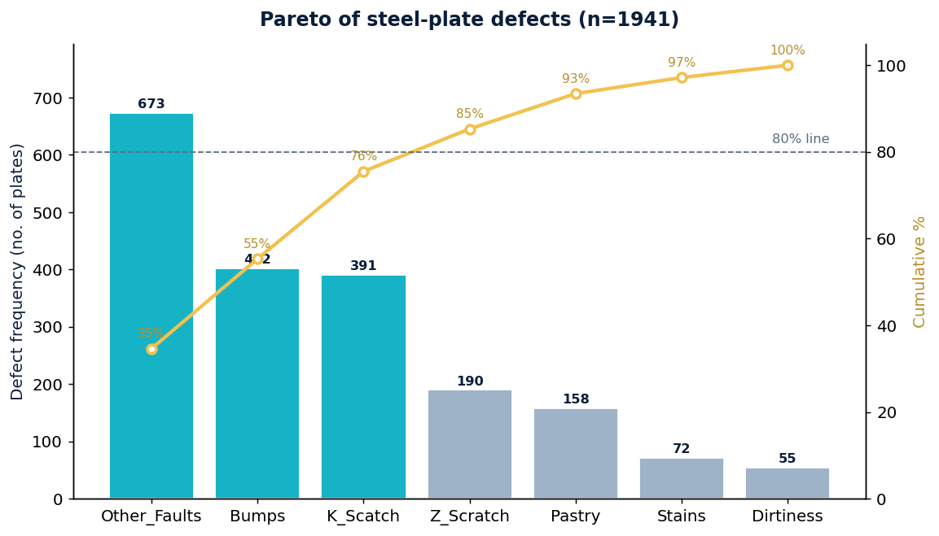
Count and cumulative by defect type
Defect type | Frequency | % of total | Cumulative %
Other_Faults | 673 | 34.7% | 34.7%
Bumps | 402 | 20.7% | 55.4%
K_Scatch | 391 | 20.1% | 75.5%
Z_Scratch | 190 | 9.8% | 85.3%
Pastry | 158 | 8.1% | 93.5%
Stains | 72 | 3.7% | 97.2%
Dirtiness | 55 | 2.8% | 100.0%
3. Root-cause analysis (ANALYZE)
Main finding: three defect types — Other_Faults (673), Bumps (402) and K_Scatch (391) — hold 75.5% of all defective plates. Focusing improvement on them maximises return per unit of effort.
Secondary finding (management): the fact that the largest category is "Other_Faults" (a catch-all bucket) signals an opportunity to improve the definition and traceability of failure modes, a prerequisite for fine root-cause analysis.
Ishikawa diagram — cause categories (6M)
- Machine: roll wear, clearances, maintenance
- Material: chemical composition, thickness, heat lot
- Method: rolling parameters, temperature, speed
- Measurement: inspection criteria, sensor calibration
- Manpower: human variability in classification
- Environment: line temperature and humidity
4. Proposed improvement (IMPROVE)
Inspection-support classifier (Random Forest) that predicts the defect type from vision/process variables. It standardises the inspection criterion (digital poka-yoke) and cuts time and human variability.
Aspect | Detail
Algorithm | Random Forest (400 trees), class_weight balanced
Validation | Stratified 25% hold-out
Metrics | Accuracy, macro F1, confusion matrix, feature importance
Expected performance* | ~75-80% accuracy (literature range for this dataset)
*The reproducible notebook computes the exact value on the full data and generates the confusion matrix and feature importance.
5. Action plan & control (CONTROL)
- Prioritise the vital few — tackle Other_Faults, Bumps and K_Scatch first (~75% of the problem).
- Redefine the defect taxonomy — shrink the "Other_Faults" catch-all and train inspection.
- SPC on critical variables — control charts and Cpk on the model’s highest-importance variables.
- Digital poka-yoke — deploy the classifier as inspection support to standardise the criterion.
- PDCA loop — recompute the Pareto and retrain per shift/batch to verify countermeasures.

Data source: Steel Plates Faults — UCI Machine Learning Repository (#198), Semeion Research Center. Analysis and model reproducible in the attached notebook.

