A3 Report — Predictive maintenance of a milling machine  Continuous improvement · TPM · DMAIC · AI4I 2020 dataset (UCI #601, 10,000 cycles) | Esteban López  Industrial Eng.  2026

1. Background & problem (DEFINE)
Unplanned breakdowns are the main enemy of availability — the first pillar of OEE. Reactive maintenance stops the line at the most expensive moment. Using 10,000 operating cycles of a milling machine (6 process variables, a machine-failure label and 5 failure modes), this A3 builds a predictive-maintenance strategy that converts unplanned stops into planned interventions — the core idea of TPM.
Goal: predict failures early, prioritise the failure modes that matter, and lift availability.
2. Current state (MEASURE)
10,000  operating cycles | 3.39%  failure rate (339 cycles) | ≈30  cycles MTBF | 0  missing values

Failures are rare and imbalanced. A Pareto of the five failure modes shows where reliability effort pays off:
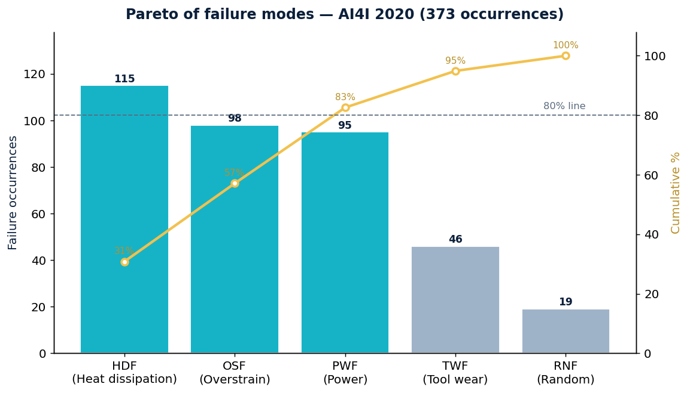
Failure modes — count and cumulative
Failure mode | Occurrences | % of total | Cumulative %
HDF — Heat dissipation | 115 | 30.8% | 30.8%
OSF — Overstrain | 98 | 26.3% | 57.1%
PWF — Power | 95 | 25.5% | 82.6%
TWF — Tool wear | 46 | 12.3% | 94.9%
RNF — Random | 19 | 5.1% | 100.0%
Note: the 5 modes total 373 occurrences across 339 failed cycles (some cycles trigger more than one mode).
3. Root-cause analysis (ANALYZE)
The three vital-few modes — heat dissipation (HDF), overstrain (OSF) and power (PWF) — concentrate 82.6% of all failure occurrences and share one physical root: torque, rotational speed and the air–process temperature gap. Rather than feeding raw sensors blindly, the model uses features derived from that physics:
- Mechanical power = Torque × angular speed → drives power failures
- Temperature gap = Process − Air temperature → drives heat-dissipation failures
- Tool wear × Torque → proxy for overstrain failures
Ishikawa — cause categories (6M)
- Machine: roll/tool wear, bearings
- Material: workpiece hardness, tool grade
- Method: feed rate, spindle speed, cooling
- Measurement: sensor calibration, thresholds
- Manpower: setup variability
- Environment: ambient temperature
4. Proposed improvement (IMPROVE)
A Random Forest predicts the machine-failure label from the process variables plus the engineered physics. Key engineering judgement: with only 3.4% failures, accuracy is misleading (a "never fails" model already scores ~96.6%). The model is judged on RECALL of the failure class — the share of real breakdowns caught in time.
Aspect | Detail
Algorithm | Random Forest (400 trees), class_weight balanced
Validation | Stratified 25% hold-out
Judged on | Recall, F1, ROC-AUC, PR-AUC (not accuracy)
Operating lever | Decision-threshold tuning: recall vs. false alarms
*The reproducible notebook computes the exact metrics, confusion matrix and feature importance on the full data.
5. Action plan & control (CONTROL)
- Predict, don’t react — each flagged failure becomes a planned stop; direct lift to availability/OEE.
- Prioritise the vital-few modes — SPC limits on temperature gap, torque and mechanical power.
- Tune the threshold — trade false alarms for higher recall based on breakdown vs. check cost.
- Condition-based alarms — turn top features into shop-floor thresholds (poka-yoke backup).
- PDCA — track MTBF and recall monthly; retrain as tooling changes.

Data source: AI4I 2020 Predictive Maintenance — UCI Machine Learning Repository (#601). Analysis and model reproducible in the attached notebook.

