Technical Report — Gas-turbine engine (Brayton cycle)  Thermodynamics · Gas turbine & jet propulsion · Cold-air-standard | Esteban López  Industrial Eng.  2026

1. Problem & specification
Analyse the air-standard Brayton cycle behind every gas turbine and jet engine. Compute each state, the thermal efficiency (ideal and with real compressor/turbine losses), the back-work ratio, and find the pressure ratio that maximises net work for a given turbine-inlet temperature.
rp = 12  pressure ratio | 1400 K  turbine inlet (TIT) | 0.85 / 0.88  comp. / turb. η | 288 K  inlet temperature

2. Method & results
States: 1 = compressor inlet, 2 = compressor exit, 3 = turbine inlet, 4 = turbine exit. Cold-air-standard (cp = 1.005 kJ/kg·K, k = 1.4); real compression/expansion via isentropic efficiencies.
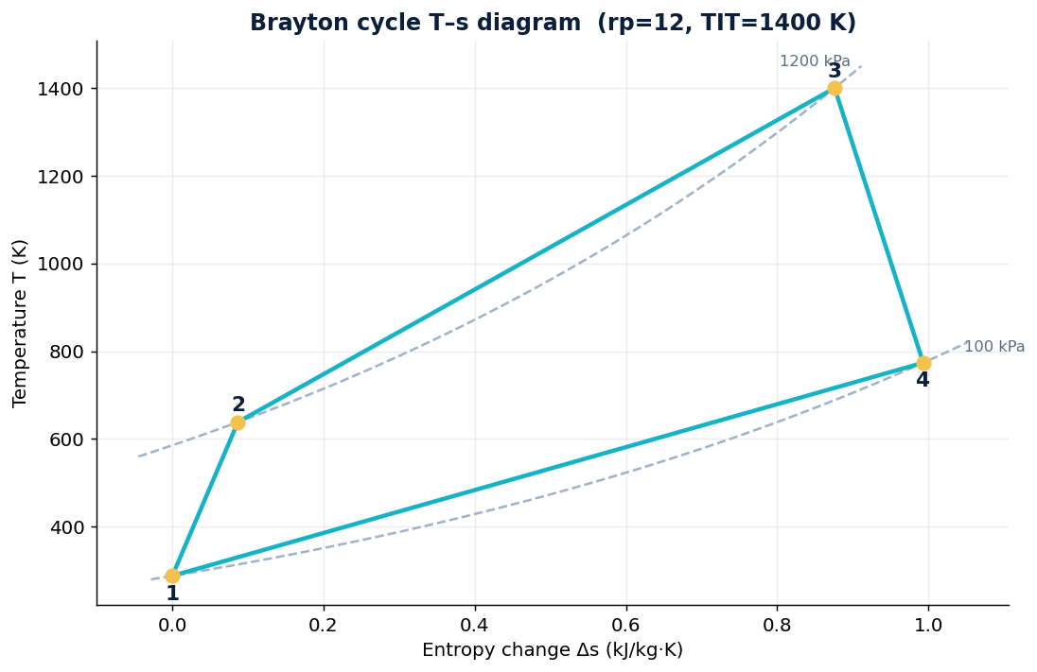
Quantity | Value
Ideal thermal efficiency | 50.8 %
Real thermal efficiency | 36.2 %
Net work | 277 kJ/kg
Turbine work | 629 kJ/kg
Compressor work | 352 kJ/kg
Heat input q_in | 765 kJ/kg
Back-work ratio | 56 %
Compressor exit T2 / Turbine exit T4 | 638 K / 774 K
3. Optimum pressure ratio & back-work
Efficiency rises with pressure ratio, but net work peaks at an optimum rp (≈ 10–12 here). The compressor consumes ~56 % of the turbine output — far more than the <1 % pump work of a steam cycle:
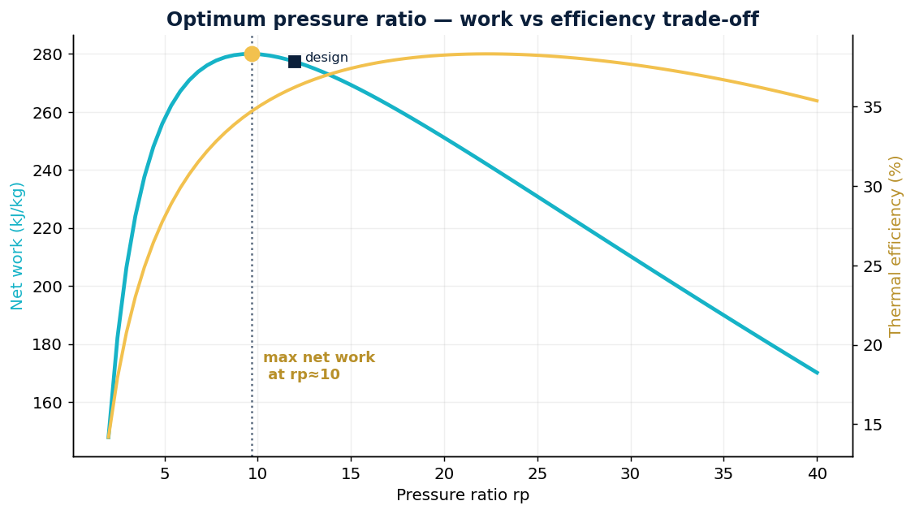
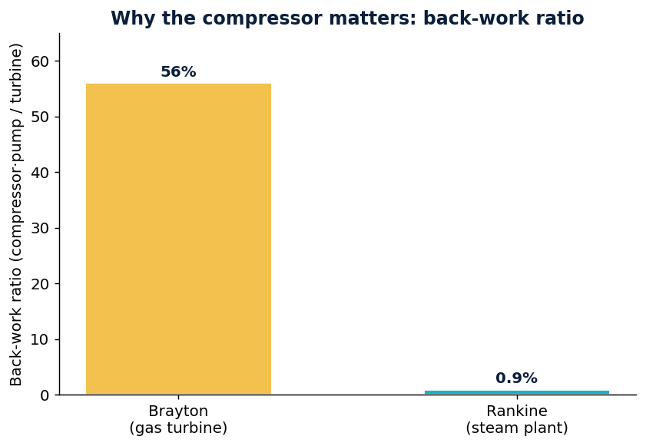
4. Aerospace link — the turbojet
A turbojet is an open Brayton cycle: the turbine only drives the compressor, and the remaining energy is left in the fast exhaust to produce thrust, F = ṁ·(V_exit − V_inlet) + (p_e − p_0)·A_e. The same analysis sizes aircraft engines, auxiliary power units (APUs) and ground/marine gas turbines — a direct bridge from industrial energy systems to propulsion and aerospace, where availability, integrity and continuity (as in GNSS) are the equivalent figures of merit.
5. Conclusion
- Pick the pressure ratio — net work peaks at an optimum rp for the chosen TIT.
- Chase turbine-inlet temperature — the dominant lever; hence materials and blade cooling.
- Mind the back-work ratio — 56 % explains the Brayton vs Rankine difference.
- Extend to real engines — regeneration, intercooling, reheat, and combined Brayton-Rankine plants.

Cold-air-standard Brayton analysis. Fully reproducible in the attached notebook.

