Design Report — Counter-flow heat exchanger (ε-NTU)  Thermodynamics · Heat transfer · ε-NTU & LMTD methods | Esteban López  Industrial Eng.  2026

1. Problem & specification
Cool a hot process-water stream using cooling water in a counter-flow heat exchanger. Determine the heat duty, outlet temperatures and effectiveness, validate the result with an independent method, and quantify how the required area grows for a colder outlet.
90 / 20 °C  hot / cold inlet | 2.0 / 2.5 kg/s  hot / cold flow | 1200 W/m²K  U (overall) | 8 m²  area

2. Method — ε-NTU and LMTD
Capacity rates: C = m·cp. With C_min = 8,410 W/K (hot) and Cr = C_min/C_max = 0.805, the number of transfer units is NTU = U·A / C_min = 1.14. For a counter-flow exchanger the effectiveness is:
ε = (1 − e^[−NTU(1−Cr)]) / (1 − Cr·e^[−NTU(1−Cr)]) Q = ε·C_min·(Th,in − Tc,in)
The result is cross-checked with the LMTD method, Q = U·A·LMTD, which must agree. Fluid properties (cp) are taken from CoolProp at each stream’s mean temperature.
3. Results
The ε-NTU operating point on the design chart, and the temperature profile along the exchanger:
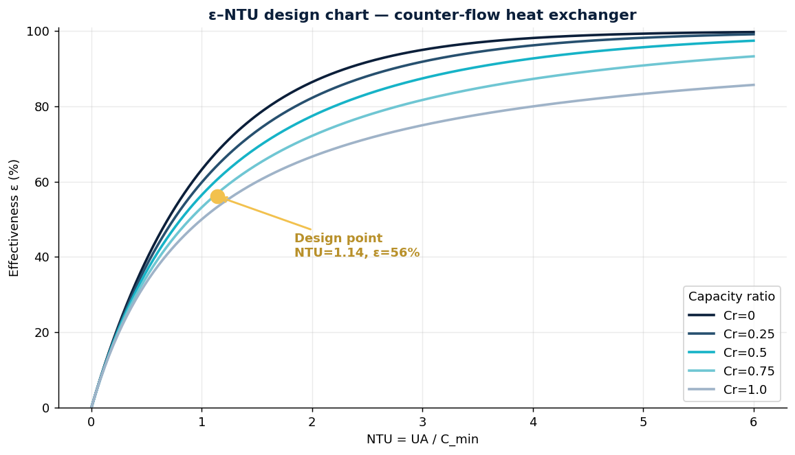
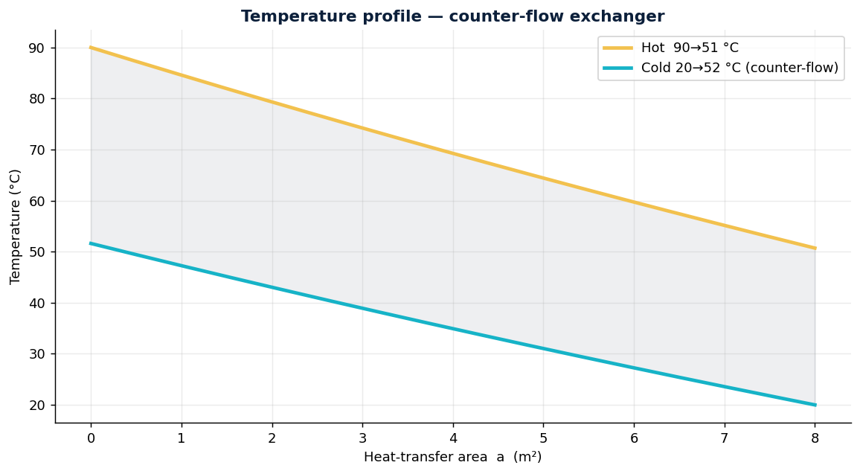
Quantity | Value
Effectiveness ε | 56.1 %
Heat duty Q (ε-NTU) | 330.3 kW
Heat duty Q (LMTD check) | 330.3 kW
Hot outlet temperature | 50.7 °C
Cold outlet temperature | 51.6 °C
LMTD | 34.4 °C
ε-NTU and LMTD agree to within 1 % — an independent check that the calculation is consistent.
4. Design trade-off
Inverting the problem (required area for a target hot-outlet temperature) shows diminishing returns: because effectiveness flattens at high NTU, cooling the hot stream below ~50 °C costs disproportionately more area. The current 8 m² already sits on the knee of the ε-NTU curve; reaching a 45 °C outlet would need roughly double the area. Fouling lowers U over time and shifts the operating point left, eroding effectiveness.
5. Conclusion — engineering decisions enabled
- Size for a target duty — choose area/U without over-building.
- Choose the configuration — counter-flow beats parallel-flow effectiveness for the same area.
- Plan for fouling — quantify the U decline and set a cleaning interval.
- Optimise total cost — next step: add pressure-drop and pumping power to the trade-off.

Methods: ε-NTU and LMTD. Fluid properties via CoolProp. Fully reproducible in the attached notebook.

