A3 Report — Line balancing of a packaging line  Lean line balancing · Discrete-event simulation (SimPy) · DMAIC | Esteban López  Industrial Eng.  2026

1. Background & problem (DEFINE)
Most shop-floor improvement must happen on site, so this A3 demonstrates the method on a digital twin. A 6-station packaging/conditioning line must deliver 80 units/hour, which sets a takt time of 45 s/unit. If any single station exceeds takt it throttles the whole line and demand is missed. Using a SimPy discrete-event model, we locate the bottleneck and quantify the gain from balancing the line — before touching anything physical.
Goal: find the bottleneck, balance the line, and measure the improvement in throughput, lead time and WIP.
2. Current state (MEASURE)
45 s  takt time (80 u/h) | S3 = 55 s  bottleneck (> takt) | 1.22  S3 utilisation | ~65 u/h  capped throughput

Station cycle times against takt — station S3 sits above the line and caps the whole process:
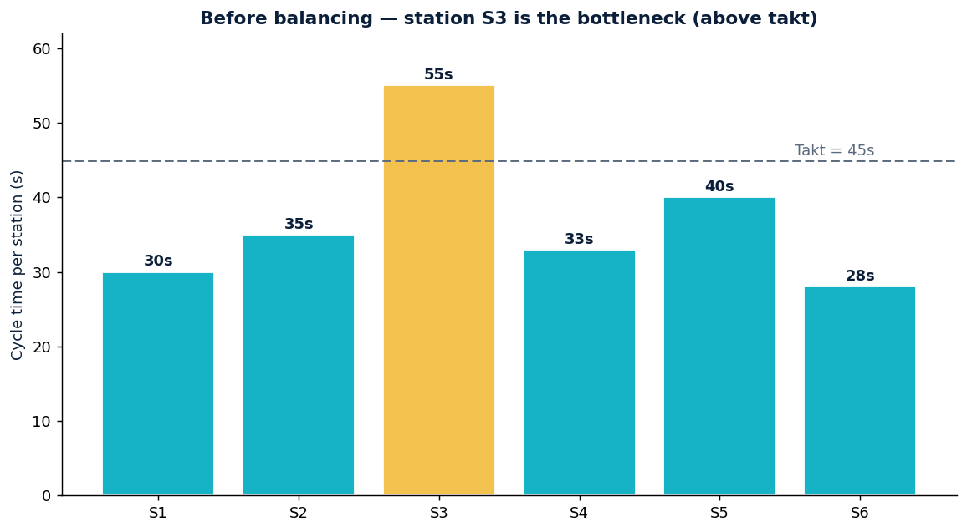
3. Analysis (ANALYZE)
Utilisation at demand equals cycle time / takt. Station S3 = 55/45 = 1.22 (> 1): it cannot keep up, so the line is capped at ~65 u/h, below the 80 u/h demand. The remaining stations are under-used and idle waiting on S3 — classic line imbalance. The fix is to redistribute work so no station exceeds takt.
4. Proposed improvement (IMPROVE)
Rebalance ~13 s of S3 work to lighter stations, keeping the same total work content (221 s). Every station then sits below takt:
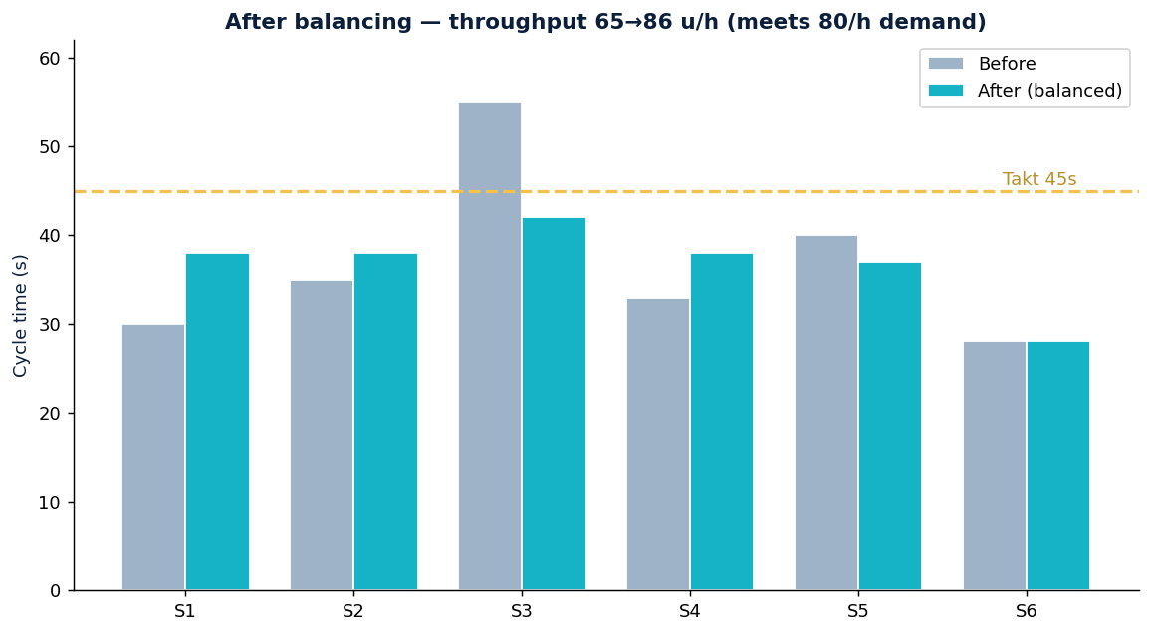
Metric | Before | After
Bottleneck cycle time | 55 s (S3) | 42 s
Throughput | ~65 u/h | ~86 u/h (+31%)
Mean lead time | backlog grows | ≈27 min
Average WIP | unbounded | ≈37 units
Demand (80 u/h) met? | No | Yes
The gain comes purely from balancing — no extra labour.
5. Action plan & control (CONTROL)
- Standardised work — keep station cycle times near the balanced target.
- Visual takt — react when a station drifts above it (the new bottleneck).
- Re-balance on demand change — takt is set by demand; recompute when the order rate moves.
- Attack variability — high variability inflates WIP and lead time even under takt.
- PDCA by simulation — test every change on the model before touching the physical line.

Method: discrete-event simulation in SimPy with realistic line parameters. Fully reproducible in the attached notebook.

