A3 Report — Quality control on a Bosch assembly line  Continuous improvement · Six Sigma · DMAIC · Bosch Production Line (Kaggle, 14.3 GB) | Esteban López  Industrial Eng.  2026

1. Background & problem (DEFINE)
Bosch records thousands of measurements as each part flows through its assembly line. The goal: predict which parts will fail quality control so they can be caught early. The data is real and large-scale — 1,184,687 parts, 968 numeric measurements across 51 stations on 4 production lines (14.3 GB) — and extremely imbalanced, so it challenges both the statistics and the engineering of the analysis.
Goal: map the value stream, find where defects concentrate, and build a defect-prediction model with the right metric.
2. Current state (MEASURE)
1,184,687  parts | 0.58%  defect rate (6,879) | 968  sensors · 51 stations | 14.3 GB  dataset size

The feature names L{line}_S{station}_F{feature} act as a value-stream map. A Pareto of measurement density shows where the line is most complex and instrumented:
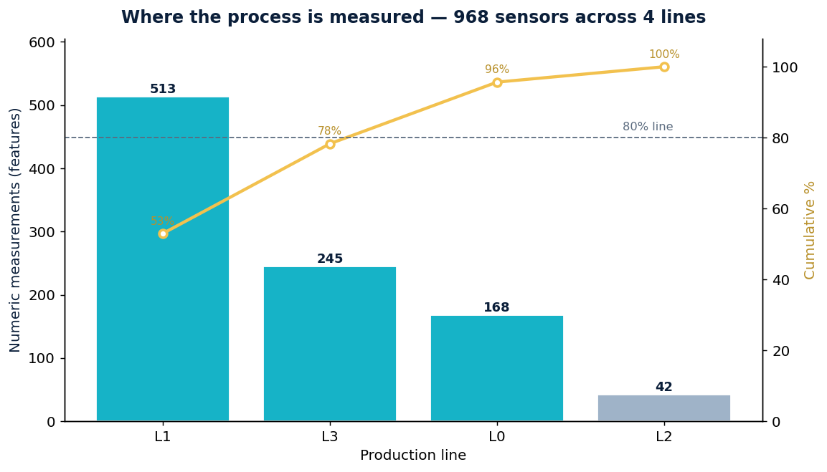
Measurement density per production line
Production line | Sensors | % of total | Cumulative %
L1 — core processing | 513 | 53.0% | 53.0%
L3 — finishing | 245 | 25.3% | 78.3%
L0 — entry | 168 | 17.4% | 95.7%
L2 — short branch | 42 | 4.3% | 100.0%
3. Root-cause analysis (ANALYZE)
Lines L1 and L3 carry 78% of all measurements — the most complex, most-monitored stages, and the natural place to focus SPC. Because the date features timestamp each step, every part’s route through the stations can be reconstructed; a station-level defect rate (computed in the notebook) reveals where failing parts concentrate.
Engineering challenges and how they were handled
- Extreme imbalance — only 0.58% defects, so MCC (not accuracy) is the metric.
- Volume (14.3 GB) — stream the file in chunks and down-cast to float32.
- Sparsity — each part visits only some stations, so most features are NaN.
4. Proposed improvement (IMPROVE)
A HistGradientBoosting model predicts the failure label. It handles NaN natively and scales to millions of rows. Engineering judgement: accuracy is meaningless here (a "all pass" model scores 99.4%); the model is judged on the Matthews Correlation Coefficient (MCC) and the decision threshold is tuned to maximise it.
Aspect | Detail
Algorithm | HistGradientBoosting (native NaN, class_weight balanced)
Data handling | chunked read + float32 down-cast; majority down-sampling
Metric | MCC + threshold tuning (not accuracy)
Expected MCC* | ~0.40–0.48 single model (winning ensembles ~0.52)
*The reproducible notebook computes the exact MCC, threshold curve and confusion matrix on the full data.
5. Action plan & control (CONTROL)
- Focus SPC where the process is complex — highest-defect-rate stations on lines L1 and L3 first.
- Catch escapes, accept some false alarms — tune threshold to MCC / cost of a missed defect.
- Trace every failing part’s route — recurring station sequences point to the stage to fix.
- Poka-yoke at critical stations — turn top signals into in-line gates that stop defects.
- PDCA at scale — re-score MCC and the station defect map per shift; retrain as the line drifts.

Data source: Bosch Production Line Performance — Kaggle competition (2016). Analysis and model reproducible in the attached notebook.

