Technical Report — Steam power plant (Rankine cycle)  Thermodynamics · Power cycles · CoolProp (IAPWS-IF97) | Esteban López  Industrial Eng.  2026

1. Problem & specification
Analyse a steam power plant operating on a Rankine cycle. Compute every thermodynamic state, the thermal efficiency (ideal and with realistic component losses), the back-work ratio and the turbine-exit steam quality, and optimise the design by sweeping boiler pressure, superheat temperature and condenser pressure.
8 MPa  boiler pressure | 500 °C  turbine inlet | 10 kPa  condenser | 0.85 / 0.85  turbine / pump η

2. Method
The four states are: 1 = condenser exit (saturated liquid), 2 = pump exit, 3 = turbine inlet (superheated), 4 = turbine exit. Enthalpies and entropies come from CoolProp (IAPWS-IF97). Efficiency:
η_th = w_net / q_in = (w_turbine − w_pump) / (h3 − h2)
3. Results
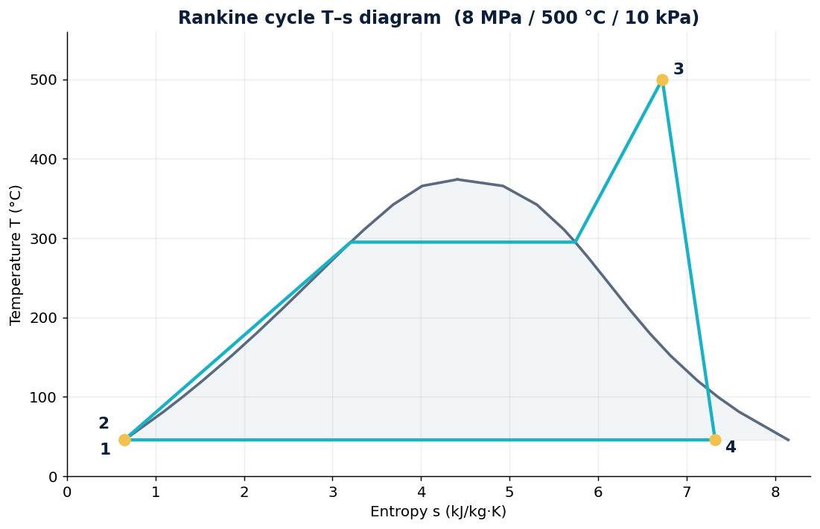
Quantity | Value
Ideal thermal efficiency | 39.4 %
Real thermal efficiency | 33.4 %
Net work | 1069 kJ/kg
Turbine work | 1079 kJ/kg
Pump work | 9.5 kJ/kg
Heat input q_in | 3198 kJ/kg
Back-work ratio | 0.88 %
Turbine-exit quality | 0.89
The back-work ratio of 0.88 % shows the pump consumes almost no work — the defining advantage of a vapour power cycle over a gas-turbine cycle.
4. Optimisation & the wetness limit
Efficiency rises with superheat temperature and with lower condenser pressure (and with boiler pressure):
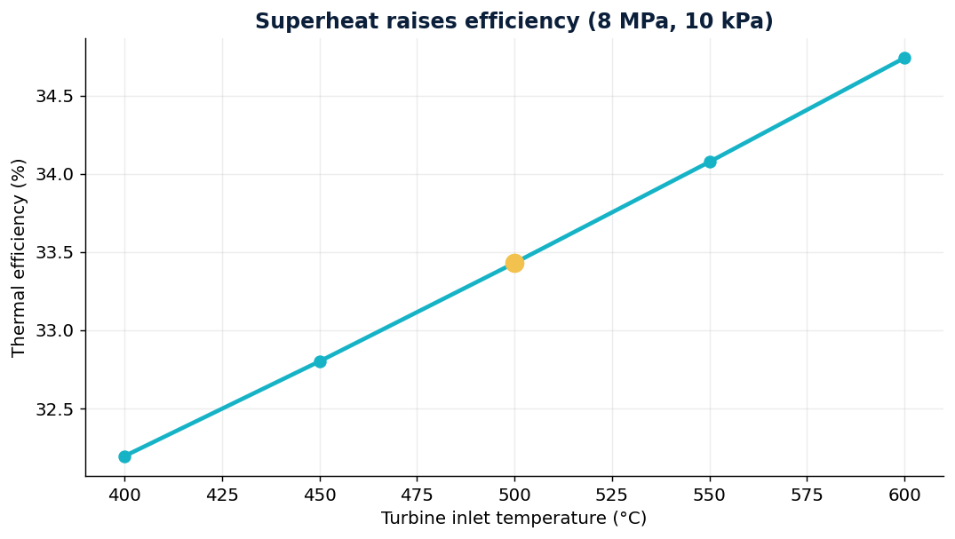
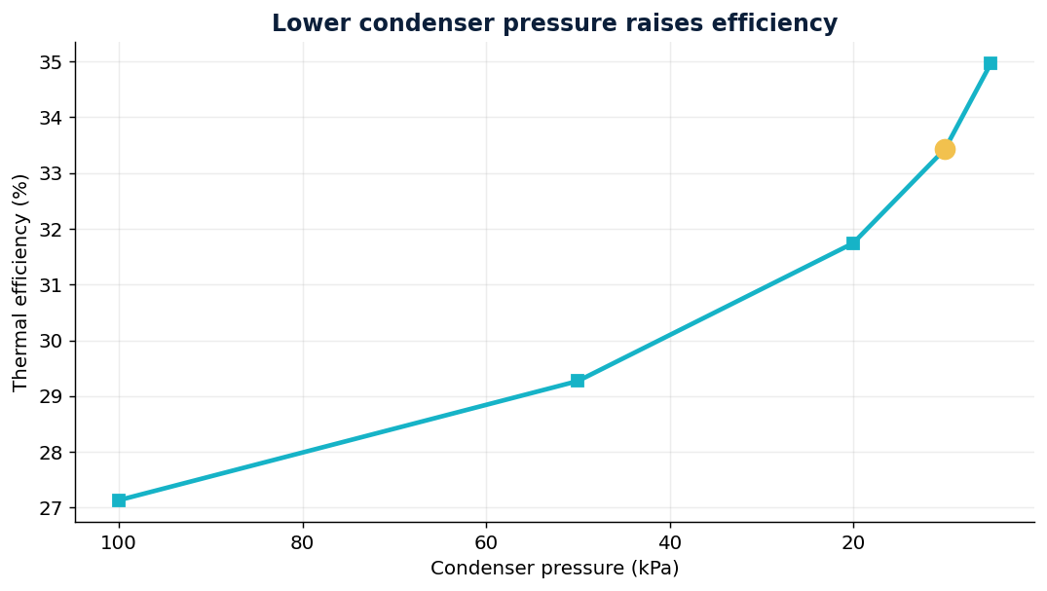
However, raising boiler pressure and lowering condenser pressure both push the turbine exit wetter. Below ~88 % quality, droplets erode the last turbine stages — the physical reason real plants use reheat (and regeneration).
5. Conclusion
- Fix the operating point — set pressures and superheat for a target efficiency.
- Respect the wetness limit — it caps how far pressure and vacuum can be pushed.
- Justify reheat & regeneration — the next design steps follow from this trade-off.
- Benchmark vs Brayton — the <1% back-work ratio explains steam-cycle dominance in base-load power.

Steam properties via CoolProp (IAPWS-IF97). Fully reproducible in the attached notebook.

