ML4T Course Project by T. Ruzmetov,

Spring 2018

**Manual Strategy for Trading**

**Introduction**

Purpose of this project is to design a trading strategy for a given stock(symbol) and time period that performs better than the benchmark (the performance of a portfolio starting with $100,000 cash, investing in 1000 shares of JPM and holding that position). To accomplish above goal, initially, we generate a set of indicators that can be used along with our manual strategy in order to create “BUY” and “SELL” signals(or orders) based on time propagation of adjusted close. In addition, we are asked to come up with the best possible strategy for only in sample period assuming future prices are known so that we can test and see the upper bound of our portfolio performance.

**Indicators**

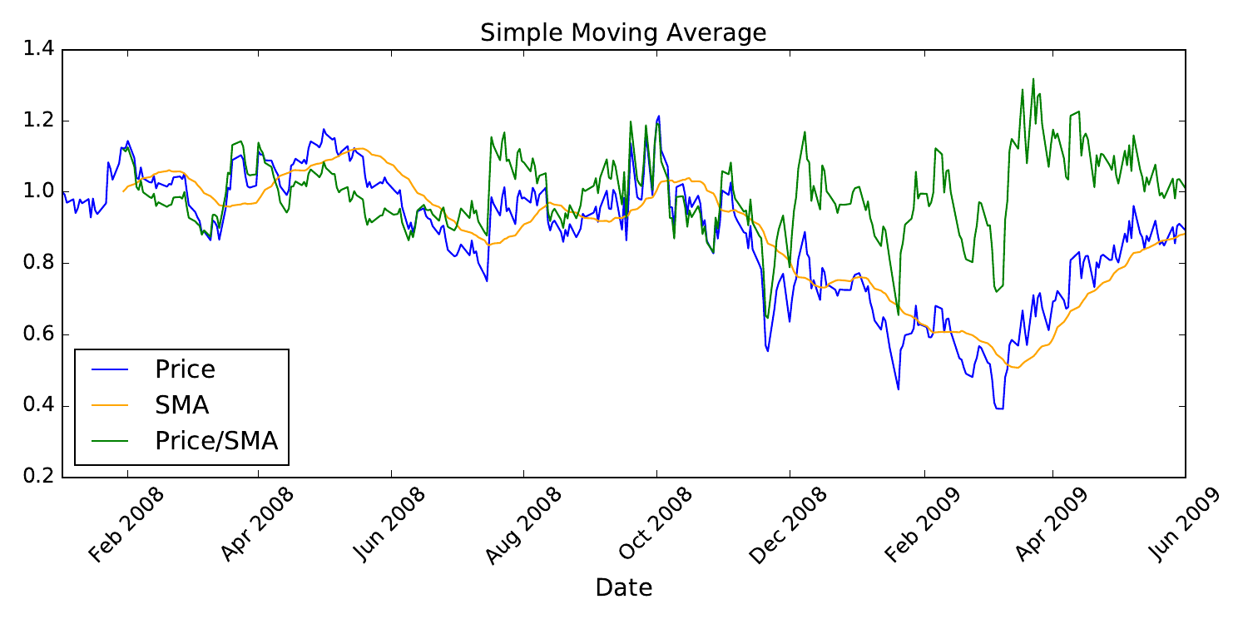

Set of trading indicators used are ‘Price/SMA’ ratio, ‘Bollinger Bands’, and ‘Momentum’.

**PRICE / SMA**

Here we demonstrate ‘ind = Price / SMA’ as trading indicator. For instance, if ‘ind > 1 + delta’ produces ‘SELL’ signal and ‘ind < 1 – delta’ generates ‘BUY’ signal. One must of course optimize for ‘delta’ and ‘number of rolling days’ for in sample period in order to get max return or maybe low risk.

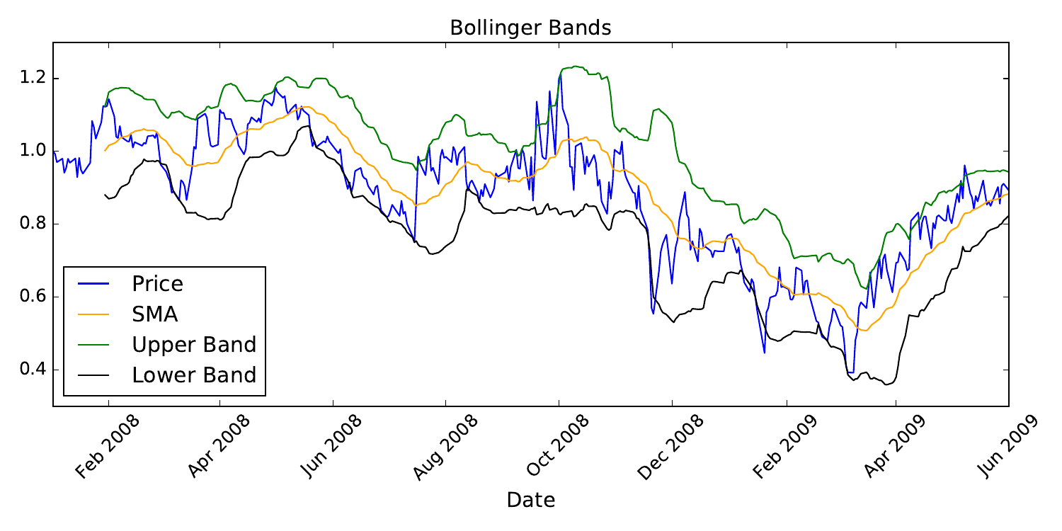**Bollinger Bands**

Another interesting indicators are Bollinger Bands that are lines ‘k’ rolling standard deviations above and below rolling mean(SMA). Crossing the lower and upper bands issue ‘BUY’ and ‘SELL’ signals respectively, where no action is taken in between. Optimization must be done for ‘k’ value and ‘number of rolling days’ for in sample period to get optimum performance.

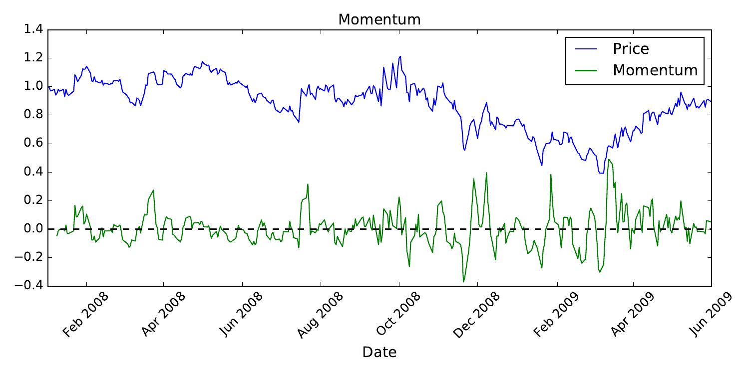**Momentum**

Momentum indicates how fast stock price is moving for a given time period. I used following formula:

‘Momentum = Price(t) / Price(t - delta) - 1’ . Momentum can be utilized as an indicator in combination with other indicator for optimal performance. For example, when price moves up by certain value and if momentum reaches zero we get ‘BUY’ signal. ‘SELL’ signal can be generated the same way when price is low and momentum hits zero.

**Best Possible Strategy**

Since we are allowed to look into future prices, it is possible to design very simple but efficient strategy. If ‘Price(t + roll_days) – Price(t) > 0’ we buy stock because price is going to go up, otherwise

we sell. I tried series of different values for ‘roll_days’ and found that ‘roll_days=1’ gives maximum cumulative return. It intuitively makes sense because if one can make profit every day it accumulates over the time and should give maximum return.

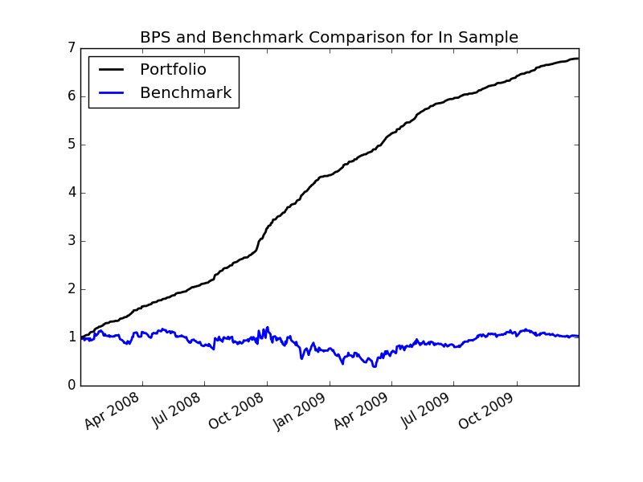

Results:

Optimal Number of Rolling Days: 1

Cumulative Return of Portfolio: 5.7844

Cumulative Return of Benchmark: 0.031973

Final Portfolio Value: 678,440.0

This is how one can make profit if exact future stock prices are known. Apparently, best strategy would be buying and selling every day, which in our case gave 578.44% profit in two years!

**Manual Strategy**

My manual strategy design is based on Bollinger Bands formulation. I track normalized stock price in between upper and lower bands. If price crosses upper band I sell 1000 or 2000 depending on how much shares I have in my holdings. If price is lower than the lower Bollinger band then I buy. Holdings are constrained to -1000, 0, +1000 as stated in project description. I optimized for number of rolling days and rolling standard deviation prefactor so that I get maximum cumulative return. Above mentioned optimal values for in sample data found are ‘rolling_days = 10’ and ‘k = 2.0’ .

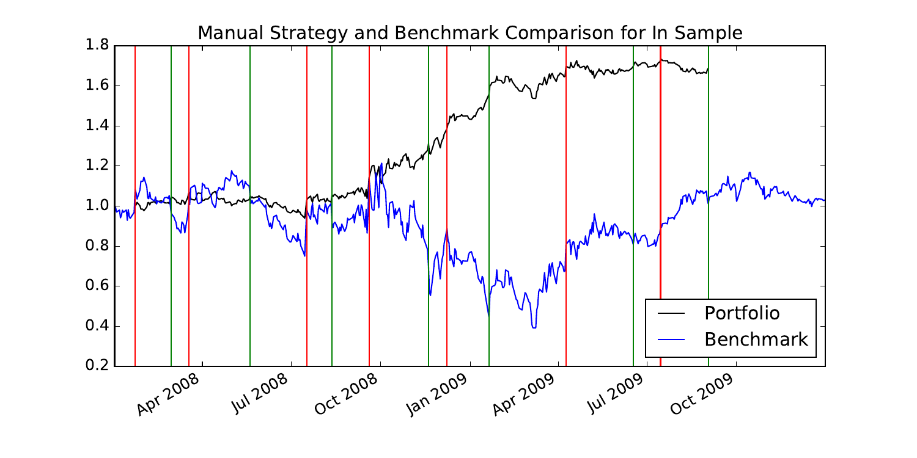**In Sample: January 1, 2008 to December 31 2009**

Here, red lines show ‘SELL’ signal, while green lines indicate ‘BUY’ signal. Portfolio and Benchmark are colored in black and blue colors respectively. As demonstrated via graphs, Portfolio performed bette than the Benchmark over in sample period.

|  |  |  |  |
| --- | --- | --- | --- |
|  | Average Daily Return | Cumulative Return | Std of Daily Return |
| Portfolio | 0.001383 | 0.688 | 0.0139 |
| Benchmark | 0.001396 | 0.032 | 0.052 |

Portfolio cumulative return yielded 68.8% profit with our manual strategy, while benchmark only made 3.2% profit. This suggests that our strategy is robust and way better than just buying and holding. On the other hand, surprisingly std_portfolio is lower than std_benchmark even if I optimized for cumulative return.

**Out of Sample: January 1, 2010 to December 31 2011**

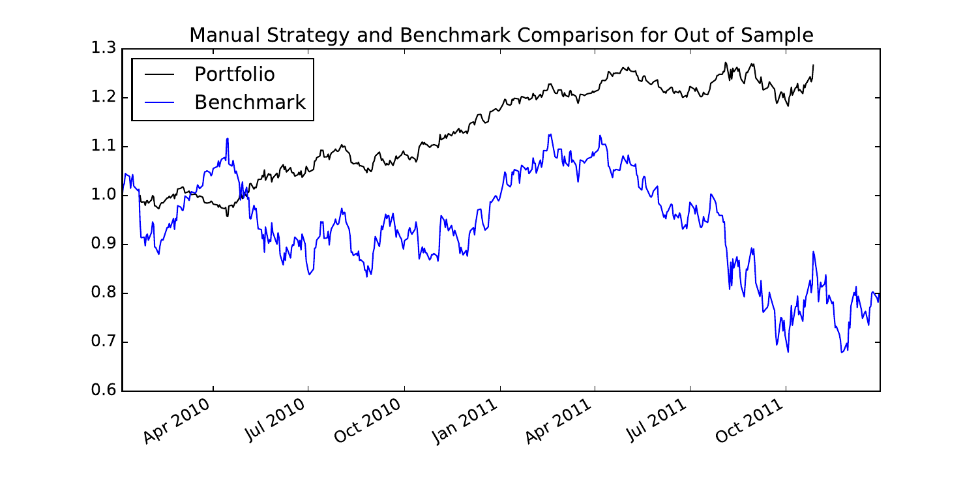

For out of sample period benchmark resulted in 20.04% loss, while our manual strategy based portfolio

outperformed the benchmark by making 26.7% gain. Apparently, during 2010 and 2011 period ‘JPM’ value overall reduced by 20.4%, where buying and just holding is the worst possible strategy.

|  |  |  |  |
| --- | --- | --- | --- |
|  | Average Daily Return | Cumulative Return | Std of Daily Return |
| Portfolio | 0.000553 | 0.267 | 0.00687 |
| Benchmark | -0.000198 | -0.204 | 0.02261 |

**Comparative Analysis**

|  |  |  |  |
| --- | --- | --- | --- |
|  | Average Daily Return | Cumulative Return | Std of Daily Return |
| In Sample | 0.001383 | 0.688 | 0.0139 |
| Out of Sample | 0.000553 | 0.267 | 0.00687 |

Comparison made between in sample and out of sample performance of manual strategy method show better(more) average daily return and cumulative return for in sample period. It makes sense to make more profit on training data than unseen data because it is more often hard to generalize.

It is possibly unexpected to see std deviation of daily return being higher for in sample data than out of sample that suggests higher risk. It might be result of maximizing cumulative return to find optimal parameters for in sample data. One could instead optimize for sharp ratio, which takes care of both profit and risk.