**Digital Communication Project**

**Title: Lab Management System with Group Chat and “Login System” Using Python Network Programming**

*By*

**Neel Shah**

**Roll No. 161080003**

**S.Y.B. Tech I.T. (Batch A)**



Veermata Jijabai Technological Institute, Matunga

**Table of Contents**

1. Abstract……………………………………………………………………………. 3
2. Introduction……………………………………………………………………… 4
3. Apparatus and Requirement…………………………………………….. 4
4. Implementation………………………………………………………………… 5
5. Timeline Chart…………………………………………………………………… 9
6. Outcome……………………………………………………………………………. 11
7. Future Developments………………………………………………………… 12
8. Cost……………………………………………………………………………………. 11

**Abstract:**

The project basically focuses on using python programming and its lower level classes like “socket” class to achieve sending and receiving messages on a computer system, along with enabling Lab Management System.

This uses network programming in python to achieve the chat server which acts as the host for the chat, and the chat client which may be attached to some other computer connected by a Wireless Network(such as over a WiFi Router or a mobile Hotspot). The program uses IP Addresses of the systems which act as the host and the client. It achieves Lab Management on the basis of the IP addresses of the clients. It checks the IP addresses of the clients to check if the same system is attempting to register attendance.

It gives a file with the attendance of that session and the total attendance of the session of the Lab.

This project will be of immense help and support for any future developments in Educational Institutions like VJTI and it can result in the revolutionising of the lab management systems. The project will use python as its basic programming language. The program will be written in this language.

**Introduction:**

The Project is about a revolution in the way “Labs” are managed in any Educational Institution. The project uses python as its basic language and networking to make communication between two systems or between two programs in the same system easy. When a message from the host is sent, it is received on the other end by the client and similarly when the client receives the message, it is displayed on the screen.

The program will result in a group chat. Before the chat window opens, there will be a “Login” window which will require the credentials of the student to enter in the chat room and mark their attendance.

The login system checks the id and password of the student who is registered for that particular computer system. If the credentials match, the system proceeds or else stops and prompts the user that the credentials entered by the user are not valid.

Once the student “Logs In”, the chat window is opened where the student enters his/her name for the attendance. The student can now send and receive messages and notifications from the other classmates and the professor himself.

**Apparatus and Requirements:**

Computer System (Minimum Intel Pentium Processor/ 2 Gigabytes RAM), Source code for the client and host, Python 3.x Interpreter, Wireless Connectivity, MySQL Servers.

**Implementation:**

The project uses python as the base language for programming. One main reason for the use of python as a language to write the source code is because this language can be widely used in many other applications and in emerging technologies like Machine Learning. The ease of programming in python is one other major reason for using python as the basic language. There are many Built- In Modules in this language providing ease of programming for the developer.

In [computer networking](https://en.wikipedia.org/wiki/Computer_networking), a port is an endpoint of communication in an [operating system](https://en.wikipedia.org/wiki/Operating_system). A port number is a 16-bit unsigned integer, thus ranging from 0 to 65535. A [process](https://en.wikipedia.org/wiki/Process_(computing)) associates its input or output channels via an [Internet socket](https://en.wikipedia.org/wiki/Internet_socket), which is a type of [file descriptor](https://en.wikipedia.org/wiki/File_descriptor), with a transport protocol, an [IP address](https://en.wikipedia.org/wiki/IP_address), and a port number. This is known as binding, and enables the process to send and receive data via the network. The operating system's networking software has the task of transmitting outgoing data from all application ports onto the network, and forwarding arriving network packets to processes by matching the packet's IP address and port number.

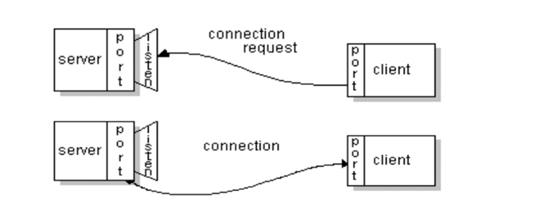

A socket is one endpoint of a two way communication link between two programs running on the network. A socket is bound to a port number so that the TCP layer can identify the application that data is destined to be sent to.

In [telecommunication](https://en.wikipedia.org/wiki/Telecommunication), a communication protocol is a system of rules that allow two or more entities of a [communications system](https://en.wikipedia.org/wiki/Communications_system) to transmit [information](https://en.wikipedia.org/wiki/Information) via any kind of variation of a [physical quantity](https://en.wikipedia.org/wiki/Physical_quantity). The protocol defines the rules [syntax](https://en.wikipedia.org/wiki/Syntax), [semantics](https://en.wikipedia.org/wiki/Semantic) and [synchronization](https://en.wikipedia.org/wiki/Synchronization) of [communication](https://en.wikipedia.org/wiki/Communication) and possible [error recovery methods](https://en.wikipedia.org/wiki/Error_detection_and_correction). Protocols may be implemented by [hardware](https://en.wikipedia.org/wiki/Computer_hardware), [software](https://en.wikipedia.org/wiki/Software), or a combination of both.

The Lab Management System connects more than two systems to the host computer, which runs the “Server” program and this lets the Professor handle the lab session with ease. The students can come in, register their attendance on the systems, and finish the work allotted.

The data about the attendance is stored in the Server computer.

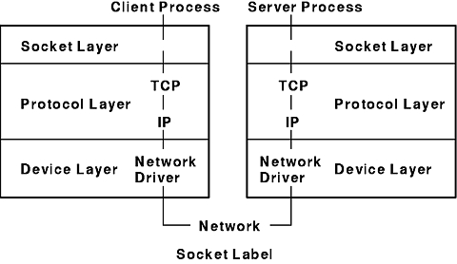

An Internet Protocol address (IP address) is a numerical label assigned to each device connected to a [computer network](https://en.wikipedia.org/wiki/Computer_network) that uses the [Internet Protocol](https://en.wikipedia.org/wiki/Internet_Protocol) for communication. [Internet Protocol version 4](https://en.wikipedia.org/wiki/IPv4) (IPv4) defines an IP address as a [32-bit](https://en.wikipedia.org/wiki/32-bit) number.[[1]](https://en.wikipedia.org/wiki/IP_address#cite_note-rfc760-1) However, because of the growth of the Internet and the [depletion of available IPv4 addresses](https://en.wikipedia.org/wiki/IPv4_address_exhaustion), a new version of IP ([IPv6](https://en.wikipedia.org/wiki/IPv6)), using 128 bits for the IP address, was developed in 1995. IP addresses are usually written and displayed in [human-readable](https://en.wikipedia.org/wiki/Human-readable) notations, such as 172.16.254.1 in IPv4, and 2001:db8:0:1234:0:567:8:1 in IPv6. IPv4 addresses are usually represented in [dot-decimal notation](https://en.wikipedia.org/wiki/Dot-decimal_notation), consisting of four decimal numbers, each ranging from 0 to 255, separated by dots, e.g., 172.16.254.1. Each part represents a group of 8 bits ([octet](https://en.wikipedia.org/wiki/Octet_(computing))) of the address.

The program will use the “Socket” class of python. This class is a lower- level class which deals with networking in python.

The Socket Class:

The [socket()](https://docs.python.org/3/library/socket.html#socket.socket) function returns a socket object whose methods implement the various socket system calls.

The module [socket](https://docs.python.org/3/library/socket.html#module-socket) exports the following elements:

socket.socket(family=AF_INET, type=SOCK_STREAM, proto=0, fileno=None)

socket.create_connection(address[, timeout[, source_address]])

socket.gethostname():Return a string containing the hostname of the machine where the Python interpreter is currently executing.

socket.sethostname(name)

Set the machine’s hostname to name. This will raise an [OSError](https://docs.python.org/3/library/exceptions.html" \l "OSError" \o "OSError) if you don’t have enough rights.

socket.accept()

Accept a connection.

The socket must be bound to an address and listening for connections.

socket.bind(address)

Bind the socket to address.

socket.close()

Mark the socket closed.

socket.connect(address)

Connect to a remote socket at address.

socket.listen([backlog])

Enable a server to accept connections.

socket.recv(bufsize[, flags])

Receive data from the socket.

socket.send(bytes[, flags])

Send data to the socket.

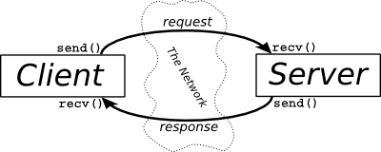

**Timeline Chart:**

|  |  |
| --- | --- |
| Week | Task |
| 1 | Installing python interpreter, searching packages and learning the basic commands. |
| 2 | Study of the “Socket” class and testing it. |
| 3 | Developing the code for the Server of chat. |
| 4 | Testing and debugging and fixing the code.  Making the code compatible to manage Attendance Systems. |
| 5 | Developing the code for Client of chat server and adding features for the lab management system. |
| 6 | Learning required functions for G.U.I. and checking the functions. |
| 7 | Including the G.U.I. (Graphical User Interface) in the program. |
| 8 | Testing, running on live system and final presentation of the project. |

**Outcome:**

At the end of the project, we will have a Lab Management System ready which can communicate between two separate programs. We will have learnt the use of python as a programming language to develop such programs which use networking, and connect such programs with MySQL Databases, and handling files using python. The project is a representation of how innovation can be brought to our educational institutions by applying our knowledge to develop the lab attendance systems and further developing other systems which can be innovative.

**Future Developments:**

This project is a perfect example of “Innovation” and how it can be brought about to make small changes in our daily life. This project can further be implemented in the labs for changing the way labs have been managed so far. This improves the efficiency of management and provides us a new system, which is both cheap and effective to implement.

**Cost:**

The python interpreters, MySQL servers and other software are available in our systems most of the times, and even if they ae not, they are available for download free of cost. If we have a basic computing system, which is a Desktop or a Laptop, the cost of the system can be ignored.

Thus, the overall cost of the project is effectively “Zero”.