Credit Card Customer & Financial Behavior Analytics
DATA ANALYTICS PROJECT
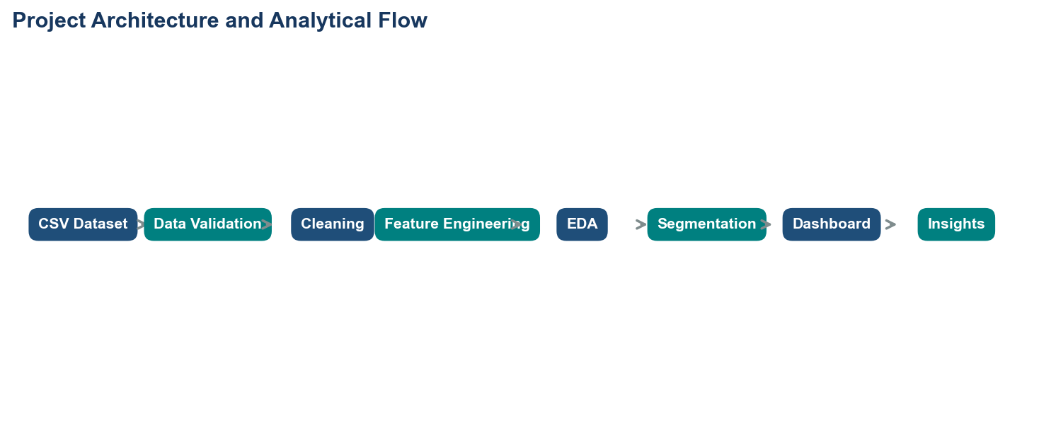
Prepared by | Technology | Dataset
NEERAJGIRI | Python | Pandas | NumPy | Matplotlib | Seaborn | Plotly | Streamlit | Credit Card Dataset for Clustering

Project title: Credit Card Customer & Financial Behavior Analytics

What this project does in one line: It transforms customer-level credit-card behavior into practical metrics, segments, visual analysis, and an interactive business dashboard.
AICTE | IBM SkillsBuild Data Analytics with AI Internship 2026

Table of Contents
1
The table of contents updates automatically when the document is opened in Microsoft Word. The section list below is included as a stable reading guide.
- 1. Executive Summary
- 2. Problem Statement
- 3. Project Objectives
- 4. Dataset Description
- 5. Data Dictionary
- 6. Data Quality Assessment
- 7. Data Cleaning & Preprocessing
- 8. Exploratory Data Analysis
- 9. Feature Engineering
- 10. Customer Segmentation
- 11. Financial Behavior Analysis
- 12. Key Findings & Insights
- 13. Business Recommendations
- 14. Dashboard Overview
- 15. Technical Architecture
- 16. Project Workflow
- 17. Limitations
- 18. Future Scope
- 19. Conclusion
- 20. References

1. Executive Summary
This project analyzes customer-level credit-card behavior using the Kaggle Credit Card Dataset for Clustering. The analysis focuses on balances, purchases, installment purchases, one-off purchases, cash advances, payments, credit limits, utilization, payment frequency, full-payment behavior, and account tenure.
The verified dataset contains one row per customer. It includes 8,950 unique customers and 18 source columns. This matters because the dashboard compares customer profiles rather than individual transaction records.
Portfolio snapshot
The source contains 8,950 customers, 18 original variables, 314 missing cells before cleaning, and 0 after cleaning. The zero-after-cleaning result means the dashboard can calculate its metrics consistently.

The project uses transparent data cleaning, ratio-based feature engineering, exploratory analysis, IQR-based outlier flagging, and rule-based customer segmentation. No predictive model or causal claim is presented. The Streamlit dashboard allows a reader to filter the portfolio and explore both segment-level and customer-level behavior.
The analysis can support descriptive business decisions such as designing segment-specific engagement experiments, monitoring credit utilization alongside payment activity, and identifying customer groups that merit deeper review. It should not be used by itself to approve credit, label customers as risky, or make personal financial recommendations.
In short: The project turns a wide customer table into an evidence-based, interactive portfolio view while keeping the analytical assumptions visible.

2. Problem Statement
Credit-card organizations collect many measures of customer behavior, but raw measures can be difficult to compare. A balance of $2,000 may represent very different behavior for customers with different credit limits. Similarly, a payment amount is easier to interpret when viewed alongside purchases, balances, and utilization.
The business problem addressed here is how to organize these measures into clear customer behavior patterns. The analysis examines spending intensity, purchase frequency, cash-advance use, installment behavior, payment activity, credit utilization, and tenure in one consistent framework.
- The problem is analytical: understand patterns and differences in the observed portfolio.
- The output is descriptive: KPIs, charts, segments, insights, and dashboard exploration.
- The project deliberately avoids unsupported claims about fraud, default, causation, or customer quality.
In short: The project addresses the gap between raw financial behavior fields and a clear, decision-supporting portfolio story.

3. Project Objectives
- Analyze customer financial behavior.
- Understand credit utilization and credit-limit context.
- Analyze purchase, installment, one-off, and cash-advance patterns.
- Study payment activity and full-payment behavior.
- Identify understandable customer segments using the existing rule-based method.
- Compare financial characteristics across segments.
- Detect unusual or extreme behavior without deleting valid observations.
- Build an interactive Streamlit dashboard with responsive filters.
- Generate evidence-based business insights and practical recommendations.
In short: The objectives cover the full analytics lifecycle while keeping the project understandable as a data analytics project rather than an ML project.

4. Dataset Description
Dataset name: Credit Card Dataset for Clustering. Source: Kaggle, https://www.kaggle.com/datasets/arjunbhasin2013/ccdata. The project reads the supplied CC GENERAL.csv file and keeps the original raw file unchanged.
Dataset item | Observed value | Why it matters
Records | 8,950 | Each record represents one customer; the count defines the population being compared.
Source variables | 18 | These fields describe account balances, spending, payments, frequencies, and tenure.
Unique customers | 8,950 | Unique IDs match the row count, verifying the one-row-per-customer grain.
Categorical fields | CUST_ID | The identifier is text; analytical behavior fields are numerical.
Tenure range | 6 to 12 months | The account-history window varies between six and twelve months.

The largest recorded source values include a balance of $19,043.14, purchases of $49,039.57, cash advances of $47,137.21, payments of $50,721.48, and a credit limit of $30,000. These are not automatically errors; they are retained as valid observations and considered in outlier analysis.
In short: The dataset is a static, customer-level portfolio snapshot with enough behavioral detail for descriptive comparison, but not enough context for causal or predictive conclusions.

5. Data Dictionary
The table below explains every source column in everyday language. Percentages and frequencies are represented as numeric values between zero and one where the dataset uses that scale.
Column | Business meaning | Data type | Observed range/example
CUST_ID | Customer identifier | object | C10001 to C19190
BALANCE | Statement balance | float64 | min 0.00; max 19,043.14
BALANCE_FREQUENCY | How often a balance is recorded | float64 | min 0.00; max 1.00
PURCHASES | Total purchases | float64 | min 0.00; max 49,039.57
ONEOFF_PURCHASES | Purchases made as one-off transactions | float64 | min 0.00; max 40,761.25
INSTALLMENTS_PURCHASES | Purchases made through installments | float64 | min 0.00; max 22,500.00
CASH_ADVANCE | Cash advance amount | float64 | min 0.00; max 47,137.21
PURCHASES_FREQUENCY | Frequency of purchase activity | float64 | min 0.00; max 1.00
ONEOFF_PURCHASES_FREQUENCY | Frequency of one-off purchases | float64 | min 0.00; max 1.00
PURCHASES_INSTALLMENTS_FREQUENCY | Frequency of installment purchases | float64 | min 0.00; max 1.00
CASH_ADVANCE_FREQUENCY | Frequency of cash advances | float64 | min 0.00; max 1.50
CASH_ADVANCE_TRX | Number of cash-advance transactions | int64 | min 0.00; max 123.00
PURCHASES_TRX | Number of purchase transactions | int64 | min 0.00; max 358.00
CREDIT_LIMIT | Assigned credit limit | float64 | min 50.00; max 30,000.00
PAYMENTS | Payments made | float64 | min 0.00; max 50,721.48
MINIMUM_PAYMENTS | Recorded minimum payment amount | float64 | min 0.02; max 76,406.21
PRC_FULL_PAYMENT | Percentage of periods paid in full | float64 | min 0.00; max 1.00
TENURE | Account tenure in months | int64 | min 6.00; max 12.00

In short: The data dictionary connects technical column names to the business behavior each field represents.

6. Data Quality Assessment
Data quality assessment means checking whether the source is complete, consistent, correctly typed, and suitable for analysis before building charts or conclusions.
Quality check | Result | Why it matters
Rows before cleaning | 8,950 | The starting population.
Rows after cleaning | 8,950 | No rows were lost because there were no exact duplicates.
Columns | 18 | Source fields loaded for analysis.
Missing cells before | 314 | These values required documented treatment.
Missing cells after | 0 | Zero means all displayed calculations have usable inputs.
Duplicate rows | 0 | No exact duplicate records were found.
Negative numeric values | 0 | No invalid negative financial values were found.

Column | Missing count | Missing percentage | Treatment
CREDIT_LIMIT | 1 | 0.0% | Median imputation
MINIMUM_PAYMENTS | 313 | 3.5% | Median imputation

Metric | Upper IQR threshold | Customers flagged
BALANCE | 4,942.93 | 695
PURCHASES | 2,715.87 | 808
CASH_ADVANCE | 2,784.55 | 1,030
CREDIT_UTILIZATION | 1.73 | 3
PAYMENTS | 4,177.92 | 808

IQR means interquartile range: the distance between the 25th and 75th percentiles, or the middle half of the values. The upper IQR threshold is a review boundary, not a proof that a record is wrong.
In short: The source is structurally clean, with two missing-value fields requiring transparent median treatment and several valid extreme values requiring contextual review.

7. Data Cleaning & Preprocessing
Step | What was done | Why it was done
Grain validation | Confirmed unique CUST_ID values and one row per customer. | Prevents accidental double-counting.
Type conversion | Converted all analytical columns to numeric values. | Makes formulas and summaries reliable.
Duplicate handling | Removed exact duplicate rows if present; observed count was zero. | Avoids counting one source record twice.
Missing values | Filled one CREDIT_LIMIT and 313 MINIMUM_PAYMENTS values with observed medians. | Keeps the customer population available for comparable calculations.
Invalid values | Checked for negative numerical values; none were found. Values are clipped at zero defensively. | Financial amounts and counts should not be negative in this dataset.
Extreme values | Retained valid extremes and flagged them with IQR thresholds. | Avoids deleting meaningful customer behavior.
Raw data | Kept the supplied CSV unchanged in the raw-data location. | Preserves reproducibility and auditability.

Imputation means filling a missing value using a documented replacement rule. Median imputation uses the middle observed value; it is less influenced by extreme values than an average. The project documents this assumption rather than presenting imputed values as originally observed.
In short: Preprocessing improves calculation reliability while preserving the raw source and avoiding blind outlier deletion.

8. Exploratory Data Analysis
Exploratory data analysis, or EDA, is the process of examining distributions and relationships before forming business interpretations. The report charts below are generated from the actual cleaned project data. Histograms are clipped at the 99th percentile only for visual readability; the underlying analysis retains all values.
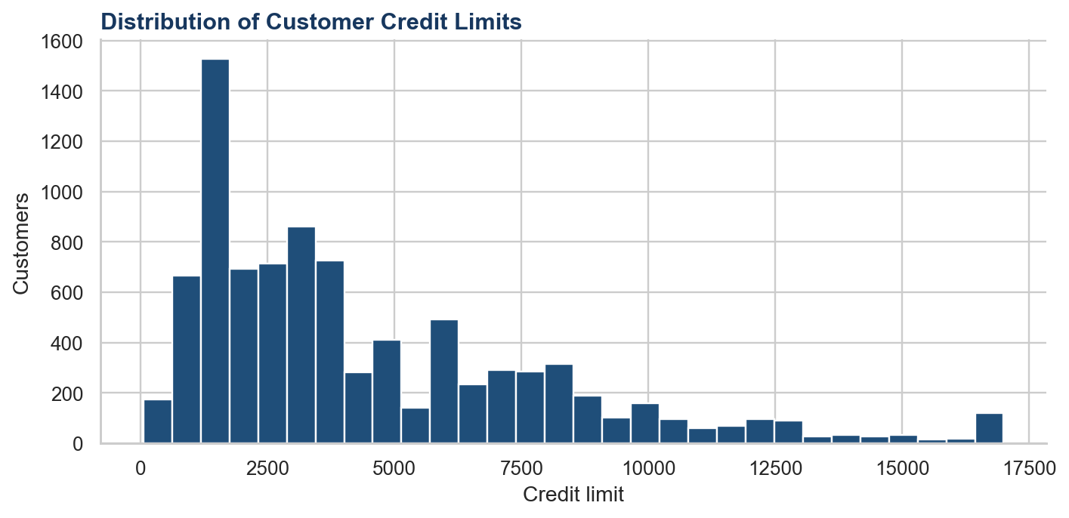
Figure 8.1 – Distribution of Customer Credit Limits
The distribution is concentrated around common credit-limit bands, with a long upper tail showing that a smaller number of customers have much larger limits.
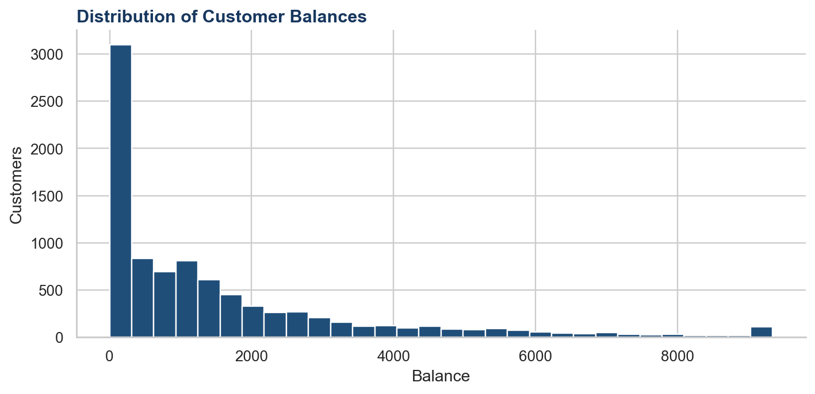
Figure 8.2 – Distribution of Customer Balances
Balances are right-skewed: many customers have relatively modest balances while a smaller group has much higher balances.
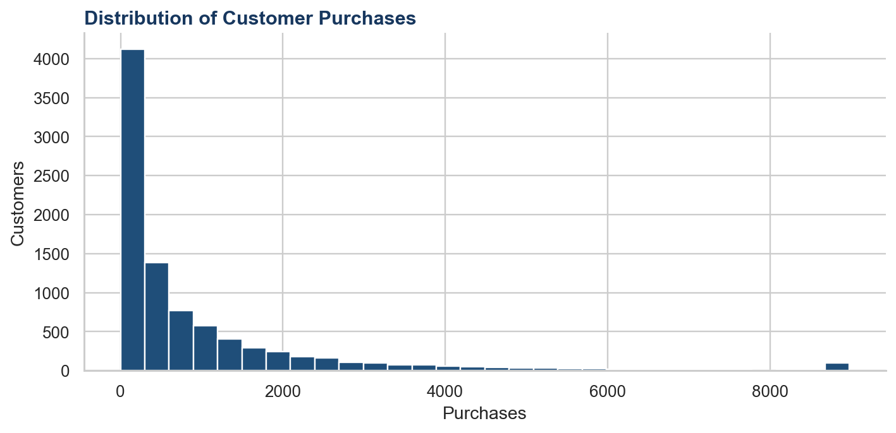
Figure 8.3 – Distribution of Customer Purchases
Purchase values are also concentrated at lower levels, with a smaller number of high-purchase observations.
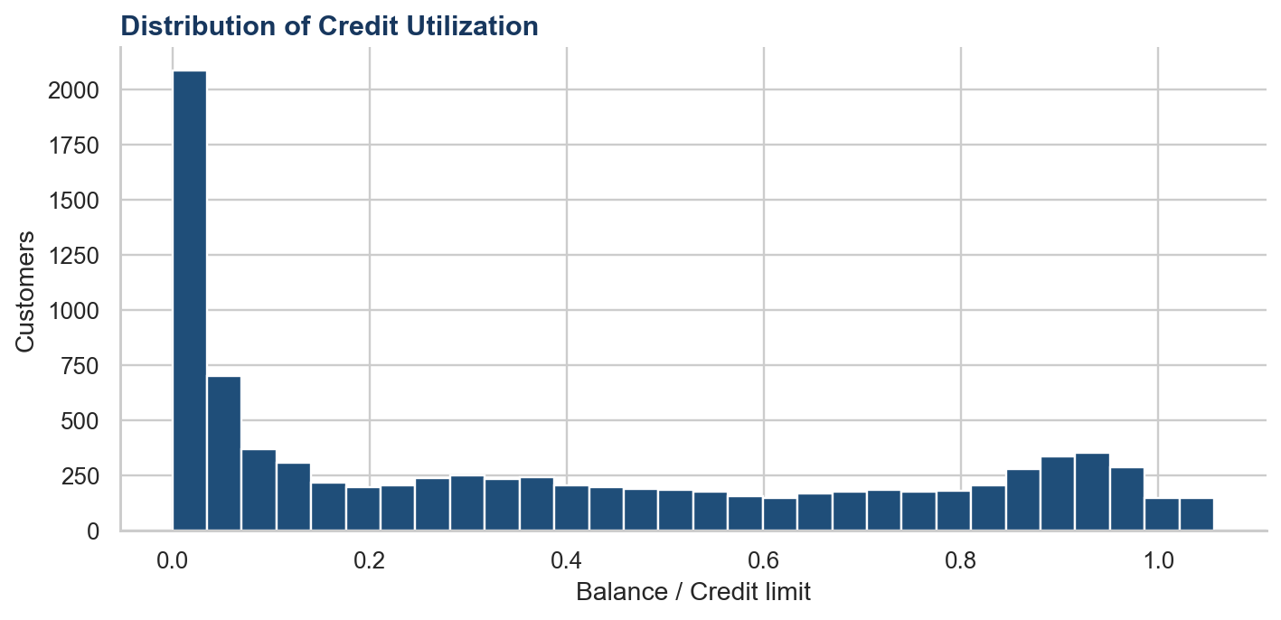
Figure 8.4 – Distribution of Credit Utilization
Most customers show lower utilization, while the upper tail identifies customers whose balances represent a larger share of their limit.
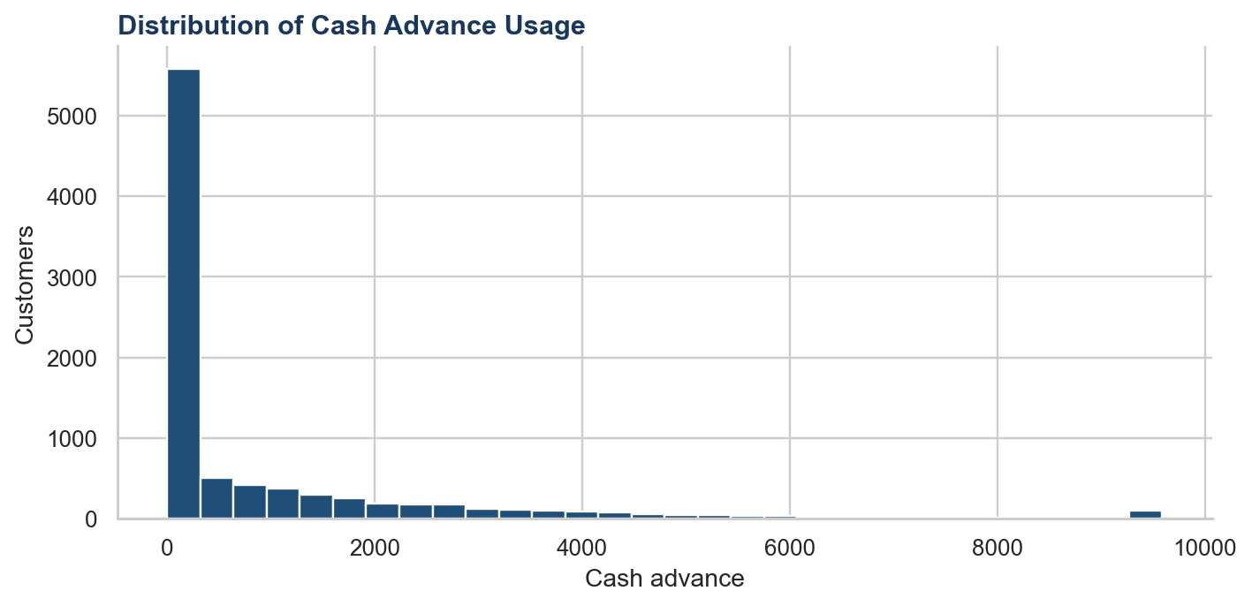
Figure 8.5 – Distribution of Cash Advance Usage
Cash advances are zero or low for many customers, with a visible group showing higher cash-advance activity.
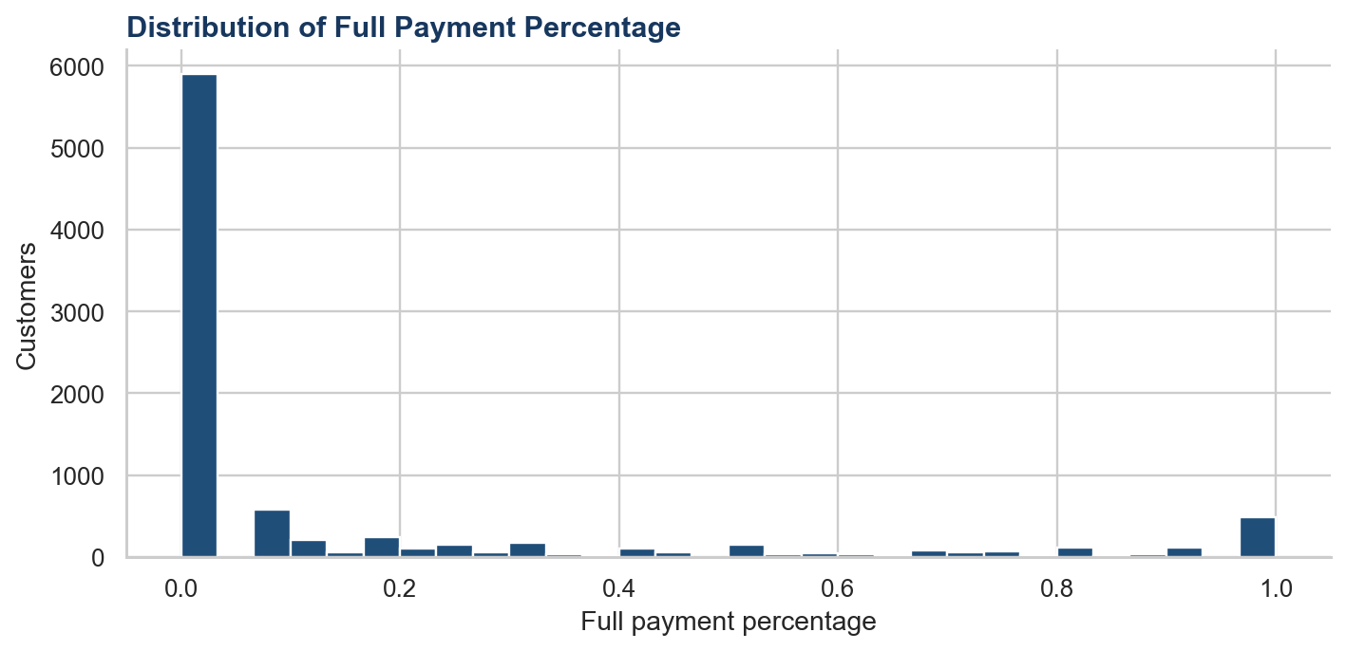
Figure 8.6 – Distribution of Full Payment Percentage
Full-payment percentages are concentrated near zero for many customers, indicating that full payment is not common across every record in the snapshot.

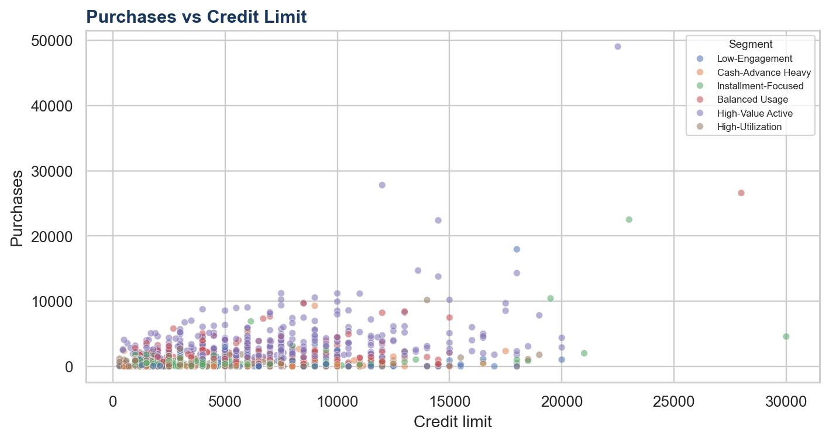
Figure 8.7 – Purchases versus Credit Limit by Customer Segment
The scatter chart compares purchase amounts with credit limits and colors customers by the rule-based segment. The pattern is an observed relationship, not proof that a larger credit limit causes higher purchases.
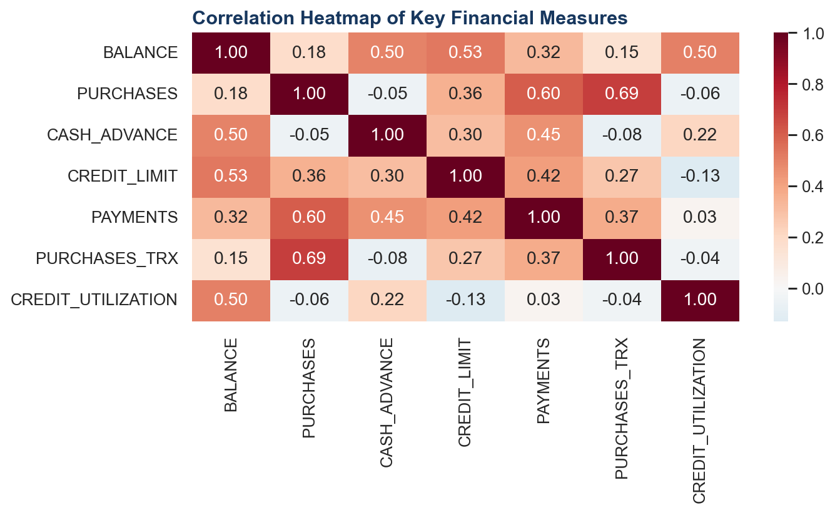
Figure 8.8 – Correlation Heatmap of Key Financial Measures
The heatmap summarizes pairwise association among important measures. It helps identify relationships worth exploring, but correlation alone cannot establish causation.
In short: The EDA shows skewed financial distributions, meaningful variation across customers, and relationships that are useful for descriptive comparison.

9. Feature Engineering
Feature engineering means creating new analytical measures from existing columns. The project uses safe division: when a denominator is zero, the derived metric is set to zero rather than producing an error or an infinite value.
Metric | Formula | What it tells the reader
Credit utilization | BALANCE / CREDIT_LIMIT | How much of the assigned limit is represented by the balance.
Payment ratio | PAYMENTS / BALANCE | Payment activity relative to balance; zero balances are handled safely.
Purchase-to-limit ratio | PURCHASES / CREDIT_LIMIT | Purchases in relation to assigned credit capacity.
Cash-advance intensity | CASH_ADVANCE / CREDIT_LIMIT | Cash advances in relation to assigned credit capacity.
Average purchase value | PURCHASES / PURCHASES_TRX | Approximate amount per purchase transaction.
Installment purchase share | INSTALLMENTS_PURCHASES / PURCHASES | Share of purchases represented by installments.

In short: The derived measures put raw amounts into context, making comparisons across customers and segments more meaningful.

10. Customer Segmentation
Segmentation means grouping customers with similar observed characteristics. The existing project uses rule-based business segments, not K-Means or another machine-learning clustering algorithm. Thresholds are calculated from the observed dataset, so the labels describe this portfolio and may change on another dataset.
Segment | Implemented rule | Business interpretation
High-Value Active | PURCHASES and PURCHASES_FREQUENCY are both at or above their dataset 75th percentiles. | High observed spending combined with frequent purchase activity.
High-Utilization | CREDIT_UTILIZATION is at or above its dataset 75th percentile. | Balances use a relatively large share of assigned limits.
Cash-Advance Heavy | CASH_ADVANCE_INTENSITY is at or above its dataset 75th percentile. | Cash advances represent a relatively large share of assigned limits.
Installment-Focused | INSTALLMENT_PURCHASE_SHARE is at least 60% and purchases are positive. | Installments represent most purchase value.
Low-Engagement | PURCHASES_FREQUENCY is at most 0.25 and PURCHASES_TRX is at or below the median. | Low observed purchase frequency and transaction activity.
Balanced Usage | Does not meet an earlier segment rule. | No single specialized behavior dominates the implemented rules.

Segment | Customers | Share | Avg purchases | Avg balance | Avg utilization | Avg cash advance
High-Utilization | 2,045 | 22.8% | $382.54 | $2,732.30 | 90.0% | $1,237.73
Installment-Focused | 1,924 | 21.5% | $521.09 | $376.72 | 9.3% | $71.40
High-Value Active | 1,384 | 15.5% | $3,562.29 | $2,050.01 | 32.7% | $623.25
Cash-Advance Heavy | 1,362 | 15.2% | $300.00 | $1,809.86 | 40.8% | $3,302.92
Low-Engagement | 1,144 | 12.8% | $290.09 | $1,113.35 | 20.5% | $481.38
Balanced Usage | 1,091 | 12.2% | $1,396.11 | $1,020.88 | 19.9% | $165.47

In short: High-Utilization is the largest implemented segment with 2,045 customers (22.8%); segment labels are descriptive groupings, not credit decisions.

11. Financial Behavior Analysis

A. Credit Utilization
Credit utilization is balance divided by credit limit. The average is 38.9%. A higher value means a larger share of assigned credit is represented by the balance; the measure should be read alongside payment activity and credit limits.
Relevant visuals: Figure 8.4, Figure 8.7, and the dashboard's Balance vs Credit Limit chart.
In short: The metric is useful for comparison, but it should be interpreted with the other financial behavior measures rather than in isolation.

B. Purchase Behavior
Average purchases are $1,003.20. Purchase totals are highly uneven, so the average should be read with the distribution and segment table rather than treated as a typical value for every customer.
Relevant visuals: Figure 8.3 and the dashboard's Purchases Distribution chart.
In short: The metric is useful for comparison, but it should be interpreted with the other financial behavior measures rather than in isolation.

C. Cash Advance Behavior
Average cash advance is $978.87. Cash-advance intensity compares this amount with credit limit, which makes customers with different limits more comparable.
Relevant visual: dashboard Cash Advance by Segment chart.
In short: The metric is useful for comparison, but it should be interpreted with the other financial behavior measures rather than in isolation.

D. Payment Behavior
Average payments are $1,733.14. The payment ratio compares payments with balance and is safely calculated when a balance is zero.
Relevant visual: dashboard Purchases vs Payments by Segment chart.
In short: The metric is useful for comparison, but it should be interpreted with the other financial behavior measures rather than in isolation.

E. Credit Limit
The average credit limit is $4,494.28, while the median is $3,000.00. The difference between average and median shows why both measures are useful when the distribution has a high-value tail.
Relevant visuals: Figure 8.1 and the dashboard Credit Limit Distribution.
In short: The metric is useful for comparison, but it should be interpreted with the other financial behavior measures rather than in isolation.

F. Customer Engagement
Average purchase frequency is 49.0%, while 22.8% of customers have zero recorded purchases. This is a descriptive engagement signal for the observation period, not an explanation of customer intent.
Relevant visual: dashboard Purchases Frequency Distribution.
In short: The metric is useful for comparison, but it should be interpreted with the other financial behavior measures rather than in isolation.

G. Installment Purchases
The installment purchase share identifies customers whose purchase value is primarily installment-based. This supports product and engagement analysis without assuming why a customer selected installments.
Relevant visual: dashboard Installment Purchases chart.
In short: The metric is useful for comparison, but it should be interpreted with the other financial behavior measures rather than in isolation.

H. Full Payment Behavior
Average full-payment percentage is 15.4%. The distribution shows that full-payment behavior varies substantially across customers.
Relevant visual: Figure 8.6 and the dashboard Full Payment Percentage Distribution.
In short: The metric is useful for comparison, but it should be interpreted with the other financial behavior measures rather than in isolation.

I. Tenure
Average tenure is 11.5 months. Tenure provides account-history context for spending and payment measures, although this snapshot cannot show how behavior changed over time.
Relevant visual: dashboard Tenure vs Spending chart.
In short: The metric is useful for comparison, but it should be interpreted with the other financial behavior measures rather than in isolation.

12. Key Findings & Insights
Finding 1
The portfolio contains 8,950 unique customers and one row per customer. This establishes the correct analytical grain and makes customer counts directly interpretable.

Finding 2
High-Utilization is the largest segment with 2,045 customers (22.8%). The largest group is the first audience for understanding the portfolio's most common observed pattern.

Finding 3
The average credit limit is $4,494.28, compared with a median of $3,000.00. Reporting both measures prevents the upper tail from hiding the middle customer experience.

Finding 4
Average credit utilization is 38.9%. Utilization provides context for balances by relating them to assigned credit capacity.

Finding 5
22.8% of customers have zero recorded purchases. The result identifies a sizable low-purchase group for further engagement analysis.

Finding 6
The observed purchases-to-credit-limit correlation is 0.36. The association is descriptive and should not be interpreted as a causal relationship.

Finding 7
Average cash advance is $978.87, with cash-advance-heavy customers identified using the portfolio's upper intensity quartile. Cash advances deserve a separate behavioral view because they differ from purchase activity.

Finding 8
Average payments are $1,733.14, while average full-payment percentage is 15.4%. Payment amount and full-payment frequency capture different aspects of payment behavior.

Finding 9
Average tenure is 11.5 months and the observed range is six to twelve months. Tenure gives context but does not provide a time series of behavior changes.

Finding 10
The source has no exact duplicate rows and no negative numerical values. The basic structural checks support using the records after the documented missing-value treatment.

In short: The strongest findings describe concentration, variation, and association in the observed portfolio without overstating what the data can prove.

13. Business Recommendations
Finding → Business interpretation → Recommended action
Segment concentration
Business interpretation: The largest segment represents the most common observed behavior.
Recommended action: Use segment profiles to design targeted engagement experiments and compare responses.

Finding → Business interpretation → Recommended action
Utilization monitoring
Business interpretation: Utilization is more interpretable when read with balance, limit, and payment measures.
Recommended action: Monitor these measures together instead of using a single ratio as a decision rule.

Finding → Business interpretation → Recommended action
Low purchase activity
Business interpretation: A measurable share of customers has zero purchases in the snapshot.
Recommended action: Consider activation research and message testing, while investigating whether the snapshot misses relevant context.

Finding → Business interpretation → Recommended action
Cash-advance behavior
Business interpretation: Cash-advance-heavy customers have a distinct behavior profile.
Recommended action: Create a separate monitoring view and review the pattern with business context before action.

Finding → Business interpretation → Recommended action
Installment behavior
Business interpretation: Installment-focused customers represent a distinct purchase mix.
Recommended action: Evaluate installment product communication and customer experience using controlled analysis.

Finding → Business interpretation → Recommended action
Static data limitation
Business interpretation: The dataset has no time dimension.
Recommended action: Add monthly history before claiming that behavior is changing or that an intervention worked.

In short: Recommendations are practical next steps for analysis and engagement planning, not guaranteed outcomes or personal financial advice.

14. Dashboard Overview
The Streamlit dashboard is the interactive application layer of the project. All displayed KPIs, tables, charts, and generated insights are recalculated from the active filtered data.
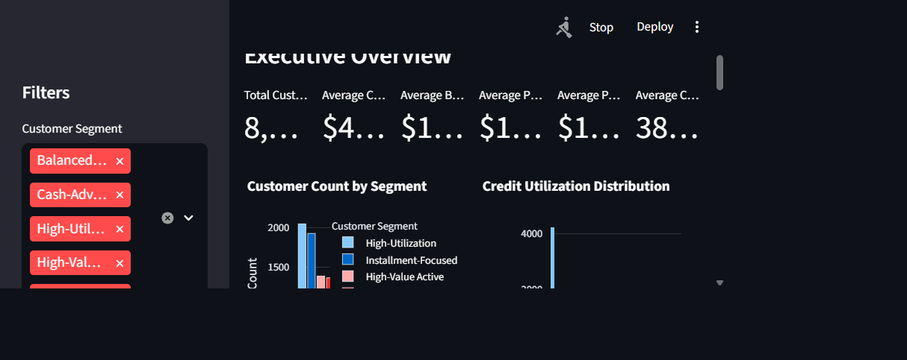
Figure 14.1 – Executive Overview Dashboard
The overview combines the main KPIs with segment distribution, utilization distribution, purchases versus credit limit, balance versus credit limit, and generated key insights.
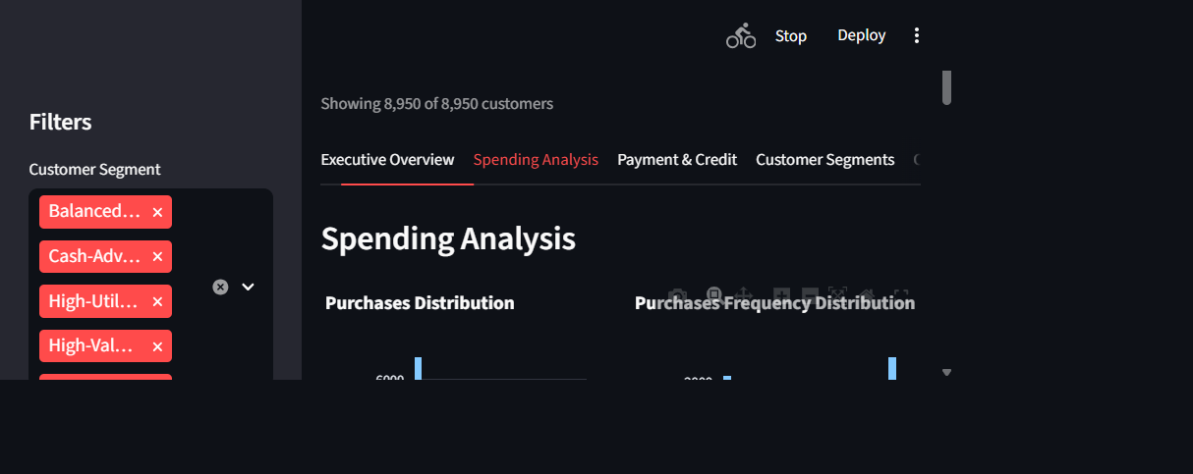
Figure 14.2 – Spending Analysis Dashboard
This view compares purchase amount, purchase frequency, one-off purchases, installment purchases, tenure versus spending, and cash advance by segment.

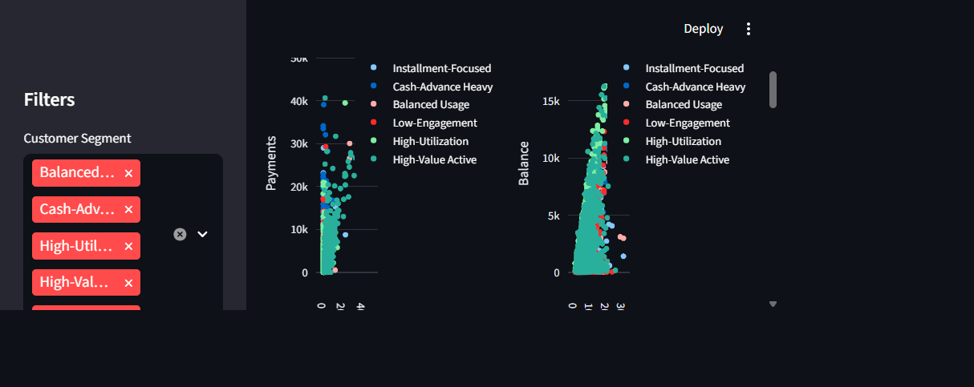
Figure 14.3 – Payment & Credit Analysis
This view connects purchases with payments, balances with credit limits, full-payment percentage, payment ratio, and the correlation heatmap.
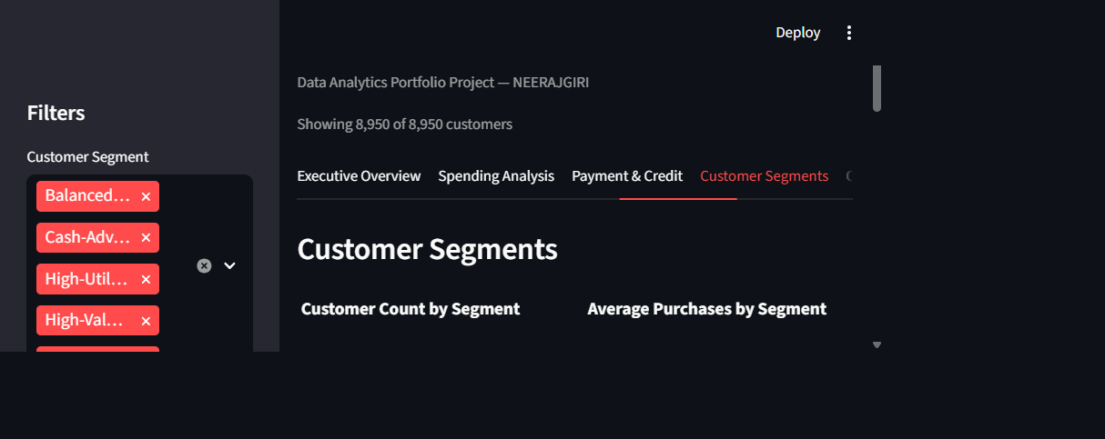
Figure 14.4 – Customer Segments
This view compares segment size, average purchases, balance, credit limit, payments, utilization, cash advance, frequency, and tenure.

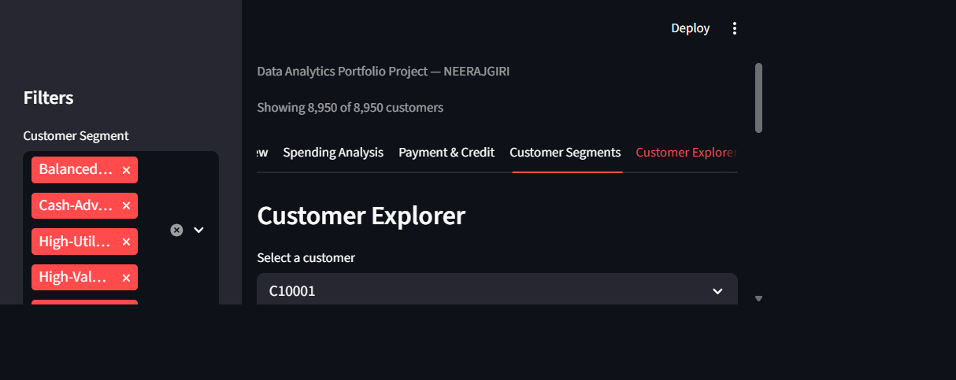
Figure 14.5 – Customer Explorer
The explorer allows one customer record to be selected and displays only relevant financial behavior metrics, without exposing personal information.
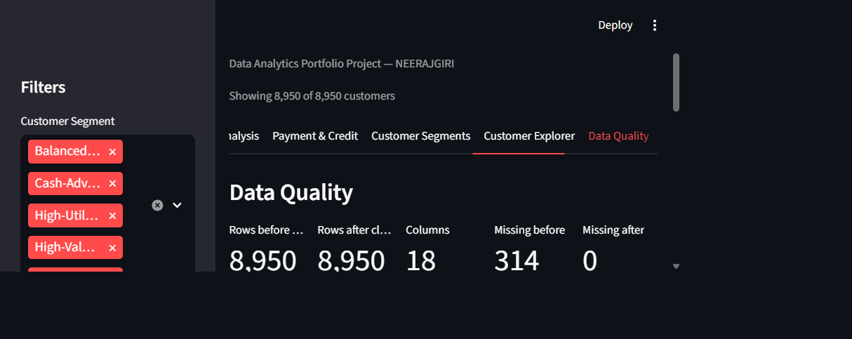
Figure 14.6 – Data Quality Dashboard
The data-quality view shows rows before and after cleaning, missing values, duplicate counts, cleaning operations, and retained outlier flags.
In short: The dashboard links portfolio-level analysis to filtered segment views and customer-level exploration through one consistent application.

15. Technical Architecture
The project is Python-based from data loading through dashboard rendering. The main source file is intentionally self-contained so another user can run the analytical application after installing requirements.txt and placing the raw CSV in the documented location.
Figure 15.1 – Technical architecture and analytical flow
File or component | Role
NEERAJGIRI_CreditCardCustomerFinancialAnalytics.py | Loads data, cleans it, engineers features, calculates KPIs, assigns segments, creates charts, and runs the Streamlit dashboard.
CC GENERAL.csv | Original manually supplied Kaggle dataset; kept unchanged as the raw input.
data/processed/cleaned_credit_card_customers.csv | Generated cleaned and feature-enriched data output.
requirements.txt | Lists the Python libraries needed to run the project.
README.md | Documents setup, functionality, project structure, and limitations.
screenshots/ | Stores actual rendered dashboard screenshots used in the portfolio and report.

In short: The architecture keeps the analytical logic visible in one main Python file while separating raw data, processed output, documentation, and screenshots.

16. Project Workflow
The workflow below shows how the project moves from a raw file to business-facing insight. Each stage has a distinct purpose and produces evidence for the next stage.
Stage | Output
Dataset | Verified source CSV and one-row-per-customer understanding.
Data validation | Column, type, missing-value, duplicate, and range checks.
Cleaning | Complete analytical table with documented imputation.
Feature engineering | Contextual ratios and behavior measures.
EDA | Distributions, relationships, and correlation views.
Segmentation | Six transparent rule-based behavior groups.
Visualization | Readable Plotly, Matplotlib, and Seaborn charts.
Dashboard | Interactive filters, tabs, tables, and customer explorer.
Business insights | Evidence-based findings and possible actions.

In short: The workflow creates a traceable path from data to information, information to insight, and insight to possible business action.

17. Limitations
- The dataset is a historical/static snapshot without a time series.
- Customer behavior may change after the observation period.
- Correlation does not establish causation.
- The dataset does not include demographic, campaign, or contextual variables that could explain behavior.
- The analysis uses only the variables supplied in CC GENERAL.csv.
- Rule-based segment thresholds are relative to this dataset and may not transfer unchanged to another portfolio.
- Median imputation makes the table complete but adds an assumption for missing values.
- The dashboard is descriptive and does not provide prediction, credit approval, fraud detection, or personal financial advice.
In short: The results are suitable for descriptive portfolio analysis, while stronger operational decisions require richer, time-based, and validated business data.

18. Future Scope
- Automated data pipelines and scheduled data-quality checks.
- Real-time or near-real-time dashboard refreshes.
- Validated thresholds based on business expertise and monitoring.
- Optional advanced customer clustering for comparison with the transparent rules.
- Predictive modeling for churn or other clearly labeled future outcomes.
- Credit-risk modeling only with appropriate labels, governance, and validation.
- Anomaly detection for unusual changes over time.
- Recommendation systems for controlled engagement experiments.
- Database integration and cloud deployment with access controls.
In short: Future improvements should add context and validation without losing the transparency of the current analytical workflow.

19. Conclusion
This project demonstrates the ability to transform raw financial customer data into a professional analytical product. The source was inspected, cleaned transparently, enriched with meaningful ratios, compared through rule-based segments, visualized in multiple ways, and presented in a responsive Streamlit dashboard.
The result is a descriptive decision-support tool: Data becomes organized information; information becomes evidence-based insight; and insight suggests business questions and possible actions. The project does not overstate what the dataset can prove, which is an important part of responsible analytics.
In short: The project connects technical Python work with clear business communication and a reproducible portfolio deliverable.

20. References
- Kaggle. Credit Card Dataset for Clustering. https://www.kaggle.com/datasets/arjunbhasin2013/ccdata
- Python Software Foundation. Python Documentation. https://docs.python.org/3/
- The pandas development team. pandas documentation. https://pandas.pydata.org/docs/
- NumPy Developers. NumPy documentation. https://numpy.org/doc/
- Matplotlib Development Team. Matplotlib documentation. https://matplotlib.org/stable/
- Waskom, M. Seaborn documentation. https://seaborn.pydata.org/
- Plotly Technologies Inc. Plotly Python documentation. https://plotly.com/python/
- Streamlit Inc. Streamlit documentation. https://docs.streamlit.io/
- python-docx documentation. https://python-docx.readthedocs.io/
In short: The report uses the supplied dataset and the documented Python analytics stack as its source material.

