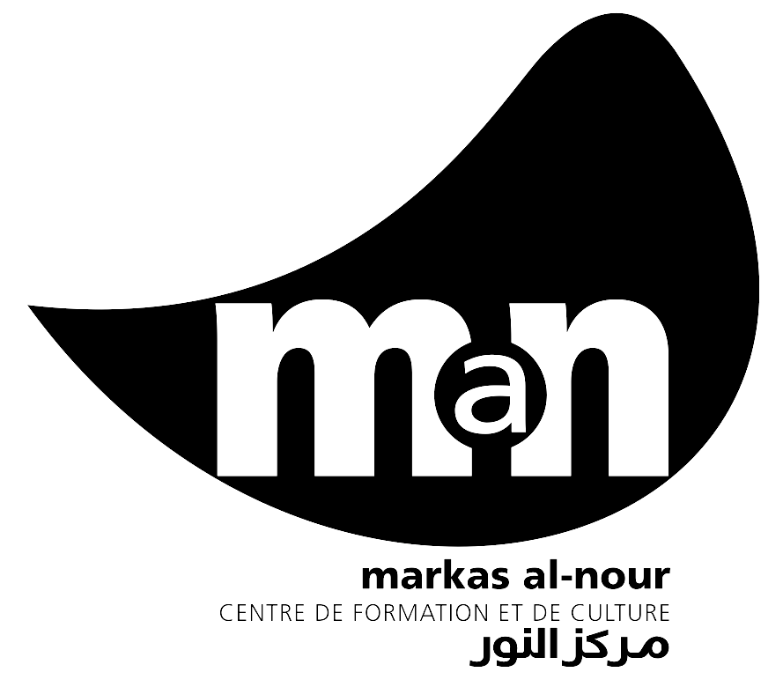
SERVICE AU SAHEL TCHAD (SAS) – Association à but non-lucratif
Markas al-Nour - | Centre de formation et de culture
Tel: 63 20 90 18 – http://markas-al-nour.org – info@markas-al-nour.org

Summary of English-results for -COURSE_ID-
Teacher's name: -TEACHER- From -FROM- to -TO-

NO | Name and surname | -TEST1- | -TEST2- | -TEST3- | -TEST4- | -TEST5- | -TEST6- | -TEST7- | -TEST8- | -TEST9-
1 | -NAME01-
2 | -NAME02-
3 | -NAME03-
4 | -NAME04-
5 | -NAME05-
6 | -NAME06-
7 | -NAME07-
8 | -NAME08-
9 | -NAME09-
10 | -NAME10-
11 | -NAME11-
12 | -NAME12-

Center director | Teacher
-RESP- | -TEACHER-

