WHY 4π
The Geometry of Isotropy
A Dialogue on Flux, Solid Angle, and the Architecture of Space
March 2026 — Draft
Abstract
This document traces a line of reasoning from a deceptively simple question — why does the flux equation contain 4π? — all the way to Emmy Noether’s theorem and the foundations of conservation laws. Each section is structured as a logical statement, an intuition, and its resolution, mirroring the progression of a live enquiry. The argument passes through solid angle geometry, Gauss’s Divergence Theorem, the dimensional argument for inverse-power laws, the conservation of specific intensity, physical realisations in lasers and pulsar beams, and the deep identification of isotropy with energy conservation through Noether’s theorem. No prior knowledge beyond introductory physics is assumed.

1. The Flux Equation and Its Components
The inverse square law of flux is one of the most encountered relationships in observational physics. Written in its standard form:
f = L / (4π d²)
Symbol | Physical Meaning
f | Flux — the power received per unit area at the detector
L | Luminosity — the intrinsic total power emitted by the source
4π | Total solid angle of all three-dimensional space (steradians)
d² | Square of the distance between source and detector

Each factor carries a distinct physical meaning. The equation is not an empirical fit — it is a theorem. This document traces the reasoning behind each component, starting with the most visually prominent and least intuitive: the 4π in the denominator.

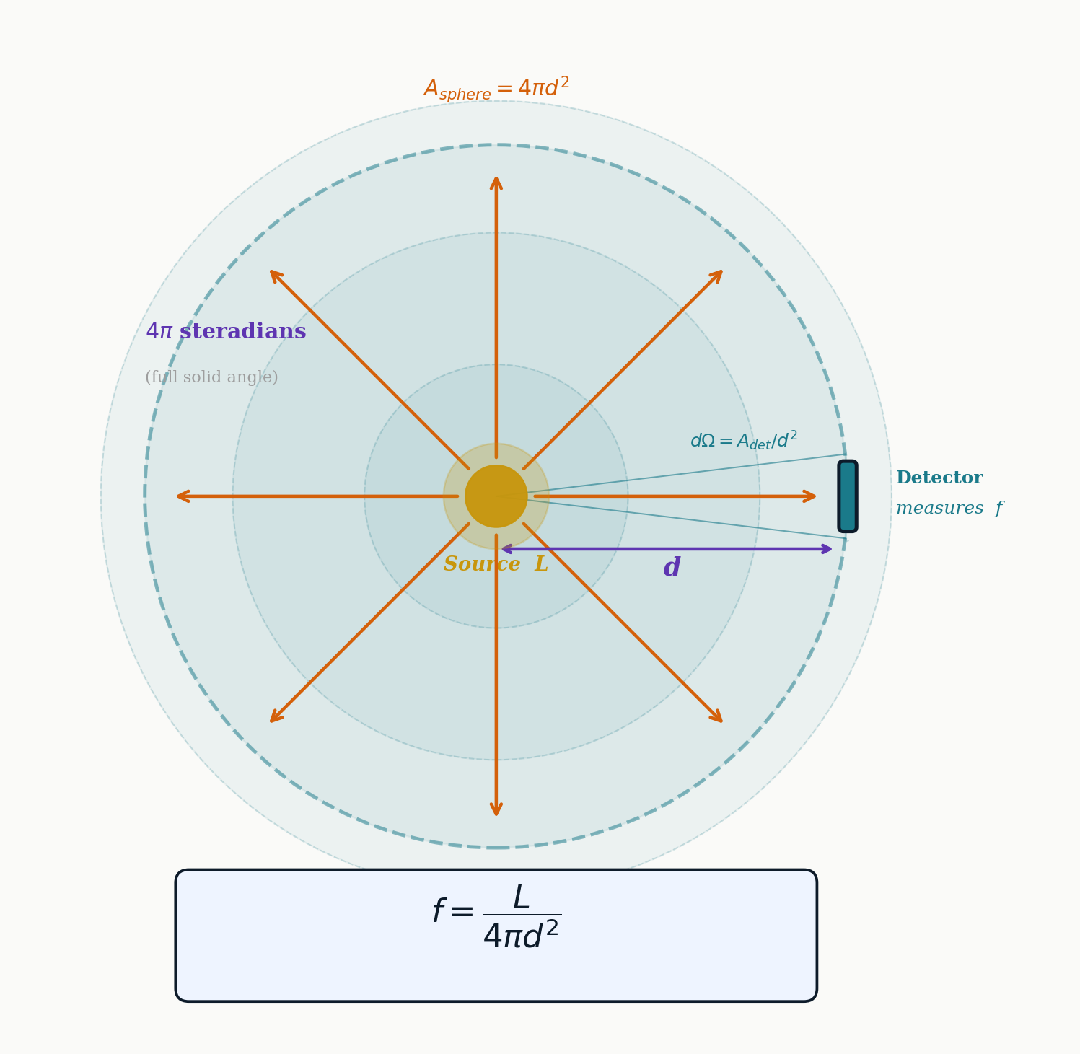
Figure 1.1: The inverse square law as a geometric statement. A source at the centre radiates isotropically into 4π steradians of solid angle. At distance d, the energy is spread over a spherical shell of area 4πd². The detector on the shell surface intercepts the fraction dΩ/4π of the total output.

2. Statement: “The 4π in the Denominator Appears Arbitrary”

2.1 The Intuition
The d² term in the denominator has an intuitive feel — light thins out with distance, and the square feels natural. But the 4π multiplier sitting next to it can feel like a constant inserted by convention rather than compelled by physics. Why π? Why 4? Why not 2π, or simply 1?

2.2 The Resolution: 4π Is the Total Solid Angle of 3D Space
The answer is geometric and exact. The solid angle element on the surface of any sphere is dΩ = sinθ dθ dφ. Integrating this over all directions:
Ωₜₒₜₐₗ = ∫₀²ᴵ dφ · ∫₀ᴵ sinθ dθ = 2π × 2 = 4π sr
This is not a convention. It is the exact measure of the entirety of three-dimensional space, as seen from any interior point. The number 4π appears because 4π steradians is what “all of space” means, quantitatively. A different universe with a different dimensionality would yield a different constant.
The 4π in the denominator of the flux equation reflects the fact that the source does not know where the detector is sitting. It broadcasts its output equally into every one of those 4π steradians. The detector, sitting at a particular angular position and distance, receives only its proportional share.

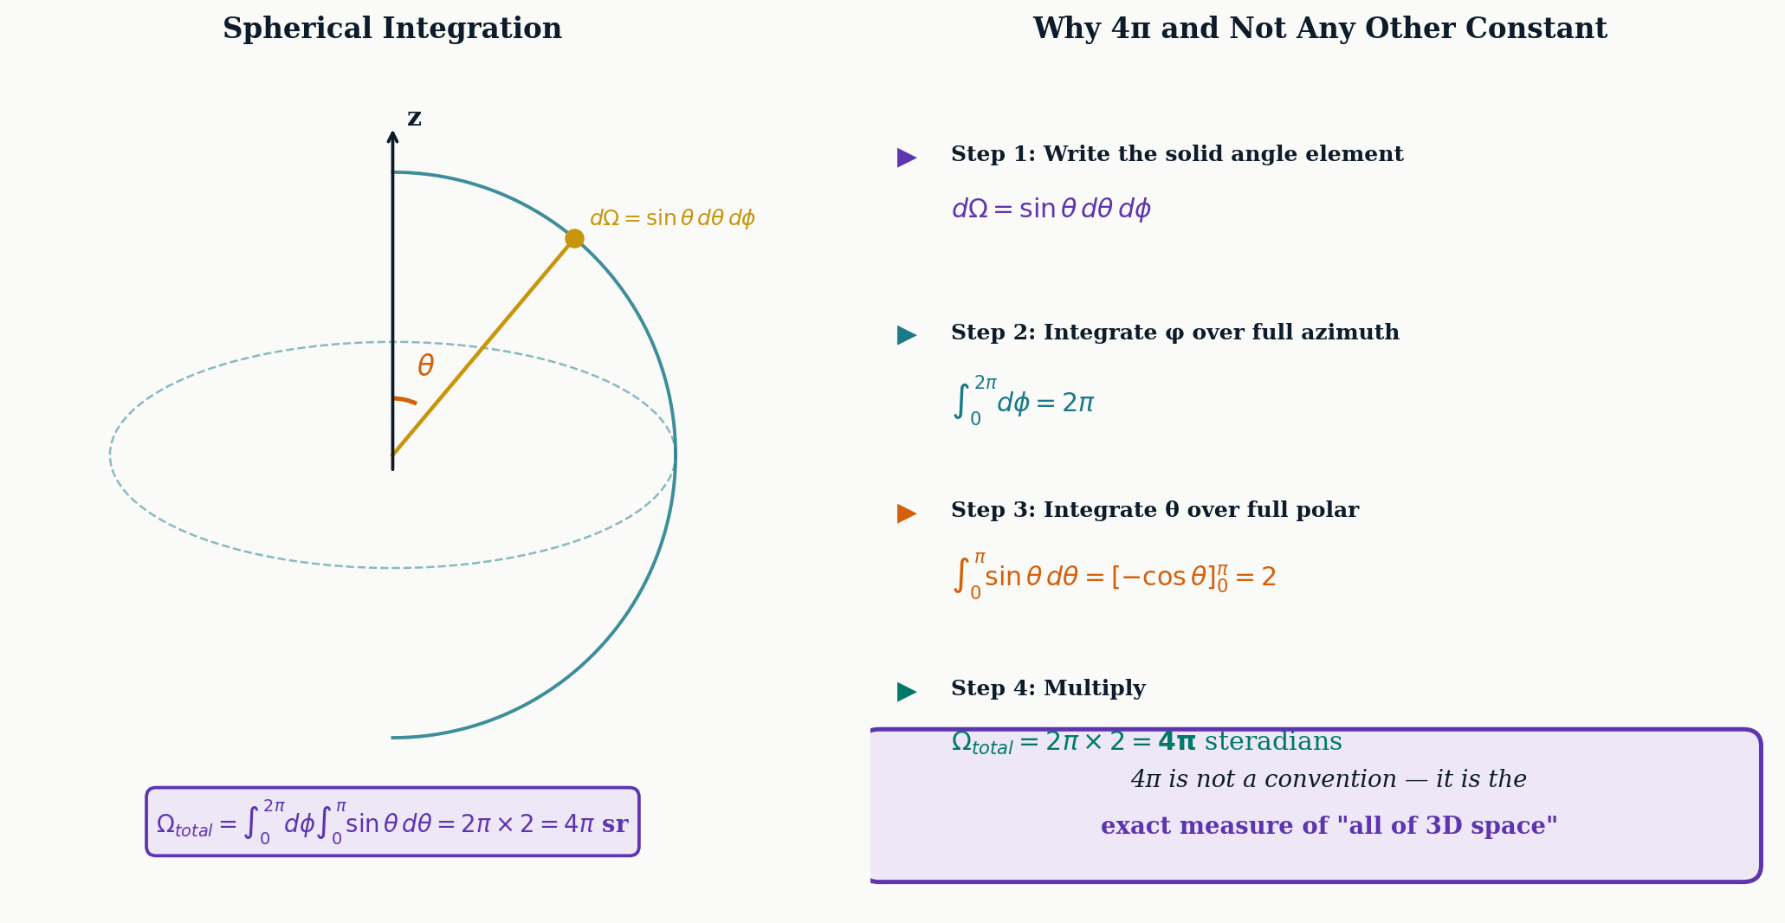
Figure 2.1: Left: the spherical coordinate system used to integrate the solid angle element sinθ dθ dφ over a complete sphere. Right: the four-step derivation confirming that the total solid angle is exactly 4π steradians — the unique constant of three-dimensional isotropic space.

2.3 From Source to Detector: The Proportional Slice
The power received by the detector follows directly from the proportionality of solid angles:
Quantity | Expression
Power per steradian (source) | L / 4π
Solid angle subtended by detector | dΩ = A_det / d²
Power received by detector | (L / 4π) × dΩ = L · A_det / (4πd²)
Flux (power per unit area) | f = L / (4πd²)

Dividing by 4π is the de-isotropisation operation: it converts the source’s total spherical budget into per-steradian currency, so the detector can price exactly the directional slice it inhabits.

3. Statement: “d² Is an Empirical Observation of Intensity Dropping”

3.1 The Intuition
The inverse square law is frequently introduced as an experimentally observed fact: measure a candle at two distances and the flux drops as the square of the ratio. This framing, while pedagogically convenient, is misleading about the nature of the law. The question is whether d² is contingent — something the universe could have arranged differently — or necessary.

3.2 The Resolution: d² Is a Theorem, Not an Observation
Energy conservation states that the total power crossing any closed surface surrounding the source must equal L. The surface’s shape does not affect this requirement. Gauss’s Divergence Theorem formalises this:
∮ₛ ƒ̲ · dA̲ = L_enclosed
The flux integral over any closed surface surrounding the source equals the enclosed source power. Choosing a sphere of radius d for convenience — the only choice consistent with isotropy (see Section 5) — gives:
f × 4πd² = L ⇒ f = L / 4πd²
The d² arises because the sphere’s surface area is 4πd². That surface area formula is a theorem of Euclidean geometry, not a measurement. In flat three-dimensional space, it is inescapable.

3.3 The Dimensionality Argument
The exponent 2 in d² is not special to our universe: it is the number of angular degrees of freedom available to the radiation in three spatial dimensions. In N spatial dimensions, photons have N−1 angular degrees of freedom, and the surface area of a hypersphere scales as r^(N−1):
Spatial Dimensions | Shell Geometry | Area Scales As | Flux Law
1D (a line) | — (no spreading) | d⁰ = 1 | f = L (constant)
2D (a plane) | Circle | 2πd | f ∝ 1/d
3D (our universe) | Sphere | 4πd² | f ∝ 1/d²
4D | Hypersphere | 2π²d³ | f ∝ 1/d³

The inverse square law is not a law of nature. It is a statement that space has three dimensions. If a measurement found flux falling as 1/d in some region, it would signal a 2D topology. The exponent in the flux law is a readout of the local spatial dimensionality.

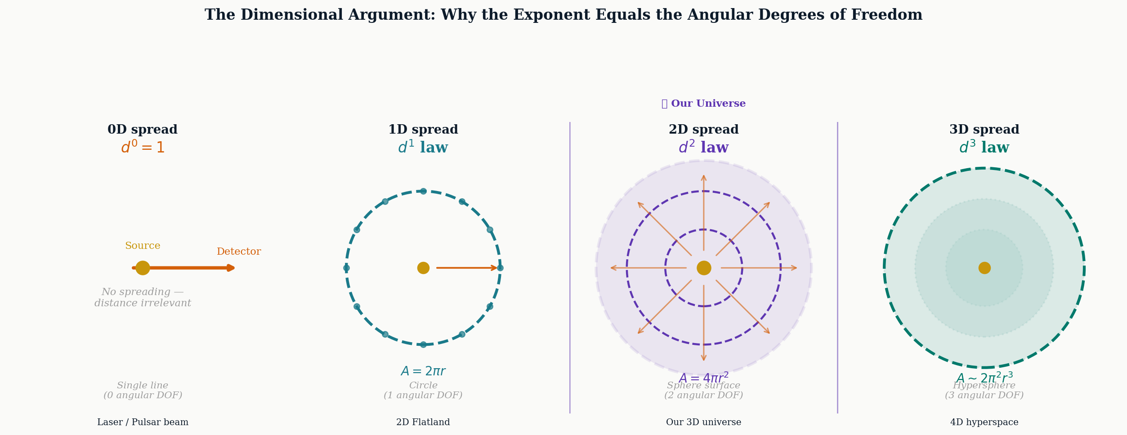
Figure 3.1: The dimensional argument illustrated. As the number of angular degrees of freedom increases from zero (a pure line) to three (a full hypersphere), the spreading geometry changes from no dilution at all to hyperspherical dilution. Our universe corresponds to two angular degrees of freedom and the familiar d² law. The highlighted panel marks our universe.

4. Statement: “What If the Source’s Output Were Confined to a Single Line?”

4.1 The Intuition
Consider a thought experiment: if all of a source’s energy could be directed along a single infinitesimally thin line aimed directly at a detector, with no angular spread whatsoever, what would the flux law become? The dimensional argument from Section 3.3 gives the answer immediately: d⁰ = 1. Distance would be completely irrelevant. The detector would receive the full output L regardless of how far away it was, provided the line remained intact.

4.2 The Resolution: d⁰ = 1 Is Not Merely Mathematical
The 1D case is not merely an abstract limit. In the line geometry, spreading dimensionality is zero: the source has no angular degrees of freedom to broadcast into. Energy cannot dilute because there is nowhere to dilute into. Two consequences follow immediately:
- The flux arriving at the detector equals the full luminosity L of the source.
- The energy of each individual photon arrives undiminished, since neither geometry nor medium nor any other mechanism removes it.

This is the regime of a collimated beam. In practice, the closest physical realisation is a laser in vacuum. Stimulated emission enforces phase coherence across the photon population, actively suppressing angular degrees of freedom at the point of emission. The beam does not spread not because spreading is energetically expensive, but because the quantum mechanism of emission forbids the angular freedom. On a macroscopic scale, a pulsar’s magnetic dipole geometry collimates the emission at the poles into a narrow beam, achieving the same suppression through field geometry rather than quantum coherence.
The 1/d² law breaks down completely for a collimated beam. A laser does not obey the inverse square law until diffraction forces it to spread. Diffraction is precisely the point at which the beam regains angular degrees of freedom — and the 4π accounting reasserts itself.

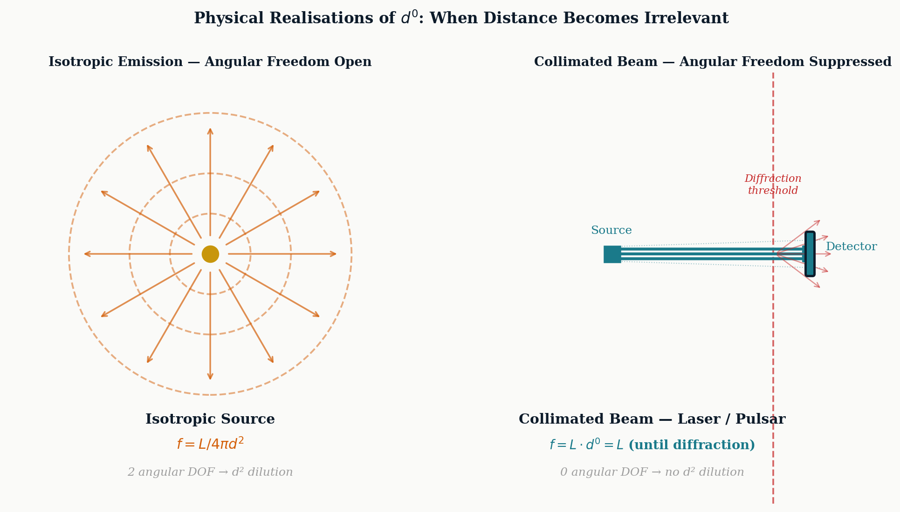
Figure 5.1: Left: an isotropic source radiating into all 4π steradians; the d² dilution is unavoidable. Right: a collimated source (laser or pulsar beam) with angular freedom suppressed. No d² dilution occurs until diffraction forces spreading, at which point angular degrees of freedom are reclaimed and the inverse square law reasserts.

5. Statement: “Why a Sphere and Not a Cube? Why a Circle and Not a Square?”

5.1 The Intuition
In stating that the source radiates into a sphere, the analysis assumes spherical geometry without fully justifying it. A Gaussian surface could be drawn as a cube, or any other closed surface. Does the choice matter? And if the sphere is the right choice, why is it?

5.2 The Resolution: Two Axioms Force the Sphere
Two physical requirements, when combined, uniquely determine the geometry:
- Conservation of energy: the total flux through any closed surface surrounding the source must equal L. The surface shape cannot affect this accounting.
- Isotropy of free space: no direction is privileged. The source has no knowledge of any preferred axis, and free space treats all directions identically.

A cube, a rectangular box, or any non-rotationally-symmetric surface would break the second requirement. Consider measuring the flux at a corner of a cube versus the midpoint of a face: the distances differ, so the flux would differ, implying the source “knows” about the cube’s geometry. This violates isotropy. The sphere is the unique closed surface that is equidistant from the interior at every point, in every direction. It is the only surface consistent with both axioms simultaneously.
The sphere is not drawn for mathematical convenience. It is the shape that appears when nothing prevents it — the natural boundary of a constraint-free, direction-free, energy-conserving source. A non-spherical surface would require an imposed constraint, a broken symmetry, something preventing uniform spread. Deviations from spherical geometry are always evidence of a constraint operating somewhere.

This principle runs through atomic physics as well. The ground-state s-orbital in hydrogen is a perfect sphere because the ground state of a spherically symmetric potential, in the absence of any preferred direction, must be rotationally symmetric. Any asymmetry would represent a broken symmetry and would cost energy. The same logic that forces the sphere in radiative transfer forces it in orbital geometry. The connection is not superficial — both are expressions of the same underlying symmetry principle.

6. Specific Intensity and the Conservation of Radiation

6.1 The Quantity That Does Not Drop
Flux decreases with distance. Specific intensity does not. This distinction is fundamental and is easily lost in the shorthand treatment of the inverse square law.
Specific intensity Iν is defined as the energy transported per unit time, per unit frequency, per unit area, per unit solid angle:
Iν = dE / (dt · dν · dA · dΩ)
In empty space, with no sources or absorbers along the path, the transport equation reduces to:
dIν / ds = 0
Specific intensity is a conserved quantity along a ray in vacuum. What does decrease with distance is the solid angle dΩ that the source subtends at the detector. As the detector recedes, the source occupies a smaller and smaller fraction of the sky. The flux drops because the detector is “collecting from a shrinking piece of the sky” — not because the radiation field in that direction has weakened.
Quantity | Varies with d? | Reason
Flux f | Yes, as 1/d² | Source subtends smaller solid angle dΩ
Specific intensity Iν | No (in vacuum) | Energy per steradian is conserved along ray
Individual photon energy | No (in vacuum) | hν unchanged; conservation of energy

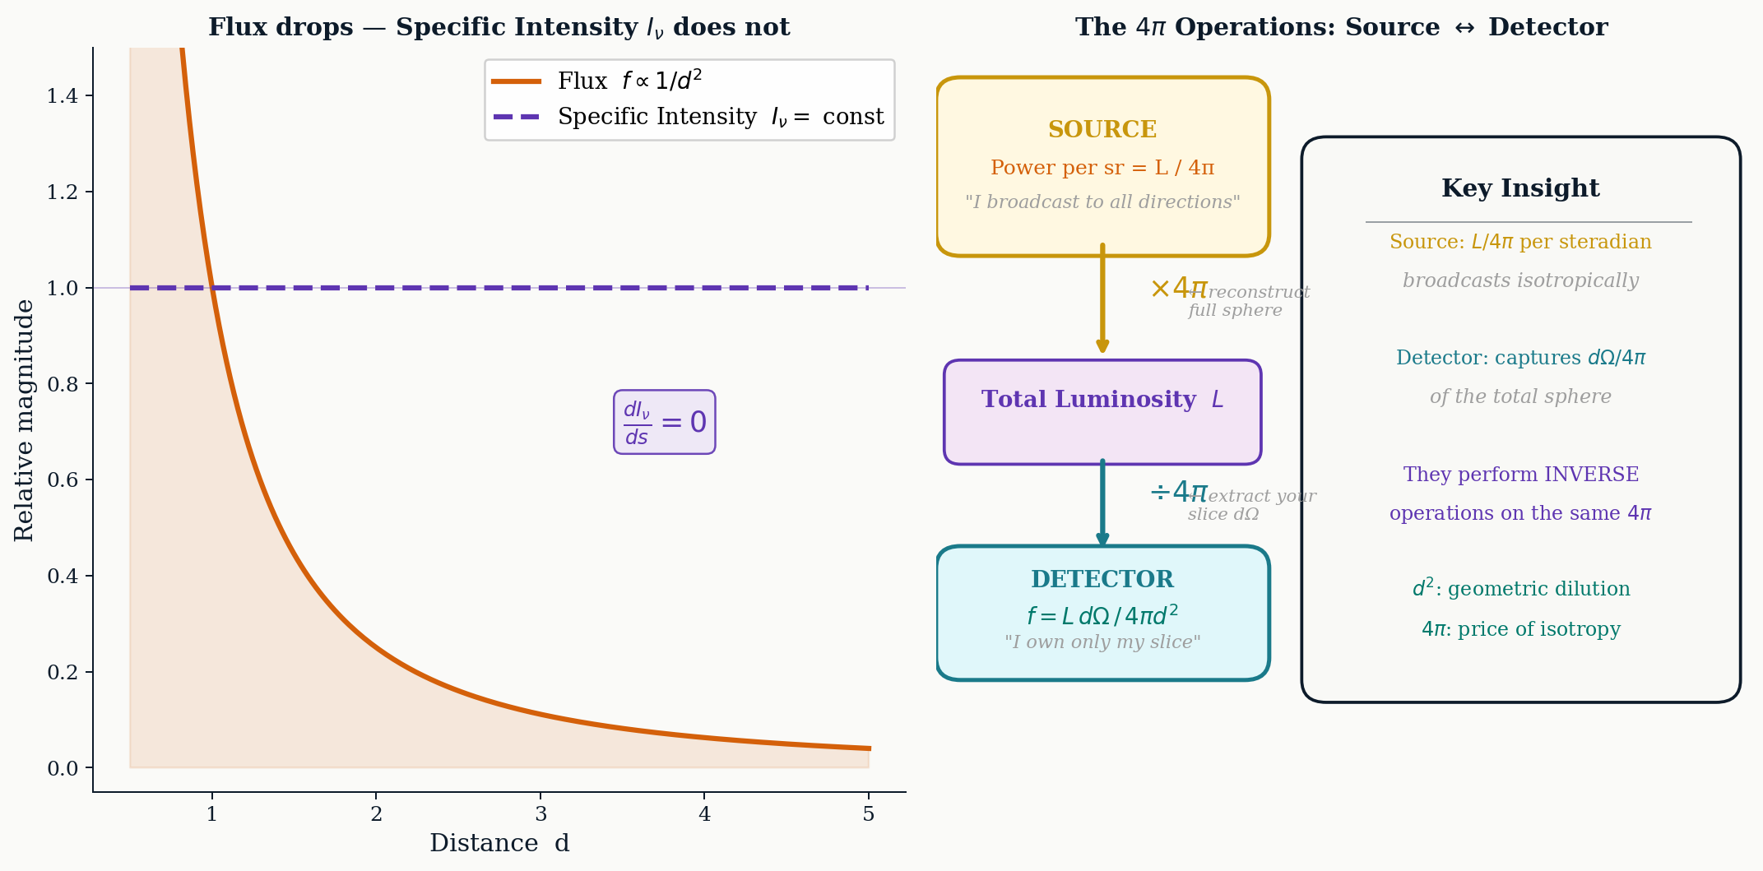
Figure 6.1: Left: the contrast between flux (which drops as 1/d²) and specific intensity Iν (which is constant along a ray in empty space). Right: the inverse operations performed by source and detector on the same 4π, illustrating how flux is the detector’s proportional share of the source’s isotropic budget.

6.2 Mean Intensity and the Restoration of the Sphere
The mean intensity Jν is defined as the average of the specific intensity over all incoming directions:
Jν = (1 / 4π) ∮ Iν dΩ
The 1/4π normalisation is precisely the inverse of the operation performed to obtain flux from luminosity. Where flux “extracts a directional slice” from the isotropic budget by dividing by 4π, mean intensity “puts the sphere back together” by averaging all slices with the same 1/4π factor. The same constant mediates both directions of the transformation.
The source multiplies its per-steradian output by 4π to fill all of space. The detector divides by 4π to recover only what its direction received. They perform inverse operations on the same 4π. The universe is consistent, and the 4π is the bookkeeping constant that makes it so.

7. The Photon as a Record of Its Path

7.1 d² as Null Hypothesis
In utopian space — perfectly flat, perfectly empty, non-expanding, no intervening matter or fields — a single photon aimed at a detector arrives with its energy completely intact. The d² in the flux equation says nothing whatsoever about this photon. It is a statistical statement about how an isotropic source shares its total output across all detectors at all positions. It describes the crowd, not the individual carrier.
The d² is the null hypothesis: the prediction for how much flux you would receive if absolutely nothing interfered with the photon along its path. Every departure from this prediction is a signal.

7.2 What the Photon Carries
A photon traversing a realistic path from source to detector does not emerge unchanged in all its properties. While its rest energy hν is conserved in vacuum (by time translation symmetry; see Section 8), several of its other properties carry the imprint of everything the path encountered:
Observable at Detector | Physical Effect Encoded
Frequency shift Δν | Gravitational potential wells, cosmological expansion, Doppler from source motion
Polarisation state | Magnetic field geometry along the path; scattering events and their geometry
Dispersion (arrival time vs ν) | Column density of free electrons — the interstellar medium (Dispersion Measure DM)
Arrival time deviation | Gravitational waves (basis of pulsar timing arrays)
Flux excess over d² prediction | Gravitational lensing — mass concentrations between source and detector
Flux deficit over d² prediction | Absorbing medium, dust, optical depth τ

The photon is not diminished by its journey. It is inscribed by it. Each photon that arrives is a sealed envelope that has passed through everything between the source and the observer, carrying imprints of every field, medium, and geometric distortion it encountered. Astrophysics is the science of reading those envelopes.

7.3 Where d² Breaks Down
The simple d² formula is modified by real physical processes:
Effect | Modified Flux Law
Absorbing medium (optical depth τ) | f = L · e^⁻ᶜ / (4πd²)
Cosmological expansion (redshift z) | f = L / (4π d_L²), d_L = (1+z) d_c
Gravitational lensing (magnification μ) | f = μ · L / (4πd²)
Curved spacetime | Replace d with luminosity distance d_L from metric

In each case, the d² template survives in form, but the additional factor is the universe’s way of writing a correction term into the photon’s record. The deviation from d² is not a failure of the law — it is the measurement.

8. The Deepest Root: Noether’s Theorem

8.1 Two Symmetries, Two Conservation Laws
Emmy Noether’s theorem (1915) establishes a rigorous correspondence between the continuous symmetries of a physical system and its conservation laws. In the context of free space, two symmetries are operational:
Symmetry of Free Space | Corresponding Conservation Law | What It Protects
Time translation: physics is the same at every moment | Conservation of Energy | The energy hν of each photon along its path
Rotational symmetry: no direction is privileged | Conservation of Angular Momentum | The spherical geometry and the 4π accounting

These two symmetries operate independently. In the d⁰ = 1 scenario (a pure line, Section 4), rotational symmetry has been completely collapsed: there is no sphere, no 4π, no d². But time translation symmetry is untouched. The photon’s energy hν arrives exactly as it departed — not because of geometry, but because the universe at no point along the path is different from any other point in time.

8.2 The Unification
The deeper result, arrived at through the chain of reasoning traced in this document, is that the axioms typically listed separately — conservation of energy, isotropy of space, spherical geometry, and Gauss’s Law — are not four independent assumptions. They are one physical fact, stated four different ways:
- Conservation of energy in a constraint-free space requires that no direction be preferred — because preferring a direction would mean energy “knows” about that direction, an imposed constraint.
- No preferred direction requires that the bounding geometry be rotationally symmetric in all directions simultaneously.
- Rotational symmetry in all directions requires the sphere — the unique closed surface equidistant from its centre in every direction.
- The sphere requires 4π as its total solid angle — the unique constant of the resulting geometry.
- Gauss’s Law is conservation of energy written in the language of the geometry that conservation itself demanded.

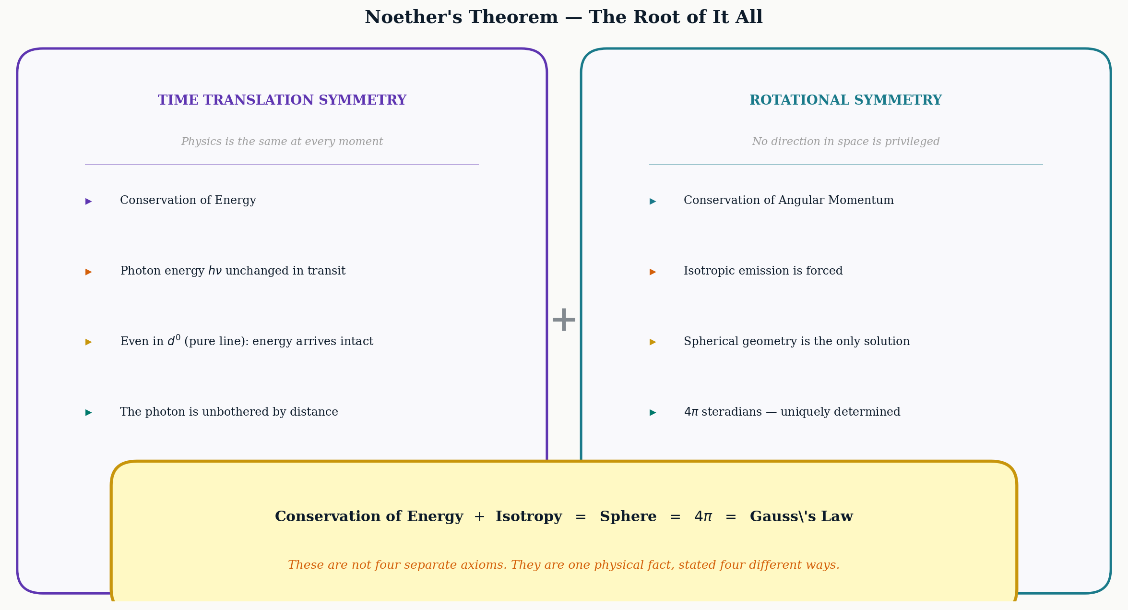
Figure 8.1: Noether’s theorem applied to the two fundamental symmetries of free space. Time translation symmetry protects the photon’s energy along its path independently of geometry. Rotational symmetry forces the spherical geometry and the 4π constant. The bottom panel states the key unification: these are not four separate axioms but one physical fact, expressed in four different mathematical languages.

Conservation of energy + Isotropy = Sphere = 4π = Gauss’s Law.
These are the same physical truth. Every deviation from spherical geometry — a laser beam, a pulsar, a crystal lattice, an atomic orbital — is evidence of a constraint operating somewhere. The sphere is not chosen for convenience. It is what appears when nothing prevents it.

9. Summary of Logical Progression
The following table summarises the chain of statements, intuitions, and resolutions developed across this document:

Statement / Intuition | Resolution
Why 4π in the denominator? | 4π steradians is the total solid angle of 3D space — the measure of all directions simultaneously. Not a convention.
d² feels empirical, like an observed drop in intensity. | d² is a geometric theorem from Gauss’s Divergence Theorem applied to a sphere forced by isotropy. It cannot be otherwise in flat 3D space.
What if all output were along a single line? | Distance becomes irrelevant: d⁰ = 1. The exponent is the count of angular DOF. In 3D space that count is 2, giving d².
Why a sphere and not a cube? | Conservation + isotropy uniquely force the sphere. Any other surface breaks rotational symmetry and implies the source “knows” a preferred direction.
The photon itself doesn’t dim. So what is d² about? | d² is a crowd-thinning statistic about isotropic sharing. Each individual photon arrives with full energy hν — by Noether, from time translation symmetry.
What does the photon carry? | A complete record of every field, medium, and geometric distortion along its path. Deviations from d² are the measurements.
Are conservation, isotropy, 4π, and Gauss’s Law independent axioms? | No. They are one fact stated four ways. Noether’s theorem sits at the root of all of them.


Figure 9.1: Recap: the 4π integral and its step-by-step derivation. What begins as a question about a constant in a formula ends as a statement about the symmetry structure of space itself.

— Draft for review —

