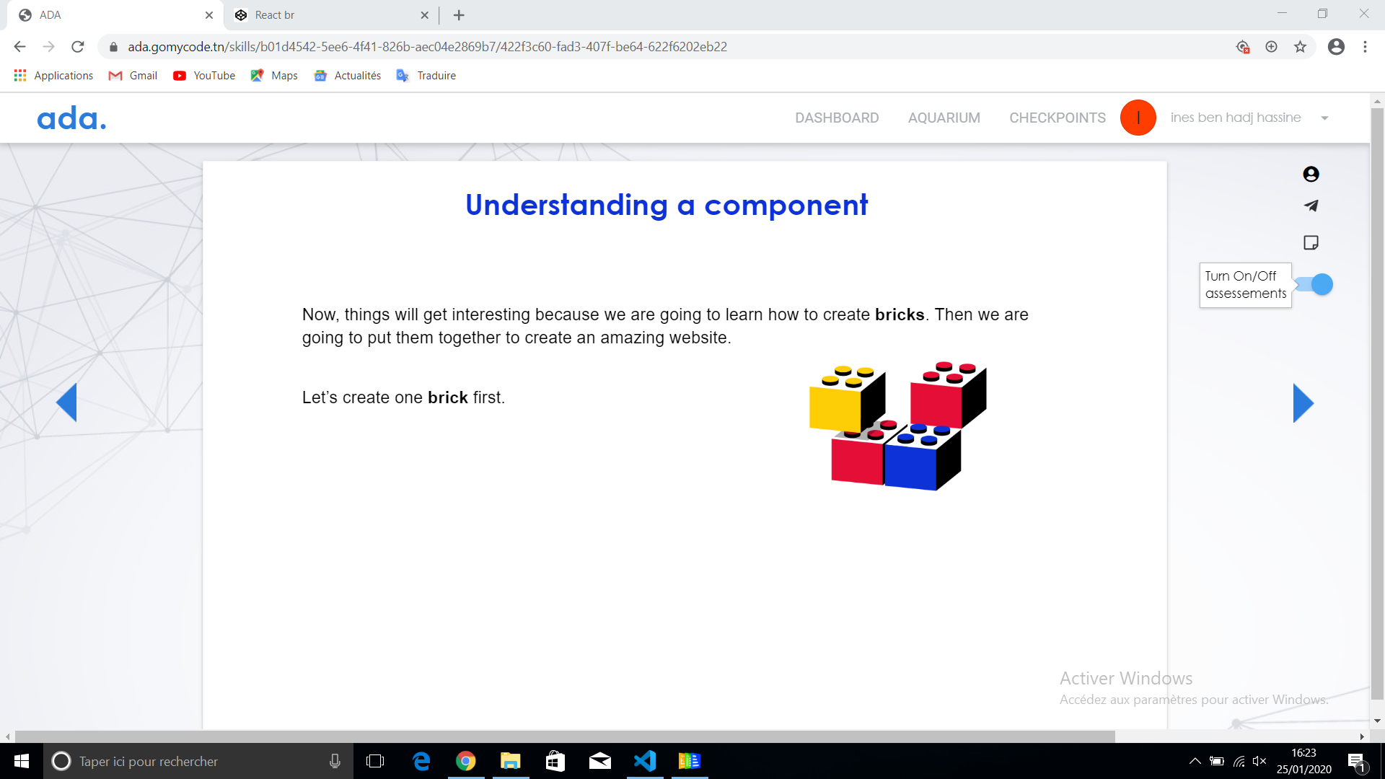

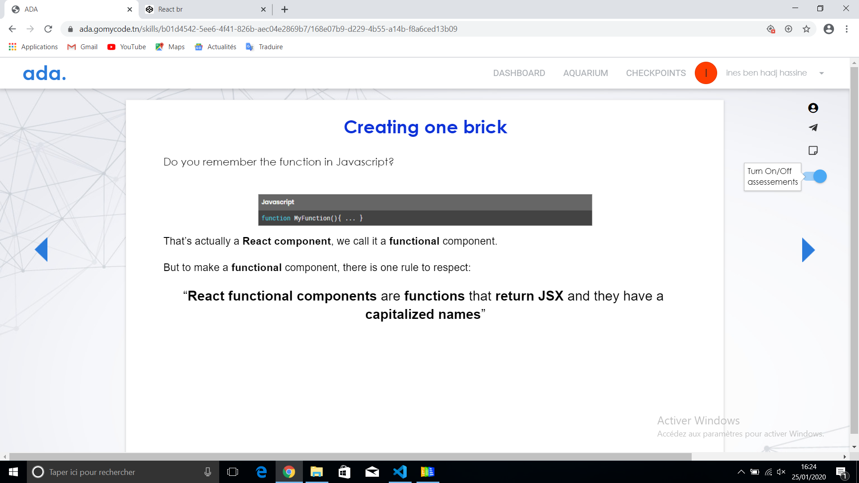

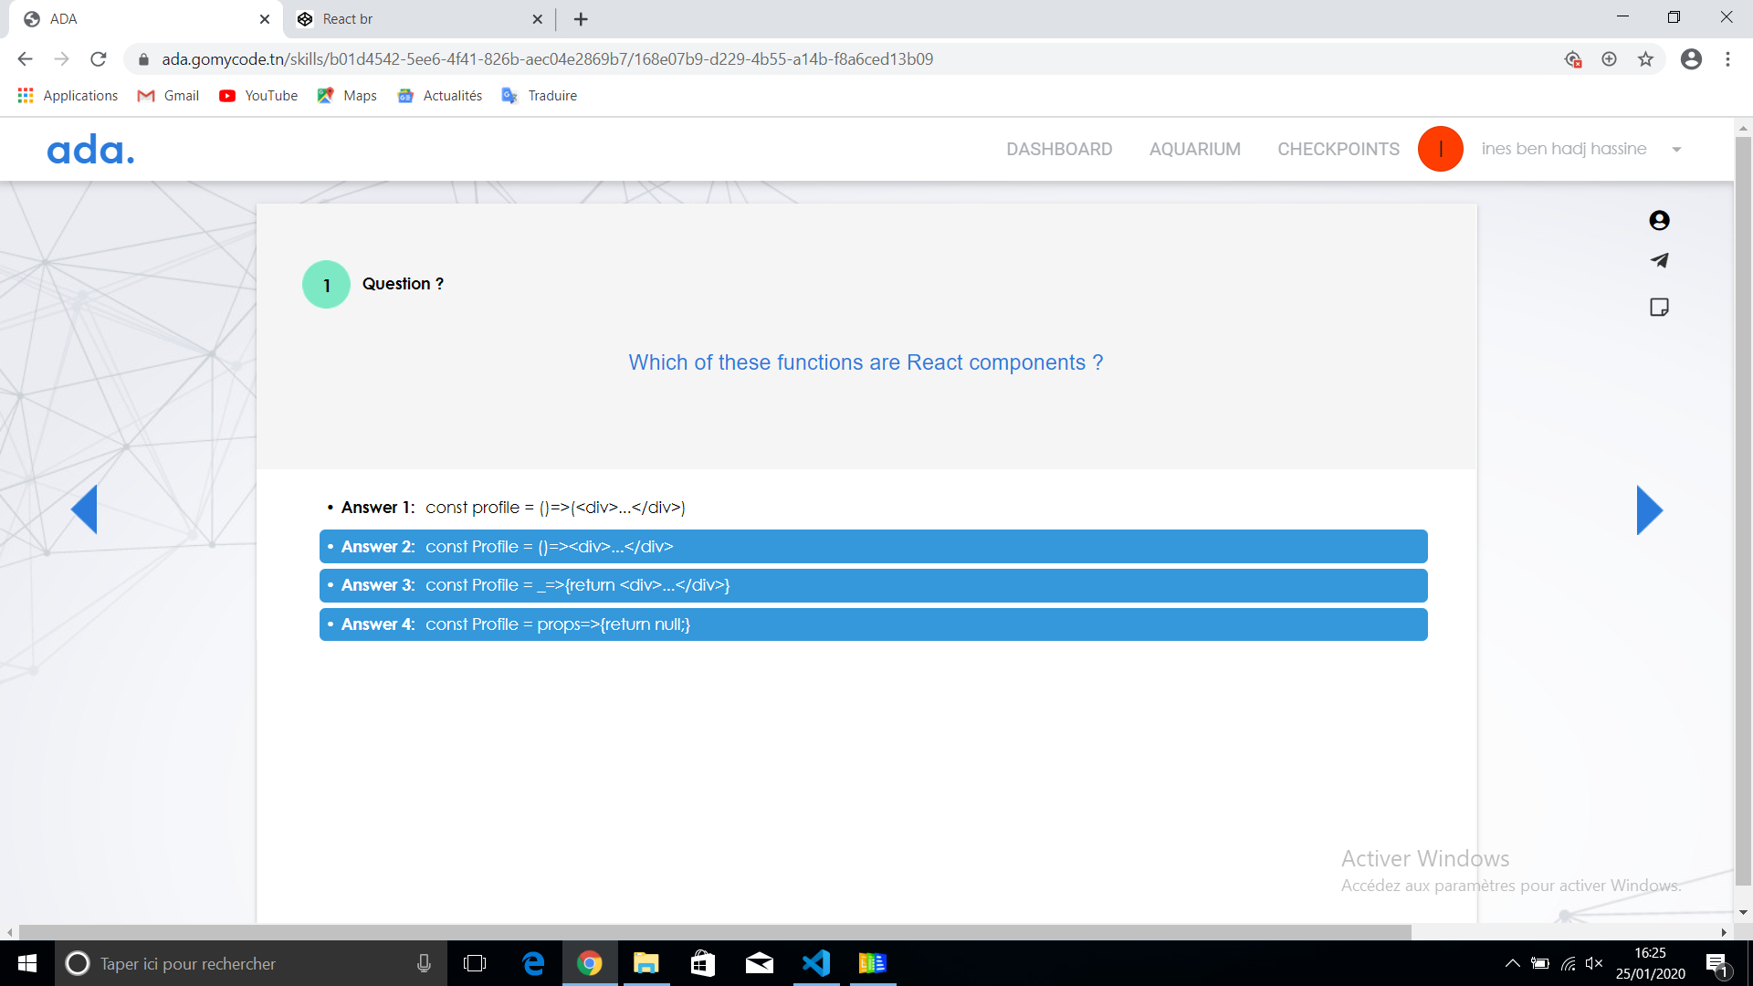

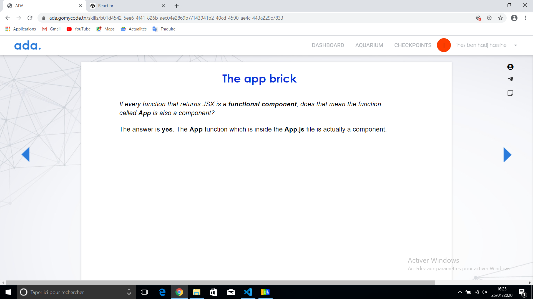

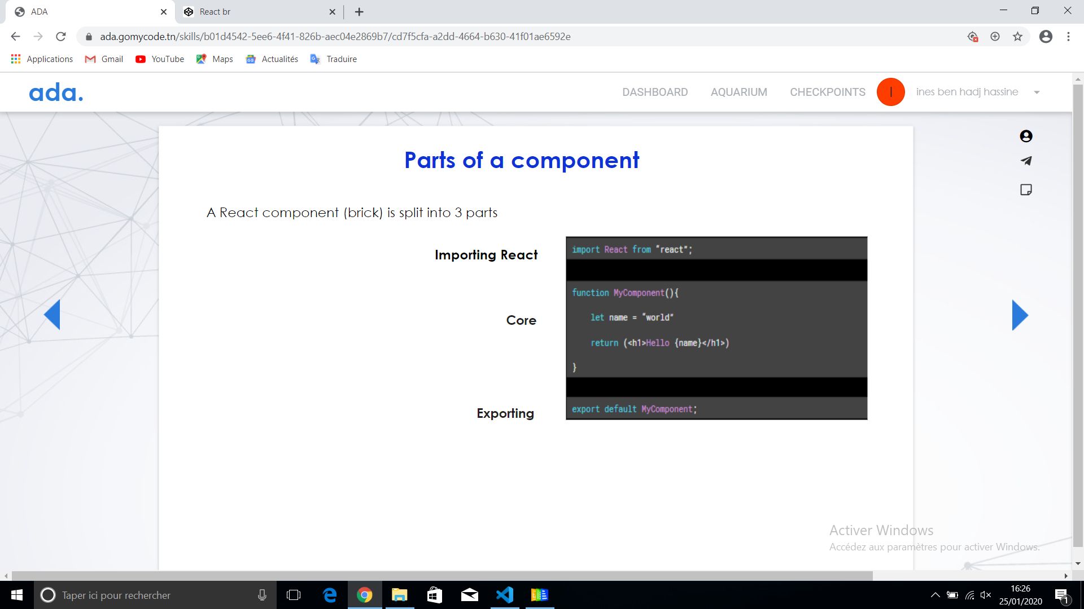

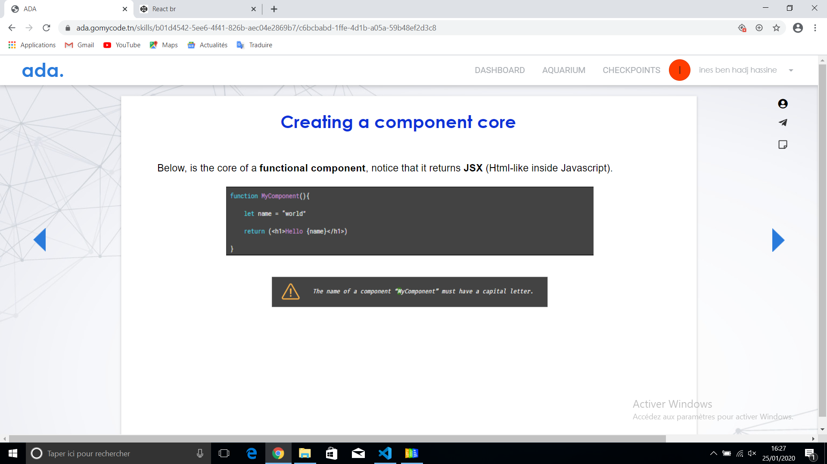

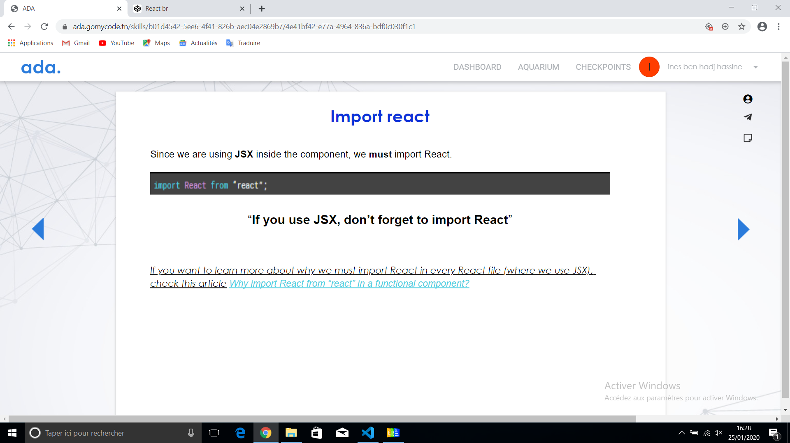

#### GETTING USED TO COMPONENTS CHECKPOINT

Getting used to components

#### **Note :**

Create a project using create-react-app.

Create 3 components:

1. Container
2. List component inside the Container
3. ListItem

Call the ListItem multiple times inside the List component

Hint:

* Don’t forget to put all your elements in a one element after the return statement since React doesn’t allow multiple elements at the top level (use <>...</> for example)