 | Industrial Processes Automation  MSc in Electrical and Computer Engineering  Scientific Area of Systems, Decision, and Control  Winter Semester 2016/2017 |  | Group: 2  75167-Francisco Oliveira  75322-Catarina Gaspar  75637-Inês Lourenço  84993-Hugo Serieiro

1st Laboratory Assignment

Alarm System for Intrusion Detection

This work aims the implementation of an intrusion detection alarm system, in a restricted space as a single room retail store. The intrusion will be detected resorting to an infrared sensor, installed in such a way that it points towards the main entrance of the space to be protected. A switch is also installed on a window of the aforementioned space.
The automation system that constitutes the alarm is to be implemented in the Schneider PLCs available on the laboratory, model Premium TSX P57 1634M or TSX P57 2634M. This document is composed by two sections: the first describes the guidelines for the first session on the lab and the second (see annex A) describes the functional specifications of all the work that will be developed in the next weeks.

Part A - System Components

General characteristics of the alarm:

The Alarm has three main modes of operation, namely OFF, Presence Detector and Active. The three modes are selected by a three positions switch. The general characteristics of the three modes of operation are detailed next:
(Mode 1) OFF – this mode deactivates the alarm completely.
(Mode 2) PRESENCE DETECTOR – the infrared sensor is used to detect movement in the room, and signalize it using both a lamp (LED) and the buzzer on the panel. The lamp should be on for 5 seconds, upon the detection of each person, and an acoustic signal with the duration of 1 second should be emitted.
(Mode 3) ACTIVE – in this mode the alarm is to be used.

Detailed specifications for mode 3, ACTIVE, are the following:
a) When requested for activation, a period of 30 seconds of inactivity is set to allow the user to abandon the space, and afterwards remains permanently activated.
b) Upon intrusion detection, by the infrared sensor or the window switch, the alarm evolves to the warning phase.
c) The alarm lights a warning on the panel and after 5 seconds the buzzer must be activated. The warning must be a periodic signal with 1 second ON and 2 seconds OFF.
d) The alarm can be deactivated pressing the # key on the command panel.

Implementation details

In order to implement the general characteristics of the alarm in a clear manner, it is important to separate into one sub-routine the mode 2, Presence Detector, and to another sub-routine the mode 3, Active. The indications of a detected presence and of an intrusion should also be implemented into one separate sub-routine. More sub-routines can be added in case they help making the code more clear.
In order to help the readability of the proposed solution, the identifiers used in the PLC program must have readable names. For example, instead of using "%I0.2.0" it is more readable to use "I_switch1_pos1". The following naming convention is therefore suggested: I_xyz for inputs, O_xyz for outputs, M_xyz for memory variables, TM_xyz for timers, SR_xyz for sub-routines, etc, where xyz denotes meaningful names.
Note: in this part of the work the infrared sensor is replaced by the two positions switch.

Report questions

Q1. Identify the inputs (switches) and outputs (LEDs and buzzer) of the intrusion detection alarm console and fill the next table.

Input  (chosen variable name) | PLC Identifier  (physical address) |  | Output  (chosen variable name) | PLC Identifier  (physical address)
I_IR | %i0.2.2 |  | O_Buzzer | %q0.4.0
I_DP | %i0.2.1 |  | O_Activo | %q0.4.3
I_Active | %i0.2.0 |  | O_DP | %q0.4.2
I_Cardinal | %i0.2.7 |  | O_Alarme | %q0.4.1

Q2. (Hardware diagram) Draw a hardware diagram of the alarm console components (switches, LEDs and buzzer) connected to the PLC. Do not forget to include the power supply.

The hardware diagram of the alarm is the following:
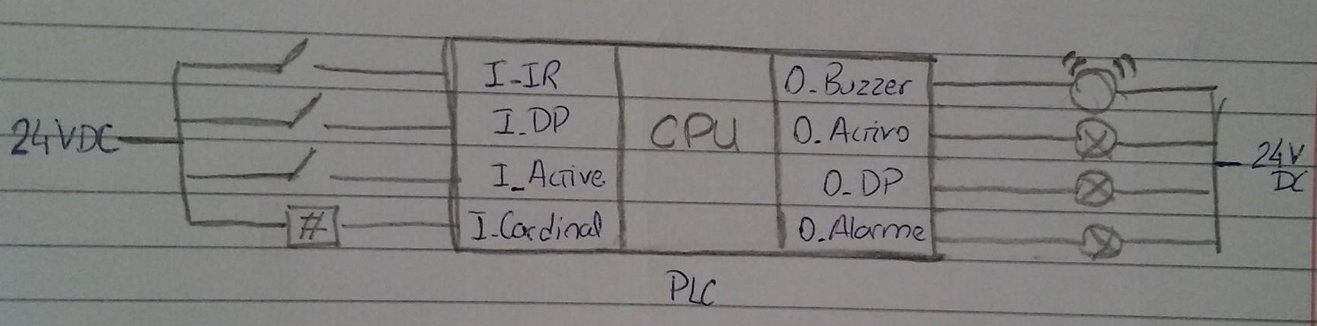

Q3. (Keypad interface) Describe briefly how the PLC interfaces (electric connections) to the keypad in the alarm console (see some information in annex B). Draw a diagram to illustrate your description.

O keypad está estruturado de forma a que haja uma matriz em que cada linha liga os três botões na sua direção horizontal, e cada coluna os 4 botões na vertical. Desta maneira, ao pressionar um botão a linha e a coluna a ele correspondentes ficam, na matriz, ambas ativas e curto-circuitadas.
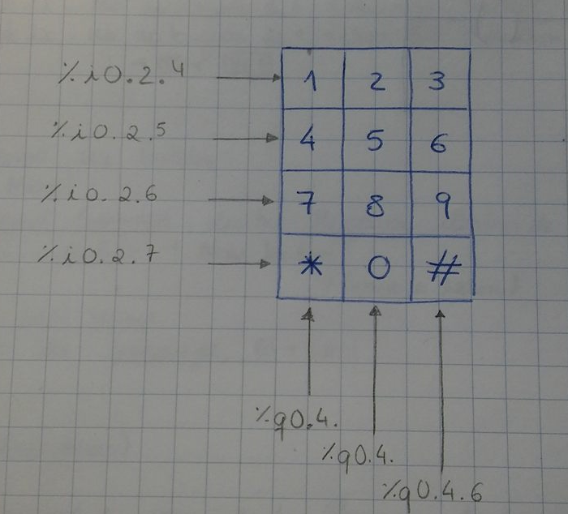
a
4
d
c
b
6
5
Cada linha do keypad é um input no PLC enquanto que cada coluna está associada a um output. Sendo assim, para que uma tecla seja premida, é necessário primeiro “activar” uma coluna, ou seja ligar esse output. Só depois é possível que o input do teclado seja reconhecido.

Como está representado no exemplo de cima, estando a coluna ‘1’ activa, ao pressionar o botão 7, fica ativas a linha ‘’C’. Assim sendo, cada botão gera uma combinação única (linha - coluna).

Q4. (Hardware test program) Design and test a ladder program that verifies the proper functioning of the output devices available in the alarm console. More precisely, the program must beep the buzzer 0.5 seconds and turn ON the three lamps (LEDs), one after the other, 0.5 seconds each.

The ladder diagram that represents the previous program is the following:

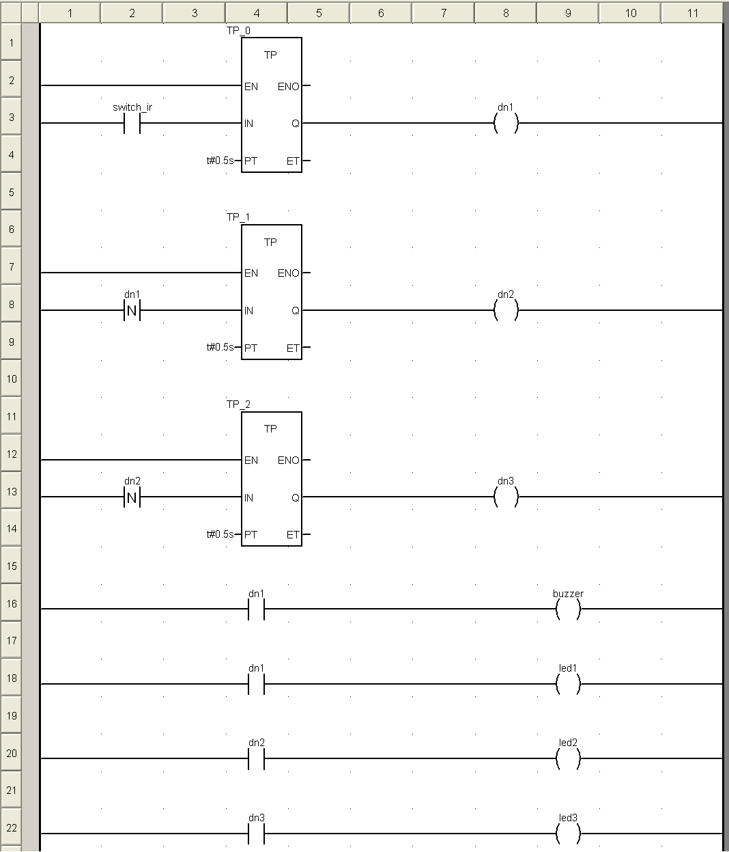

Q5. (Multiple accesses to the buzzer) Create a ladder sub-routine where the buzzer can be turned ON by one of two alternative memory variables (BOOL), and can be unconditionally turned OFF by another memory variable (BOOL). Create a third way of actuating the buzzer, also commanded by a memory variable (BOOL), where the buzzer sounds with a periodic signal, 1 second ON and 2 seconds OFF.

The previous problem is represented by:
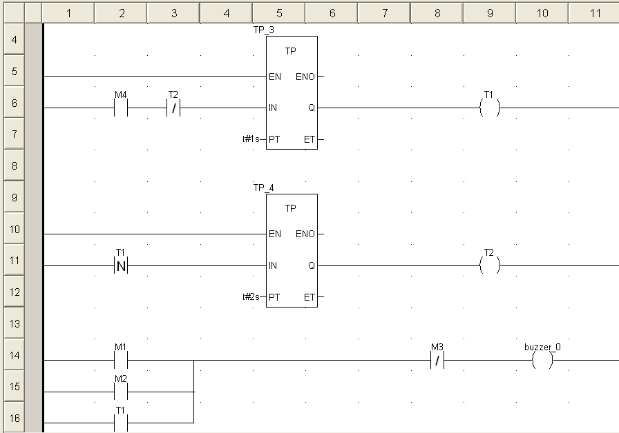

Q6. Consider the alarm application in this and the next questions. List and describe the timers that will be used, their function, and the delay times to be selected for each one.

Timer name and/or physical address | Operation mode | Time Delay (s) | Short description of the  usage of the timer
T_PM_led | TP | 5 | No Presence Mode, é o período de 5s que o led está ligado quando é detetada 1 pessoa
T_PM_Buz | TP | 1 | No Presence Mode, é o período de 1s que o buzzer está ligado quando é detetada 1 pessoa
T_M_activity | TON | 30 | Garantir os 30 segundos iniciais de inatividade do modo 3 - Active
T_AM_buz | TON | 5 | Após a deteção de um intruso, no Modo Activo, há um tempo de espera de 5s antes de ligar o buzzer
T_AM_led | TP | 1 | Quando, em Modo Activo, é detetado um intruso, há um período de 1s em que o led de alarme está ligado
T_AM_2 | TP | 2 | Controla o período de 2 segundos em que o led de alarme está desligado
Q7. List the sub-routines to implement in the alarm application. In particular indicate the routine names and list variables shared with other routines or sub-routines. Classify the listed variables as "input", "output" or "input and output".

Sub-rotinas | Variáveis partilhadas | Classificação | Partilhadas com
SR_DP | Flag_DP  DP_Led  DP_Buzzer | I  O  O | Alarme  SR_Output  SR_Output
SR_Active | Flag_Active  M_activity  M_alarme  Active_Buzzer  Active_Led | I  I / O  I / O  O  I / O | Alarme  SR_Output  SR_Output  SR_Output  SR_Output
SR_output | Flag_DP  Flag_Active  DP_Buzzer  DP_Led  Active_Buzzer  M_activity  M_alarme  Active_Led | I  I  I  I  I  I  I  I | Alarme  Alarme  SR_DP  SR_DP  SR_Active  SR_Active  SR_Active  SR_Active

As variáveis indicadas na tabela acima são as partilhadas entre sub-rotinas. Para além destas, há variáveis locais que são apenas específicas dentro da respetiva rotina ou sub-rotina, como: I_DP, I_Active, I_IR, I_Cardinal, T_2s, Keypad_out, O_Buzzer, O_DP, O_Activo e O_Alarme.

Q8. Design one or more ladder sections to solve the aforementioned automation problem.

As rotinas e sub-rotinas implementas são:
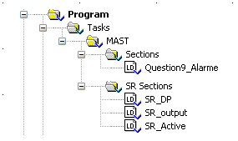

Section: “Alarme” – Programa principal
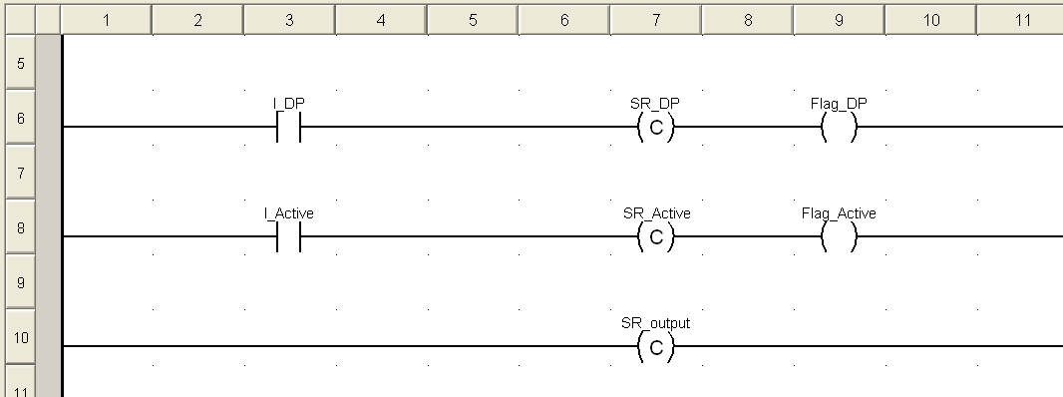

Sub-section: “SR_DP” – Detetor de presença
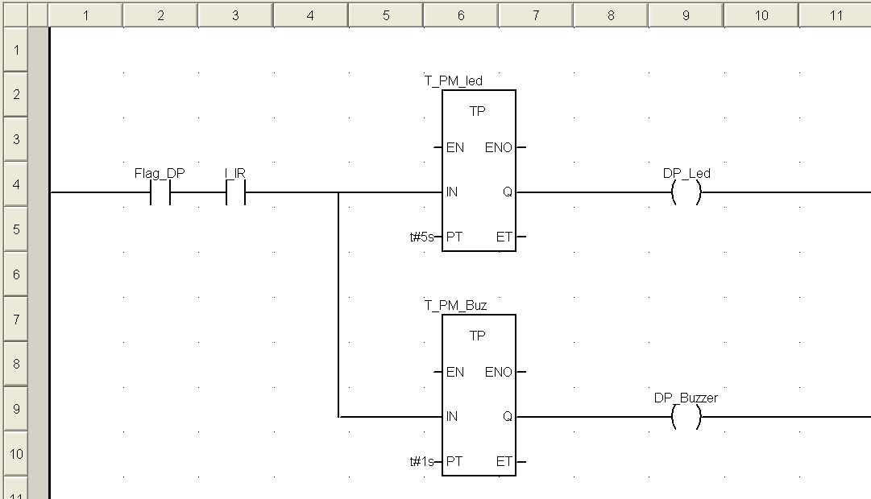

Sub-section: “SR_Active”
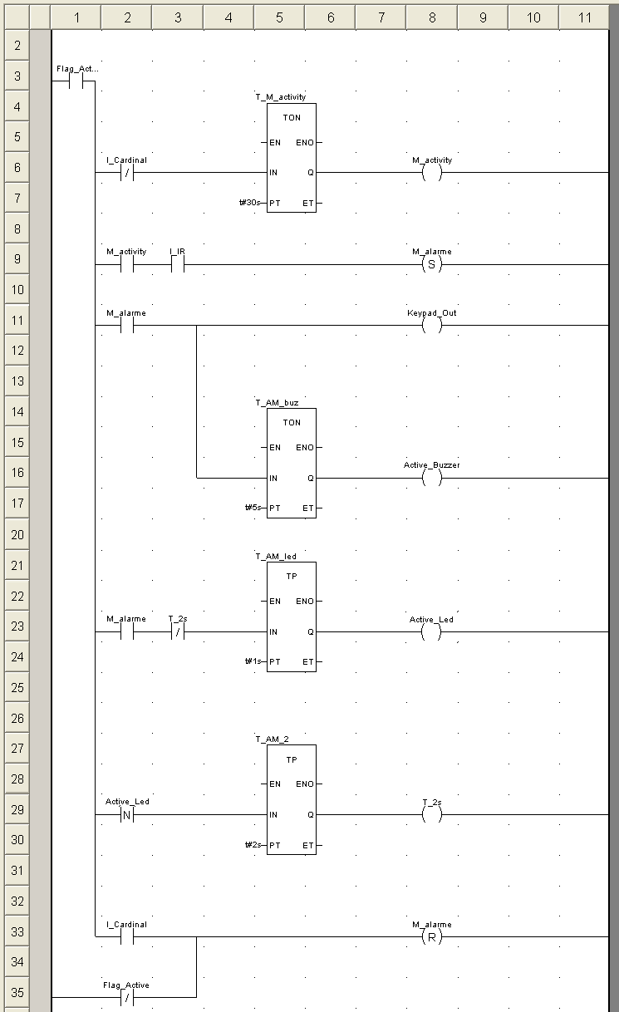

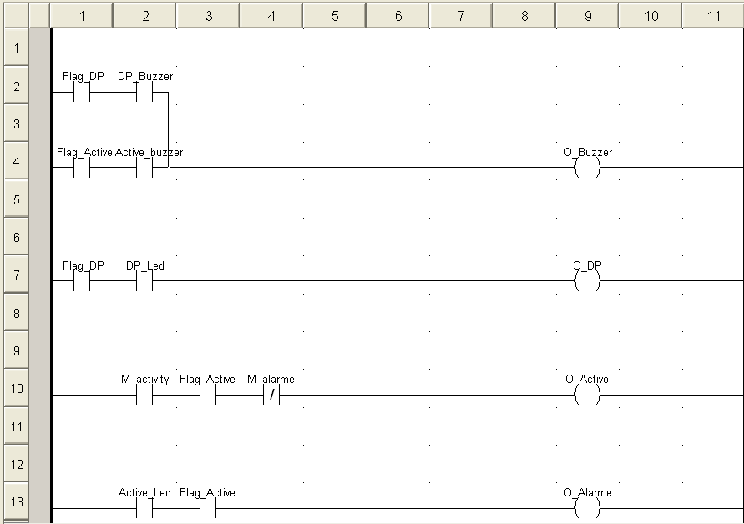
Sub-section: “SR_output”

Q9. Upload the program to the PLC and execute it. Comment how it runs.

O programa está dividido em 4 partes: Uma rotina principal e 3 sub-rotinas, em que a primeira chama as três. Uma delas (SR_output) está sempre ativada, com o objetivo de que sempre que qualquer variável acione um output, ele seja imediatamente ativado, independentemente do estado das outras sub-rotinas.
As outras duas sub-rotinas (SR_DP e SR_Active) são ativadas alternadamente consoante o modo que o utilizador escolha para o alarme, através do switch de 3 posições do input. A 3ª posição consiste no modo OFF, em que o alarme está desativado logo nenhum output está ligado.

Se o utilizador escolher o modo Detetor de Presença, é chamada a sub-rotina SR_DP, que só é ativada quando o sensor de Infravermelhos (I_IR) for ligado. Aí, são ligados dois timers: Um que chama uma variável que ligará o led durante 5 segundos, e outro que ligará o buzzer durante 1 segundo. Estas duas variáveis vão ser inputs para a sub-rotina SR_output, responsável então por ativar os endereços físicos desses outputs, conjuntamente com outras variáveis vindas da outra sub-rotina, SR_Active, em que estando os outputs de uma sub-rotina ou da outra ativada, o desejado output será ativado.

Quando esta outra rotina é escolhida com o switch, o timer conta 30 segundos e só passado esse tempo é que as restantes operações podem acontecer. Se for detetado um intruso, ativa-se o botão “#” para ser possível desligar o alarme, e um timer conta 5s até ser enviado um sinal para começar a tocar o buzzer, à rotina SR_output. Dois outros timers garantem a ativação e desativação de um led, durante respetivamente 1 e 2 segundos. As duas flags (Flag_DP e Flag_Active) são usadas nas sub-rotinas para que os outputs do programa sejam desligados caso se mude de modo de alarme, bem como também para que os temporizadores reiniciem sempre que se volta a entrar na sub-rotina.

Annex A - Functional Specifications of the Alarm

The Alarm has three main modes of operation, OFF, Presence Detector and Active. The three modes are selected by a three positions switch. The three modes operate as detailed next:
(Mode 1) OFF – this mode deactivates the alarm completely.
(Mode 2) PRESENCE DETECTOR – the infrared sensor is used to detect the movement on the room/space, that be signalized resorting both to a lamp and to the buzzer on the panel. The lamp should be on for 5 seconds, upon the detection of each person, and an acoustic signal with the duration of 1 second should be emitted.
(Mode 3) ACTIVE – in this mode the alarm is to be used.

Detailed specifications for mode 3, ACTIVE, are the following:
a) When requested for activation, a period of 30 seconds of inactivity is set to allow the user to abandon the space, and afterwards remains permanently activated.
b) Upon intrusion detection, by the infrared sensor or the window switch, the alarm evolves to the warning phase.
c) The alarm lights a warning on the panel and after 5 seconds the buzzer must be activated. The warning must be a periodic signal with 1 second on and 2 seconds off.
d) The alarm can be deactivated pressing the # key on the command panel.

Advanced Characteristics of the Alarm:

An advanced alternative for the alarm activation/deactivation consists on the use of a code previously set by the human owner (e.g. 9665). To implement the activation function, the following procedure must be implemented:
a) switch the alarm mode to ACTIVE.
b) introduce the activation code (e.g. 9665).
c) press #, and wait for 30 seconds to allow the user to abandon the space.
d) start the intrusion detection function, i.e. the alarm is fully operational.

To deactivate the alarm, upon intrusion detection or to allow the use of the space, the following instructions must be accomplished:
a) Introduce the secret code (the same as the activation one, e.g. 9665).
b) Press #
c) Change the alarm mode to a mode other the ACTIVE.

Special Characteristics of the Alarm:

A safer mode of operation for the intrusion detection alarm is to allow the user to change the activation/deactivation code. The code 1234 is initially used, as a factory preset. To change the code, the following operations must be done:
a) Press *, followed by the pre-programmed code.
b) Introduced the new code to be used, finished by *
In the case where a mistake occurs, press the code **** to reset the code to the factory default.

Available Material

In the laboratory there are six different working places, all with similar PLCs but different consoles. All workplaces have a PLC Schneider model P57. All of them have a power supply with 24V and/or 12V and a desktop PC, with the Unity Pro v6 development software and the PLC manuals, in PDF format.
In each workplace there will be also an alarm console with the following components:

12 buttons keyboard  12V buzzer  1 three positions switch  1 two positions switch  3 LEDs | 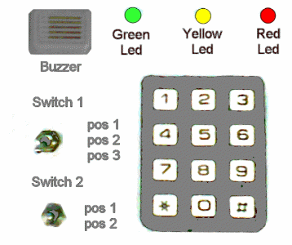

The solution for this automation problem must be based on the languages described on the IEC-61131-3 standard, i.e. ladder diagrams, instruction list and structured text.

Annex B - 4x3 Keypad

The keypads that are used in the laboratory have 12 keys arranged in a 4x3 matrix (see the next figure). The terminology to be used in the laboratory is the following: the three columns are named by the digits 1,2,3 and the four lines by the letters a,b,c,d.
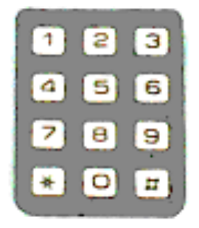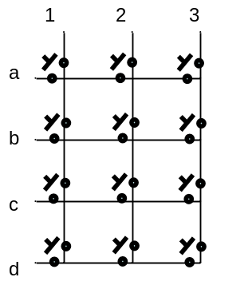

The next image shows the inside of a keypad. Notice that keypads can be made simply of contacts which are short circuited when someone presses a button. For example pressing key "eight" shorts the circuit of column 2 with line c. Most 4x3 keypads have 4+3 wires. Some, as the one shown in the figure bellow, can have also an 8th wire which will not be used in the project.

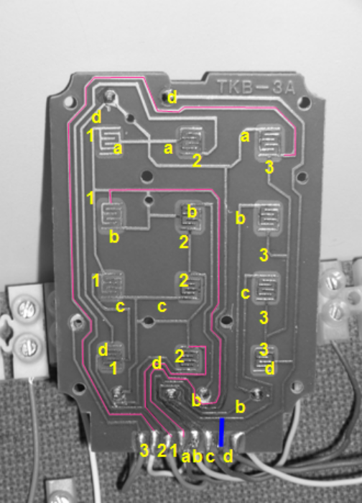

In this picture the pads with holes for wiring the keypad to a terminal (or a PLC) are marked, from left-to-right, 3,2,1,a,b,c,d. This sorting is not standard among manufacturers. In most cases columns and lines are mixed and unsorted as the base printed circuit boards are simpler. Every 4x3 keypad must be tested to identify the pads corresponding to the 3 columns and the 4 lines.

A possible algorithm for identifying the 3 pads that can act the columns and the 4 pads that can read the lines is the following:

- Choose 2 of the 7 pads of the keyboard and use the multimeter (ohmmeter) to verify that, after pressing all keys, the 2 chosen pads (i) can or (ii) cannot be short circuited.

- If case (i), i.e. the two chosen pads can be short circuited by a pressed key, then press another key in the same column and change one of the two selected pads to the other 5 positions. If the novel key is not identified, then return the changed pad to its original location and do the same 5 tests with the other pad. This procedure allows naming a pad as column 1, 2 or 3.

- If case (ii), then the two chosen pads connect to two lines or to two columns, not one line and one column. Need to reselect one pad of the selected pair. Repeat this until a pair of pads is in accordance with case (i).

- After identifying the pad defining one column, it is easy to identify 4 pads corresponding to the 4 lines, as pressing keys in the right column must always do a short circuit to another pad.

- Having identified 1+4 pads, the remaining two pads are connected to the two other columns. Pressing a key in one column or the other makes a short circuit to one of the four lines.

2010 original guide by Prof. Paulo J. Oliveira, 2017 rev. by Prof. José Gaspar

