 | Industrial Processes Automation  MSc in Electrical and Computer Engineering  Scientific Area of Systems, Decision, and Control  Winter Semester 2016/2017 |  | Group: ____  __-_____  __-_____  __-_____  __-_____

2nd Laboratory Assignment

Handling Faults in Keyboard Reading

This laboratory assignment aims at studying Discrete Event Systems (DESs) in the aspects of modeling, analysis of properties and synthesis. Synthesis will be based on a recent methodology in the framework of supervised control. This assignment further develops the previous assignment in the keyboard reading component by introducing fault handling mechanisms.
The tools to be used in this work are MATLAB, including a supervisor design toolbox, and a Petri Net editor. In the last part of the work the Schneider PLCs will be used once more to validate the proposed methodologies.

Part A - Petri Net

DES modeling:

Using as a base guideline the work done in the first laboratory assignment, it is now desired to model the process of reading one keyboard key as a DES. In particular is supposed to develop a Petri Net that describes the events and the state evolution of the key reading system. Complementing the formal definition of the Petri Net, it is desired also to obtain the corresponding incidence matrix.

Note: in order to obtain a Petri Net as simple as possible (less than 20 places), the rejection of multiple keys (first laboratory, part B) should not be included now; the rejection of multiple keys will be subject of formal analysis in part C of this assignment.

Note2: See in the course webpage tools helping this part of the assignment, namely the graphical editor "pmedit" (windows 32) which allows creating models to import with the Matlab toolbox "tpn5". Both tools are compressed in a single ZIP file "PN_editor_MATLAB_sim_and_Manual.zip". See also Matlab functions simulating Petri nets, in particular the "5 Philosophers" demo and a template for simulating the keyboard "lab2_sim_kb_v5.zip".

Q1: Write the list of events of the DES you are proposing. (Fill the next table, adding as many lines as needed).
Event Identifier | Description

Q2: Write the list of conditions of the DES you are proposing. (Fill the next table, adding as many lines as needed).
Condition Identifier | Description

Q3: Write the table of pre and post conditions for each of the events. (Fill the next table, adding as many lines as needed).
Event | Pre-Conditions | Post-Conditions

Q4: Draw the corresponding Petri Net. Comment about the temporizations implemented in the first assignment and which are not currently included in the proposed DES.

Q5: Obtain the incidence matrix, D=D⁺-D⁻, describing the proposed Petri Net.

Q6: Run the default "5 philosophers dinner" simulation referred in Annex 1. Comment whether all requests to eat are satisfied or not. Modify function PN_tfire.m to simulate random inputs, as detailed in Annex 1, and comment again on the satisfied requests to eat and, in particular, whether one philosopher can be more satisfied than others. Simulate the Petri net you proposed, as requested in this guide, and comment whether the simulated Petri net may have or not privileged transitions or places while receiving random inputs.

Annex 1 - Philosophers Dinner Simulation

Please find in the webpage of the course the "5 philosophers dinner" simulation files as a zip file. Decompress the zip file and run pdinner_tst.m. Note that you need also the RDP.M function found in the tpn5 toolbox that you have to install beforehand.

The pdinner_tst.m demonstration script loads a Petri net model shown in figure1 and built using PMEDIT. The Petri net model is read using the referred RDP.M function.

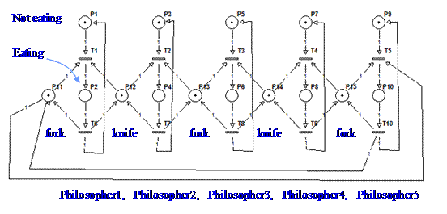
Figure 1: Petri net model representing the 5 philosophers dinner problem.

The default simulation has the transitions scheduled, driven by a time table. In order to run a simulation where the transitions are driven randomly, you can edit the file PN_tfire.m and replace the line:
qk= pdinner_IO(act, t);

by the line:
qk= round(rand(1,5)); qk= [qk not(qk)];

Note that only transitions 1 till 5 are computed randomly. Transitions 6 till 10 are defined simply as the negation of the transitions 1 till 5.

To have more information on the Petri net simulator and the specific simulation of the "5 philosophers dinner" see:
http://users.isr.ist.utl.pt/~jag/course_utils/13_pn_sim/PN_sim.html

Original guide by Prof. Paulo J. Oliveira. Revised by Prof. José Gaspar (2016).

