**C.H.I.P. Fridge**

Course: Ambient Intelligence, Campus: Alameda, Group number: 02

Group members: Ana Jin - 99176, Inês Pissarra - 99236, Juliana Marcelino - 99261



# Introduction

The Internet of Things brought new features and facilities to human life, changing also the way we interact with our devices. Furthermore, eating and drinking is one of the basic needs of any human being and, therefore, something we also spend a lot of time on. With access to new technologies, improving this time and making it more enjoyable is possible.

C.H.I.P. (Cool Home Intelligent Partner) is a smart fridge with tons of functionalities. This appliance revolutionizes how we interact with our kitchen environment, integrating advanced technology to enhance efficiency and convenience.

With a Shopping List Integration, CHIP automatically updates your shopping list as items are used or running low, sending it through email.

CHIP tracks items stored in the fridge, recognizing the items inserted via a camera outside the fridge.

Stay ahead of expiration dates and restock efficiently with timely alerts and reminders. The smart fridge ensures you are notified when items run low or are nearing expiration.

CHIP has a red light integrated that notifies the user when it is time to go shopping.

With this solution it is possible for the user to have complete knowledge of what they have in the fridge, avoiding food waste and helping to monetize the time dedicated to shopping.

# Literature Review

Ms. Priti C. Sane et al. in Smart Refrigerator and Vegetable Identification System Using Image Processing and IoT [1], propose a smart refrigerator, focusing on vegetables, but is extensible to other products. The main goal is to reduce food waste and improve human lifestyles. This refrigerator uses a camera that continuously captures images of the vegetables from the refrigerator, and, with the help of machine learning, the vegetables are classified. It also includes sensors to measure the weight of the products, and other sensors to detect the temperature and humidity of the refrigerator.

The paper also mentions the problem of the expiration date of the food but does not specify how to handle it.

Focusing now on hardware, it suggests a refrigerator that has an Arduino UNO connected to Wi-Fi for data transmission, and interacts with humans via an application that can suggest some recipes and allows the user to check the vegetables available in the fridge.

The user will have to enter some relevant information such as the minimum amount of content in order to receive an alert to buy more if there is not enough.

The refrigerator has a push button to distinguish “storage” from “taking out for use”, but its use is not very detailed.

The author also warns of potential security flaws.

In IoT Based Interactive Smart Refrigerator [2], authored by Shalini K. J., Poornavi S. R., Sahana D. K., Sheik Thamanna, Spoorthi Y. D., the objective is to design a refrigerator prototype that reduces waste and improves shopping efficiency by allowing the users to track food items.

In this project, an Android app shows how much food is in the fridge using sensors. Eggs, milk, and bread are tracked with IR (solid item quantity), load (weight measurement), and ultrasonic sensors. The controller compares sensor readings to set limits and sends data to an online platform. The app then updates with this info, letting users order food easily. It also suggests recipes based on available ingredients by a machine learning algorithm, using a camera to identify vegetables. The camera sends images to the app, using K-means clustering to recognize vegetables by their color and number of edges, and then it suggests recipes based on the recognized vegetable.

Inside the application is possible to get real-time updates on the fridge and place orders from an online vendor. From the author’s point of view, this smart refrigerator is cost-effective and user-friendly.

A feature highlighted by the author that could be left for future work is the expiration date scan, to alert the user when any product in the fridge expires.

# Problem

As referenced before, eating and drinking is one of our basic needs. To ensure a good quality of life, we spend a good part of our time preparing (cooking) and choosing (shopping) our food. Furthermore, there is a lot of food waste because we don’t know exactly what we have in the fridge. Therefore, we intend to make people's lives easier with CHIP, a smart refrigerator that will allow the user to monetize the time dedicated to shopping and cooking, and also reduce the problem of food waste.

Stakeholders will be young people, adults, and elderly people who cook and do their food shopping; and current fridge producers who may want to incorporate this technology into their products.

## Solution Requirements

CHIP The fridge will…

R1 - … recognize the food it currently has;

R2 - … create a shopping list taking into account the user’s recent history;

R3 - … detects the expiration date of the food, allowing the user to avoid food

waste and also adjust the shopping list accordingly;

R4 - … alert the user when the food is about to expire / already expired;

R5 - … send alerts and shopping lists to the user’s email;

R6 - … present a high level of security to protect customer’s privacy, not being able to collect images out of the perimeter of the fridge and protecting the collected data (existing food history, …).

R7 - … allow the user to insert/change products’ quantity

## Assumptions

It is assumed that…

A1 - … the environment where the device is inserted has electricity;

A2 - … there is internet connectivity;

A3 - … the user understands a basic application.

# Proposed Solution

## Overview

The idea of our project is to create a smart fridge that will help the user reduce food waste and have better management of what they have in the fridge. This way they can save money and time. We want to create a simple application to reach more people. Another goal is to automate the process as much as possible. It would be possible for the user to change information anyway.

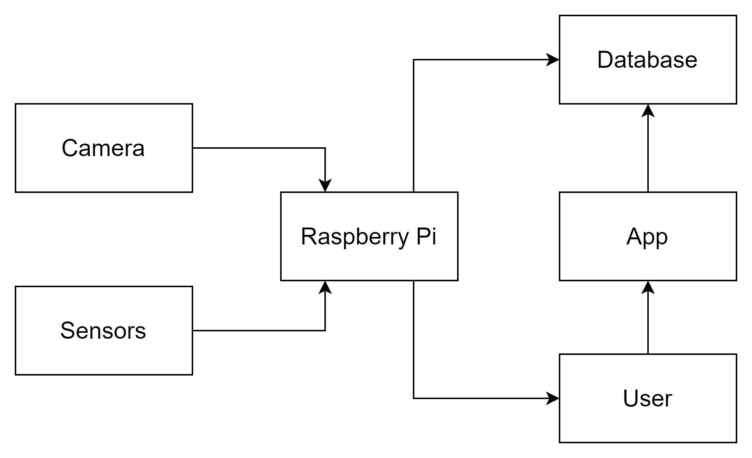

* Camera: Identify the items present in the fridge
* Light sensor: Identifies the presence of products
* Raspberry Pi: Process information received from the sensor and camera
* App: The user can see the data collected and manage his shopping list on the fridge’s screen.
* LED: alert the user of new notifications

## Logical design

* The Raspberry Pi, when receiving the images captured by the camera, recognizes the products using machine learning, processes them, and sends the data to the database, where the information is stored.
* The light sensor detects if the product is inside the fridge, sending the information to the Raspberry Pi.
* If a product is removed from the fridge, the Raspberry Pi updates the information.
* The Raspberry Pi has a database in which the expiration dates are stored, sending an alert when this date is close.
* With the history of products added to the fridge and consumed, the Raspberry Pi can create a possible shopping list.

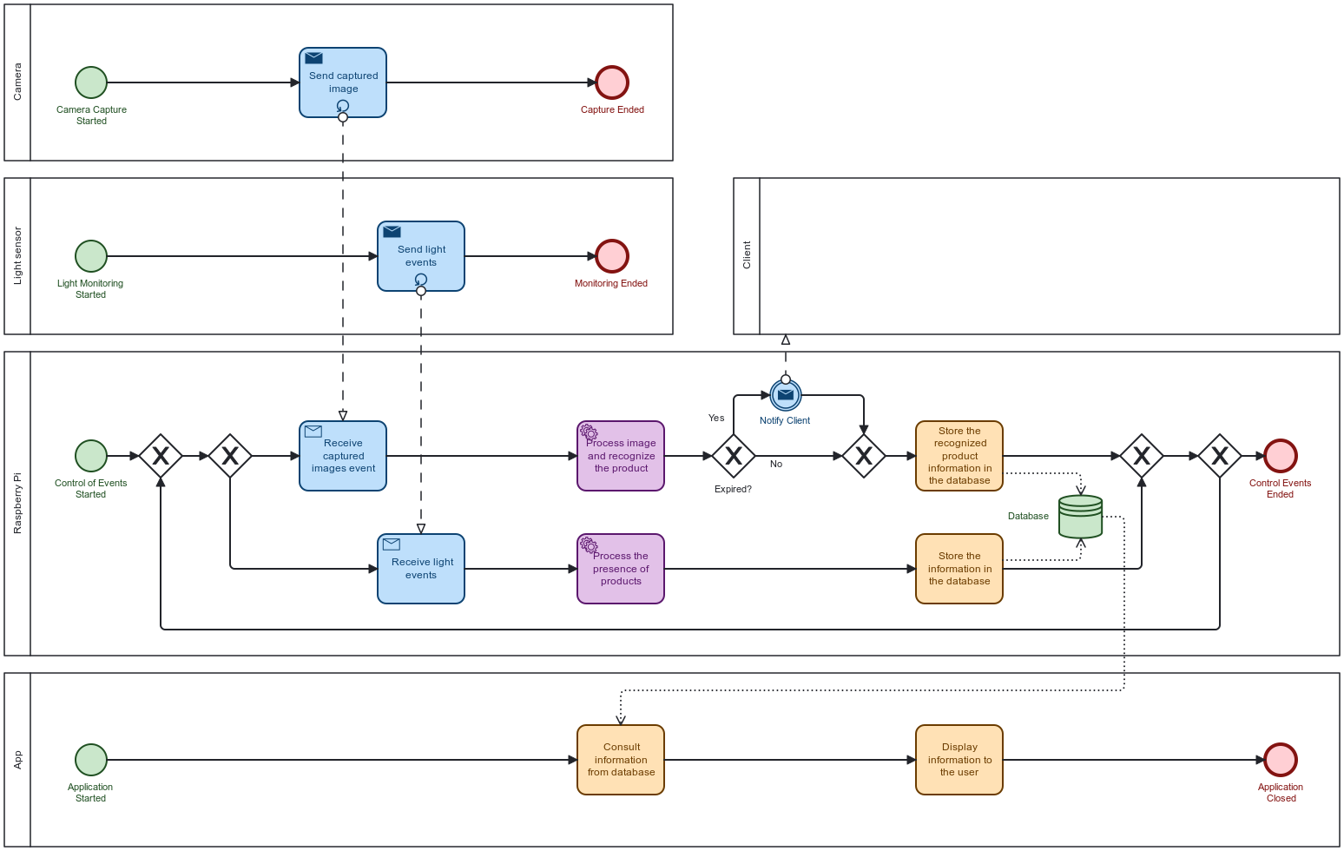

## Technology selection

The primary development platform needed is Visual Studio Code. As for the programming language for implementation, we chose Python.

There’s a camera outside the refrigerator that is connected to the Raspberry Pi, sending the images there. The sensors are responsible for identifying the presence of products and the data is also sent to Raspberry Pi. These pieces of information are then processed and sent to the database so that the user can see everything in real time on the fridge’s screen.

# Bill-of-materials

## Hardware

* Camera - To identify the food inside the fridge
* Light sensor - To identify the presence of products
* Raspberry Pi - To process information, create a shopping list, and store information on the database
* LED - to alert the user of new notifications
* SD card

## Software

* Tensorflow, numpy - to recognize products
* Pytesseract - to recognize the validation date
* Smtplib library - to send notifications by email to the client

# Plan

The most important feature that we want to achieve is the recognition of the products. Then a database is created that stores all the information. With this feature complete we will be able to create the application and the feature that creates the shopping list based on the content of the fridge. We then want to implement the feature that, when inserting a product in the fridge, it will scan the expiration date so that alerts are sent when the products are almost expired.

Since we had yet to gain experience with hardware, we decided to work together instead of dividing tasks.

# Bibliography

[1] Ms. Priti C. Sane, Prof. Harish K. Barapatre, Prof. Ankit Sanghavi, “Smart Refrigerator and Vegetable Identification System Using Image Processing and IoT”, Open Access International Journal of Science and Engineering, vol. 6, Issue 4, April 2021

[2] Shalini K J, Poornavi S R, Sahana D K, Sheik Thamanna, Spoorthi Y D, “IoT Based Interactive Smart Refrigerator”, International Journal of Advanced Research in Computer and Communication Engineering, vol. 10, Issue 6, June 2021