MA473 – Computational Finance Laboratory

Lab – 05

Dipanshu Goyal 210123083

# Question – 1

The given transformed PDE is discretized in space domain by using central-difference to get a system of ODEs in time domain. Those system of equations can be represented using vector and matrices and then different schemes like Explicit-Euler, Implicit-Euler, Runge-Kutta, etc. can be applied to them to get approximate solutions to the given PDE. The main idea is to vectorize the code of the schemes to support vectors instead of scalars which we use to solve one ODE at a time.

Below are the results obtained by applying above mentioned schemes after applying method of vertical lines to the given PDE :-

1. Explicit-Euler

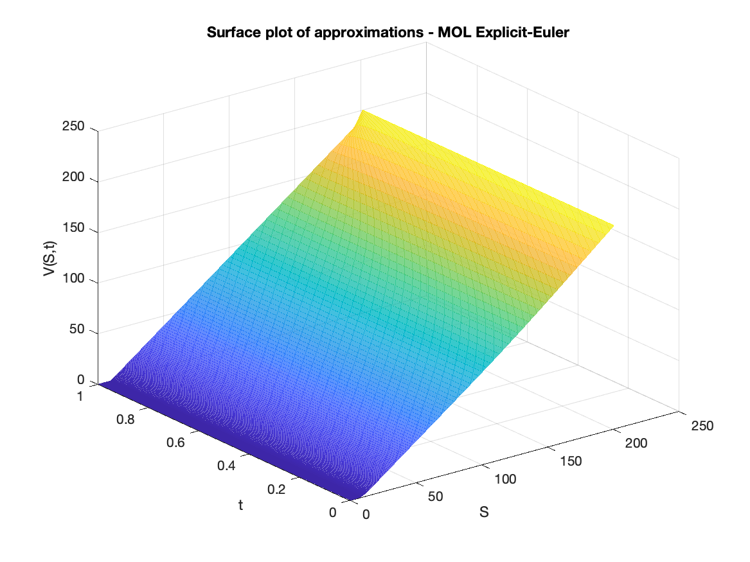

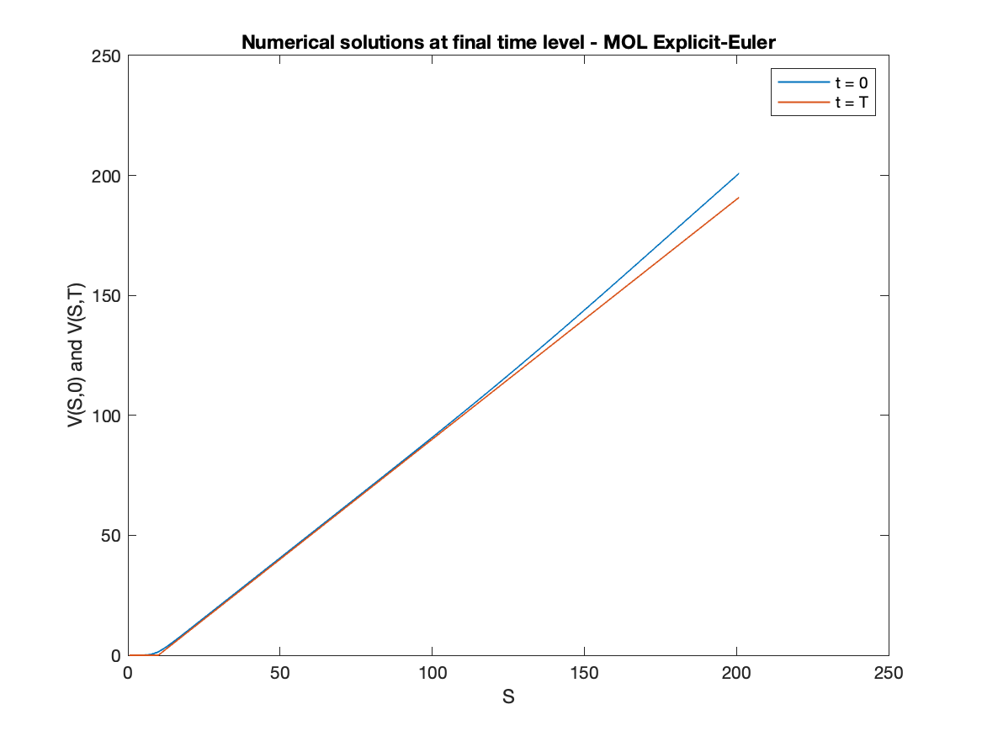

1. Implicit-Euler

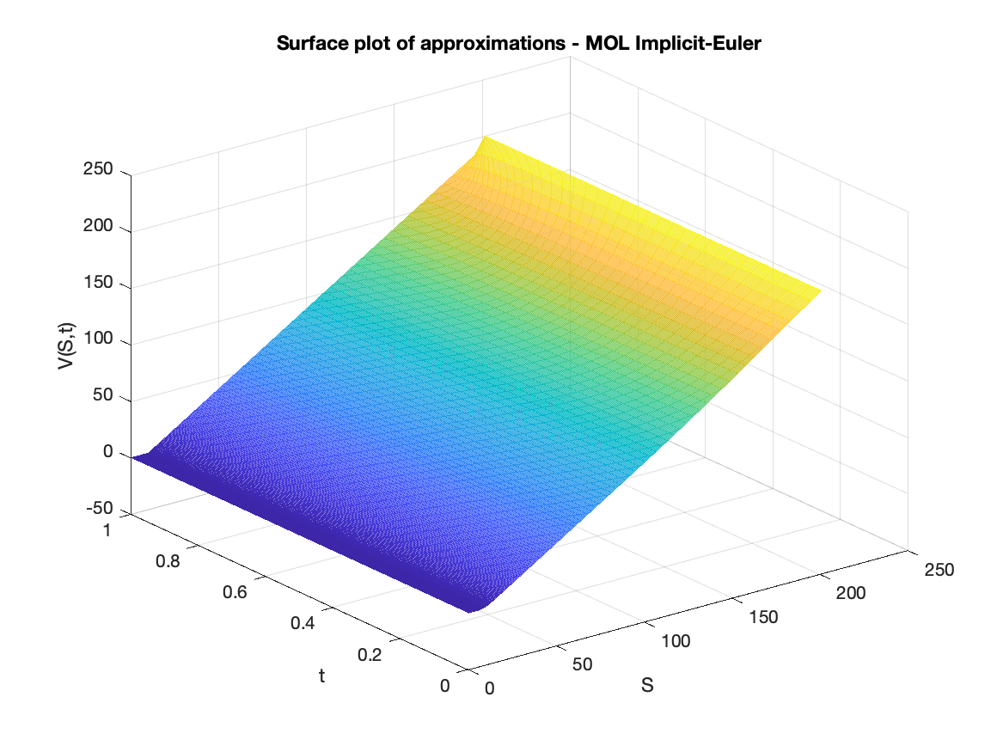

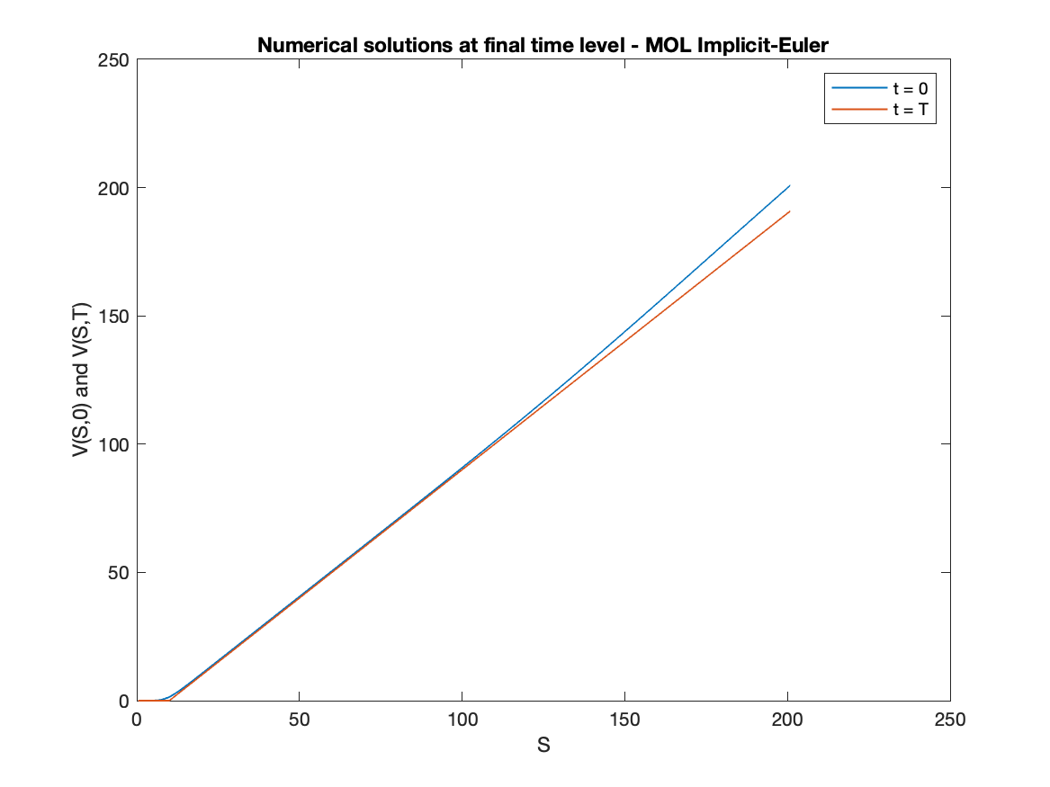

1. Second Order Runge-Kutta

