MA473 – Computational Finance Laboratory

Lab – 08

Dipanshu Goyal 210123083

# Question – 1

The surface plot and final time plots for trapezoidal and simpson’s quadrature are given below :-

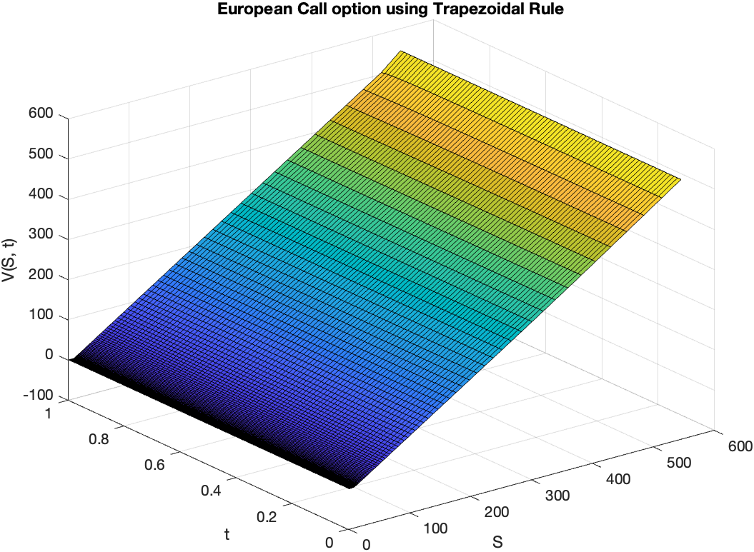

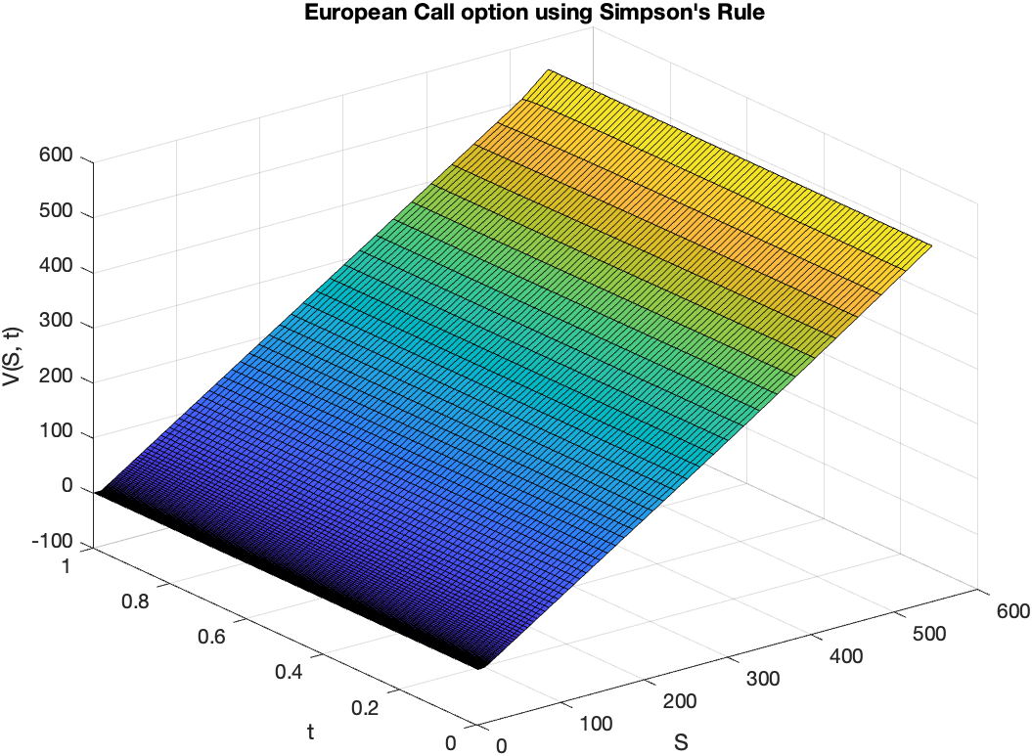

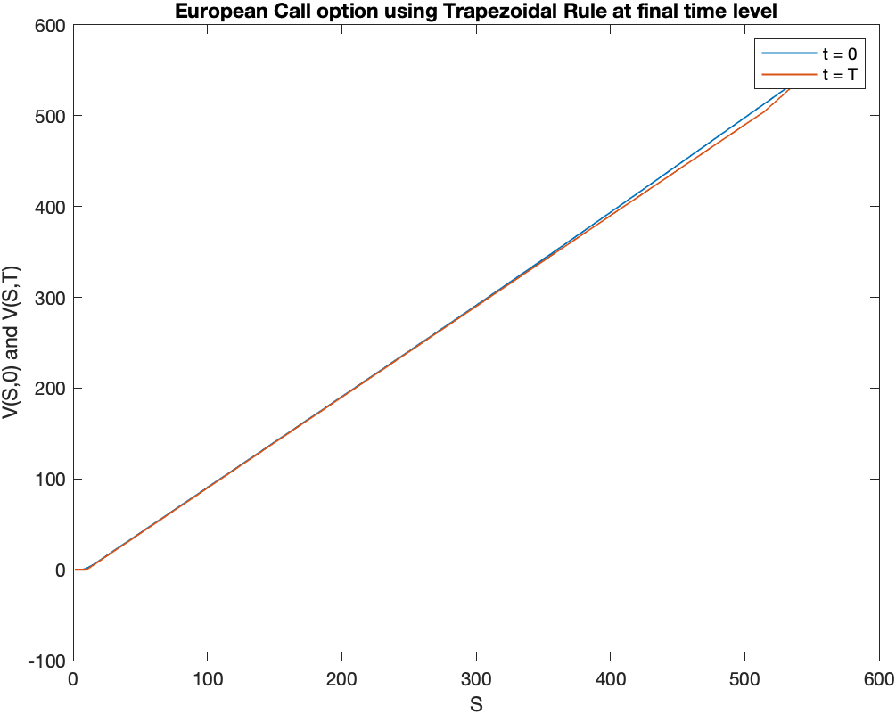

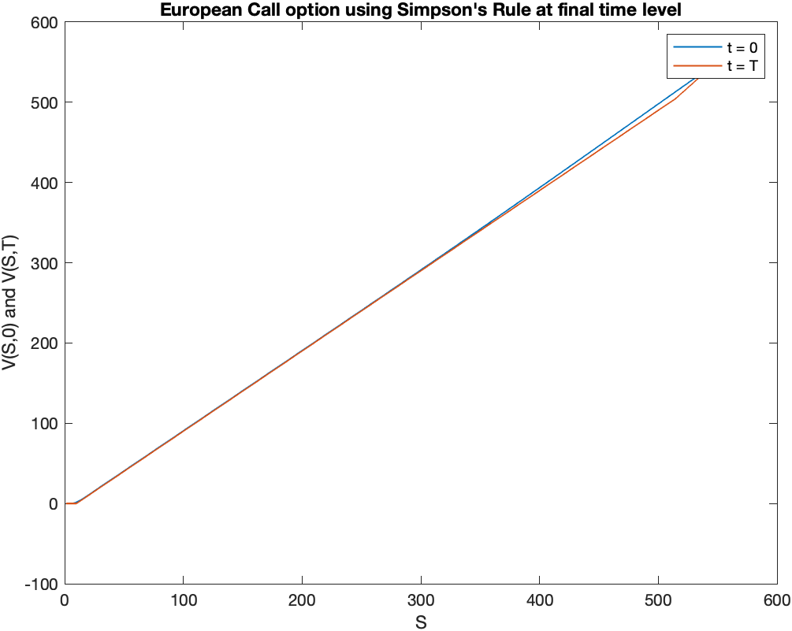

By using the Double-meshing technique, the L2 norm errors are calculated and order of convergence plot thus formed are shown below for both the methods :-

